Pattern 1
Current-State Upsert
Doc 1 of 6 — Base CDC pattern. Key partitioning + idempotent upsert + LSN ordering guard. Keeps one latest row per entity with safe replay behaviour under at-least-once delivery.
P1 Current-State Upsert
Key partitioning + ON CONFLICT DO UPDATE + LSN guard. Per-entity strongly consistent.

Use for | APIs, dashboards, serving layer, search indexes, operational queries — anything needing current state
Consistency | Per-entity strongly consistent with key partitioning + LSN guard. Eventually consistent across entities and across tables in the same source transaction.
History | Latest state only — previous states overwritten on each update. Add P2 alongside for full history.
Combine with | P2 when you need history; P4 for cross-table aggregate consistency; P5 for regulated systems
Do NOT use | When you need every intermediate row state, full history, or point-in-time reconstruction
See also | Doc 0 (overview), Doc 2 (P2 history), Doc 4 (P4 aggregates), Doc 5 (P5 regulated)

Critical Rules
These rules are non-negotiable. Violating any one of them breaks correctness or safety.
• All events for the same entity key must go to the same Kafka partition (key partitioning). This is a correctness requirement, not a throughput optimisation.
• Commit Kafka offsets only after the Postgres transaction commits. Never before.
• Use a comparable ordering type for source_position: pg_lsn for Postgres CDC, bigint for MySQL binlog sequence, numeric SCN for Oracle.
• Apply updates only when the incoming source_position is strictly newer than the stored position (the LSN guard).
• If CDC events are partial updates (only changed columns), do not blindly overwrite every business column — use explicit per-column merge rules. See the Partial Updates section.

Two Mechanisms, Two Distinct Jobs
A common source of confusion: the upsert and the LSN guard are separate mechanisms serving different purposes. Both are needed.

Mechanism | What it does | What it does NOT do
Key partitioning | Guarantees all events for the same entity arrive at the same consumer in source order. | Does not prevent side effects re-firing after a crash restart.
ON CONFLICT DO UPDATE  (upsert) | Prevents duplicate rows. Standard Postgres merge — nothing CDC-specific. | Does not prevent side effects (audit triggers) re-firing on a replayed event.
LSN guard  (WHERE pos < incoming) | Rejects stale replays after crash. Rejects late out-of-order arrivals from retries. | Does not guarantee ordering. That is key partitioning's job.

Sequence
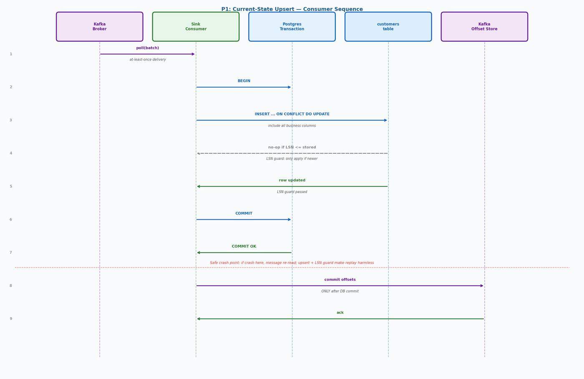
Figure 1 — P1 consumer sequence: poll → BEGIN → upsert with LSN guard → COMMIT → commit offsets

Step-by-Step
- Poll Kafka batch (at-least-once delivery)
- BEGIN Postgres transaction
- For each event: execute upsert with LSN guard WHERE clause
- If incoming source_position ≤ stored: WHERE clause blocks the update — row unchanged, no side effects fired
- If incoming source_position > stored: row updated with new business columns and CDC metadata
- COMMIT Postgres transaction
- Commit Kafka offsets — ONLY after DB commit, never before

CRASH RECOVERY | Crash after step 6 (DB commit) but before step 7 (offset commit): message re-read on restart. The upsert prevents a duplicate row. The LSN guard prevents any side effects (audit triggers, downstream calls) from re-firing.

SQL Reference

DDL
CREATE TABLE customers (
customer_id bigint PRIMARY KEY,
name text NOT NULL,
email text,
status text,
-- CDC metadata (required on every P1-managed table)
last_source_position pg_lsn, -- use pg_lsn for Postgres CDC
-- text, -- use text for MySQL/Oracle (binlog pos / SCN)
last_source_ts timestamptz,
last_txn_id text,
last_event_op text CHECK (last_event_op IN ('INSERT','UPDATE','DELETE')),
is_deleted boolean NOT NULL DEFAULT false,
created_at timestamptz NOT NULL DEFAULT now(),
updated_at timestamptz NOT NULL DEFAULT now()
);

CREATE INDEX customers_lsn_idx ON customers (last_source_position);

COMMENT ON COLUMN customers.last_source_position IS
'LSN guard value: only apply events where incoming pos > this.
pg_lsn for Postgres; cast to text for MySQL/Oracle source.';

Upsert — Full-Row Events
-- Use when CDC events carry full business state (Openflow default)
INSERT INTO customers (
customer_id, name, email, status,
last_source_position, last_source_ts, last_txn_id, last_event_op, is_deleted
)
VALUES (
:customer_id, :name, :email, :status,
:source_position::pg_lsn, :source_ts, :txn_id, :op, false
)
ON CONFLICT (customer_id) DO UPDATE SET
name = EXCLUDED.name,
email = EXCLUDED.email,
status = EXCLUDED.status,
is_deleted = false,
last_source_position = EXCLUDED.last_source_position,
last_source_ts = EXCLUDED.last_source_ts,
last_txn_id = EXCLUDED.last_txn_id,
last_event_op = EXCLUDED.last_event_op,
updated_at = now()
-- LSN guard: only apply if the incoming event is strictly newer
WHERE customers.last_source_position IS NULL
OR customers.last_source_position < EXCLUDED.last_source_position;

Delete Events (Tombstone Upsert)
-- Soft delete: set is_deleted = true, preserve the row for audit visibility
-- Uses INSERT ... ON CONFLICT for consistency — same LSN guard as inserts/updates
INSERT INTO customers (
customer_id, is_deleted,
last_source_position, last_source_ts, last_txn_id, last_event_op
)
VALUES (
:customer_id, true,
:source_position::pg_lsn, :source_ts, :txn_id, 'DELETE'
)
ON CONFLICT (customer_id) DO UPDATE SET
is_deleted = true,
last_source_position = EXCLUDED.last_source_position,
last_source_ts = EXCLUDED.last_source_ts,
last_txn_id = EXCLUDED.last_txn_id,
last_event_op = 'DELETE',
updated_at = now()
WHERE customers.last_source_position IS NULL
OR customers.last_source_position < EXCLUDED.last_source_position;

Partial Updates
Openflow and most CDC tools default to sending full row images (all columns) in each event, so the full-row upsert above is usually correct. However, some configurations send partial update events that contain only the changed columns.

Warning: If CDC events are partial patches, the full-row upsert will overwrite unchanged columns with NULL. This silently destroys data. Verify with your Openflow connector configuration: check whether REPLICA IDENTITY is set to FULL on the source Postgres tables. If not, only the changed columns plus PK are present in UPDATE events.

Handling Partial Events
-- Option A: Set REPLICA IDENTITY FULL on source tables (recommended)
-- This makes every UPDATE event carry the full before and after row.
ALTER TABLE customers REPLICA IDENTITY FULL;

-- Option B: If full images are not available, use explicit per-column COALESCE
-- Only update a column if the incoming event has a non-null value for it.
ON CONFLICT (customer_id) DO UPDATE SET
name = COALESCE(EXCLUDED.name, customers.name),
email = COALESCE(EXCLUDED.email, customers.email),
status = COALESCE(EXCLUDED.status, customers.status),
...
WHERE customers.last_source_position IS NULL
OR customers.last_source_position < EXCLUDED.last_source_position;

-- Note: COALESCE merging has limits — it cannot distinguish between
-- "field intentionally set to NULL" and "field not present in event".
-- REPLICA IDENTITY FULL is the cleaner solution.

Key Partitioning
Without key partitioning, the same entity can race across multiple consumers. Even with the LSN guard protecting against the worst outcomes, you are relying on timing rather than design. Set the partition key in Openflow at the connector level.

Postgres / Oracle CDC | Partition key = primary key column (e.g. customer_id). Set in extraction tool connector config.
Oracle CDC | Partition key = primary key via XStream. Configure in Openflow Oracle connector (or extraction tool equivalent).
Stability | The partition key must never change for the lifetime of the pipeline. Repartitioning breaks per-entity ordering.
Multi-table | For cross-table consistency (e.g. orders + lines + payments), use P4 (aggregate-root partitioning) instead.

Note: LSN (pg_lsn) values are only comparable within the same Postgres instance. For multi-shard sources, inject a logical clock at the Openflow layer and carry it as the ordering field instead of raw LSN.

Failure Scenarios
Crash before DB commit | Event replayed. No durable DB change. Safe.
Crash after DB commit, before offset commit | Replay is stale. LSN guard blocks re-apply. Side effects not re-fired. Safe.
Duplicate event (same source_position) | LSN guard rejects update. Row unchanged. Safe.
Late out-of-order arrival | LSN guard rejects update (pos < stored). Latest state preserved. Safe.
Hot key / hot partition | One partition becomes throughput bottleneck. Consider redesigning aggregate boundaries.
Malformed / poison event | Route to dead letter queue. Never block partition processing.

Validation and Reconciliation
- Compare source max LSN vs customers.last_source_position — growing gap signals consumer lag or missed events
- Monitor stale-skip count (LSN guard rejections) and alert on sustained increase — indicates ordering problems
- Validate monotonicity: last_source_position must never move backward for any entity key
- Run row-level spot checks by customer_id between source and target — sample N rows per hour
- Monitor consumer lag via cdc_consumer_state table

-- Monotonicity check: flag any key where position moved backward
-- (should return zero rows in a healthy pipeline)
SELECT customer_id, last_source_position
FROM customers
WHERE last_source_position < LAG(last_source_position)
OVER (PARTITION BY customer_id ORDER BY updated_at);

-- Consumer lag check
SELECT consumer_group, topic, partition_id,
now() - last_processed_at AS lag_interval
FROM cdc_consumer_state
ORDER BY lag_interval DESC NULLS LAST;

CDC Pipeline Patterns — Doc 1: P1 Current-State Upsert (merged)

