Pattern 2
Append-Only Event Log
Doc 2 of 6 — Every CDC event written as a new row. Nothing ever overwritten. Full history preserved permanently. Always run alongside P1.
P2 Append-Only Event Log
INSERT with composite (pk, source_position) PK. Naturally idempotent. No LSN guard needed.

Use for | Audit trail, compliance, GDPR erasure, event sourcing, time-travel queries, data warehouse history feeds
Consistency | Append-only — all state transitions preserved in insertion order per entity
History | Full history — every INSERT, UPDATE, DELETE kept as a separate row forever
Primary key | (entity_pk, source_position) composite — never conflicts, never overwrites, naturally idempotent on replay
Combine with | Always run alongside P1. P2 alone cannot serve current-state queries efficiently.
Do NOT run alone | Querying current state from an append-only log requires a full scan or a separate materialised view
See also | Doc 0 (overview), Doc 1 (P1 for current state), Doc 5 (P5 for regulated staging)

How It Works
Instead of ON CONFLICT DO UPDATE, every event is a straight INSERT. The composite primary key (entity_pk, source_position) makes conflicts impossible — each event has a unique source_position so no two rows ever share the same PK. Nothing is ever updated in place. The table grows indefinitely.

On crash and replay, the same event arrives again with the same (entity_pk, source_position). ON CONFLICT DO NOTHING silently skips it. No LSN guard is needed because the PK itself provides natural idempotency.

KEY DIFFERENCE FROM P1 | P1 keeps one row per entity (latest state). P2 keeps one row per event. P1 overwrites. P2 never overwrites. Run both from the same Kafka topic with independent consumer groups.

Sequence
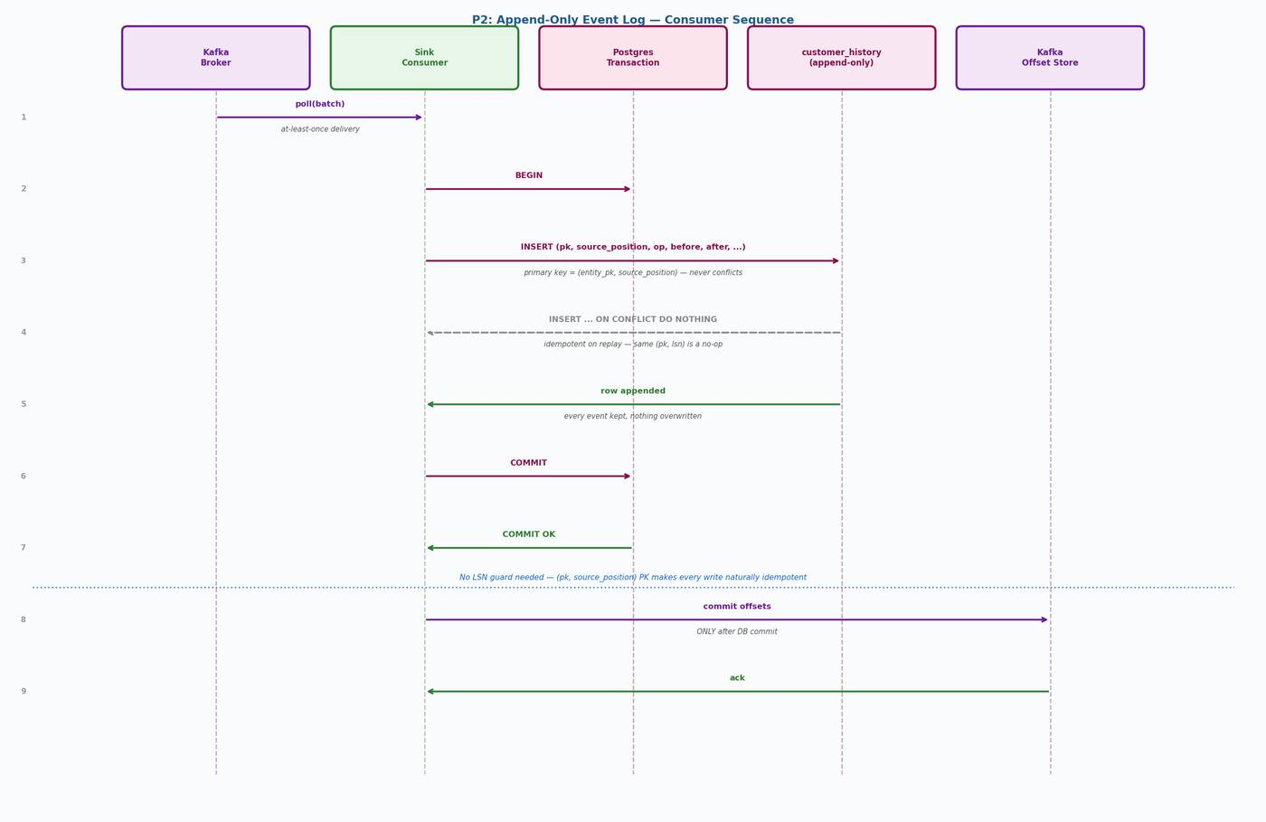
Figure 1 — P2 consumer sequence: straight INSERT with (pk, lsn) PK — no LSN guard, no conflict possible

Step-by-Step
- Consumer polls a batch of messages from Kafka (at-least-once delivery)
- Consumer opens a Postgres transaction
- For each event: INSERT into the history table with all fields including before/after images
- ON CONFLICT (entity_pk, source_position) DO NOTHING handles any replay idempotently
- Consumer commits the Postgres transaction
- Consumer commits Kafka offsets — ONLY after DB commit

Note: No LSN guard is needed in P2. The composite PK (customer_id, source_position) ensures every replay is a silent no-op. This is simpler than P1 and equally safe.

Sink Write
INSERT INTO customer_history (
customer_id, source_position, source_ts,
txn_id, event_seq_in_txn, op,
before_image, after_image,
kafka_topic, kafka_partition, kafka_offset
)
VALUES (
:customer_id, :source_position::pg_lsn, :source_ts,
:txn_id, :event_seq_in_txn, :op,
:before, :after,
:topic, :partition, :offset
)
ON CONFLICT (customer_id, source_position) DO NOTHING;
-- Idempotent on replay: same (pk, lsn) is silently skipped.
-- Cast to ::pg_lsn for Postgres CDC; use text directly for MySQL/Oracle.

DDL
CREATE TABLE customer_history (
-- Composite PK: entity key + source position
customer_id bigint NOT NULL,
source_position pg_lsn NOT NULL, -- pg_lsn for Postgres CDC
-- text NOT NULL, -- use text for MySQL/Oracle
-- Event metadata
source_ts timestamptz,
txn_id text,
event_seq_in_txn int,
op text NOT NULL CHECK (op IN ('INSERT','UPDATE','DELETE')),
-- Full row images
before_image jsonb,
after_image jsonb,
-- Kafka provenance
kafka_topic text,
kafka_partition int,
kafka_offset bigint,
-- Ingestion timestamp
ingested_at timestamptz NOT NULL DEFAULT now(),
PRIMARY KEY (customer_id, source_position)
);

CREATE INDEX customer_history_ts_idx
ON customer_history (source_ts DESC);

CREATE INDEX customer_history_txn_idx
ON customer_history (txn_id, event_seq_in_txn);

COMMENT ON TABLE customer_history IS
'Append-only event log. Nothing is ever updated or deleted.
(customer_id, source_position) PK ensures natural idempotency.
source_position is pg_lsn for Postgres CDC; use text for MySQL/Oracle.';

Query Patterns

Current State
-- Do NOT use P2 for current-state queries.
-- Use the P1 customers table instead.
-- This is why P2 always runs alongside P1.

Full History for an Entity
SELECT op, source_ts, before_image, after_image
FROM customer_history
WHERE customer_id = 123
ORDER BY source_position ASC; -- pg_lsn ordering is correct and numeric

State at a Point in Time
-- What did customer 123 look like on 1 March 2026?
SELECT after_image
FROM customer_history
WHERE customer_id = 123
AND source_ts <= '2026-03-01T00:00:00Z'
ORDER BY source_position DESC -- pg_lsn: correct numeric ordering
LIMIT 1;

-- Note: if source_position is stored as text (e.g. Oracle SCN as string),
-- order by source_ts DESC, event_seq_in_txn DESC instead.
-- Text ordering of LSN strings is lexicographic, not numeric.

All Changes in a Transaction
SELECT op, source_ts, after_image
FROM customer_history
WHERE txn_id = 'your-txn-id'
ORDER BY event_seq_in_txn ASC;

GDPR Erasure
-- For GDPR right-to-erasure: nullify PII in all history rows.
-- P2 rows are never deleted, but PII fields can be redacted.
UPDATE customer_history
SET after_image = after_image - 'email' - 'phone' - 'address',
before_image = before_image - 'email' - 'phone' - 'address'
WHERE customer_id = :customer_id;

-- Also redact the P1 current-state table:
UPDATE customers
SET email = NULL
WHERE customer_id = :customer_id;

Retention Strategy
An append-only table grows without bound. Define a retention policy before going to production. Three common approaches:

Option A: Range Partitioning by Month (Recommended)
-- Partition the history table by ingested_at month.
-- Old partitions can be detached and archived to S3 or cold storage.
CREATE TABLE customer_history (
customer_id bigint NOT NULL,
source_position pg_lsn NOT NULL,
ingested_at timestamptz NOT NULL DEFAULT now(),
...
PRIMARY KEY (customer_id, source_position, ingested_at)
) PARTITION BY RANGE (ingested_at);

CREATE TABLE customer_history_2026_04
PARTITION OF customer_history
FOR VALUES FROM ('2026-04-01') TO ('2026-05-01');

-- Archive old partition:
-- ALTER TABLE customer_history DETACH PARTITION customer_history_2025_01;
-- Then COPY to S3 and DROP.

Option B: Time-Based DELETE
-- Schedule a periodic job to delete rows older than the retention window.
-- Simple but less efficient than partitioning for very large tables.
DELETE FROM customer_history
WHERE ingested_at < now() - interval '2 years';

-- Run during off-peak hours. VACUUM ANALYZE after.

Option C: Archive to S3 via Openflow
-- Use Openflow's PutS3Object processor to archive old rows to S3.
-- Keep only a rolling window in Postgres for fast query access.
-- Query historical S3 data via Snowflake external stage or Athena.

Relationship to P1
Same Kafka topic | P1 and P2 consumers read from the same topic with independent consumer groups
Independent commits | Each consumer commits its own Kafka offsets independently
Different tables | P1 writes to customers (one row per entity). P2 writes to customer_history (one row per event).
Different queries | P1 for current state. P2 for history, audit, time-travel, event replay.
Lag independence | P2 can fall behind P1 without affecting P1 correctness. Size the P2 consumer group accordingly.

CDC Pipeline Patterns — Doc 2: P2 Append-Only Event Log

