Pattern 3
Transactional Outbox
Doc 3 of 6 — Solves the dual-write problem. Guarantees an event reaches Kafka if and only if the source DB transaction committed. A producer-side pattern.
P3 Transactional Outbox
Write the event to an outbox table in the same DB transaction as the business write. A relay publishes to Kafka.

Use for | Cross-service messaging, microservice domain events, any case where a lost or phantom event causes business harm
Consistency | Strictly consistent — the event is published if and only if the source transaction committed
Producer side | P3 solves the outbound publishing problem only. The receiving service still needs P1 or P2 to persist events.
Relay options | Polling process (simple, some latency) or Openflow/Debezium reading outbox via CDC (recommended, zero delay)
Combine with | P1 or P2 at the receiving service. P3 handles reliable outbound publishing; P1/P2 handle inbound consumption.
Do NOT use for | Simple intra-database replication where P1 alone is sufficient
See also | Doc 0 (overview), Doc 1 (P1 at the consumer), Doc 2 (P2 at the consumer)

The Problem: Dual-Write
Without the outbox pattern, publishing to Kafka and writing to the database are two separate operations. A crash between them produces one of two equally bad outcomes:

Without the outbox: two failure modes
• DB committed, Kafka publish failed — the event is lost forever. Downstream services never see the change. Data diverges silently.
• Kafka published, DB commit failed (or rolled back) — a phantom event propagates. The business table has no record of it. Downstream systems act on something that never happened.

The outbox solves this by writing the event to an outbox table in the same database transaction as the business write. Both commit atomically or neither does. The event can never be lost and can never be a phantom.

Sequence
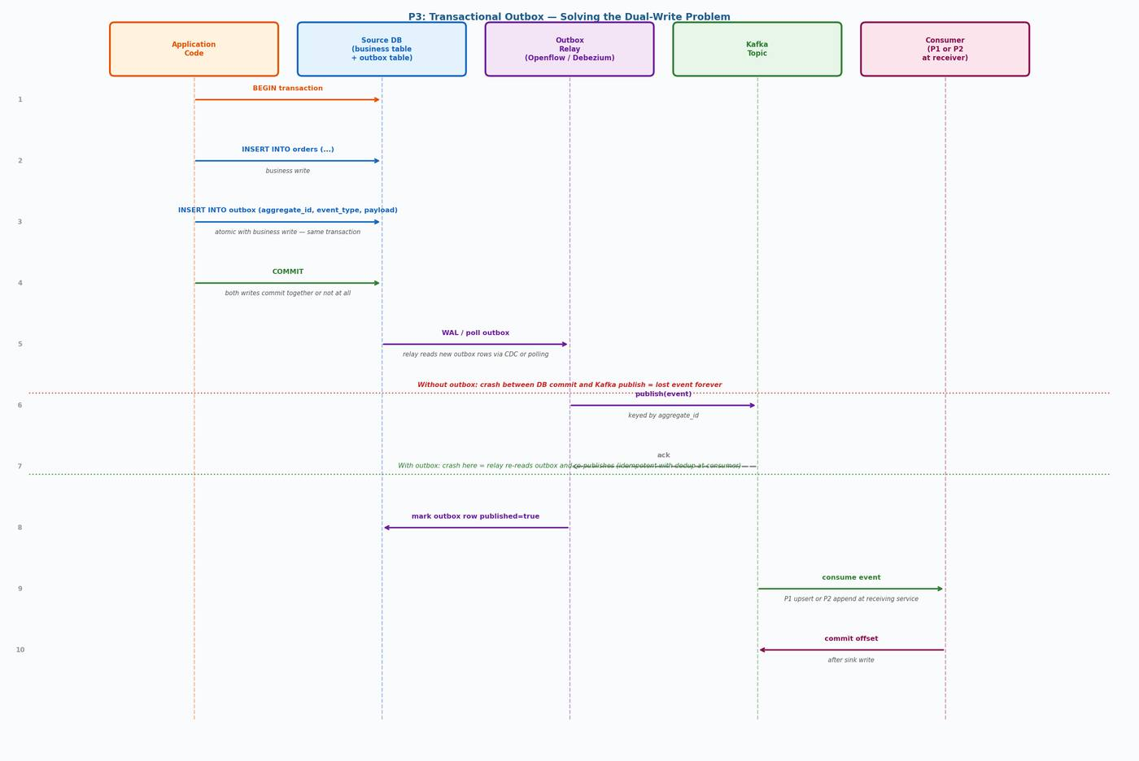
Figure 1 — P3 sequence: atomic outbox write → relay reads via CDC → publish to Kafka → consumer applies P1 or P2

Step-by-Step
- Application begins a database transaction
- Application writes to the business table (e.g. orders)
- Application writes to the outbox table in the same transaction — same atomic commit
- Transaction commits — both writes land or neither does
- Relay detects new outbox row (via CDC stream or polling)
- Relay publishes the event to Kafka, keyed by aggregate_id
- Relay marks the outbox row published = true and sets published_at
- Consumer at the receiving service applies the event using P1 or P2

CRASH SAFETY | If the relay crashes after publishing but before marking published=true, it re-reads the outbox row on restart and re-publishes. The consumer handles the duplicate transparently via P1's LSN guard or P2's ON CONFLICT DO NOTHING.

Why Openflow as the Relay is Better Than Polling
The relay can be a simple polling process (SELECT WHERE published = false, publish, UPDATE). This works but adds polling latency and a separate job to maintain. Using Openflow (or Debezium) to read the outbox table via CDC is better for three reasons:
- Zero polling delay — new outbox rows appear as WAL events, picked up immediately
- Same infrastructure already in place — Openflow is already reading the database's WAL for other tables
- No separate scheduled process — the outbox relay is just another table in the replication set

Note: When using Openflow as the relay, add the outbox table to the Openflow connector's replication set. Route outbox events to a dedicated Kafka topic rather than mixing them with row-level CDC events from other tables.

Outbox DDL
CREATE TABLE outbox (
id uuid PRIMARY KEY DEFAULT gen_random_uuid(),
-- Idempotency key: prevents duplicate outbox rows on application retry
idempotency_key text UNIQUE, -- set by application (e.g. request-id)
aggregate_type text NOT NULL, -- e.g. "order", "customer"
aggregate_id text NOT NULL, -- e.g. "order-123"
event_type text NOT NULL, -- e.g. "OrderPlaced"
payload jsonb NOT NULL,
created_at timestamptz NOT NULL DEFAULT now(),
published boolean NOT NULL DEFAULT false,
published_at timestamptz
);

CREATE INDEX outbox_unpublished_idx
ON outbox (created_at)
WHERE published = false;

COMMENT ON TABLE outbox IS
'Transactional outbox. Write here atomically with business writes.
Relay reads and publishes to Kafka. Never query for business logic.
Prune published rows regularly — see cleanup job below.';

Application Write Pattern
-- Always write business table and outbox in the same transaction.
-- Use idempotency_key to prevent duplicate outbox rows if the
-- application retries a failed transaction with the same request.
BEGIN;

INSERT INTO orders (order_id, customer_id, total, status)
VALUES (:order_id, :customer_id, :total, 'PLACED');

INSERT INTO outbox (idempotency_key, aggregate_type, aggregate_id, event_type, payload)
VALUES (
:request_id, -- unique per request; prevents double-insert on retry
'order',
:order_id,
'OrderPlaced',
jsonb_build_object(
'order_id', :order_id,
'customer_id', :customer_id,
'total', :total,
'timestamp', now()
)
)
ON CONFLICT (idempotency_key) DO NOTHING; -- safe application-level retry

COMMIT;

Outbox Pruning
The outbox table will grow indefinitely without a cleanup job. Published rows have no further value once the relay has confirmed publication. Schedule a regular pruning job:

-- Delete published rows older than the retention window.
-- Run this as a scheduled job (pg_cron, external scheduler).
-- Adjust retention window based on your debugging and audit needs.
DELETE FROM outbox
WHERE published = true
AND published_at < now() - interval '7 days';

-- Run VACUUM ANALYZE after bulk deletes to reclaim space.
VACUUM ANALYZE outbox;

-- Alternative: use range partitioning by created_at
-- and DROP old partitions for zero-cost cleanup.

Note: Do not prune rows where published = false. Those are events that have not yet been relayed. Pruning them would lose events. Only prune published = true rows.

Idempotency on Application Retry
If the application retries a failed request (e.g. after a network timeout where it is not known whether the transaction committed), it may attempt to insert the same outbox row again. Without protection, this produces a duplicate event in Kafka. Two options:

Option A: Idempotency Key (Recommended)
The application sets a client-generated idempotency_key (e.g. a request ID or correlation ID) on each outbox row. ON CONFLICT (idempotency_key) DO NOTHING means retries silently skip the insert if the row already exists. See the application write pattern above.

Option B: Consumer-Side Deduplication
If you cannot add an idempotency_key to the application, rely on the consumer for deduplication. P1's LSN guard rejects duplicate events with the same source_position. P2's ON CONFLICT DO NOTHING on (pk, source_position) does the same. The duplicate event is published to Kafka but silently discarded at the sink.

Consumer Side: P1 or P2
P3 only covers the outbound side. At the receiving service you still need a sink pattern:
- Use P1 if the receiving service needs current state of the entity
- Use P2 if the receiving service needs full history or an audit trail
- Use both P1 and P2 if you need both

Note: The consumer of a P3-published event should treat it as at-least-once delivery. The relay may re-publish after a crash. P1's LSN guard and P2's ON CONFLICT DO NOTHING both handle this transparently.

Failure Scenarios
Business write committed, relay crash before publish | Relay restarts, re-reads outbox (published=false), re-publishes. Safe.
Relay publishes, crash before marking published=true | Relay re-publishes on restart. Consumer deduplicates via P1/P2 idempotency. Safe.
DB transaction rolled back | Outbox write also rolled back atomically. No event enters Kafka. Safe.
Application retries a failed request | ON CONFLICT (idempotency_key) DO NOTHING prevents duplicate row. Safe.
Consumer crash after P1/P2 write, before offset commit | Message re-read. P1 LSN guard or P2 ON CONFLICT DO NOTHING handle replay. Safe.

CDC Pipeline Patterns — Doc 3: P3 Transactional Outbox

