Pattern 4
Aggregate-Root Partitioning
Doc 4 of 6 — A variant of P1 where all records belonging to the same aggregate share one Kafka partition key, ensuring cross-table ordering at the consumer.
P4 Aggregate-Root Partitioning
Partition ALL related tables by the aggregate root ID (e.g. order_id). Same consumer receives all events in order.

Use for | Order + order_lines + payments; any multi-table bounded context where cross-table consistency matters at the sink
Consistency | Cross-table strongly consistent within the aggregate. Eventually consistent across different aggregates.
vs plain P1 | P1 keys by row PK (each table independent). P4 keys all related tables by the aggregate root ID.
History | Latest state only, same as P1. Add P2 for full history.
Set where | In the extraction tool connector config (Openflow, Glue, custom), or in a stream transformation before the consumer
Combine with | P2 for history of aggregate events; P5 for regulated systems
See also | Doc 0 (overview), Doc 1 (P1 the base), Doc 2 (P2 for history)

The Problem with Plain P1 for Multi-Table Aggregates
In plain P1, each table is partitioned by its own PK. This means:
- orders partitioned by order_id — goes to e.g. Partition 3
- order_lines partitioned by line_id — may go to Partition 7
- payments partitioned by payment_id — may go to Partition 12

Three different partitions means three different consumers, processing independently. Any join across orders + order_lines + payments at the target will see a window of inconsistency between the first and last event being applied. At normal throughput this window is milliseconds to low seconds, but it is real and any query during that window returns a torn transaction.

P4 FIX | Route all three tables using order_id as the partition key. All events for order_id=999 — whether header, line, or payment — go to the same Kafka partition and are processed by the same consumer in the exact order Kafka received them.

Sequence
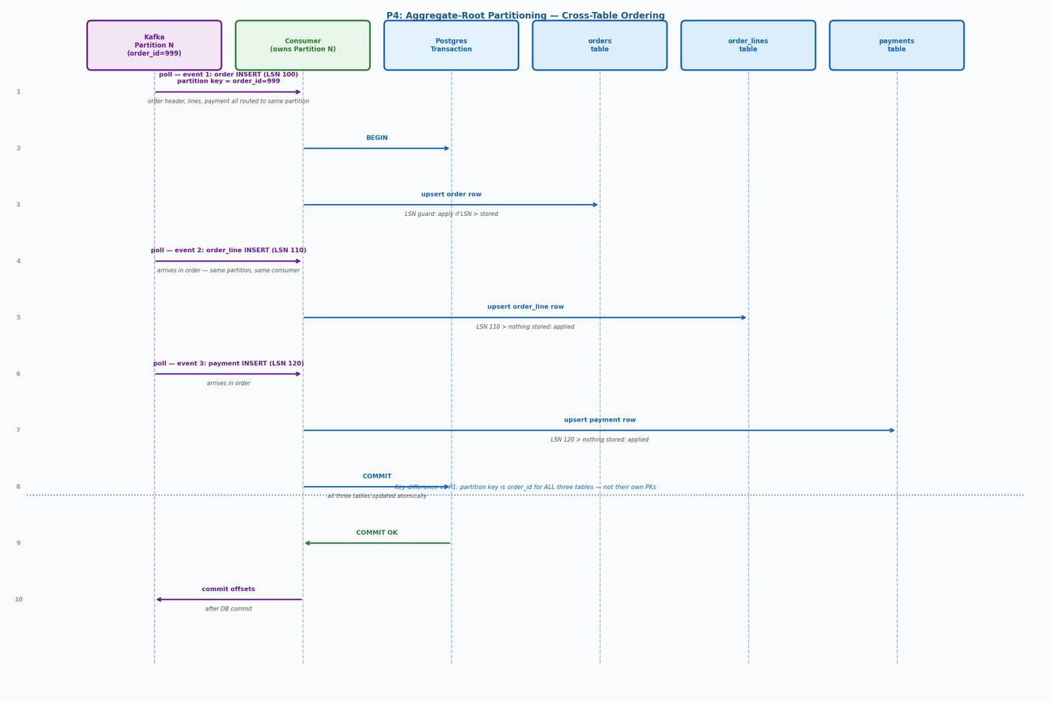
Figure 1 — P4 sequence: all three tables for order_id=999 arrive at one consumer in source order

Step-by-Step
- Openflow reads WAL events for orders, order_lines, and payments
- All three events for the same order_id are keyed with order_id as the partition key
- Kafka routes all events for order_id=999 to the same partition (e.g. Partition 5)
- Consumer owning Partition 5 receives all three events in source LSN order
- Consumer opens a single Postgres transaction and applies all three upserts with LSN guard
- Consumer commits — all three tables updated atomically in one transaction
- Consumer commits Kafka offsets after DB commit

Note: The upsert SQL for P4 is identical to P1 (see Doc 1). The only difference is the Kafka partition key. The LSN guard still applies per-table using each table's own last_source_position column.

Partition Key Configuration
-- P1 (plain): each table keys by its own row PK
orders -> partition key = order_id (own PK)
order_lines -> partition key = line_id (own PK -- may go to different partition)
payments -> partition key = payment_id (own PK -- may go to different partition)

-- P4 (aggregate-root): all tables key by the root
orders -> partition key = order_id
order_lines -> partition key = order_id (same partition as order header)
payments -> partition key = order_id (same partition as order header)

-- Set in Openflow connector config per table:
-- orders: partition_key = "order_id"
-- order_lines: partition_key = "order_id" (not line_id)
-- payments: partition_key = "order_id" (not payment_id)

-- The order_id field must exist in every CDC event payload.
-- Openflow carries all source columns in the event by default.

DDL
Warning: Do not add foreign key constraints to CDC target tables. If an order header event is delayed or arrives after a line item event, the FK constraint will fail the INSERT. CDC pipelines cannot guarantee source-order delivery across tables even with P4 — P4 guarantees partition-level ordering, but the merge procedure applies events sequentially. Remove FKs or use DEFERRABLE INITIALLY DEFERRED if referential integrity is essential.

CREATE TABLE orders (
order_id bigint PRIMARY KEY,
customer_id bigint NOT NULL,
status text,
total numeric,
-- CDC metadata (required on every P4-managed table)
last_source_position pg_lsn,
last_source_ts timestamptz,
last_event_op text,
is_deleted boolean NOT NULL DEFAULT false,
updated_at timestamptz NOT NULL DEFAULT now()
);

CREATE TABLE order_lines (
line_id bigint PRIMARY KEY,
order_id bigint NOT NULL, -- no FK constraint: see warning above
product_id bigint,
quantity int,
unit_price numeric,
last_source_position pg_lsn,
last_source_ts timestamptz,
last_event_op text,
is_deleted boolean NOT NULL DEFAULT false,
updated_at timestamptz NOT NULL DEFAULT now()
);

CREATE TABLE payments (
payment_id bigint PRIMARY KEY,
order_id bigint NOT NULL, -- no FK constraint: see warning above
amount numeric,
status text,
last_source_position pg_lsn,
last_source_ts timestamptz,
last_event_op text,
is_deleted boolean NOT NULL DEFAULT false,
updated_at timestamptz NOT NULL DEFAULT now()
);

-- If referential integrity is required, use deferred constraints:
-- ALTER TABLE order_lines ADD CONSTRAINT fk_order
-- FOREIGN KEY (order_id) REFERENCES orders(order_id)
-- DEFERRABLE INITIALLY DEFERRED;
-- This allows the consumer to insert lines before the header
-- within the same transaction, deferring the FK check to COMMIT.

Limitations and Edge Cases

Hot Aggregates
If one order_id generates a very high event rate (e.g. a high-frequency trading order with thousands of updates per second), all those events land on one partition and are processed serially. This is the inherent trade-off: cross-table ordering requires serialisation within an aggregate. If this becomes a bottleneck, consider splitting high-velocity sub-entities into a separate P1 stream where cross-table ordering is not required.

Cross-Aggregate Consistency
P4 gives strong consistency within a single aggregate (all events for order_id=999). It does not give consistency across different aggregates (order_id=999 and order_id=1000 are independent). This is correct by design — different aggregates are independent business entities.

Partition Key Stability
The aggregate root key (order_id) must be stable for the lifetime of the pipeline. If it changes, earlier events for the same entity may be on a different partition than later events, breaking per-entity ordering. Plan partition count and key strategy upfront. Avoid repartitioning on live data.

Event Ordering Within a Transaction
P4 guarantees that all events for the same aggregate root arrive at the same consumer in the order Kafka received them. However, if a source transaction updates an order header and a line item simultaneously, the WAL may emit them in either order. The LSN guard protects against stale re-application, but if you need strict transaction-boundary semantics, consider buffering by txn_id in the consumer and applying all events of a transaction together.

CDC Pipeline Patterns — Doc 4: P4 Aggregate-Root Partitioning

