Pattern 5
Staging-Then-Merge
Doc 5 of 6 — Every consumed event written to raw_cdc_events first. Merge procedure applies to final tables. The staging row is also the audit record.
P5 Staging-Then-Merge
Consume into raw_cdc_events (PENDING) → Merge procedure applies to final table → status updated to PROCESSED or FAILED.

Use for | Regulated systems (financial, healthcare), any system needing replay without re-reading Kafka, incident recovery
Consistency | Per-entity strongly consistent (same as P1) plus full replay capability from staging
Audit record | raw_cdc_events with apply_status = APPLIED / SKIPPED_STALE / FAILED. One table, not two.
Overhead | More storage (staging rows persist), more complexity (merge procedure), slightly higher latency
Combine with | P1 always (final tables use P1 upsert + LSN guard). Add P2 if full event history is also needed.
Mistake to avoid | Treating P5 as optional for regulated systems. If incident replay is a compliance requirement, P5 is mandatory.
See also | Doc 0 (overview), Doc 1 (P1 which P5 wraps), Doc 2 (P2 for full event history)

How It Works
P5 wraps P1. The consumer writes every Kafka record to raw_cdc_events (the staging table) with status PENDING before doing anything else. A separate merge procedure reads PENDING rows, applies them to final tables using the P1 upsert with LSN guard, and updates the staging row status to PROCESSED (or FAILED). The staging row becomes the permanent audit record.

KEY INSIGHT | P5 does not replace the P1 upsert and LSN guard — it wraps them. The merge procedure still uses ON CONFLICT DO UPDATE with the WHERE pos < incoming guard. P5 adds a durable pre-merge record of every consumed event, and keeps the outcome (APPLIED / SKIPPED_STALE) as the audit trail.

Sequence
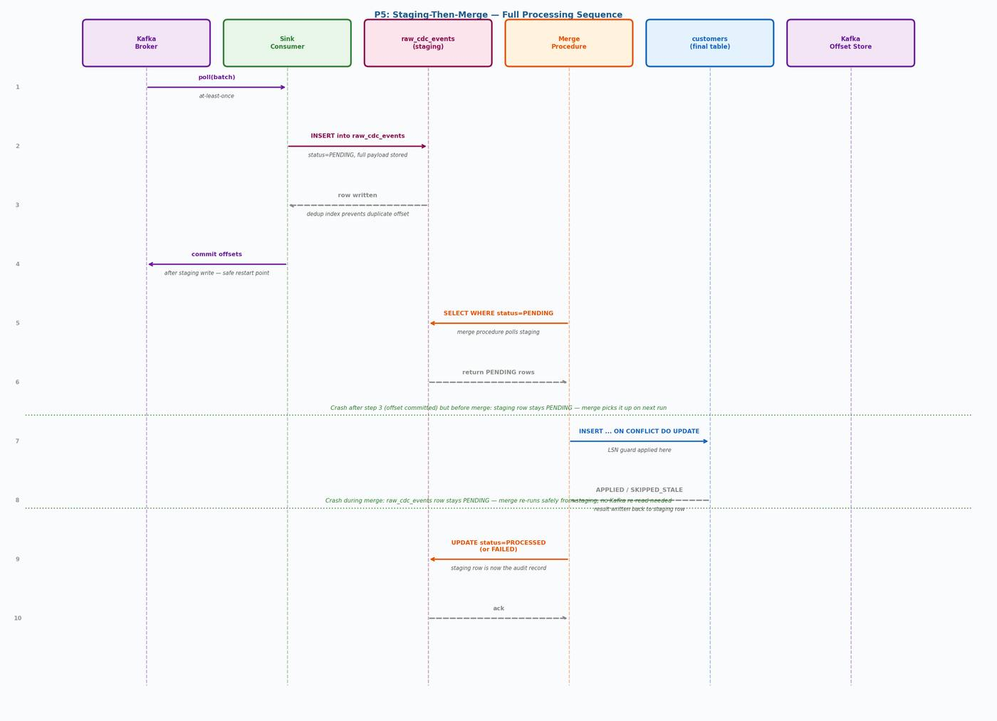
Figure 1 — P5 full sequence: poll → stage PENDING → commit offset → merge reads PENDING → upsert final → update status

Step-by-Step
- Consumer polls a batch of messages from Kafka
- Consumer inserts each event into raw_cdc_events with processing_status = PENDING
- The UNIQUE INDEX on (topic, partition_id, kafka_offset) prevents duplicate staging rows on replay
- Consumer commits Kafka offsets — after the staging write, not after the merge
- Merge procedure runs (continuously or on schedule): SELECT WHERE status = PENDING
- For each PENDING row: run the P1 upsert with LSN guard on the final table
- Record the outcome in apply_status: APPLIED, SKIPPED_STALE, or SKIPPED_DUPLICATE
- Update processing_status to PROCESSED (or FAILED with error_message)

TWO SAFE CRASH POINTS | Crash after step 4 (offset committed): staging row stays PENDING, merge picks it up on next run. No Kafka re-read needed. Crash during merge (steps 6–8): staging row stays PENDING, merge re-runs safely from staging. Final table is protected by the LSN guard.

raw_cdc_events: One Table, Not Two
Earlier CDC designs used a separate cdc_event_audit table alongside a staging table. This is unnecessary duplication. raw_cdc_events already holds every consumed event. Adding apply_status and skip_reason columns to the same table eliminates the extra table, the extra write, and the extra join.

raw_cdc_events serves as both staging AND audit record
• processing_status = PENDING: event consumed from Kafka, awaiting merge
• processing_status = PROCESSED: merge ran successfully (check apply_status for outcome)
• processing_status = FAILED: merge raised an unhandled error — row stays queryable for diagnosis
• apply_status = APPLIED: the final table row was updated
• apply_status = SKIPPED_STALE: LSN guard rejected — incoming position older than stored
• apply_status = SKIPPED_DUPLICATE: same (pk, lsn) already applied previously
• skip_reason: human-readable explanation of why the event was not applied
• Replay: set processing_status back to PENDING and re-run the merge procedure — no Kafka re-read

DDL
CREATE TABLE raw_cdc_events (
id bigserial PRIMARY KEY,
-- Kafka provenance
topic text NOT NULL,
partition_id int NOT NULL,
kafka_offset bigint NOT NULL,
message_key text,
-- Event content
payload jsonb NOT NULL,
table_name text NOT NULL,
op text NOT NULL CHECK (op IN ('INSERT','UPDATE','DELETE')),
pk_json jsonb NOT NULL,
source_position text NOT NULL, -- text for cross-source compatibility
source_ts timestamptz,
txn_id text,
event_seq_in_txn int,
-- Processing state (also serves as audit record)
ingest_time timestamptz NOT NULL DEFAULT now(),
processing_status text NOT NULL DEFAULT 'PENDING'
CHECK (processing_status IN ('PENDING','PROCESSED','FAILED')),
apply_status text
CHECK (apply_status IN
('APPLIED','SKIPPED_STALE','SKIPPED_DUPLICATE','FAILED')),
skip_reason text,
processed_at timestamptz,
error_message text,
retry_count int NOT NULL DEFAULT 0
);

-- Dedup: prevents duplicate staging rows on consumer restart
CREATE UNIQUE INDEX raw_cdc_events_dedup
ON raw_cdc_events (topic, partition_id, kafka_offset);

-- Merge polling: efficient scan for PENDING rows per table
CREATE INDEX raw_cdc_events_pending
ON raw_cdc_events (table_name, ingest_time)
WHERE processing_status = 'PENDING';

-- Audit query: look up all events for a given entity
CREATE INDEX raw_cdc_events_entity
ON raw_cdc_events (table_name, pk_json, source_position);

COMMENT ON TABLE raw_cdc_events IS
'Staging table AND audit record. PENDING = awaiting merge.
PROCESSED = merge complete. apply_status = outcome.
To replay: set processing_status = PENDING and re-run merge.';

Merge Procedure

Illustrative Single-Table Version
The CASE statement below is illustrative. For a pipeline with many tables, use the dispatch table approach in the next section.
CREATE OR REPLACE PROCEDURE merge_pending_cdc_events()
LANGUAGE plpgsql AS $$
DECLARE
rec raw_cdc_events%ROWTYPE;
v_rows int;
v_reason text;
BEGIN
FOR rec IN
SELECT * FROM raw_cdc_events
WHERE processing_status = 'PENDING'
ORDER BY table_name, ingest_time
FOR UPDATE SKIP LOCKED -- safe for parallel merge workers
LOOP
BEGIN
CASE rec.table_name
WHEN 'customers' THEN
INSERT INTO customers (...)
VALUES (...)
ON CONFLICT (customer_id) DO UPDATE SET ...
WHERE customers.last_source_position IS NULL
OR customers.last_source_position < EXCLUDED.last_source_position;
GET DIAGNOSTICS v_rows = ROW_COUNT;
v_reason := CASE WHEN v_rows > 0 THEN NULL
ELSE 'incoming LSN not newer than stored' END;
-- Add WHEN branch for each additional table
END CASE;

UPDATE raw_cdc_events SET
processing_status = 'PROCESSED',
apply_status = CASE WHEN v_reason IS NULL THEN 'APPLIED'
ELSE 'SKIPPED_STALE' END,
skip_reason = v_reason,
processed_at = now()
WHERE id = rec.id;

EXCEPTION WHEN OTHERS THEN
UPDATE raw_cdc_events SET
processing_status = 'FAILED',
apply_status = 'FAILED',
error_message = SQLERRM,
retry_count = retry_count + 1
WHERE id = rec.id;
END;
END LOOP;
END;
$$;

Scaling: Batch Processing
The procedure above processes one row per transaction. At high volume this creates many small transactions with high per-row overhead. For production at scale, batch PENDING rows per table and apply them in a single transaction per batch:
-- Process up to :batch_size PENDING rows for one table in one transaction.
-- Call this repeatedly until v_pending_backlog is zero.
CREATE OR REPLACE PROCEDURE merge_batch(p_table text, p_batch_size int DEFAULT 500)
LANGUAGE plpgsql AS $$
DECLARE
v_ids bigint[];
BEGIN
-- Lock a batch of PENDING rows for this table
SELECT array_agg(id ORDER BY ingest_time)
INTO v_ids
FROM raw_cdc_events
WHERE processing_status = 'PENDING'
AND table_name = p_table
LIMIT p_batch_size
FOR UPDATE SKIP LOCKED;

IF v_ids IS NULL THEN RETURN; END IF;

-- Apply the batch (table-specific logic here)
-- ... upsert into target table ...

-- Mark the whole batch as processed in one UPDATE
UPDATE raw_cdc_events
SET processing_status = 'PROCESSED',
apply_status = 'APPLIED',
processed_at = now()
WHERE id = ANY(v_ids);
END;
$$;

Scaling: Dynamic Dispatch for Many Tables
A CASE statement becomes unmaintainable with 20+ tables. Use a dispatch table instead: register table-specific merge functions in a configuration table and call them dynamically.
-- Dispatch table: maps table names to their merge functions
CREATE TABLE cdc_merge_handlers (
table_name text PRIMARY KEY,
handler_func text NOT NULL, -- e.g. 'merge_customers'
is_active boolean NOT NULL DEFAULT true
);

INSERT INTO cdc_merge_handlers VALUES
('customers', 'merge_customers', true),
('orders', 'merge_orders', true),
('payments', 'merge_payments', true);

-- Dynamic dispatch in the merge loop:
EXECUTE format('CALL %I($1)', v_handler) USING rec;

Reconciliation Views
-- Pending backlog (should stay near zero in steady state)
CREATE VIEW v_pending_backlog AS
SELECT table_name,
count(*) AS pending_count,
min(ingest_time) AS oldest_pending
FROM raw_cdc_events
WHERE processing_status = 'PENDING'
GROUP BY table_name
ORDER BY pending_count DESC;

-- Skipped / stale events (rising count = ordering problem)
CREATE VIEW v_skipped_events AS
SELECT table_name, apply_status, skip_reason,
count(*) AS count,
max(processed_at) AS most_recent
FROM raw_cdc_events
WHERE apply_status IN ('SKIPPED_STALE','SKIPPED_DUPLICATE')
GROUP BY table_name, apply_status, skip_reason
ORDER BY count DESC;

-- Failed events needing attention
CREATE VIEW v_failed_events AS
SELECT table_name, error_message,
count(*) AS count,
max(ingest_time) AS most_recent
FROM raw_cdc_events
WHERE processing_status = 'FAILED'
GROUP BY table_name, error_message
ORDER BY count DESC;

Replay Procedure
-- Replay events for a specific table and time window
-- without re-reading Kafka.
UPDATE raw_cdc_events
SET processing_status = 'PENDING',
apply_status = NULL,
skip_reason = NULL,
error_message = NULL,
processed_at = NULL
WHERE table_name = 'customers'
AND processing_status IN ('PROCESSED','FAILED')
AND ingest_time >= '2026-04-01'
AND ingest_time < '2026-04-02';

-- Then re-run the merge procedure.
-- The LSN guard ensures only genuinely newer events are applied.
-- Events that were already at the correct LSN are marked SKIPPED_STALE harmlessly.
CALL merge_pending_cdc_events();

-- Verify the replay:
SELECT apply_status, count(*)
FROM raw_cdc_events
WHERE table_name = 'customers'
AND ingest_time >= '2026-04-01'
AND ingest_time < '2026-04-02'
GROUP BY apply_status;

CDC Pipeline Patterns — Doc 5: P5 Staging-Then-Merge

