**IoT Analytics- ThingSpeak**

ThingSpeak is an open-source Internet of Things application and API to store and retrieve data from things using the HTTP and MQTT protocol over the Internet or via a Local Area Network.

ThingSpeak has integrated support from the numerical computing software [MATLAB](https://en.wikipedia.org/wiki/MATLAB) from [MathWorks](https://en.wikipedia.org/wiki/MathWorks), allowing ThingSpeak users to analyze and visualize uploaded data using Matlab without requiring the purchase of a Matlab license from Mathworks.

The ThingSpeak service is operated by MathWorks. In order to sign up for ThingSpeak, you must create a new MathWorks Account or log in to your existing MathWorks Account.

ThingSpeak is free for small non-commercial projects.

It works with Arduino, Raspberry Pi and MATLAB (premade libraries and APIs exists).

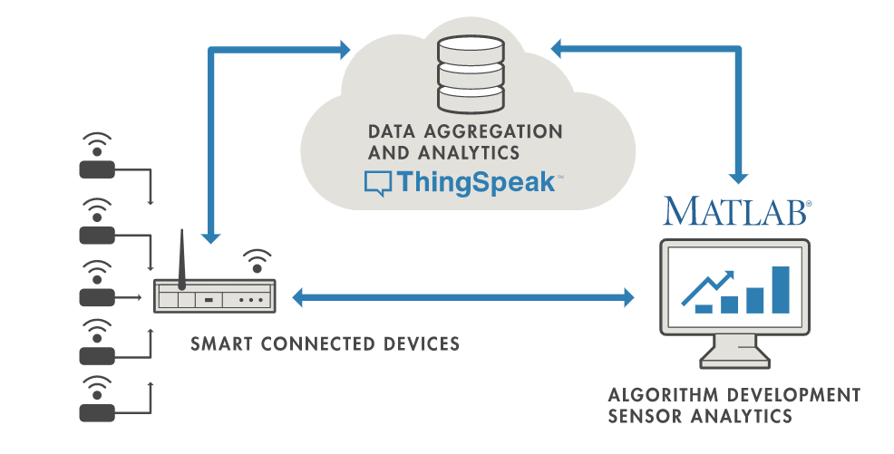

**ThingSpeak Key Features**

ThingSpeak allows you to aggregate, visualize and analyze live data streams in the cloud. Some of the key capabilities of ThingSpeak include the ability to:

* Easily configure devices to send data to ThingSpeak using popular IoT protocols.
* Visualize your sensor data in real-time.
* Aggregate data on-demand from third-party sources.
* Use the power of MATLAB to make sense of your IoT data.
* Run your IoT analytics automatically based on schedules or events.
* Prototype and build IoT systems without setting up servers or developing web software.
* Automatically act on your data and communicate using third-party services like Twilio® or Twitter®.

**For User-Interface:-**

There are many applications available for the users to track and monitor the data measured by the different sensors.

Example: **Virtuino, ThingView, ThingShow ,**etc.

These apps provide real time monitoring of the graphs, histograms, bars, etc. of all the statistical data entered and sent to the corresponding Channel ID which is configured in the app. along with the Channel’s Read API Key.