Title

Tim Cashion

# Read in data

Our data is from…

## Data Sources

Data is fun.

### Data sources really detailed

Some people don’t like MSC seafood. They’re wrong (Agnew et al. 2013).

# Analysis

# Results

## `stat_bin()` using `bins = 30`. Pick better value with `binwidth`.

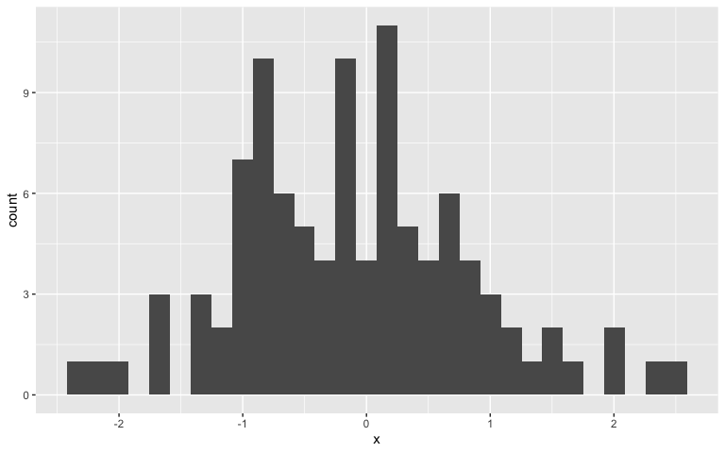

Figure 1: This is a plot

Our results are clearly shown in Figure 1.

While we *expect* a value of 0 for our mean, our **actual mean** is -0.084109. Our unrounded mean is -0.0841088141990891. When we don’t use toString, let’s see what happens -0.0841088.

For more details, see Table 1.

Table 1: Summary statistics of our data

|  |  |  |
| --- | --- | --- |
|  | x | y |
|  | Min. :-2.39477 | Min. :0.000458 |
|  | 1st Qu.:-0.77571 | 1st Qu.:0.067240 |
|  | Median :-0.11132 | Median :0.455233 |
|  | Mean :-0.08411 | Mean :0.906496 |
|  | 3rd Qu.: 0.55013 | 3rd Qu.:0.972322 |
|  | Max. : 2.45301 | Max. :6.017238 |

Agnew, David J., N. L. Gutiérrez, A. Stern-Pirlot, A. D.M. Smith, C. Zimmermann, and K. Sainsbury. 2013. “Rebuttal to Froese and Proelss "Evaluation and legal assessment of certified seafood".” *Marine Policy* 38: 551–53. <https://doi.org/10.1016/j.marpol.2012.07.002>.