一、HOME首页：
1.配色底色略暗沉，可以稍微明亮点吗？或者有接近logo这种适合的配色吗？（如果实在没合适的好看的，把最上面这一栏导航栏变成白色背景？）
2.这个logo要在深色背景里，就把白色的图+白色的字（上面中文繁体，下面英文这个）合并就可以了。

3.导航栏可以加一个“信息指南”，内容我们原官网有的。
4.这俩大标题没对齐，Our Partners也收进来点？然后给图标缩小点？感觉这几个图标太大。全联和维普的放在最后两个。
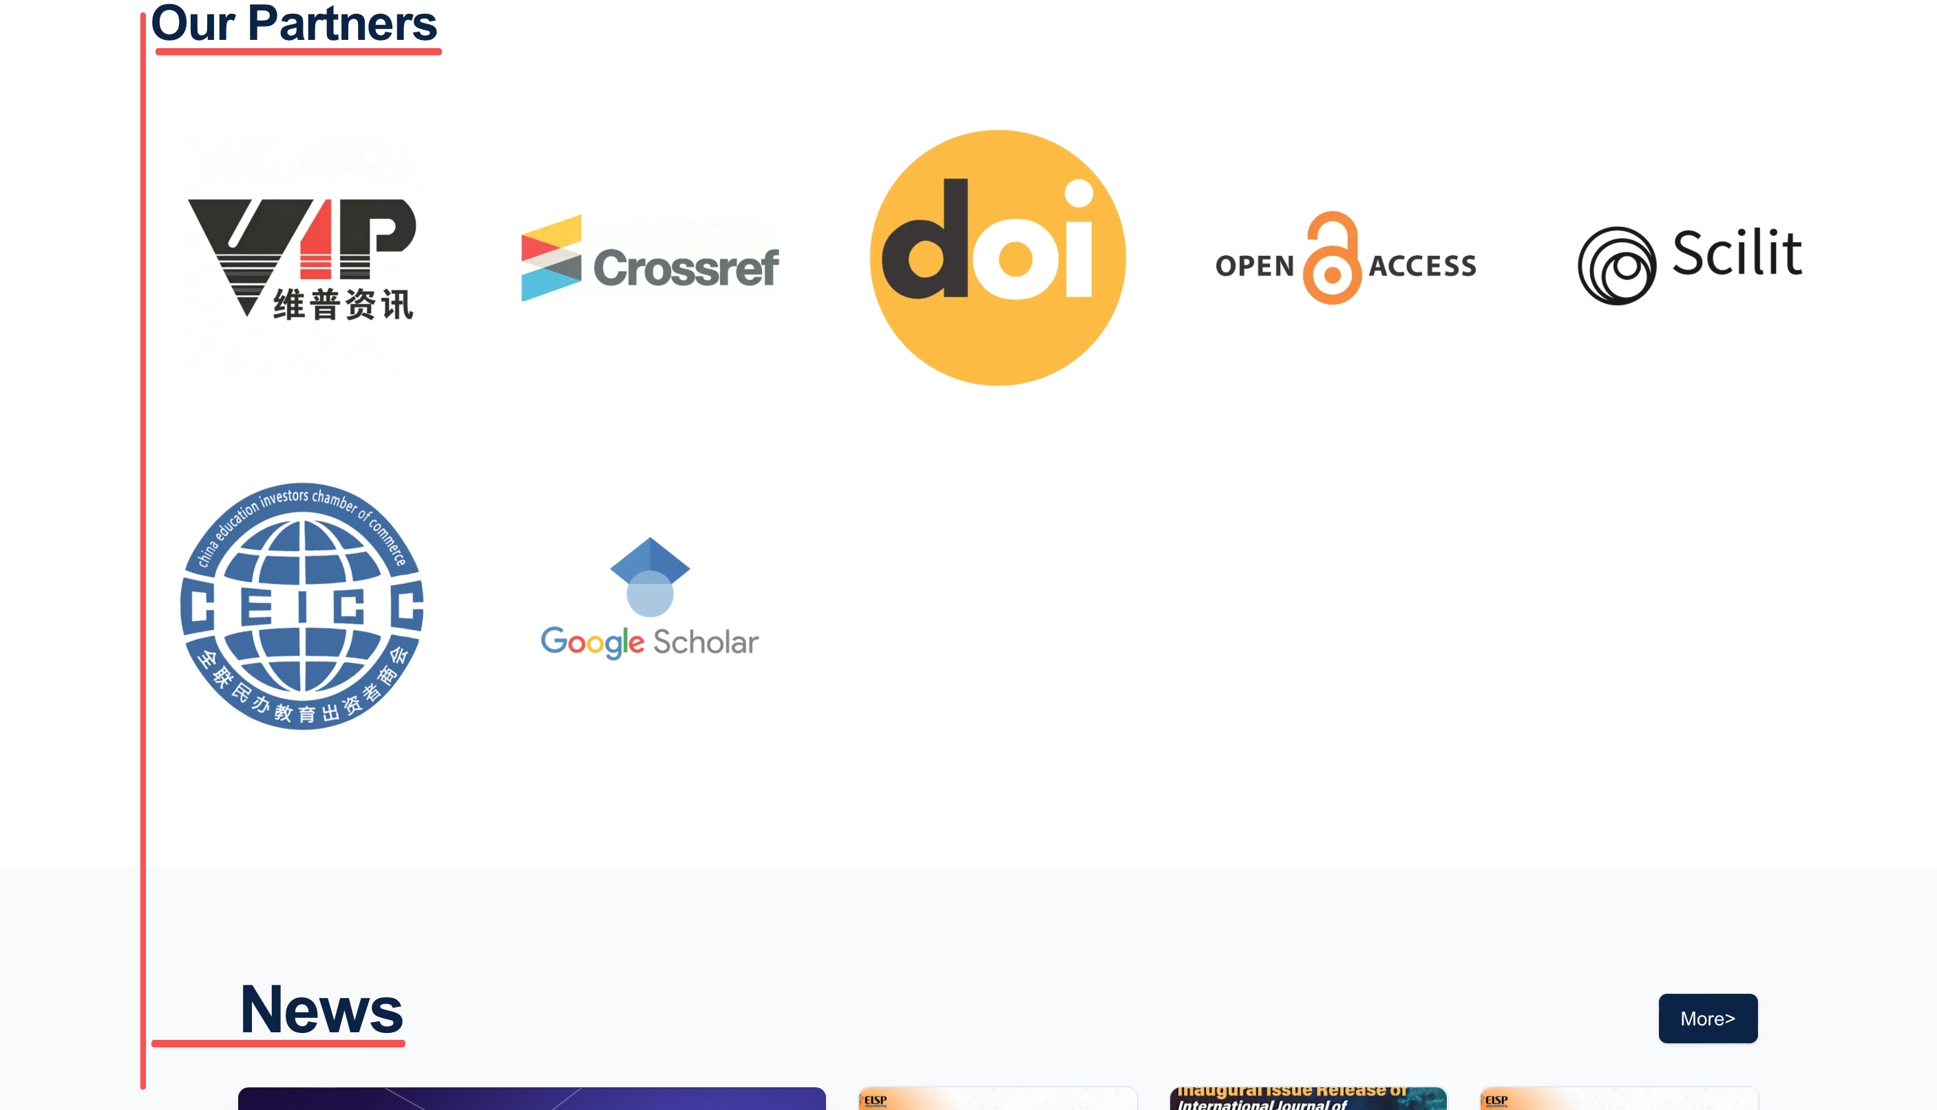
5.原官网有“作者服务”，这一栏的内容只有这儿能点击，所以要加一下。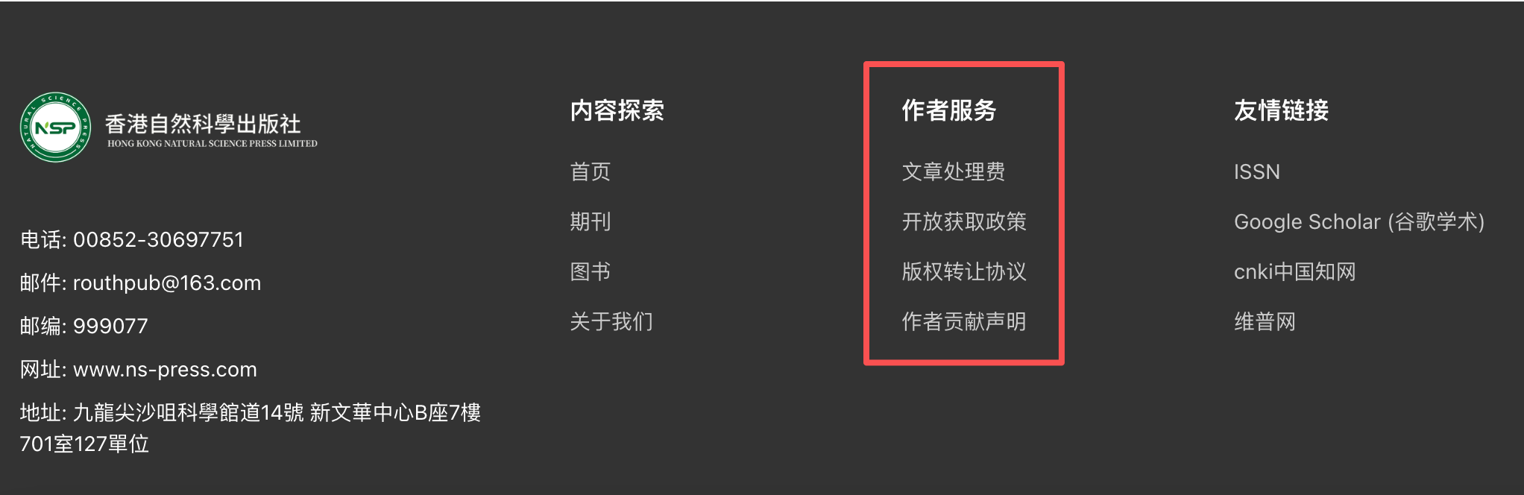

二、JOURNALS期刊
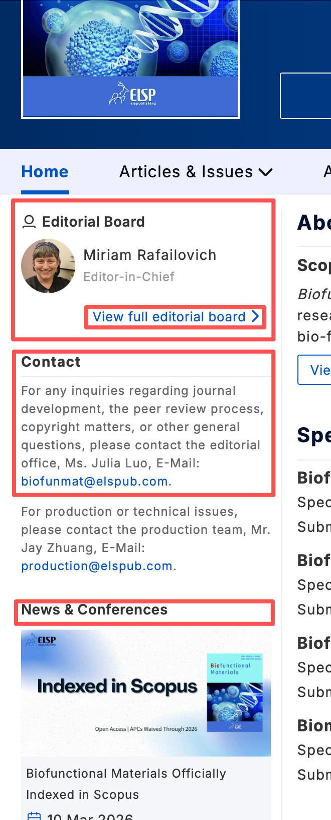
1.点一本期刊进去后的左侧：
1.1 这儿也只放一个主编+浏览全部编委会成员的链接。
1.2 这个Contact的内容留一下，邮箱目前全部换
成routhpub@163.com，在我们上传期刊信息的时候可
以自己改这个内容，到时候方便换其他人的邮箱。
1.3 News & Conferences这块儿不要。
1.4 这下面后台可以加图片不，比如这本刊进了哪些数
据库，像现有的6本可以加维普、DOI、谷歌学术这些
logo在旁边。

三、ABOUT关于
1.公司简介内容改为：
Company Profile
Hong Kong Natural Science Press is headquartered in Hong Kong, China. Specializing in academic publishing, we operate under an open access (OA) model and are committed to delivering high-quality academic publishing services to researchers worldwide. Leveraging Hong Kong's international advantages, we actively promote local research findings to a global audience while proactively introducing cutting-edge academic resources from overseas, building a comprehensive publishing system covering life sciences, earth sciences, engineering, and technology. Through digital technologies and multilingual platforms, we break down geographical barriers and facilitate the flow of knowledge, fostering deep connections within the global scientific community with professionalism and rigor, and continuously driving the advancement of international scholarship.

Mission
Upholding academic integrity, driving the global flow of knowledge.
We are committed to transforming cutting-edge research into practical professional insights, empowering institutions, scholars, and industry decision-makers with clear intellectual guidance in a complex world.

Vision
To become the premier gateway for academic exchange between East and West.
We do more than define academic standards—we are committed to building a borderless knowledge infrastructure, enabling rigorous ideas to transcend geographical boundaries and nourish a more resilient global intellectual community.

2.每处地址的Unit 127，都删一下：
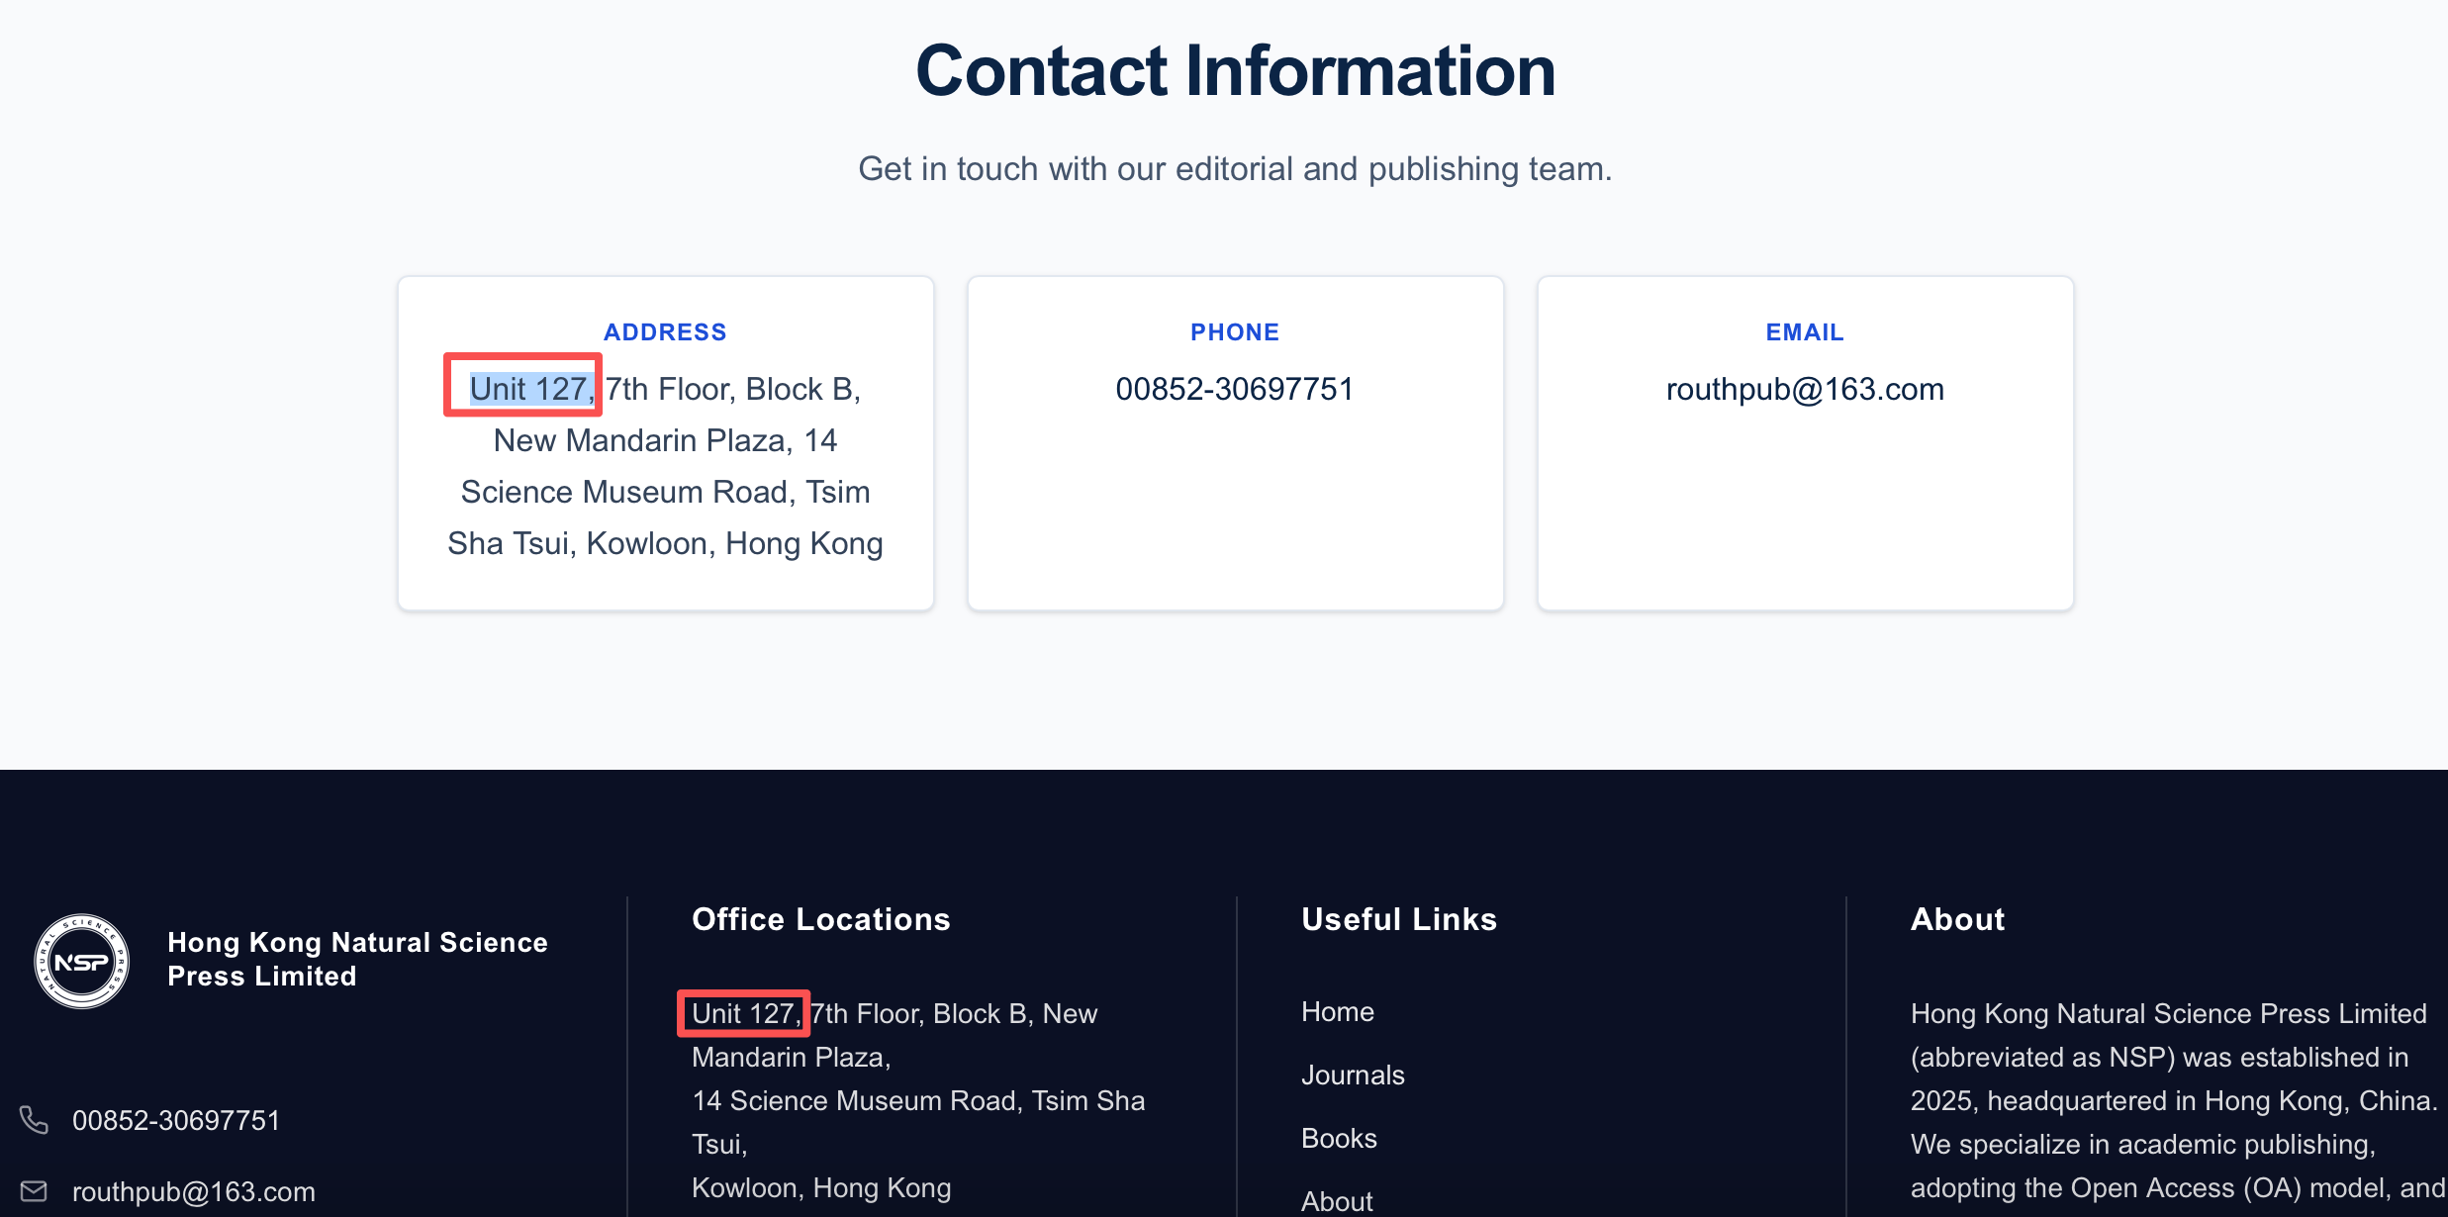

3.这个“Contact Information联系信息”下面的3个格子要不改成之前官网这个好看点：