Final Project Checkpoint #1
We initially ran various structures of Tensorflow neural network models to categorize the CFAIR-10 dataset. The first 2 models in the below figure use only dense layers and preform as well as a random guess (~10% accuracy with 10 classes involved).
The following series of models was trained for 10 epochs each. Their layer structure is in the attached code.
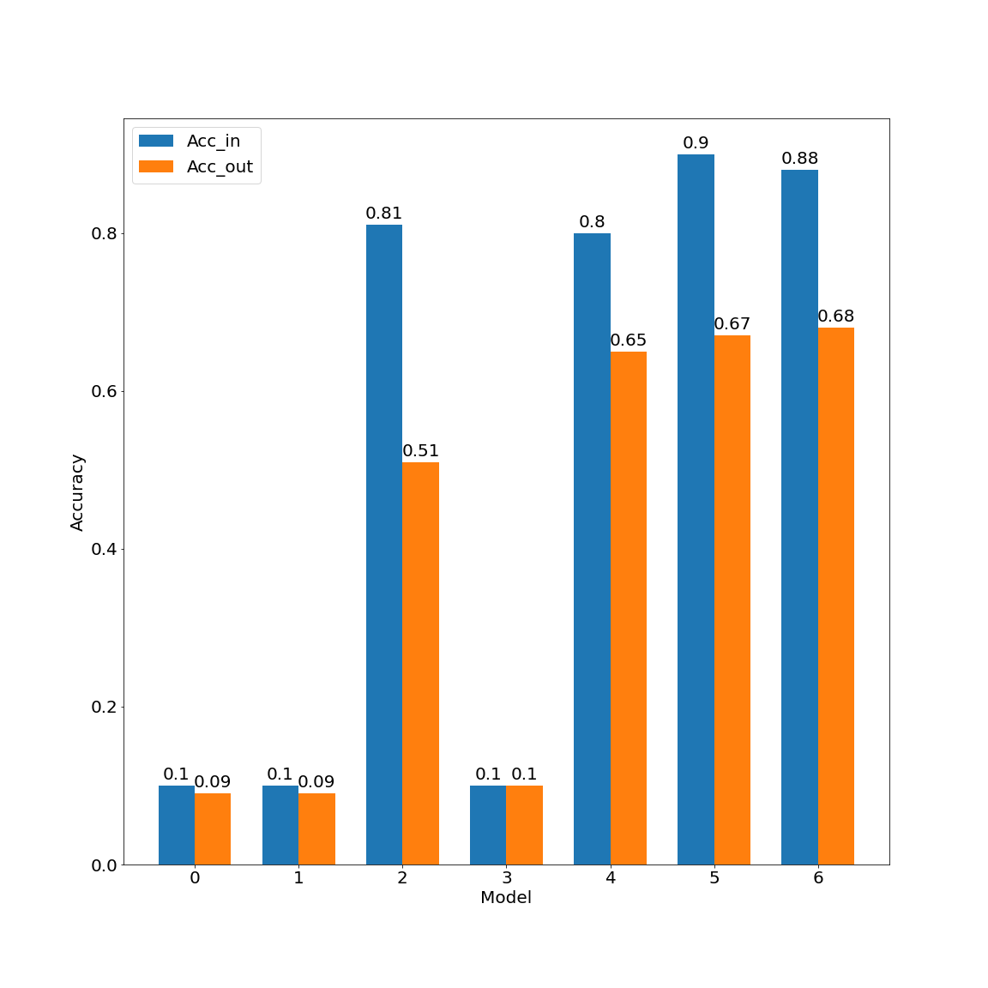
Accuracy Error
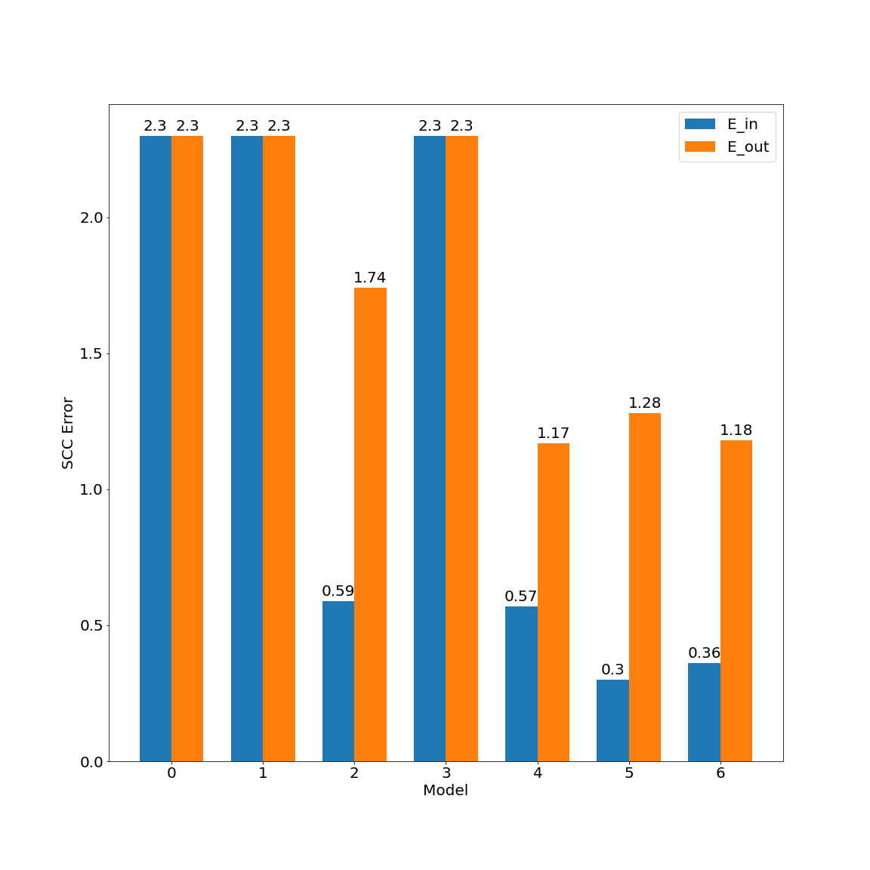
The following series of models was trained for 20 epochs each
Accuracy Error
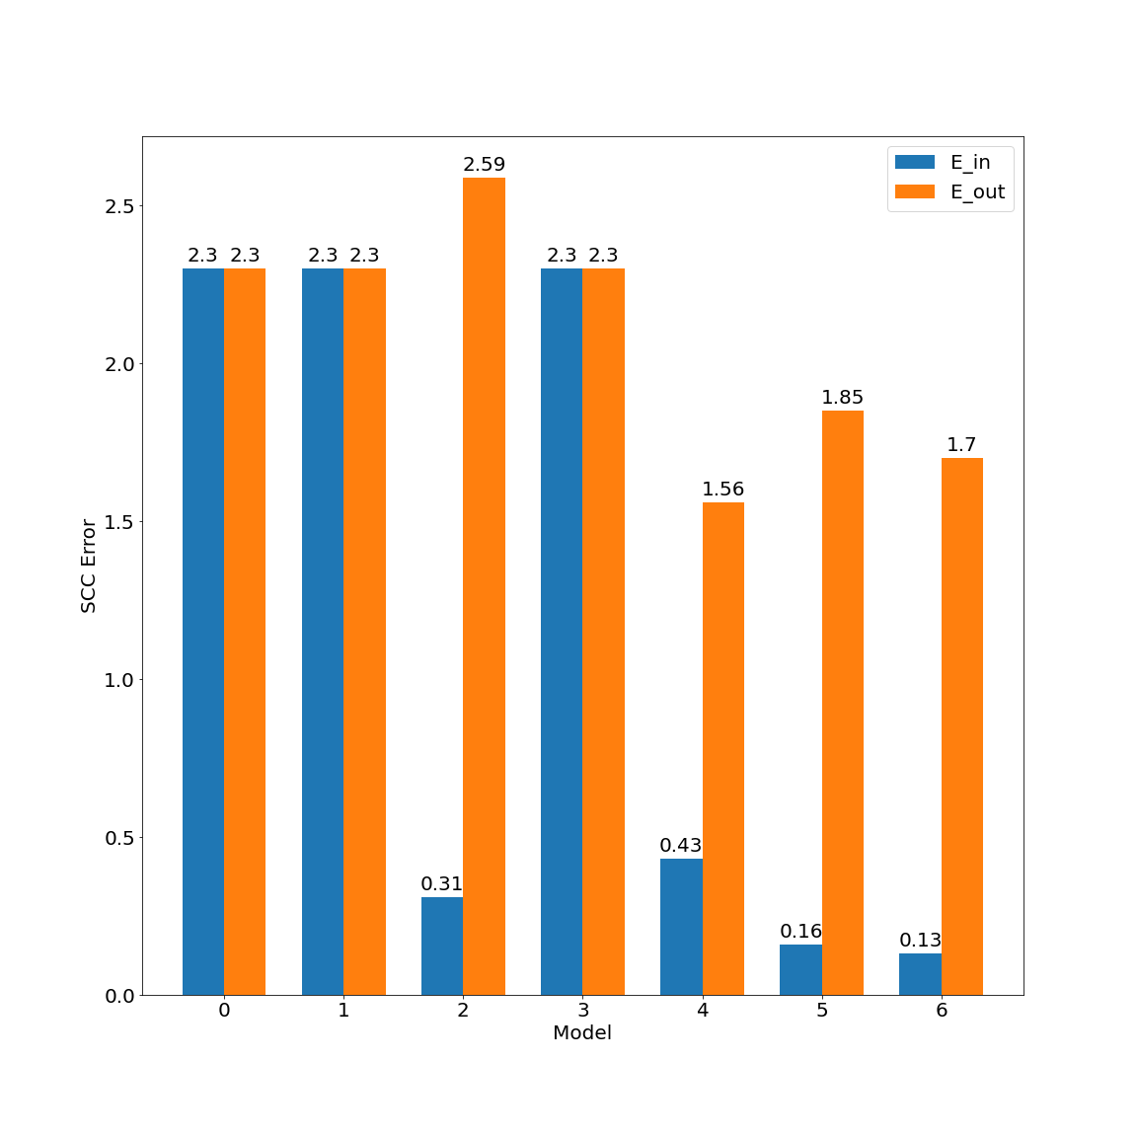
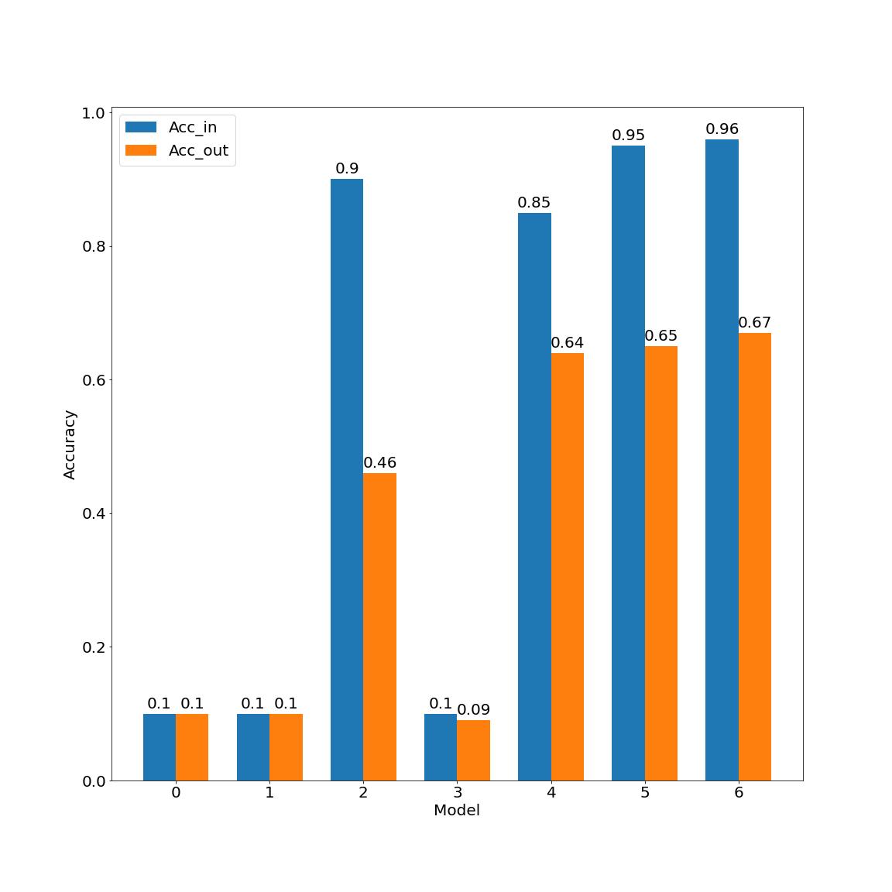

The first two and fourth models (0, 1, 3) consistently behave as random guesses. The other models, all of which involve convolutional layers, preform better on average, at least in E_in. The models labeled as (2) and (3) does not use max pooling, which may explain their worse performance - (2) preforming poorly out of sample and (3) preforming poorly in sample as well.
It is of note how (2) has a higher error measure than the practically random models - this is because it weighs its incorrect guesses more heavily, whereas the 'random' models actually guess the same number almost every single time, with a relatively even confidence spread between the different categories.
We can see from these results that the more complex models, with lower E_in values correlating with lower E_out only inconsistently at best. Of particular note is the third model, which consistently demonstrates symptoms of overfitting, with a low E_in but an E_out that implies near random guessing

