Homework for General Physics1 Optics-Part2

(a reminder: all Hecht’s problems are refer to the electronic version)

1. Hecht’s, problem 7.6.  
   Determine the optical path difference for the two waves A and B, both having vacuum wavelengths of 500nm, depicted in Fig. P.7.6; the glass (n=1.52) tank is filled with water (n=1.33). If the waves start out in-phase and all the above numbers are exact, find their relative phase difference at the finishing line.  
   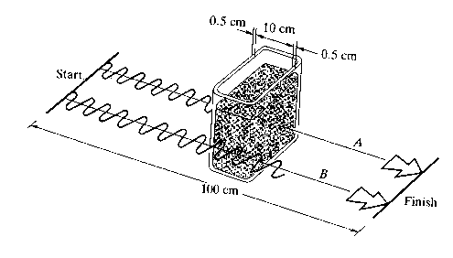FIGURE P.7.6
2. Hecht’s problem 7.15  
   Imagine that we strike two tuning forks, one with a frequency of 340 Hz, the other 342 Hz. What will we hear?
3. Hecht’s problem 7.29  
   An ionized gas or plasma is a dispersive medium for EM-waves. Given that the dispersion equation is  
      
   where  is the constant plasma frequency, determine expressions for both the phase and group velocities and show that .
4. Given a Femto-second (10-15 s) laser pulse, (i.e. the duration of pulse in time, or temporal width) estimate its spectral width, i.e. the width in frequency domain. Given the central wavelength of the spectral distribution is 500 nm, what is the spectral width in wavelength? Was it able to excite Sodium transition around 580 nm?
5. Calculate the interference pattern generated by 3 points as instead of two used in Young’s experiment. The 3 points (A, B, C) are on a straight line and equal spaced (AB=BC), the receiving plane is parallel with ABC and at distance D. The A, B, C have same amplitude and initial phase. (As illuminated by a broad laser beam).
6. Two ***plane*** waves with same frequency, wavelength and initial phase travel with an angle 2θ between them. Let’s arrange the coordinate system as following: Wave A forms angle θ with +Z axis, and wave B forms an angle of –θ with +Z; the wave vectors k of both waves lie in the Y-Z plane; the amplitude are A0 for both waves and along the X direction. 1) Please write out the wave form for A and B.(in terms of k, , A0 , θ and y, z) 2) On an observing screen of x-y plane at z=0, what is the interference pattern? (i.e. intensity distribution), and what is the spacing between the adjacent maxima.
7. In the two-slits Young’s experiment, the distance to screen is 2 m and the wavelength of light used is 600 nm, and the spacing of the slits is 1mm. Now we insert a thin plate of glass (n=1.5) of thickness 0.05 mm is placed over one of the slits, what is the resulting lateral fringe displacement at the screen?
8. Hecht’s problem 9.10.

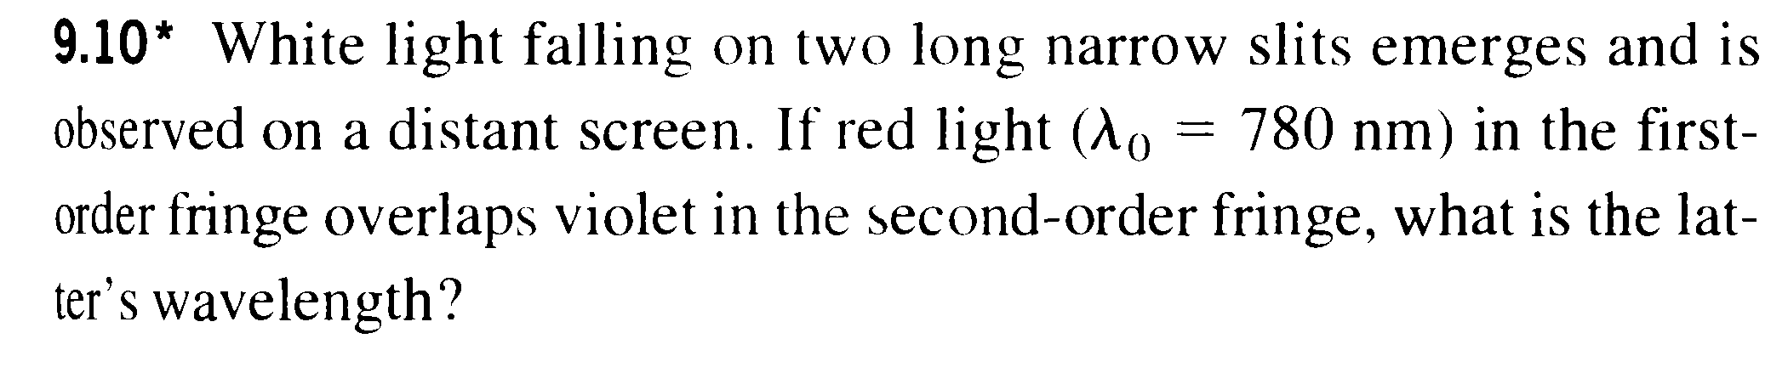

1. Hecht’s problem 9.28

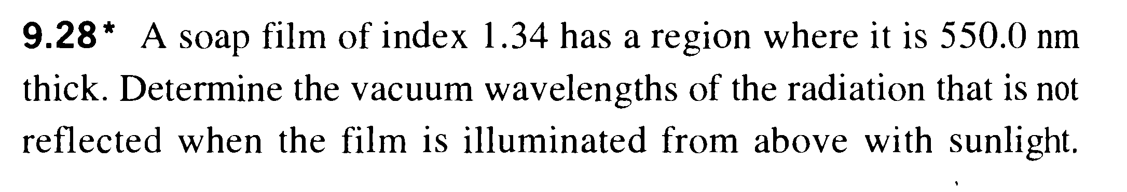

1. Hecht’s problem 9.33

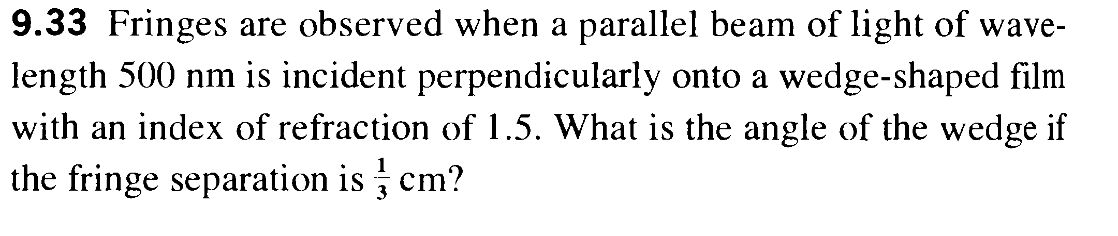

1. Hecht’s 9.35

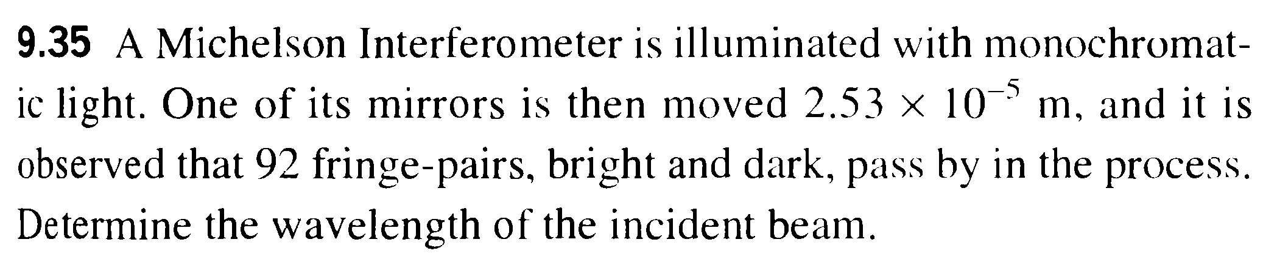

1. This problem I briefly discussed in the lecture, now you may give it a proof: For two waves with same amplitude A and fixed initial phase (say both =0), but different frequency ω1 and ω2, in the class I stated that if the detection time required to record the intensity τ<<2π/Δω, interference can still be observed (i.e. the intensity at certain spatial point is different from the summation of intensity). Please prove this statement. (You may prove it using the Beat equation, Hecht 7.2.1 or the same one in my notes, that at a fixed space point the averaged intensity is different than 2A2; Or use the formula for intensity of two sources and prove that the cross term is not zero)
2. The figure below shows a Rayleigh refractometer to measure the refractive index. Light form coherently illuminated slits go through separate arms of length L each and recombined afterwards to form certain interference pattern. Both arms are in vacuum initially and gas would be slowly introduced into one of the arms. This will cause a shift of the interference pattern. If total of m fringes moves across the observing point while the gas was filling. Show that the refractive index of the gas n would be: .



Recommended practices:, Hecht’s 7.1， 7.12 ； Hecht’s 9.4; 9.13; 9.14; 9.16; 9.24 Zhao’s (Vol.1): (problem 1,2, pg 159); (questions 2,3,4, pg 179); (problems 2,4,6,7; pg180) (problems 1,2,3,4,6; pg300)