**TABLE OF CONTENTS**

1. **INTRODUCTION**
   1. Purpose
   2. Overview
   3. Technology
2. **SYSTEM OVERVIEW**
3. **SYSTEM ARCHITECTURE**
   1. Design pattern
   2. Software Schema
4. **DATA DESIGN**
   1. DBMS
   2. Tables
   3. ER Diagram
5. **HUMAN INTERFACE DESIGN**
   1. Overview of User Interface
   2. Screen Images
6. **REFERENCE**
7. **INTRODUCTION**
   1. Purpose

This software design document describes the architecture and system design of an event managing system. This software is used to keep track of events and related information such as the clients, participants, venues, etc.

* 1. Overview

With the use of Event Managing Application, clients can easily manage and keep track of all the events associate with themselves or public events. Participants can view any happening event from anywhere. Data is centralized so that it is available to all the clients, admin, and participants.

* 1. Technology
* Programming language: JAVA, J2EE
* Front-End: HTML, CSS, Jquery, JSP
* Database: MySQ Server
* Tools: Netbeans 8.2, SQL workbench
* Web Server: Apache Tomcat 8
* Frame work: Hibernate with MVC

1. **SYSTEM OVERVIEW**

Functionality performed by User:

* Login to access user profile
* Logout to exit personal account
* Add/Edit new event
* View details of selected event
* Add new Venue
* View profile/user details

1. **SYSTEM ARCHITECTURE**
   1. Design pattern
   2. Software Schema
2. **DATA DESIGN**
   1. DBMS

MySQL is used to manage the database. MySQL is cost-effective, reliable, and high performance that helps users store/manipulate data faster, and easier.

* 1. Tables

* 1. ER Diagram

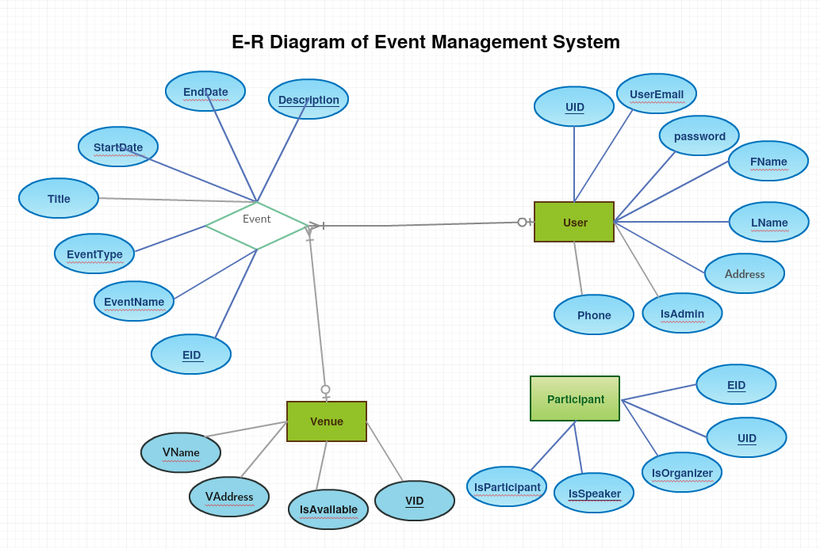

**HUMAN INTERFACE DESIGN**

* 1. Overview of User Interface
  2. Screen Images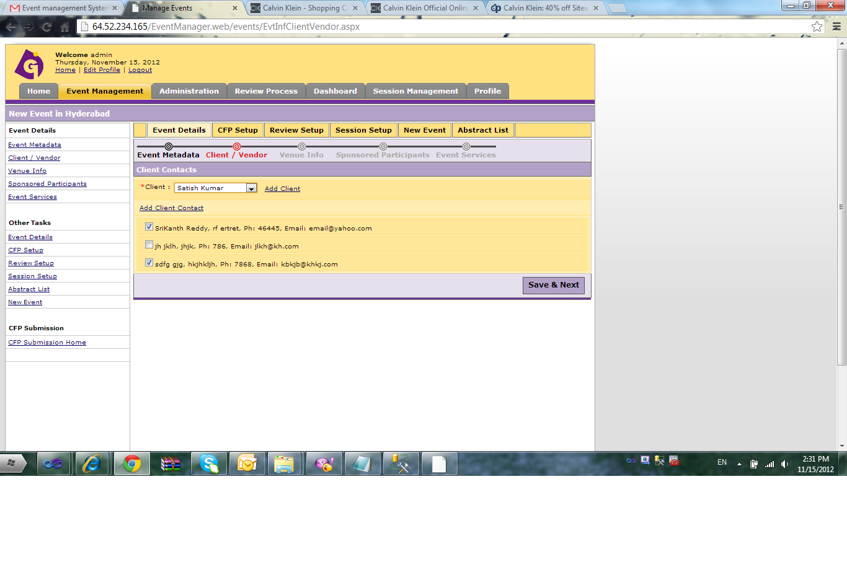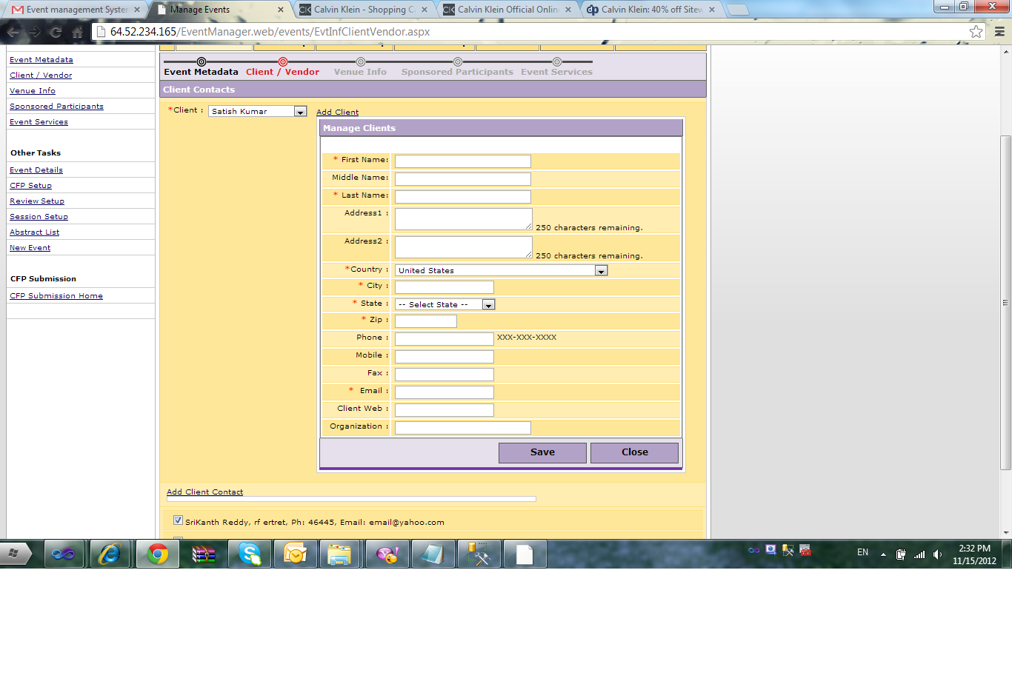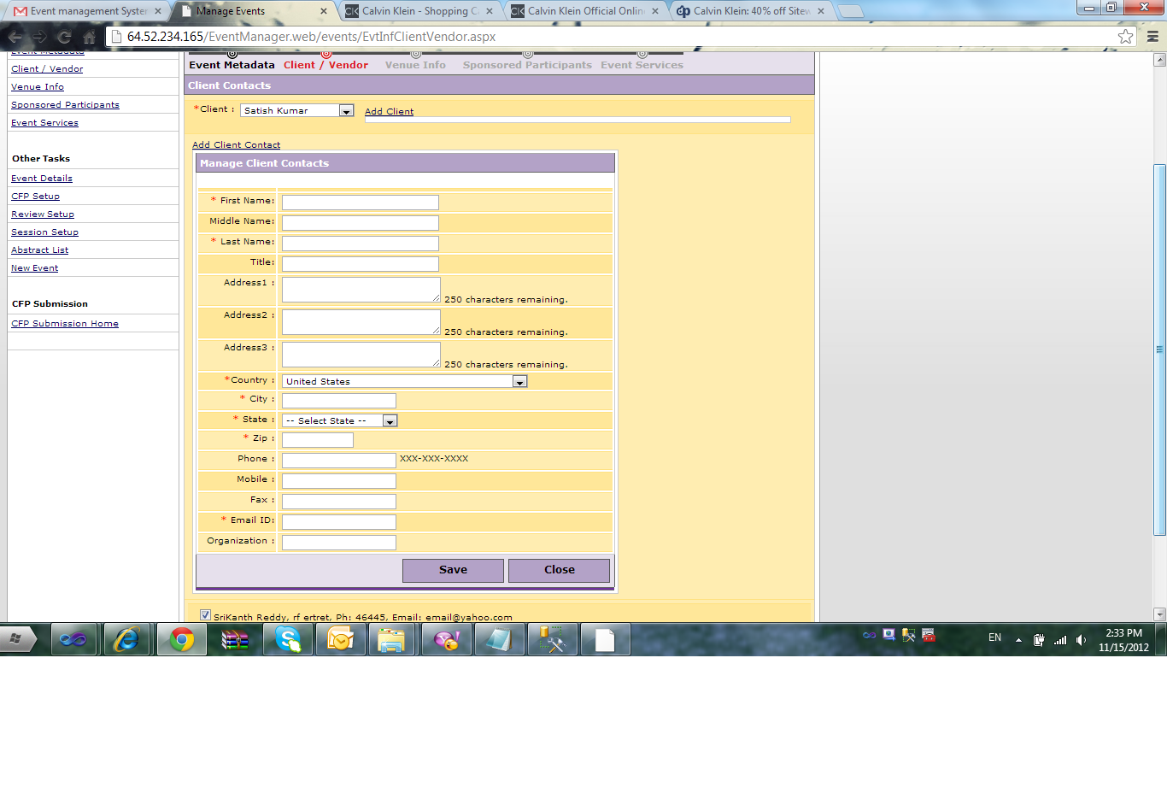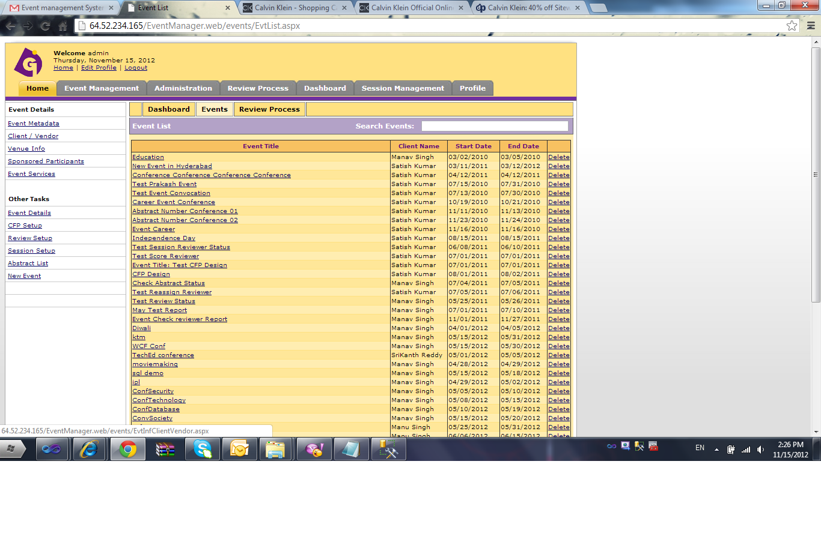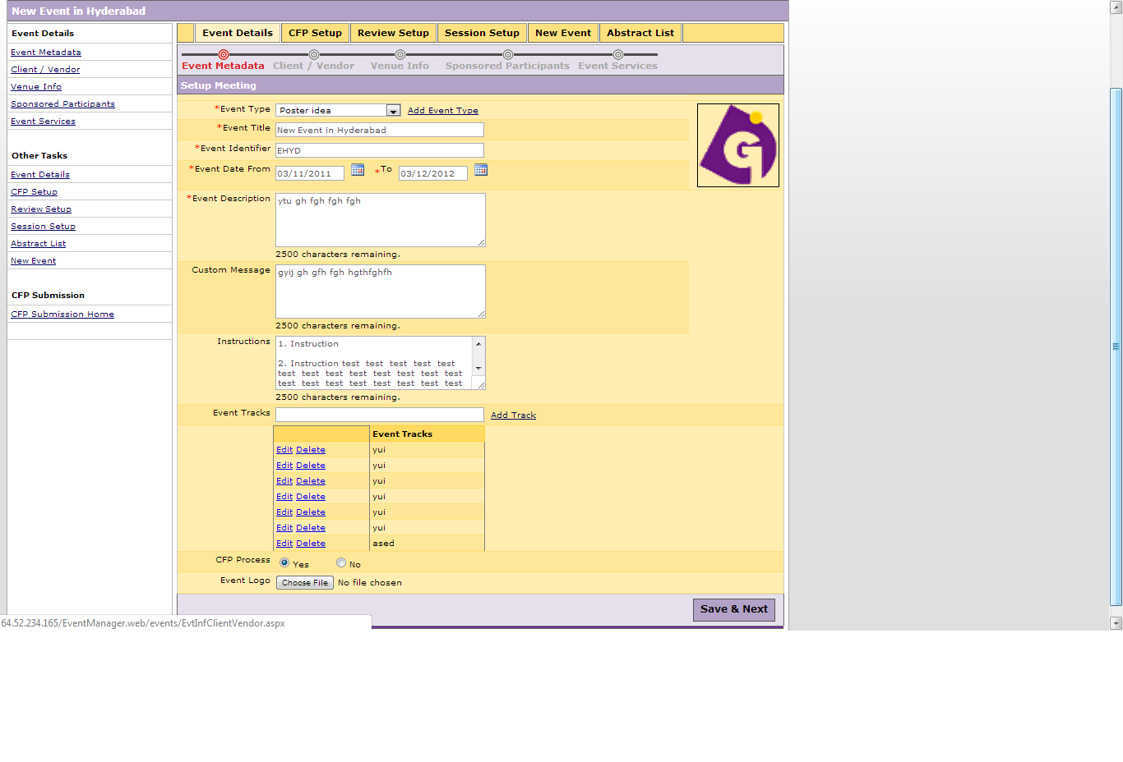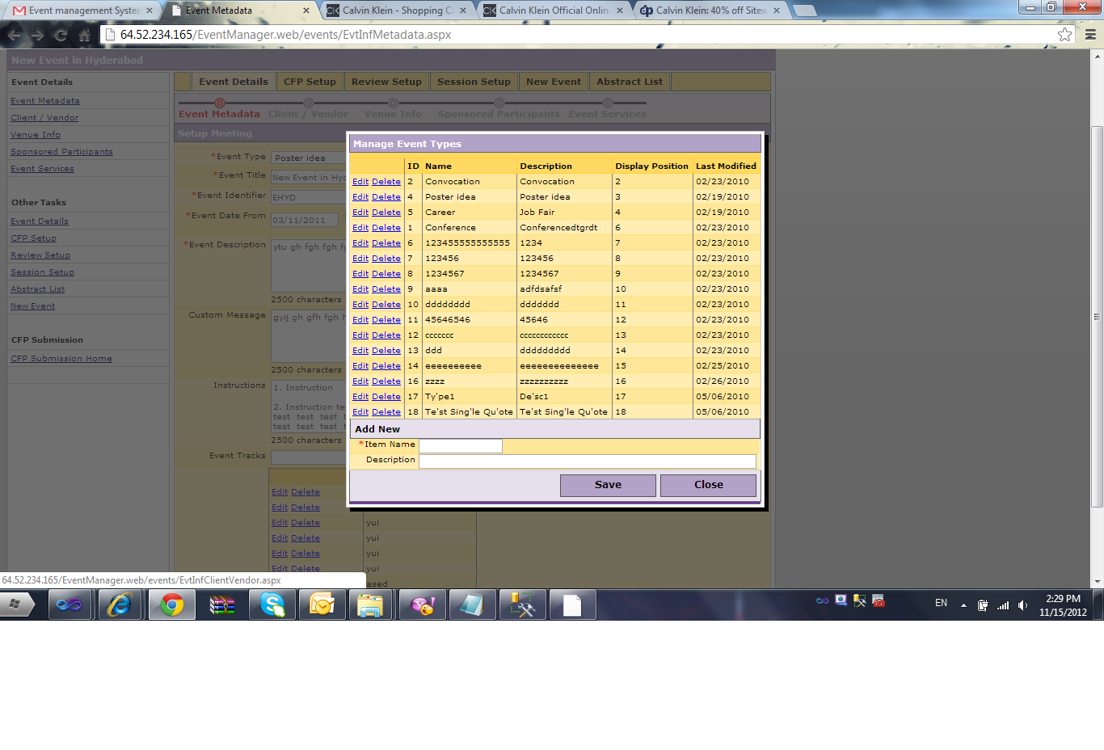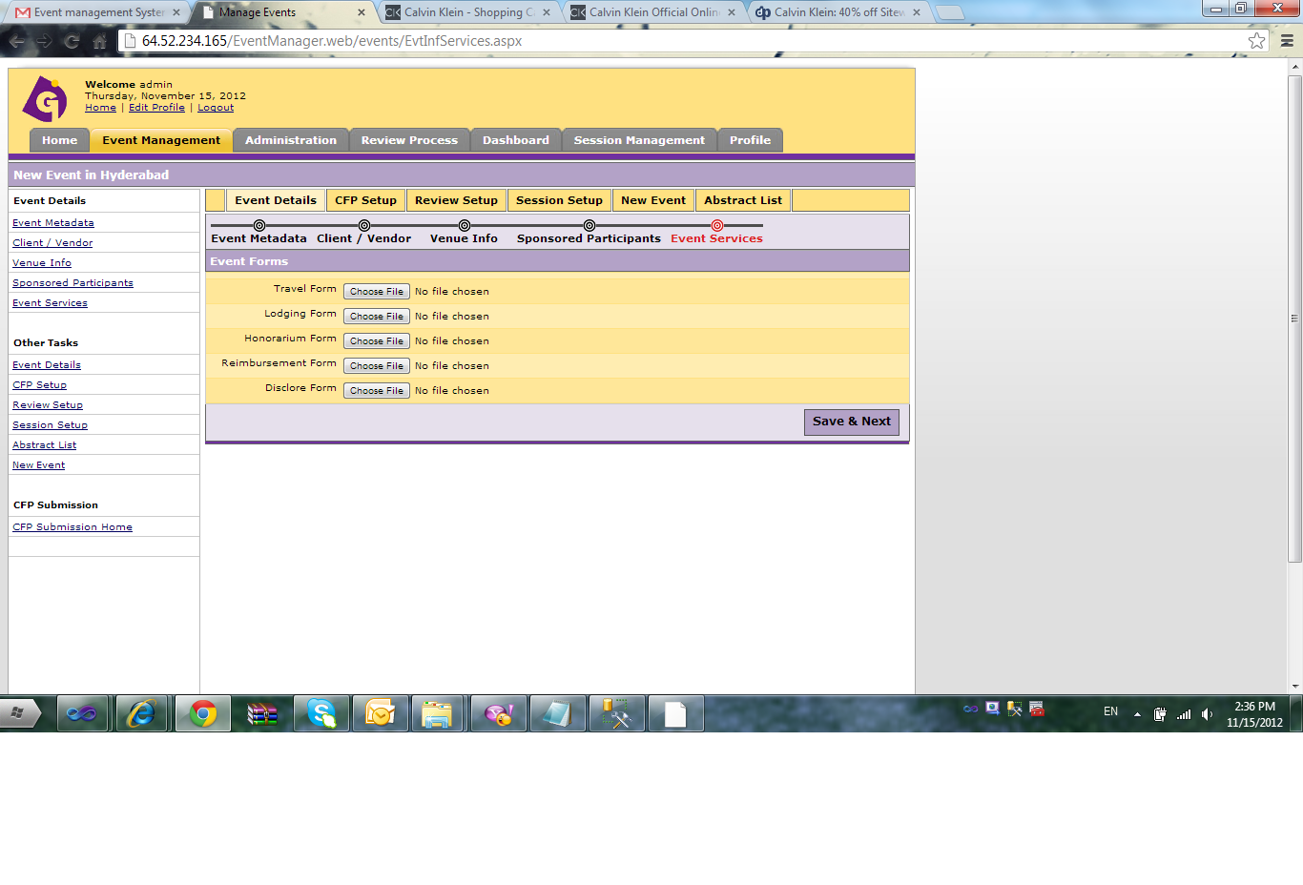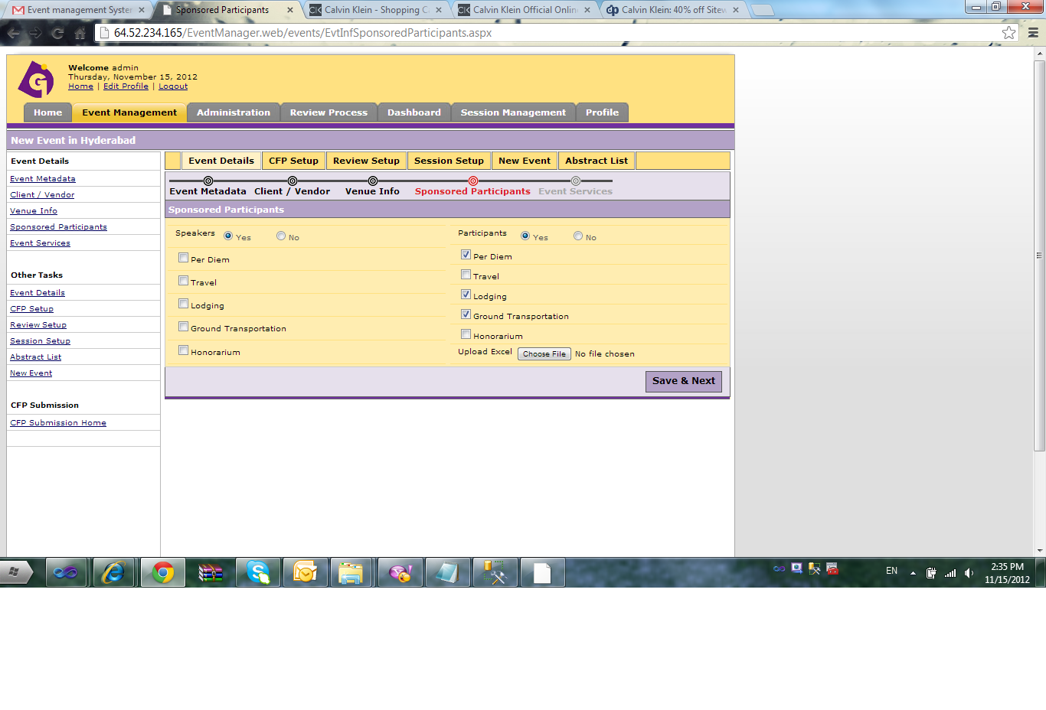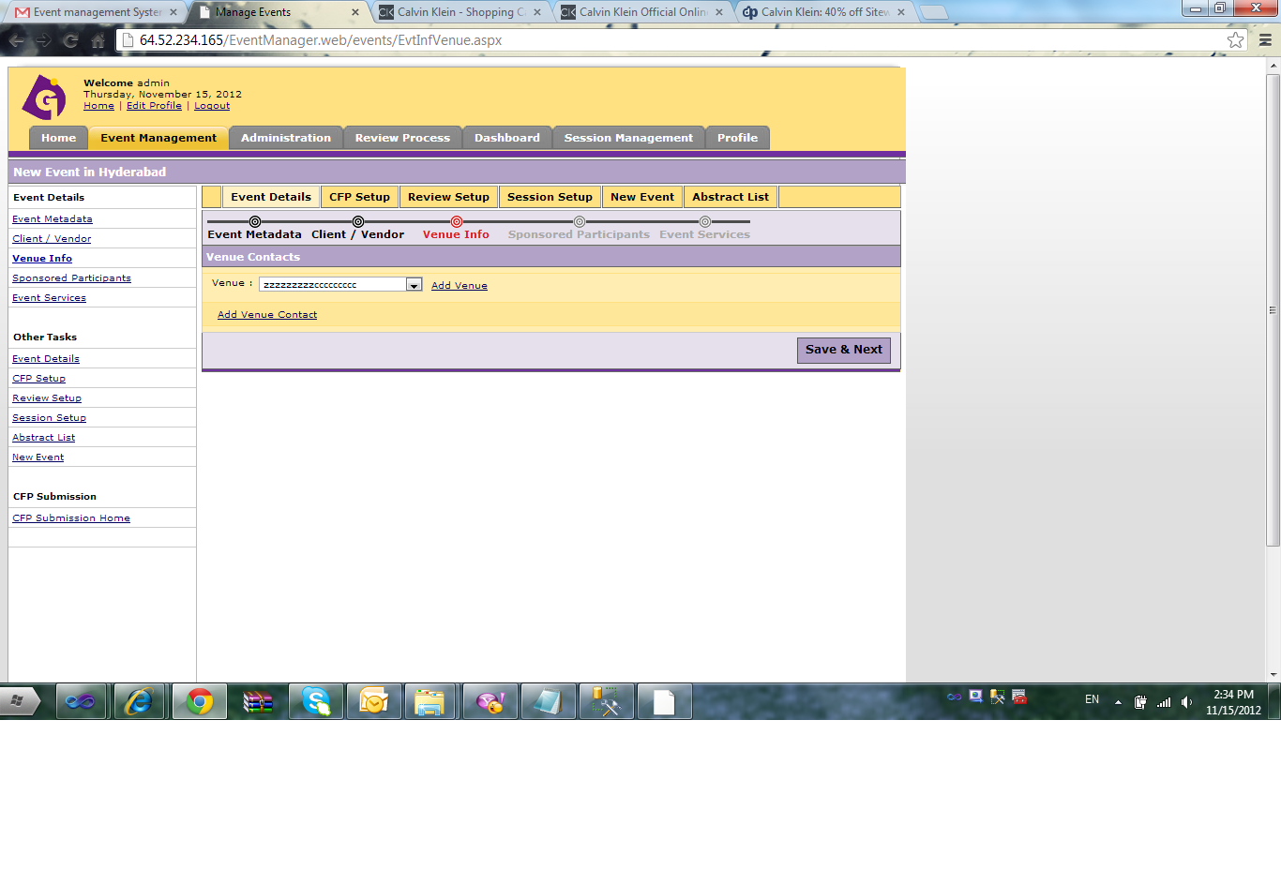

1. **REQUIREMENTS MATRIX**
   1. <http://www.w3schools.com/sql>
   2. <http://www.javapoint.com/hibernate-tutorial>
   3. <http://stackoverflow.com>
   4. SummitWorks letters from Maruthi