JARVIS
Jarvis script — Setup Guide

Free step-by-step guide · Open source · Windows

What is this?
This project turns a double clap into a full desk workflow: Spotify starts, Chrome opens your sites, an ElevenLabs voice speaks a welcome line, and Cursor comes to the front all from one Python script listening to your microphone.
The code is open source. You can read it, fork it, and change every part of the workflow to match your own setup.
ℹ This is an AI workflow starter, not full automation. The clap orchestrates your apps — you still add your own AI tools, prompts, and habits on top of it.

What happens when you double clap?
- Spotify opens and plays your chosen track
- Claude opens in Google Chrome (fullscreen on your chosen monitor)
- Jarvis speaks your welcome line via ElevenLabs
- Cursor is focused and sent fullscreen

What you need before starting
- A working microphone (built-in or external)
- Internet connection (for ElevenLabs voice + downloading the project)
- These apps installed:
  - Python 3.10 or newer
  - Visual Studio Code
  - Google Chrome
  - Spotify (desktop app or web)
  - Cursor (optional but used in the default workflow)

STEP 1

Install Python
Go to python.org/downloads and download the latest Python 3 installer for Windows.
Download: https://www.python.org/downloads/
⚠ During install, check "Add python.exe to PATH" at the bottom of the first screen. Then click Install Now.
Verify Python works. Open Command Prompt or PowerShell and run:
python --version
ℹ You should see something like: Python 3.12.x
STEP 2

Install Visual Studio Code
Download: https://code.visualstudio.com/download
Download the Windows installer, run it, and finish with default options.
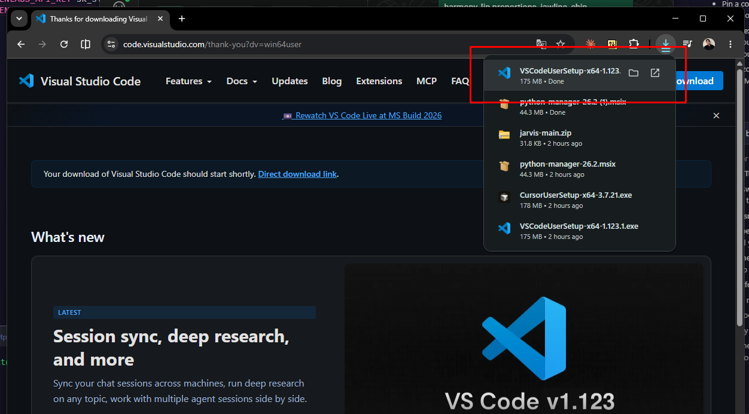

STEP 3

Download the project from GitHub
Repository: https://github.com/hectorg2211/jarvis
On the GitHub page, click the green Code button → Download ZIP.
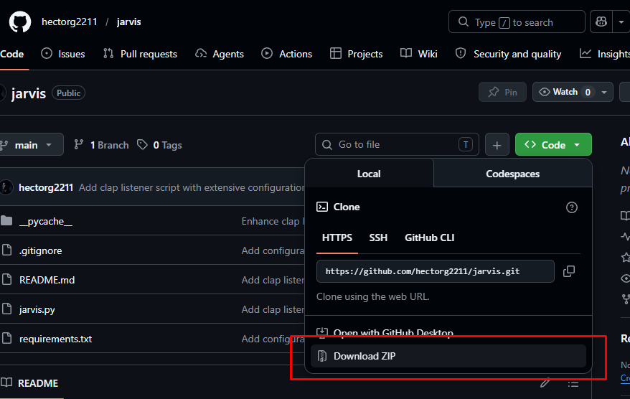
Extract the ZIP. You should have a folder containing at least:
- jarvis.py
- requirements.txt
- README.md
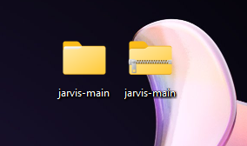

STEP 4

Open the project in VS Code
In VS Code: File → Open Folder → select the extracted jarvis-main folder
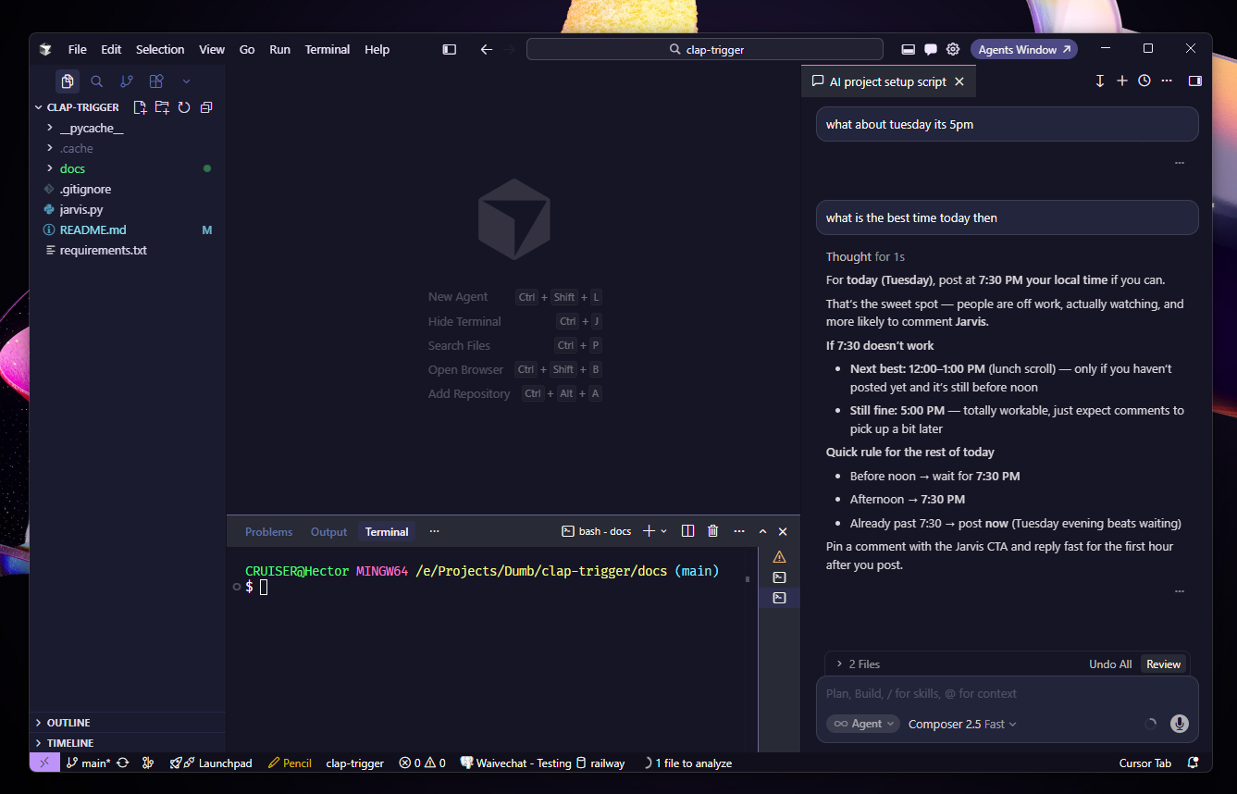
STEP 5

Install Python dependencies
In VS Code: Terminal → New Terminal (or Ctrl+`). Make sure the terminal path is your project folder, then run:
python -m pip install -r requirements.txt
ℹ Wait until it finishes without errors. This installs numpy, sounddevice, elevenlabs, python-dotenv, and websockets.
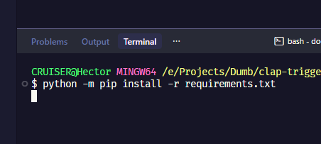

STEP 6

Get your ElevenLabs API key and Voice ID
The Jarvis welcome voice uses ElevenLabs text-to-speech. You need a free or paid account and two values: an API key and a Voice ID.
Sign up / log in: https://elevenlabs.io

6a — Create an API key
In ElevenLabs: click developers (bottom-left) → Profile + API key → Create API key → copy and save it somewhere safe.
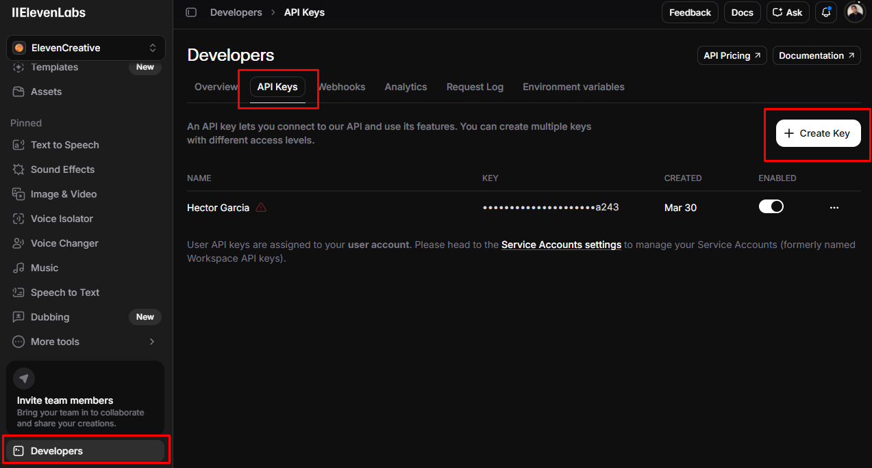

Go to Voices (or My Voices) → pick a voice you like → open its settings → copy the Voice ID (a short alphanumeric string).
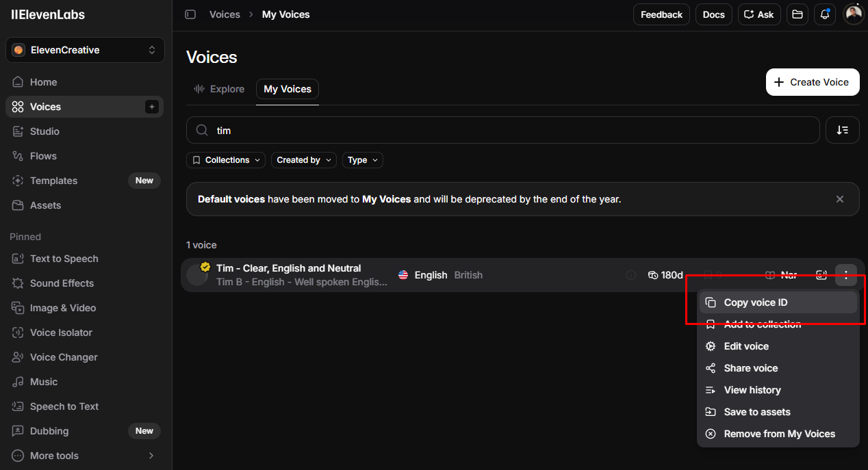
STEP 7

Create your .env file
In VS Code, in the same folder as jarvis.py, create a new file named exactly:
.env
Paste the following and replace with your real values:
ELEVENLABS_API_KEY=your_key_here
ELEVENLABS_VOICE_ID=your_voice_id_here
Save the file (Ctrl+S).
⚠ Never share your .env file or commit it to GitHub — it contains your private API key.
STEP 8

Run Jarvis
In the VS Code terminal, run:
python jarvis.py
ℹ If Windows asks for microphone access, click Allow. You should see log lines like "Listening (double clap…"
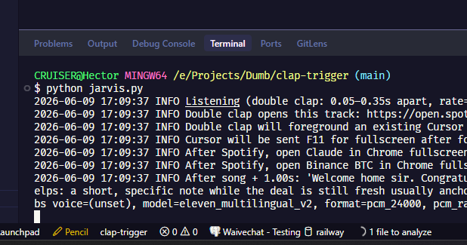
STEP 9

Test the double clap
Clap twice quickly (about a tenth of a second apart). If everything is set up:
- Spotify opens and plays your chosen track
- Claude opens in Google Chrome (fullscreen on your chosen monitor)
- Jarvis speaks your welcome line via ElevenLabs
- Cursor is focused and sent fullscreen

ℹ The welcome sequence runs once per session. To trigger it again, stop the script (Ctrl+C) and run python jarvis.py again.
STEP 10

Customize (optional)
Open jarvis.py and edit the constants at the top of the file. Common changes:

Setting | What it does
SONG_URI | Spotify or YouTube URL that plays on clap
JARVIS_WELCOME_PHRASE | What Jarvis says out loud
OPEN_CLAUDE_CODE_IN_CHROME | Turn Claude tab on/off
CLAUDE_CODE_URL | Which Claude URL opens (default: new chat)
FOCUS_EXISTING_CURSOR_ON_DOUBLE_CLAP | Focus Cursor instead of opening new
SPIKE_RATIO | Lower = easier to detect claps; higher = fewer false triggers

You can also set optional URLs in .env instead of editing code:
CLAUDE_CODE_URL=https://claude.ai/new

Troubleshooting

Problem | Fix
No reaction to claps | Clap closer to the mic. Lower SPIKE_RATIO slightly (e.g. 7.0 → 5.0). Check Windows Settings → System → Sound → Input and pick the correct mic.
No welcome voice | Confirm ELEVENLABS_API_KEY and ELEVENLABS_VOICE_ID in .env. Restart the terminal and run jarvis.py again.
Wrong microphone | List devices: python -c "import sounddevice as sd; print(sd.query_devices())" then add JARVIS_INPUT_DEVICE=0 (use your device index) to .env.
Audio / PortAudio error | Update sound drivers. Try changing SAMPLE_RATE to 48000 in jarvis.py.
Chrome or Cursor not opening | Install Chrome and Cursor. The script looks for cursor.exe in standard install paths.
Clap works once, then nothing | Expected — welcome runs once per process. Press Ctrl+C and start again.

Quick Links
Project (open source): https://github.com/hectorg2211/clap-trigger
Python downloads: https://www.python.org/downloads/
Visual Studio Code: https://code.visualstudio.com/download
ElevenLabs: https://elevenlabs.io
Claude: https://claude.ai
Cursor: https://cursor.com

📸 Enjoyed this guide?
Follow me on Instagram for more AI workflows, tools & builds
@hex.gar

Questions or improvements? The project is open source — open an issue or submit a PR.

