iOS Design Patterns

Must read:

Xamarin:

<http://docs.xamarin.com/guides/ios/application_fundamentals/delegates,_protocols,_and_events>

Apple:

https://developer.apple.com/library/ios/referencelibrary/GettingStarted/RoadMapiOS/chapters/StreamlineYourAppswithDesignPatterns/StreamlineYourApps/StreamlineYourApps.html

1.

* most important design pattern is MWC
  + Model View Controller

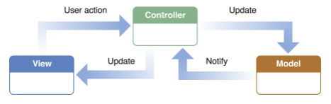

* Model
  + Encapsulates the data of an app and defines a logic
* View
  + Is an object that users can see, knows how to draw itself

and might respond to user actions

* Controller
  + Intermediary between one or more View objects and

one or more Model objects.

2.

* other design patterns includes following
  + Delegation
  + Protocol
  + Notification Center
  + Target – Action
  + KVO – Key Value Observing
  + Blocks
* Delegation
  + Acting on behalf on another object
  + Used when an object receives many events and it wants the same

Object to handle each of those events.

* + C# == Events

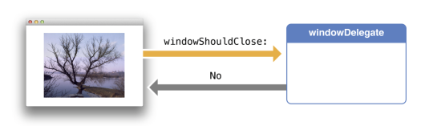

* Protocol
  + Enabling communication between objects not related by inheritance
  + C# == Interfaces (abstract classes)

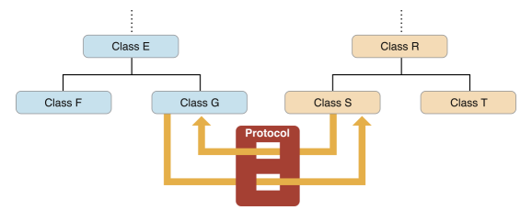

* Notification Center
  + Notifiying Interested Observers of an Event
  + Every object can register an event
  + Every object can subscribe to an event

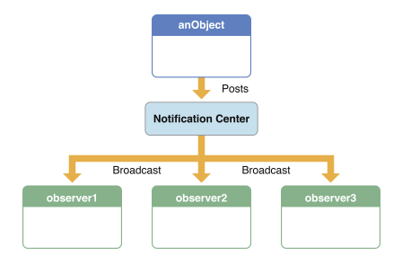

* Target Action
  + Encapsulating a message to be sent when event occurs
  + Used when you have close relationship between two objects
  + ViewController and on of its Views (UIButton)

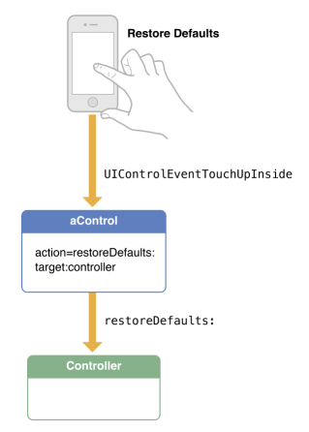

* Key – Value Observing
  + Notifying an observer when a value changes
  + Allows an object to observe a property of another object

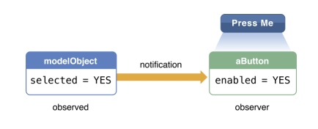

* AppDelegate
  + One of main jobs is to track the state transitions the app goes trough while is is running.
  + application:willFinishLaunchingWithOptions:
    - used to make any final tweaks, or to complete your’s app initialization
* UIViewController
  + ViewDidLoad, ViewWillAppear, ViewWillDisappear
    - ViewDidLoad
      * Initialize your ViewController
      * It will be called probably just once
    - ViewWillAppear
      * Is called every time view appears
* Manages a set of UIViews
* UINavigationController
  + Handles navigation of UIViewControllers
    - Transition (push, modal or custom)
      * Push – drill down
      * Modal – Covers entire screen

