异常1：找不到teamid

**HTTP Status 500 -**

**type** Exception report

**message**

**description** The server encountered an internal error () that prevented it from fulfilling this request.

**exception**

org.springframework.web.util.NestedServletException: Request processing failed; nested exception is org.mybatis.spring.MyBatisSystemException: nested exception is org.apache.ibatis.binding.BindingException: Parameter 'teamid' not found. Available parameters are [1, 0, param1, param2]



解决：



异常2：找不到staffjobnumber

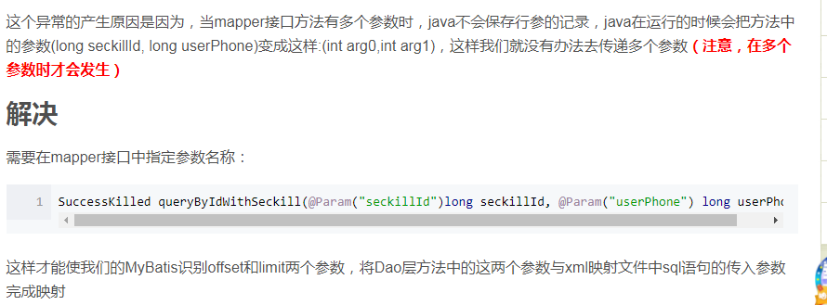

解决：

Dao:



Provider:

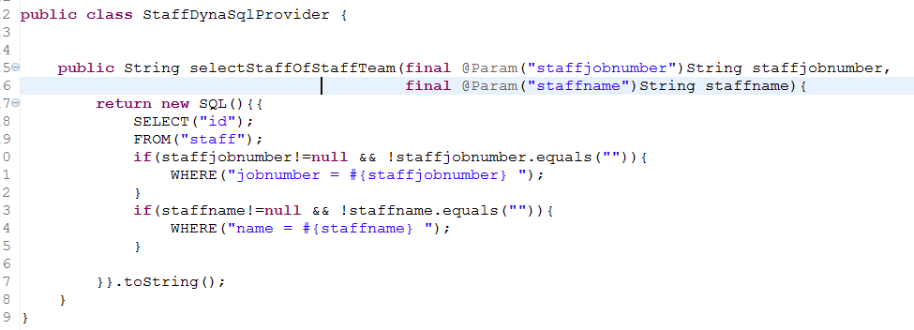

异常3：找不到emailInfo

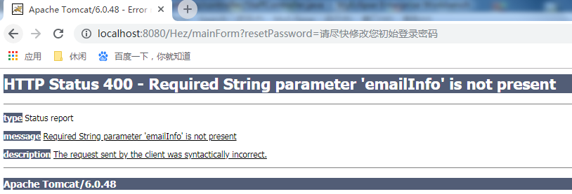

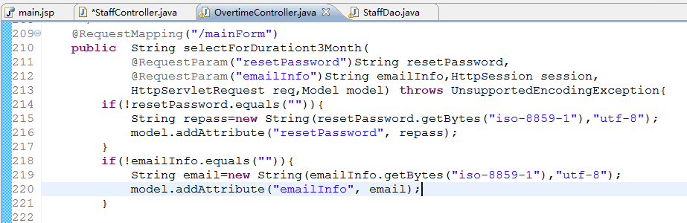

解决：if加上else条件，非emailInfo设默认值为空

