**Model1:**

**Number of Parameters, MAC Operations and Output Size for Model 1**

|  |  |  |  |
| --- | --- | --- | --- |
| **Layer Name** | **Output Size** | **Parameters** | **MAC Operations** |
| Conv2D | 16x16x32 | 896 | 295,014,912 (16x16x32x3x3x3x32) |
| BatchNormalization | 16x16x32 | 256 | 0 |
| Conv2D | 8x8x64 | 18,496 | 118,111,488 (8x8x64x3x3x32x64) |
| BatchNormalization | 8x8x64 | 512 | 0 |
| Conv2D | 4x4x128 | 73,856 | 590,252,544 (4x4x128x3x3x64x128) |
| BatchNormalization | 4x4x128 | 512 | 0 |
| Conv2D | 4x4x128 | 1,47,584 | 590,252,544 (4x4x128x3x3x128x128) |
| BatchNormalization | 4x4x128 | 512 | 0 |
| Conv2D | 4x4x128 | 1,47,584 | 590,252,544 (4x4x128x3x3x128x128) |
| BatchNormalization | 4x4x128 | 512 | 0 |
| Conv2D | 4x4x128 | 1,47,584 | 590,252,544 (4x4x128x3x3x128x128) |
| BatchNormalization | 4x4x128 | 512 | 0 |
| MaxPooling2D | 1x1x128 | 0 | 0 |
| Flatten | 128 | 0 | 0 |
| Dense | 128 | 16,512 | 16,512 |
| BatchNormalization | 128 | 512 | 0 |
| Dense | 10 | 1,290 | 1,280 |

**Formula for Calculating MACs** (output_height * output_width * output_channels) * (kernel_height * kernel_width * input_channels) * output_channels

**Did you observe any overfitting? Should the model train for longer, shorter, or about that number of epochs.**

The Validation accuracy is lower than the Training accuracy. The Validation loss is higher than the Training loss. Hence, Model1 is Overfitting.

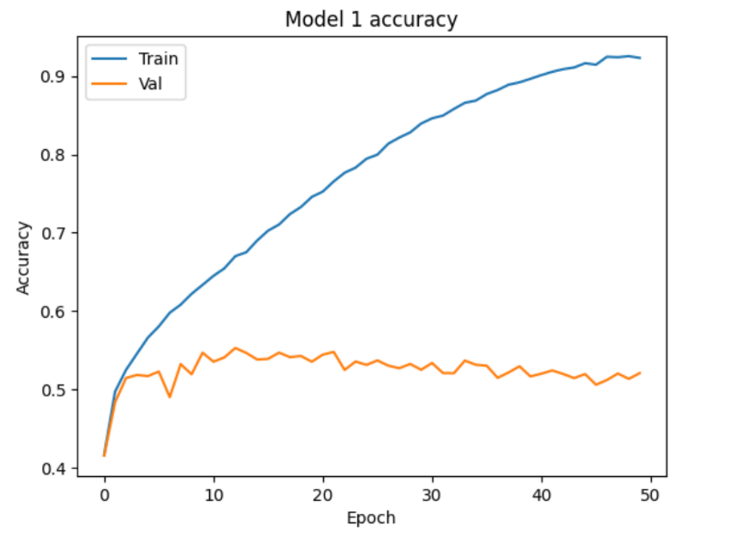

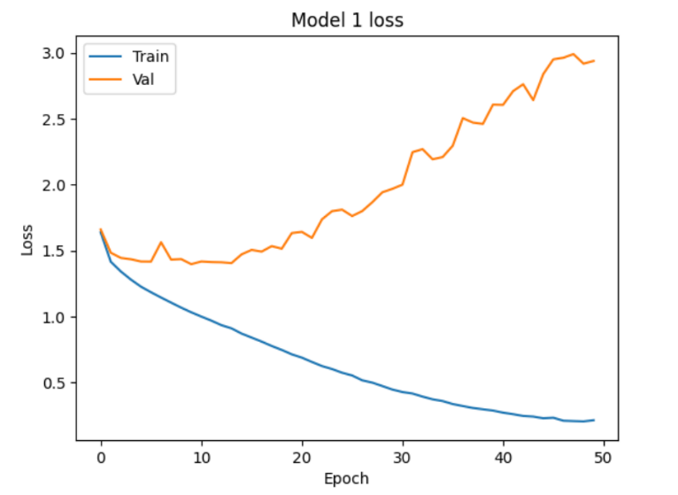

**Does it correctly label the picture?**

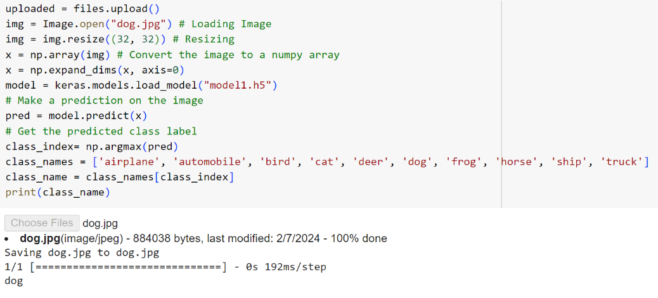Sample image of Dog is tested on Model 1 and it correctly classified

**Model2**

|  |  |  |  |
| --- | --- | --- | --- |
| **Layer** | **Output Shape** | **Parameters** | **MAC Operations** |
| Conv2D | (16, 16, 32) | 896 | 294,912 (16x16x32x3x3x3x32) |
| BatchNormalization | (16, 16, 32) | 128 | 0 |
| DepthwiseConv2D | (8, 8, 32) | 288 | 57,600 (8x8x32x3x3x1) |
| Conv2D | (8, 8, 64) | 2,112 | 36,864 (8x8x64x1x1x32) |
| BatchNormalization | (8, 8, 64) | 256 | 0 |
| DepthwiseConv2D | (4, 4, 64) | 576 | 14,400 (4x4x64x3x3x1) |
| Conv2D | (4, 4, 128) | 8,320 | 9,216 (4x4x128x1x1x64) |
| BatchNormalization | (4, 4, 128) | 512 | 0 |
| DepthwiseConv2D | (2, 2, 128) | 1,152 | 3,600 (2x2x128x3x3x1) |
| Conv2D | (2, 2, 128) | 16,512 | 512 (2x2x128x1x1x128) |
| BatchNormalization | (2, 2, 128) | 512 | 0 |
| DepthwiseConv2D | (1, 1, 128) | 1,152 | 3,600 (1x1x128x3x3x1) |
| Conv2D | (1, 1, 128) | 16,512 | 128 (1x1x128x1x1x128) |
| BatchNormalization | (1, 1, 128) | 512 | 0 |
| DepthwiseConv2D | (1, 1, 128) | 1,152 | 3,600 (1x1x128x3x3x1) |
| Conv2D | (1, 1, 128) | 16,512 | 128 (1x1x128x1x1x128) |
| BatchNormalization | (1, 1, 128) | 512 | 0 |
| GlobalAveragePooling2D | (None, 128) | 0 | 0 |
| Flatten | (None, 128) | 0 | 0 |
| Dense | (None, 128) | 16,512 | 16,512 |
| BatchNormalization | (None, 128) | 512 | 0 |
| Dense | (None, 10) | 1,290 | 1,280 |

**Did you observe any overfitting? Should the model train for longer, shorter, or about that number of epochs.**

The validation accuracy is lower than the training accuracy. The validation loss is higher that the training loss. So, this model is overfitting.

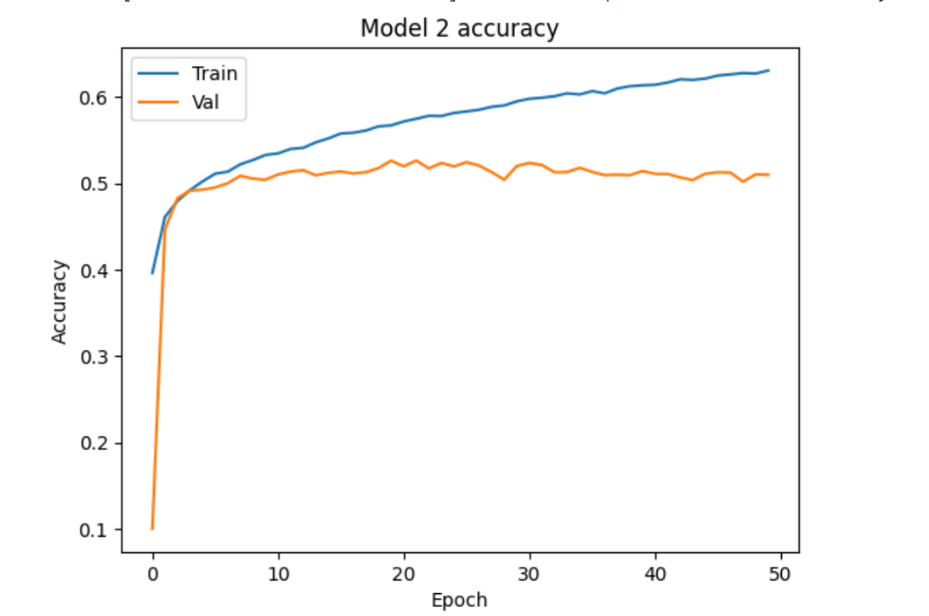

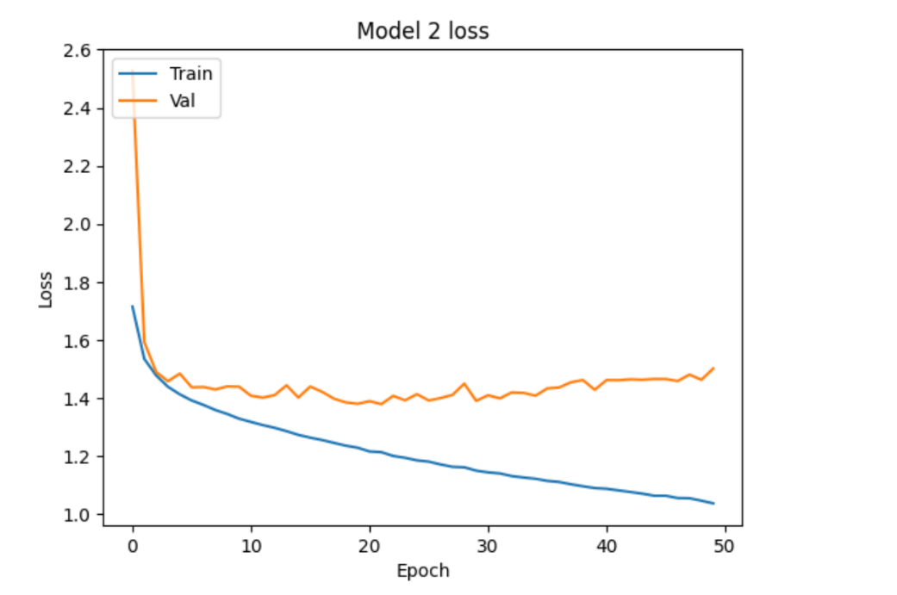

**Does it correctly label the picture?**Sample image of Dog is tested on Model 2 and it correctly classified.

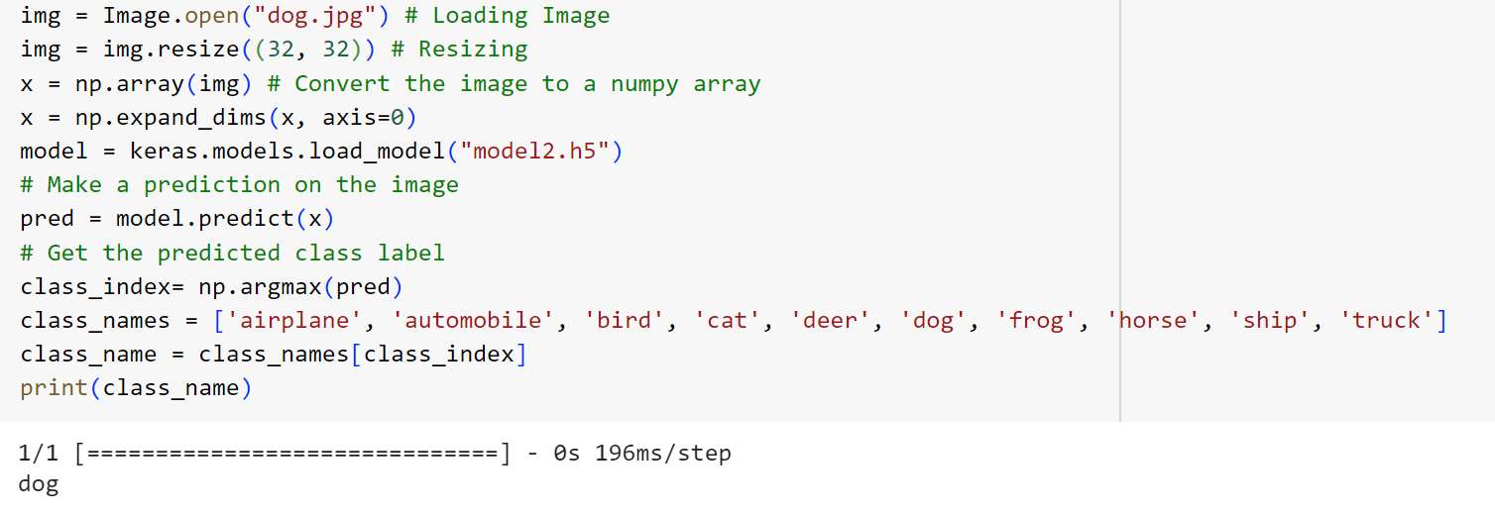

**Model3**

|  |  |  |  |
| --- | --- | --- | --- |
| **Layer** | **Output Shape** | **Parameters** | **MAC Operations** |
| InputLayer | (None, 32, 32, 3) | 0 | 0 |
| Conv2D | (None, 16, 16, 32) | 896 | 294,912 (16x16x32x3x3x3x32) |
| BatchNormalization | (None, 16, 16, 32) | 128 | 0 |
| Dropout | (None, 16, 16, 32) | 0 | 0 |
| Conv2D | (None, 8, 8, 64) | 18,496 | 36,864 (8x8x64x3x3x32) |
| BatchNormalization | (None, 8, 8, 64) | 256 | 0 |
| Dropout | (None, 8, 8, 64) | 0 | 0 |
| Conv2D | (None, 4, 4, 128) | 73,856 | 36,864 (4x4x128x3x3x64) |
| BatchNormalization | (None, 4, 4, 128) | 512 | 0 |
| Dropout | (None, 4, 4, 128) | 0 | 0 |
| Conv2D | (None, 4, 4, 128) | 4,224 | 11,520 (4x4x128x1x1x32) |
| Add | (None, 4, 4, 128) | 0 | 0 |
| Dropout | (None, 4, 4, 128) | 0 | 0 |
| Conv2D | (None, 2, 2, 128) | 1,47,584 | 11,520 (2x2x128x3x3x1) |
| BatchNormalization | (None, 2, 2, 128) | 512 | 0 |
| Dropout | (None, 2, 2, 128) | 0 | 0 |
| Conv2D | (None, 1, 1, 128) | 1,47,584 | 32 (1x1x128x1x1x128) |
| BatchNormalization | (None, 1, 1, 128) | 512 | 0 |
| Dropout | (None, 1, 1, 128) | 0 | 0 |
| Add | (None, 4, 4, 128) | 0 | 0 |
| Dropout | (None, 4, 4, 128) | 0 | 0 |
| Conv2D | (None, 4, 4, 128) | 1,47,584 | 36,864 (4x4x128x3x3x32) |
| BatchNormalization | (None, 4, 4, 128) | 512 | 0 |
| Dropout | (None, 4, 4, 128) | 0 | 0 |
| Conv2D | (None, 4, 4, 128) | 1,47,584 | 36,864 (4x4x128x3x3x32) |
| BatchNormalization | (None, 4, 4, 128) | 512 | 0 |
| Dropout | (None, 4, 4, 128) | 0 | 0 |
| Add | (None, 4, 4, 128) | 0 | 0 |
| Dropout | (None, 4, 4, 128) | 0 | 0 |
| MaxPooling2D | (None, 1, 1, 128) | 0 | 0 |
| Flatten | (None, 128) | 0 | 0 |
| Dense | (None, 128) | 16,512 | 16,512 |
| BatchNormalization | (None, 128) | 512 | 0 |
| Dense | (None, 10) | 1,290 | 1,280 |

**Did you observe any overfitting? Should the model train for longer, shorter, or about that number of epochs.**  
The validation accuracy is almost similar to the training accuracy. The validation loss is nearly same as training loss. So, this model is slightly overfitting.

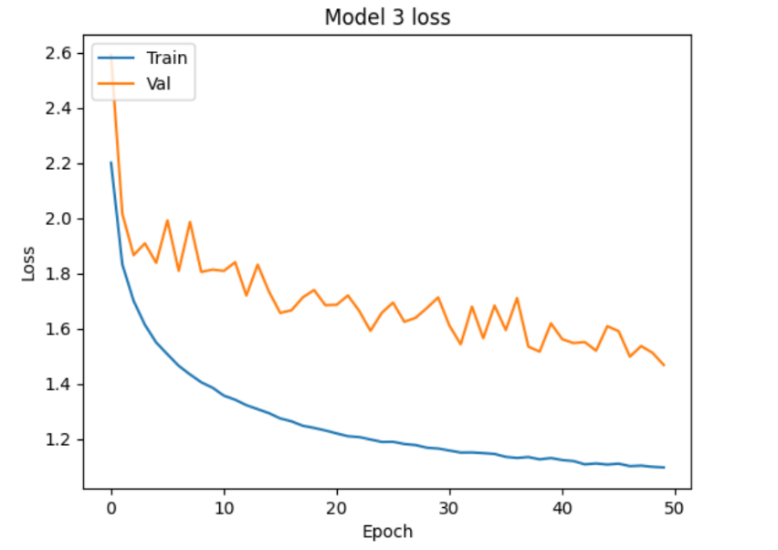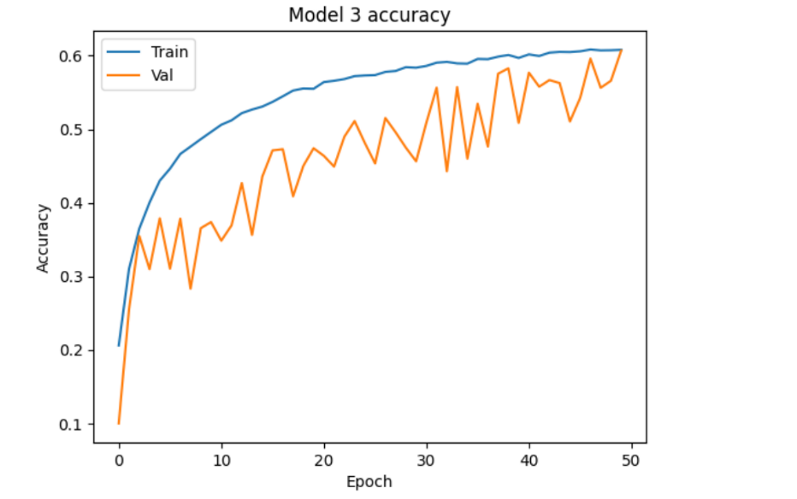

**Does it correctly label the picture?**A picture of an dog was tested, and Model3 Classified it as Truck.

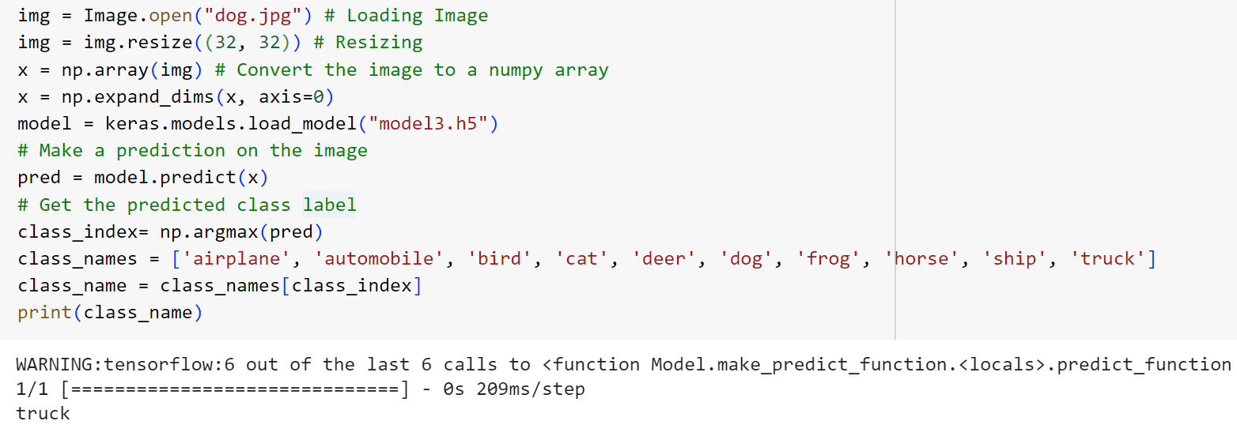

**Model_50K**

|  |  |  |  |
| --- | --- | --- | --- |
| **Layer** | **Output Shape** | **Parameters** | **MAC Operations** |
| Conv2D | (None, 16, 16, 32) | 416 | 819,200 (16x16x32x3x3x32) |
| BatchNormalization | (None, 16, 16, 32) | 128 | 0 |
| Activation | (None, 16, 16, 32) | 0 | 0 |
| SeparableConv2D | (None, 8, 8, 64) | 2,400 | 36,864 (8x8x64x3x3x32) |
| BatchNormalization | (None, 8, 8, 64) | 256 | 0 |
| SeparableConv2D | (None, 4, 4, 128) | 8,576 | 36,864 (4x4x128x3x3x64) |
| BatchNormalization | (None, 4, 4, 128) | 512 | 0 |
| Dropout | (None, 4, 4, 128) | 0 | 0 |
| SeparableConv2D | (None, 4, 4, 128) | 17,664 | 36,864 (4x4x128x3x3x128) |
| BatchNormalization | (None, 4, 4, 128) | 512 | 0 |
| Dropout | (None, 4, 4, 128) | 0 | 0 |
| MaxPooling2D | (None, 1, 1, 128) | 0 | 0 |
| Flatten | (None, 128) | 0 | 0 |
| Dense | (None, 128) | 16,512 | 16,512 |
| Dropout | (None, 128) | 0 | 0 |
| Dense | (None, 10) | 1,290 | 1,280 |

**Did you observe any overfitting? Should the model train for longer, shorter, or about that number of epochs.**  
The validation accuracy is similar to the training accuracy. The validation loss is also the same as training loss. Model_50K performing better than previous models

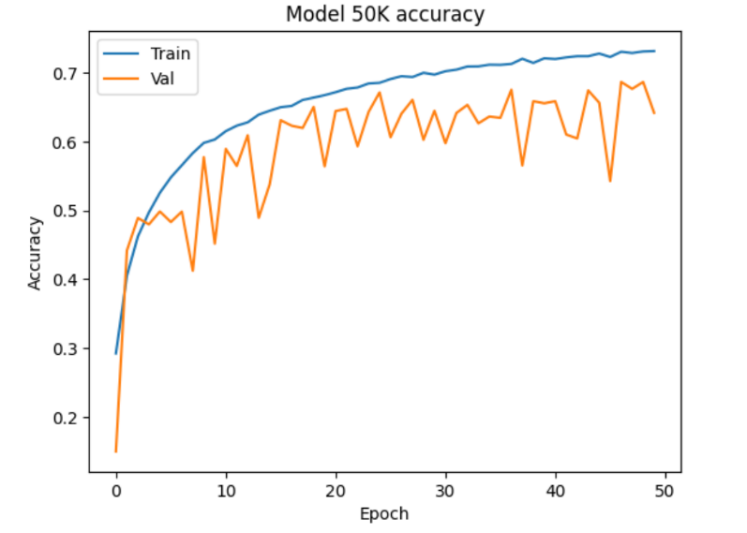

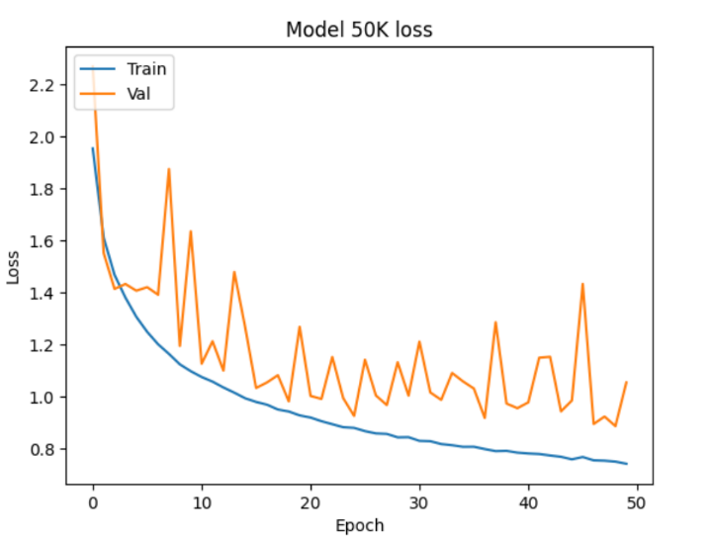

**Does it correctly label the picture?**A picture of a dog was tested, and it classified it as cat.

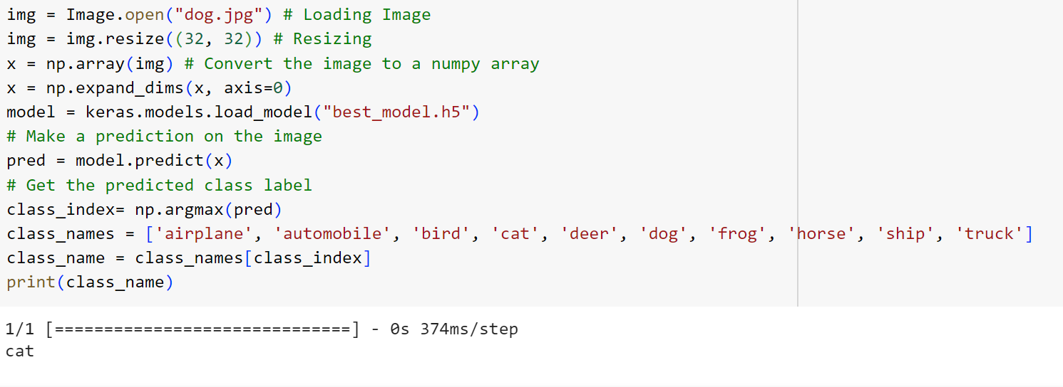

**How did the three models compare? Consider final accuracy, time per epoch to train, number of epochs needed to reach a given accuracy, overfitting.**The model50K exhibited the highest accuracy, reaching 0.742. The average training time per epoch ranged from 4 to 5 seconds. Training the models for 50 epochs proved effective, with overfitting showing improvement from model 1 to model50K.

**What did you observe? What model architecture or training decisions made the most difference?**

Reducing the number of model layers has had an impact on accuracy. As model layers are reduced, accuracy increases and overfitting decreases. Additionally, this reduction decreases the number of parameters.