**States with recreational marijuana have lower rates of vaping associated lung injury**

Coady Wing, PhD, Indiana University O’Neill School of Public and Environmental Affairs

1315 E 10th St., Bloomington, IN 47405, [cwing@indiana.edu](mailto:cwing@indiana.edu), +1 (812) 855-0563

Ashley C. Bradford, MA, Indiana University O’Neill School of Public and Environmental Affairs

Aaron E. Carroll, MD, MS, Indiana University School of Medicine

Alex Hollingsworth, PhD, Indiana University O’Neill School of Public and Environmental Affairs

**Word Count: 594**

**Introduction**

In the past six months, over 1,600 cases of e-cigarette or vaping associated lung injury (EVALI) have been reported to the CDC. The specific cause of EVALI is unknown, but most patients report using e-cigarettes to consume tetrahydrocannabinol (THC), the primary psychoactive component of marijuana. The CDC and others have hypothesized that black-market THC products may cause EVALI1,2.

Some states have legalized marijuana and THC-containing products for recreational use. Many other states allow purchases for qualifying medical purposes. In the remaining states, all forms of consumption and distribution are illegal, and those who use THC likely obtain it from the black market. If black market THC products are responsible for EVALI, then case rates may be lower in recreational marijuana states.

**Methods**

To examine this hypothesis, we compared EVALI case rates across states with different marijuana regulations and across states with differing rates of e-cigarette use. We obtained EVALI data from the CDC2, e-cigarette prevalence from BRFSS3, and population data from SEER4. We defined the EVALI case rate as the mid-point of the CDC reported range divided by the state population. We classified states as medical marijuana states if they had a medical marijuana law by January 2019, but no recreational dispensaries. We classified states as recreational marijuana states if they had a recreational law and at least one recreational dispensary by January 2019: Alaska, Washington, Colorado, Oregon, Nevada, California, and Maine.

**Results**

Exhibit 1A shows the number of reported EVALI cases per 1 million population in each state. We sorted states by the EVALI rate and found that recreational marijuana states have significantly fewer EVALI cases/million than other states. The average recreational marijuana state had 1.7 EVALI cases/million. In contrast, the EVALI case rate was 8.8 cases/million in medical marijuana states and 8.1 cases/million in prohibition states. This means that recreational marijuana states have 7.1 (p < .001) fewer cases/million than medical marijuana states, and 6.4 (p < .002) fewer cases/million than prohibition states. The difference in the EVALI case rate between medical and prohibition states is not statistically significant. Exhibit 1B shows that the prevalence of e-cigarette use does not significantly differ between recreational, medical, and prohibition states.

Exhibit 2 demonstrates that the relationship between the EVALI cases rate and the prevalence of e-cigarette in each state is not significantly different from zero.

We next examined the relationship between the EVALI case rate each of these factors (medical marijuana, recreational marijuana, and prevalence of e-cigarette use) simultaneously using multivariate regression. Results from this analysis confirm our earlier findings; there is no significant relationship between the EVALI case rate and e-cigarette use (coef=-1.3, p-value=.20) or medical marijuana (coef=0.3, p-value=.92), but there is a significant relationship between the EVALI case rate and recreational marijuana legalization (coef=-7.5, p-value<.001).

**Discussion**

The distribution of EVALI cases suggests that they are concentrated in states where consumers do not have legal access to recreational marijuana dispensaries. One possible inference from our results is that the presence of legal markets for marijuana has helped mitigate the EVALI outbreak in some parts of the country. The statistical analysis in this note is limited in that these are simple cross-sectional comparisons of case rates, which do not attempt to adjust for the possibility of confounding by other factors that might explain differences in EVALI case rates. Nevertheless, the data from the outbreak so far provide suggest that further restrictions on the legal market for marijuana could lead to more EVALI. Recent proposals to ban e-cigarette products raise similar concerns about the unintended public health consequences of black markets for recreational drugs5,6.

Exhibit 1

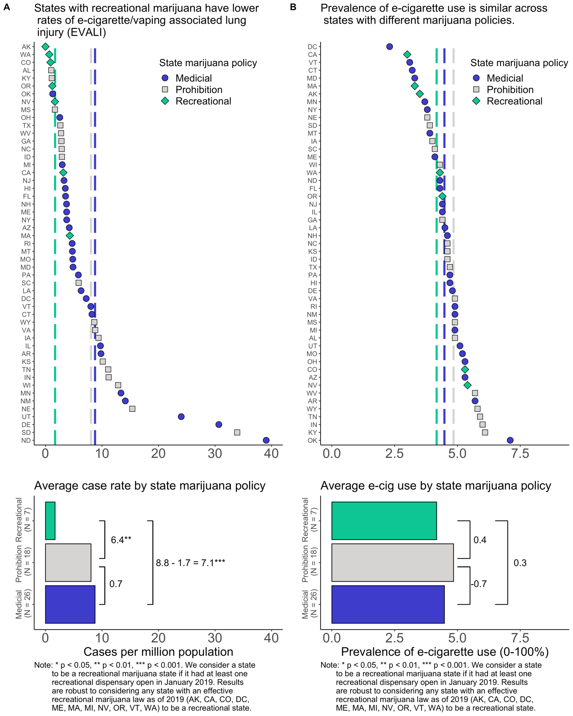

Exhibit 2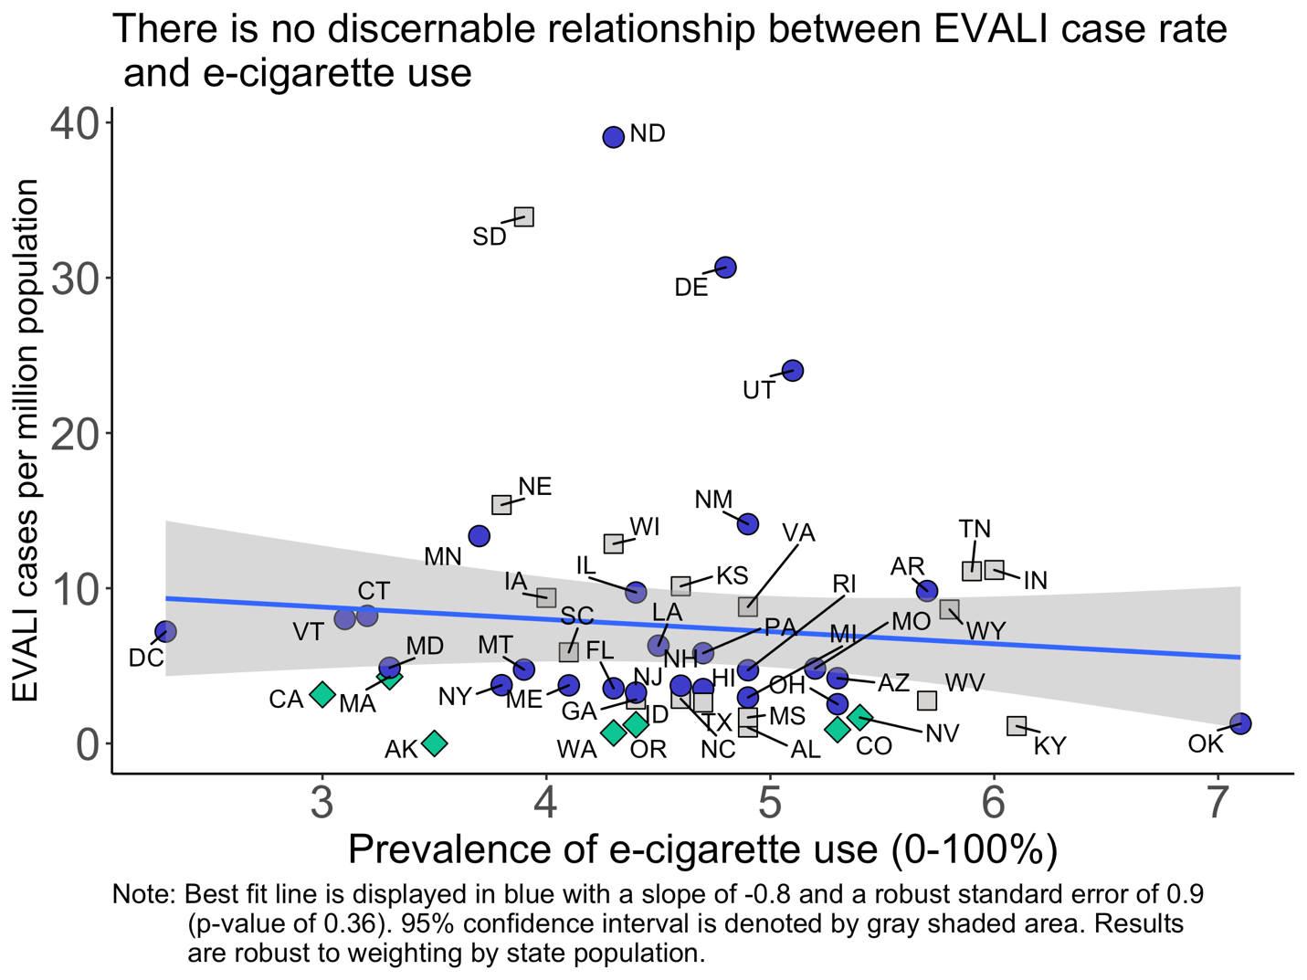

**References**

[1] Layden JE, Ghinai I, Pray I, et al. Pulmonary illness related to e-cigarette use in Illinois and Wisconsin — preliminary report. N Engl J Med. DOI: 10.1056/NEJMoa1911614.

[2] Perrine CG, Pickens CM, Boehmer TK, et al. Characteristics of a Multistate Outbreak of Lung Injury Associated with E-cigarette Use, or Vaping — United States, 2019. MMWR Morb Mortal Wkly Rep 2019;68:860–864. DOI: <http://dx.doi.org/10.15585/mmwr.mm6839e1>

[3] Centers for Disease Control and Prevention (CDC). Behavioral Risk Factor Surveillance System Survey Data. Atlanta, Georgia: U.S. Department of Health and Human Services, Centers for Disease Control and Prevention, 2017.

[4] Surveillance, Epidemiology, and End Results (SEER) Program Populations (1969-2017) (www.seer.cancer.gov/popdata), National Cancer Institute, DCCPS, Surveillance Research Program, released December 2018.

[5] Farzal, Z., Perry, M. F., Yarbrough, W. G., & Kimple, A. J. (2019). The Adolescent Vaping Epidemic in the United States—How It Happened and Where We Go From Here. JAMA Otolaryngology–Head & Neck Surgery, 145(10), 885. <https://doi.org/10.1001/jamaoto.2019.241>

[6] Karlamangla, S. (2019). Los Angeles could ban all e-cigarettes and vaping devices. *Los Angeles Times*. Retrieved from <https://www.latimes.com/california/story/2019-10-08/e-cigarettes-vaping-devices-proposed-ban-los-angeles>. Accessed 1 November 2019.