Replies for “Association of states' marijuana legalization policies for medicinal and recreational use and vaping associated lung injury” (JNO19-4156-T)

Dear Dr. Rubenfeld,

We write to you with a revised version of our article “Association of states' marijuana legalization policies for medicinal and recreational use and vaping associated lung injury” (JNO19-4156-T) for JAMA Network Open. We thank you for the opportunity to resubmit the paper. We believe that addressing the concerns and comments raised by both yourself and the referees have helped us to improve the paper. In our replies below we describe in detail the changes we have made. **XXXXX**

Many of the comments asked us to add to the manuscript length. Given the journal’s word limitations, we revised the manuscript to focus on the edits we deemed most important, ensuring that we stay below the word limit. Although we could not incorporate all suggestions into the manuscript, we have included responses are directly in the response text to the referees even if they were not fully incorporated into the text.

The remainder of the document contains our replies to specific comments. We look forward to hearing from you. Please let us know if you or the referees have any questions or concerns.

Sincerely,

Coady Wing, Ashley Bradford, Aaron Carroll, and Alex Hollingsworth

**Comments from Dr. Rubenfeld**

Thank you for your comments and helpful suggestions. We believe this has improved our manuscript. We describe how we have addressed all of your concerns below. Your comments are in italics; our responses are in regular print.

*General comments*

1. *The authors need to clearly define their analytic subgroups. There is no definition of “not well at birth” provided in the manuscript.*

**RESPONSE:**

Thank you for identifying that this important delineation was not clear in our manuscript. Well at birth is a binary variable (0 or 1) provided by the managed care organization for each infant member. Because the full definition of “Well at birth” is considered proprietary information by the managed care organization, we sought and received permission to share a summary of the information used to generate this variable. Specifically, an infant is considered “not well at birth” if any of the following conditions are met:

1. The infant has a claim that contains a Diagnosis Related Group (DRG) code identifying the infant as sick or if the infant does not contain the normal newborn code (e.g. DRG code 795). The full set of DRG codes used by the managed care organization is proprietary, or
2. The infant stays in the hospital longer than the mother, or
3. The infant has any claims for intensive care (i.e,, NICU), or
4. The infant’s length of stay is greater than seven days, or
5. The infant is transferred to another facility.

Infants who do not meet any of the above criteria are considered “well at birth.”

We have added the following text explaining this on page 4: “Well at birth” is a designation constructed by the managed care organization using an algorithm that identified those infants who are diagnosed as a healthy newborn (e.g. an absence of serious diagnoses or an explicit diagnosis newborn), who are not admitted to a non-general room (e.g. ICU), transferred to another facility, and who stay in the hospital less than their mother and less than seven days.”

1. *It is unclear to me that the research design overcomes selection bias. The authors note that “Infant engagement in care management was defined as any engagement beginning during the first month of life.” Why were some infants engaged in the first month of life and not others? It seems unlikely that the MCO targeted its care management resources randomly. Does “engagement” represent care management being offered or families accepting? An ITT approach with care management being offered would be a robust result. If “engagement” is defined as families that accepted and “engaged” with care management, then the results are likely selection bias. The authors need to make strong argument for why their findings aren’t simply selection bias.*

**RESPONSE:**

Thank you for this helpful suggestion. In our main results, engagement indicated that an offer of care management that was accepted. If care management engagement was offered but not accepted we had coded the individual as not having being enrolled in care management. The managed care organization provided data on all infants offered and enrolled in care management, which allows us to perform the analysis you suggest. We re-estimated our analysis using your suggestion as our independent variable of interest and the results are presented in tabular form below. Column six represents the main variable of interest for this new intent to treat specification. Here we see that the results are robust to this change in definition from engaged in care management to offered care management. The coefficient is slightly attenuated (-0.053 vs. -0.074), but is still statistically significant at the <.01 level.

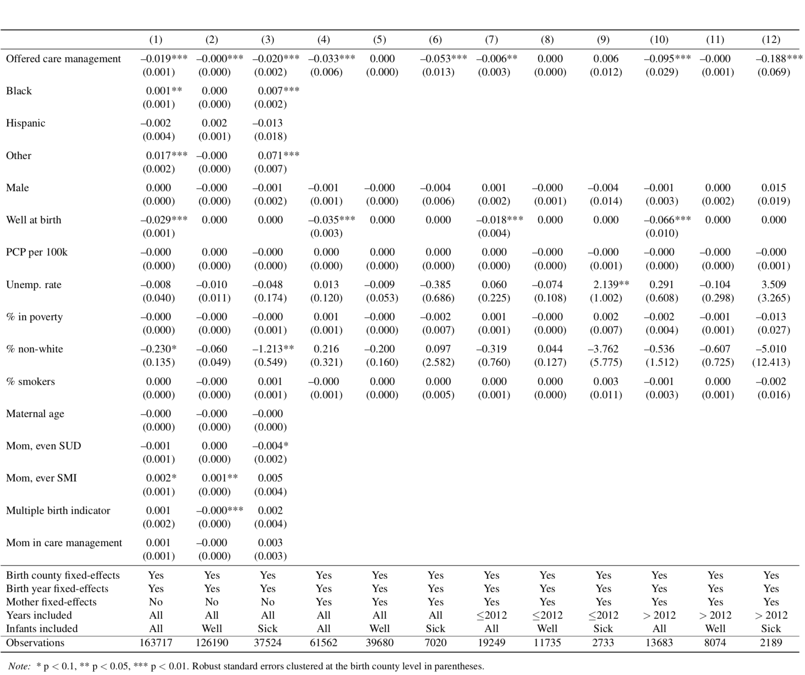

We would be concerned about selection bias if the managed care organization was selecting the healthiest infants (i.e., those unlikely to die) to be in care management. Evidence regarding a lack of this problematic selection is provided by our summary statistics in Exhibit 1 of the paper showing that only 18% of those infants in care management were defined as well-at-birth compared to 78% of infants not in care management that were considered well at birth. Those who are flagged as “not well at birth” are significantly more likely to die during the first year of life (unadjusted rate of 3.38% vs. 0.04%), suggesting that there is not selection on likelihood of survival in who is engaged in care management. Those infants who are selected for care management have an adjusted predicted mortality rate of 7.5 percent. This further suggests that those infants selected for care management are not likely to come from places with low infant mortality rates or be born in years with lower infant mortality rates. See our response to point 3 as to how this number was calculated.

In addition, our within family comparison further mitigates the possibility that our results are driven by selection of mothers since we are comparing to one another. Moreover, in our within-family specification that focuses on those infants not well at birth, we are even further reducing the possibility of selection bias by comparing all siblings from the same mother that were born “not well” at birth to one another. We have tightened the text on page 4 to better reflect how our analysis incorporates the potential for selection and have mentioned the potential selection issue in our limitations section.

*Abstract*

1. *In the results the authors state care management was associated with “7.4 (p<.001) percentage point reduction. I don’t understand where that value comes from. Did you mean a 7.4 percent (relative) reduction? You can’t have a 7.4 (absolute) percentage point reduction in mortality when the maximum mortality in any group is 3.6 percent.*

**RESPONSE:**

Thank you for pointing out this confusing portion of our text. Given the limited word count, we did not provide enough detail. It is true that the maximum observed death rate for any of the groups reported in Table 1 is 3.6 percent. This 3.6 percent represents the unadjusted death rate infants born not well at birth, who are *not* involved in care management. The adjusted (i.e. predicted) mortality rate for those infants born not well at birth who also have at least one sibling not well at birth (i.e. those infants in our preferred model) is 7.5%. We calculate this risk adjusted death rate by accounting for the role of birth county, year, and mother fixed effects as well as characteristics of the county-year, mother, and infant. Thus, the estimated 7.4 percentage point reduction in the probability of death in the first year of life for those infants enrolled in care management from this sample is not impossible, but large. We have added text to page 5 clarifying this point stating that “the predicted (i.e. regression adjusted) mortality rate for this group in the absence of care management is 7.5%.” Moreover, we indicate in the discussion section that this finding is highly-relevant and to Medicaid agencies serving the most vulnerable infants and we note that more work is needed to identify the specific mechanisms of care management leading to this decline in infant mortality.

*Introduction*

1. *In the second paragraph, it looks like citation 4 is incorrectly connected to the third sentence. It would be very helpful if it was replaced with a link to the specific care management requirements that were adopted by Ohio Medicaid.*

**RESPONSE:**

Thank you for pointing this out. We have updated this reference (it is now the 11th citation number) to link to the specific requirements: Ohio Department of Medicaid. Medicaid managed care provider agreements (Jan 1, 2013 to June 20, 2013; March 1, 2013 to June 30, 2014; July 1, 2014 to June 30, 2015). Available at: <https://medicaid.ohio.gov/Managed-Care/For-Managed-Care-Plans>. Published January 2015. Accessed August 20, 2019.

*Methods*

1. *How were data on death status obtained? These data are not typically included in Medicaid claims. The manuscript says “known enrollment and death status…” There should be a clear statement about how much data on the outcome was missing.*

**RESPONSE:**

The managed care organization obtained information on status of death from the Ohio Department of Job and Family Services, from parents, and other agencies. The managed care organization does not believe there is a high-likelihood of misreporting or underreporting. Similarly, we know the enrollment status for all infants. We see how our initial writing was unclear and have deleted the phrase “with known enrollment and death status” from the text to avoid confusion and the suggestion that there are excluded infants due to missing data. Thank you for pointing out this confusing text.

1. *There needs to be a better explanation for how the MCO selected infants for care management.*

**RESPONSE:**

We agree that this was missing from the original manuscript. We have added a brief description of this to the text on page 2: “Care management was offered to infants who were predicted to be high-cost or who were identified as high-risk pregnancies.”

1. *Please clarify whether the engagement in care management was an indicator supplied within the claims or somehow otherwise constructed.*

**RESPONSE:**

Enrollment in care management was provided by the managed care organization, who is aware of which infants were enrolled in their program. Please see response #2 for more detail. We have added this information to the manuscript.

1. *“well-at-birth” vs. “not well” is not defined. These need to be very clearly defined.*

**RESPONSE:**

Please see response #1. We have added a clearer description of this to our text.

1. *Don’t spend space describing a less rigorous design (simple cross-sectional). Focus on the most rigorous design that you ultimately present anyway.*

**RESPONSE:**

As suggested, we have reduced the amount of space we devote to the cross-sectional design in the text. We still find some exposition of this research design helpful for the reader to understand the differences in the within-family design so we have not eliminated it from our analysis.

1. *Need more explanations and/or references for how key covariates were defined: “maternal substance use disorder,” “maternal serious mental health issue [sic - illness].”*

**RESPONSE:**

All of these variables are indicators if the mother was ever diagnosed and were constructed from claims data using Expanded Diagnosis Clusters (EDCs) to identify each diagnosis grouping. For example, substance use disorder is EDC PSY02 and serious mental health issue is PSY01 through PSY12. A list of all EDC groups can be found here, <https://www2.gov.bc.ca/assets/gov/health/conducting-health-research/data-access/expanded-diagnostic-cluster-dictionary.pdf>. We have revised the text to clarify that these are indicators of maternal conditions constructing using EDCs.

1. *Clarify that average number of hospital beds and distance to nearest hospital is not time-invariant. However, the birth year fixed effects might account for this. Similarly, several of the maternal characteristics treated as time-invariant are not, and this should be listed as a limitation.*

**RESPONSE:**

Yes, as you point out, it is possible for these values to change within an area across time. However, since the variance is likely limited over such a short time period most of the effect is likely picked up by the birth county fixed effects. We have changed our example on page 3 to be a characteristic far more likely to be time invariant, rural/urban status to avoid any misleading or incorrect statements about invariance.

The way in which the maternal characteristics mentioned are calculated are such that they are time-invariant (as we have now better described in the manuscript). However, it is true that these could change across time for some mothers. We have altered the language to better reflect this on page 3.

1. *There needs to be a more clear explanation of what comparisons are being made by the model. The authors should include the specification for their model in a methods appendix.*

**RESPONSE:**

Unfortunately, we are limited by the word count, two exhibits, and we are not allowed to have a data appendix. Please find the econometric specification below.

$$Death_{i}=β 1{\left(Care Management\right)}_{i}+γX_{i}+ηZ_{m}+δW_{c}+τ_{t}+θ_{c}+μ_{m} + ϵ_{i}$$

This equation is at the infant level and the dependent variable of interest is whether or not the infant died during the first year of life. The indicator variable, *1(Care Management)*, takes the value 1 if the infant was enrolled in care management during the first month of life and takes the value zero otherwise. *Xi,* is a vector of infant characteristic (related to race, gender, and an indicator of well-at-birth or not, and if the birth of this infant included other births (e.g., twins)). *Zm* is a vector of maternal characteristics, such as age, ever substance use disorder, ever serious mental illness, and if the mother is engaged in care management. *Wc* is a vector of community characteristics included primary care physicians per 100,000 population, the unemployment rate, the % non-white, % smokers, and the % in poverty. $τ_{t}, θ_{c},$ and $μ_{m}$ are each fixed effects for birth year, birth county, and mother, respectively. When these fixed effects are included some of the control variables are no-longer identified and are thus dropped from the model (e.g. when mother fixed-effects are included, the variable for ever substance use disorder for mother is not included). Standard errors are clustered at the birth county level.

Should the Editor request it, we would be happy to include this in a methods appendix.

*Discussion*

1. *It would be helpful for readers if the authors could expand upon the hypothesis that “better management of specialist care” was a key driver of the outcomes. What did the MCO do that they think might have contributed? For example, did the MCO focus on connecting infants to specialists, ensuring appropriate and timely specialist follow up visits, assess families identification of unmet need for specialist care, encourage collaboration and communication between specialists and/or the PCP, etc.? I recognize that this is an idea without data to test it, but the description is too vague to even understand what was done that might have helped.*

**RESPONSE:**

The care management program is intended to be holistic and includes connecting infants to specialists, ensuring appropriate and timely specialist follow up visits, assessing need for specialist care, and encourage collaboration and communication between specialists and/or the PCP. In particular the program focuses on providing needed support to help member connect with providers and specialists, coordinate social services, coordinate communication.  The managed care organization also informed us that they increased their partnerships with agencies that could result in such referrals as a result of enhanced care management. We have added language in the text to better describe this on page 7: “Due to enhanced care management, the managed care organization we study began connecting infants to specialists, ensuring appropriate and timely specialist follow up visits, assessing need for specialist care, and encouraging collaboration and communication between specialists and/or the primary care physician. In particular the program focuses on providing needed support to help member connect with providers and specialists, coordinate social services, coordinate communication.”

1. *I wasn’t quite clear why the authors were suggesting more infants in general should be engaged in care management when the effects were concentrated among the “not well” however that is defined. If few infants in this specific group received care management, then it makes sense to say that more “not well” infants should be engaged, but not otherwise health infants.*

**RESPONSE:**

Agreed. Thank you for this note. We have changed the language to suggest that more “not well” infants should be engaged on page 7.

1. *There is no discussion of the limitations of the study and their implications for interpretation.*

**RESPONSE:**

Thank you for this suggestion. It is very important for readers to understand the limitations and resulting implications. We have added a limitations section outlining our limitations on page 8.

1. *In the last paragraph, please note whether the MCO had any activities to address social determinants or if this is just an idea for opportunities for greater impact.*

**RESPONSE:**

We have added relevant text to page 7 noting that this MCO was not specifically focused on addressing social determinants to reduce infant mortality.

*Conclusion*

1. *Please be more specific in the first sentence about the population studied “…**enrolled in a Medicaid MCO in Ohio.”*

**RESPONSE:**

This is an important point. We have changed the title to “Care management reduces infant mortality for Medicaid managed care enrollees in Ohio” to ensure that it is clear this is not a national study. We have also changed the specific sentence you point out on page 8.

**Reviewer: 2**

Thank you for your comments and helpful suggestions. We believe this has improved our manuscript. We describe how we have addressed all of your concerns. Your comments are in italics; our responses are in regular print.

1. *Are there other, previous studies that have examined the impact of care management on infant mortality, or some other related outcome for that matter?  It was surprising there were no citations related to previous evaluations of MCO care management in the introduction.*

**RESPONSE:**

We have added additional text and citations to the introduction: “Prior studies find evidence that care management for pregnant women may lead to fewer preterm births (Roman et al. 2014) and fewer low birth weight births (Hillemeier et al. 2015; Kroll-Desrosiers et al. 2016). Additionally, Michigan’s Maternal Infant Health Program reported reduced infant mortality among participants in a statewide enhanced prenatal and postnatal care program (Meghea et al. 2015).”

References:

Hillemeier MM, Domino ME, Wells R, Goyal RK, Kum HC, Cilenti D, Whitmire JT, Basu A. Effects of maternity care coordination on pregnancy outcomes: propensity-weighted analyses. Maternal and child health journal. 2015 Jan 1;19(1):121-7.

Kroll-Desrosiers AR, Crawford SL, Simas TA, Rosen AK, Mattocks KM. Improving pregnancy outcomes through maternity care coordination: a systematic review. Women's Health Issues. 2016 Jan 1;26(1):87-99.

Meghea CI, You Z, Raffo J, Leach RE, Roman LA. Statewide medicaid enhanced prenatal care programs and infant mortality. Pediatrics. 2015 Aug 1;136(2):334-42.

Roman L, Raffo JE, Zhu Q, Meghea CI. A statewide Medicaid enhanced prenatal care program: impact on birth outcomes. JAMA pediatrics. 2014 Mar 1;168(3):220-7.

1. *Who is the target audience for this paper?  (It only becomes clear in the Discussion section)*

**RESPONSE:**

Our target audience are policy makers involved with Medicaid managed care. We have added wording in the abstract to better reflect this. Thank you for pointing out that this was not clear early on.

1. *What is a "high-risk" infant?  To improve clarity, it would be helpful to provide a definition or examples of what this means.*

**RESPONSE:**

We have revised the manuscript and provided a full response to this question in our response to reviewer 1 (see #1).

*Methods*

1. *Description of methods and data reporting could be improved.*

**RESPONSE:**

We have provided an enhanced description of data and attempted to better clarify our methods. Specifics edits made are detailed in our responses to reviewer 1 (see #1, 5, 6, 7, 8, 10).

1. *Suggest authors more clearly define  "infant engagement."  Currently as written (pg 6, line 33), "...any engagement beginning during the first month of life"  is vague.   Provide examples of "engagement."*

**RESPONSE:**

In our main results, engagement is a binary indicatory variable that reflects if an offer of care management from the managed care organization was accepted. If care management engagement was offered but not accepted we had coded the individual as not having being enrolled in care management. The managed care organization provided data on all infants offered care management. We have altered the text on page 3 to reflect this clarification.

1. *how was healthy / non-healthy infant defined?*

**RESPONSE:**

Please see response #1 to reviewer 1. We have added a clearer description of this to our text.

1. *It is not clear why the authors used both a "cross-sectional" and* *"within-family" study design.*

**RESPONSE:**

The cross-sectional design is our baseline to which we compare the within-family study. A potential concern with the within-familydesign is that there may not be enough power to detect an effect in the smaller sample. Broadly, the cross-sectional design helps show that these effects hold in the general population and the within-family design show that the effects hold in a well-identified setting. We now emphasize this in our manuscript.

*Results and tables*

1. *Presentation of results within the manuscript and tables could be improved.*

**RESPONSE:**

As suggested, we have tightened the wording in the results section and we have reformatted Exhibit 1 to be clearer and to better reflect the underlying data used in our analyses. Thank you for pointing out that these sections were unclear.

1. *Throughout, percentages without the "n" were not very meaningful.*

**RESPONSE:**

Thank you for pointing out that this was unclear. We have ensured that an appropriate “N” accompanies any mention of a percent throughout the text and tables. We have also ensured that Exhibit 1 contains the appropriate total “N” at the top of each column as well.

1. *For all regression models, the lack of tabular data was suspicious.*

**RESPONSE:**

We regret that space constraints did not allow us to report this table. We certainly were not trying to hide anything or raise suspicion. Please note that we are only allowed two exhibits and we are not allowed an appendix – and we chose to present our results in a way that we thought would be easiest to understand and most clear to readers. Please find the full table below. We would be happy to include this in an online appendix if the Editor allows it.

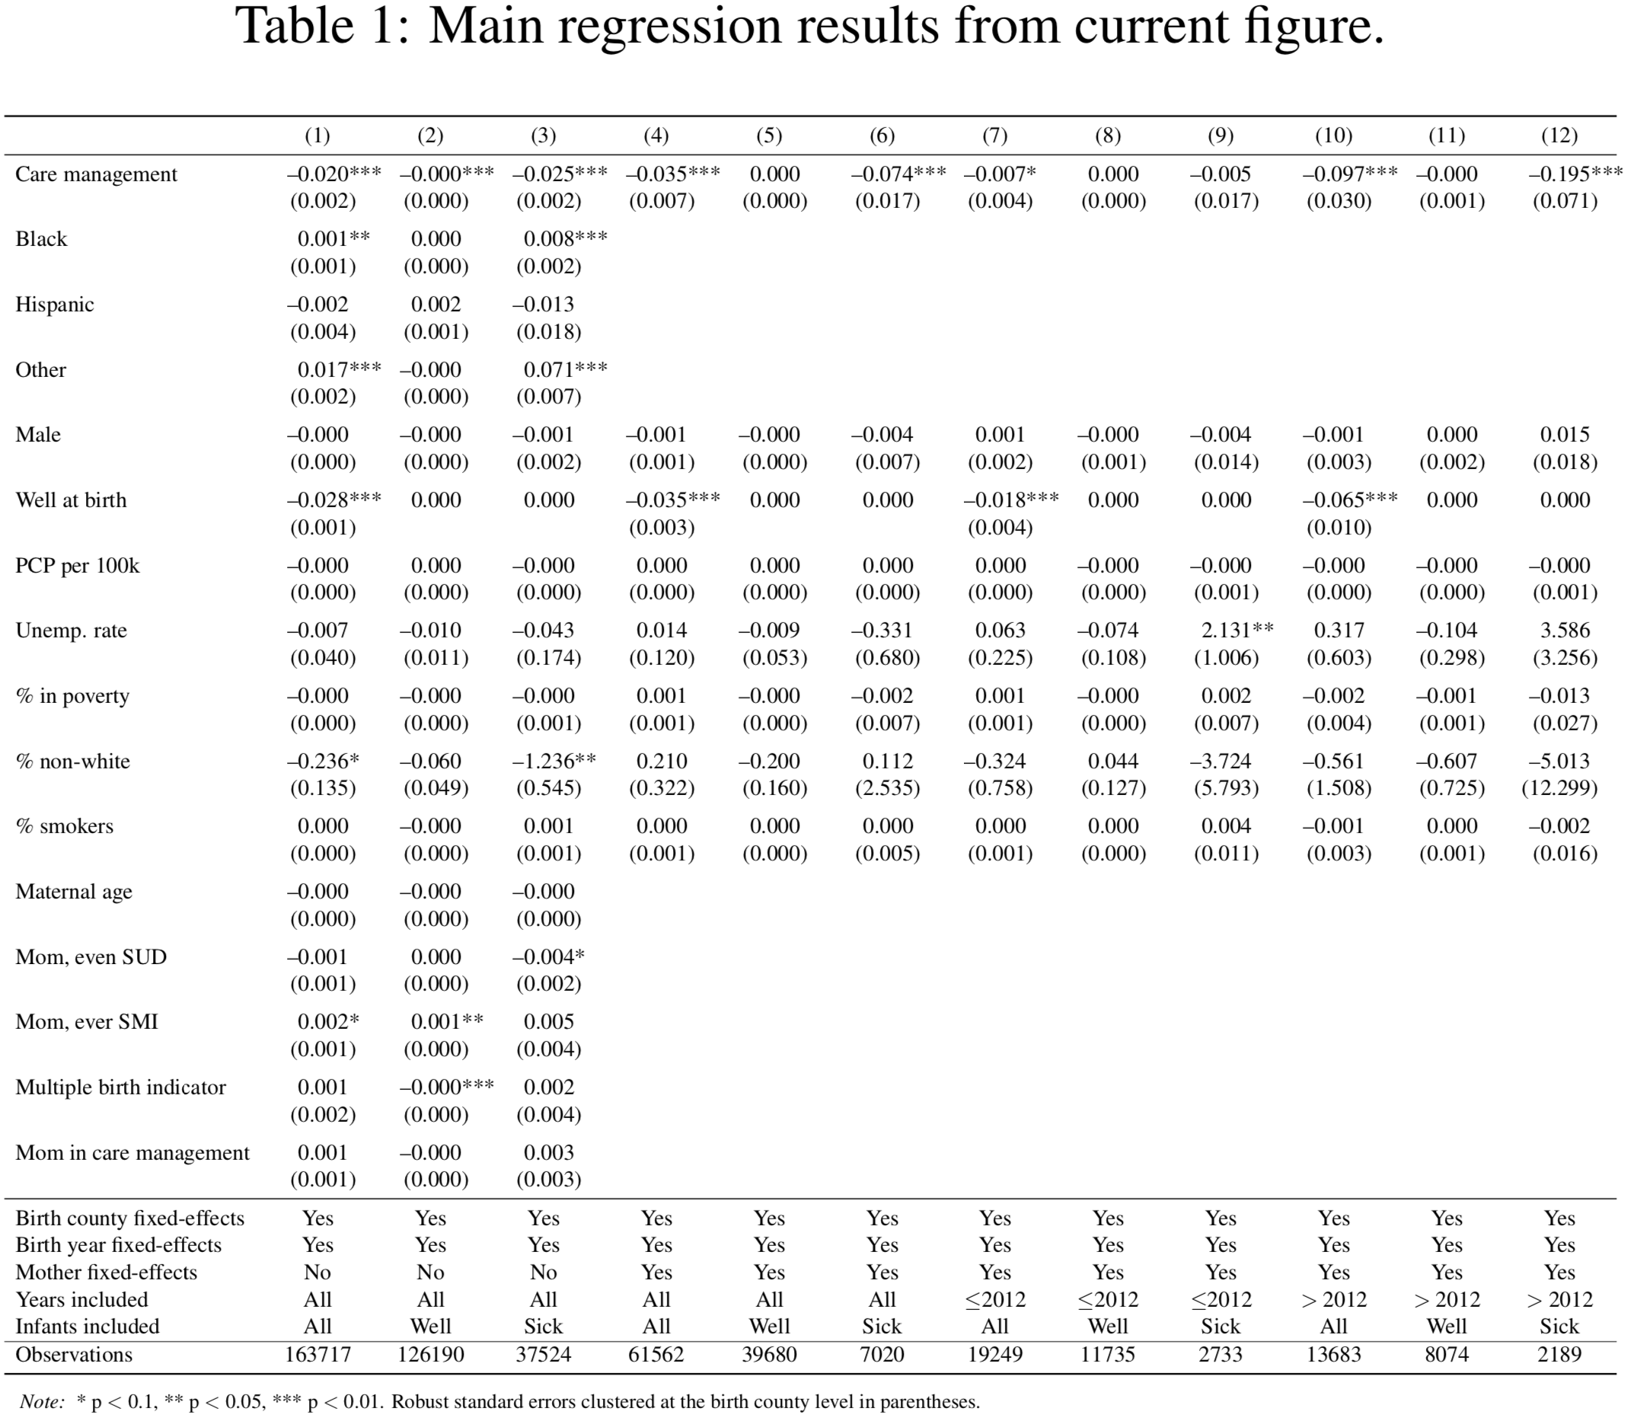

*Discussion*

1. *What are the study limitations?*

**RESPONSE:**

Thank you for this suggestion. It is very important for readers to understand the limitations and resulting implications. We have added a limitations section outlining our limitations on page 8.

1. *Authors wrote, "few infants were engaged in care management, suggesting that there is room for many infants to benefit from it."  The policy implications for Medicaid MCOs could be better expressed.  For example, it's not entirely clear how it is determined an infant is engaged in care management or not.  Who makes that decision and how?  This is a policy question for state Medicaid MCOs to address.*

**RESPONSE:**

Thank you. We have expanded the discussion to include the specific recommendation that those infants identified as “not well at birth” should have care management extended to them, that the state regulations should be evidence based, and that care management for those most likely to benefit should be encouraged by state regulators. This added text appears on both pages 7 and 8.

*Miscellaneous*

1. *The manuscript reads like a case study, the results should be qualified as such.  How generalizable are the results to other Medicaid MCOs in other states?*

**RESPONSE:**

We agree that generalizability of results is a key limitation and have added this to the limitations section. We have added in both the introduction and discussion text indicating that this study is a case study.

1. *Along these lines, the title should include the location, Ohio.*

**RESPONSE:**

This is an important point. We have changed the title to “Care management reduced infant mortality for Medicaid managed care enrollees in Ohio” to ensure that it is clear this is not a national study.