**Association of state marijuana legalization policies for medical and recreational use and vaping associated lung disease**

Coady Wing, PhD, Indiana University O’Neill School of Public and Environmental Affairs

1315 E 10th St., Bloomington, IN 47405, [cwing@indiana.edu](mailto:cwing@indiana.edu), +1 (812) 855-0563

Ashley C. Bradford, MA, Indiana University O’Neill School of Public and Environmental Affairs

Aaron E. Carroll, MD, MS, Indiana University School of Medicine

Alex Hollingsworth, PhD, Indiana University O’Neill School of Public and Environmental Affairs

**Word Count: 987**

**Introduction**

From June 2019 to January 2020, over 2,500 cases of e-cigarette or vaping associated lung injury (EVALI) were reported to the CDC. The specific cause of EVALI is unknown, but most patients report using e-cigarettes to consume tetrahydrocannabinol (THC), the primary psychoactive component of marijuana. The CDC and others have hypothesized that black-market THC products may cause EVALI1,2.

Some states have legalized marijuana and THC-containing products for recreational use. Many other states allow purchases for qualifying medical purposes. In remaining states, all forms of consumption and distribution are illegal, and those who use THC likely to obtain it from the black market. If black market THC products are responsible for EVALI, then case rates may be lower in recreational marijuana states. The goal of this cross-sectional study was to measure the extent to which states where marijuana is legal have lower rates of EVALI than states where it is illegal.

**Data**

We conducted a cross-sectional analysis at the state-level (n = 51). We obtained data on the number of reported EVALI for each state in 2019 from the CDC2, estimates of the prevalence of any e-cigarette use in each state in 2017 from BRFSS3, and estimates of state populations in 2017 from SEER4. We defined the EVALI case rate in each state as the mid-point of the CDC reported range of cases per million population. We classified states as medical marijuana states if they had a medical marijuana law by January 2019, but no recreational dispensaries and states as recreational marijuana states if there was at least one recreational dispensary open by January 2019.

**Methods**

Throughout, the unit of analysis was the state and all analyses are unweighted. We estimated a linear regression of the state EVALI case rate per 1 million people on indicator variables for recreational and medical marijuana states, leaving prohibition states as the reference group. The coefficients on the marijuana law variables are estimates of the difference in mean unadjusted EVALI case rates in recreational compared to prohibition states and medical compared to prohibition states.

Differences in e-cigarette use might confound or otherwise bias the estimated relationship between EVALI and state marijuana laws if e-cigarette use differs across states with recreational, medical, and prohibition laws. We investigate this possibility by fitting linear regressions of the state-level prevalence of e-cigarette use on indicator variables for recreational and medical marijuana laws. We also fit an augmented regression of EVALI case rates on both the indicators for state marijuana laws and e-cigarette prevalence. All regressions use heteroskedasticity robust standard errors. We used two-tailed p-values to assess the null hypotheses of no effect and rejected the null if the p-value was less than .05.

**Results**

The top panel of Figure 1A shows the number of reported EVALI cases/million in each state. Recreational marijuana states have among the rate of EVALI of all states. To test for differences in average EVALI case rates across states with different marijuana policies, we regressed EVALI case rates on indicators for recreational and medical marijuana laws. The results are in the bottom panel of Figure 1A. The average recreational marijuana state had 1.7 EVALI cases/million (95% CI: 0.3 to 3.1). In contrast, the EVALI case rate was 8.8 cases/million (95% CI: 5.1 to 12.5) in medical marijuana states and 8.1 cases/million (95% CI: 4.1 to 12.0) in prohibition states. A test of the difference in mean case rates implies that recreational marijuana states have 7.1 (p < .001; 95% CI: -10.9 to -3.2) fewer cases/million than medical marijuana states, and 6.4 (p = .004; 95% CI: -10.4 to -2.3) fewer cases/million than prohibition states. The difference in the EVALI case rate between medical and prohibition states is not statistically significant (p = .783; 95% CI: -4.5 to 5.9).

The top panel of Figure 1B shows the prevalence of e-cigarette in each state. To test for systematic differences in e-cigarette use, we regressed e-cigarette prevalence on marijuana law indicators. The bottom panel of Figure 1B shows that the average e-cigarette use rate is quantitatively similar across the three groups of states and none of the differences are statistically significant at conventional levels.

Figure 2 shows a scatter plot of EVALI case rates against e-cigarette use rates. The graph suggests no association between EVALI cases rate and the prevalence of e-cigarette in each state, but it does show that EVALI rates are lower in recreational marijuana states. We also used multivariable regression to estimate the association between the EVALI case rate and marijuana laws after adjusting for the prevalence of e-cigarette use. The results confirm our earlier findings. Average EVALI case rates are 7.2 cases/million lower in recreational marijuana states (p = .003; 95% CI: -11.8 to -2.6) than in prohibition states. There is no significant difference between EVALI case rates in prohibition and medical marijuana states (coef = 0.3; p = .93; 95% CI: -5.3 to 5.8). There is no significant relationship between the prevalence of e-cigarette use and EVALI case rates (coef = -1.3; p = .20; 95% CI: -3.3 to 0.7).

**Discussion**

The data suggests EVALI cases are concentrated in states where consumers do not have legal access to recreational marijuana dispensaries. This relationship does not appear to be explained by state-level differences in e-cigarette use, and EVALI case rates are not strongly correlated with state-level prevalence of e-cigarette use. or is protective against

The reason for the relationship is not yet clear. It is possible that in recreational states people tend to purchase marijuana products at legal dispensaries, which could be less likely to sell the contaminated products that cause EVALI. However, the statistical analysis and generalizability of results in this note are limited in that analyses are simple cross-sectional comparisons and do not exploit a quasi-experimental research design. For example, this analysis does not adjust for the possibility that the CDC data may be systematically biased in a manner that causes recreational marijuana states to differentially report EVALI. This analysis is also limited in that it uses state-level data, rather than individual-level data, thus results may be subject to the ecological fallacy. To date, we know very little about the complicated interactions between safety regulations, bans, and prohibitions for goods like marijuana, tobacco, and vaping products. Future research should examine these issues in more detail.

Acknowledgements

Dr Wing and Dr Hollingsworth had full access to all the data in the study and take full responsibility for the integrity of the data and the accuracy of the data analysis. No authors of this study have relevant financial or conflicts of interest to disclose.

Figure 1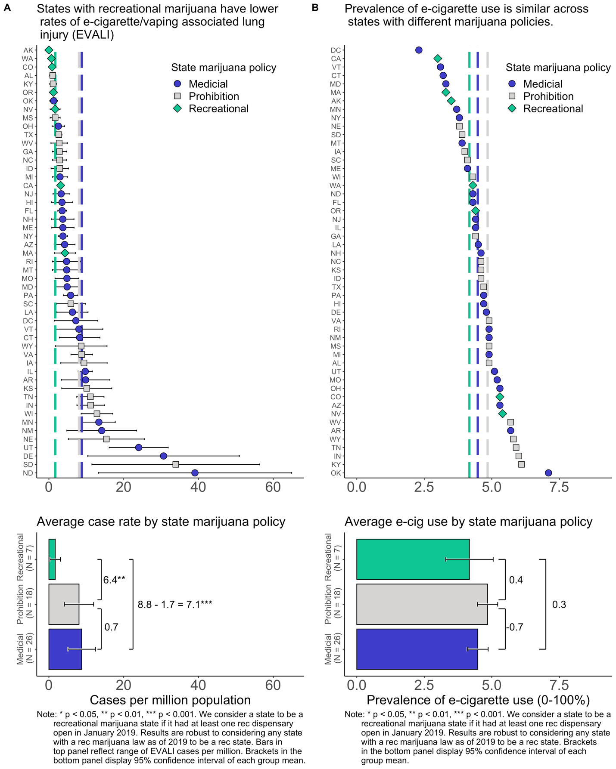

Figure 2

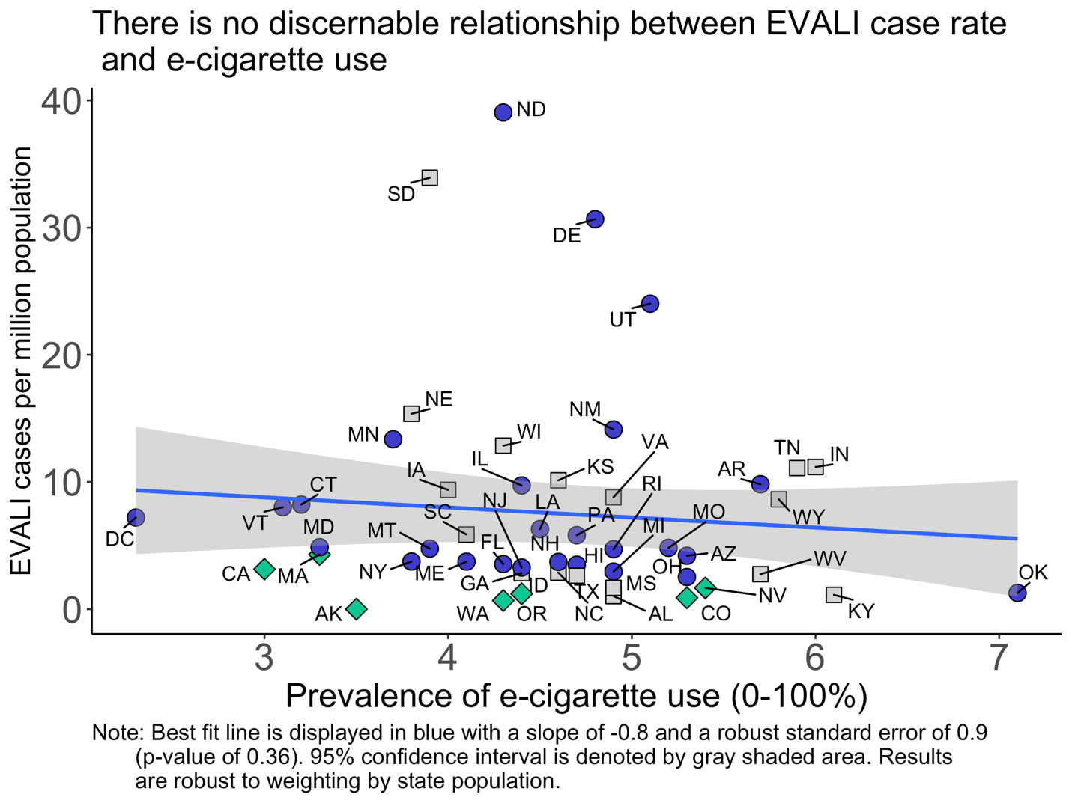

**References**

[1] Layden JE, Ghinai I, Pray I, et al. Pulmonary illness related to e-cigarette use in Illinois and Wisconsin — preliminary report. N Engl J Med. DOI: 10.1056/NEJMoa1911614.

[2] Perrine CG, Pickens CM, Boehmer TK, et al. Characteristics of a Multistate Outbreak of Lung Injury Associated with E-cigarette Use, or Vaping — United States, 2019. MMWR Morb Mortal Wkly Rep 2019;68:860–864. DOI: <http://dx.doi.org/10.15585/mmwr.mm6839e1>

[3] Centers for Disease Control and Prevention (CDC). Behavioral Risk Factor Surveillance System Survey Data. Atlanta, Georgia: U.S. Department of Health and Human Services, Centers for Disease Control and Prevention, 2017.

[4] Surveillance, Epidemiology, and End Results (SEER) Program Populations (1969-2017) (www.seer.cancer.gov/popdata), National Cancer Institute, DCCPS, Surveillance Research Program, released December 2018.