Supplementary Figure 1. More examples of medical VQA tasks on various modalities: medical report generation, disease diagnosis and multi-turn dialogue. ‘Q’ denotes question and ‘A’ is the predicted answer of ConceptVLM.
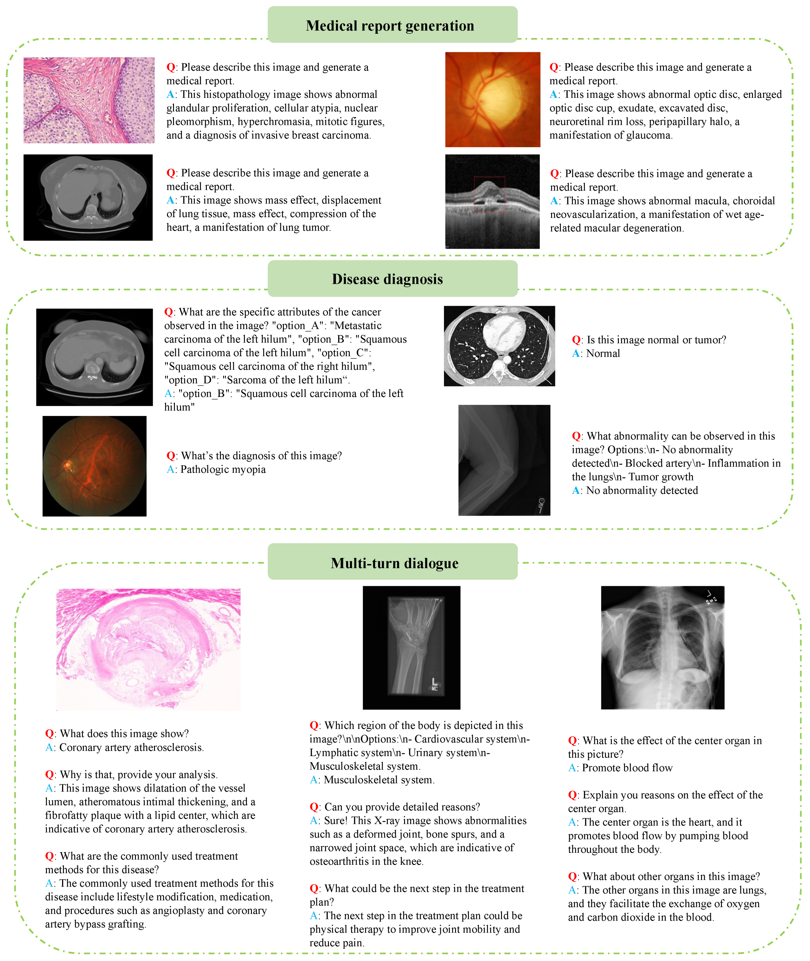

Supplementary Figure 2. More examples of complex reasoning ability of ConceptVLM on MCQs_EN dataset.
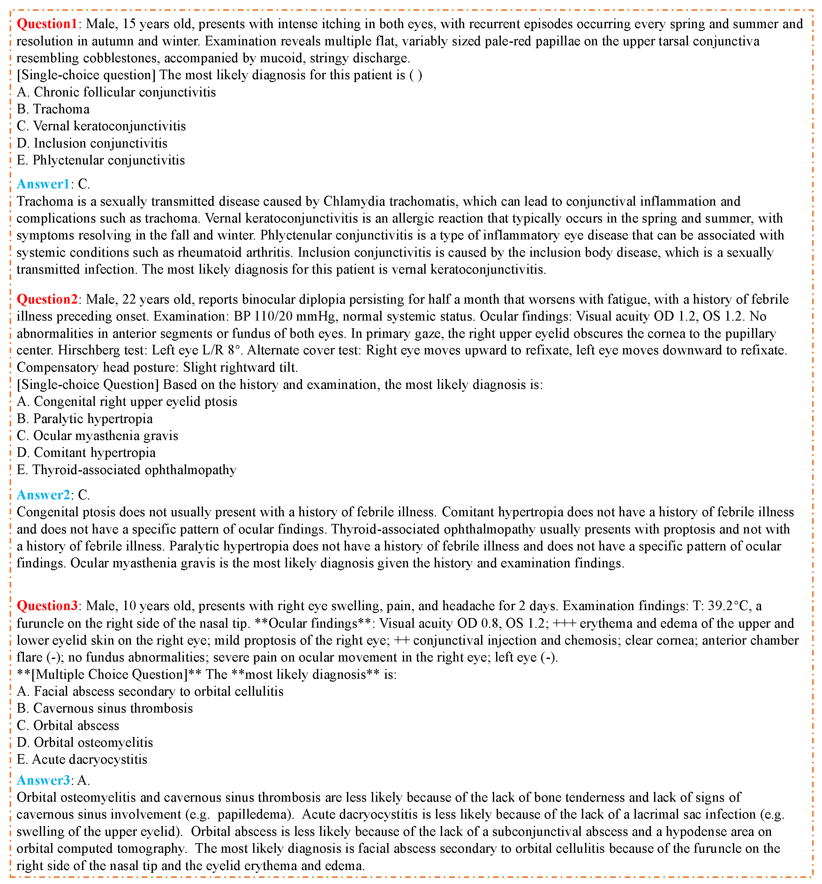

Supplementary Figure 3. More examples of complex reasoning ability of ConceptVLM on MCQs_CN dataset.
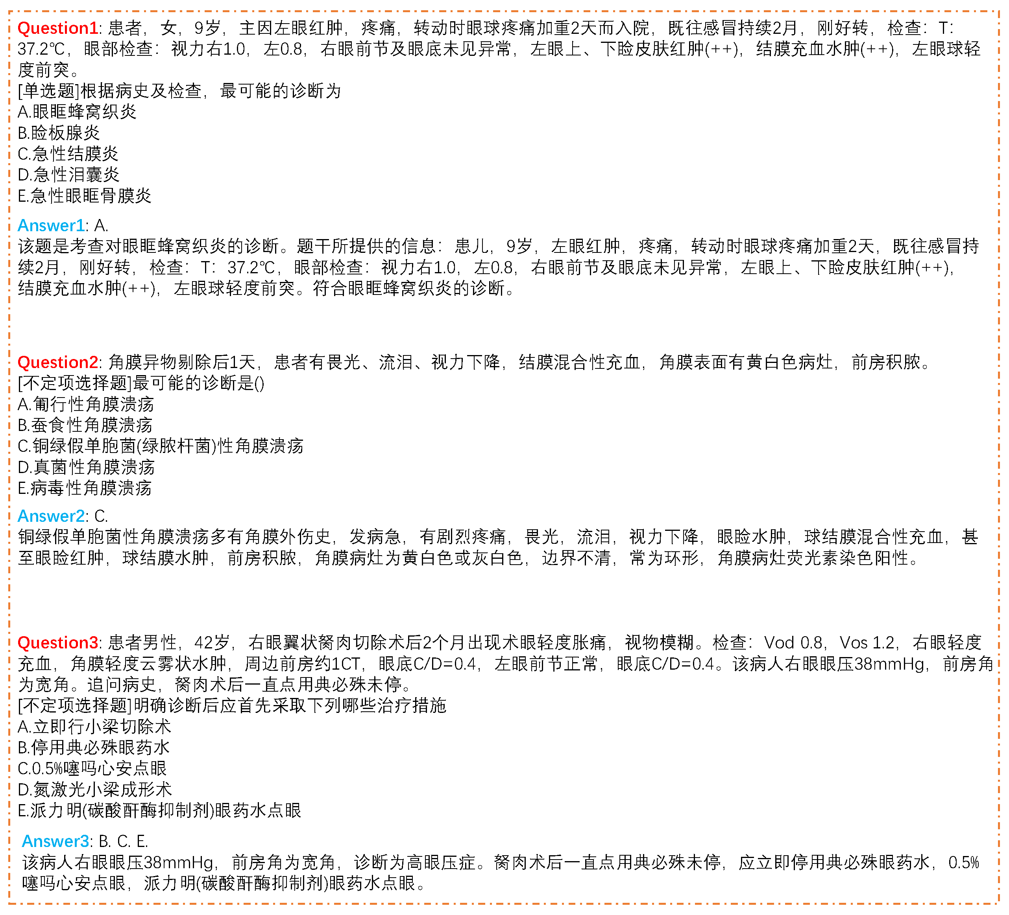
Supplementary Figure 4. Failure cases of ConceptVLM, primarily characterized by misdiagnosis and overly uniform response patterns.
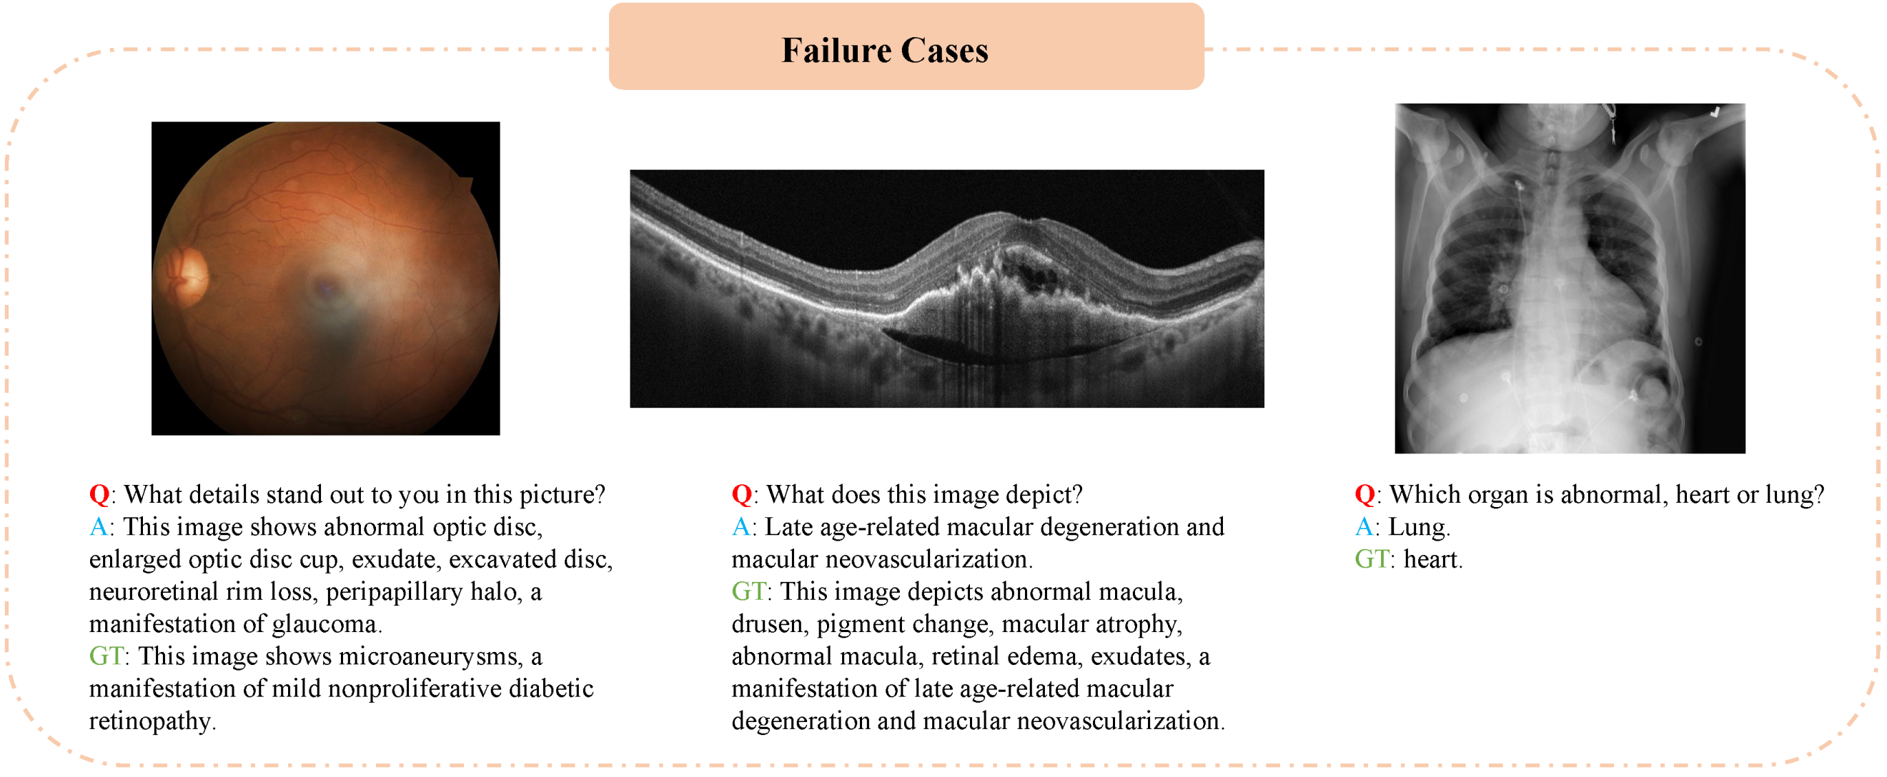

Supplementary Figure 5. Instruction prompts for generating question-answer pairs using Qwen2.5-72B model.
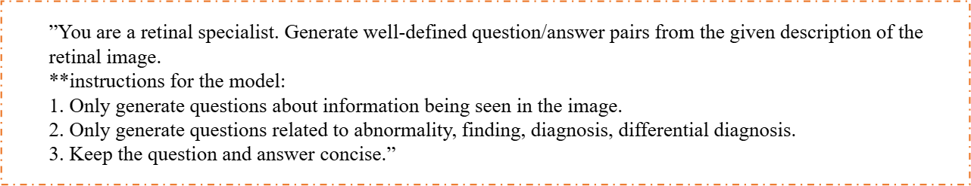
Supplementary Figure 6. Qualitative analysis of semantic coherence in ConceptVLM: Model-generated responses accurately describe clinical findings even when key medical concepts are absent from the concept dictionary (highlighted in yellow).
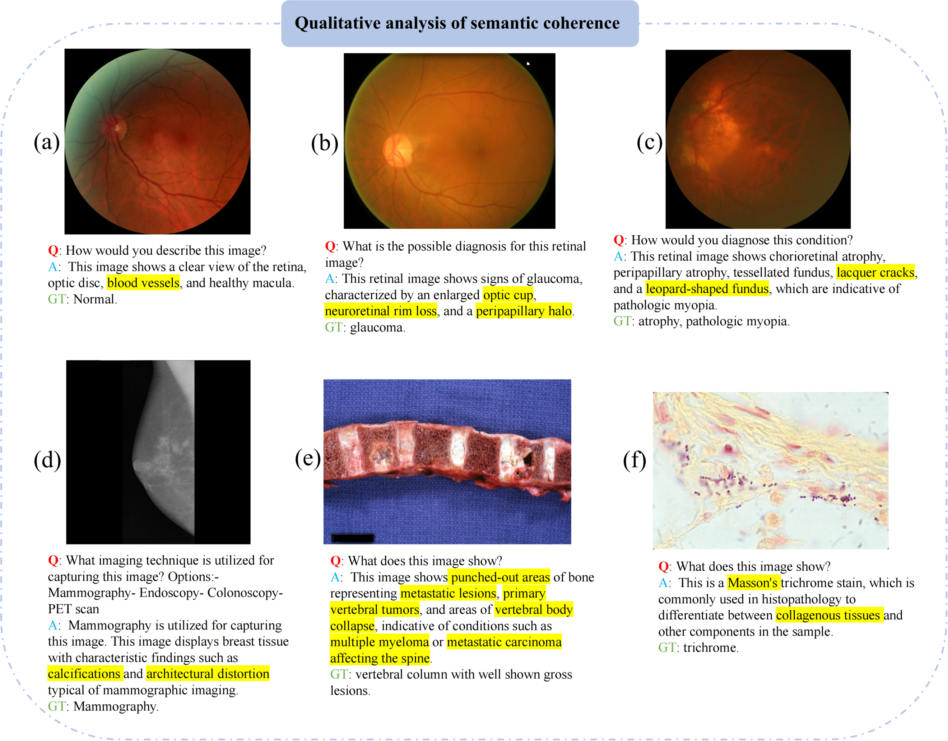

Supplementary Figure 7. Multilingual reasoning error analysis - MCQs_CN dataset.
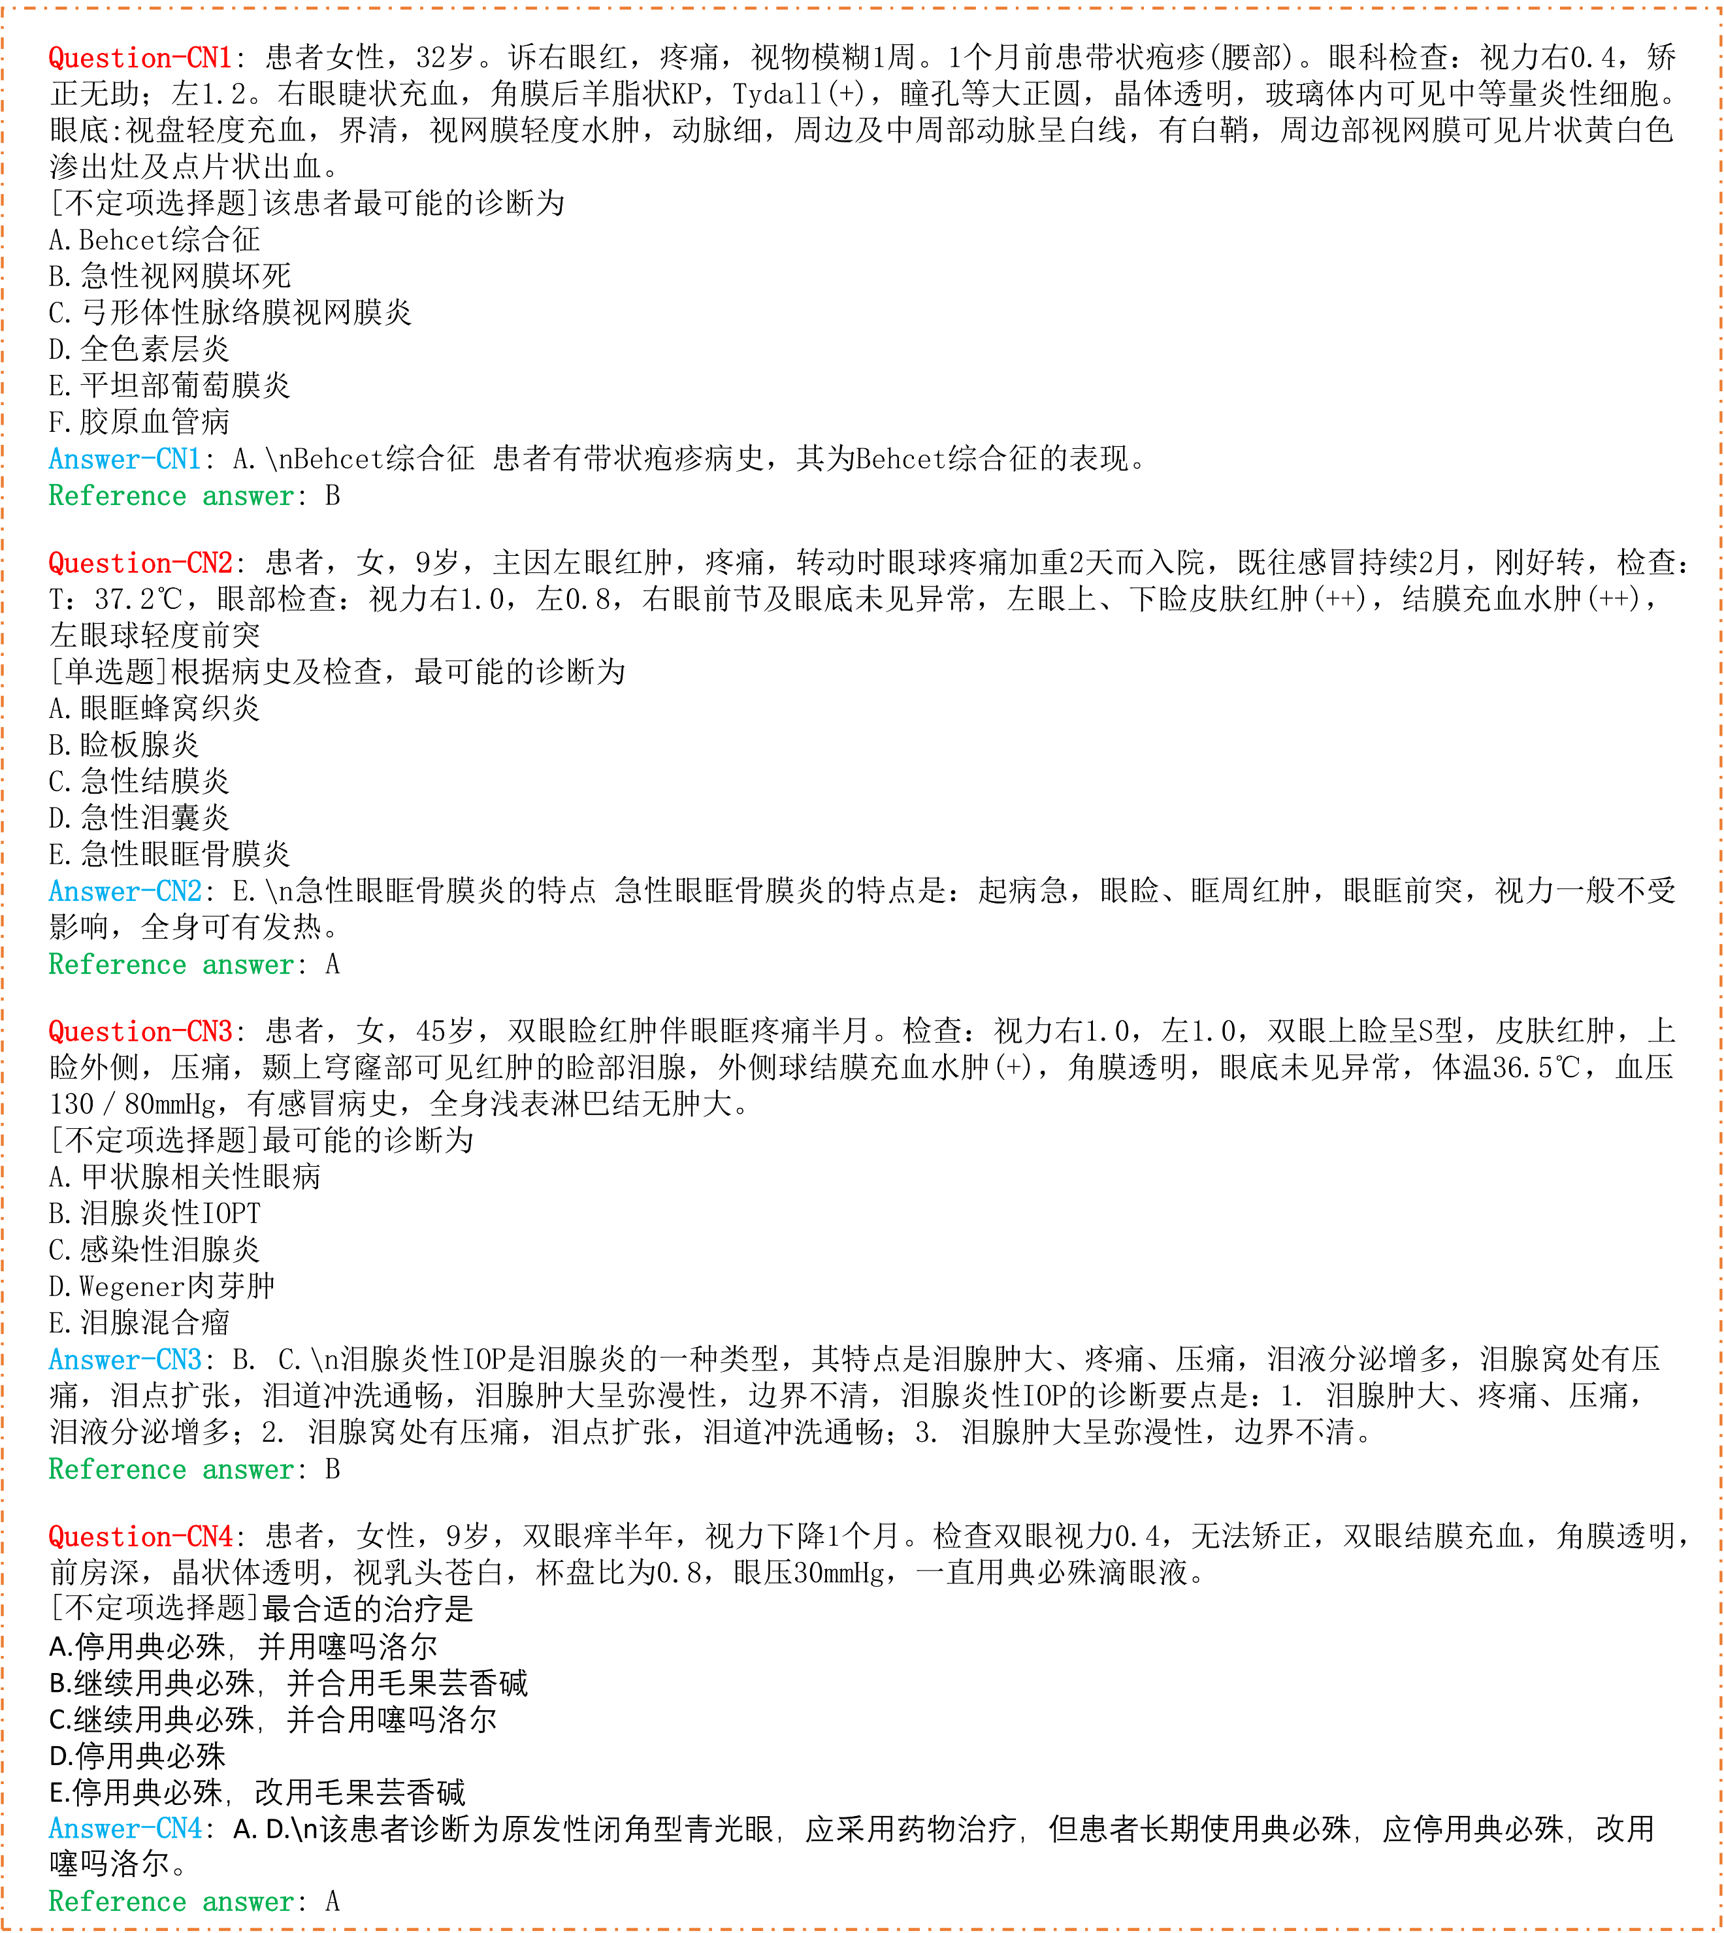

Supplementary Figure 8. Multilingual reasoning error analysis - MCQs_EN dataset.
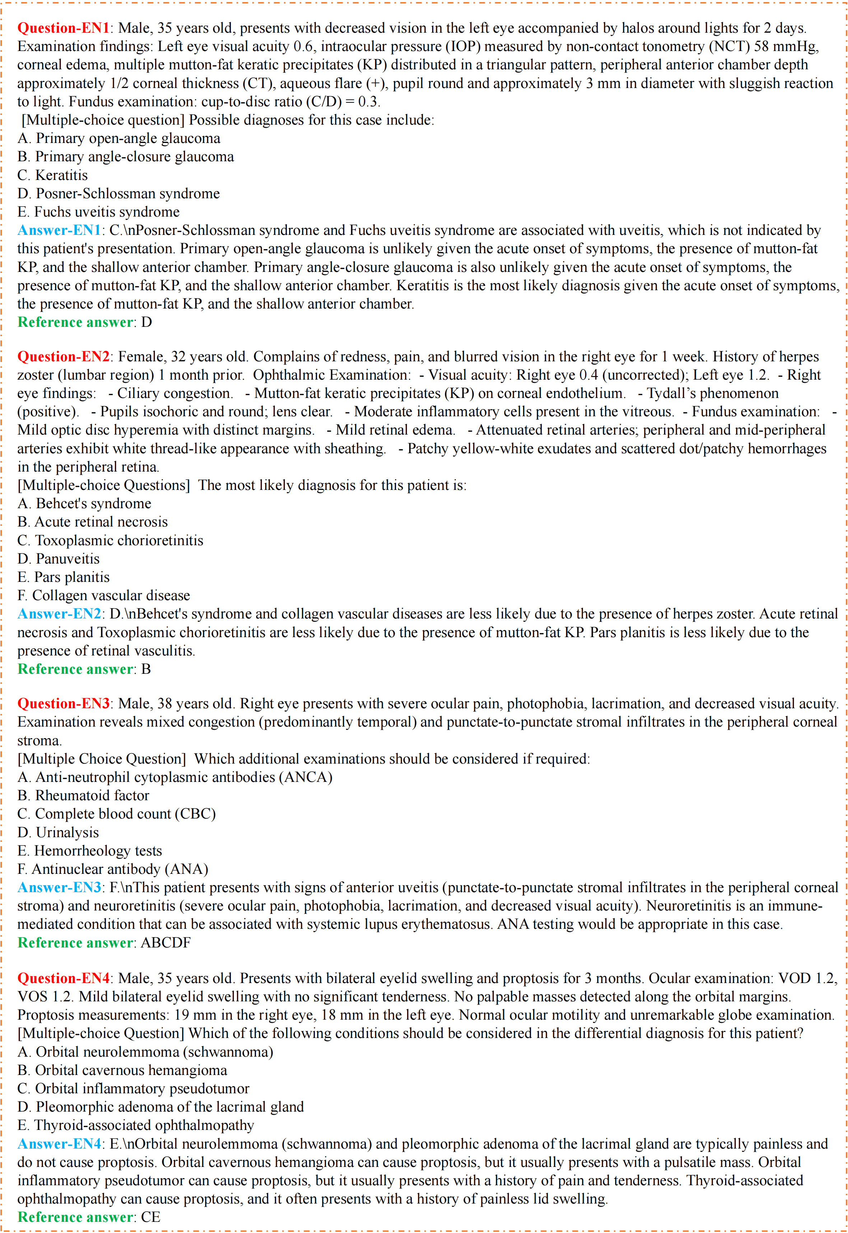

Supplementary Table 1. Visual question answering accuracy on four out-of-domain datasets. The best-performing model for each metric is bolded. 95% CI is included in parentheses. * and ** denote statistical significance of ours compared to the best baseline model with $p<0.05$and $p<0.01$, respectively.
Methods | Omnimed_Ophthalmology | Omnimed_CT | Omnimed_Pathology | Omnimed_Xray
Internvl-v2 | 0.526 (0.505, 0.547) | 0.570 (0.540, 0.600) | 0.700 (0.682, 0.718) | 0.676 (0.651, 0.701)
Llava-med | 0.363 (0.331, 0.395) | 0.341 (0.316, 0.366) | 0.316 (0.295, 0.337) | 0.438 (0.407, 0.469)
Huatuo-vision | 0.672 (0.644, 0.700) | 0.600 (0.575, 0.625) | 0.715 (0.696, 0.734) | 0.740 (0.716, 0.764)
Health-GPT | 0.524 (0.483, 0.565) | 0.332 (0.299, 0.365) | 0.508 (0.486, 0.530) | 0.637 (0.603, 0.671)
Ours | 0.705 (0.685, 0.725)** | $${0.595 (0.565, 0.625)}^{ns}$$ | 0.727 (0.710, 0.744)* | $${0.735 (0.707, 0.763)}^{ns}$$

Supplementary Table 2. Visual question answering performance using different ratio of instruction data on SLAKE and PathVQA datasets. The best-performing model for each metric is bolded. 95% CI is included in parentheses. * and ** denote statistical significance of Ours-40% compared to LLaVA-med at $p<0.05$and $p<0.01$, respectively.
Methods | SLAKE |  | PathVQA
Methods | OPEN | CLOSE | OPEN | CLOSE
Internvl-v2 | 0.625 (0.572, 0.678) | 0.718 (0.664, 0.772) | 0.205 (0.156, 0.254) | 0.651 (0.610, 0.692)
Ours-10% | 0.888 (0.853, 0.923) | 0.839 (0.806, 0.872) | 0.264 (0.209, 0.318) | 0.635 (0.585, 0.685)
Ours-20% | 0.889 (0.853, 0.925) | 0.860 (0.823, 0.897) | 0.304 (0.257, 0.351) | 0.714 (0.667, 0.760)
Ours-30% | 0.890 (0.851, 0.929) | 0.871 (0.828, 0.914) | 0.356 (0.315, 0.397) | 0.883 (0.839, 0.927)
Ours-40% | 0.891 (0.856, 0.926)** | 0.885 (0.848, 0.922)** | 0.421 (0.378, 0.464)* | 0.921 (0.880, 0.962)*
Llava-med | 0.871 (0.834, 0.908) | 0.867 (0.828, 0.906) | 0.396 (0.353, 0.439) | 0.911 (0.870, 0.952)

Supplementary Table 3. Complex reasoning accuracy on MCQs_EN and MCQs_CN datasets. Best performing model for each metric is bolded. 95% CI is included in parentheses. * and ** denote statistical significance compared to ours with $p<0.05$and $p<0.01$, respectively.
Methods | MCQs_EN | MCQs_CN
OpenAI o1 | 0.723 (0.638,0.798)** | $${0.685 (0.597, 0.763)}^{ns}$$
OpenAI o3-mini | 0.577 (0.487,0.663)* | $${0.692 (0.597, 0.763)}^{ns}$$
Ours | 0.507 (0.419, 0.596) | 0.692 (0.605, 0.770)
Internvl-v2 | 0.490 (0.404, 0.581)* | 0.684 (0.597, 0.763)*
Huatuo-vision | 0.484 (0.396, 0.574)* | 0.400 (0.315, 0.489)**

Supplementary Table 4. Investigation of the hyperparameter K in constructing the medical key concept dictionary. ** denotes statistical significance compared to K=5 with p < 0.01.
K | PolyOphthalmology
K | OPEN | CLOSE
3 | 0.633 (0.573,0.668)** | 0.775 (0.724, 0.797)**
5 | 0.727 (0.673, 0.753) | 0.807 (0.768, 0.834)
10 | $${0.719 (0.668, 0.745)}^{ns}$$ | $${0.793 (0.763, 0.820 )}^{ns}$$

Supplementary Table 5. VQA performance on the SLAKE and PathVQA datasets. * and ** denote statistical significance of ours compared to the best baseline model with $p<0.05$and $p<0.01$, respectively. † denotes that ours is statistically significantly worse than the best baseline model ($p<0.05$).
Methods | SLAKE |  | PathVQA
Methods | OPEN | CLOSE | OPEN | CLOSE
Internvl-v2 | 0.625 (0.582, 0.668) | 0.718 (0.680, 0.756) | 0.205 (0.194, 0.216) | 0.651 (0.630, 0.672)
Llava-med | 0.871 (0.842, 0.900) | 0.867 (0.841, 0.893) | 0.396 (0.382, 0.410) | 0.911 (0.898, 0.924)
Med-flamingo | 0.235 (0.197, 0.273) | 0.457 (0.416, 0.498) | 0.021 (0.017, 0.025) | 0.527 (0.505, 0.549)
Huatuo-vision | 0.410 (0.367, 0.453) | 0.760 (0.725, 0.795) | 0.084 (0.076, 0.092) | 0.661 (0.640, 0.682)
Health-GPT | 0.784 (0.748, 0.820) | 0.772 (0.737, 0.807) | 0.324 (0.311, 0.337) | 0.913 (0.900, 0.926)
Ours | 0.904 (0.879, 0.929)** | 0.903 (0.878, 0.928)** | $0.385 (0.371, 0.399)$† | 0.926 (0.914, 0.938)*

Supplementary Table 6. VQA performance on the PolyOphthalmology datasets. ** and *** denote statistical significance of ours compared to the best baseline model with $p<0.01$and $p<0.001$, respectively.
Methods | PolyOphthalmology
Methods | OPEN | CLOSE
Internvl-v2 | 0.112 (0.090, 0.134) | 0.388 (0.362, 0.414)
Llava-med | 0.357 (0.324, 0.390) | 0.134 (0.115, 0.153)
Med-flamingo | 0.090 (0.069, 0.111) | 0.041 (0.030, 0.052)
Huatuo-vision | 0.511 (0.476, 0.546) | 0.137 (0.118, 0.156)
Health-GPT | 0.503 (0.468, 0.538) | 0.031 (0.021, 0.041)
Ours | 0.727 (0.696, 0.758)** | 0.807 (0.785, 0.829)***

Supplementary Table 7. Evaluation results of our method with different backbones on four out-of-domain datasets. The best-performing model for each metric is bolded. 95% CI is included in parentheses. * and ** denote statistical significance of ours compared to the backbone model with $p<0.05$and $p<0.01$, respectively. † denotes that ours is statistically significantly worse than the best baseline model ($p<0.05$).
Methods | Omnimed_Ophthalmology | Omnimed_CT | Omnimed_Pathology | Omnimed_Xray
Internvl-v2-8B | 0.526 (0.505, 0.547) | 0.570 (0.540, 0.600) | 0.700 (0.682, 0.718) | 0.676 (0.651, 0.701)
Ours + Intern. | 0.705 (0.685, 0.725)** | 0.595 (0.565,0.625)* | 0.727 (0.710, 0.744)* | 0.735 (0.707,0.763)*
Qwen2.5-vl-7B | 0.694 (0.684, 0.708) | 0.557 (0.535, 0.579) | 0.615 (0.595, 0.635) | 0.727 (0.716, 0.738)
Ours + Qwen. | 0.752 (0.741, 0.763)** | 0.563 (0.540, 0.586)* | 0.595 (0.587, 0.633) † | 0.743 (0.732, 0.759)*

Supplementary Table 8. Complex reasoning accuracy on MedMCQA_radiology and MedMCQA_pathology datasets. Best performing model for each metric is bolded. 95% CI is included in parentheses. * denote statistical significance of ours compared to the other models with $p<0.05$.
Methods | MedMCQA_radiology | MedMCQA_pathology
Internvl-v2 | 0.558 (0.543, 0.572) | 0.667 (0.659, 0.674)
Huatuo-vision | 0.539 (0.523, 0.564) | 0.653 (0.641, 0.667)
Ours | 0.567 (0.550, 0.581)* | 0.679 (0.664, 0.687)*

Supplementary Table 9. Report generation performance on the MIMIC-CXR-RRG dataset. The best-performing model for each metric is bolded. 95% CI is included in parentheses. * denotes statistical significance of ours compared to the other models with $p<0.05$.
Methods | BLEU-1 | BLEU-4 | METOR | ROUGE-L
Internvl-v2 | 0.239 (0.227, 0.231) | 0.022 (0.021,0.023) | 0.103 (0.098, 0.105) | 0.172 (0.169, 0.175)
Huatuo-vision | 0.204 (0.201, 0.206) | 0.014 (0.014, 0.015) | 0.091 (0.089, 0.093) | 0.143 (0.142, 0.145)
Ours | $${0.243 (0.240, 0.246)}^{ns}$$ | $${0.020 (0.018, 0.022)}^{ns}$$ | $${0.108 (0.107, 0.109)}^{ns}$$ | 0.182 (0.180,0.184 )*

Supplementary Table 10. Performance comparison among ConceptVLM (Ours), the official Internvl-v2-8B model without fine-tuning, a LoRA-fine-tuned Internvl-v2-8B (Baseline), and a LoRA-fine-tuned Huatuo-vision model (Huatuo-Tuned) on four out-of-domain datasets. The best-performing model for each metric is bolded. 95% CI is included in parentheses. * and ** denote statistical significance of ours compared to the backbone model with $p<0.05$and $p<0.01$, respectively.
Methods | Omnimed_Ophthalmology | Omnimed_CT | Omnimed_Pathology | Omnimed_Xray
Internvl-v2-8B | 0.526 (0.505, 0.547) | 0.570 (0.540, 0.600) | 0.700 (0.682, 0.718) | 0.676 (0.651, 0.701)
Huatuo-tuned | 0.687 (0.651, 0.712) | 0.586 (0.561, 0.613) | 0.697 (0.688, 0.727) | 0.721 (0.697, 0.749)
Baseline | 0.649 (0.615, 0.683) | 0.553 (0.529, 0.582) | 0.690 (0.677, 0.701) | 0.663 (0.644, 0.687)
Ours | 0.705 (0.685, 0.725)** | 0.595 (0.565,0.625)* | 0.727 (0.710, 0.744)* | 0.735 (0.707,0.763)*

Supplementary Table 11. Comparison between DPO strategy and ConceptVLM on the PolyOphthalmology dataset. DPO is applied to the same LoRA-finetuned baseline using synthetic preference pairs (ground-truth answers as “chosen”, base-model outputs as “rejected”). * and ** denote statistical significance of ours compared to the best baseline model with $p<0.05$and $p<0.01$, respectively.
Methods | PolyOphthalmology
Methods | OPEN | CLOSE | ROUGE-L
Baseline | 0.528 (0.568, 0.594) | 0.678 (0.653, 0.727) | 0.557 (0.546, 0.562)
DPO strategy | 0.683 (0.654, 0.707) | 0.711 (0.683, 0.738) | 0.638 (0.630, 0.643)
Ours | 0.727 (0.696, 0.758)** | 0.807 (0.785, 0.829)** | 0.674 (0.670, 0.678)*

Supplementary Table 12. Ablation study of the dual-loss components on the PolyOphthalmology dataset. ** denote statistical significance of ours compared to the best baseline model with $p<0.01$.
Methods | PolyOphthalmology
Methods | OPEN | CLOSE
w/o Key Concept Loss (Baseline) | 0.528 (0.568, 0.594) | 0.678 (0.653, 0.727)
w/o Standard CE | 0.447 (0.413, 0.480) | 0.754 (0.735, 0.781)
Ours (dual-loss) | 0.727 (0.696, 0.758)** | 0.807 (0.785, 0.829)**

