To The Future
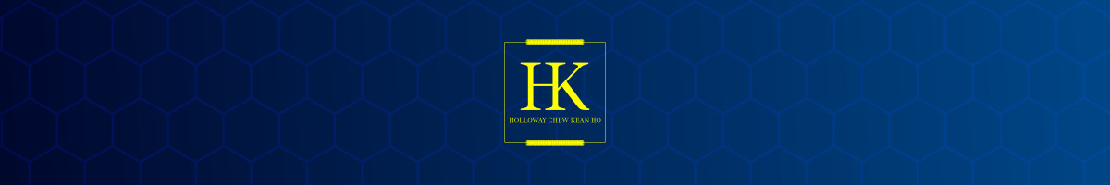

To all New Maintainers
Congrats! People care about your products. Keep up the good work.

To the aspiring folks…

- focus on solving a business problem. You’ll attract users without needing to roll out a marketing campaign.

- Don’t underestimate the “one-time” fun app. It can anytime become a popular tool for everyone to use (true story).

- Always differentiate facts and data from individual opinions. Don’t waste too much time on the latter.

- Engineering specifications and actual documentation are way better than “he says she says” stuff by the influencers.

Epilogue
Thanks for reading thoroughly. Well, we come to an end now.

Don’t give up and stay connected! My blessing to you.

YouTube  @chewkeanho-soundtracks  @chewkeanho-tech-codex  @hollowaykeanho | Independent Research  ORCID (0000-0003-4202-4863)  Zenodo Individual Repository | Digital Product Development  github.com/hollowaykeanho  github.com/chewkeanho
Mastodon Social  https://mastodon.online/@hollowaykeanho | BlueSky Social  https://bsky.app/profile/hollowaykeanho.com | Telegram Messenger  https://t.me/chewkeanho
Reddit Social
https://www.reddit.com/user/hollowaykeanho/

