

**INF3710 – Bases de données**

**Automne 2023**

**TP No. 5**

**Groupe JB2_18**

**[2152361] – Axelle Stevia Letieu Tchemeni**

**[2306665] – Holly Yen-Healey**

**Soumis à : M. Rachad Chazbek**

**[2023-11-09]**

**Requête SQL**

1) SELECT specialite FROM medecins WHERE idmedecin = 3;



2) SELECT nom, prenom FROM medecins WHERE anneesexperience > 10;

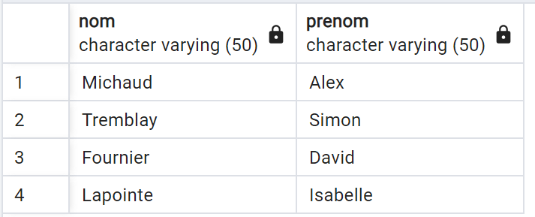

3) SELECT COUNT(*) FROM patientexamens;

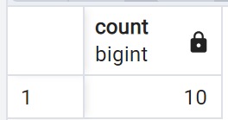

4) SELECT nomexamen, cout, MAX(dateexamen) FROM examens NATURAL JOIN patientexamens GROUP BY nomexamen, cout ORDER BY cout DESC LIMIT 1

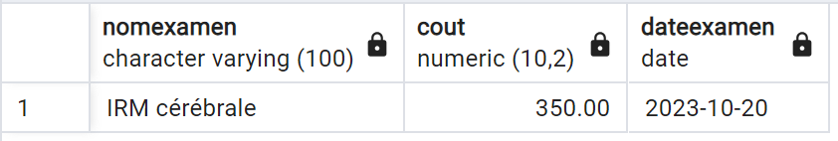

5) On choisit l’ordre décroissant des noms

SELECT prenom, nom, age(CURRENT_DATE,datedenaissance) FROM patients ORDER BY nom DESC;

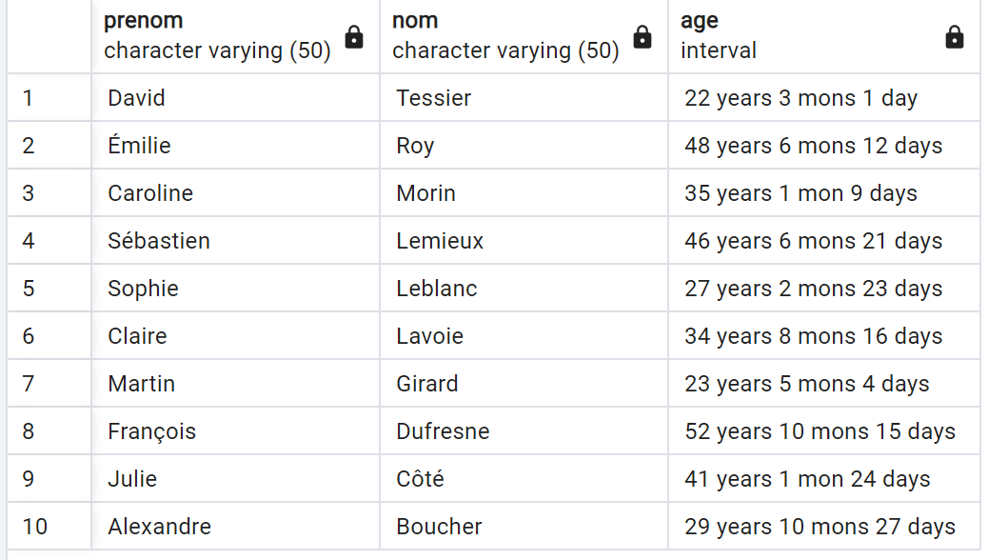

6) SELECT AVG(cout) FROM examens ;

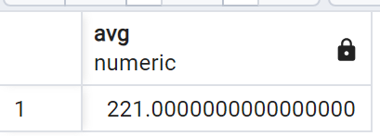

7) SELECT M.prenom, M.nom, COUNT(RDV.idrendezvous) AS "Nombre de rendez-vous"

FROM medecins M, rendezvous RDV

WHERE M.idmedecin = RDV.idmedecin

AND RDV.daterendezvous >= '2023-09-21'

GROUP BY M.idmedecin ;

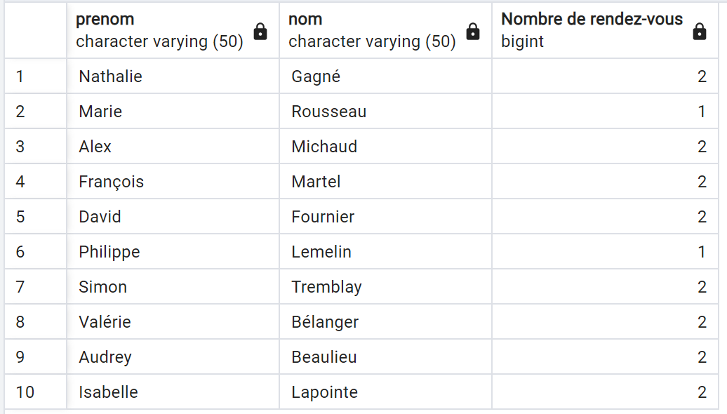

8) SELECT prenom, nom, numerodetelephone FROM patients NATURAL JOIN rendezvous

WHERE daterendezvous >= '2023-11-13' AND daterendezvous <= '2023-11-19' ;

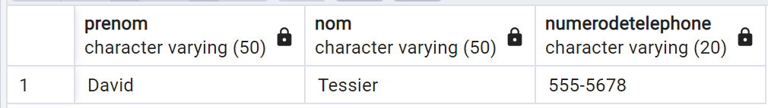

9) SELECT nom, prenom, SUM(cout)

FROM patients NATURAL JOIN patientexamens NATURAL JOIN examens NATURAL JOIN services

WHERE idpatient = 4 AND nomservice LIKE 'C%'

GROUP BY nom, prenom ;

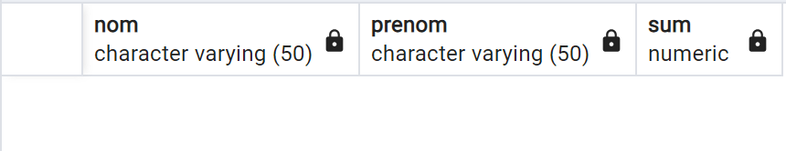

10) SELECT P.nom, P.prenom FROM patients P, rendezvous RDV, medecins M

WHERE P.idpatient = RDV.idpatient AND M.idmedecin = RDV.idmedecin

AND M.anneesexperience = (SELECT MAX(anneesexperience) FROM medecins) ;

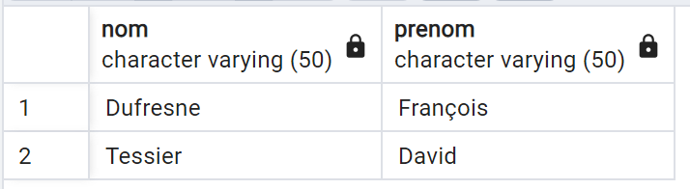

11) SELECT P.nom, P.prenom FROM patients P, patientexamens PE, examens E

WHERE P.idpatient = PE.idpatient AND E.idexamen = PE.idexamen

AND E.cout > 200

GROUP BY P.idpatient

HAVING SUM(cout) > 2000 ;



12)

SELECT M.prenom, M.nom FROM medecins M, rendezvous RDV

WHERE M.idmedecin = RDV.idmedecin

AND RDV.daterendezvous <= CURRENT_DATE AND RDV.daterendezvous >= CURRENT_DATE - INTERVAL '6 month'

GROUP BY M.idmedecin

HAVING COUNT(idpatient) =

(SELECT COUNT(idpatient) FROM rendezvous

WHERE daterendezvous <= CURRENT_DATE AND daterendezvous >= CURRENT_DATE - INTERVAL '6 month'

GROUP BY idmedecin ORDER BY COUNT(idpatient) DESC LIMIT 1) ;

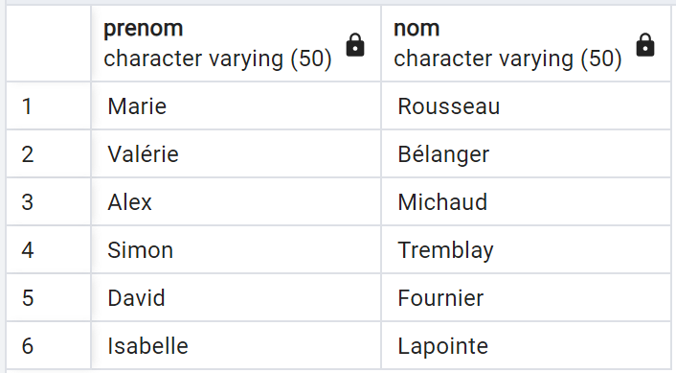

Plusieurs médecins ont vu le nombre maximal de patients pendant les 6 derniers mois (2 patients).

13)

SELECT prenom, nom FROM medecins

WHERE idmedecin NOT IN (SELECT idmedecin FROM rendezvous) ;



Q14)

Option 1 : tous les patients avec le nombre maximal d’examens et respectant les autres conditions sont affichés

SELECT P.prenom, P.nom FROM patients P, patientexamens PE

WHERE P.idpatient = PE.idpatient

AND PE.resultat <> 'Résultats normaux'

GROUP BY P.idpatient

HAVING COUNT(dateexamen) =

(SELECT COUNT(dateexamen) FROM patientexamens WHERE resultat <> 'Résultats normaux'

GROUP BY idpatient ORDER BY count(dateexamen) DESC LIMIT 1);

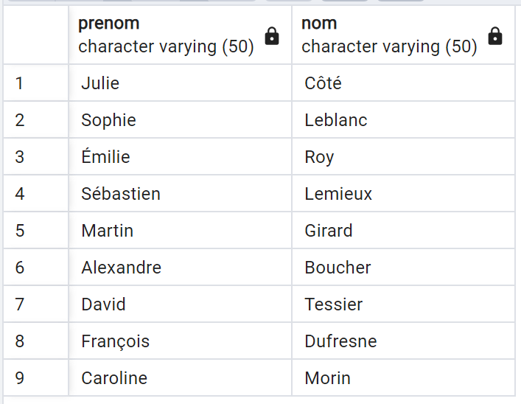

Option 2 : on affiche un seul des patients qui a le nombre maximal d’examens et les autres conditions affichées

SELECT P.NOM, P.PRENOM

FROM PATIENTS P, PATIENTEXAMENS PE

WHERE P.IDPATIENT = PE.IDPATIENT

AND PE.RESULTAT <>'Résultats normaux'

GROUP BY P.IDPATIENT

ORDER BY COUNT(DISTINCT PE.IDEXAMEN) DESC LIMIT 1;



Q15)

Méthode1:

SELECT prenom, nom FROM patients NATURAL JOIN patientexamens PE NATURAL JOIN examens E

GROUP BY idpatient

HAVING COUNT(DISTINCT idservice) = (SELECT COUNT(DISTINCT idservice) FROM services);

Méthode 2:

SELECT P.NOM, P.PRENOM

FROM PATIENTS P, PATIENTEXAMENS PE, EXAMENS EX

WHERE P.IDPATIENT = PE.IDPATIENT

AND PE.IDEXAMEN = EX.IDEXAMEN

AND EX.IDSERVICE = ALL(SELECT IDSERVICE FROM SERVICES );



Q16)

CREATE VIEW V_TotalExamens(V_nom, V_prenom, V_tot) AS

SELECT P.nom , P.prenom, SUM(E.cout)

FROM patients P, patientexamens PE, examens E

WHERE P.idpatient = PE.idpatient AND PE.idexamen = E.idexamen

AND P.adresse LIKE '%e__' OR P.adresse LIKE '%o__'

GROUP BY P.idpatient

HAVING SUM(E.cout) >= 500

ORDER BY P.nom ASC, SUM(E.cout) DESC

