
Define your plate layout

This screen helps you prepare your experimental plate metadata by defining what the plate layout is

1. Dilutions Mode (Standard Assay Layout)
- Specify the number of rows and columns for the plate.
- Define the X and Y dilutions used in the experiment.
- The Strains field can represent either unique strains or repeats of the same strain, i.e. it is the number of time the dilution series repeats.
- Square Gird Cells specifies whether the distance between spot center points in the x and y directions is constant (Square Gird Cells = true).
- Gap Between Strains specifics whether there is a blank column between neighboring strains.
NB do not set this to true if there is one strain per column, rather set Square Grid Cells to false

2. Arrayed Mode
- Use this mode to compare the size of a spot at each location on one image(s) to the same location on other image(s).

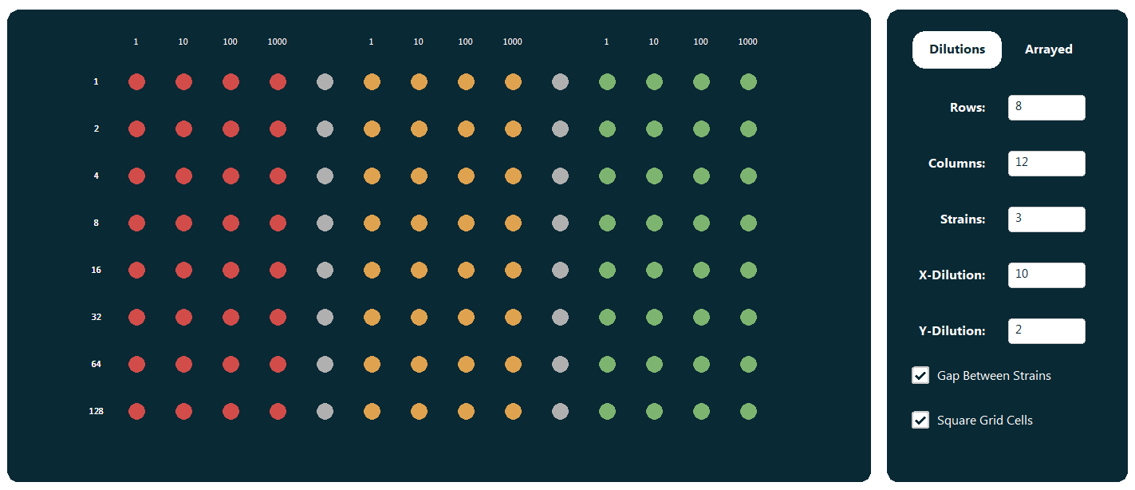
Examples:
This layout could represent
3 repeats of the same strain with a gap (grey) in-between each repeat or 3 unique strains with a gap (grey) between neighboring strains

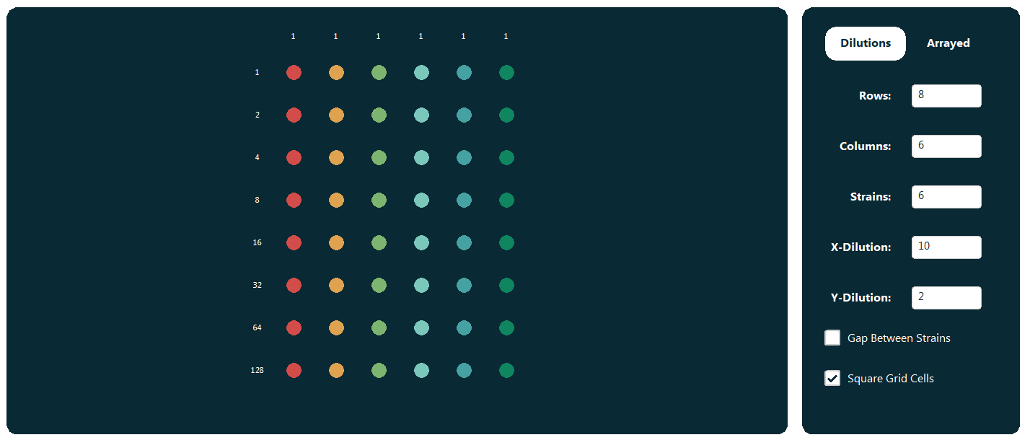

This layout could represent 6 repeats of the same strain, 6 different strains, 2 repeats for 3 different strains,3 repeats for 2 different strains etc.


Assign Your Strains
This screen helps you prepare your experimental plate metadata. Follow these steps to set up your strain information and plate layout.

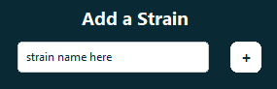
Step 1: Add Your Strains
- Click in the text field under "Add a Strain."
- Type the name of each unique strain in your experiment.
- Press the "+" button to add the strain.
- Each strain will be automatically assigned a unique color.

Step 2: Add a Plate
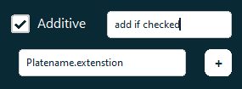
- Enter the exact filename for each plate (including the extension).
- Example: Plate1_experiment.jpg
- (Optional) Add an additive:
  - Check the Additive box if your plate has additional conditions.
  - Enter the additive name if applicable.
- Press the "+" button to add the plate.

Step 3: Assign Strains to Positions
For each plate:
- Click "Assign" next to a strain name.
- Select the correct position on the plate grid.
- Repeat for all strains.
- Visually verify assignments on the plate grid.
- Use the "Next Plate" and "Previous Plate" buttons to move between plates.

- If plates have strains in identical positions complete the layout of the first plate and then click copy previous for all other plates.

Step 4: Preview and Verify
- Click "Preview All Plates" to review your metadata.
- Carefully check the plate layouts for accuracy.
- If you find an error, use the navigation buttons to return to the specific plate and make corrections.
- When finished, click "Next" to save the metadata for future use.
- You’ll be taken back to the title screen, where you must select "Upload Assays" to match your metadata.

Crop Your Image
- Click on the top-left corner of the desired area.
- Drag to the bottom-right corner to define the crop region.
- To restart, simply begin a new crop by clicking again.
Use a Consistent Marker: Always crop to a clear and consistent marker, such as the outer edge of the plate, for uniformity across all images. The horizontal measurement is used to scale the quantifications so that quantifications are based on the plate width rather than the image dimensions, allowing reliable comparisons across images captured at different zoom levels
Leave Adequate Space: Avoid cropping too close to the spots; ensure there’s a margin to include all relevant areas.

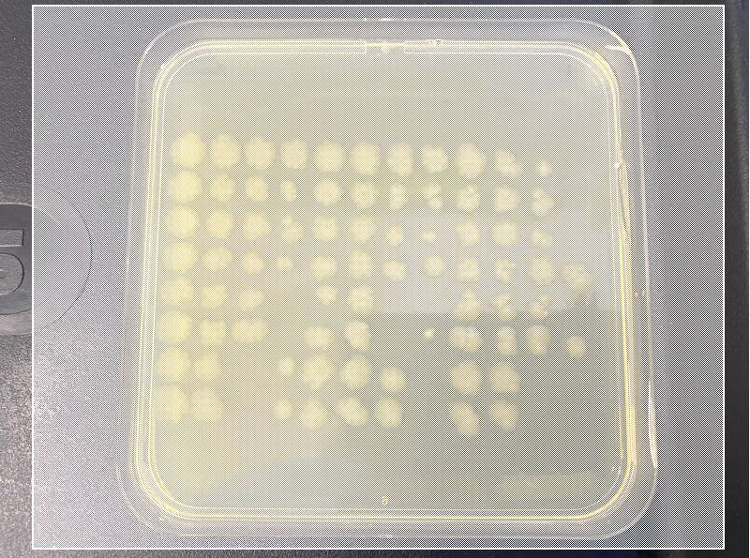
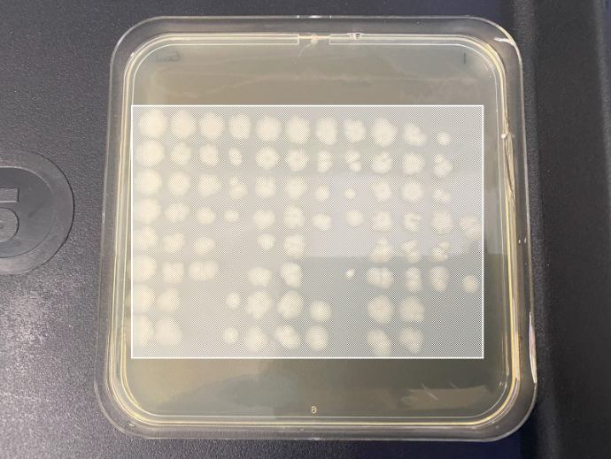
Examples:
Bad: Includes excessive background or is not aligned with a clear marker, compromising scaling accuracy.

Bad: Cropped too close to the spots, missing critical margins.
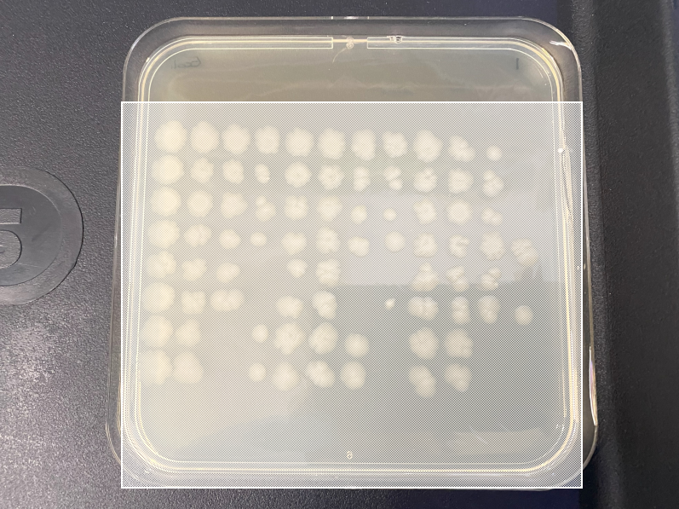
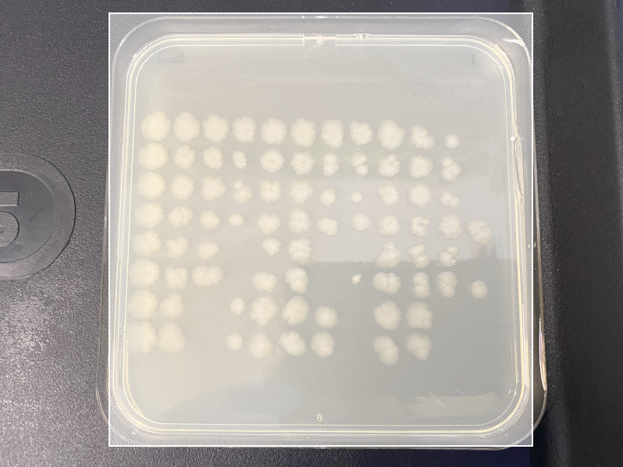

Good: Contains all spots with a margin. Horizontally cropped to a consistent and clear marker (e.g., the plate edge)
Good: Contains all spots with a margin. Horizontally cropped to a consistent and clear marker (e.g., the plate edge)


Refine Local Adaptive Thresholding Parameters
This page lets you adjust the parameters for local adaptive mean thresholding to achieve more accurate segmentation. While default values are provided, they may not work well for all images. Adjusting these settings will update the contours and help produce results that better reflect your data. All final settings will be included in the PDF export.

What is Threshold?
Thresholding determines whether a pixel belongs to the foreground (e.g., a quantifiable spot) or the background (irrelevant areas) by comparing the pixel’s intensity to its surroundings.
- Lower values classify more pixels as part of spots, but this may overestimate spot size or include noise and artefacts.
- Higher values classify more pixels as background, which reduces noise but might miss faint spots.

What is Block Size?
Block size specifies the size of the neighboring area analyzed to determine if a pixel belongs to the foreground or background.
- Smaller block sizes capture finer details but may introduce noise and complexity.
- Larger block sizes create smoother results but may miss small features.

What is Minimum Size?
This parameter sets the smallest allowable spot size relative to the image width. Spots smaller than this size will be ignored.

Common Issues and Fixes
1. Spot edges are not detected correctly.
- Solution: Increase the block size and lower the threshold.
2. Outer spots are disappearing.
- Cause: The spots overlap the plate edge, which may be ignored during analysis.
- Solution: Re-crop the image, excluding the top or bottom plate edge.


Adjust Binary Image
This screen allows you to fine-tune the detected regions in the image by adding or removing specific areas. You can make adjustments to either the original or contoured image view.

Tools

- Original to Contoured Image Toggle
Toggle contour overlays on or off to switch between the original and contoured views.


- Undo and Redo Buttons
Quickly reverse or reapply your previous actions for efficient editing.
- Zoom Controls



Zoom in or out on the image and use the scroll bars to navigation. Tip: Zoom in to increase the accuracy when using pen or eraser tools

- Pen Tools

Thin Pen: Adds small, precise areas
Thick eraser: Add larger regions.

- Eraser Tools

Thin eraser: Remove small, precise areas.

Thick eraser: Remove larger regions.
Flood eraser: Eliminate large, continuous areas of unwanted white pixels in a single click.


Confirm Grid Calculation
The grid is calculated by detecting circular regions and grouping them into rows and columns. Dark Grey Regions: indicate that the region was are ignored as it extends too far outside their primary block.

Before Calculating the Grid
- Edit Connections: Use the editing tools to disconnect spots that are linked to each other or to light reflections.
- Erase Non-Spots: Ensure that any non-spot regions within the grid boundary are erased for accurate quantification.

Adjusting the Grid
- If the grid is incorrect, click Recalculate Grid and Delete Points where crosses are detected on non-spots.
- If your assay has sparse spots, click Add Points to manually place crosses where spots should be even in blank columns.
- Grid not detecting well? Try recreating the metadata and uncheck “Square Grid Cells”.

Important Notes
- The grid does not need to align perfectly with each spot.
- Spots extending outside their primary block will still have their entire area counted within their main block.

