Holly Bancroft

CIS2901c Case Study

8/1/21

**Increment 5 User Documentation**

**Increment 5 Revisions:**

The following pages were added

Page 11: Explains how to use the vendors menu, and how to view and add vendors

Page 12: Explains how to delete and update vendors

Page 13: Explains how to join the vendor table and maintenance table by displaying the vendors that have performed maintenance

**Increment 4 Revisions:**

The following pages were added

Page 9: Explains the maintenance menu, and how to add and view maintenance performed

Page 10: Explains how to delete and update maintenance descriptions

**Increment 3 Revisions:**

The following pages were added.

Page 5. Explains the tenant’s menu, including how to look up a tenant and add a new tenant.

Page 6. Explains how to delete and update a tenant.

**Increment 2 Revisions:**

The following pages were added.

Page 4. Explains the process of adding a new property, and the fields that are required.

Page 5. Explains the process of deleting a property. Also explains how to update a property, and provides examples from screenshots of the program.

# Table of Contents

Table of Contents 1

Application Overview 2

The Properties Menu 3

View Existing Properties 3

Adding A New Property 4

Deleting A Property 5

Update a Property 6

The Tenants Menu 6

Look Up Tenant 7

Add New Tenant 7

Delete Tenant 8

Update Tenant 8

The Maintenance Menu 9

View Maintenance 9

Add New Maintenance 9

Delete Maintenance 10

Update Maintenance 10

The Vendor Menu 11

View Vendors 11

Add a New Vendor 11

Delete Vendor 12

Update Vendor Information 12

List All Vendors With Maintenance Performed 13

## Application Overview

This is a rental property management application. It tracks properties, tenants, maintenance, and vendors. It allows the user to view the information in an organized way. The user is able to view, update, delete, and add new objects into the database from this application. When the application first starts, the user is presented with this menu in the console. The user currently can navigate the menu by entering the corresponding number.

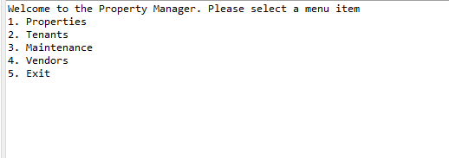

## The Properties Menu

When the properties menu is selected, there are 4 options to either view, update, delete, or add a new property to the database. The user enters the number of the action they would like to take.

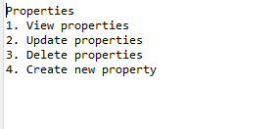

## View Existing Properties

If the user chooses menu option 1, all of the existing properties in the database will be displayed. This is accomplished with a SQL statement (SELECT * FROM property;). Here is the current output:

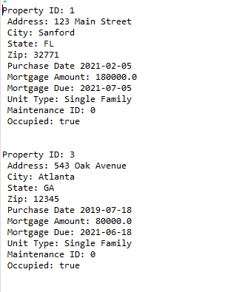

# Adding A New Property

If the user chooses menu option 2, they can add a new property row to the table. The user is prompted to enter information for each field. After entering the information, there will be a message displayed to indicate whether or not the property was added successfully.

|  |  |
| --- | --- |
| **Field** | **Description** |
| Property ID | Required. Enter a unique integer to identify the property. Should not exceed 11 integers |
| Address | Required. Enter text for the property’s address. Should not exceed 30 characters. |
| City | Required. Enter text for the property’s city, Should not exceed 30 characters. |
| State | Required. Enter text for the property’s state. Should not exceed 30 characters. |
| Zip code | Required. Enter an integer for the property’s zip code. Should not exceed 11 integers. |
| Purchase Date | Required. Enter a date for when the property was purchased in the format of M/D/YYYY. |
| Mortgage Amount | Not required. Enter a dollars and/or cents without a $ symbol or commas for how much the mortgage is. |
| Mortgage Payment Due Date | Not required. Enter a date for when the next mortgage payment is due in the format of M/D/YYYY |
| Unit Type | Required. Enter text for what unity type the property is. Should not exceed 30 characters. |
| Maintenance ID | Not required. Enter an integer for the ID of the maintenance that was performed. |
| Is Occupied | Required. Enter the text ‘true’ or ‘false’ to indicate if the property is tenant occupied. |

An example of this feature in action:

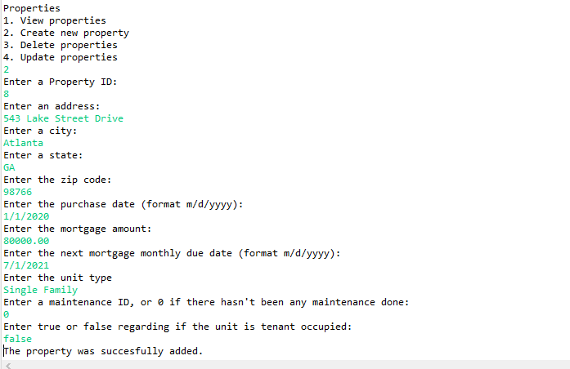

# Deleting A Property

If the user chooses menu option 3, they will be prompted to enter the Property ID of the property they would like to delete from the database. There will be a message displayed to indicate whether or not the property was successfully deleted.

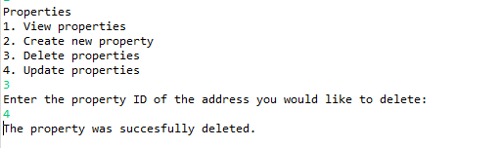

# Update a Property

If the user chooses menu option 4, they will be prompted to enter the property ID of the property they would like to update. Then they will be required to update each field (refer to ‘Adding A New Property’ for a list of the fields). There will be a message displayed to indicate if the property was succesfully updated.

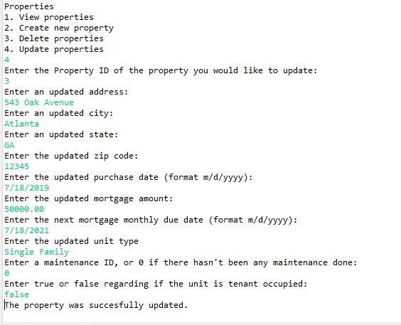

# The Tenants Menu

When the tenants menu is selected, there are 4 options to either view a tenant, update, delete, or add a new tenant to the database. The user enters the number of the action they would like to take.

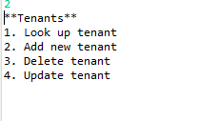

# Look Up Tenant

To look up a tenant, the user would enter the tenant id to view that tenant’s information. The information is then displayed on the screen.

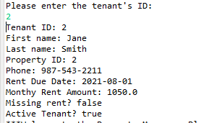

# Add New Tenant

To add a new tenant, the user is asked to supply the following information

|  |  |
| --- | --- |
| **Field** | **Description** |
| Tenant ID | Required. Enter a unique integer to identify the tenant. Should not exceed 11 integers |
| First Name | Not required. Enter the tenant’s first name. Should not exceed 30 characters. |
| Last Name | Not required. Enter the tenant’s last name. Should not exceed 30 characters. |
| Property ID | Not required. This is the foreign key in relation to the property table. It identifies the property the tenant is occupying. |
| Phone | Not required. Enter the tenant’s phone number. |
| Rent Due | Not required. Enter the date the tenant’s rent is due. |
| Rent Amount | Not required. Enter the monthly rent amount due. |
| Missing Rent | Not required. Enter true or false regarding if the tenant missed a rent payment. |
| Active Tenant | Not required. Enter true or false regarding if the tenant is currently occupying a property. |

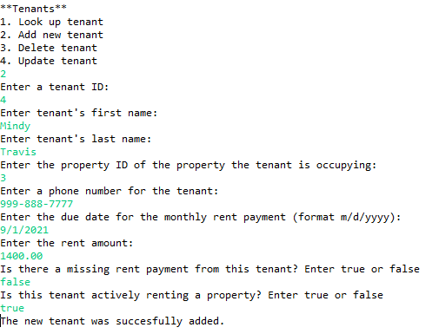

# Delete Tenant

To delete a tenant, the user is asked to enter the tenant ID of the tenant they would like to delete from the database. A message will display to indicate whether this request was successful.

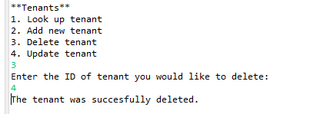

# Update Tenant

To update a tenant, the user is asked to provide the id of the tenant to update, and then update the fields that were listed under ‘add new tenant’. A message will display to indicate that the tenant was successfully updated.

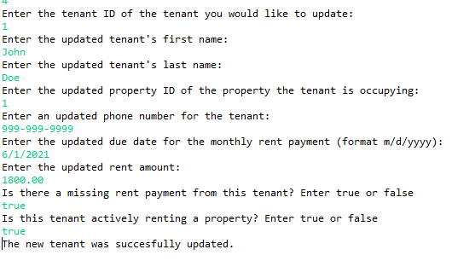

# The Maintenance Menu

When the maintenance menu is selected, there are 4 options to either view maintenance performed, update, delete, or add a new maintenance performed to the database. The user enters the number of the action they would like to take.

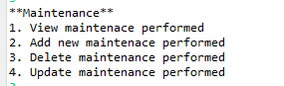

# View Maintenance

To view maintenance, the user would enter the maintenance id to view the description. The information is then displayed on the console screen.

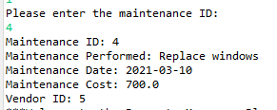

# Add New Maintenance

To add new maintenance, the user is asked to supply the following information

|  |  |
| --- | --- |
| **Field** | **Description** |
| Maintenance ID | Required. Enter a unique integer to identify the maintenance performed. Should not exceed 11 integers |
| Maintenance Performed | Not required. A short description of the maintenance performed, such as “Replaced Windows”. Should not exceed 30 characters. |
| Maintenance Date | Not required. Enter the date that the maintenance was completed. |
| Maintenance Cost | Not required. Enter a decimal number for the cost of the maintenance performed. |
| Vendor ID | Not required. Enter the ID of the vendor who performed the maintenance, which is a foreign key of the vendor table. |

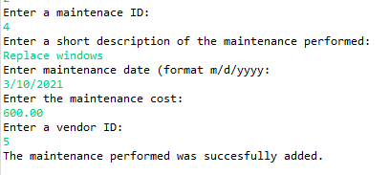

# Delete Maintenance

To delete a maintenance description, the user is asked to enter the maintenance ID of the description they would like to delete from the database. A message will display to indicate whether this request was successful.

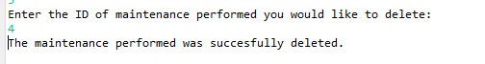

# Update Maintenance

To update a maintenance description, the user is asked to provide the id of the maintenance to update, and then update the fields that were listed under ‘add new tenant’. A message will display to indicate that the tenant was successfully updated.

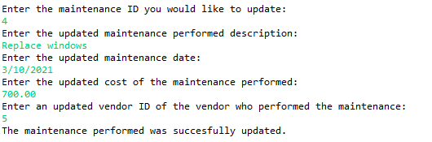

# The Vendor Menu

The vendor sub menu gives 5 options to choose from. This is where the user can interact with information on vendors that have either worked on properties or who’s information is stored for possible future use. You can view vendors, add a new vendor, delete a vendor, update a vendor, and view only vendors who have performed maintenance in the past.

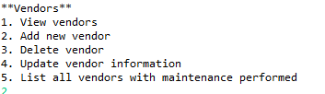

# View Vendors

If the view vendors option is selected, all the vendors listed in the database will be displayed.

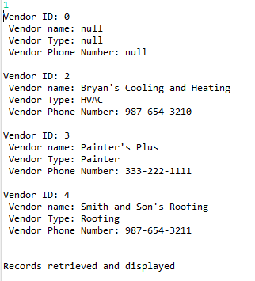

# Add a New Vendor

To add a new vendor to the database, the user is asked to supply the following information

|  |  |
| --- | --- |
| **Field** | **Description** |
| Vendor ID | Required. Enter a unique integer to identify the vendor. Should not exceed 11 integers |
| Vendor Name | Not required. Enter the vendor’s name or title. Should not exceed 60 characters. |
| Vendor Type | Not required. Enter a descriptive category of what type of service the vendor provides, such as plumbing services. Should not exceed 60 characters. |
| Vendor Phone | Not required. Enter the phone number of the vendor. Should not exceed 12 characters. |

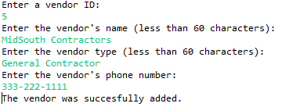

# Delete Vendor

To delete a vendor, the user is asked to provide the vendor ID of the vendor they would like to permanently remove from the database. The program will indicate if the deletion was successful or not.



# Update Vendor Information

To update a particular vendor’s information, the user is asked to enter the id of the vendor to update. Then they are asked to fill in the updated information. A message will display to indicate if this was successful.

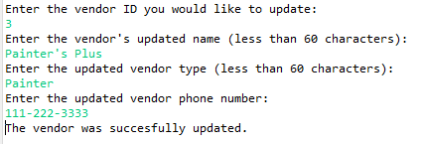

# List All Vendors With Maintenance Performed

This menu option will join the maintenance table and the vendor table to list the vendors that have performed maintenance and what type of maintenance they performed.

