UKRAINIAN LEGAL FUNDATION
KYIV INTERNATIONAL INSTITUTE OF SOCIOLOGY

QUESTIONS ON NATIONAL
INTEGRITY


Analytical Report

Kyiv - 1998
Table of Contents
Introduction
The Research Objectives, Object And Subject
The Basic Results
2.1. What Is Corruption For Population Of Ukraine
2.2 The Extent Of Corruption Widespread In Different Official Bodies And Organizations
2.2.1. Respondents’ Esteem Of Corruption Widespread Among Authorities
Of Different Establishments And Organizations
2.2.2. General Tendency of Establishments Distribution
(by the frequency of population appellations)
2.2.3. Dependence Between the Level of Corruption
and Frequency of Appellations
2.2.4. The Esteems of Those, Who Has a Personal Experience
of Getting in Touch with Bribery
2.2.5. How the Collide with Corruption
Resulted on Moral and Material Condition of Victims
2.3. The Attitude To Different Measures Against The Corruption Widespread
2.4. The Information About Corruption Penetration
Findings 19

Introduction
The integrity in Ukraine is very interesting but rather unresearched on societal and state levels phenomenon. The determination of the integrity level in state and the level of public trust to the state bodies, as indicators of the Ukrainian integrity, has become one of the important tasks of Ukrainian Legal Foundation (ULF) activity.
Sociological research "Question on National Integrity" was developed and processed by Kiev International Institute of Sociology (KIIS) on March 25 - August 15, 1998 within the framework of the project "The Ukrainian Integrity " to the order of ULF.
The report was prepared by coordinators of the project Julia Myroshnychenko and Maria Osipova under general edition of Valery Khmelko.
The essential help in realization of the research was given by the specialists of the Ukrainian Legal Foundation. KIIS expresses especial gratitude to Mykola Poludenny and Larissa Denisenko for the fruitful collaboration.

The Research Objectives, Object And Subject

The method of general sample survey enables collecting and analyzing information, representative for population of Ukraine, on interested to the researcher questions. The fact, that an independent institute is a realizator of the research, increases a level of trust from the side of respondents. The point is that population is still afraid to open their thoughts on the corruption to the official persons. So, in this way the general sample survey could gather the information absent in state and departmental statistics.
The objective of research was to study some aspects of the Ukrainian population attitude toward corruption, and questions, connected with this problem, such as:
- the direct understanding of a term “corruption”;
- extent of corruption widespread in different official bodies;
- the attitude to different measures against corruption;
- the level, population penetrate with information about corruption;
- relative efficiency of measures against corruption.
The object of given research was the adult population of Ukraine from 16 years old. The selection occurred on a basis of specially developed sample, representative for the object of research as a whole.
Subject of research - opinion of the studied population concerning the corruption in Ukraine.

The Basic Results

2.1. What Is Corruption For Population Of Ukraine
Results of the survey have shown, that the majority of population of Ukraine has certain opinion on the definition of corruption. Only 2.9 % of surveyed respondents could not define corruption at all. The majority of them were:
- with low education background (64.1 % with less than 10 classes),
- retired persons (58.7 %),
- aged from 50 years (68.1 %),
- women (71.6 %).
In general, the more than a half of respondents, which answered to the questions about their understanding of the term "corruption", define corruption as "bribery, venality of the official functionaries, political figures" (56.7 %); for 54 % corruption - is “abuse of power, exceeding of official powers for the own enrichment "(see Chart 1). A little bit less respondents understand corruption on macro level as ‘cooperation of government and criminal structures, Mafia in power" (42.4 %) and as "stealing of the state and peoples property "(40.2 %). The rest of alternatives were grade as following: 9.8 % see corruption as "method of overcoming difficulties of solving personal problems with officials" and 18.9 % -- "mutual protection" and 28.5% as ‘swindle, dishonesty’.

Chart 1. "What Is Corruption On Your Point Of View? "
% of respondents chosen certain alternative. The sum of percents is greater then 100, because respondent could choose more than one alternative
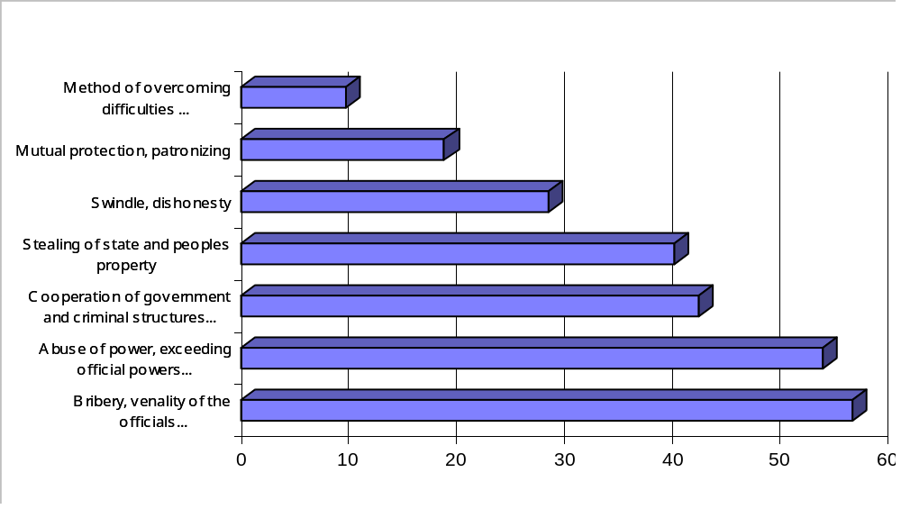

The group of respondents mentioned a certain alternative differs by the social-demographic characteristics. For example, alternatives-winners ("bribery..." and "abuse ... of the official powers for the own enrichment") man mentioned more often than women, the people with education higher than secondary complete more often than the rest of education groups of surveyed.
Among the people, which defined corruption as "bribery... ":
- more people of 20-29 and 40-49 years;
- more inhabitants of South and East regions.
In contrast, among those, who defined corruption as "abuse... of the official powers ...":
- more people from 20 to 39 years;
- more inhabitants of West- and East-Central regions;
- more qualified workers and specialists.
It is possible to tell, that population of Ukraine did not form the identical one-alternative definition to the term ‘corruption’. More often respondents chose (see Chart 2) at once two alternatives -- 30.9 % (among them excelled people of 30-39, with higher education, inhabitants of West region). Variants with one- and three-alternative definition of corruption (accordingly 22.9 % of respondents and 22.8 %) were rather widespread also. Just one alternative more often than the rest of groups chose: youth 16-19 and persons aged 40-49, with secondary complete education, engaged in agriculture or students (pupils). Three alternatives were the most popular among people with vocational education. Rather significant (23.4 %) percentage of respondents chose more than three alternatives of corruption definition, offered in the questionnaire.

Chart 2. "What is Corruption on Your Point of View? "
% of respondents chosen certain quantity of alternatives

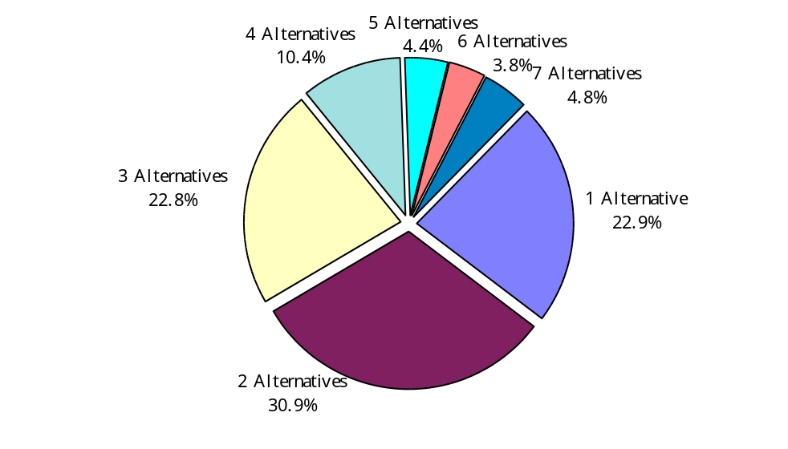

Near 7 % of surveyed have defined corruption, as a combination ‘of bribery, ... of the official functionaries, political figures" with "the abuse of power, exceeding of official powers for the own enrichment ". This combination of alternatives became the most popular among all respondents defined the corruption (see Chart 3).
The second place -- 6.5 % of respondents (or every third of those, who chose one alternative) -- won “abuse of power, exceeding official powers for own enrichment".
The third and fourth place is divided between variants, pointed by 4 % of surveyed: corruption -- "bribery, ... of the official functionaries, political figures" (every fourth among those, who chose one alternative) and corruption -- "bribery ... of the official functionaries", based on "abuse ... of the official powers for the own enrichment "and that actually is "stealing of the state and peoples property’(every fifth respondent, among those, who associate corruption at once with 3 alternatives).

Chart 3. The Most Popular Alternatives
(Or Combination Of Alternatives) For Corruption Definition (By The Quantity Of Chosen Variants)
% from all respondents
Hence, the greatest percentage of respondents associates the corruption with bribery, venality of the official functionaries, based on abuse...of the official powers for the purpose of own enrichment, though we can not speak about universal and precise opinion, what is corruption for population of Ukraine.
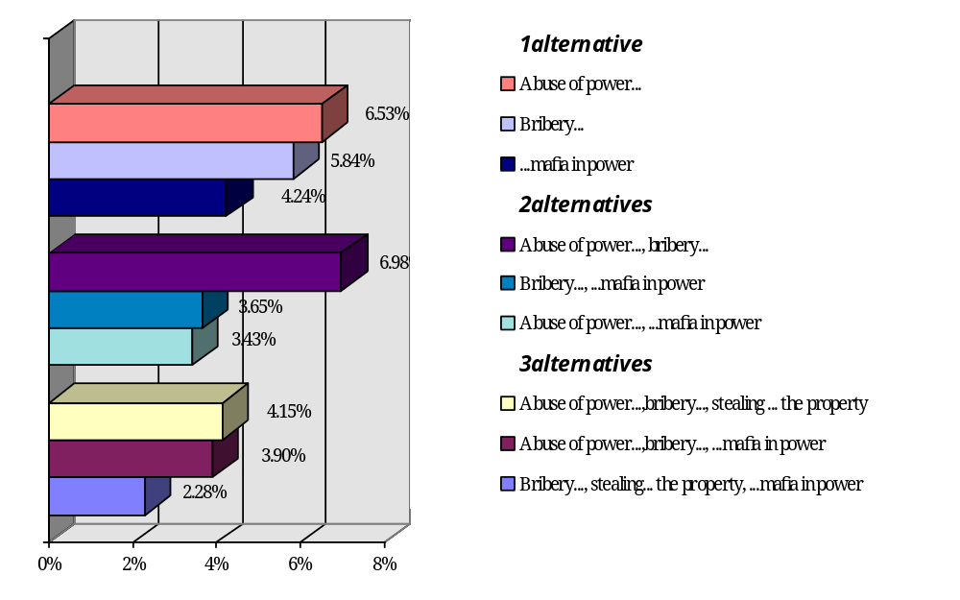

2.2 The Extent Of Corruption Widespread In Different Official Bodies And Organizations

2.2.1. Respondents’ Esteem Of Corruption Widespread Among Authorities

Of Different Establishments And Organizations

First of all, we must point, that respondents showed a strong will to measure the level of bribery widespread, among the officials of different establishments and organizations.
In the questionnaire respondents were asked to esteem the level, they considered corruption is widespread among the officials of 19 proposed by the researcher establishments and organizations. For the estimation they used five-grade scale, from 1 -- "entirely widespread" to 5 -- "widespread very much". Estimations distributed as following:

Table 1. All-Ukraine Average Esteem
Of Corruption Widespread Level Among The Officials
Of Different Establishments And Organizations

Establishment or organization | Average
State auto inspection | 4.17
Medical care organizations | 4.09
Militia | 4.04
Higher education establishments | 4.04
Ministries and other central executive branches | 3.99
Local self-government bodies | 3.93
Customs department | 3.93
Tax inspection bodies | 3.89
The Supreme Soviet | 3.88
Courts | 3.82
Public prosecutors department | 3.76
President’s Administration | 3.71
Privatization bodies | 3.52
Army | 3.37
Banks | 3.36
Secondary education establishments | 3.21
State TV company | 3.15
The last job | 2.64
Churches | 2.47

Hence, the most corrupted establishments, on population opinion are:
- State auto inspection -- 4.17
- Medical care organizations- 4.09
- Militia -- 4.045
- Higher education establishments -- 4.04
- Ministries and other central executive branches-3.99

Based on the respondents’ esteems, we could determine a few groups of establishments and organizations, that differs by certain characteristics:
- By the reliability level of the esteem:
- Establishments and organizations, with low determination of corruption widespread level esteem (35-50 % respondents could not estimate a level corruption widespread at all)
- State TV -- 47.6 %,
- Church -- 41.6 %,
- Banks -- 38.4 %;
- Establishments and organizations, with high determination of corruption widespread level esteem (only 5-20 % respondents could not estimate a level of corruption):
- Medical care organizations -- 10.9 %,
- Local authorities -- 16.2 %,
- Higher education establishments -- 16.3 %,
- Militia -- 17.5 %,
- State auto inspection- 18.3%,
- Secondary education establishments -- 19.3%;
- By the expansion of bribery among the officials (under five-grade scale):
- Establishments and organizations, where the bribery, on the respondents’ opinion, is strongly widespread (more than 60 % of answers on the question: "To what extend does bribery widespread among the officials in the following organizations? " -- were " rather widespread " and " widespread very much"):
- Medical care organizations -- 69 %
- State auto inspection- 68.5 %
- Higher education establishments -- 65.7 %
- Militia -- 64.6 %
- Local self-government bodies -- 61.3 %
- Ministries and other central executive branches -- 60.8 %
- Establishment and organizations, where the bribery, on the respondents’ opinion, is almost not widespread (25-40 % of answers on the question: "To what extend does bribery widespread among the officials in the following organizations? "-- were "almost not widespread " and "entirely widespread"):
- Church --39.7%
- The last job --39.2%
Though the majority of establishments, on population of Ukraine thought, are corrupt, far from everyone considers, that bribery -- the only way to solve the problem with the official functionaries. 37 % respondents, are sure, that for the successful solution of any problem with the officials it is not obligatory to give a bribe. People with higher education, specialists and respondents of the age of 60-69 informed about this more often than other groups.
Just little fewer respondents -- 33 % consider, that it is impossible to solve any problem with the official functionaries without a bribe. The greatest part of respondents, shared this opinion, differs from other groups by the following social-demographic characteristics: they aged from 16 to 49, have vocational or incomplete higher education, and do not receive enough information about corruption from mass media, more often -- inhabitants of West and West-Central regions.

2.2.2. General Tendency of Establishments Distribution

(by the frequency of population appellations)

To distinguish respondents opinions about corruption widespread in 19 establishments and organizations by the quantity of respondents’ appellations to these establishments (the indicator of a potential possibility of getting in touch with the bribery, venality of the officials in these establishments) a special question with the request to determine quantity of contacts with these establishments during the last 12 months was given. The data have shown, that, in average, only 14.5 % of respondents appeal to the given establishments and organizations during last year.
By the frequency of population appellations, the establishment and organization could be divided into the following groups:
- Establishments and organizations, that are in greater demand among population (more than 25 % of respondents at least once appeal to during the last year):
- Medical care organizations-56.4%,
- The last job -- 35.6 %,
- Churches -- 27.1 %,
- Local self-government bodies -- 26.2 %;
- Establishments and organizations, that are not so popular among population (respondents appeal to frequently -- from 25% to 10 %):
- Secondary education establishments -- 18.1 %,
- Tax inspection bodies -- 17.6 %,
- State auto inspection-15.9 of %,
- Privatization bodies -- 14.8 %,
- Militia -- 12.7 %,
- Higher education establishments -- 12.2 %;
- Establishments and organizations, to which respondents appeal very seldom -- only in special cases (less than 10 %):
- Banks -- 9.1 %,
- Courts -- 7.2 %,
- Customs department -- 6.1 %,
- Public prosecutors department -- 4.5 %,
- Army -- 4.2 %,
- Ministries and other bodies central executive power --3 %,
- State TV company --1.7%,
- The Supreme Soviet -- 1.6 %,
- President’s Administration -- 1.5 %.

2.2.3. Dependence Between the Level of Corruption

and Frequency of Appellations

It is very interesting to compare the respondents’ esteems of corruption widespread level in a particular establishment or organization with the quantity of particular appellations to that establishment. This allows to reveal the dependence between the opinions of respondents and acquired communicational experience from contacts with bodies and organizations. Examining establishments and organizations by already determined three groups (on the quantity of appellations), we shall define the direct and reverse dependence.
- Establishments and organizations, that are in greater demand among population -- medical care organizations, the last job, church and local self-government bodies -- on character of dependence of corruption widespread level esteem from quantity of appellation subdivided into two groups:
- Establishments and organizations with higher probability of high corruption level; corruption widespread level estimation of which increases with the enlargement of contact experience (the more times respondents appeal to particular establishment, the greater is the corruption widespread level esteem):
- Medical care organizations,
- Local self-government bodies,
- The last job

Table 2: Quantity Of Contacts/Level Of Corruption Dependence In Group Of Establishments And Organizations, That Are In Greater Demand Among Population
% of respondents, who chose alternatives "corruption is widespread very much" and "the corruption is rather widespread ".

 | Frequency of appellation
Establishment or organization | 1-2 times | Not once or twice, but no greater than 10 | Tens of times
Medical care organizations | 68.1 % | 69.7 % | 79 %
Local self-government bodies | 63.3 % | 65.2 % | 69.5 %
The last job | 23.5 % | 25.3 % | 31.6 %
- Establishments and organizations with higher probability of a low corruption level; corruption widespread level estimation of which decreases with the enlargement of communication experience with them (the more times respondents appeal to particular establishment, the lower is the corruption widespread level esteem):
- Church -- 44.4 % of those, who contact 1-2 times consider that corruption is not widespread in this establishment, 55% of those, who addressed less than 10 times, 69.9% of those, who contact it tens of times.
- All establishments and organizations, are not so popular among population, belong to a group with higher probability of high corruption level:
- Tax inspection bodies,
- State auto inspection,
- Privatization bodies,
- Militia,
- Secondary education establishments,
- Higher education establishments.

Table 3: Quantity Of Contacts/Level Of Corruption Dependence In Group Of Establishments And Organizations, That Are Not So Popular Among Population
% of respondents, who chose alternatives "corruption is widespread very much " and "the corruption is rather widespread ".

 | Frequency of contacts
Establishments and organizations | 1-2 times | Not once or twice, but no greater than 10 | Tens of times
State auto inspection | 85 % | 86 % | 92.6 %
Militia | 78.8 % | 86 % | 89.5 %
Higher education establishments | 66.7 % | 67.9 % | 83 %
Tax inspection bodies | 64.2 % | 75 % | 82.7 %
Privatization bodies | 39 % | 45.5 % | 60 %
Secondary education establishments | 32 % | 44 % | 42 %

- For the third group of establishments, to which appeal only in special cases, it is expediently to compare only the corruption level estimation of those, who contact them at least once during past year and those, who did not contact at all (as percentage of those, who contact them is too small).
For the main part of such establishments: President’s Administration, Supreme Soviet, ministries and other central executive branches, public prosecutors department, customs department and courts -- the following statements is fair: the absolute majority of respondents, both, who appealed to these establishments, and, who did not appeal at all, consider these establishments and organizations corrupted, and the difference between their estimations is statistically significant.

Chart 4 Distribution Of Those,
Who Consider Corruption Widespread
Among Certain State Structures
% of respondents, who chose alternatives "corruption is widespread very much" and "corruption is rather widespread ". Difference between those, who contact them at least once during past year and those, who did not contact at all.
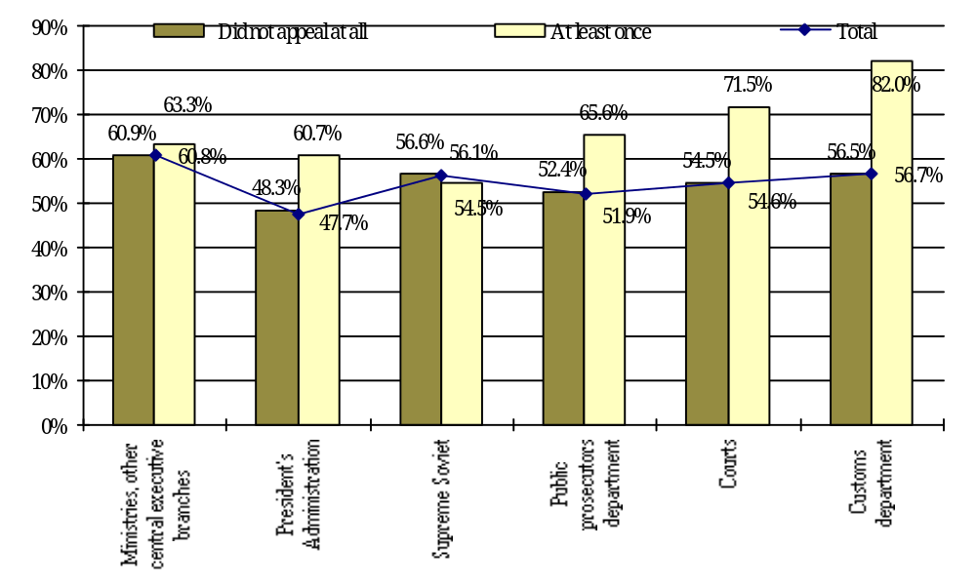
It is not possible to estimate the dependence in the rest of establishments and organization such as state TV, army and banks, because of large percentage of uncertain answers.

General Tendencies in bribery widespread evaluation:

- Increasing in quantity of appellation leads to the decreasing in percentage of respondents chose intermediate variant -- "With the same frequency I met as cases of bribery, so their absence ", and also increasing in percentage of respondents, chose extreme estimations (increases the percentage of those chose alternatives: "corruption is widespread very much" , "entirely widespread")
The exception is an estimation of higher education establishment’s level of corruption (% of respondents considered corruption rather widespread fell from 29 % (1-2 contacts) to 18 % (less than 10 contacts) and then rose again to 22 % (tens of contacts). It can testify to the difference between constant contact purposes and purposes of seldom contacts.
- The majority of establishments gets higher estimation of a corruption level among those, who appealed to them, than among those, who did not appeal to them at all. However there are few exceptions, concerning to which the statement, that the corruption level esteems among those, who contact it constantly is better then of those, who did not contact at all, is faith.

2.2.4. The Esteems of Those, Who Has a Personal Experience

of Getting in Touch with Bribery

As survey data shows, only a little greater than one third of respondents (36.8 %) in the estimations of a corruption level was based on personal experience of getting in touch with the facts of corruption during the last year. The majority -- 61 % -- states, that both personally, and members of their family did not collide with the facts of corruption during this period.
By the social-demographic characteristics, direct witnesses of corruption more likely to become man (by 10 % greater than average in Ukraine); at the age from 16 to 49 years (by 25 % greater); the people with vocational (by 23 % greater) or higher (by 44 % greater) education; the specialists (by 50 % greater), schoolboys (or students) (by 48 % more than average); and also inhabitants of West (by 7 % greater) and South (by 6 % greater) regions.
Answers of those, who personally collided with displays of corruption confirmed a presence of a high level of corruption in the following establishments and organizations: medical care organizations, state auto inspection, higher education establishments, tax inspection bodies, local self-government bodies.
ÒÎÐ 5 -- "The five most corrupt organization" based on the thoughts of those, who had the opportunity to collide with the bribery among officials during last year is:
(respondents, who collided with bribery during last year in general, were asked to name five the most corrupted, on their opinion, establishments and organizations; so the percent in brackets shows what percent of respondents among those, who collided with corruption, consider named establishment or organization to be the most corrupted):
- Medical care organizations (44.7 %)
- State auto inspection (20.8 %)
- Local self-government bodies (16.9 %)
- Tax inspection bodies (14.4 %)
- Higher education establishments(13.2 %)
As you could see, the TOP 5 corrupted establishments and organizations, generated according to thoughts of eyewitnesses, is almost similar to TOP 5 corrupted establishments and organizations, according to opinion of all respondents. Differences are only expresses in the way, establishments arranged: for all respondents the first place won state auto inspection, the second -- medical establishments, on the third place - the militia, the fourth occupy higher education establishments, and the last -- fifth place - got ministries and other central executive branches.

2.2.5. How the Collide with Corruption

Resulted on Moral and Material Condition of Victims

Among those, who personally collided with corruption, majority -- 45 % -- consider themselves morally, so financially victimized. However 21.6 % do not consider themselves injured at all (52 % of them collided with the facts of corruption among the officials weather seldom or 26 % almost never).
The distribution of different kinds of victimized by age groups is the following:

Table 4. Distribution of Corruption Victims by the Character of Damage and Age Group
% respondents of certain age group, which chose one of the offered alternatives

 | Character of damage
Age Group | I do not consider myself a victim | I had both financial, and moral damage | I had only moral damage | I had only financial damage
16-19 | 6.7 % | 7.0 % | 6.8 % | 8.6 %
20-29 | 27.8 % | 22.8 % | 15.6 % | 26.4 %
30-39 | 22.2 % | 19.0 % | 27.6 % | 13.5 %
40-49 | 18.9 % | 22.8 % | 25.6 % | 23.3 %
50-59 | 12.2 % | 14.0 % | 12.1 % | 6.7 %
60-69 | 6.7 % | 7.0 % | 8.8 % | 12.9 %
From 70 | 5.6 % | 7.0 % | 3.5 % | 8.6 %

As Table 4 shows, the greatest number of respondents, who are 20-29 years old (27.8 % of that kind of received damage) suffer financially; half of victimized only in moral aspect are the respondents of 20-29 years and of 40-49 years (22.8 % for each group); the percentage of victims, that damaged both morally, and materially through collided with corruption is greatest among the respondents by the age of 30-39 (27.6 % of suffered that way).
Rather great percentage of young people, aged 20-29 (26.4 %), among respondents collided with the facts of corruption, do not consider themselves to be victims.
Character of damage -- purely subjective estimation, and it could vary from habit, tradition that could be common to population of certain territory.
Chart 6. Distribution Of Corruption’s Actions Victims
By The Character Of Damage And By Regions
% inhabitants of certain region, which chose one of the offered alternatives
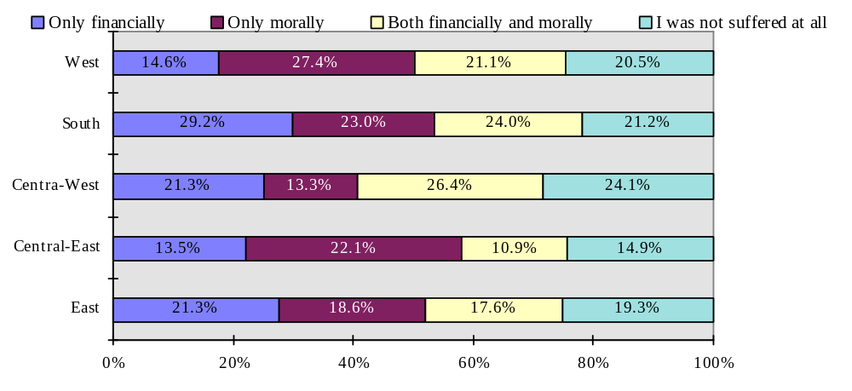
On the South and on the East of Ukraine live people, which suffer basically financially (29 % of all suffered that way). The greatest number of respondents, suffered only morally lives in the West (27.4%) and Central-East of Ukraine (22.1%).
More women suffer only materially, however in the rest of aspects -- frequently suffer man. Do not consider themselves to be a victim also the greater number of man.

2.3. The Attitude To Different Measures Against The Corruption Widespread

As a whole, population of Ukraine more likely to consider, that government almost does not do anything for the sake of prevention of corruption expansion or effective struggle with it. 63.4 % of population "completely agreed " or "almost agreed " with the statement that the authorities does not use any measures for struggle against bribery. Therefore some of measures offered by the researcher is almost unknown for the inhabitants of Ukraine. The share of those, who does not know anything about measures against corruption, the named in the questionnaire, makes in average 35 % (and in case of adding them to percentage of those, who could not give the exact answer makes 43 %).
The most unknown to population:
- The program "Clean Arms " (50 % respondents have assured, that they do not know anything about this program)
- Criminologictic expertise of all normative acts (35 %).
Measures, concerning to direct control of state employee work are rather known to population:
- Introducing of strong accounting of all government organs of Central executive branches about execution of the “Law about struggle against corruption” in their organizations (only 26 % do not know anything about this measure),
- Attestation of government officials (24 % do not know anything),
- Introducing of obligatory income declaration by government officials (19% do not know anything).
The most well known, the most general, but however the less effective under the estimations of respondents, measure -- adoption of the “Law about the Struggle against the Corruption” closes the list of measures.
The main reasons for ineffectiveness of measures, listed in the questionnaire, are following:
- Powerful government officials have too many privileges and rights to permit or prohibit (61.2 %)
- Budget resources used not as if they must be used (50.6 %)
- In practice many people do not accomplish demand of laws (48.1 %)
- Dishonesty, bribery among governmental officials (46 %)
- Laws do not envisage sanctions for their infringements (36.5 %)
As for the rest of possible reasons, why authorities’ measures against corruption, offered in the questionnaire, are inefficient, we could say, that they do not consider to be very important. The share of respondents who chose them does not exceed 23 %.
The most effective measures, on the opinion of surveyed, are “introducing of a strong accounting of all government organs of Central executive branches about execution of the “Law about struggle against corruption” in their organizations” (28.3 %) and “introducing of obligatory income declaration by government officials” (25.9 % respondents are sure, that the measure is effective).
Two thirds of respondents agreed with the statement, that some government actions give rise to the expansion of the bribery.
The most unsatisfactory and irritate for population is the fact of privileged layer -- people's existence. A thought, that there are some persons, who have especial official powers and rights and could use them in personal purposes is indignant ordinary people. So, among actions, that on respondents’ opinion, more than others promote the expansion of bribery and venality of the officials, are:
- Too much enfranchisement to officials (39.1 % respondents chose this alternative),
- Preservation of inviolability Status for the deputies and judges (37.8 %).
The second place, among actions, that promote corruption occupies "insufficient control of accepted laws execution " (33.3 %).
Next group of governmental actions, that occupies the third place among the corruption promotion ones, includes the following:
- Detention of enactment laws, which have been already elaborated (27%),
- Permission of opening anonymous bank accounts (27.3 %),
- Detention of effective laws against bribery elaboration (26.5 %),
- Reservation in normative acts creepholes for bribery (26.5 %),
- Insufficient control under the using of budget funds (24.4 %).
Among basic measures, which government needs to undertake for preventing or effective struggle against bribery among the officials, on respondents’ opinion, are:
- To annul the status of inviolability for judges and deputies (52 %).
- To reinforce the control of accepted laws execution (47 %),
- To prohibit to officials to use anonymous bank accounts (43 %),
- To reduce taxes (36.4 %),
- To reinforce the officials’ responsibility for bribery (30.3 %),
- To proclaim earned income declarations of government officials (28%),
- To bring in harshly merit rating and special requirement for state officials (25.4%).
The most inefficient, among listed in the questionnaire measures are "to provide international financial institutes aid, attract foreign investors " (only 6 % vote for the necessity of the usage of this measure) and "to elaborate and introduce in action the Code of ethics of official functionaries " (5 %).
The rest of measures mentioned only by 14-19 % of respondents.
Very interesting is to explore the attitude of the respondents toward the suggestion to estimate utility of position of Assignee of the Supreme Soviet of Ukraine on the Human Rights in struggle against bribery. The opinions distributed approximately equally for each alternative:
- The smallest quantity of respondents has appeared as totally optimistically set. They considered that this position will help in struggle against the corruption (22.5 %). More often than other this alternative chose people aged 16-29 or 60-69, respondents with vocational education, retired people, and inhabitants of West region;
- 25.1 % of respondents do not know anything about this position. Among them more often are woman, people with incomplete secondary education, widowed respondents, retired people, inhabitants of East region, person by the age greater than 70 years.
- A little bit more respondents have appeared as pessimists (25.2 %). They considered that this position will not help anyhow in the struggle against corruption. More often they are 30-49 years, have higher or vocational education, are specialists, who are not satisfied with the quantity of information about corruption in mass media, and are inhabitants of West-Central region.
- The greatest percentage of respondents chose alternative that everything will depend on the person, which occupies the position (26.3 %). These respondents by the social-demographic characteristics do not differ a lot from the average survey distribution -- only people with vocational education, aged 40-49 more often answered that way.

2.4. The Information About Corruption Penetration

Population of Ukraine is possible to divide into 3 groups by the sources they used to get the information about corruption. Without taking into account the percentage of respondents, that unable to define the sources of information in general (4 %), the least, for the number of respondents- 18 % -- is a group of respondents, who receive the information about corruption without using mass media: from relatives, familiar people, friends; in transport, in the street from the unfamiliar people and from their personal experience. 38 % respondents receive the news about the corruption only from mass media. The greatest percentage of respondents- 40 % -- combine these two ways of information reception.

Chart 7. Sources Of The Information About The Corruption
% respondents, who use given groups of sources for the reception of information about corruption
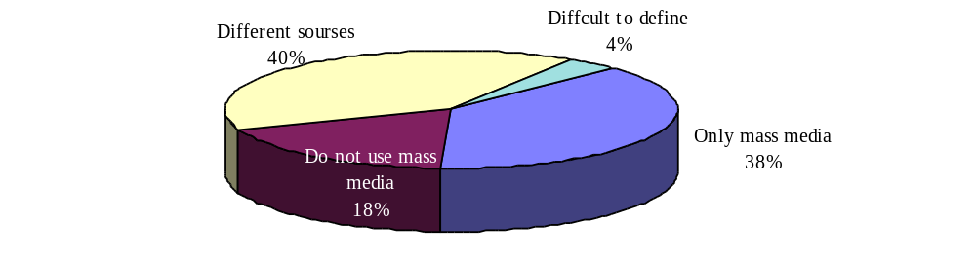
In general, mass media occupies the main place among sources of reception of the information about the corruption for population of Ukraine. The most popular source of information about corruption is TV -- 66.3 % of surveyed mentioned TV among sources, from which they receive the information about bribery. Considerably smaller is share of people, who use publications in press as one of such sources -- 49.7 % of respondents. The smallest percentage noted that radio programs help them to receive such information -- 27.6 %.
In the same time rather significant is the percentage of those, who receive the information about corruption from familiar people and friends (41.7 %). 26 % respondents more receive the information about corruption from personal experience.
The information about corruption, appeared in mass media, considered by population as reliable however insufficient. Among those, who uses at least one of mass media: TV, radio broadcasts or press -- 38 % considered the information about bribery "reliable" or "more often reliable ", and only for 21 % the information is not reliable. In the same time the majority of respondents -- 51 % -- unsatisfied with the enlightenment of problem in mass media -- they noted, that information there is a lack of information on interested (that is, corruption) topic. There is the direct dependence between satisfaction in volume of the received information, and estimation of its reliability: those, who have enough information about corruption estimate highly its reliability.

Chart 8. Dependence Between The Estimation Of Reliability
Of The Information And The Level Of Satisfaction With It Quantity
% respondents, which estimated a level of reliability of the information in a certain way, distributed by satisfaction/dissatisfaction with the quantity of the information about corruption
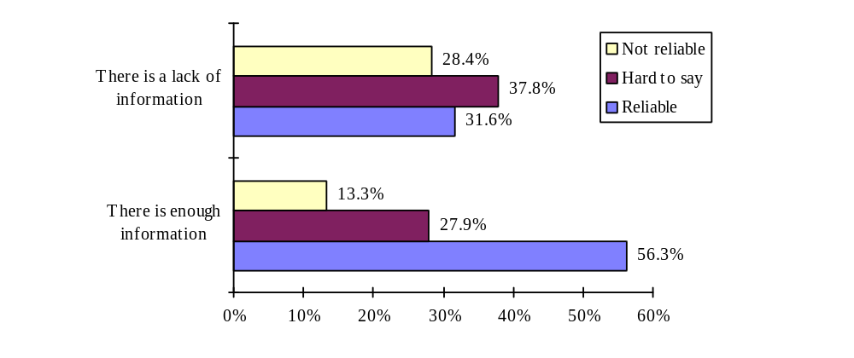
More than a half of respondents, want to receive more information -- 55 %. It is natural, that percent of those, who are willing to receive more information among those, who are unsatisfied with the quantity of the information about corruption in mass media, is higher -- 72.9 %, though among those, who are satisfied with the amount of the received information about corruption, it is also rather high -- 43.9 %

Chart 9. Dependence Between The Desire
To Receive The Greater Quantity Of Information
And The Level Of Satisfaction With It Quantity
% respondents, who wish (do not wish) to receive more information, by satisfaction/dissatisfaction with the amount of the information about corruption
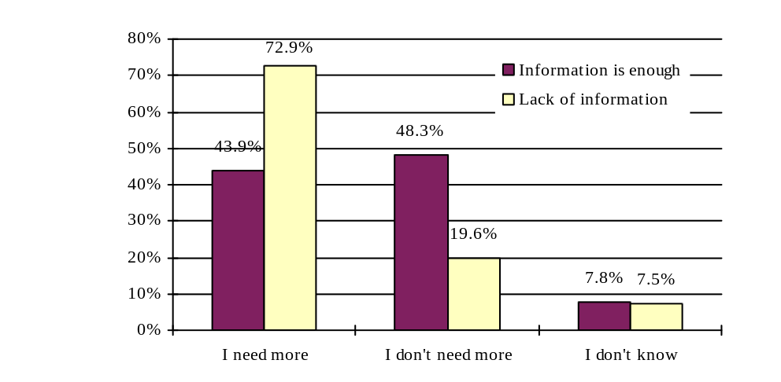
It is interesting, that persons, interested in political situation (that answered, that there is enough information about corruption in mass media, and nevertheless want to receive more), mainly are retired people, schoolboys, students or unemployed, aged 16-19 or 60-69, who live in the South of Ukraine, and consider, that it is not obligatory to give a bribe for solving any problem with the officials. The opposite category of the persons (that in spite of dissatisfaction with the amount of received information does not want to receive more) -- apolitical persons -- mainly consists from respondents of 20-39 years old, serving or specialists, with higher or vocational education, that also live in the South of Ukraine.
The absolute majority of respondents (87 %) considers, that persons, who inform the society about bribery require protection from governmental services. Moreover, 86 % of population consider, that the law, according to which the state bodies would guarantee protection of the citizens, who inform about facts of corruption should be adopted.
Opinions about using of paid informers, for exposure of bribery facts divided as following: 37 % consider, that if is necessary for the state bodies, but 35 % considered that the existence of paid informers is impossible. The rest -- 28 % -- shocked by the question and did not know, what to answer.
Findings

- For the majority of population of Ukraine corruption is "bribery, venality of official functionaries, political figures" (56.7 %) and "abuse of power, exceeding of official powers for own enrichment" (54 %).
- The average esteem of corruption widespread level in different establishments and organizations (based on five-grade scale) is following:

 | State auto inspection | 4.17
 | Medical care organizations | 4.09
 | Militia | 4.04
 | Higher education establishments | 4.04
 | Ministries and other central executive branches | 3.99
 | Local self-government bodies | 3.93
 | Customs department | 3.93
 | Tax inspection bodies | 3.89
 | The Supreme Soviet | 3.88
 | Courts | 3.82
 | Public prosecutors department | 3.76
 | President’s Administration | 3.71
 | Privatization bodies | 3.52
 | Army | 3.37
 | Banks | 3.36
 | Secondary education establishments | 3.21
 | State TV company | 3.15
 | The last job | 2.64
 | Churches | 2.47

- The less certain is the estimation of corruption level on State TV (only 52 % respondents give the estimation). The most certain -- the estimation of corruption level in medical care establishments (89 % give the estimation).
- 26 % of respondents (taking into account the nearest members of family - 37%) collided with displays of corruption during the last year personally.
- The most corrupted by certificates of those, who directly collided with displays of corruption during last year, are following establishments and organizations:
- Medical care organizations (44.7 %)
- State auto inspection (20.8 %)
- Local self-government bodies (16.9 %)
- Tax inspection bodies (14.4 %)
- Higher education establishments (13.2 %)
- 72 % of respondents consider themselves suffered through bribery. Moreover, 45% from collided with corruption consider themselves being suffered as morally, so financially.
- The main source of reception of the information concerning corruption is TV (66 %); the second place occupies press -- 50 %; on the third -- friends and familiar people (42 %).
- There is the direct dependence between satisfaction with quantity of the received information and the estimation of its reliability: those, who satisfied with the amount of information about corruption estimate its’ reliability higher than other groups. The number of respondents considered, that the information about corruption in mass media is not reliable approximately twice smaller than the number of those, who considers it reliable (20 % against 38 %).
- The most known measures on the struggle against corruption are: adopting the “Law about Struggle against Corruption," attestation of government officials and introducing of obligatory income declaration by government officials.
- The most effective measures, according to the opinion of surveyed, are “introducing of a strong accounting of all government organs of Central executive branches about execution of the “Law about struggle against corruption” in their organizations” (28.3 %) and “introducing of obligatory income declaration by government officials” (25.9 % respondents are sure, that the measure is effective).
- The most inefficient measure on population opinion is the adoption of the “Law about Struggle against corruption."
- The main reasons for ineffectiveness of measures, noted in the questionnaire, are following:
- Powerful government officials have too many privileges and rights to permit or prohibit (61.2 %)
- Budget resources used not as if they must use (50.6 %)
- In practice many people do not accomplish demand of laws (48.1 %)
- Dishonesty, bribery among governmental officials (46 %)

- Among actions, that on the respondents’ opinion, more than others promote the expansion of bribery and venality of the officials, are:
- Too much enfranchisement to officials (39.1 % respondents chose this alternative)
- Preservation of inviolability Status for the deputies and judges (37.8 %).
- Insufficient control of accepted laws' execution (33.3 %).
- The basic measures, which government needs to undertake for preventing or effective struggle against bribery among the officials, on respondents’ opinion, are:
- To annul the status of inviolability for judges and deputies (52 %).
- To reinforce the control of accepted laws execution (47 %),
- To prohibit to officials to use anonymous bank accounts (43 %),
- The most inefficient, among listed in the questionnaire measures are "to provide international financial institutes aid, attract foreign investors" (only 6% vote for the necessity of the usage of this measure) and "to elaborate and introduce in action the Code of ethics of official functionaries" (5 %).
- The absolute majority of respondents (87 %) considers, that persons, who inform the society about bribery require protection from governmental services. Moreover, 86 % of population consider, that the law, according to which the state bodies would guarantee protection to the citizens, who inform about facts of corruption should be adopted.
- Opinions about using of paid informers, for exposure of bribery facts are not certain: 37 % consider, that if is necessary for the state bodies, but 35 % consider that the existence of paid informers is impossible. The rest -- 28 % -- shocked by the question and did not know, what to answer.
- Share of respondents, that are sure, that for the successful solution of any problem with the officials it is not obligatory to give a bribe -- 37 %. Only a little bit smaller -- 33 % consider, that without a bribe it is impossible to solve any problem with the officials.
- 76% respondents consider, that bribery now meets more often than earlier (before the Independence).

