NYC311 - Boroughs Main Analysis

Oleh Dubno & Daniel Argov

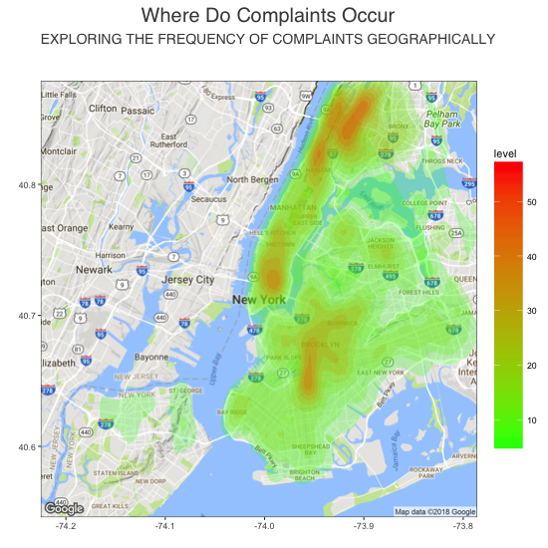

# **What** - Complaints by Borough

| [**Borough**](javascript:sort('ts',0,false)) | [**Population**](javascript:sort('ts',5,true))Estimate 2016-07-01 |
| --- | --- |
| [Bronx](javascript:sym('36005')) | 1,471,160 |
| [Brooklyn](javascript:sym('36047')) (Kings County) | 2,648,771 |
| [Manhattan](javascript:sym('36061')) (New York County) | 1,664,727 |
| [Queens](javascript:sym('36081')) | 2,358,582 |
| [Staten Island](javascript:sym('36085')) (Richmond County) | 479,458 |

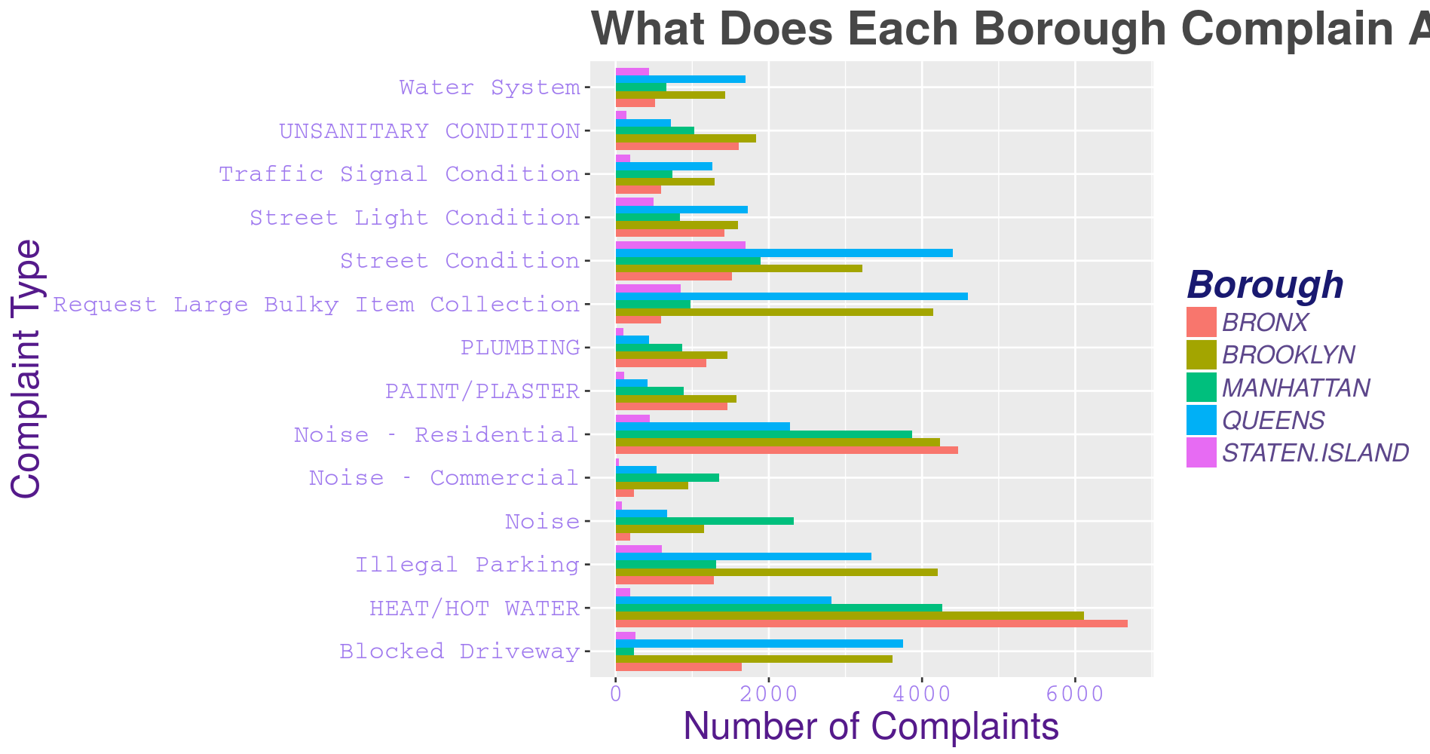

There’s a wealth of information in this section, which shows the frequency of complaints by Borough. We can easily see that all of the boroughs outside of Staten Island have similar levels of complaint frequency. This is due to the simple fact of the populations of each borough, as see here on the left.

If we dive in to what Staten Islanders complain about, we can see that the top two are *Street Condition*, and *Request Large Bulky Items*. Interestingly, If we look at just Staten Island and Queens side by side, we see a common trend in that the two top complaints are similar. This may be attributed to the fact that the both boroughs are reliant on cars for the bulk of travel means. Also, many of the properties are larger.

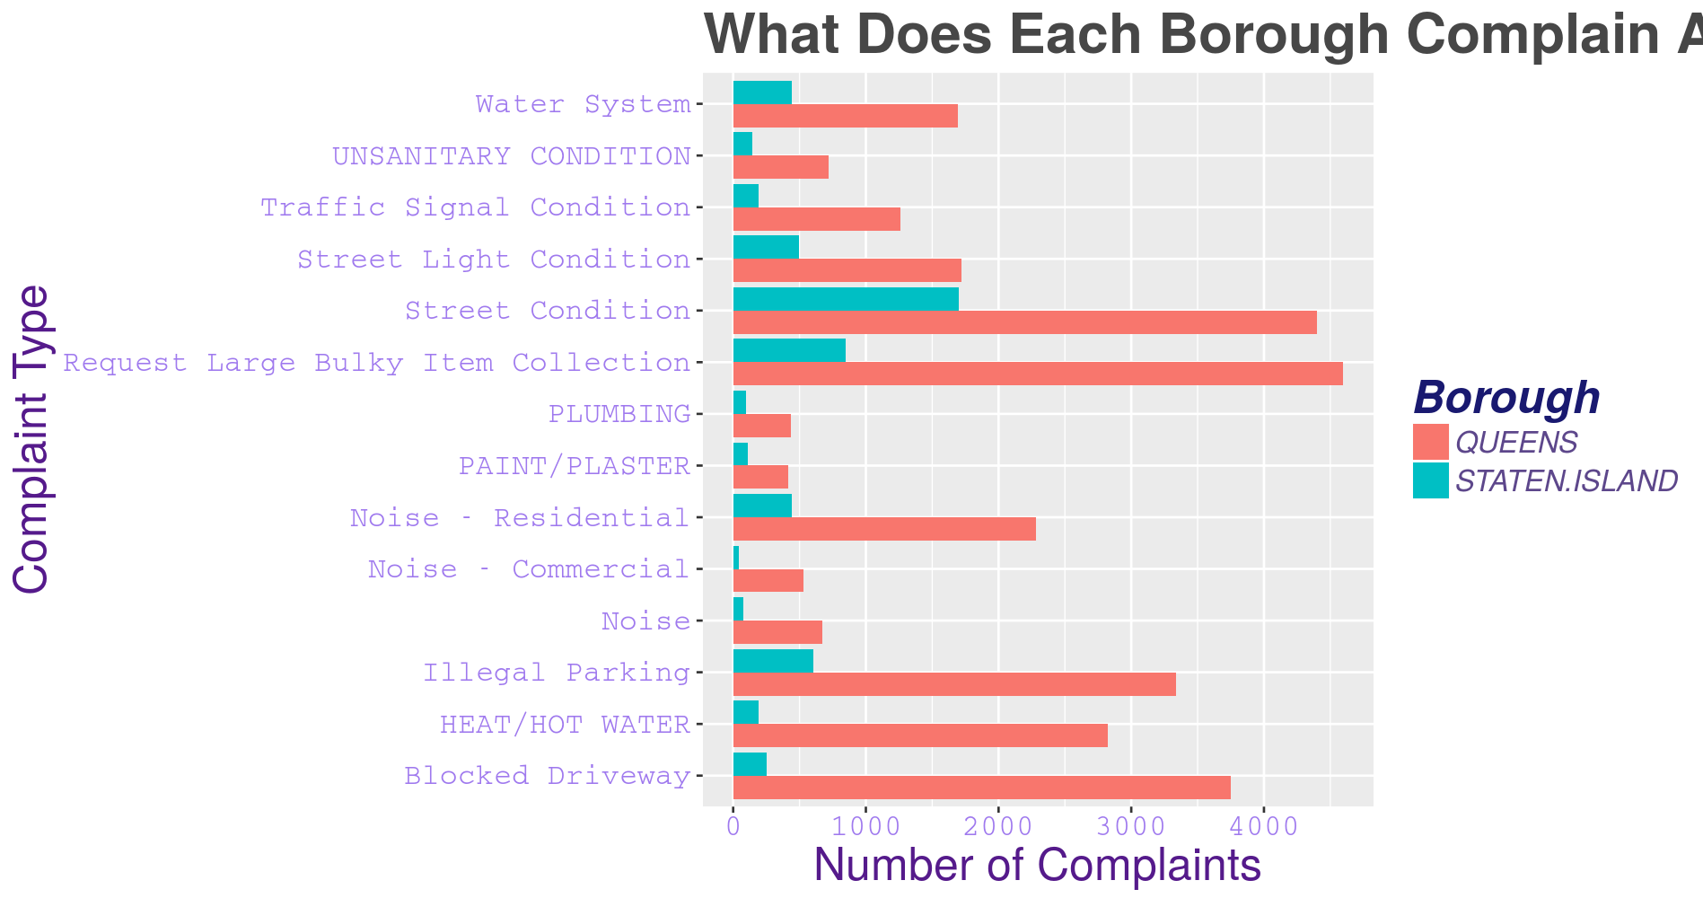

## Heading 2

Find even more easy-to-use tools on the Insert tab, such as to add a hyperlink or insert a comment.

“Quote”

To apply any text formatting you see on this page with just a tap, on the Home tab of the ribbon, check out Styles.

|  |  |  |
| --- | --- | --- |
|  | Column Heading | Column Heading |
| Row Heading | Text | 123.45 |
| Row Heading | Text | 123.45 |

Source: NYC Borough population statistic: <https://www.citypopulation.de/php/usa-newyorkcity.php>