Where Does Taiwan's Food Waste Go? A Data Review of the System Behind Baked Tipsy, 2015–2024
Holly Liou

1. Introduction
I founded Baked Tipsy to explore whether surplus bread could become an ingredient rather than a waste product. Having exited the business, I wanted to examine the waste-management system surrounding that experiment, rather than assume that upcycling necessarily delivers substantial environmental benefits. This report places my entrepreneurial experience within Taiwan's municipal waste system. It is a descriptive review, not a lifecycle assessment or an evaluation of Baked Tipsy's commercial performance.
My research asks how much food waste Taiwan records as recovered, which destinations receive it, how these quantities changed over the study period, and how recovery per resident differs across counties and cities. I examine a combined hypothesis: recorded food-waste recovery has contracted; growth in composting and other recovery routes has not fully replaced the decline in pig-feed use; and recovered quantities per person vary substantially across localities. These propositions concern recorded flows, not the underlying causes of waste generation or collection performance.
The distinction matters for a startup review. A product can demonstrate a possible use for surplus material without resolving the larger challenges of collection, treatment capacity, or market demand. Understanding those surrounding flows provides a more useful basis for reflection than either celebrating upcycling uncritically or dismissing it because a single business operates at a limited scale.

2. Data and Methods
I used the Ministry of Environment's STAT_P_150, “General Waste Discharge Account” (一般廢棄物排放帳), for national annual flows, and STAT_P_45, “General Waste Clearance and Treatment” (一般廢棄物清理情況), for county and city comparisons. National analysis covers 2015–2024. For population denominators, I used the Ministry of the Interior's Department of Household Registration tables, “Village, Neighborhood, Household and Population Counts by Sex and Area” (村里鄰戶數及人口數按性別及區域別分), selecting December year-end populations.
The analysis was implemented in Python using pandas and Plotly in Google Colab. I converted Republic of China calendar years to Gregorian years by adding 1911, standardized county names, and merged annual county records with population by year and county. The population merge was checked for duplicate keys and missing matches. The county comparison includes all 22 counties and cities in 2024.
I calculated the food-waste recovery share as recovered food waste divided by total general waste generated, multiplied by 100. Although the chart labels this a “recovery rate,” it measures food recovery's share of the overall waste stream, not the proportion of all food waste recovered. Per-capita recovery equals recovered tonnes multiplied by 1,000 and divided by registered population. I also calculated generated waste per resident and food recovery's share of county waste generation. A Sankey diagram presents national waste destinations and the subsequent division of recovered food waste into composting, pig feed, and other uses.

3. Findings

The national waste system is much larger than its separately recovered food stream
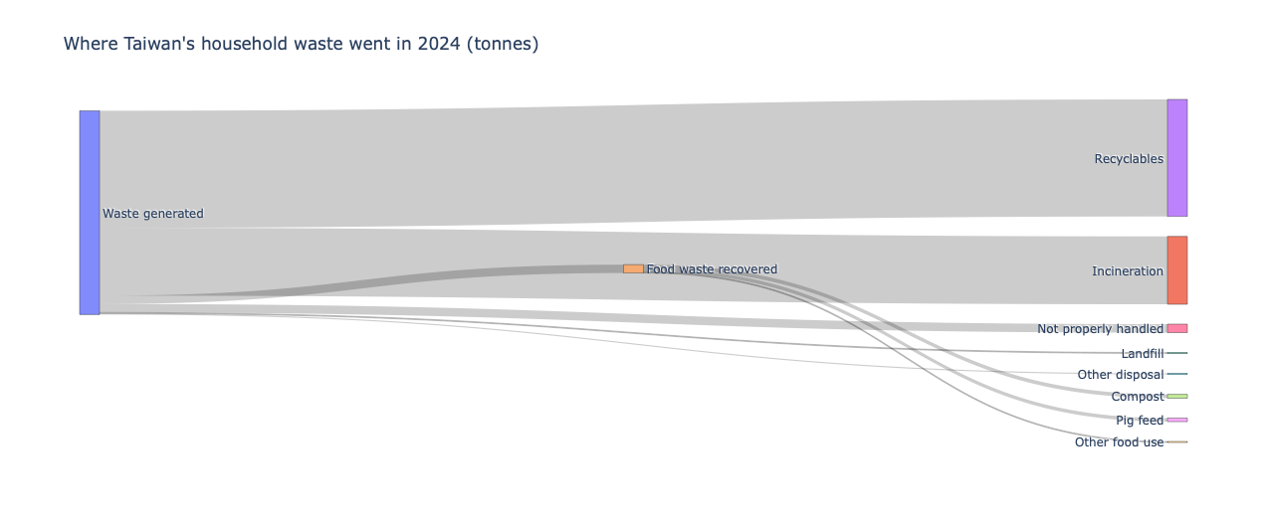
Figure 1. Where Taiwan's household waste went in 2024 (tonnes).
Taiwan recorded 12,351,875 tonnes of general waste generated in 2024. Recyclables accounted for 7,094,531 tonnes, or 57.44%, while incineration accounted for 4,112,991 tonnes, or 33.30%. Separately recovered food waste totaled 505,302 tonnes, equivalent to 4.09% of total generation. Within that food stream, 231,369 tonnes went to composting, 216,361 tonnes to pig feed, and 57,572 tonnes to other uses.
The Sankey makes the relative scale of these recorded destinations visible. Food recovery is a distinct but comparatively small stream within the overall account. It does not show that food waste itself represents only a small fraction of generated waste: food discarded in mixed garbage is not separately identified here. Likewise, “other uses” is an aggregate category, not evidence that a particular high-value upcycling technology has expanded.

Other destinations did not fully offset the decline in pig-feed use
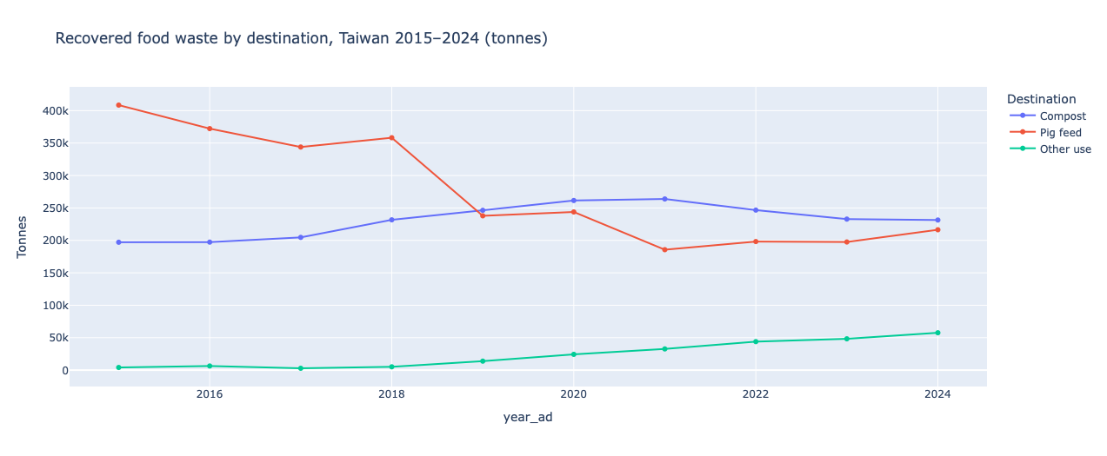
Figure 2. Recovered food waste by destination, 2015–2024 (tonnes).
Pig-feed recovery fell from 408,524 tonnes in 2015 to 237,849 tonnes in 2019, a decline of 170,675 tonnes, or 41.78%. Over the same interval, composting rose from 197,107 to 246,367 tonnes, gaining 49,260 tonnes. Other uses gained 9,752 tonnes. These increases were substantially smaller than the reduction in pig-feed use, and total recorded food recovery fell from 609,706 to 498,045 tonnes.
Composting first exceeded pig feed in the observed annual series in 2019. This was a change in the balance of recorded destinations, not simply an expansion of recovery capacity. By 2024, pig-feed use remained below its 2015 level, at 216,361 tonnes. Other uses had increased from 4,076 to 57,572 tonnes, but total food recovery remained below the starting level. Thus, the data support the narrower hypothesis that increases in alternative recorded destinations did not fully offset the pig-feed decline. They do not identify where the difference went or establish that it was incinerated.

Food recovery contracted overall, but not continuously
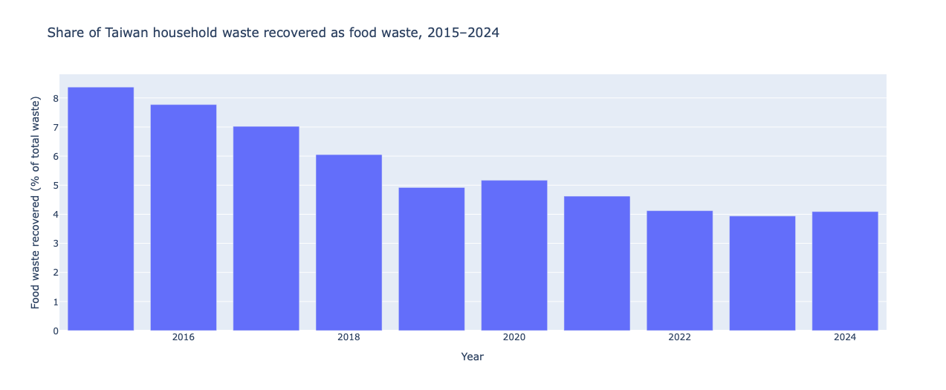
Figure 3. Food waste recovered as a share of total household waste, 2015–2024.
Total generated waste increased from 7,282,863 tonnes in 2015 to 12,351,875 tonnes in 2024, an increase of 69.60%. Over the same period, recorded food recovery declined by 17.12%, from 609,706 to 505,302 tonnes. Food recovery's share of generated waste consequently fell from 8.37% to 4.09%.
This endpoint comparison supports an overall contraction, but not a continuous annual decline. Recovered food waste increased from 478,565 tonnes in 2023 to 505,302 tonnes in 2024. The recovery share also rose over that interval, from 3.94% to 4.09%. The longer-term pattern therefore combines a lower endpoint with intervening fluctuations and a recent rebound.
The denominator requires particular care. Generated waste rose from 7,851,606 tonnes in 2017 to 9,834,046 tonnes in 2018, a 25.25% increase. Until changes in reporting coverage or definitions are verified, comparisons spanning that break should be interpreted cautiously. A later comparison still shows a lower food-recovery share: 4.92% in 2019 versus 4.09% in 2024. However, absolute food recovery was slightly higher in 2024 than in 2019. A falling share can therefore coexist with growth in recovered tonnage when total recorded waste grows faster.

County differences remain substantial after excluding offshore counties
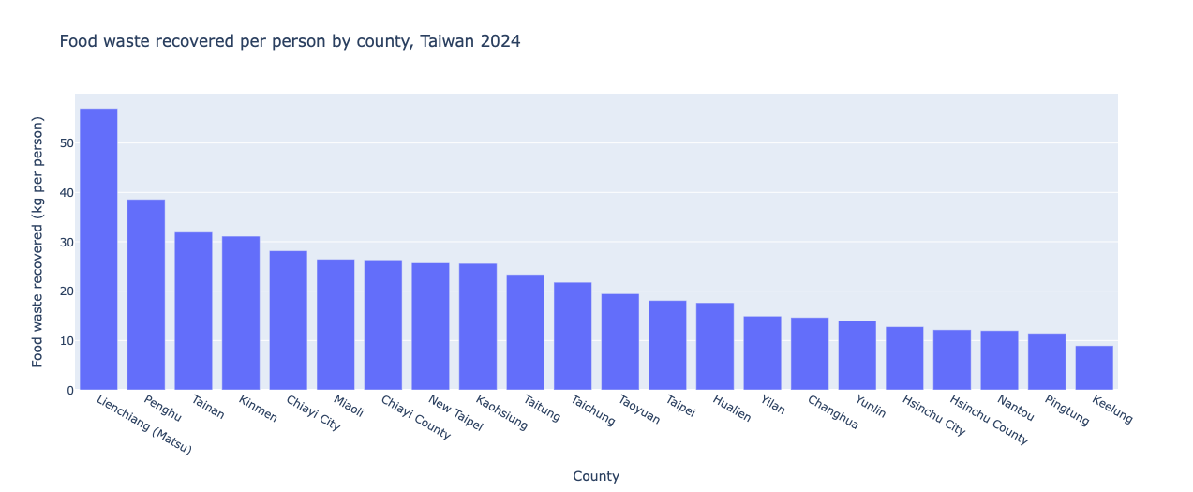
Figure 4. Food waste recovered per registered resident by county, 2024 (kg).
Using year-end registered population, Lienchiang County (Matsu) recorded the highest food recovery per person, at 57.0 kg, compared with 8.9 kg in Keelung City, the lowest. The unrounded highest-to-lowest ratio was approximately 6.4. Penghu County recorded 38.6 kg per person, Tainan City 31.9 kg, Kinmen County 31.1 kg, and Chiayi City 28.2 kg.
Because offshore counties have small registered populations and may serve visitor populations, I also excluded Lienchiang, Penghu, and Kinmen. Among the remaining jurisdictions, Tainan was highest and Keelung lowest, with an approximately 3.6-fold difference. The geographic spread is therefore not solely an offshore-county effect.
These results establish variation in recorded recovery per registered resident. They do not rank environmental performance or demonstrate that policy differences explain the spread. Differences in collection coverage, waste composition, visitor activity, and reporting practices are possible explanations requiring additional evidence.

4. Limitations
The datasets describe general or municipal waste, not a comprehensive food-loss inventory. They do not provide a complete account of business and industrial waste or pre-consumer food losses. Baked Tipsy's bakery-surplus input belongs to a different supply context, so municipal recovery cannot measure its available bread supply, avoided disposal, or environmental benefit. No emissions savings or economic returns are estimated here.
The unexplained 2018 increase in total generation may reflect a reporting or definitional change, but that explanation remains unverified. Mixed-garbage food content is also unmeasured, preventing estimation of unrecovered food waste. Year-end registered population is a consistent denominator rather than a measure of people actually served throughout the year; visitor activity could inflate apparent per-resident recovery, particularly offshore. County variation alone cannot establish causality.
African swine fever controls provide documented policy context, not a verified explanation of the observed decline. An official Environmental Protection Administration notice instructed non-compliant food-waste-feeding farms to switch to conventional feed or leave production by March 31, 2019. It also described continued regulated food-waste feeding, rather than a universal ban [4]. Establishing the policy's contribution would require a separate causal analysis.
Finally, the published national destination totals exceed generated waste by one tonne in 2024, while county recovered food waste sums to 505,308 tonnes, six tonnes above the national figure. Some earlier food-destination subtotals also differ from their reported totals by one tonne. I retain source values without forcing reconciliation; these small discrepancies do not alter the reported rounded comparisons.

5. Reflection
Baked Tipsy succeeded as an act of advocacy. Years later, people still tell me the brand changed how they think about food waste, and the business earned revenue. I always knew our environmental impact was limited by scale. Each 4-tonne batch of beer used only 10–20 kg of surplus bread. But I did not understand how limited it was until I saw the system it sat within. Taiwan recovers about 505,000 tonnes of household food waste a year, the share recovered has roughly halved since 2015, and per-person recovery differs more than threefold between main-island counties. Against numbers like these, one product cannot move the system, however good its story. The levers are collection systems, treatment capacity, and policy. That is why I am learning to work with data, and why I want to move beyond advocacy and education toward work on industry-scale systems.
Baked Tipsy batch figures are the author's own estimates, not dataset values.

References
1. Ministry of Environment. STAT_P_150: 一般廢棄物排放帳. https://data.moenv.gov.tw/dataset/detail/STAT_P_150
2. Ministry of Environment. STAT_P_45: 一般廢棄物清理情況. https://data.moenv.gov.tw/dataset/detail/STAT_P_45
3. Ministry of the Interior, Department of Household Registration. 縣市村里鄰戶數及人口數, December population tables. Download portal: https://www.ris.gov.tw/info-popudata/app/awFastDownload/toMain_panel . Direct 2024 workbook: https://www.ris.gov.tw/info-popudata/app/awFastDownload/view?type=ods&m4c=m1s1&d5c=11300
4. Environmental Protection Administration. 非洲豬瘟防疫無假期 環保署春節無休稽查養豬場. Official notice describing the March 31, 2019 compliance deadline. https://enews.moenv.gov.tw/moenv-news/zh-tw/News/13385

