CS 499 Module One Assignment

- Self-Introduction

  - How long have you been in the Computer Science program?
4 years

  - What have you learned while in the program? List three of the most important concepts or skills you have learned.

I learned how programming languages are different but still share a lot of the same ideas. Once you understand one, it makes learning others way easier, kind of like how knowing one Romance language helps you learn the others.

I learned how working with tools like modern OpenGL and event-driven input systems teaches you a way of thinking. Once you understand one setup, you start noticing the same patterns in others and it becomes much easier to move into new technologies. It is kind of like learning to drive one car first, because after that other cars make a lot more sense.

I also learned how important teamwork and communication are in coding. Using Git correctly, writing code that is easy to read, and doing clear reviews really helps projects go smoothly. It feels a lot like back in highschool in the marching band, because when everyone communicates well and does their part the whole group succeeds together.

  - Discuss the specific skills you aim to demonstrate through your enhancements to reach each of the course outcomes.
I plan to show that I can build stronger and more secure programs by adding real security features and checking for weaknesses. I want my projects to show that I can think like a developer who protects users and systems.

I also want to upgrade my database skills by moving beyond basic stored lists in Python and using a real database system with proper queries and structure. This will help show that I can work with actual data systems the way they are used in real jobs.

Another skill I want to improve is organization. I want to keep my projects neat, structured, and updated instead of leaving them scattered and forgotten after each class. This will show professional habits and improvement in long term project management.

  - How do the specific skills you will demonstrate align with your career plans related to your degree?
Learning stronger security practices supports my career goals because secure software is needed everywhere, especially in government and corporate environments. Being able to write programs that protect data and prevent threats will make me a stronger candidate for programming roles.

Improving my database skills aligns with my career goals because almost every modern system stores, manages, and retrieves data. Knowing how to design and use real databases, instead of simple storage in code, will help me work in many different computer science jobs, especially those related to software development or system back-end work.

Becoming more organized and improving how I structure projects supports my future in programming because professional developers need to manage code, folders, and updates in a consistent and clear way. Good organization helps with teamwork, long-term maintenance, and returning to projects later, which are all important skills in real work environments.

  - How does this contribute to the specialization you are targeting for your career?
These enhancements support the specialization I am aiming for by helping me build a stronger foundation in real software development practices. Strengthening my security skills prepares me for roles where protecting systems and data is important, which is common in government and professional tech work.

Improving databases helps me work with systems that rely on real data instead of just simple in-code storage. Getting better at organizing and structuring projects supports professional development workflows and long-term maintenance. Finally, expanding my OpenGL work with more advanced features gives me experience solving complex technical problems, which will help me in more advanced programming positions.

- ePortfolio Set Up:

  - Submit a screen capture of your ePortfolio GitHub Pages home page that clearly shows your URL.
    - You already have a repository in GitHub where you uploaded projects in previous courses. Your ePortfolio will reside in GitHub but can link to work at other sites, such as Bitbucket.

  - Use the GitHub Pages link in the Resource section for directions on:
    - How to create your GitHub website and publish code to GitHub Pages
    - Issues, such as adding links to other sites

  - Paste a screenshot of your GitHub Pages home page with your URL clearly showing in the space below.

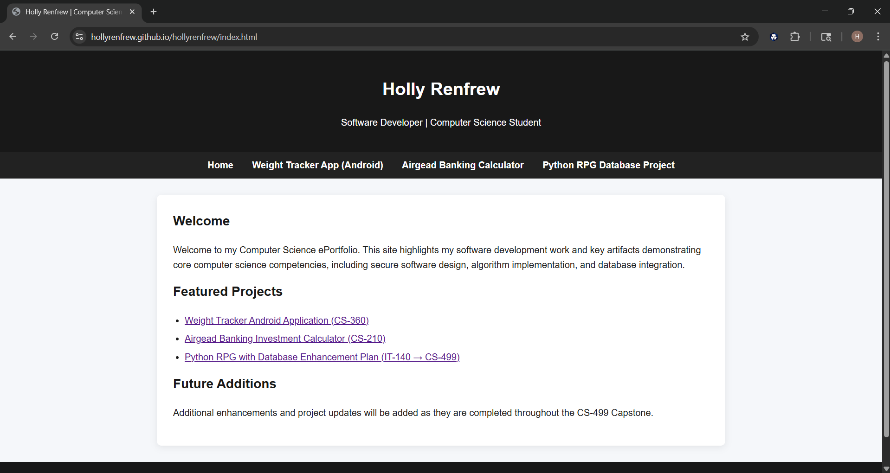

- Enhancement Plan:

  - Category One: Software Engineering and Design
    - Select an artifact that is aligned with the software engineering and design category and explain its origin. Submit a file containing the code for the artifact you choose with your enhancement plan.

CS 360 – Weight Tracker Application

    - Describe a practical, well-illustrated plan for enhancement in alignment with the category, including a pseudocode or flowchart that illustrates the planned enhancement.
For this enhancement, I hope to improve the login system to strengthen security and protect user accounts. I will replace the current “remember me” SharedPreferences method with secure session storage using Android’s EncryptedSharedPreferences so passwords and sensitive data are never stored directly. I will also add login rate-limiting so repeated failed attempts temporarily lock the account, reducing the risk of brute-force guessing.

Additionally, I will add optional two-factor authentication (2FA) for users who want extra protection. When enabled, the user will enter a one-time code along with their password. All login messages and errors will be generic to prevent username guessing. Finally, I will clean up how SMS permission and phone numbers are handled so they are only used after user consent.

Pseudocode:
onLogin(username, password):
if tooManyFailedAttempts(username): show "Try again later"
if verifyPassword(password) == false:
recordFailedAttempt(username)
show "Invalid credentials"
else:
resetFailedAttempts(username)
if 2FA enabled:
requestCode()
if codeInvalid: show "Invalid credentials"
token = createSecureSessionToken()
saveToEncryptedPrefs(token)
goToDashboard()

    - Explain how the planned enhancement will demonstrate specific skills and align with course outcomes.

      - Identify and describe the specific skills you will demonstrate that align with the course outcome.

This enhancement shows skills in secure software design by protecting login information, using encrypted storage, and adding two-factor authentication and login rate-limiting. It also demonstrates the ability to follow real-world security practices for user authentication and defend against common attacks like password guessing or unauthorized access.

      - Select one or more of the course outcomes below that your enhancement will align with.
- Design, develop, and deliver professional-quality communications adapted to specific audiences and contexts.
- Demonstrate an ability to use well-founded and innovative techniques, skills, and tools in computing practices for the purpose of implementing computer solutions that deliver value and accomplish industry-specific goals.
- Develop a security mindset that anticipates adversarial exploits in software architecture and designs to expose potential vulnerabilities, mitigate design flaws, and ensure privacy and enhanced security of data and resources.

Course Outcomes:

- Employ strategies for building collaborative environments that enable diverse audiences to support organizational decision-making in the field of computer science.
- Design, develop, and deliver professional-quality oral, written, and visual communications that are coherent, technically sound, and appropriately adapted to specific audiences and contexts.
- Design and evaluate computing solutions that solve a given problem using algorithmic principles and computer science practices and standards appropriate to its solution while managing the trade-offs involved in design choices.
- Demonstrate an ability to use well-founded and innovative techniques, skills, and tools in computing practices for the purpose of implementing computer solutions that deliver value and accomplish industry-specific goals.
- Develop a security mindset that anticipates adversarial exploits in software architecture and designs to expose potential vulnerabilities, mitigate design flaws, and ensure privacy and enhanced security of data and resources.

  - Category Two: Algorithms and Data Structures

- Select an artifact that is aligned with the algorithms and data structures category and explain its origin. Submit a file containing the code for the artifact you choose with your enhancement plan. You may choose work from the courses listed under Category One.

CS-210 Airgead Banking Investment Calculator

- Describe a practical, well-illustrated plan for enhancement in alignment with the category, including a pseudocode or flowchart that illustrates the planned enhancement.

To enhance this artifact for the Algorithms and Data Structures category, I will upgrade the calculation logic to perform monthly compound-interest calculations with annual aggregation instead of annual-only updates. I will also introduce a dynamic data structure (std::vector) to store yearly results in a custom struct containing the year, ending balance, and interest earned. This enhancement increases the algorithmic complexity, accuracy, and scalability of the program and provides structured access to calculated financial data.

Pseudocode:
balance = initial_investment
monthlyRate = (annual_interest / 100) / 12
results = empty vector

for each year in total_years:
yearlyInterest = 0

for each month in 12:
balance += monthly_deposit
monthlyInterest = balance * monthlyRate
balance += monthlyInterest
yearlyInterest += monthlyInterest

store (year, balance, yearlyInterest) in vector

- Explain how the planned enhancement will demonstrate specific skills and align with course outcomes.

  - Identify and describe the specific skills you will demonstrate to align with the course outcome.

This enhancement demonstrates algorithm design and improvement, data structure implementation, and modular software development. Specifically, I will refine the compound-interest algorithm, add structured result storage using a vector of year-records, and refactor the program for readability and maintainability. These skills reflect my ability to optimize computational logic, apply appropriate data structures, and enhance existing software based on real-world needs.
  - Select one or more of the course outcomes listed under Category One that your enhancement will align with.
- Design and evaluate computing solutions that solve a given problem using algorithmic principles and computer science practices and standards appropriate to its solution, while managing the trade-offs involved in design choices.
- Demonstrate an ability to use well-founded and innovative techniques, skills, and tools in computing practices for the purpose of implementing computer solutions that deliver value and accomplish industry-specific goals.

  - Category Three: Databases

    - Select an artifact that is aligned with the databases category and explain its origin. Submit a file containing the code for the artifact you choose with your enhancement plan. You may choose work from the courses listed under Category One.

This artifact is my console-based text adventure (RPG) in Python from IT-140. Players move through rooms (N/S/E/W) and choose between sword, bow, or axe, each with different might, hit rate, crit chance, and bow-specific ammo with double attacks. The current version stores player attributes (e.g., name, hp, str, and other stats) in memory during a run. It originated as a coursework text game to practice control flow, functions, and basic game logic.

For the Databases category, I will enhance it by integrating a relational database (SQLite) so player profiles, stats, boons/banes, inventory (e.g., arrows), room state, and combat logs are persisted and queriable with SQL.

    - Describe a practical, well-illustrated plan for enhancement in alignment with the category, including a pseudocode or flowchart that illustrates the planned enhancement.

- Add SQLite with a normalized schema:
  - players(id, name, hp, str, dex, int, luck, room, created_at)
  - modifiers(id, name, kind, hp, str, dex, int, luck) (boons/banes)
  - player_modifiers(player_id, modifier_id) (many-to-many)
  - inventory(player_id, item, qty) (e.g., arrows)
  - combat_log(id, player_id, turn, weapon, hit, crit, dmg, ts)

- Implement a data access layer (parameterized queries) for CRUD on player, modifiers, inventory, and logs.
- Update the game loop to save/load state from DB: name entry, apply selected boons/banes to stats, persist movement (room), and record combat outcomes.
- Seed default weapons and modifiers; support multiple save slots by player name.
Pseudocode:

on_start():
connect DB; ensure tables exist; seed default modifiers/weapons

main_menu():
if new_game:
name = input("Enter name")
base_stats = {hp:100, str:10, dex:10, int:10, luck:5, room:"start"}
chosen = choose_boons_and_banes()
final_stats = apply_modifiers(base_stats, chosen)
player_id = INSERT INTO players(name, hp, str, dex, int, luck, room)
for mod in chosen: INSERT INTO player_modifiers(player_id, mod_id)
else if continue:
player_id = SELECT id FROM players WHERE name = input_name ORDER BY created_at DESC LIMIT 1
load stats/room from players; load chosen modifiers

game_loop(player_id):
while playing:
room = SELECT * FROM rooms WHERE id = players.room
show_exits(room)
cmd = input(N/S/E/W or ATTACK or INVENTORY or SAVE/QUIT)

if move:
to = SELECT to_room FROM exits WHERE from_room=room AND direction=cmd
if to: UPDATE players SET room=to WHERE id=player_id

if attack:
weapon = SELECT * FROM weapons WHERE name=chosen
if weapon.needs_ammo: check arrows in inventory; decrement if >0
resolve_hit_crit_damage()
INSERT combat_log(...)

if save/quit: commit and exit
    - Explain how the planned enhancement will demonstrate specific skills and align with course outcomes.

      - Identify and describe the specific skills you will demonstrate that align with the course outcome.
The planned enhancement demonstrates my ability to design and implement a persistent data system within an existing software application. By integrating SQLite into the text-based RPG, I will transform the game from using temporary, in-memory variables to a persistent relational database that stores player profiles, stats, chosen boons and banes, inventory, room location, and combat logs.
This enhancement involves skills including database schema design, query construction, data modeling, and the use of secure parameterized SQL statements. Additionally, I will refactor my program using a structured data access layer, improving modularity and maintainability. These efforts illustrate my ability to apply professional software engineering practices and modern computing tools to create a more robust, scalable, and realistic game system.

      - Select one or more of the course outcomes listed under Category One that your enhancement will align with.

    - Design and evaluate computing solutions that solve a given problem using algorithmic principles and computer science practices and standards appropriate to its solution, while managing the trade-offs involved in design choices.
    - Demonstrate an ability to use well-founded and innovative techniques, skills, and tools in computing practices for the purpose of implementing computer solutions that deliver value and accomplish industry-specific goal.

- ePortfolio Overall Skill Set

  - Accurately describe the skill set to be illustrated by the ePortfolio overall.
    - Skills and outcomes planned to be illustrated in the code review

In the code review, I hope to show how I apply professional coding practices, such as modular structure, clear naming, and secure coding techniques. I plan to highlight how I use proper data handling, logic flow, and industry-standard approaches to authentication, storage, and data processing. The code review will demonstrate my ability to design, analyze, and refine solutions based on real-world expectations and software engineering standards.

    - Skills and outcomes planned to be illustrated in the narratives

In the narratives, I will explain how each enhancement strengthens the project and builds on the original course work. I will describe my thought process, the decisions I made, and how those choices reflect industry best practices. The narratives will also show my communication skills by clearly explaining technical decisions in an organized and understandable way.

    - Skills and outcomes planned to be illustrated in the professional self-assessment

In the professional self-assessment, I will reflect on my growth throughout the program and evaluate how I developed as a software professional. I will describe my strengths, identify areas of improvement, and explain how the skills I gained connect to my career goals. This will show my ability to think critically about my work and understand how to continue improving in a professional environment.

