# Questionnaire Analysis

The questionnaire was given to all employees in the IS department, the questionnaire aims were explained to them, and they were also informed as to why the results were required. From this sample, 11 completed questionnaires were returned. The users were given the option of completing the questionnaire anonymously if they preferred.

## Aims

The main aim of the questionnaire is to provide some primary data from the end users of the current system. As there are over 20 users of the current system, there was not enough time or resources to interview everyone. Therefore a questionnaire was devised to get some feedback from users, it was hoped that the feedback collect via the questionnaire would back up previous findings from the observation and interviews with managers. To allow a wide selection of feedback there was a mixture of closed and open questions; giving the respondents the opportunity to give their full opinion on the current system and allow possible suggestions for future development.

## Closed Question Analysis

To analyse the closed questions, the number of times a particular response was chosen was added up and then displayed on a bar graph to get a visual representation the results. From this the range of responses and the most commonly selected responses can be easily identified.

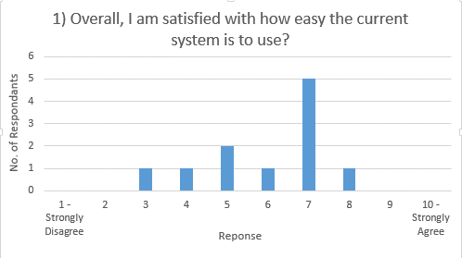**1) Overall, I am satisfied with how easy the current system is to use?**

|  |  |
| --- | --- |
| Response | Number of Respondents |
| 10 - Strongly Agree | 0 |
| 9 | 0 |
| 8 | 1 |
| 7 | 5 |
| 6 | 1 |
| 5 | 2 |
| 4 | 1 |
| 3 | 1 |
| 2 | 0 |
| 1 - Strongly Disagree | 0 |

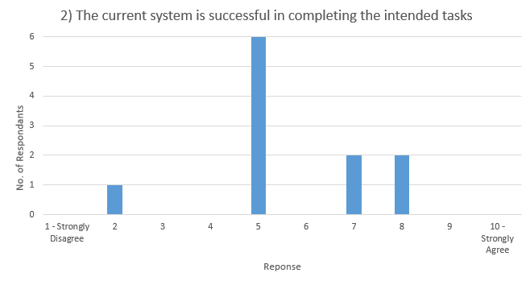**2) The current system is successful in completing the intended tasks**

|  |  |
| --- | --- |
| Response | Number of Respondents |
| 10 - Strongly Agree | 0 |
| 9 | 0 |
| 8 | 2 |
| 7 | 2 |
| 6 | 0 |
| 5 | 6 |
| 4 | 0 |
| 3 | 0 |
| 2 | 1 |
| 1 - Strongly Disagree | 0 |

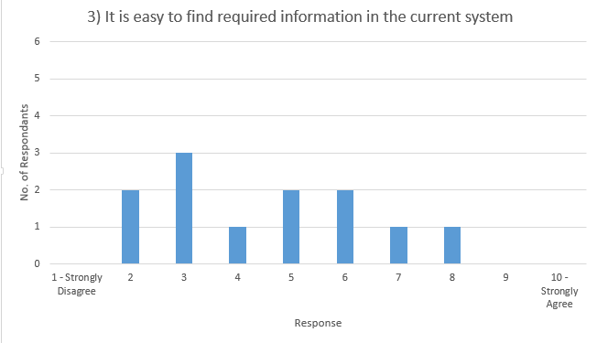**3) It is easy to find required information in the current system**

|  |  |
| --- | --- |
| Response | Number of Respondents |
| 10 - Strongly Agree | 0 |
| 9 | 0 |
| 8 | 1 |
| 7 | 1 |
| 6 | 2 |
| 5 | 2 |
| 4 | 1 |
| 3 | 3 |
| 2 | 2 |
| 1 - Strongly Disagree | 0 |

## Open Question Analysis

To analyse the open questions, all the responses have been categorised into groups, these groups are the headings of each column. Any further comments were then added into the table in the rows of the appropriate group. This allows any easier way to view all comments and highlight any key responses, it all shows any themes or common answers to the question.

**4) What does the current system do well?**

|  |  |  |  |
| --- | --- | --- | --- |
| Time Recording | Call Management | User Interaction | Nothing |
| Time Keeping | Displays priorities and fix times etc. | Lets colleagues know what needs doing and what has been done. | Left blank |
| Time reporting – weekly, monthly | Central point for issues. | Integrates well with our user base. |  |
| Good way to see how much time is spent [on a call] and what issues throughout the day/week/month | Provides historic information on issues/calls. |  |  |
|  | Ability to log calls against problem profiles. |  |  |
|  | Good for management of problem solving. |  |  |

**5) What improvements would you make to the current system?**

|  |  |  |  |
| --- | --- | --- | --- |
| Data Management | Reliability | Design | System use with the business/ Functionality |
| Better search functionality, the free text search isn’t the best when searching for a call. | Not crash every day. | Fewer click throughs. | System is being used for more than it is designed for. |
| Improve search capability – context search. | Stability – current system crashes a lot. | Better navigation and fewer icons. | Workflow driven problem determination and resolution. |
| Better management of issues. | Stop all the errors. I.e. Constantly crashing. | More user friendly – too cluttered. | Re-evaluation of how calls are assigned. |
| Easier to store information and gain access to it. | Improve reliability. | Create FAQ | Option for public/ private updates. |
| Issues being stored alphabetically. |  | Improve functionality – linking and unlinking calls. | Users to track their own f number (call) |
| The search facility is not always so successful – therefore a better search function. |  |  |  |

**6) What would you say are the most important features of a new helpdesk system for Numatic?**

|  |  |  |  |
| --- | --- | --- | --- |
| Call Management | Time Recording | Design | Functionality / System use with the business |
| Ability to record and track issues. | Time keeping and booking. | User friendly. | Used properly and updated by everyone. |
| A workload sharing system. | Time recording. | Simple and intuitive – avoid large user guide | User to monitor [call] progress. |
| Keeping track of customer issues. |  | Intuitive. | Merging duplicates. |
| Solution finding. |  |  | Better way of documenting solutions. |
| Suggesting solution before helpdesk call submitted. |  |  |  |
| Managing issues and being able to search easier for previous similar issues. |  |  |  |
| Searching of calls. |  |  |  |
| Historic data search and logging accurate information against issues. |  |  |  |

**7) Do you have any other comments or suggestions about the current or new system?**

Keep it simple.  
Current system is overloaded with junk.

## Overall Findings