**Strategy for Resume Template Modification**

Nicholas Hoats

South University

Course ID: ITS4117

Matthew Chrenka

10/24/2024

**Strategy for Resume Template Modification**

**Project Objective**

The purpose of this project is to enhance an existing resume template by making it modern, visually appealing and interactive. This re-work demonstrated from the web perspective that I understand HTML, CSS and JavaScript. I wanted to not just alter the look of the resume but add even more interactive elements — like a dark mode toggle and a download resume feature.

**Approach and Methodology**

1. Initial Analysis and Layout Understanding

Before making changes, I carefully reviewed the existing HTML and CSS structure of the provided resume template. My goal was to ensure the structural integrity of the document while implementing modern, user-friendly design choices. The layout consisted of sections for profile, experience, education, skills, and interests, each styled using a set of predefined colors and fonts. I maintained this structure but updated the styles to align with current design trends.

1. Styling Updates

To modernize the look of the resume, I applied the following key changes:

* Color Palette: I added smaller details in blue and orange to make the existing color scheme work with buttons styles throughout the resume. The buttons with high contrast, orange background (#ffb300) and white text. I also changed the background color to (#fdd835) which is a nice light orange whenever you hover over them.
* Buttons: I added a “Download Resume” and “Toggle Dark Mode” button at the bottom of the resume. The buttons are designed to match the overall color scheme and are interactive, with rounded corners and smooth hover transitions.

1. Interactivity and JavaScript Integration

A key part of modernizing the resume involved adding interactive elements using JavaScript:

* Dark Mode Toggle: To improve the user experience, I added a dark mode feature. When the user clicks the “Toggle Dark Mode” button, the background and text colors change to a dark theme. This feature was implemented by toggling a dark-mode class on the <body> element using JavaScript.
* Print Resume Functionality: To add a useful and interactive feature, I implemented a "Download Resume" button that allows the user to print or save the resume as a PDF. This button triggers the browser’s print functionality through JavaScript using the window.print() method. When the user clicks the button, the print dialog opens, providing an easy way to print the resume or save it as a PDF. This feature enhances the usability of the resume for both digital and physical copies, ensuring that the design can be shared in multiple formats.

1. Responsiveness and Flexibility

Given the variety of devices that users might view the resume on, it was important to make the design responsive. I ensured that the layout adjusts properly for smaller screens by using flexible units like percentages for width and adding padding where necessary.

1. Final Testing and Tweaks

After implementing the changes, I thoroughly tested the resume on multiple devices and browsers to ensure compatibility and consistency. I also made slight adjustments to the spacing and alignment of certain elements to ensure everything displayed perfectly regardless of screen size.

1. Source Code

**HTML**

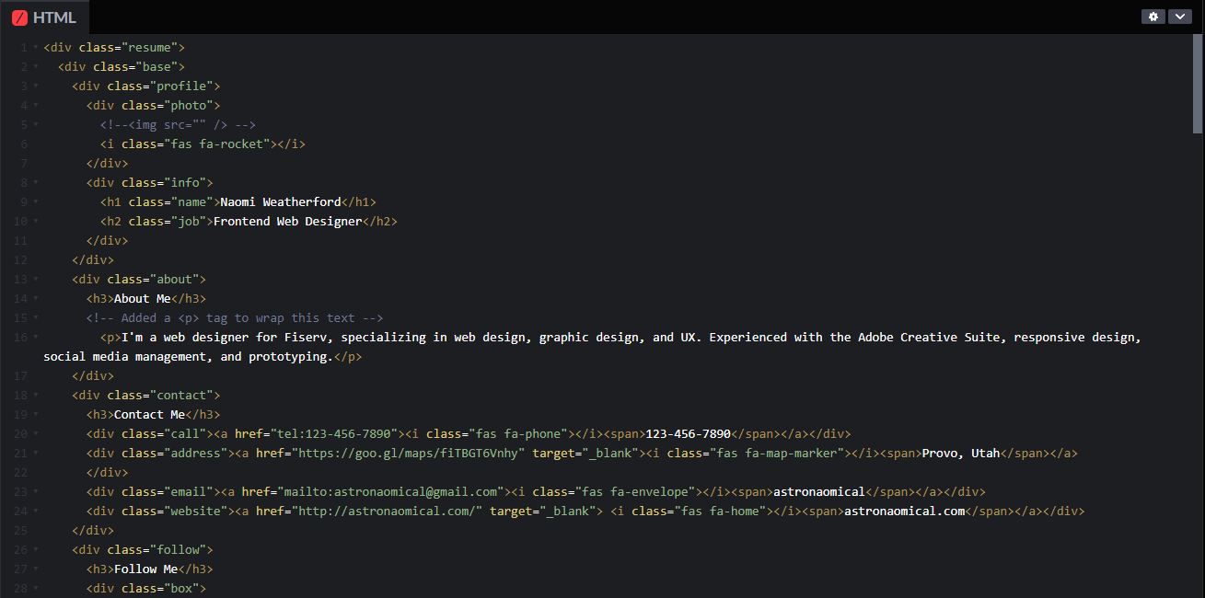

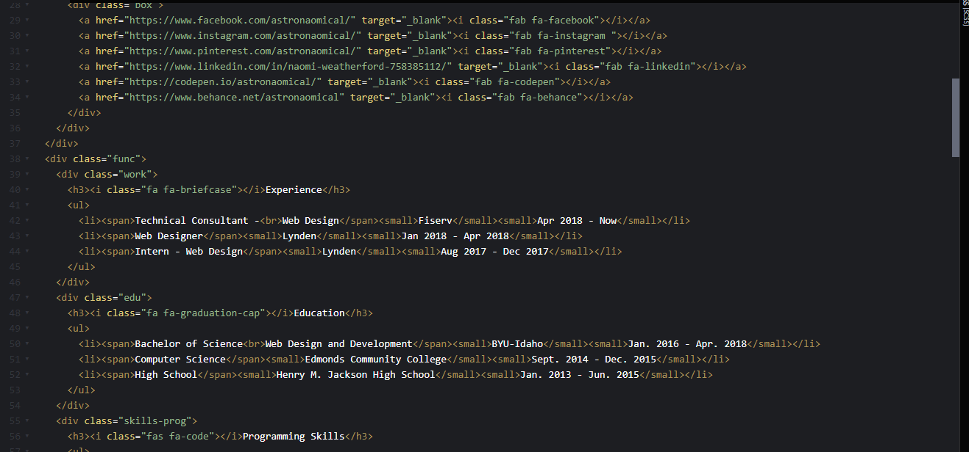

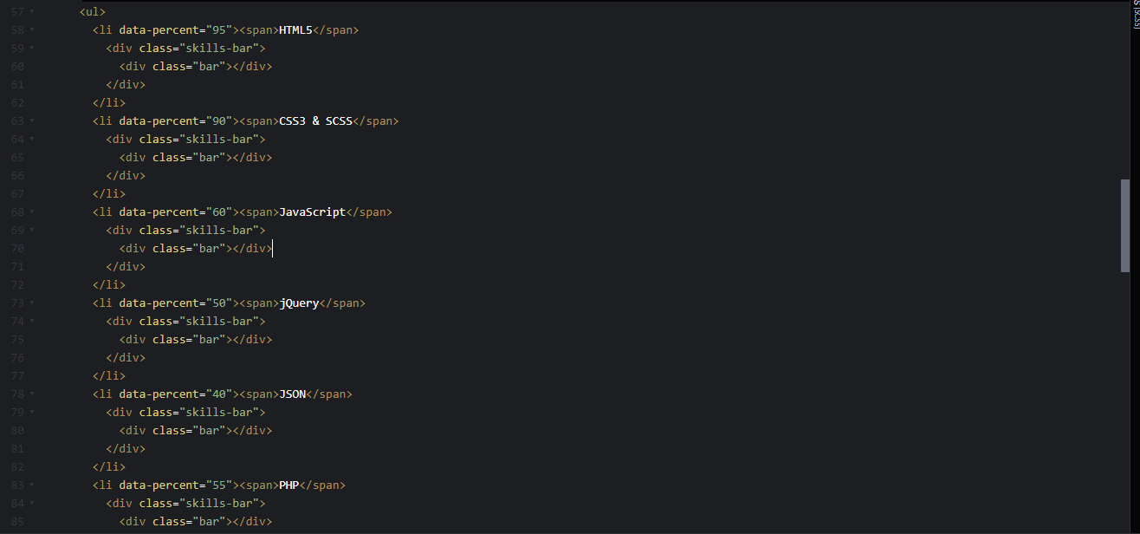

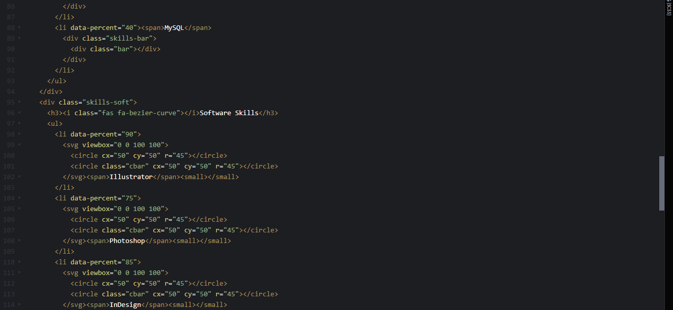

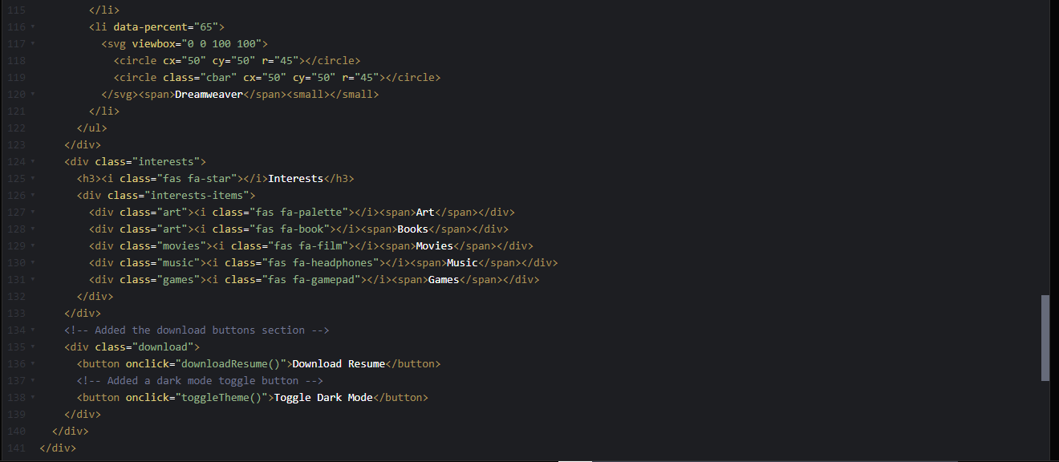

**CSS**

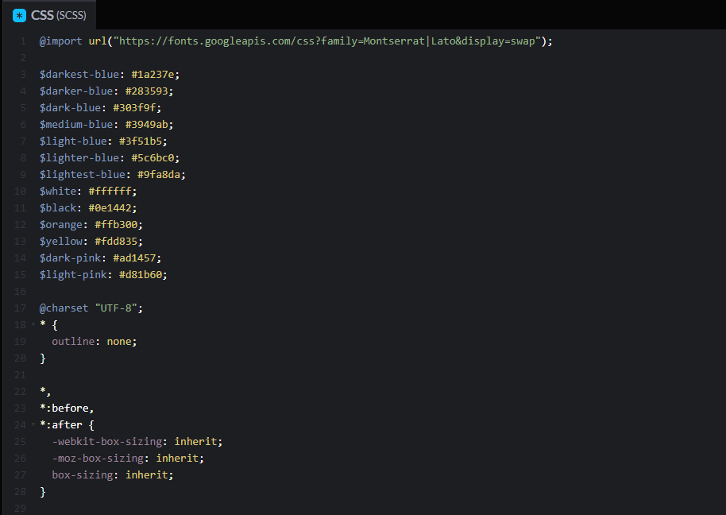

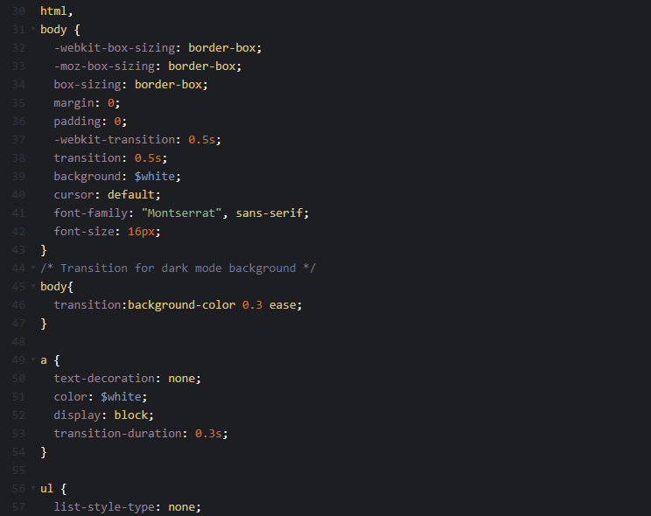

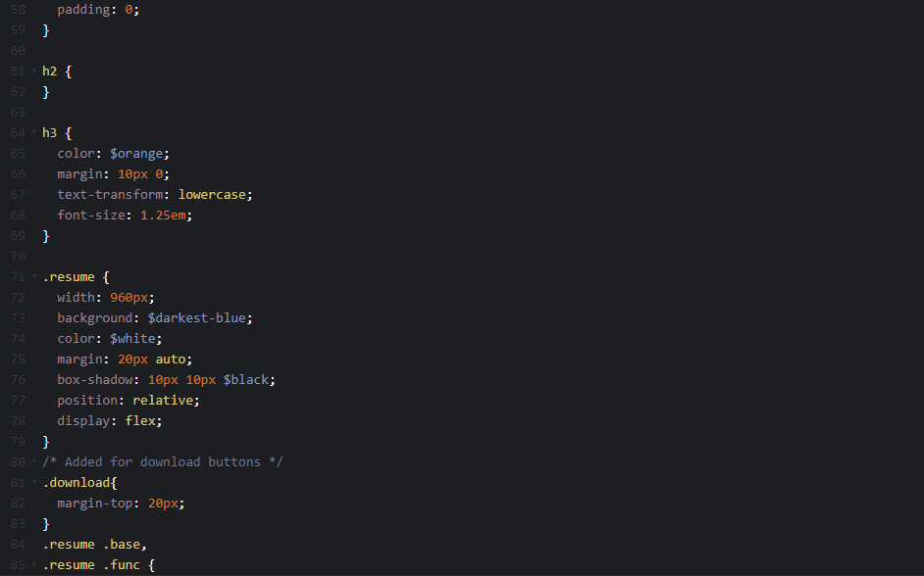

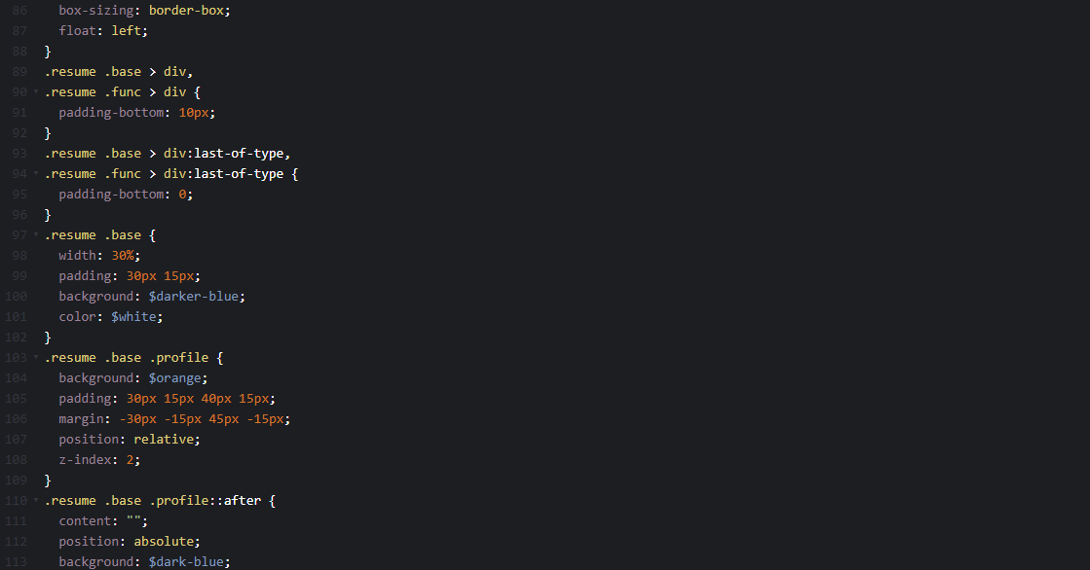

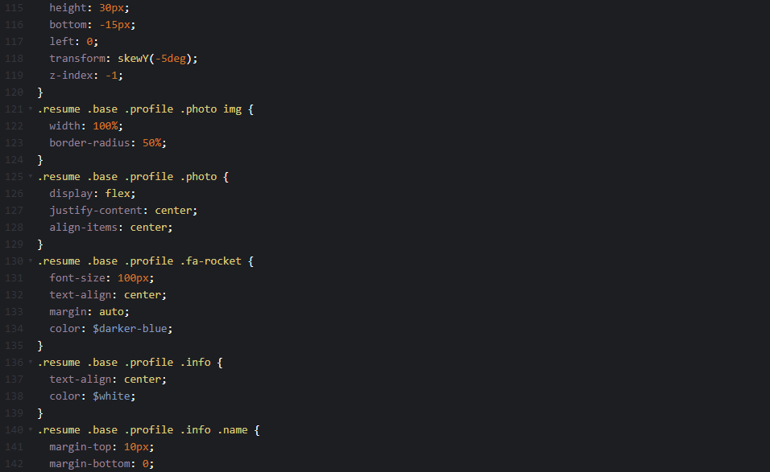

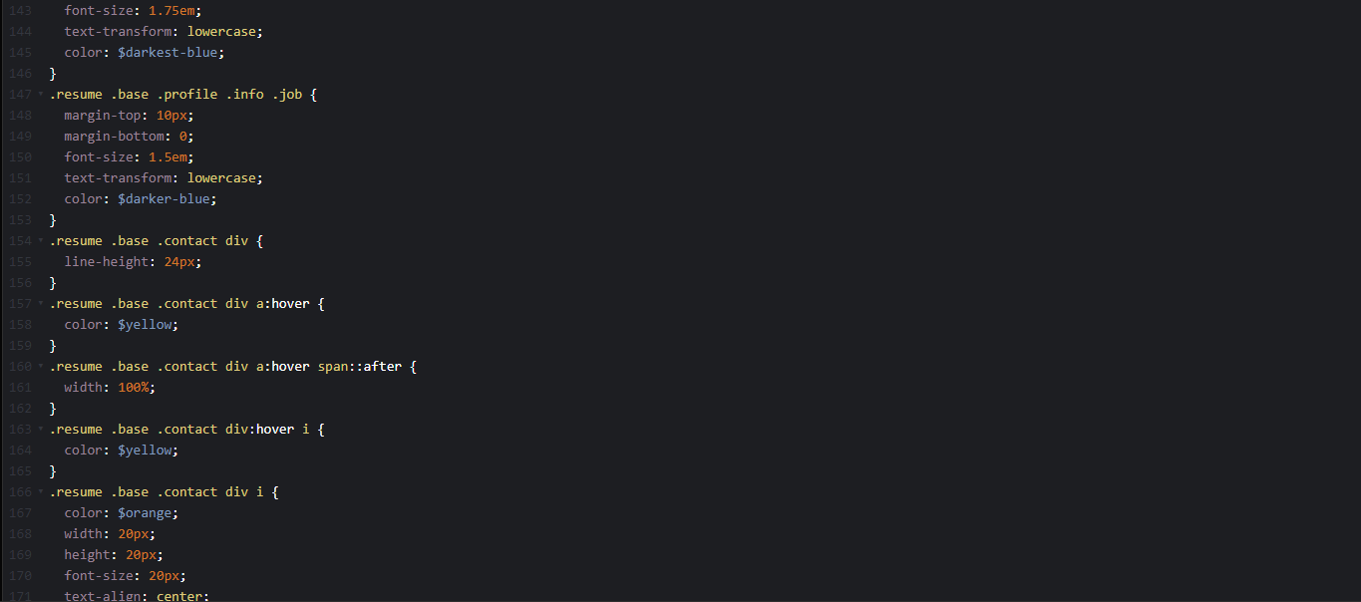

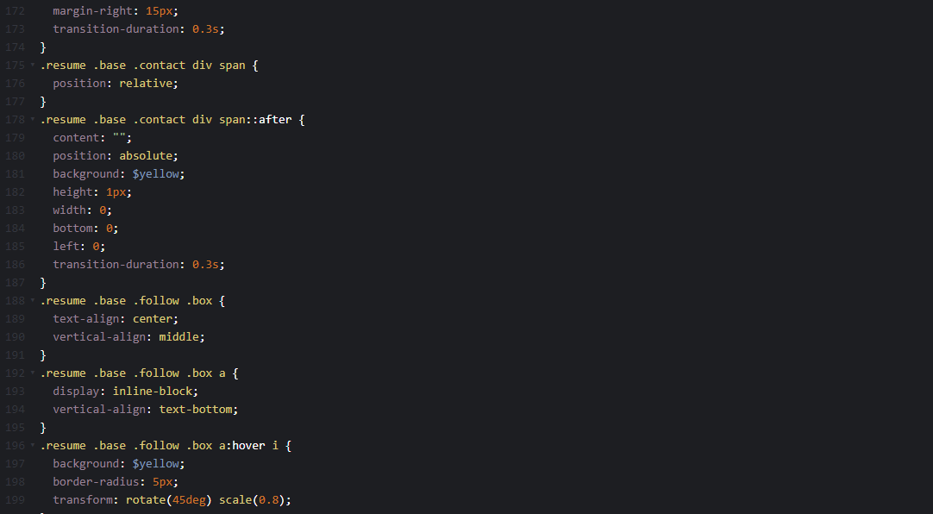

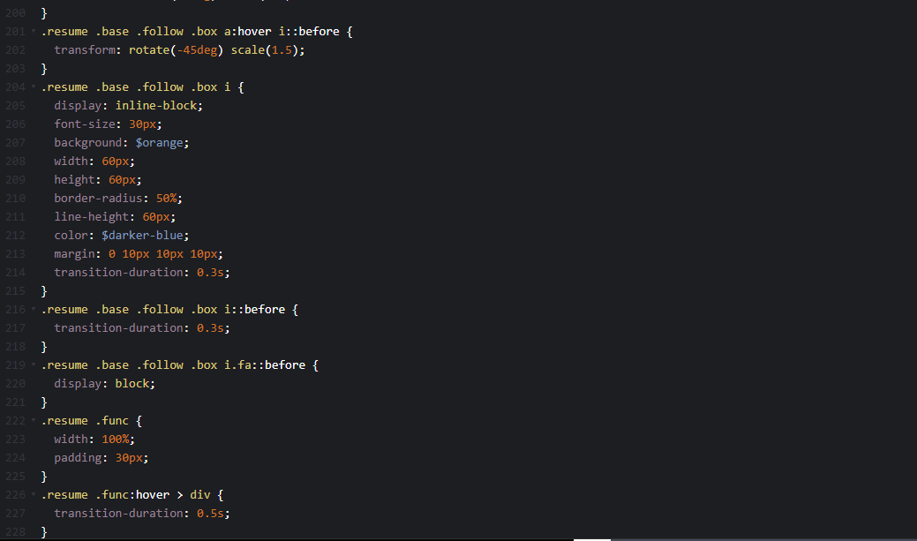

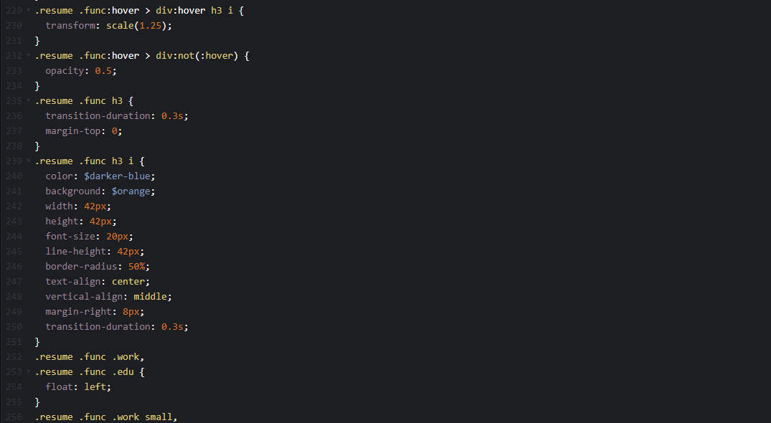

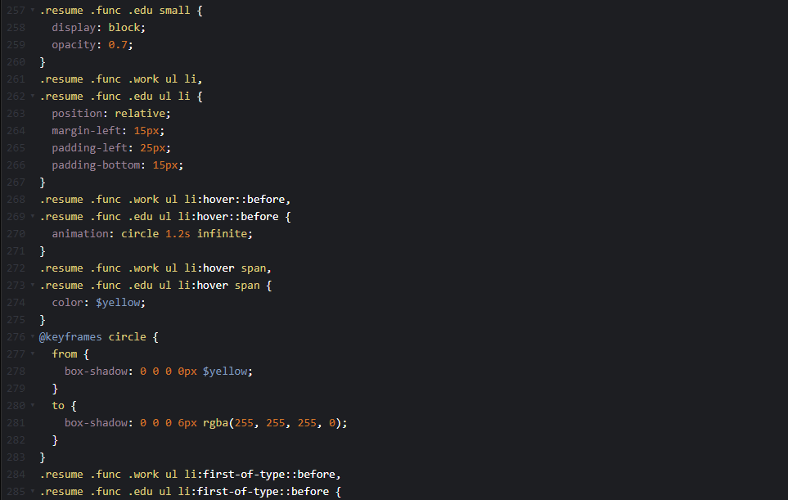

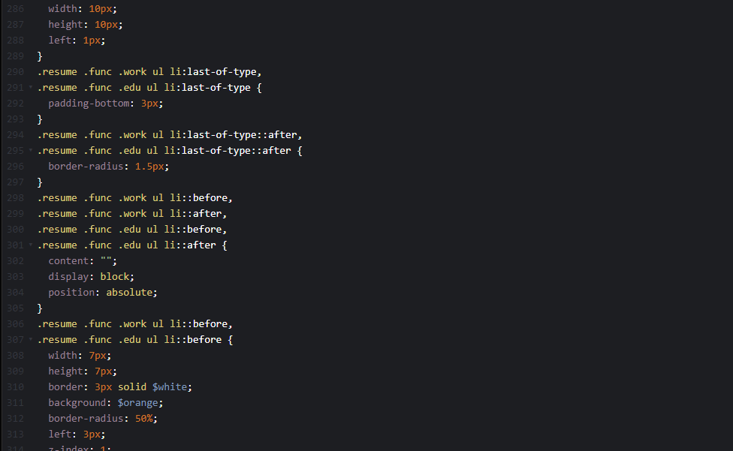

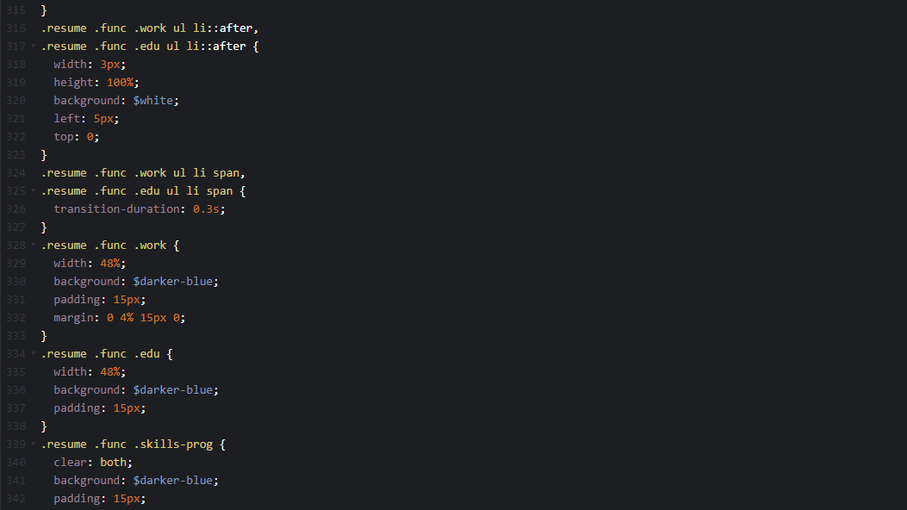

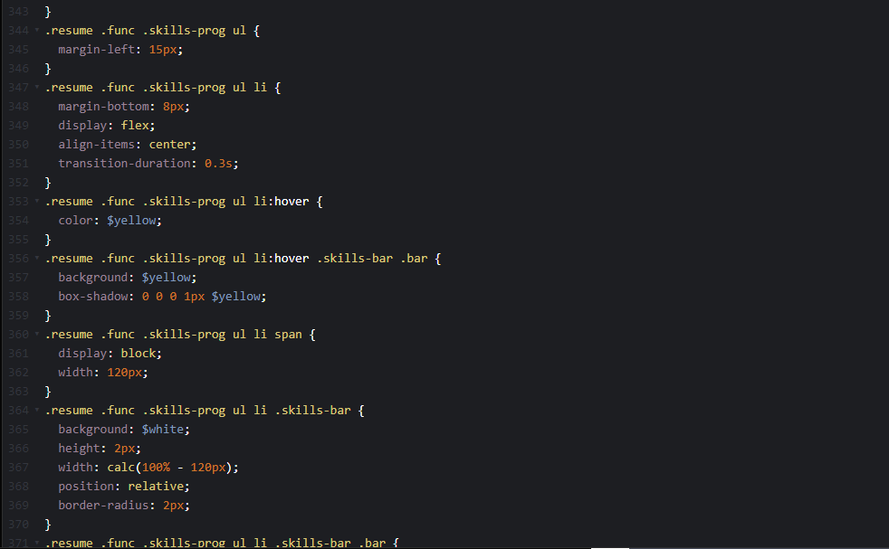

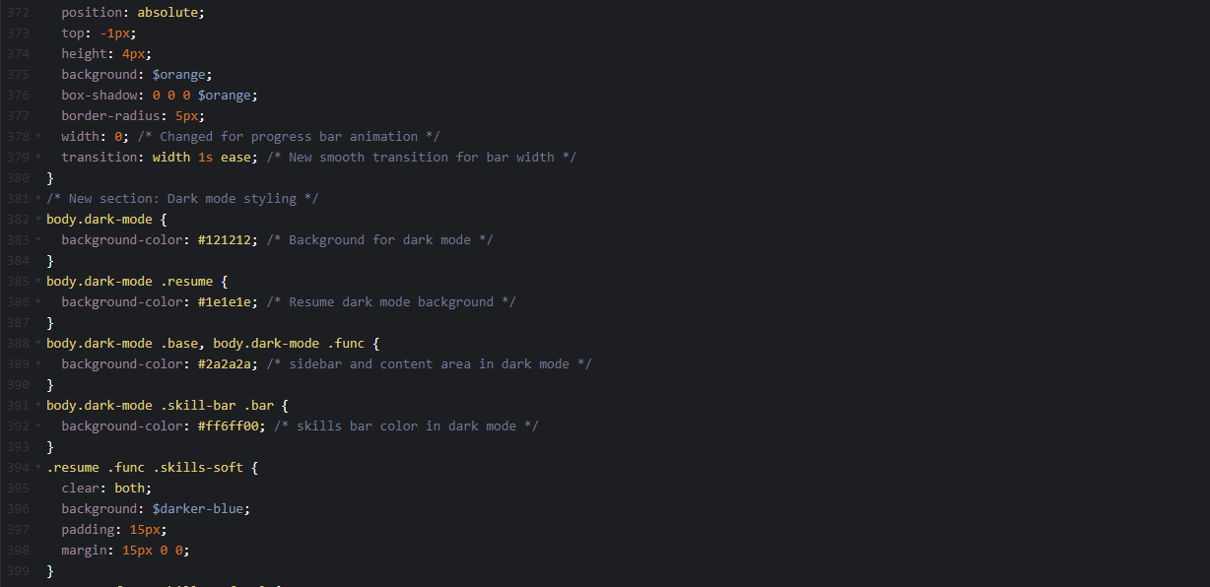

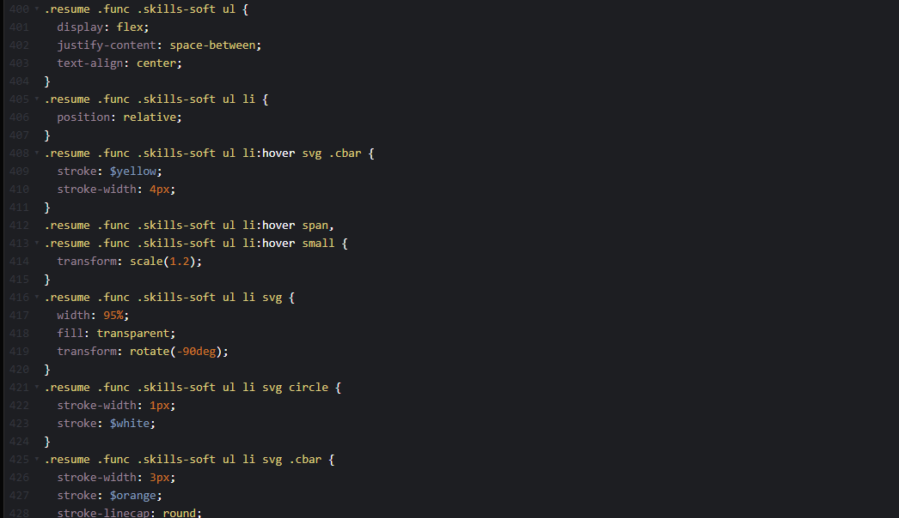

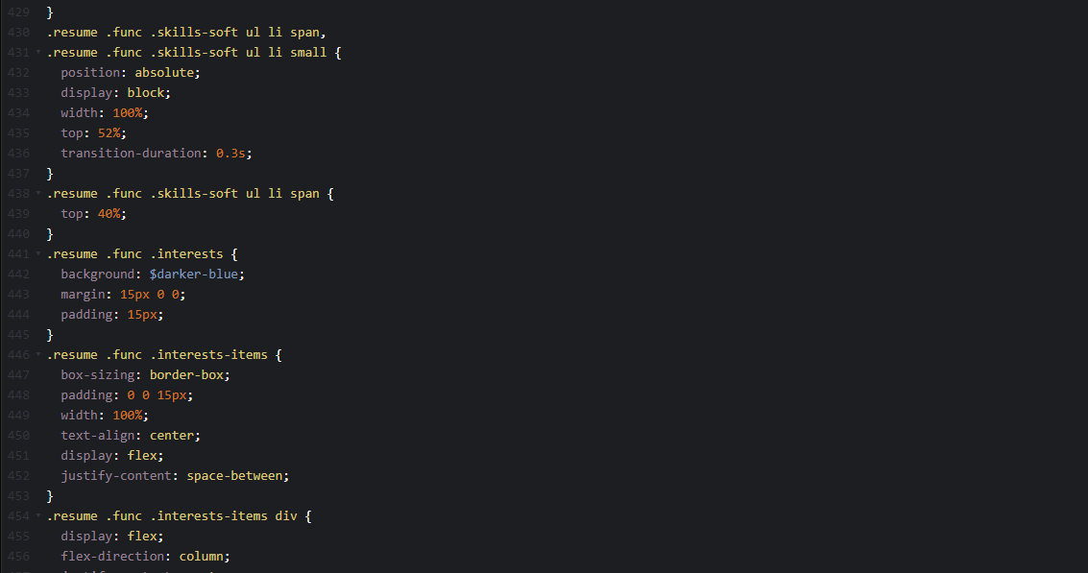

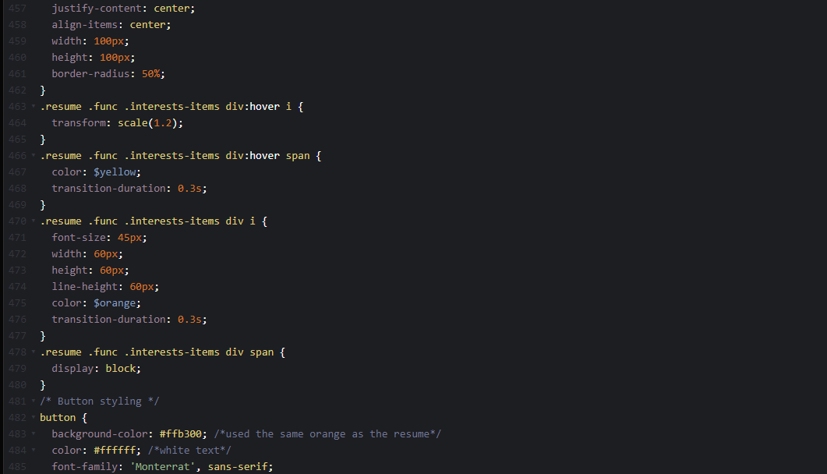

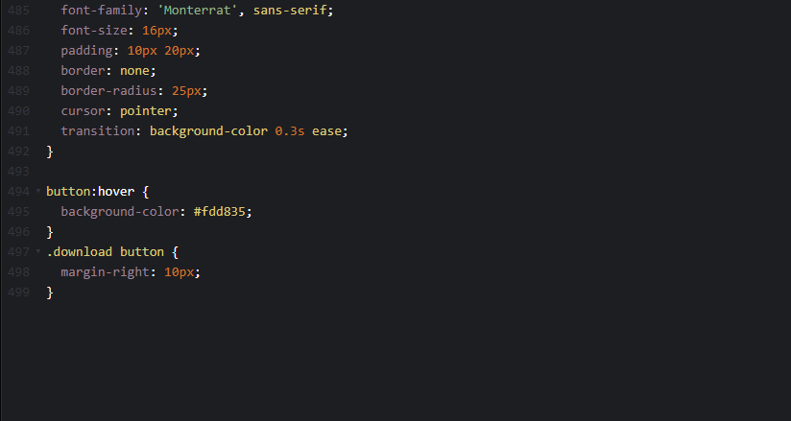

**JavaScript**

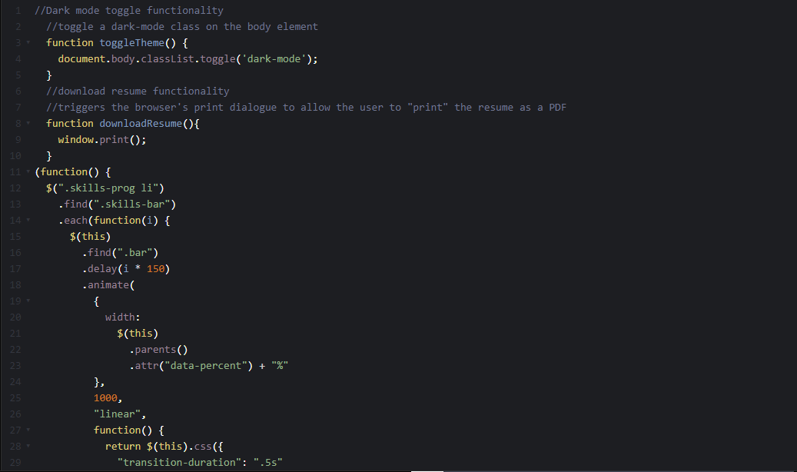

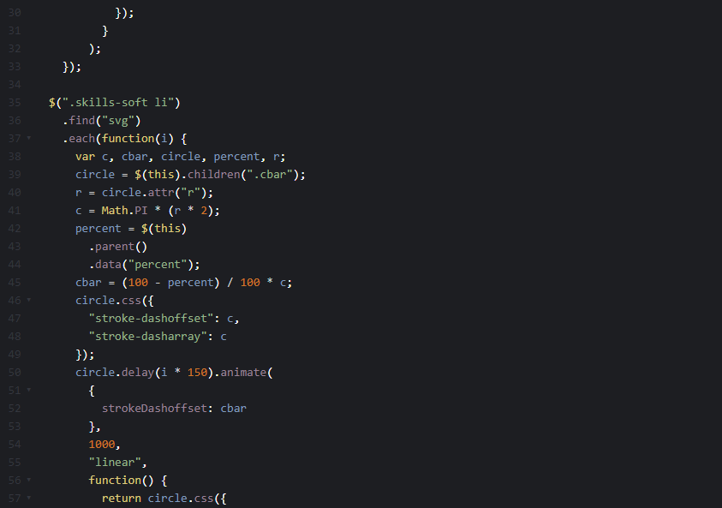

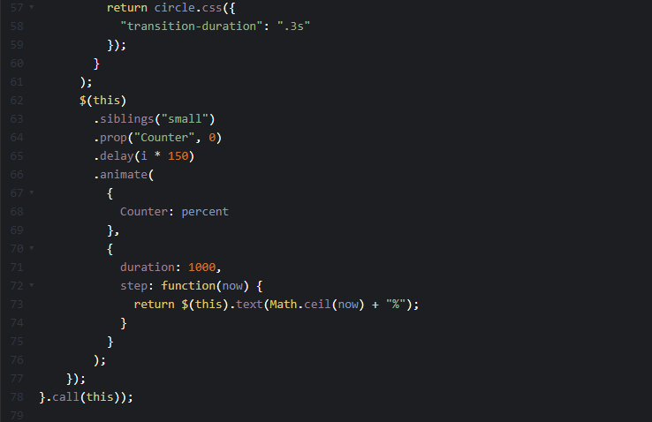

**Conclusion**

By applying these changes, I successfully transformed the provided template into a modern, interactive, and user-friendly resume. The design updates, paired with JavaScript enhancements, create a polished and engaging user experience.