Some title

Author One1,2, Author Two1, Author Three2*

1Cool School

2Sweet Center

*Corresponding author

Author Three: email

Department

University

Address

Phone

Author contact information

Author One: email

Author Two: email

Author Three: email

CRediT author statement

Author One: Conceptualization, Methodology, Validation, Formal Analysis, Investigation, Resources, Data Curation, Writing – Original Draft, Writing – Review & Editing, Visualization. Author Two: Software. Author Three: Supervision, Project Administration, Funding Acquisition.

# Abstract

Your abstract goes here.

# Keywords

key1; key2; key3

# 1 Introduction

Check out my [R Markdown Guide](https://www.hzaharchuk.com/rmarkdown-guide/) for more information on making this platform work for you!

## 1.1 Section 1

Some more text with a footnote[1] and a reference (Person, 2021).

## 1.2 Section 2

PersonOne and PersonTwo (2021) is an example of an in-text reference.

## 1.3 Section 3

Here are a couple of references (PersonOne et al., 2021; PersonOne & PersonTwo, 2021).

# 2 Methods

This template uses the mtcars data set included in base R.

## 2.1 Participants

You can reference the number of participants (in this case, the number of different car models in mtcars) from the child document: 32.

##### 2.2 Materials

You can add dynamic section number references; for example, Section 1. Just add {#your-label} after the section header. Note that labels can **only** have alphanumeric characters, which **do not** include underscores. Use dashes instead!

## 2.3 Procedure

You can also reference a table number, as in Table 2.1, using the chunk label. Again, the labels must be alphanumeric, and for tables, there must be a caption in the kable function.

Table 2.1: Table caption

|  |  |  |  |
| --- | --- | --- | --- |
| Number of cylinders | Miles per gallon | Horse power | Weight |
| 4 | 27 | 83 | 2 |
| 6 | 20 | 122 | 3 |
| 8 | 15 | 209 | 4 |

# 3 Results

Here we report the mean values and standard deviations of the weight variable (*M* = 3217 lbs, *SD* = 978 lbs).

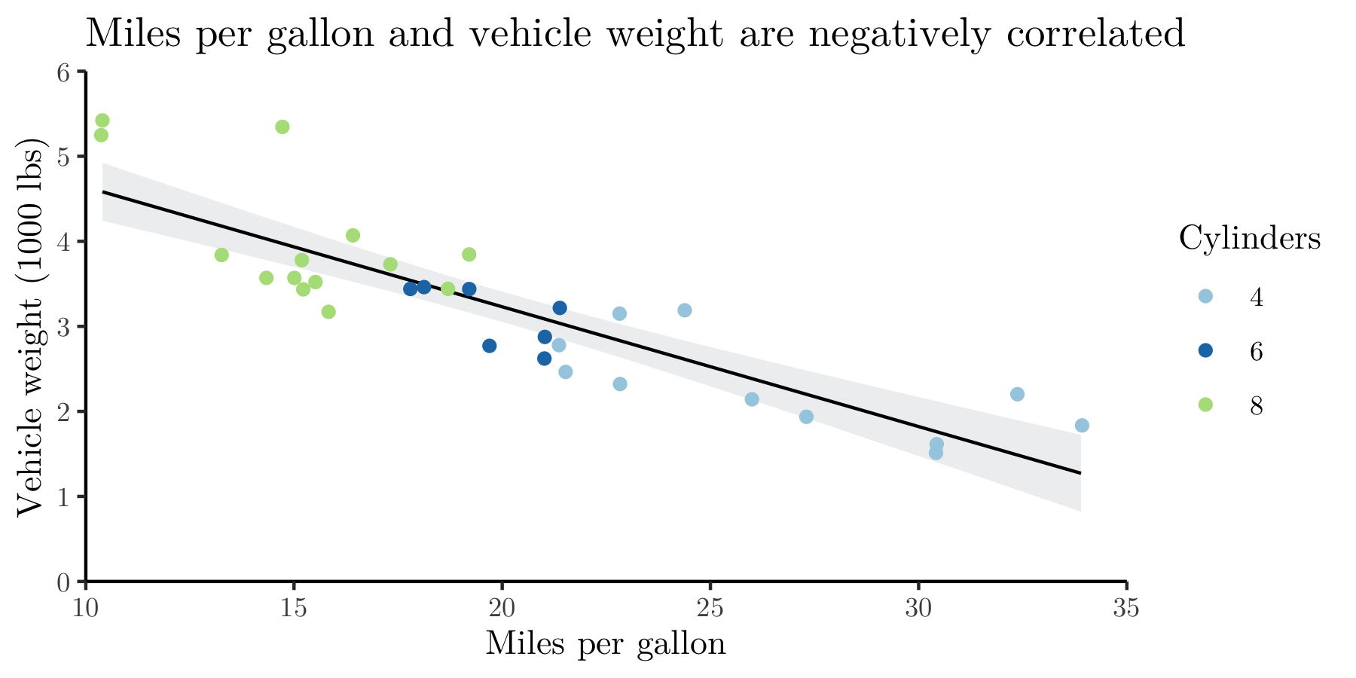

Figure 3.1: Example of a figure caption.

Like tables, you can reference figure numbers using the alphanumeric chunk label, as in Figure 3.1. Unlike tables, the figure caption goes in the chunk arguments using fig.cap, rather than in the kable function itself.

Using the helper functions in the source_script.R file, I can easily include APA-formatted statistics for the correlation between miles per gallon and weight (*r*(30) = -0.87, *p* < .001).

# 4 Discussion

A thoughtful discussion goes here.

# Funding and acknowledgements

Your statement goes here.

# References

Person, A. (2021). A title. *Some Journal*, *1*(1), 1–2.

PersonOne, A., & PersonTwo, B. (2021). Another title. *A Different Journal*, *1*(1), 1–2.

PersonOne, A., PersonTwo, B., & PersonThree, C. (2021). *Book title* (A. Editor, Ed.; 1st ed., Vol. 1, pp. 1–2). Some publisher.

1. Hello!