**Boden Archuleta**

**Jason Holman**

**STORE MANAGEMENT SYSTEM: USER STORIES**

**Iteration 1 (Feb 28)**

1. As a user, I want to check out a list of items bought by a customer
2. As a user, I want to update the inventory (change price, availability, add new products,...)

Use cases:

Use case: Check out

Steps:

1. The system displays the login screen.

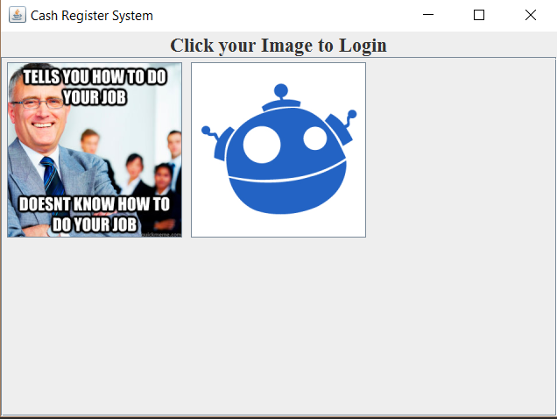

1. User clicks on their picture
2. The system opens a popup prompting them to enter their code.
3. If the user is a cashier.
4. System displays home screen

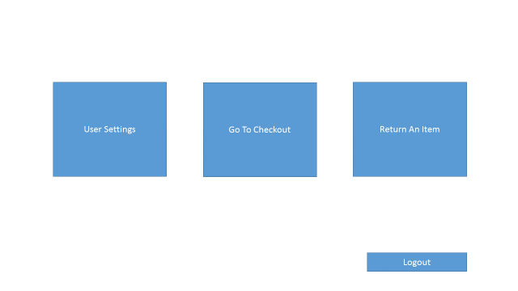

1. If the user clicks on user settings, the system displays user settings screen. It is not necessary to change all fields at once.

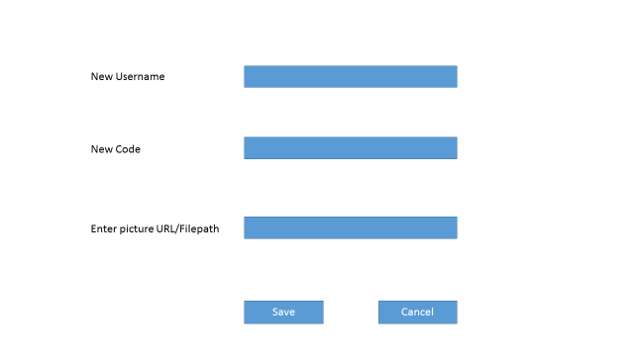

1. If the User clicks on the return item button, the system displays the return item screen.

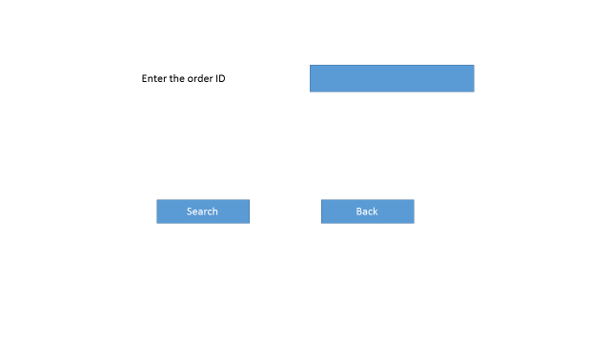

1. If the order ID is not in the database, a popup will alert the user.
2. If it is found the system displays the return screen

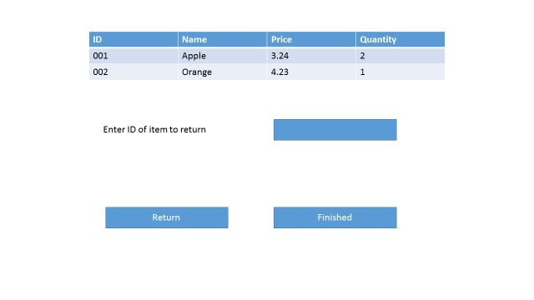

1. If the user clicks on the checkout button, the system displays the checkout screen

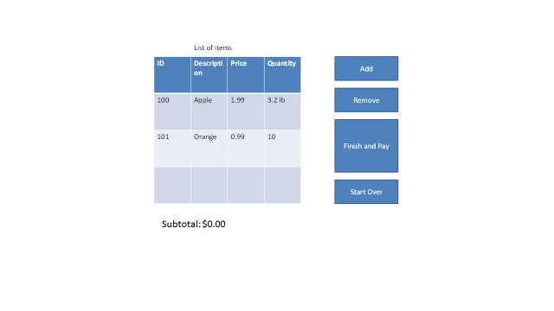

1. User clicks on button Add to add a new item
2. System updates information of the new item in the list of items
3. User repeats step 4 for all items
4. User clicks on button “Finish and Pay”
5. System displays the Payment screen



1. User chooses payment type
2. If user choose payment type of Cash, system displays change screen. A pop up will appear telling the user how much change that they are given.

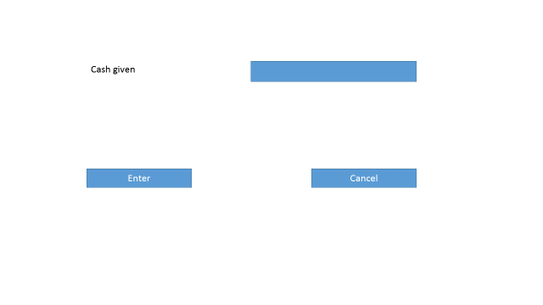

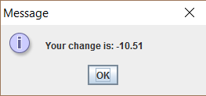

1. System displays the Receipt screen for printing:

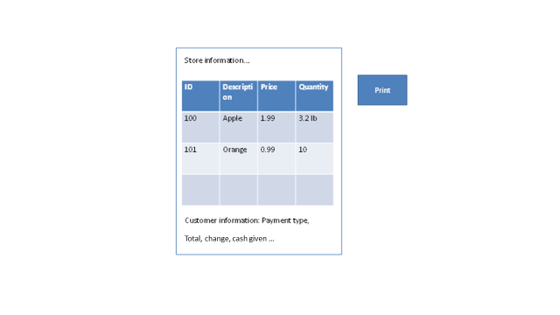

11. If user choose payment type of Credit Card:

11.1. System displays the Credit Card screen:



11.2 User inputs credit card information and click button OK.

11.3 System display Receipt screen



**If the user is a manager**

1. **System displays the manager screen**

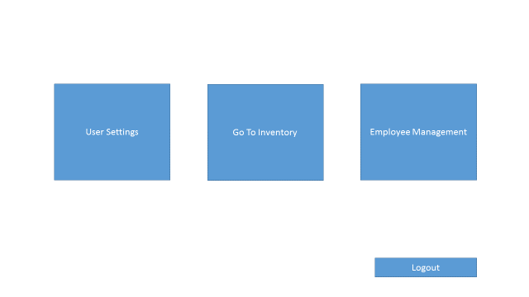

1. **User presses the update inventory button**
2. **System displays the inventory screen**

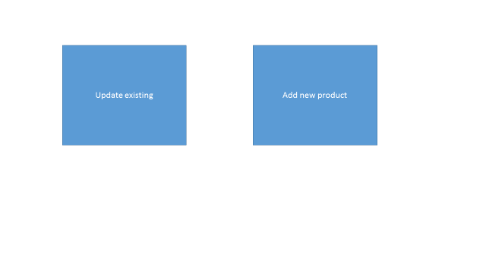

1. **User clicks update existing button**

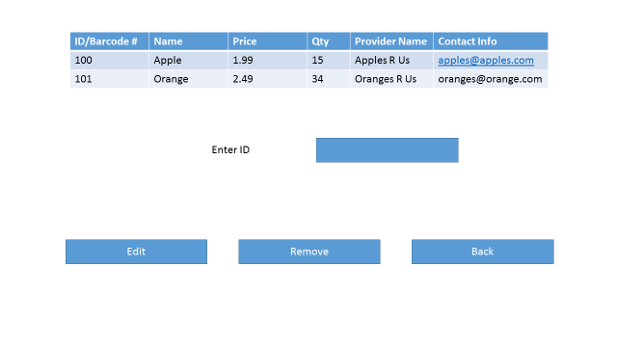

1. **User enters id into a text field**
2. **System displays the update product screen**

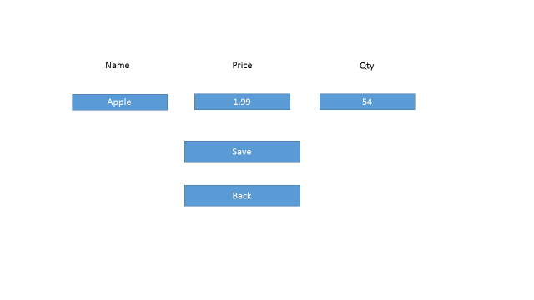

1. **User inputs data, and clicks save**
2. **System goes back to inventory screen**



1. **User clicks back button**
2. **User clicks add new product button**
3. **System displays new product screen**

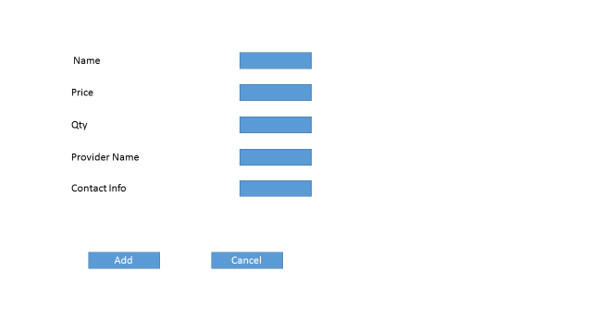

1. **User clicks Add**
2. **System displays inventory screen**
3. **If user presses user information button, the system displays user info screen**



1. **If user clicks on employee management, the system displays employee management screen**

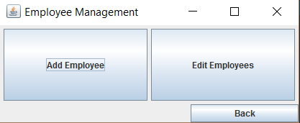

1. **If user clicks on add employee, the system displays add employee screen**

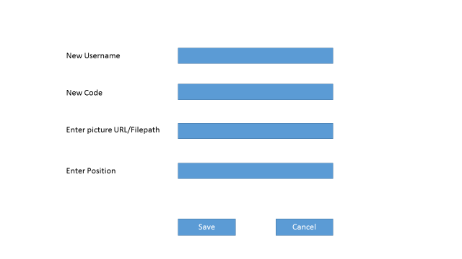

1. If user clicks delete employee, the system displays edit employee screen

