Jason Holman

Boden Archuleta

Iteration 1 Architecture Design

1. User interface classes: main screen, checkout screen, payment screen, receipt screen, credit card screen, inventory screen, update inventory screen, update product screen, manage employee screen, user settings screen, return items screen, and new product screen.
2. Database classes: productDriver, employeeDriver, and orderDriver.
3. Logic classes: validate, navigation,
4. Data Access layer: update database, product class, and order class

Business Logic layer: validate class

User Interface layer: main screen, checkout screen, payment screen, receipt screen, credit card screen, inventory screen, update inventory screen, update product screen, and new product screen

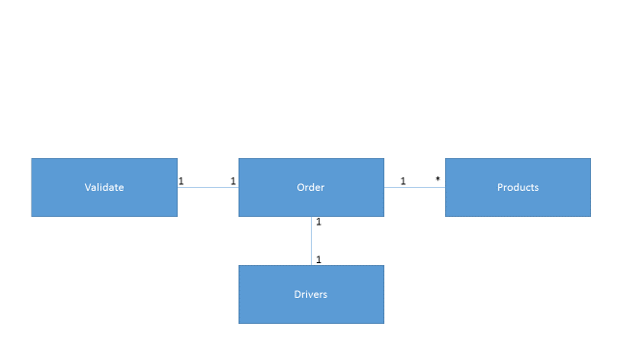

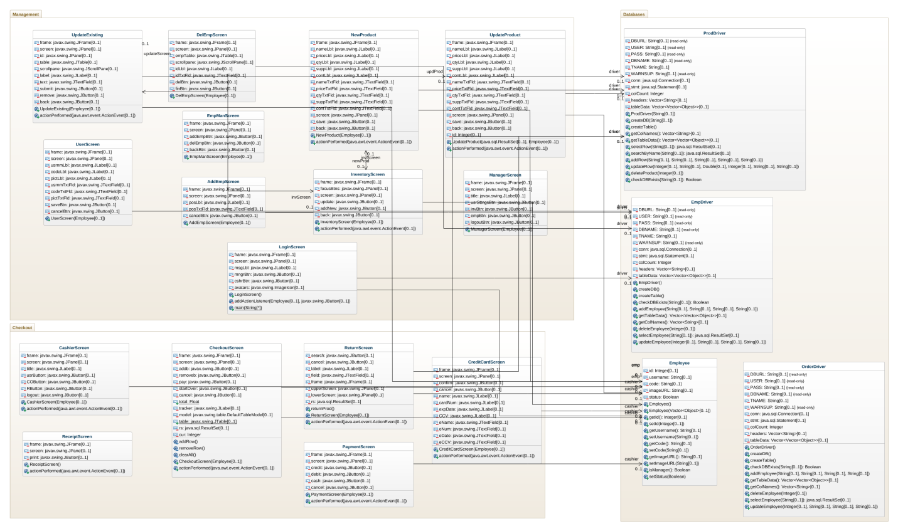

<https://repository.genmymodel.com/holmanjr/CS3450-course-project>