**Boden Archuleta**

**Jason Holman**

**STORE MANAGEMENT SYSTEM: USER STORIES**

**Iteration 1 (Feb 28)**

1. As a user, I want to check out a list of items bought by a customer
2. As a user, I want to update the inventory (change price, availability, add new products,...)

Use cases:

Use case: Check out

Steps:

1. The system displays the main screen



1. User clicks on button “Checkout”
2. The system displays the Checkout screen



1. User clicks on button Add to add a new item
2. System updates information of the new item in the list of items
3. User repeats step 4 for all items
4. User clicks on button “Finish and Pay”
5. System displays the Payment screen



1. User chooses payment type
2. If user choose payment type of Cash, System displays the Receipt screen for printing:



11. If user choose payment type of Credit Card:

11.1. System displays the Credit Card screen:



11.2 User inputs credit card information and click button OK.

11.3 System display Receipt screen



**Updating inventory**

1. **System display main screen**
2. **User presses the update inventory button**
3. **System displays the inventory screen**

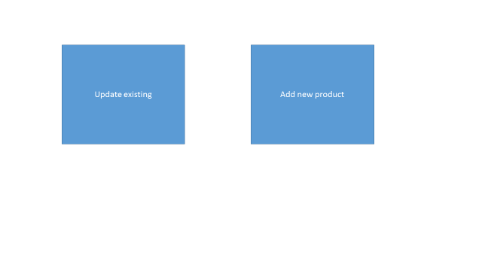

1. **User clicks update existing button**

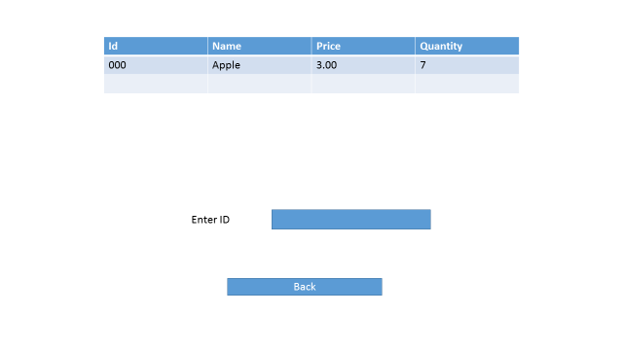

1. **User enters id into a text field**
2. **System displays the update product screen**

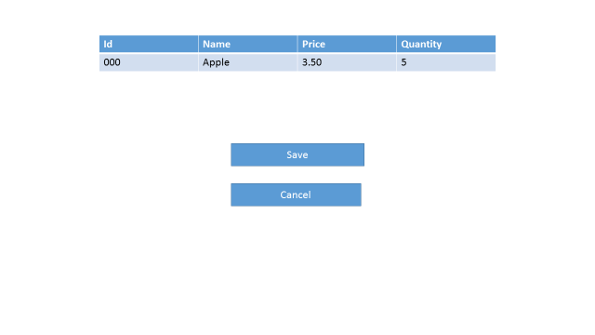

1. **User inputs data, and clicks save**
2. **System goes back to inventory screen**

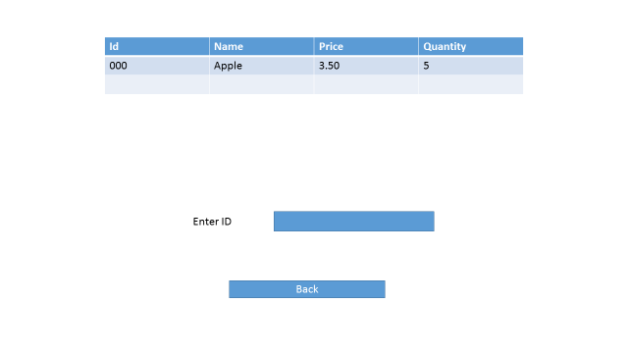

1. **User clicks back button**
2. **User clicks add new product button**
3. **System displays new product screen**

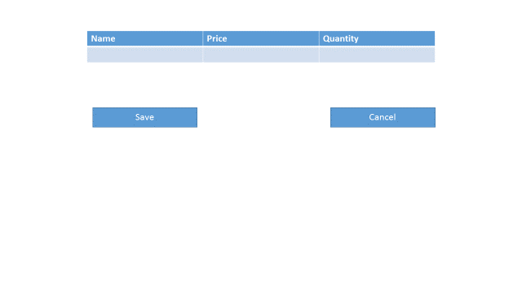

1. **User clicks save**
2. **System displays inventory screen**