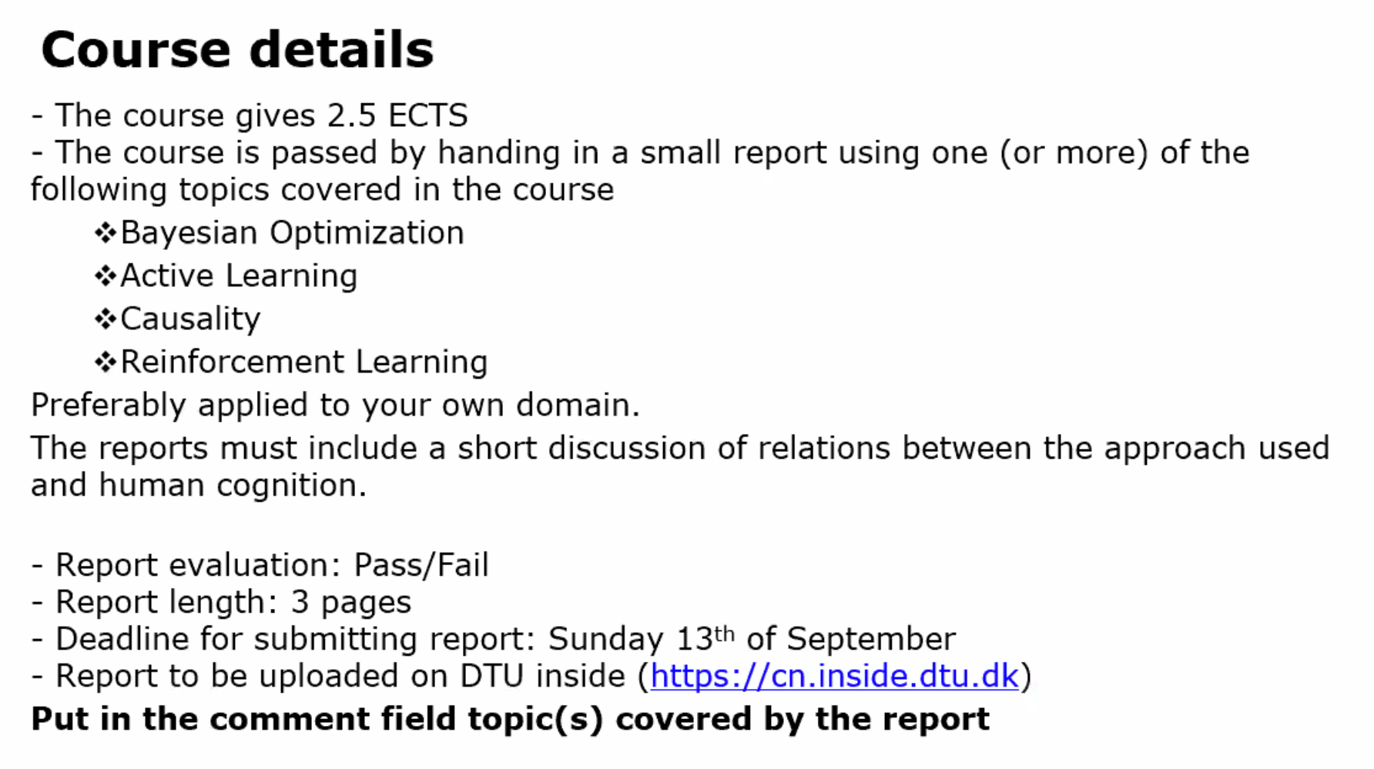

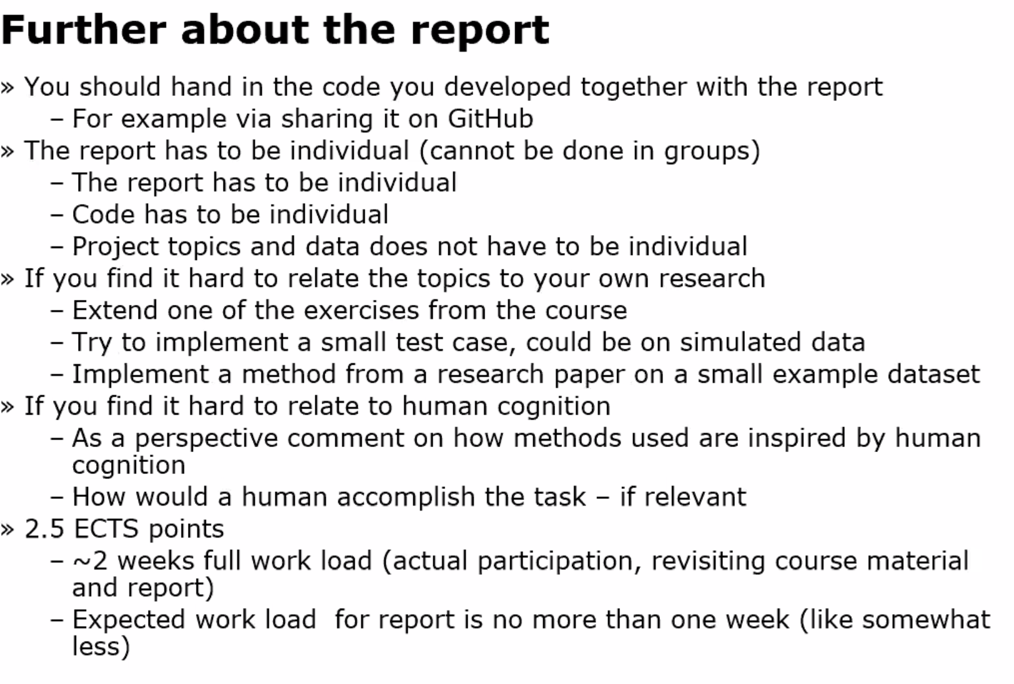

Human cognition 🡪 Talk about motivation for method (from a cognition point of view)