Assignment 08

# GitHub

https://github.com/holmesak95/Assignment08

# Introduction

This is my process through Assignment 08 for the Foundations of Programming (Python) course. This assignment involves using objects to hold CD information and using it in CD inventory menu program.

# Assignment 08 Process

I copied the script that Dirk created containing the script header and pseudocode. I didn’t want to re-invent the wheel, so I used parts of last week’s assignment as the foundation for this assignment. I added my structured error handling to check for valid integers and strings (which in turn took care of type conversions). I also kept some of the functions like last week’s assignment: print_menu(), menu_choice, show_inventory(), add_inventory(), and delete_cd() functions. I made small tweaks to them when necessary (for example I made sure to use CD objects in the add_inventory() and delete_CD() functions).

The major changes were in the CD() class. I created the constructor to set the CD_ID, CD_Title, and CD_Artist attributes. I also created the getters and setters, where the setters also contained error handling. Finally, I created one method to format the attributes so they are separated by commas, thus allowing easy writing to a .csv file. I had to make slight adjustments to saving and loading the file, so it uses attributes instead of dictionaries.

# Assignment 06 Results

Below are screenshots of the results when running the script through both Spyder and the terminal.

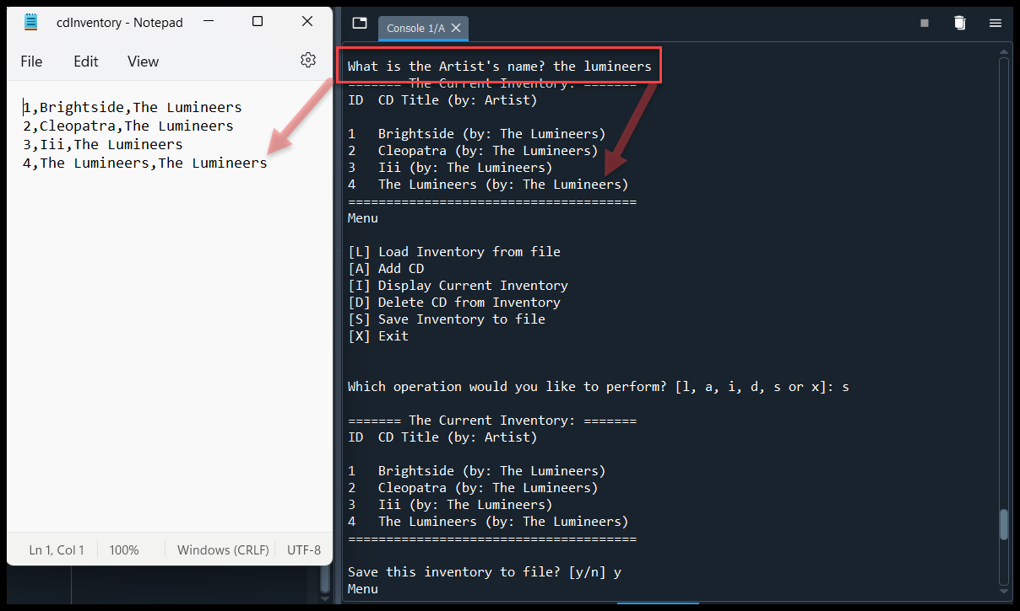

Figure 1: Results of the script when run through Spyder

# 

Figure : Results of the script when run through the Terminal

# Summary

In this assignment, I learned about various concepts like objects and classes. The assignment went well; I used code similar to my last assignment for some of the minor functionality so hopefully that was okay. I also feel like there is an easier way to grab attributes from an object and format it into .csv output.

**Note:** formatting of Python code throughout this document is done using [saravjishut](https://saravjishut.org/syntax) syntax highlighter [external reference]