Stroupe
University of Minnesota Duluth
Completed by: Benett Holmstrom
Possible Characteristics of Literature
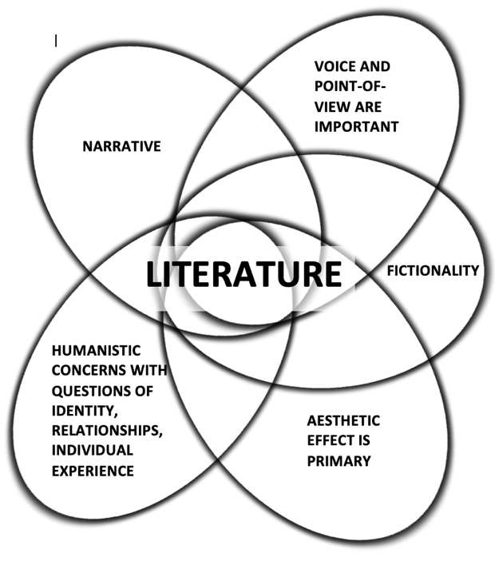
1. Narrative
In “The Flowers,” the narrative is driven at the pace the author
chooses. The movement of time and revelation of detail is
entirely dependent on her.

In Unravel, and other story-oriented video games for that
matter, the plot and story are both under the control and
direction of the writers. However, the player can decide the pace at which that narrative is which the narrative is driven, being they are
in control of the main character/primary character(s).

I think that Unravel, up until this point within this assignment,
could be considered literature. Narrative is a fundamental part
of literature, and “The Flowers” and Unravel both utilize it. Suppose
we didn’t categorize “The Flowers” as a short story and Unravel as
a videogame; when the narrative of each is laid out, we can identify the fact that they both contain one of the most important parts of what makes literature “literature.”

2. Voice and Point of view are important
Understanding the point of view within “The Flowers” is paramount to understanding the meaning of the story at hand. When you pay close attention to the details shared by the narrator of the setting, the atmosphere, and the characteristics of Myop, you benefit by understanding the emotional weight of the story since those nuances in detail play such a vital role in the story.

As for Unravel, the voice and point of view are still just as relevant. The player’s perspective is that of Yarny, a living figure made of yarn whose backstory is shared through cutscenes and details apparent in the setting of the game.

My opinion still holds that Unravel, and other videogames of similar nature, can be considered literature through the same logic/”proof” used in question 1. “The Flowers” is not a short story and Unravel is not a videogame. I know that the main character of “The Flowers” is a young girl named Myop, who is being raised in a sharecropping family living in the South. The main character of Unravel is named Yarny, a figure made from loose threads of yarn, who adventures around his owner’s small cottage to learn more about his personal story and upbringing.

3. Fictionality
“The Flowers” is fiction inspired by real events that have taken place in history. The EXACT character of Myop is not real, but it is possible that she could have existed and experienced the events that she did in “The Flowers.”

Unravel is speculative fiction, in that it falls more under the category of fantasy. It is impossible (at least today…we’ll see!) for a strand of yarn to come to life, establish sentience, and grow the desire to learn about their history.

Fictionality is not as much of an attribute of literature as it is a possible trait. Literature can be fiction or nonfiction, and in the discussion of “The Flowers” and Unravel, it so happens to be that both are different variations of fiction. Thus, both possess literary attributes.

4. Aesthetic Effect is Primary
As for “The Flowers,” aesthetic effects are important in developing a vivid understanding of the story’s setting. If “The Flowers” was written with very little aesthetic detail, then for all we know, Myop may have just been a kid that came across a body.

The aesthetics in Unravel are arguably primary, and more heavily focused on than the aesthetics of “The Flowers.” It is important for a videogame to be designed with aesthetics in mind, since that is how the player will be interpreting the story at any given moment – Unravel pulls this off very well.

“The Flowers” and Unravel both pay keen attention to aesthetics, and treat them with care. As for both, the aesthetics help establish a literary foundation for all the other literary elements to be further constructed.

5. Humanistic Concerns with Questions of Identity, Relationships, Individual Experience
This is the forefront of “The Flowers,” especially when the reader takes the time to piece together all of the nuances that contribute to the setting. What is the state of wellness of Myop and her family, given that they are sharecroppers in a time shortly after the Civil War? How will Myop’s exposure to the body affect her future relationship with her mother and the rest of her family? What other trauma has her family been exposed to?

Unravel raises questions about Yarny’s search for identity. In some nondescript morning day, he springs to life and makes note of his surroundings – who is his “owner” (that is, the lady carrying the basket of sewing goods that Yarny fell from)? What is the story of her family – did she have a spouse? Children? Is this Yarny’s purpose, to discover these secrets for himself and apply them to his own meaning?

Unravel treats its existential storytelling elements just as carefully as “The Flowers.” Both craft characters and surroundings in which we, the reader/player can feel empathetic for. Such traits would warrant their sources as being considered literary.

