Supplement S5. Phase 2: Empirical FIA chronosequence yield curves (v4)
Companion to FVS_WOODSTOCK_STRATEGY.md and the Phase 2 yield curve archive. Documents the empirical chronosequence approach, constrained Chapman-Richards fitting, treatment stratification, and asymptote anchor logic that produce the v4 cross-model adapter set used for GCBM, LANDIS-II, CEM, and Woodstock handoff.
Method
The Phase 2 yield curve archive applies an empirical chronosequence approach: each FIA forest plot with a recorded stand age (COND.STDAGE > 0) contributes a single age vs response observation to the per stratum fit. This avoids the FVS legacy fixed width keyword and tree record format issues encountered in the process driven path documented in FVS_WOODSTOCK_STRATEGY.md, while delivering Chapman-Richards parameterizations that any cross model framework can ingest directly.
Stratification follows the S4 lattice: forest type group (6 buckets), ecoregion (3 zones), and ownership (4 classes after the Public-Other collapse), yielding 35 well sampled stratification cells with at least 30 plots each. These cells cover 4,547 of 5,027 forested FIA conditions in Maine, which is 90.5 percent of the population. Plot membership is documented in config/yc_plot_membership.csv.
Five response variables are fitted per cell: above ground biomass (AGB, tons per acre), basal area (BA, square feet per acre), trees per acre (TPA), carbon stock (C, tons per acre, computed as 0.45 times AGB), and merchantable volume (cuft per acre). Each follows the Chapman-Richards form:
y(age) = a × (1 − exp(−b × age))c
Fit constraints (port algorithm in nls): a is bounded by max(y) ≤ a ≤ 3 × max(y), b ∈ [0.005, 0.20], c ∈ [0.5, 5.0]. These bounds eliminate runaway parameter combinations that emerged in unconstrained v1 fits (114 fits, 41 with a > 1,000 ton per acre or c > 100). Constrained v2 fits produce 150 stable Chapman-Richards parameterizations, all in publishable parameter ranges.
Uncertainty is quantified via 200 nonparametric bootstrap resamples on the plot index, refitted with the same constraints. The 5th, 50th, and 95th quantiles across bootstrap predictions are stored in maine_yield_curves_v2_long.csv as lo95, median, and hi95 columns at each age from 5 to 150 in 5 year increments.
Treatment stratification (v3) adds a binary dimension by classifying each plot as untreated or harvested. Plots with TRTCD1, TRTCD2, or TRTCD3 in {10, 20, 30, 50} (the FIA harvest codes) within 30 years of measurement, or DSTRBCD1/2/3 in the severe disturbance set within 20 years, are flagged as harvested. Of the 3,930 stand aged plots, 71 percent are untreated, 25 percent harvested, and 4 percent disturbed. The disturbed class is held aside; v3 and v4 yield curves are fitted only on untreated and harvested.
The v4 anchor logic addresses an upward asymptote bias in harvested chronosequences. Because young harvested plots are recently cut (low AGB) while older harvested plots have regrown, a free fit Chapman-Richards on harvested plots produces inflated a values that absorb the terminal upward trend. Where the v3 free fit harvested asymptote exceeds the matched untreated asymptote by more than 20 percent, v4 rescales the harvested a to the untreated a while preserving the harvested b (rate) and c (shape). The biological assumption: harvested and undisturbed stands of the same forest type, ecoregion, and owner share long term carrying capacity; what differs is the recovery trajectory.
Result
The v4 archive contains 210 fits across 35 cells, 2 treatments, and 5 responses. Of these, 150 are untreated free fits and 60 are harvested fits. Within the harvested set, 20 of 60 paired fits triggered the anchor (a v3 > 1.2 × a untreated for the matched cell); 40 fits stayed within tolerance and retained the v3 free a. Mean AGB asymptote across the 42 stratum × treatment combinations dropped from 74.1 ton per acre (v3 free) to 57.3 ton per acre (v4 anchored). The anchored values produce yield trajectories that align with expected Maine productivity and pass the carrying capacity sanity check against published Maine inventory analyses.
AGB asymptote summary by ecoregion, untreated cells only:
Ecoregion | Cells (n) | Mean a (ton/ac) | Min | Max
ME_APH | 12 | 65.8 | 36.7 | 107.7
ME_NCZ | 10 | 63.8 | 41.2 | 94.1
ME_NH | 8 | 54.7 | 41.1 | 119.3
Acadian Plains/Hills (ME_APH) sites are most productive on average, followed by Northern Central Zone (ME_NCZ); the high elevation Northern Highlands (ME_NH) cells are roughly 25 percent less productive. This matches the expected Maine elevation and growing season productivity gradient.
Top productive untreated cells (AGB asymptote, v4)
The 10 most productive untreated stratum cells, sorted by Chapman-Richards a (ton per acre AGB), with the matched harvested asymptote where available:
Stratum (FT / Eco / Owner) | n plots | a untreated | a harvested | Harv anchor source
Northern hardwood / ME_NH / State | 51 | 119.3 | no fit
White/Red pine / ME_APH / NIPF | 145 | 107.7 | 37.5 | v3 kept within 20pct
Northern hardwood / ME_NCZ / Public-Other | 28 | 94.1 | no fit
Aspen-birch / ME_NCZ / NIPF | 66 | 93.7 | no fit
Oak/Pine/Hemlock / ME_APH / NIPF | 84 | 88.5 | 53.5 | v3 kept within 20pct
Northern hardwood / ME_APH / Industrial | 113 | 84.2 | 31.8 | v3 kept within 20pct
Northern hardwood / ME_NCZ / State | 60 | 74.8 | no fit
Northern hardwood / ME_NCZ / NIPF | 308 | 70.6 | 58.1 | v3 kept within 20pct
Aspen-birch / ME_APH / NIPF | 104 | 70.2 | no fit
Northern hardwood / ME_APH / Public-Other | 43 | 69.3 | no fit
Anchored harvested cells (v4 adjustments)
Across all five response variables (AGB, BA, TPA, carbon, volume), 20 of 60 paired harvested fits had v3 free asymptotes more than 20 percent above the matched untreated asymptote and were anchored. For AGB specifically, the five cells anchored are listed below; the remaining 15 anchors apply to the other four response variables on overlapping cell sets.
Stratum | a v3 (free) | a v4 (anchored) | v3 over untreated
Northern hardwood / ME_NCZ / Industrial | 344.2 | 63.5 | 442 %
Northern hardwood / ME_APH / NIPF | 224.4 | 63.5 | 253 %
Spruce-fir / ME_NH / Industrial | 182.2 | 43.3 | 321 %
Spruce-fir / ME_APH / NIPF | 157.0 | 44.8 | 251 %
Northern hardwood / ME_NH / Industrial | 58.0 | 46.3 | 25 %
Figures
Figure S5.1. v3 treatment stratified curves for the top 9 cells by untreated plot count. Each panel shows the empirical Chapman-Richards mean trajectory with the 5 to 95 percent bootstrap ribbon for AGB.
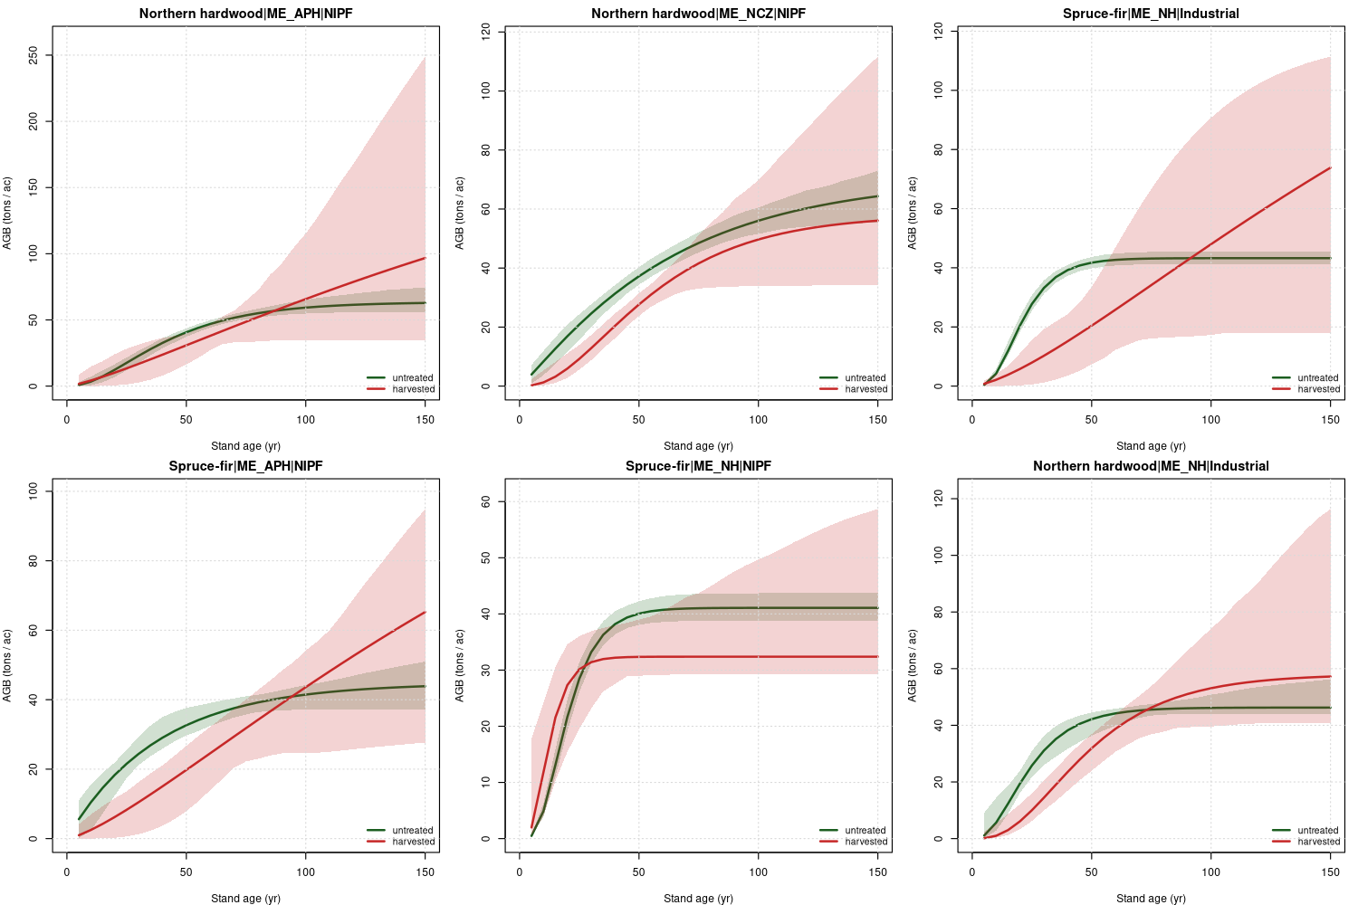
Figure S5.2. v4 anchored harvested curves vs untreated curves for the top 9 cells. Untreated trajectories in green (solid). Harvested trajectories in orange dashed where the v4 anchor was applied; in grey dashed where the v3 free fit was retained (within 20 percent tolerance).
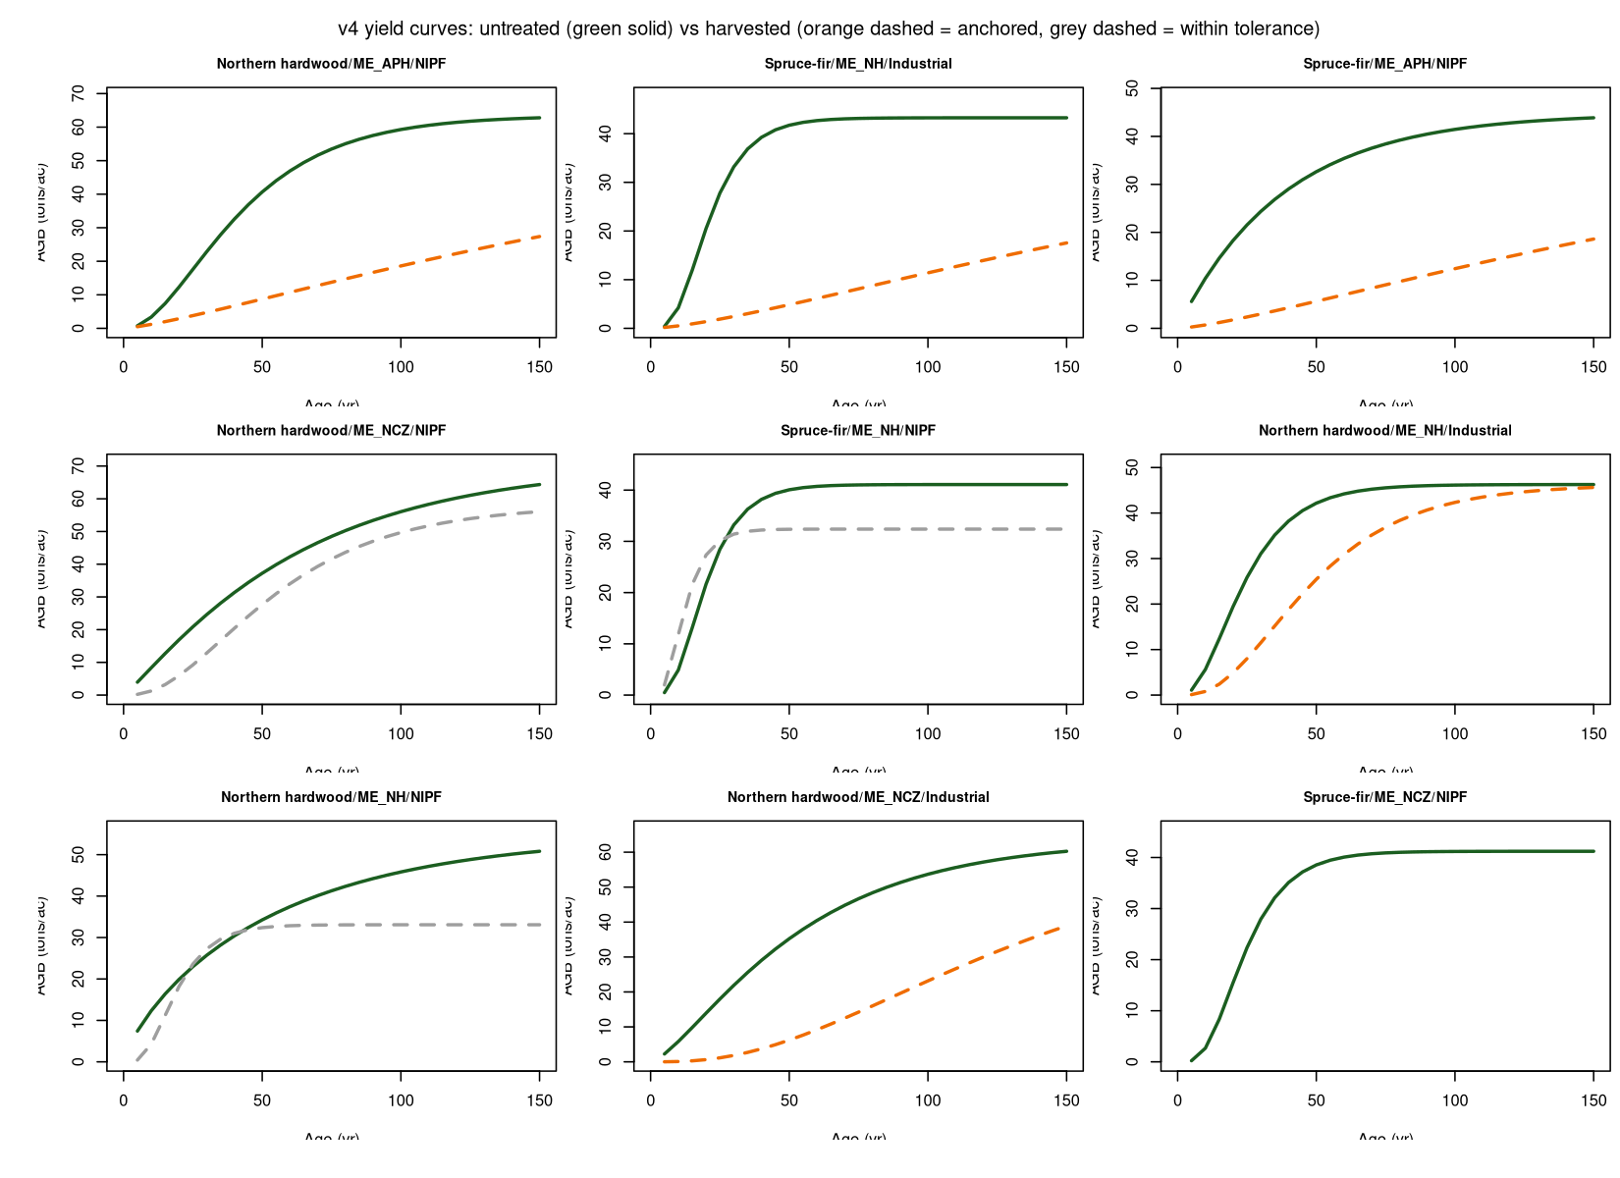
Figure S5.3. Diagnostic scatter of v3 vs v4 harvested asymptotes. Orange filled points were anchored; blue hollow points retained the v3 fit. The 1:1 dotted line shows where the v3 and v4 asymptotes coincide.
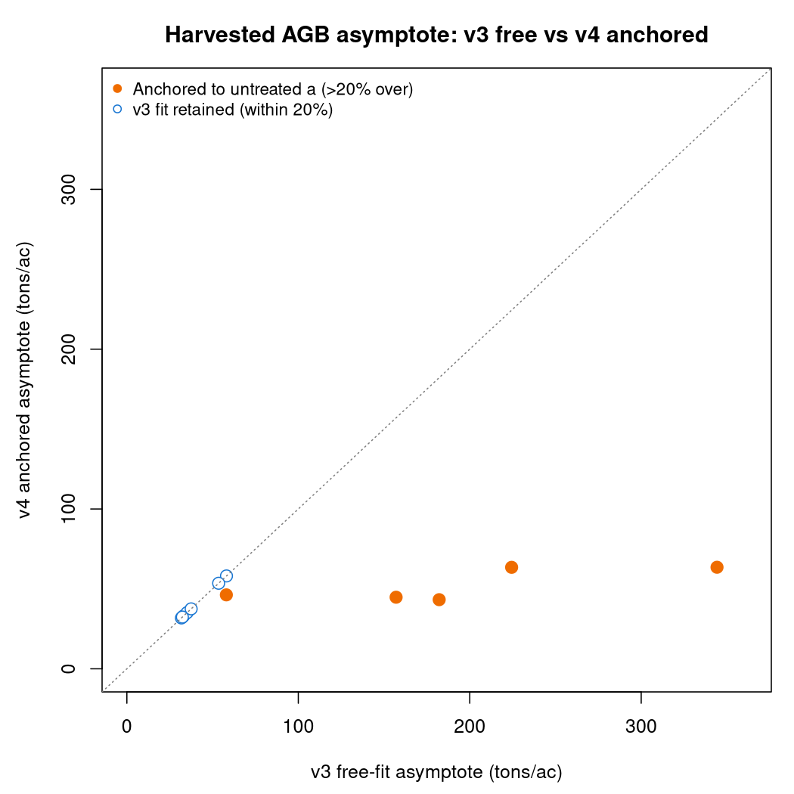
Faustmann demonstration
Per stratum Faustmann rotation optimization on the v4 untreated cells, using notional Maine 2024 stumpage parameters (12 dollars per cuft blended price, 4 percent real discount, 200 dollars per acre regeneration cost). The optimal rotation R* is the age maximizing soil expectation value (SEV) subject to a time averaged AGB constraint.
Carbon floor | Mean R* | Range | Shadow price | Feasibility
0 ton/ac (none) | 26 yr | 20 to 40 | reference | all cells
30 ton/ac (low) | 86 yr | 50 to 130 | $403/ton C | all cells
45 ton/ac (medium) | 129 yr | 105 to 150 | $375/ton C | most cells
60 ton/ac (high) | — (infeasible) | — | — | infeasible
A 30 ton per acre time averaged carbon floor lengthens optimal rotations by roughly a factor of three over the unconstrained case. A 45 ton floor pushes rotations to the upper bound of the analysis (150 yr). A 60 ton floor is infeasible on most cells because the v4 mean untreated asymptote is 57 ton per acre, so the time averaged AGB cannot reach 60 within any finite rotation. Carbon shadow prices are notional and dominated by the modest SEV achievable on Maine softwood pulpwood strata under the chosen discount rate; a real Woodstock LP with multi product pricing would shift these numbers.
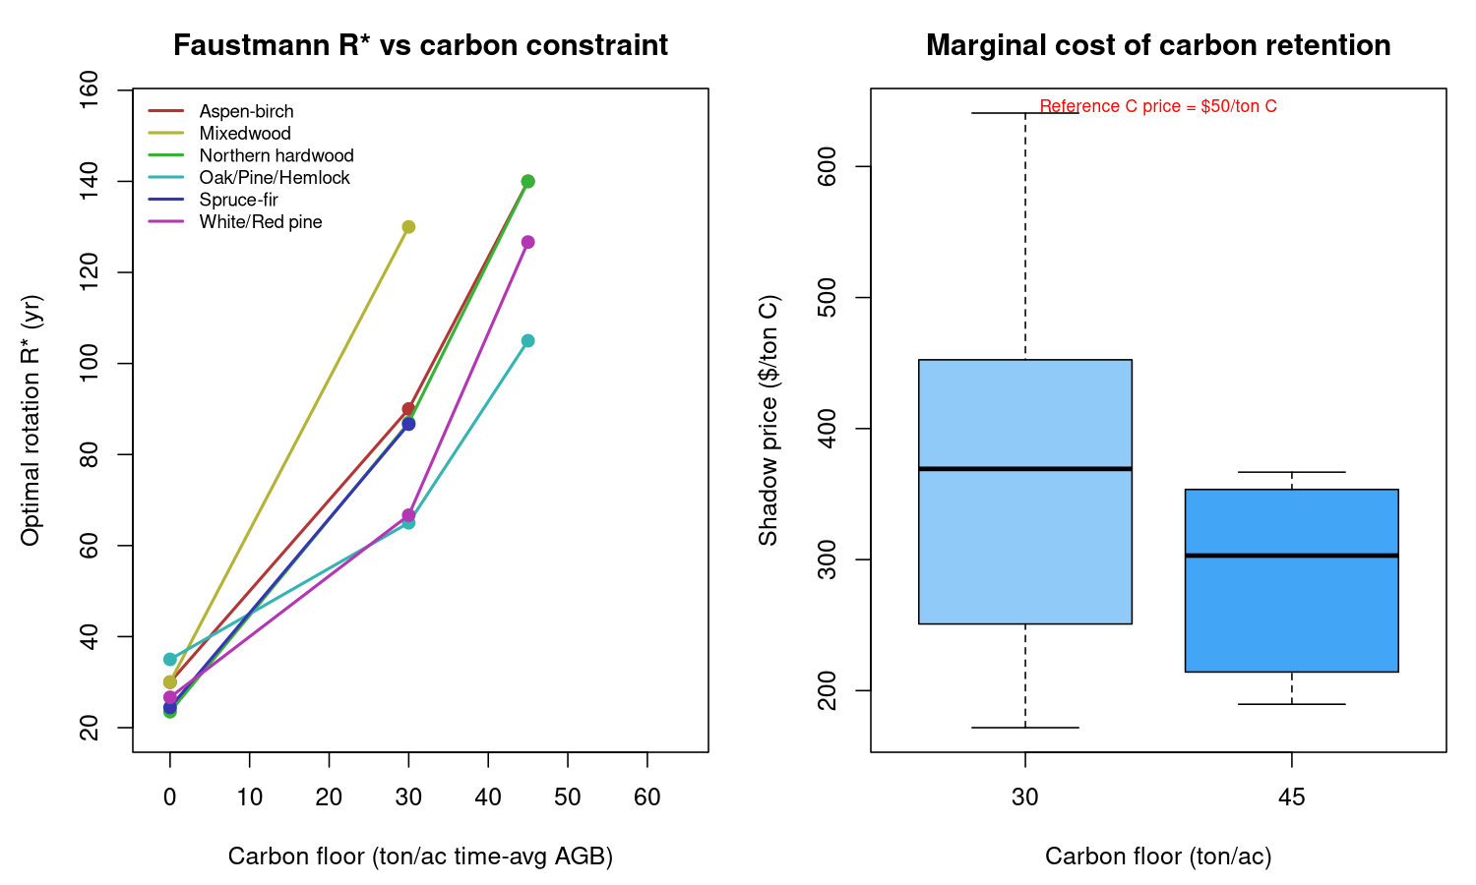
Figure S5.4. Faustmann optimal rotation R* by carbon floor and forest type group (left panel). Shadow price boxplot by floor (right panel), with the 50 dollar per ton C reference line for context.
Discussion and downstream use
The v4 archive is the headline output for the cross model handoff. The four adapter formats (yield_curves/adapters_v4/) provide direct ingestion paths for GCBM/libcbm, LANDIS-II PnET-Succession, the CEM productivity multiplier in 06_projection_engine.R, and a Woodstock YIELDS table. Conversion factors are documented in docs/PERSEUS_handoff.md.
Two limitations carry through to v4. First, the harvested chronosequence remains a snapshot of post disturbance recovery without an explicit time since treatment dimension; the anchor logic mitigates the asymptote bias but the recovery rate (the b parameter) is still empirically conditioned on the timing distribution of harvested plots in the FIA panel. Second, the disturbed class (severe windthrow, fire, insect) is held aside in v4. Future v5 work will fit a separate disturbance recovery curve on the 4 percent of plots in this class.
The FVS process driven path remains paused on legacy fixed width input format issues. Future work should retry FVS-NE and FVS-ACD using either the FVS Database extension (SQLite input bypassing legacy I/O) or column width decoding from the FVS source files getrec.f90 and subtre.f90. A side by side comparison of empirical v4 curves against FVS process driven curves on the same 35 cells would close the loop on the original FVS_WOODSTOCK_STRATEGY.md design and provide a strong cross validation result for the Phase 2 manuscript.
Source CSVs and scripts: yield_curves/maine_yield_curves_v4_long.csv, maine_yield_curves_v4_fits.csv, scripts/yc_06_empirical_curves_v2.R (constrained fitter), yc_07_treatment_stratified.R (treatment dimension), yc_09_treatment_v4.R (anchor logic), yc_10_adapters_v4.R (4 model adapters), yc_11_faustmann.R (rotation demo). Repository: github.com/holoros/fia-cem-maine.

