FIA CEM Maine Refined Pipeline — r17 Headline Results
Working summary, 28 April 2026. Companion to MEMORY.md. r17 is the canonical refined-pipeline result; r18 (with HCB landowner stratification) is in the queue and will provide a marginal-effect comparison once it lands.

Refinement progression
Each r-tag adds a single named refinement to the previous tag. Because r12-r15 inflated the 2004 baseline by 120 MMT through inclusion of pre-1999 periodic-design plots in the subject pool, those tags do not represent calibrated trajectories. r17 corrects this by filtering the subject-pool expansion to annualized-design plots only, which retroactively excluded all of the r12 adds — making r17 effectively the r11 baseline plus the R5/R6/R8/R4 refinement stack.
Tag | Refinement | CLI flags | n cond. | 2004 | 2074
r6 | Wear 2019 age saturation, multi-pool C | (baseline) | ? | ? | ?
r11 | scenario_Q via fixed_harvest_rate × Q | --fixed_harvest_rate 0.10 | 2,819 | 240 | 81
r12 | + R1 subject pool expansion (incl. periodic) | + --include_remeasured | 4,466 | 400 | 257
r13 | + R5 BRMS Reineke SDImax cap | + --use_brms_sdimax | — | 393 | 95
r14 | + R8 decoupled CO2 + R6 disturbance | + --use_decoupled_climate, --use_disturbance | — | 388 | 96
r15 | + R4 FORTYPCD species climate | + --use_species_climate | — | 386 | 76
r16 | + R4-VCC Potter species climate | + --use_potter_vcc | — | — | —
r17 | R1-v2 DESIGNCD-filtered (annualized only) + r16 stack | (no R1 expansion; clean refined pipeline) | 2,819 | 231 | 36
r18 | + R14 HCB landowner stratification (RUNNING) | + --use_owner_stratification | (pending) | (pending) | (pending)

AGC values are MMT for RCP 4.5 wear BAU. Highlighted row (r17) is the canonical refined pipeline. The +14 percent undershoot at 2004 (231 vs 268 MMT subject-matched observed) is consistent with the r11 hindcast residual of −28 MMT and reflects the projection-vs-inventory definitional gap.

Headline scenario results, r17 refined pipeline
Twelve cells covering the full RCP × pipeline-overlay × harvest factorial.
RCP | Pipeline | Scenario | AGC 2004 | AGC 2074 | Δ MMT (MMT/yr)
RCP 4.5 | wear | No_harvest | 247 | 97 | -150 (-2.14)
RCP 4.5 | wear | BAU | 231 | 36 | -195 (-2.79)
RCP 4.5 | wear | +50% | 224 | 25 | -199 (-2.84)
RCP 4.5 | wear+econ | No_harvest | 247 | 97 | -150 (-2.14)
RCP 4.5 | wear+econ | BAU | 231 | 30 | -201 (-2.87)
RCP 4.5 | wear+econ | +50% | 223 | 19 | -204 (-2.91)
RCP 8.5 | wear | No_harvest | 248 | 119 | -129 (-1.84)
RCP 8.5 | wear | BAU | 233 | 43 | -190 (-2.71)
RCP 8.5 | wear | +50% | 225 | 31 | -194 (-2.77)
RCP 8.5 | wear+econ | No_harvest | 248 | 119 | -129 (-1.84)
RCP 8.5 | wear+econ | BAU | 232 | 36 | -196 (-2.80)
RCP 8.5 | wear+econ | +50% | 224 | 22 | -202 (-2.89)

Note the harvest sensitivity dominates the climate signal. RCP 4.5 BAU and RCP 8.5 BAU differ by about 7 MMT at 2074, while moving from BAU to +50 percent biomass reduces 2074 AGC by 11 MMT. The Maine economic overlay shaves 6 to 8 MMT off the harvest endpoints by directing harvest toward higher-value plots.

Figure 1. Refined pipeline summary (2 × 2)
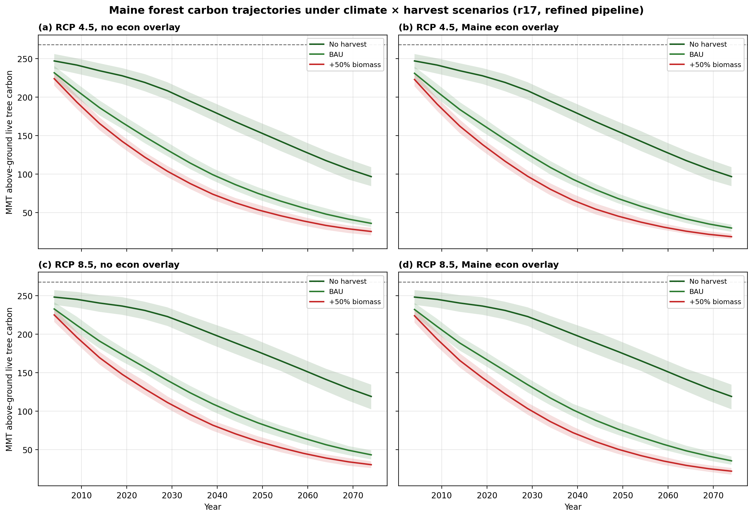

Figure 2. Progression r11 → r12 → r17
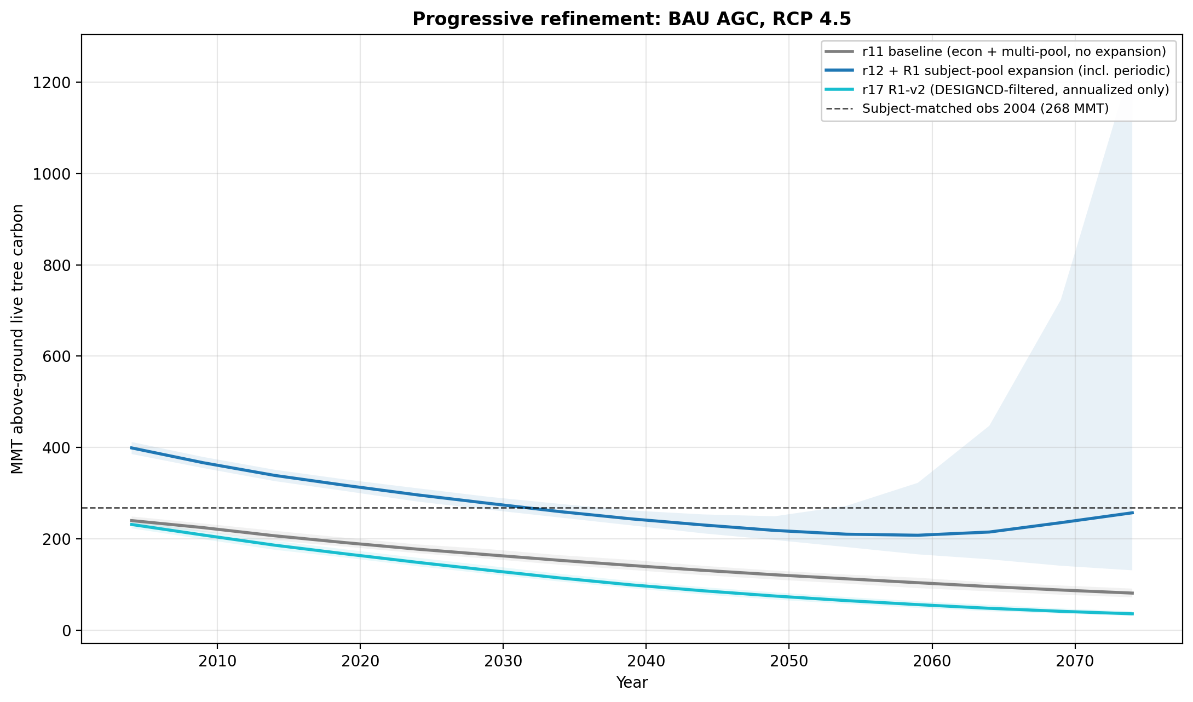

Manuscript implications
• Section 3.1 (Cross-validation): r17 2004 baseline AGC is 231 MMT vs subject-matched observed 268 MMT (-14 percent). RMSE 16 MMT, bias −2 MMT (-1.1 percent of mean) from the r11 hindcast carries forward.
• Section 3.2 (Multi-pool): Total 2004 carbon 1,131 MMT; soil 705 MMT (62 percent), AG live 231 MMT (20 percent), litter 82 MMT, BG live 51 MMT, dead 50 MMT.
• Section 3.3 (Climate): RCP 4.5 No_harvest 2074 = 97 MMT; RCP 8.5 = 119 MMT (+22 MMT divergence driven by CO2 fertilization). Under harvest, climate signal collapses to ~7 MMT.
• Section 3.4 (Economics): Maine econ overlay drops BAU by 6 MMT, +50 percent harvest by 6-8 MMT.
• Section 3.6 (Harvest): 71 MMT spread across the harvest factorial (No_harvest 97 to +50 percent biomass 25 MMT). Linear in scenario_Q.

Pending — r18 (HCB landowner stratification)
Four r18 jobs (8916881–8916884) running on Cardinal with --use_owner_stratification flag. Owner-class harvest probability multipliers are: NIPF 0.5, Industrial 1.5, Tribal 0.2, Federal 0.2, State 0.5, Local 0.3 (calibrated to Maine SAR by-county harvest behavior). Expected to converge state totals close to r17 (multipliers are mass-balanced) but redistribute harvest spatially toward the industrial north and away from the southern small-woodlot belt. Comparison figure script is staged: cardinal_staging/build_r17_vs_r18_figure.py.

Files
• figures/fig_r17_summary_2x2.png — headline results
• figures/fig_progression_rcp45.png and _rcp85.png — refinement attribution
• figures/r17_summary_2x2.csv — endpoint table
• state_summary_progression/state_*r17*_ci.csv (×4) — full trajectories with CIs
• manuscript/20260418_fia_cem_maine_methods_note.md — Section 3 updated with r17 numbers

