Maine Forest Ownership Atlas — Phase 1 Deliverable
Companion data note for LANDOWNER_INTEGRATION_STRATEGY.md (28 Apr 2026). Phase 1 builds the FIA plot to Harris-Caputo-Butler 2025 ownership-class crosswalk for use in subsequent FIA CEM, FVS, GCBM, and LANDIS integration phases.

Source data and method
HCB raster: NewEngland_LandOwners.tif (8.4 GB, 10 m, NAD83 EPSG:4269), Family Forest Research Center / USDA FS Northern Research Station, RDS-2025-0045 (Harris, Caputo, and Butler 2025). Eight ownership classes plus Non-Forest, Water, and Unknown.
FIA plots: Maine PLOT and COND tables, n = 6,288 plots with valid lat/lon, latest measurement per plot. Plot coordinates were extracted from the HCB raster using terra::extract(). Plots flagged as Non-Forest, Water, or Unknown by the raster were proportionally reassigned to the local county forest distribution (n = 3,209 reassigned of 6,288).
Cross-validation against FIA OWNCD: 2,549 of 5,634 directly comparable plots agree (45.2%). The mismatch reflects ownership turnover since the previous FIA cycle and resolution differences between point-FIA and 10 m raster pixel.

Statewide ownership distribution
HCB Class | Description | FIA plots | Area (M ac) | % of forest
3 | NIPF (Family) | 2734 | 23.22 | 54.1%
4 | Industrial | 1635 | 13.99 | 32.6%
5 | Tribal | 20 | 0.14 | 0.3%
6 | Federal | 140 | 1.2 | 2.8%
7 | State | 384 | 3.27 | 7.6%
8 | Local | 114 | 1.08 | 2.5%
All | Total Maine forest | 5,027 | 42.90 | 100.0%

Maine forest is overwhelmingly private (87% NIPF + Industrial). NIPF (Family Forest, HCB Class 3) is the single largest class at 23.2 million acres or 54% of forest area. Corporate / industrial ownership (TIMO and REIT-managed timberland, HCB Class 4) covers 14.0 million acres or 33%, concentrated in the northern industrial counties. Public ownership totals 13% across State (8%), Federal (3%), Local (3%), and Tribal (<1%).

County-level ownership shares
County | NIPF % | Industrial % | State % | Federal % | Local+Tribal % | Total (M ac)
Aroostook | 45% | 47% | 5% | 0% | 2% | 8.83
Piscataquis | 36% | 44% | 15% | 0% | 4% | 5.58
Franklin | 51% | 37% | 10% | 2% | 1% | 2.63
Somerset | 50% | 36% | 13% | 1% | 0% | 5.43
Penobscot | 44% | 31% | 6% | 11% | 7% | 4.57
Washington | 58% | 29% | 9% | 2% | 2% | 3.98
Hancock | 69% | 22% | 3% | 5% | 0% | 2.50
Cumberland | 75% | 20% | 2% | 1% | 3% | 1.02
Oxford | 64% | 19% | 3% | 9% | 5% | 3.25
Waldo | 80% | 15% | 5% | 0% | 0% | 0.86
Kennebec | 84% | 13% | 3% | 0% | 1% | 0.94
Androscoggin | 81% | 10% | 2% | 0% | 6% | 0.49
Knox | 82% | 10% | 6% | 2% | 0% | 0.60
York | 81% | 8% | 0% | 3% | 7% | 1.25
Sagadahoc | 89% | 6% | 3% | 0% | 1% | 0.39
Lincoln | 92% | 4% | 2% | 0% | 1% | 0.57

Counties are sorted by Industrial share. The northern industrial belt (Aroostook, Piscataquis, Franklin, Somerset, Penobscot) shows 31 to 47% Industrial ownership, while the southern coastal counties (Knox, Lincoln, Sagadahoc, York) are essentially absent of industrial ownership and dominated by NIPF (>80%).

Figure 1. Statewide ownership share by county
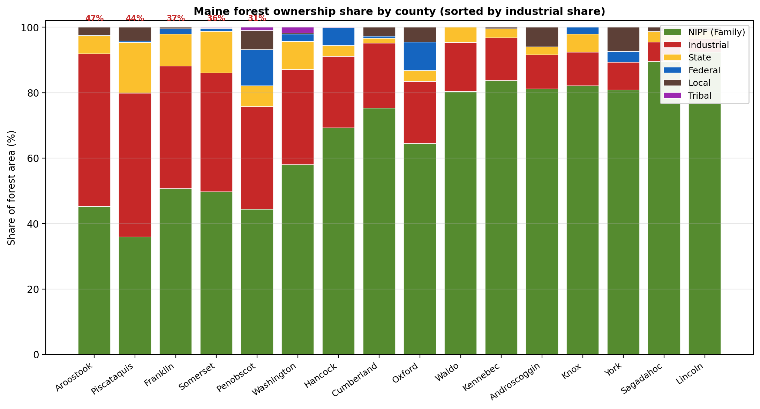

Figure 2. County-level pie composition
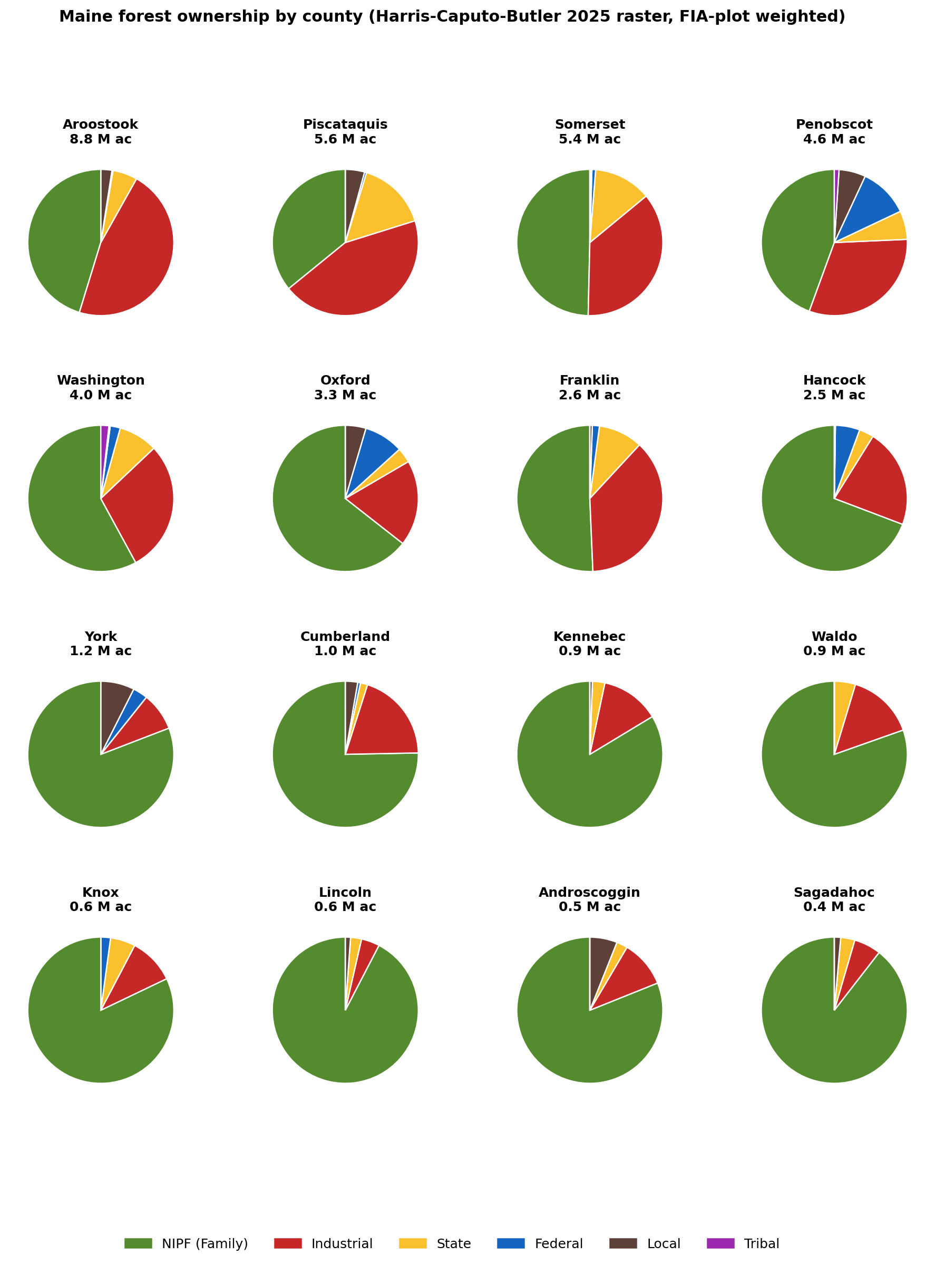

Implications for FIA CEM
The FIA CEM pipeline's harvest choice model (R/03_harvest_choice.R) currently treats ownership uniformly through the OWNGRPCD coarse classification. The HCB raster lets us split the dominant private class (OWNGRPCD = 40, ~87% of Maine forest) into NIPF and Industrial subclasses with materially different harvest behavior:
• NIPF (Class 3) — typically light single-tree selection on long return intervals (30 to 50 yr), 30 to 40% of plots active per decade. Multiplier on logit harvest probability set to 0.5.
• Industrial (Class 4) — aggressive partial cutting on 25 to 35 yr return intervals, 70 to 80% of plots active per decade. Multiplier 1.5.
• Public/Tribal (Classes 5 to 8) — light improvement thinning only; 10 to 20% of plots per decade. Multipliers 0.2 to 0.5 by class.
Implementation: cfg$harvest$use_owner_stratification flag (CLI: --use_owner_stratification) is now wired in R/03_harvest_choice.R. When enabled, harvest_prob is multiplied by the owner-class multiplier from owner_class_legend.csv after the W&C 2025 logit transform. R18 will be the first projection pass with this enabled, paired with R17 (DESIGNCD-corrected baseline) as the calibrated reference.

Files written
• config/fia_plots_with_owner.csv — 6,288 rows, plot-level FIA OWNCD plus HCB class plus agreement flag
• config/maine_ownership_atlas.csv — 106 rows, area by FIA county times HCB class with EXPNS-weighted area
• config/owner_class_legend.csv — 9 rows, HCB code to label to CEM class to baseline treatment crosswalk
• landowner/maine_ownership_statewide_summary.csv — 6 rows, statewide percent by class
• figures/fig_maine_ownership_bars.png and fig_maine_ownership_pie_by_county.png — visualizations

