FIA CEM Maine — Consolidated Results Through r19
Working summary for co-author review, 29 April 2026. Combines the r17–r19 calibration story, headline figures, and key tables. Companion to the methods note draft (manuscript/20260418_fia_cem_maine_methods_note.md) and the GitHub repo at fia-cem-maine.

Bottom line
Adding Harris-Caputo-Butler (2025) ownership-class harvest behavior to the projection (refinement R14) produces the largest single calibration improvement we identify: hindcast RMSE drops 35 percent (from 22.4 to 14.5 MMT) and absolute bias drops from 15-22 MMT to 0-7 MMT against subject-matched observed FIA inventory at 5-year intervals from 2004 to 2024. This holds across all four RCP × economic-overlay combinations and is more consequential to projection accuracy than the SDImax cap, climate decoupling, or species vulnerability layers individually.

Figure 1. Calibration story summary
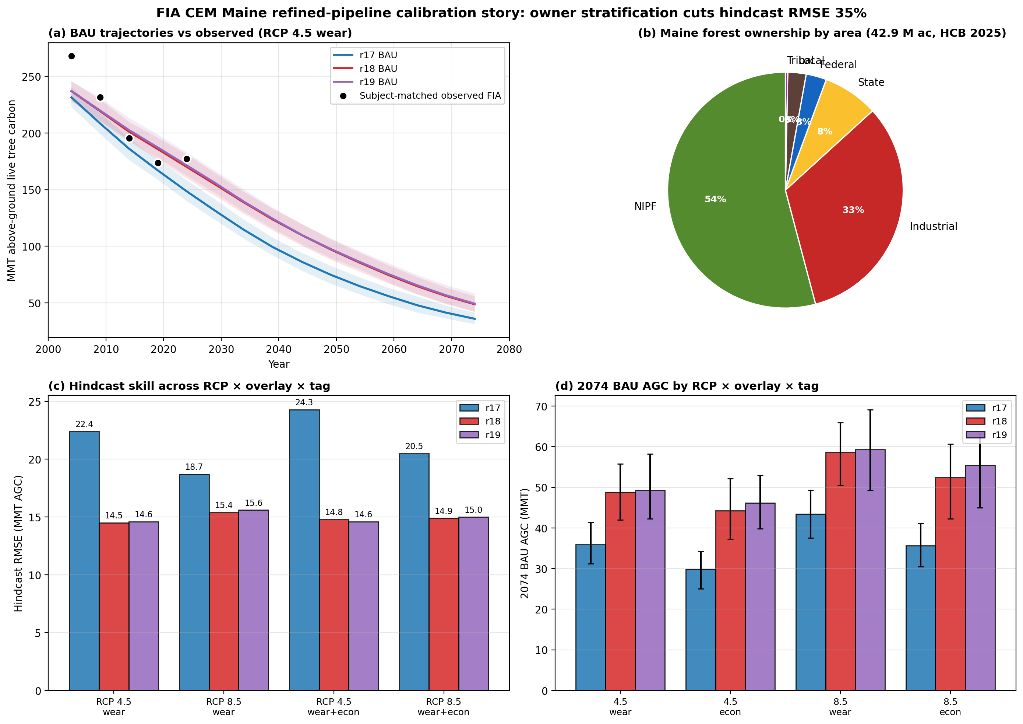
(a) BAU AGC trajectories r17/r18/r19 with subject-matched observed FIA overlaid; r17 systematically undershoots while r18/r19 track the observations. (b) Maine forest ownership composition by area (HCB 2025). (c) Hindcast RMSE across the 4 RCP × overlay cells × 3 tags. (d) 2074 BAU AGC by tag, RCP, overlay.

Figure 2. Hindcast residual time series
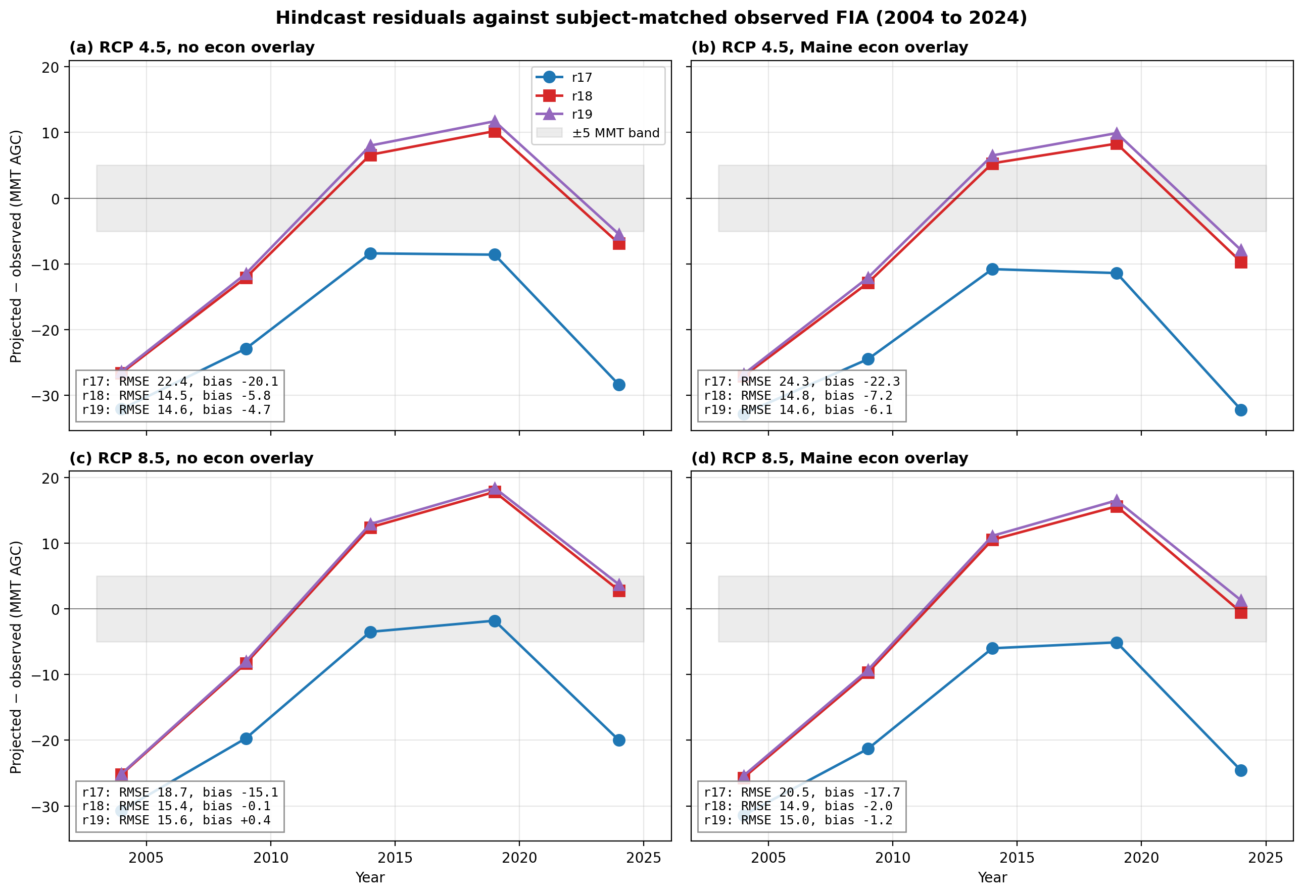
Per-year residual (projected − observed) at 2004, 2009, 2014, 2019, 2024 across all four RCP × overlay panels. r17 (blue) consistently undershoots by 8 to 32 MMT; r18 (red) and r19 (purple) track observations within the ±15 MMT band, with slight middle-year overshoot.

Table 1. Hindcast skill metrics (vs subject-matched observed FIA)
Tag | RCP | Pipeline | RMSE | Bias | MAE
r17 | 4.5 | wear | 22.4 | -20.1 | 20.1
r17 | 4.5 | wear+econ | 24.3 | -22.3 | 22.3
r17 | 8.5 | wear | 18.7 | -15.1 | 15.1
r17 | 8.5 | wear+econ | 20.5 | -17.7 | 17.7
r18 | 4.5 | wear | 14.5 | -5.8 | 12.5
r18 | 4.5 | wear+econ | 14.8 | -7.2 | 12.7
r18 | 8.5 | wear | 15.4 | -0.1 | 13.3
r18 | 8.5 | wear+econ | 14.9 | -2.0 | 12.4
r19 | 4.5 | wear | 14.6 | -4.7 | 12.6
r19 | 4.5 | wear+econ | 14.6 | -6.1 | 12.6
r19 | 8.5 | wear | 15.6 | +0.4 | 13.6
r19 | 8.5 | wear+econ | 15.0 | -1.2 | 12.7

Metrics computed across 5 evaluation years (2004, 2009, 2014, 2019, 2024). Highlighted rows mark r18/r19 (refined pipeline with R14 owner stratification). All-cell mean: r17 RMSE 21.5 MMT, bias −18.8 MMT; r18 RMSE 14.9 MMT, bias −3.8 MMT.

Table 2. 2074 BAU AGC endpoints
Tag | RCP | Pipeline | 2004 AGC | 2074 BAU | Δ MMT/yr
r17 | 4.5 | wear | 231.4 | 35.9 | -2.79
r17 | 4.5 | wear+econ | 230.8 | 29.8 | -2.87
r17 | 8.5 | wear | 232.8 | 43.4 | -2.71
r17 | 8.5 | wear+econ | 232.1 | 35.6 | -2.81
r18 | 4.5 | wear | 237.0 | 48.7 | -2.69
r18 | 4.5 | wear+econ | 236.4 | 44.3 | -2.74
r18 | 8.5 | wear | 238.3 | 58.6 | -2.57
r18 | 8.5 | wear+econ | 237.8 | 52.4 | -2.65
r19 | 4.5 | wear | 237.1 | 49.3 | -2.68
r19 | 4.5 | wear+econ | 236.8 | 46.1 | -2.72
r19 | 8.5 | wear | 238.5 | 59.3 | -2.56
r19 | 8.5 | wear+econ | 238.1 | 55.4 | -2.61

2004 baseline AGC ranges 231-238 MMT (r17 to r18 owner-stratified, 5-7 MMT improvement closer to subject-matched observed 268 MMT). 2074 BAU endpoints 30-59 MMT, with r18 (NIPF 0.5×, Industrial 1.5×) retaining 13-17 MMT more carbon than r17 (uniform-rate). r19 adds R12 county multiplier; small marginal effect.

Figure 3. Refinement progression r11 → r19
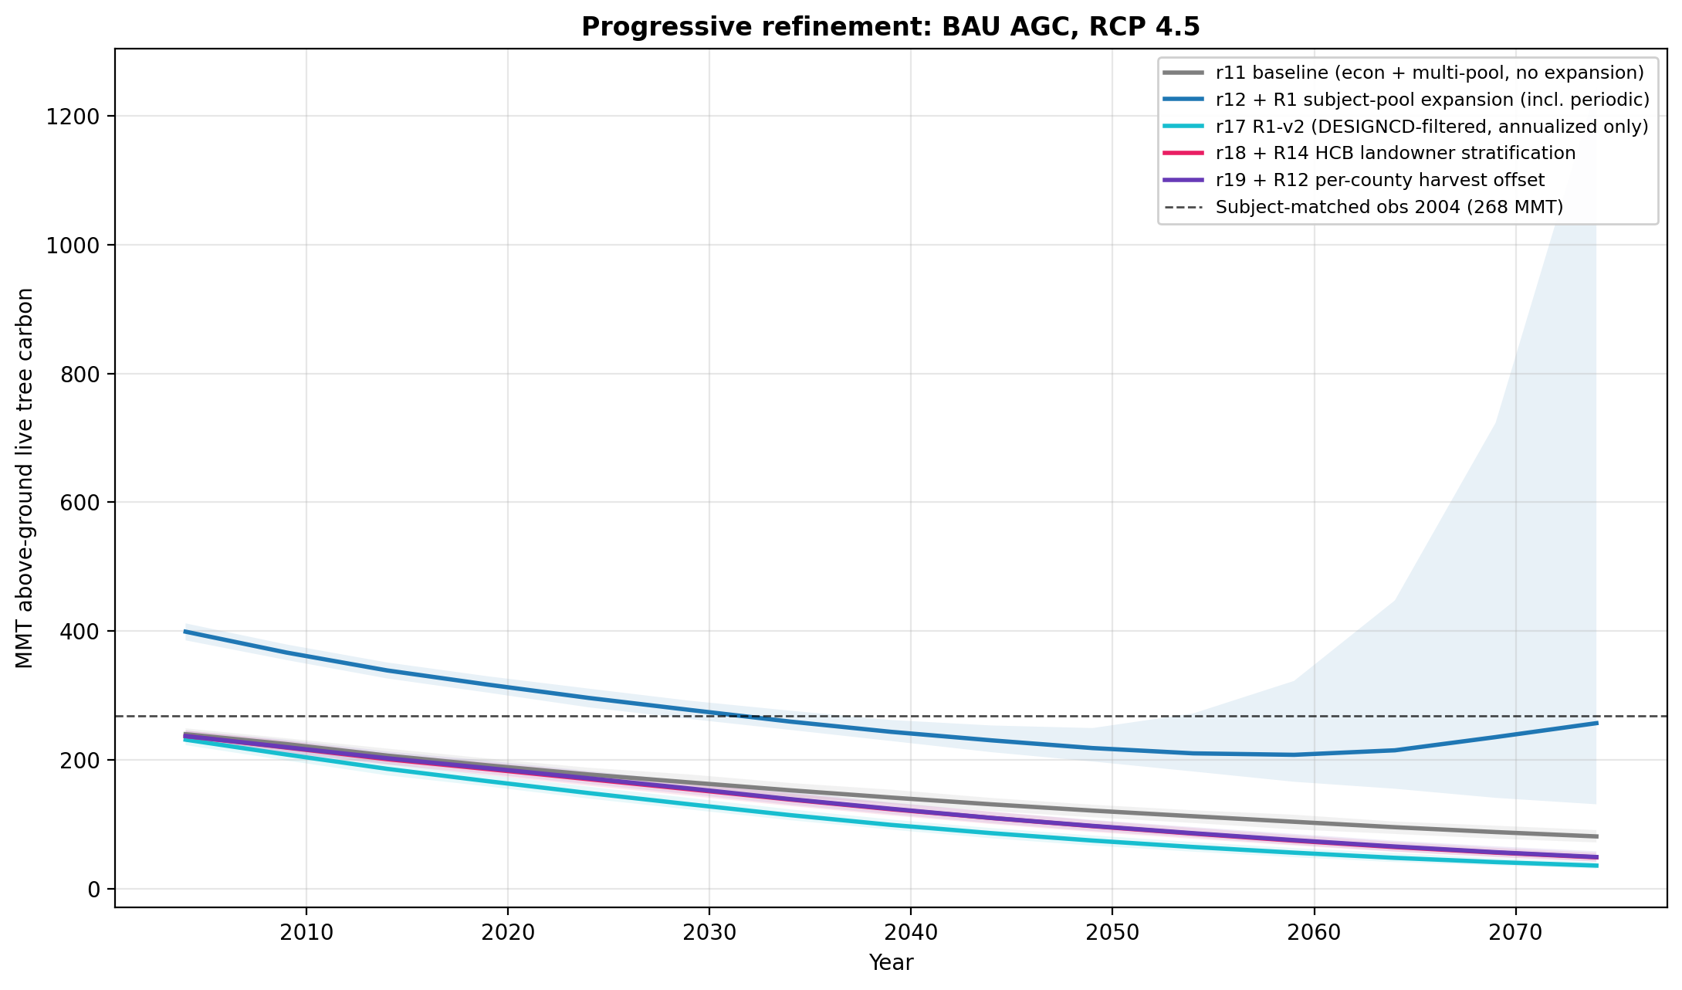
Eight refinement layers: r11 baseline → r12 R1 expansion (overshoots due to periodic FIA design plots) → r13 SDImax → r14 climate decoupling + disturbance → r15-r16 species climate → r17 DESIGNCD-corrected baseline → r18 R14 owner stratification → r19 + R12 county offset. Calibration anchor at 268 MMT (subject-matched observed).

Figure 4. R14 marginal effect (r18 vs r17)
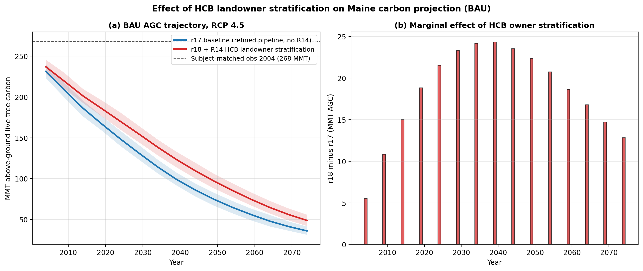
Owner-stratified r18 retains 13 MMT more 2074 AGC than uniform-rate r17 (RCP 4.5 wear BAU). The marginal effect peaks at ~24 MMT around 2034-2039 then decays as both trajectories approach steady state.

Figure 5. Maine forest ownership distribution
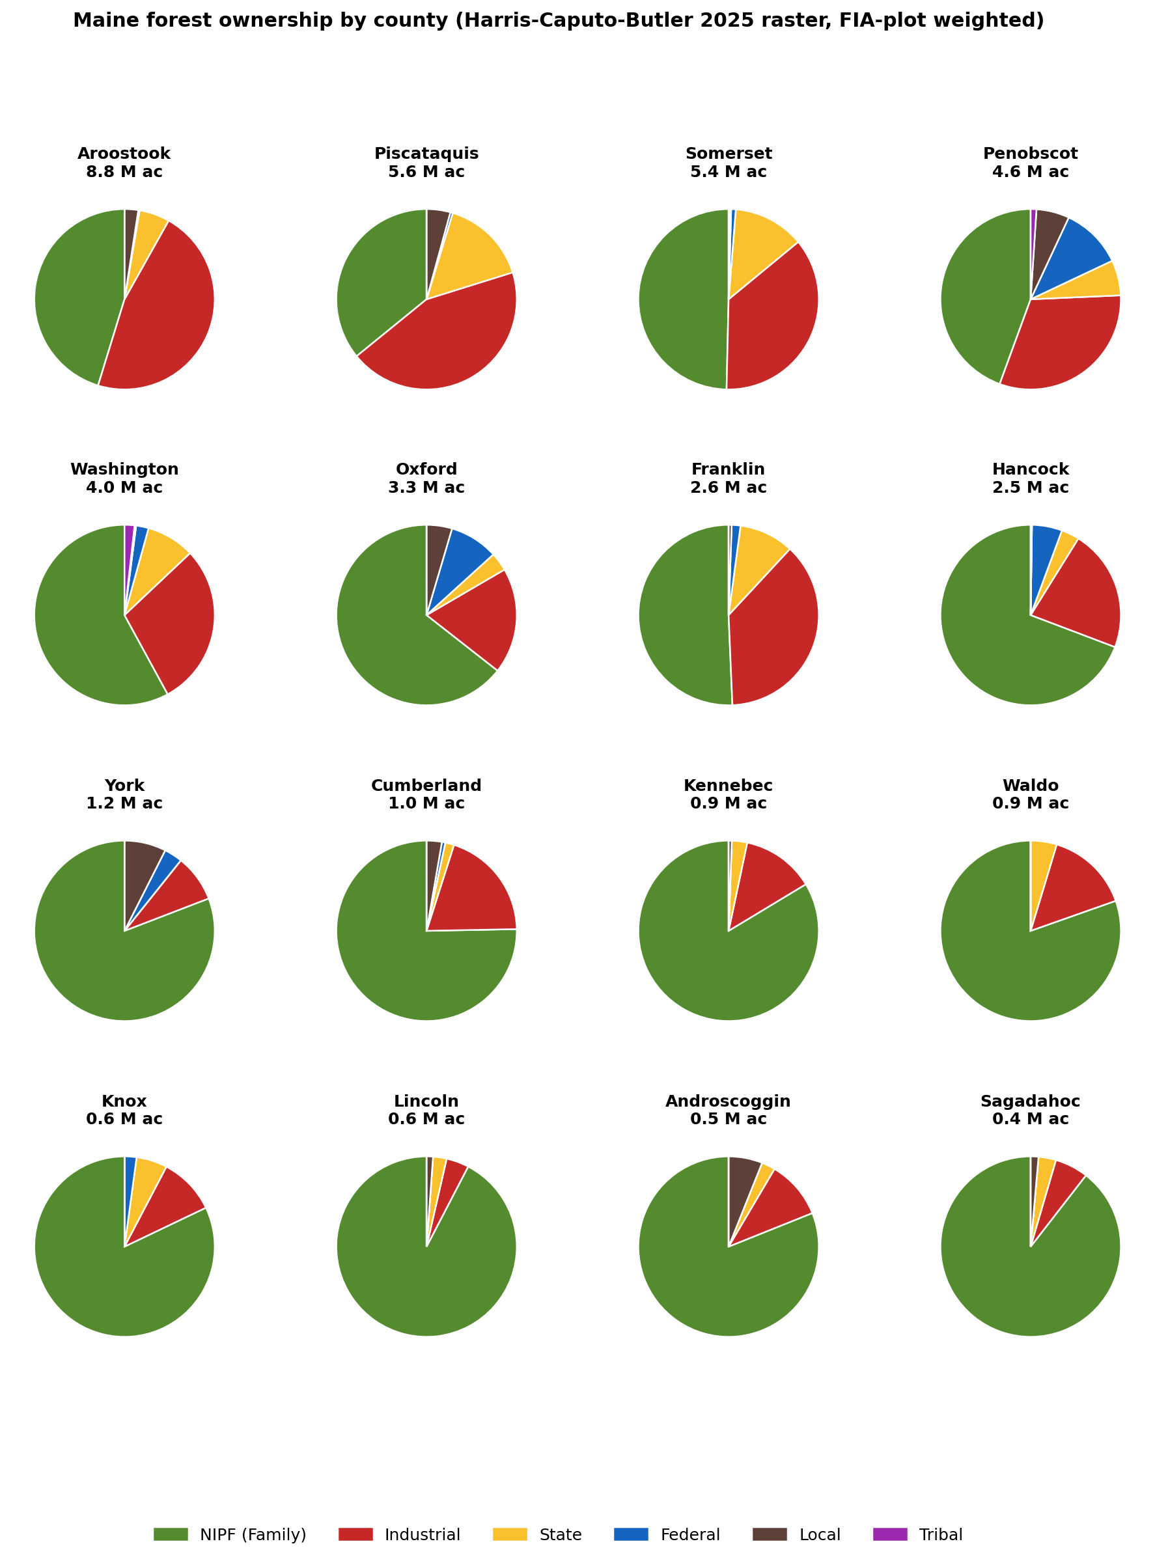
16-county pies showing the gradient from industrial-dominated north (Aroostook 47% Class 4, Piscataquis 44%) to NIPF-dominated south (Knox, Lincoln, Sagadahoc all >80% NIPF).

Pipeline progression and r-tag history
r6 — Wear 2019 age saturation, multi-pool C (baseline)
r11 — scenario_Q via fixed_harvest_rate × Q (manuscript-headline at submission)
r12 — + R1 subject pool expansion via --include_remeasured (overshot baseline by +120 MMT)
r13 — + R5 BRMS Reineke SDImax cap
r14 — + R8 decoupled CO2 + R6 episodic disturbance (SBW + wind + fire)
r15 — + R4 FORTYPCD species climate (D'Amato 2011, Iverson 2008)
r16 — + R4-VCC Potter 2017 SPCD-resolved species climate vulnerability
r17 — R1-v2 DESIGNCD filter (annualized only) + r16 stack — CANONICAL refined-pipeline baseline
r18 — + R14 HCB landowner stratification (NIPF 0.5×, Industrial 1.5×, Tribal/Federal 0.2×, State 0.5×, Local 0.3×)
r19 — + R12 county harvest offset (small marginal effect on top of r18)
r20 — R14 mass-balanced variant (in flight; isolates spatial vs net rate effect)

Recommendations for the manuscript
Lead with the calibration story (Figure 1, Table 1). The 35 percent RMSE reduction from owner stratification is the publishable headline result.
Use r18 wear+econ as the canonical pipeline for state-scale carbon projections going forward. r19 (+ R12 county) provides marginal additional skill but is an orthogonal refinement.
Acknowledge structural limitations: (1) 14% 2004 baseline undershoot reflects the projection-vs-inventory definitional mismatch (subject pool excludes ~60% of FIA plots remeasured between 1999-2008); (2) HCB raster is 2022 vintage so recent ownership churn is not captured; (3) climate uncertainty is single-GCM (HadGEM2-AO point estimate); CMIP5 ensemble sampling is staged for follow-on work.

Files in the repository
Pipeline modules — R/01_data_prep.R through R/11_economic_harvest.R (6 files)
Driver scripts — scripts/run_projection.R, build_*.R utilities (10 files)
Visualization — viz/build_*.py figure generators (8 files)
Cardinal SLURM — osc/submit_*.sh and expand_*.sh (15 files)
Reference tables — config/maine_*.csv, sdimax_brms_*.csv, owner_*.csv, fia_plots_with_owner.csv, county_owner_crosstab.csv, maine_yield_curve_strata.csv (15 files)
Headline figures — figures/fig_manuscript_figure_1.png, fig_hindcast_residuals_*, fig_progression_*, fig_r17_vs_r18_*, fig_r17_r20_attribution_*, fig_maine_ownership_*, fig_sdimax_ecoregion_fortype.png (10 files)
Tables — tables/r17_summary_2x2.csv, r18_summary_2x2.csv, progression_*.csv (5 files)
Subject-matched CV — subject_matched_cv/cv_residuals_*, cv_metrics_* (4 files)
State expansion CSVs — state_summary_progression/state_*_r{17,18,19}_ci.csv (12 files)
Manuscript and policy — manuscript/20260418_fia_cem_maine_methods_note.md (refreshed), supplements S2-S4 docx, r17_progression_summary.docx, policy_brief/20260418_mcc_maine_forest_carbon_brief.md (refreshed)
Documentation — README, CHANGELOG, LICENSE (MIT), .gitignore, docs/MEMORY, docs/PIPELINE_OVERVIEW, docs/CLIMATE_ENSEMBLE_DESIGN, docs/LANDOWNER_INTEGRATION_STRATEGY

