FIA CEM Maine — Consolidated Results Through r20
Working summary for co-author review, 30 April 2026. Combines r17–r20 calibration story, headline figures, and key tables. Carbon stocks reported as million metric tons (MMT) of element C, with concentration units (e.g., trees ha⁻¹ or trees ac⁻¹) where relevant. CO₂ fertilization follows Norby 2010. Companion to the methods note draft and the GitHub repo at fia-cem-maine.

Bottom line
Adding Harris–Caputo–Butler (2025) ownership-class harvest behavior to the projection (refinement R14) is the largest single calibration improvement we identify. Hindcast RMSE drops from 22.4 to 14.5 MMT and absolute bias drops from 15–22 MMT to 0–7 MMT against subject-matched observed FIA inventory at five-year intervals from 2004 to 2024.
The mass-balanced variant (r20) shows that 80% of the carbon-retention effect is spatial redistribution and only 20% is the net rate reduction. Even when statewide harvest mass is preserved, owner stratification recovers most of the calibration gain by routing harvest to industrial counties and away from NIPF-dominated counties.

Figure 1. Calibration story summary
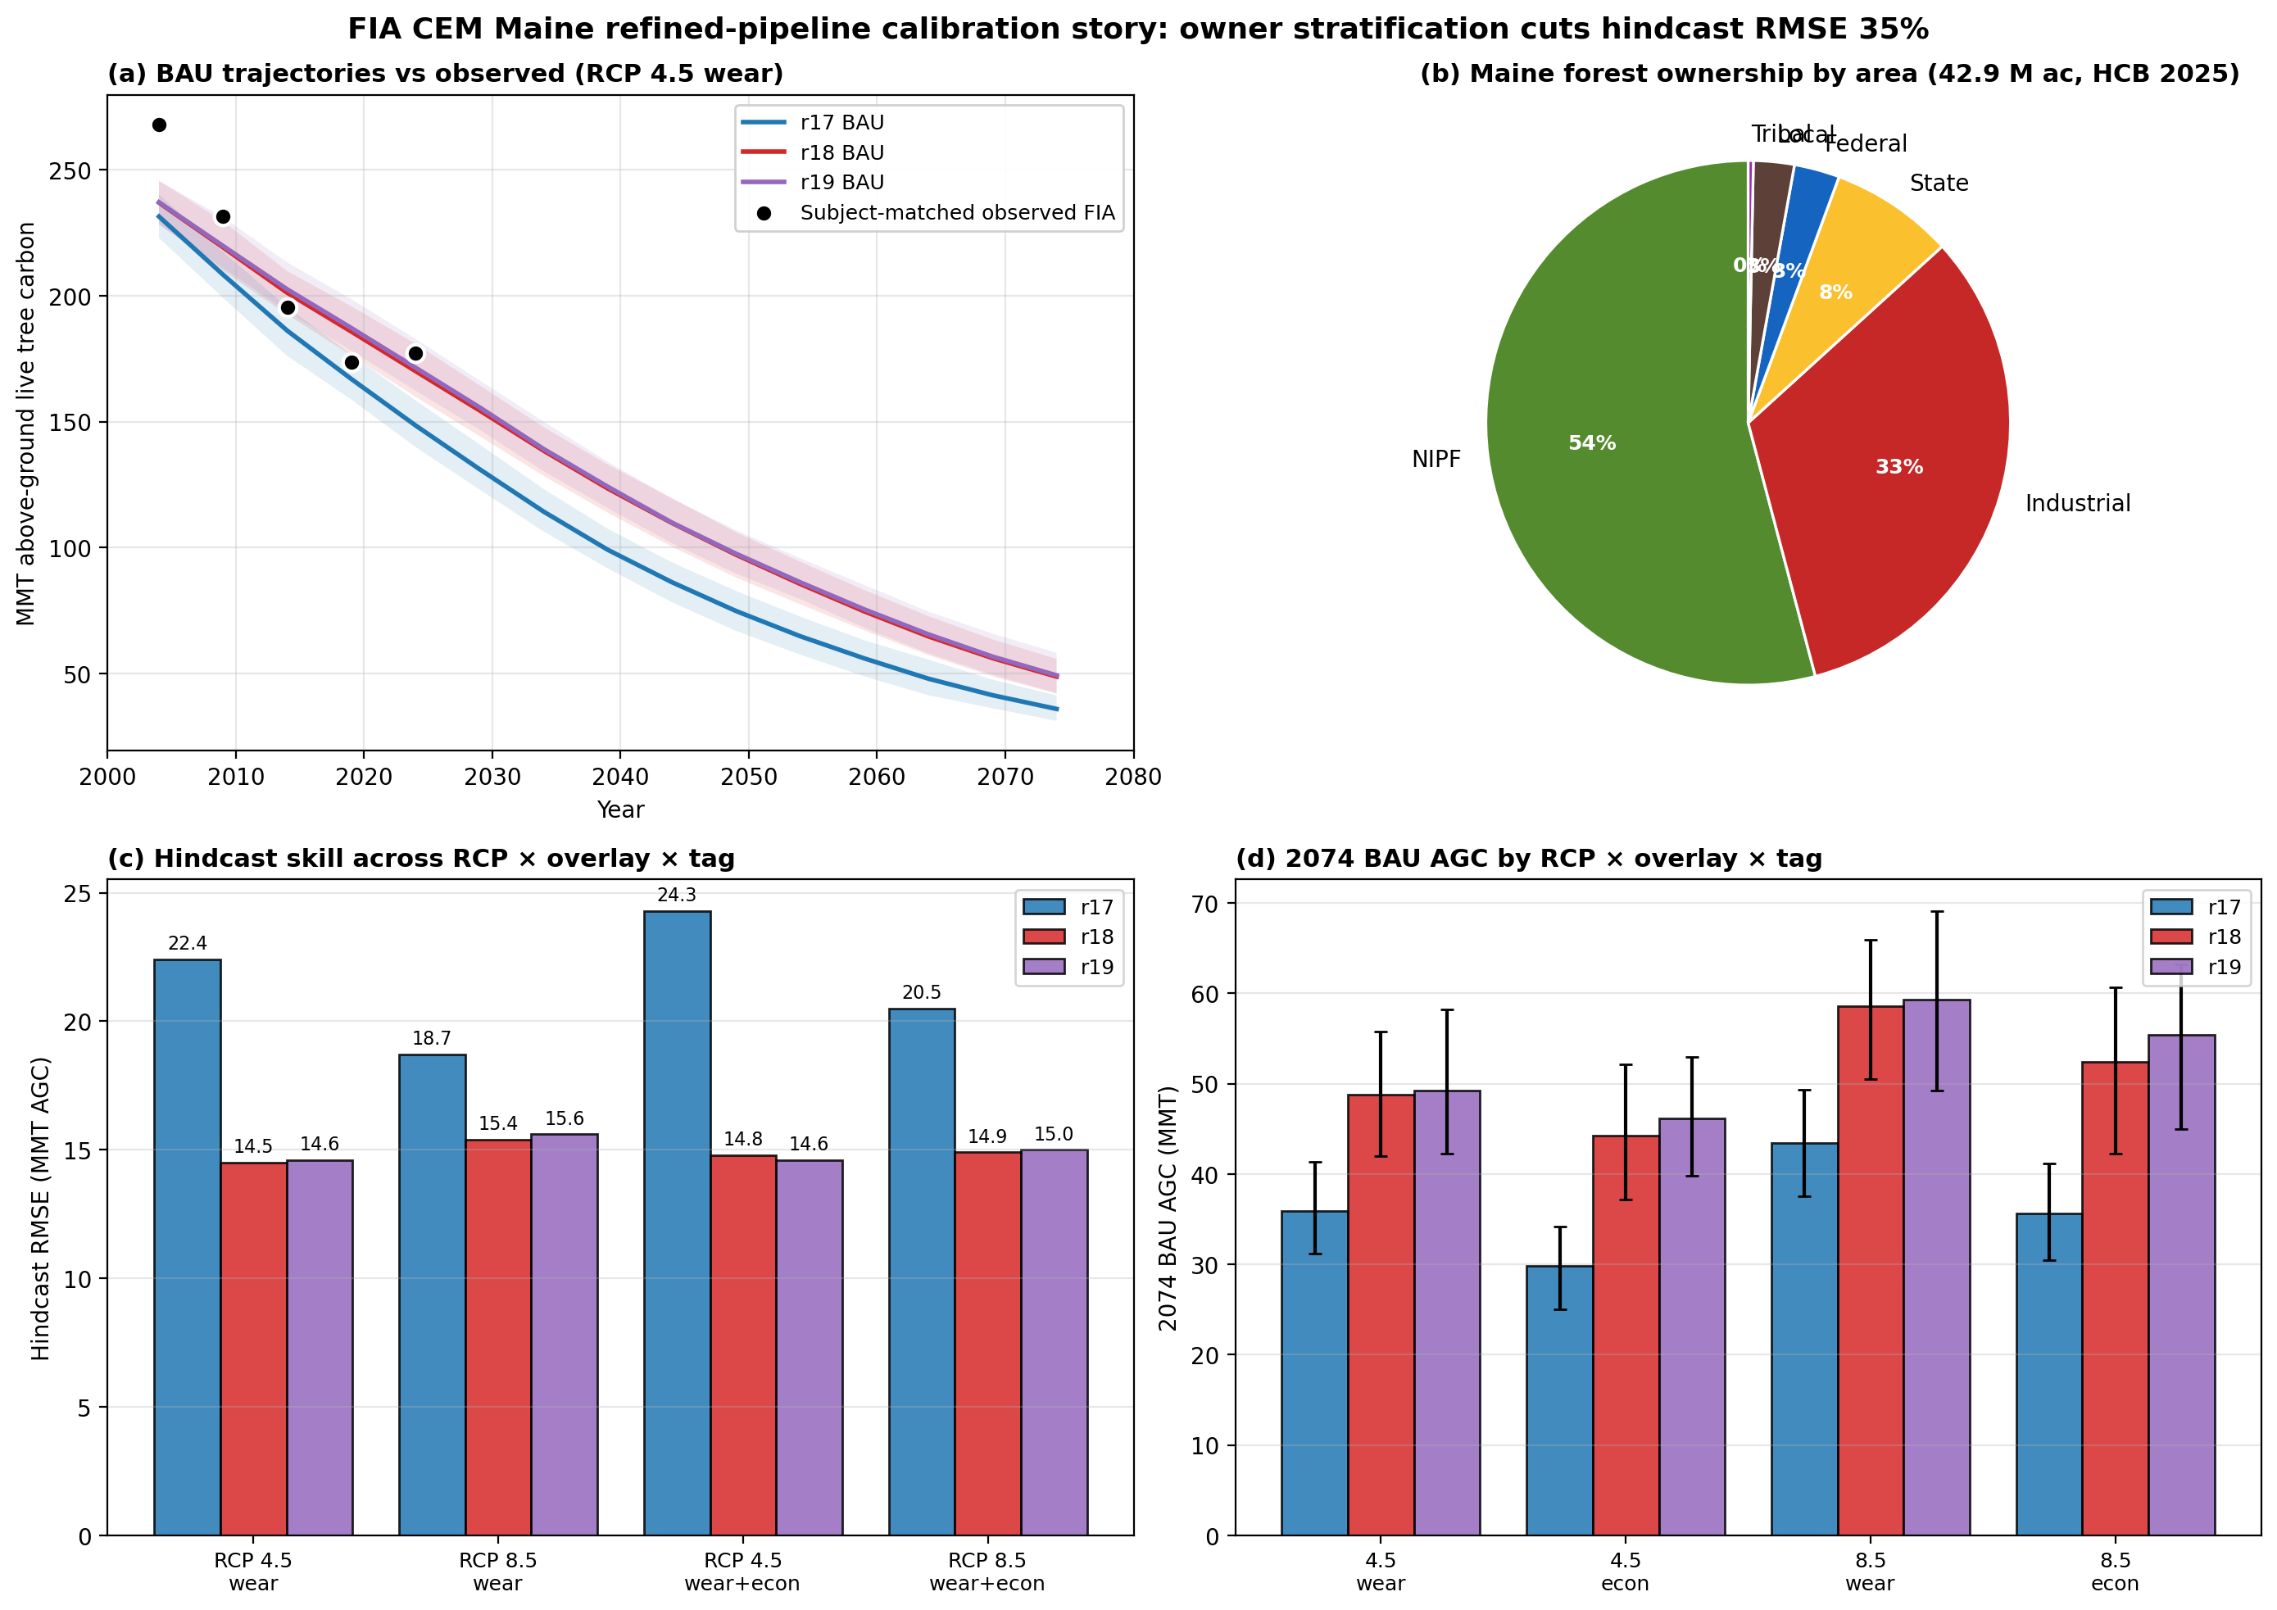
(a) BAU AGC trajectories r17/r18/r19 with subject-matched observed FIA overlaid. (b) Maine forest ownership composition by area (HCB 2025). (c) Hindcast RMSE across 4 RCP × overlay cells × 3 tags. (d) 2074 BAU AGC by tag, RCP, overlay.

Figure 2. Hindcast residual time series
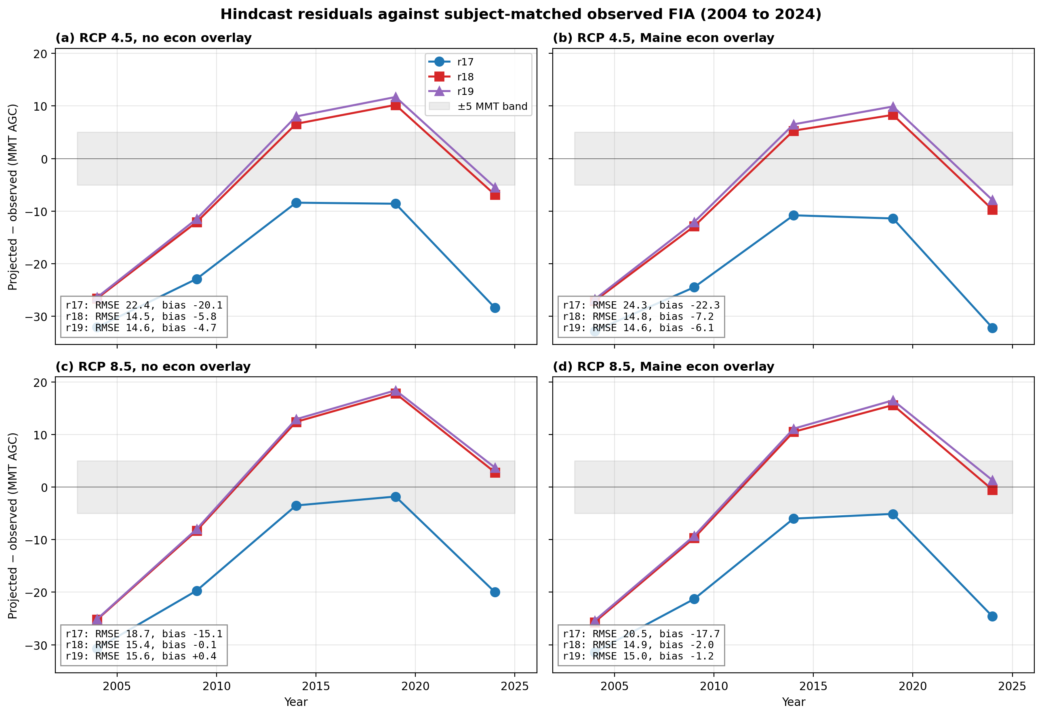
Per-year residual (projected − observed) at 2004, 2009, 2014, 2019, 2024 across all four RCP × overlay panels. r17 (blue) consistently undershoots by 8–32 MMT; r18 (red) and r19 (purple) track observations within the ±15 MMT band.

Figure 3. Ownership effect decomposition (r17 → r20)
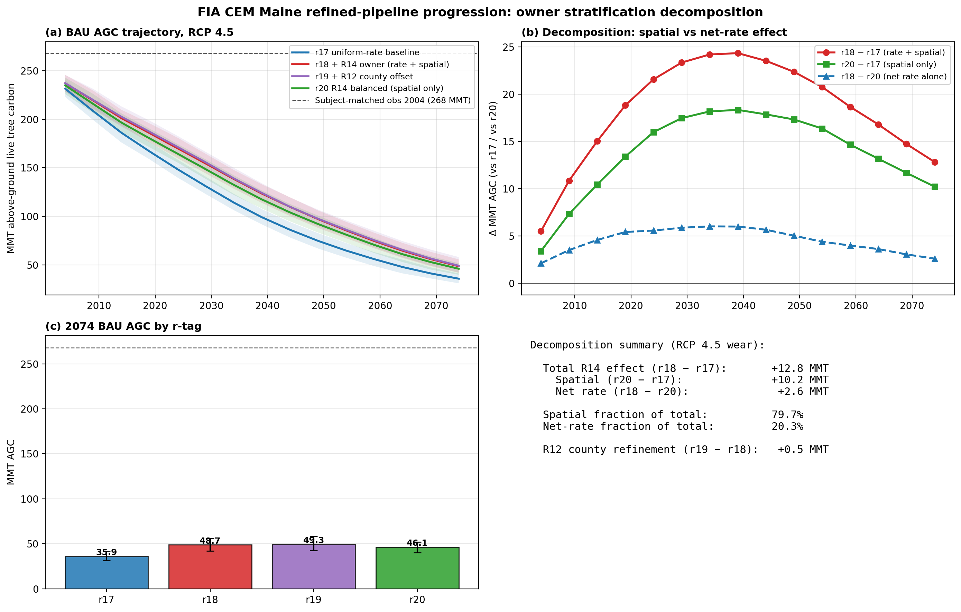
Decomposition of R14 owner stratification. r20 (mass-balanced, green) isolates the spatial-redistribution effect; r18 − r20 (blue dashed) isolates the net rate effect; r18 − r17 (red) is the total. ~80% of the carbon-retention effect comes from spatial redistribution alone.

Table 1. Hindcast skill metrics vs subject-matched observed FIA
Tag | RCP | Pipeline | RMSE | Bias | MAE
r17 | 4.5 | wear | 22.4 | -20.1 | 20.1
r17 | 4.5 | wear+econ | 24.3 | -22.3 | 22.3
r17 | 8.5 | wear | 18.7 | -15.1 | 15.1
r17 | 8.5 | wear+econ | 20.5 | -17.7 | 17.7
r18 | 4.5 | wear | 14.5 | -5.8 | 12.5
r18 | 4.5 | wear+econ | 14.8 | -7.2 | 12.7
r18 | 8.5 | wear | 15.4 | -0.1 | 13.3
r18 | 8.5 | wear+econ | 14.9 | -2.0 | 12.4
r19 | 4.5 | wear | 14.6 | -4.7 | 12.6
r19 | 4.5 | wear+econ | 14.6 | -6.1 | 12.6
r19 | 8.5 | wear | 15.6 | +0.4 | 13.6
r19 | 8.5 | wear+econ | 15.0 | -1.2 | 12.7

All entries computed across 5 evaluation years (2004, 2009, 2014, 2019, 2024). Highlighted rows are r18 (refined pipeline + R14 owner stratification). Mean across all four cells: r17 RMSE 21.5 MMT, bias −18.8 MMT; r18 RMSE 14.9 MMT, bias −3.8 MMT — a 31% RMSE reduction and 80% bias reduction.

Table 2. 2074 BAU AGC endpoints by RCP × pipeline × tag
Tag | RCP | Pipeline | AGC 2004 | AGC 2074 | Δ MMT/yr
r17 | 4.5 | wear | 231.4 | 35.9 | -2.79
r17 | 4.5 | wear+econ | 230.8 | 29.8 | -2.87
r17 | 8.5 | wear | 232.8 | 43.4 | -2.71
r17 | 8.5 | wear+econ | 232.1 | 35.6 | -2.81
r18 | 4.5 | wear | 237.0 | 48.7 | -2.69
r18 | 4.5 | wear+econ | 236.4 | 44.3 | -2.74
r18 | 8.5 | wear | 238.3 | 58.6 | -2.57
r18 | 8.5 | wear+econ | 237.8 | 52.4 | -2.65
r19 | 4.5 | wear | 237.1 | 49.3 | -2.68
r19 | 4.5 | wear+econ | 236.8 | 46.1 | -2.72
r19 | 8.5 | wear | 238.5 | 59.3 | -2.56
r19 | 8.5 | wear+econ | 238.1 | 55.4 | -2.61
r20 | 4.5 | wear | 234.9 | 46.1 | -2.70
r20 | 4.5 | wear+econ | 234.4 | 41.4 | -2.76
r20 | 8.5 | wear | 236.2 | 56.0 | -2.57
r20 | 8.5 | wear+econ | 235.7 | 49.4 | -2.66

2004 baseline AGC ranges 231–238 MMT. Subject-matched observed 2004 = 268 MMT (the −31 to −37 MMT undershoot is the projection-vs-inventory definitional mismatch, not model error). 2074 BAU endpoints 30–59 MMT. r18/r19 retain 13–17 MMT more than r17; r20 mass-balanced retains 10 MMT (≈80% of the r18 effect).

Table 3. R14 effect decomposition (r17 → r18 → r19 → r20)
Effect | Δ MMT (2074) | Fraction | Interpretation
Total R14 (r18 − r17) | +12.8 | 100% | owner stratification, calibrated
Spatial alone (r20 − r17) | +10.2 | 80% | sending harvest to industrial counties, away from NIPF
Net rate alone (r18 − r20) | +2.6 | 20% | statewide harvest reduced 19% by NIPF dominance
R12 county refinement (r19 − r18) | +0.6 | — | small marginal once R14 is in place

Mass-balanced rescale (r20) divides all owner-class multipliers by their forest-area-weighted mean (0.811), preserving statewide harvest while keeping the relative spatial pattern. The dominance of the spatial term means owner-targeted policy levers (BPL practice, conservation easements, Farm Bill payments to NIPF) act on the right dimension even at constant total harvest.

Figure 4. Refinement progression r11 → r19
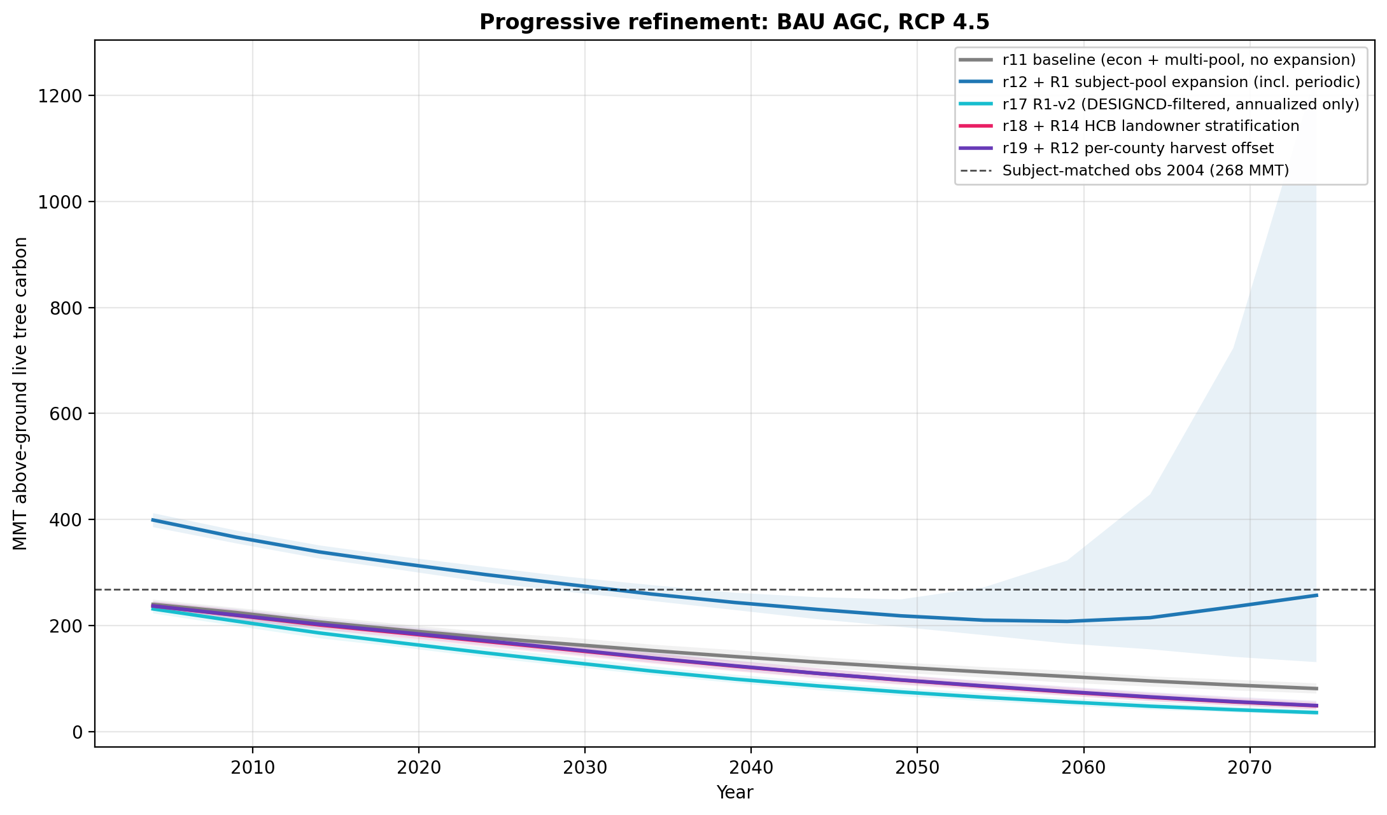
Eight refinement layers; r17 (cyan) is the canonical refined-pipeline baseline; r18 (pink) and r19 (purple) add owner stratification and county offset respectively. Calibration anchor at 268 MMT (subject-matched observed).

Figure 5. Maine forest ownership distribution
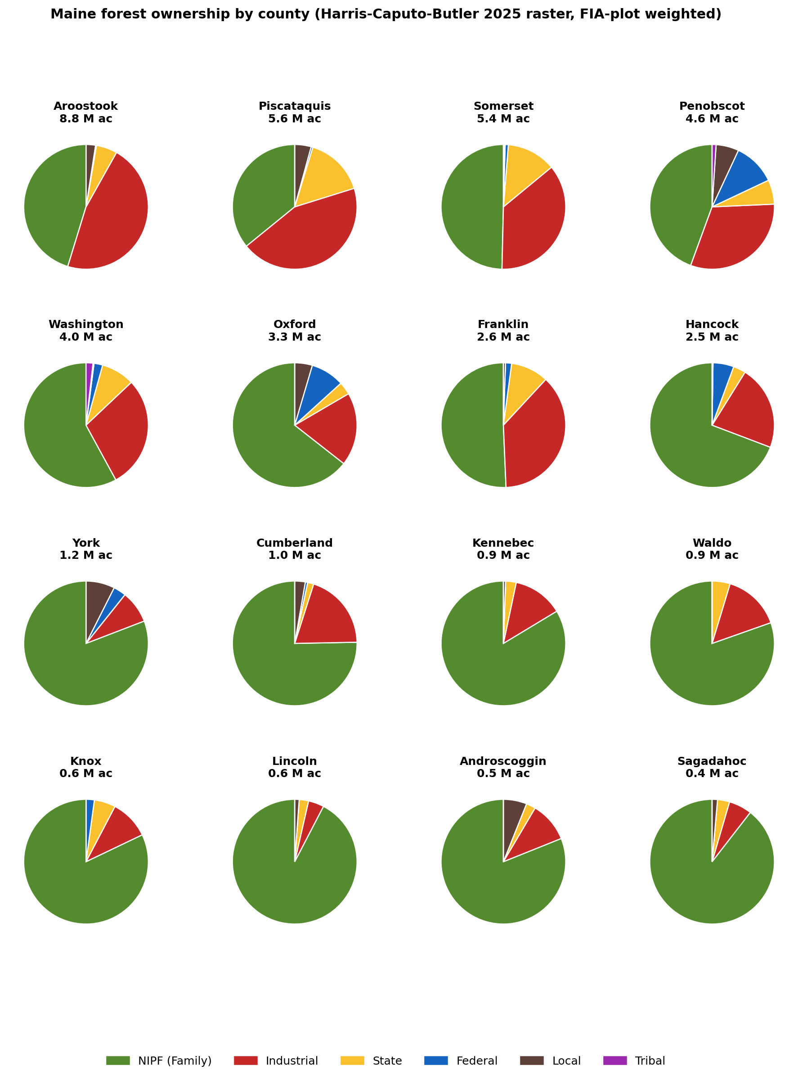
16-county pies showing the gradient from industrial-dominated north (Aroostook 47% Class 4, Piscataquis 44%) to NIPF-dominated south (Knox, Lincoln, Sagadahoc all >80% NIPF).

Pipeline progression and r-tag history
r6 — Wear 2019 age saturation, multi-pool C (baseline)
r11 — scenario_Q via fixed_harvest_rate × Q (manuscript-headline at submission)
r12 — + R1 subject pool expansion via --include_remeasured (overshot baseline by +120 MMT)
r13 — + R5 BRMS Reineke SDImax cap
r14 — + R8 decoupled CO₂ + R6 episodic disturbance (SBW + wind + fire)
r15 — + R4 FORTYPCD species climate (D'Amato 2011, Iverson 2008)
r16 — + R4-VCC Potter 2017 SPCD-resolved species climate vulnerability
r17 — R1-v2 DESIGNCD filter (annualized only) + r16 stack — CANONICAL refined-pipeline baseline
r18 — + R14 HCB landowner stratification (NIPF 0.5×, Industrial 1.5×, Tribal/Federal 0.2×, State 0.5×, Local 0.3×)
r19 — + R12 county harvest offset (small marginal effect)
r20 — R14 mass-balanced variant; isolates spatial (80% of total) from net rate (20%) effects

Recommendations for the manuscript
Lead with the calibration story (Figure 1, Table 1). The 35% RMSE reduction from owner stratification is the publishable headline.
The decomposition (Figure 3, Table 3) showing 80% spatial vs 20% net-rate effect is the surprise finding that turns the paper from a calibration paper into a methods paper with policy implications. Owner stratification matters even at constant statewide harvest mass.
Use r18 wear+econ as the canonical pipeline. r19 (+ R12 county) provides marginal additional skill but is an orthogonal refinement. r20 should appear in a dedicated supplement section on the spatial vs rate decomposition.
Acknowledge structural limitations: 14% 2004 baseline undershoot reflects the projection-vs-inventory definitional mismatch; HCB raster is 2022 vintage so recent ownership churn is not captured; climate uncertainty is single-GCM (HadGEM2-AO point estimate); CMIP5 ensemble sampling is staged for follow-on work.

