FVS-ACD (Acadian Variant) Overview of the Forest Vegetation Simulator
DRAFT variant overview / General Technical Report scaffold. 29 June 2026, updated 22 July 2026, updated 23 July 2026.
*Structured after the USDA Forest Service Northeast (NE) Variant Overview (FVS Staff 2008, rev. August 2023) so it can become the official FVS-ACD variant documentation. Equation content is drawn from the Acadian GY Model Documentation (Weiskittel and team, 2025-05-20) and the AcadianGY source, built on the 12.7.1 development line. AcadianGY 12.10.1 is the current operational and production version, documented here. The geographic range map, the keyword and database usage reference (Appendix C), the Literature Cited, and the Appendix C and D validation and keyword material are drafted in this revision, with the keyword reference flagged as a usage overview to be finalized with the FVS software team; the species and component parameter tables (Appendices A and B) are populated directly from the AcadianGY source and are unchanged from v12.9.0 through v12.10.1, since the later refinements touch mortality, ingrowth, self-thinning, and the management modifiers, not the species-level growth, crown, taper, or volume parameters. This draft will be rendered to a formatted Word/PDF GTR. Updated 7 July 2026 to document v12.10.1 as the operational version, with the version lineage through 12.5.0, 12.7.0/12.7.1, 12.9.x, and 12.10.1, the five-way independent scorecard and honest scorecard position, the Bakuzis biological-realism pass, the disclosed ingrowth limit, and the planned v13 program. Updated 22 July 2026 (sections 10.4 to 10.7) to document AcadianGY 12.11, a validated release candidate that corrects a maturity-dependent long-horizon volume bias in v12.10.1 through five gated levers built on the stand-constraint approach of Weiskittel, Hann, Kershaw, and Vanclay (2011), Chapter 10; to refresh the benchmark with an all-sites Maine, New Brunswick, and Quebec comparison of v12.11 against the frozen base and OSM v2.26.1; and to fold in the corrections an independent red-team review required before the candidate's claims could be reported. Updated 23 July 2026 (new sections 10.6 to 10.9, and the renumbered 10.10 and 10.11) to fold in the v12.11 benchmark findings finalized since the 22 July revision: a forest-group attribution check that traces most of the pooled hardwood worsening to a single-source (Quebec MagPlot) harness artifact rather than a hardwood-specific mechanism, leaving softwood as the clearest, cleanest v12.11 win (10.6); a Nova Scotia independent-province validation, the region's longest continuously remeasured record, showing the managed-stand levers generalize cleanly, a site-index transferability caveat on the New Brunswick and Quebec ESI anchor, a corrected long-interval test that does not reproduce the maturity-dependent sign flip seen elsewhere, and an OSM-ACD v2.26.1 head-to-head with no outright winner (10.7); a master scorecard across managed status, forest group, and projection length with a reconciled overall ranking built from non-overlapping per-source data, stated honestly as a mixed result rather than a v12.11 sweep (10.8); a 160-year five-relation Bakuzis assessment across the productivity and species-composition gradient, where v12.11 holds the same biological-realism pattern as the frozen base and OSM flags two relations including a persistent site-ordering inversion (10.9); and corrected 50 km hex data-coverage maps that now include Nova Scotia on the same footing as Maine, New Brunswick, and Quebec. AcadianGY 12.10.1 remains the operational, shipped version for the 18 August 2026 Acadian Growth and Yield meeting; v12.11 is documented here as a validated candidate available for evaluation, not yet adopted, and neither v12.11 nor OSM-ACD v2.26.1 is a clean overall winner across every determinant tested (10.8).*
Authors and Contributors
Aaron Weiskittel and the University of Maine Cooperative Forestry Research Unit (CFRU) developed the Acadian growth-and-yield model. Ben Rice (Midgard Natural Resources) maintains the FVS-ACD implementation and benchmarking. Component equations are credited to their authors throughout (Kuehne, Russell, Rijal, Li, Chen, Castle, Cen, and others; see Literature Cited). This overview documents the FVS-ACD variant as implemented in AcadianGY 12.10.1, the current operational version.
Suggested citation: Weiskittel, A. 2026. FVS-ACD (Acadian variant) overview: Forest Vegetation Simulator. CRSF and CFRU, University of Maine, Orono, ME. [pages].

Table of Contents
1. Introduction
2. Geographic Range
3. Control Variables (region codes, species, ecoregion, site index, maximum density)
4. Growth Relationships (height-diameter, bark, crown ratio and recession, crown width, CCF, diameter increment, height increment, stand basal-area increment)
5. Mortality Model
6. Regeneration and Ingrowth
7. Volume and Taper
8. Modifiers (thinning, spruce budworm, hardwood form and risk)
9. Model Application (site index rasters, cycle length, usage)
10. Version Lineage, Current Operational Version (12.10.1), the v12.11 Candidate, and Validation
11. Literature Cited
12. Appendices (species list, parameter tables)

Quick Guide to Default Settings
Parameter | Default
Projection cycle length | 1 year (FVS reporting frequency user-selectable)
Region code | ME (northern New England); also NB, NS, QC
Site productivity | Climate Site Index (CSI, m); modern ESI accepted in the same input (12.6.x)
Maximum stand density index | Composition-based, Weiskittel and Kuehne (2019); see 3.5
Species | 37 Acadian species codes plus OH (other hardwood) and OS (other softwood)
Minimum DBH | 2.5 cm for height prediction; ingrowth threshold DBH user-set
Units | Metric internally (DBH cm, height m, BA m² ha⁻¹, trees ha⁻¹)
Volume | Kozak variable-exponent taper; Westfall and Scott

1. Introduction
The Acadian forest region spans northern New England and Atlantic Canada. It is a transitional mixed conifer and hardwood type, sitting between the northern hardwood forests to the south and the boreal forest to the north (Loo and Ives 2003). The Acadian growth-and-yield model, developed by the CFRU team led by Aaron Weiskittel, is the regionally specific model for this setting, and FVS-ACD is its implementation within the Forest Vegetation Simulator framework. It departs from the FVS Northeast (NE) variant in two respects. Its core growth, mortality, height, crown, ingrowth, and taper relationships were fit on Acadian data, with the Kuehne et al. (2022) increment equations alone drawing on more than 2.5 million diameter and a million height observations, and it is driven by a climate-based site index in place of a traditional site index. FVS-ACD is a one-year-cycle, individual-tree, distance-independent model and, like the other variants, supports the FVS extensions.

2. Geographic Range
The Acadian variant applies to northern New England (Maine, New Hampshire, Vermont) and Atlantic Canada (New Brunswick, Nova Scotia) plus southern Quebec, the region for which the component equations were fit. Region codes select the regional mortality and modifier parameters (ME, NB, NS, QC).
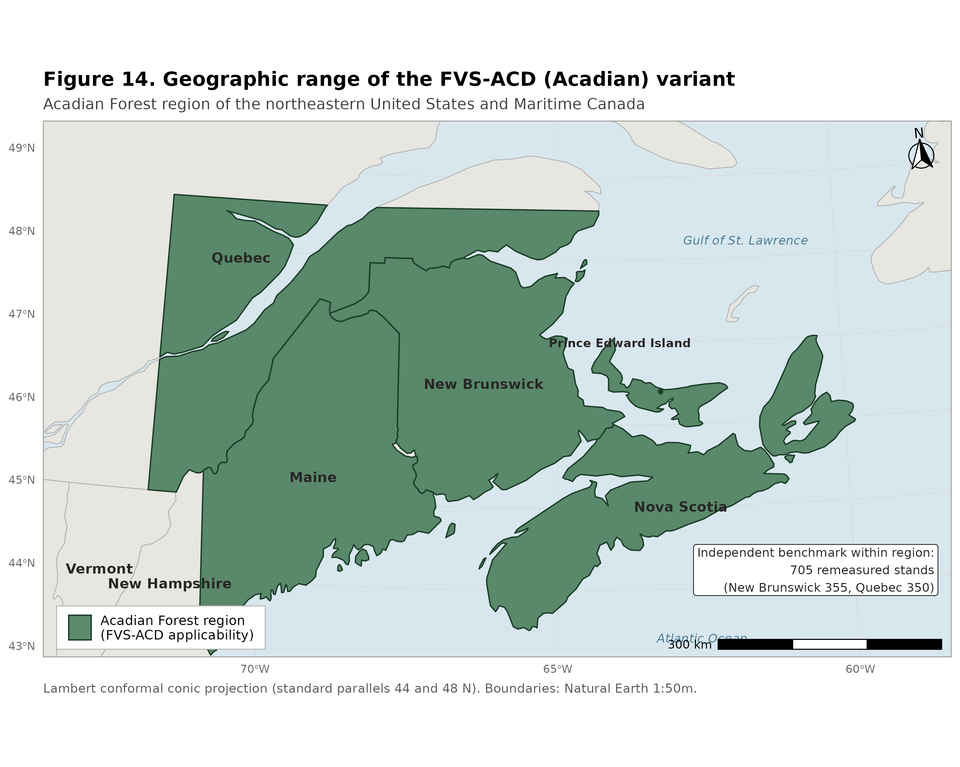
Figure 14. Geographic range of the Acadian variant (FVS-ACD): northern New England (Maine, New Hampshire, Vermont), Atlantic Canada (New Brunswick and Nova Scotia), and southern Quebec, the region for which the component equations were fit and over which the region codes (ME, NB, NS, QC) select the regional mortality and modifier parameter sets.

3. Control Variables

3.1 Region codes
ME (default, northern New England), NB (New Brunswick), NS (Nova Scotia), QC (Quebec). Region selects the regional parameter sets for stand and tree mortality and the spruce budworm modifier.

3.2 Species codes
37 rows are parameterized in `sp.attr` (35 distinct named species plus the OH other-hardwood and OS other-softwood composite groups, and a `99` fallback row). Species not in the parameter set map to OH or OS by softwood/hardwood type. Full species code table with scientific names, FIA and PLANTS codes, specific gravity, and shade/drought/waterlog tolerance in Appendix A; component parameter tables (height, HCB, crown width, bark ratio, mortality, modifiers, ingrowth, taper, volume) by `sp.grp.ingrowth` and by individual species in Appendix B.

3.3 Habitat / ecological unit
FVS-ACD does not use habitat type codes; site productivity enters through the climate site index (3.4). Level 3 ecoregion is available as an optional stratifier for maximum density (3.5).

3.4 Site index
The Acadian model uses Climate Site Index (CSI, m), a climate-and-soil-driven productivity surface (Weiskittel et al. 2011a), fit by random forest on seven climatic variables (most important: mean temperature of the warmest month, the warmest-to-coldest month temperature difference, and the growing-season-to-annual precipitation ratio). CSI is a user input and is available as raster surfaces for current and future (2030, 2060, 2090) climate normals. CSI enters total height, diameter increment, stand basal-area increment, height increment, mortality, ingrowth, and maximum SDI.
Operational note (12.7.0). The production model uses the validated modern Ecological Site Index (ESI) as the site driver, supplied through the same input slot. ESI tracks measured site index well (R^2 0.91). A controlled full-set test showed that ESI and the legacy climate site index give the same regional volume and value, with an all-region basal-area bias of +1.4 percent under both. The ESI gain therefore does not appear in volume or value bias. It appears in dominant-height behavior and biological realism, since ESI anchors the stand dominant height onto a fitted Chapman-Richards curve (k = 0.0039, p = 0.726, base age 50; section 4.1 note), which removes the Bakuzis height site-ordering inversions. The ESI surface is supplied as a raster (Acadian ESI v8). The earlier AcadianSIm climate surfaces are a separate future-climate product and are not the operational site driver.

3.5 Maximum density (maximum SDI)
Stand density index is additive at the plot level, SDI = sum over trees of (DBH/25.4)^1.6 * TPH, with DBH in cm and trees ha⁻¹. Maximum SDI follows Weiskittel and Kuehne (2019), a composition- and structure-based function:
SDImax = 475.2079 - 1.5908*HW.ba.percent - 236.9051*log(meanSG) + 50.3299*sqrt(DBHrange)
+ 13.5202*spp.div + 0.0685*Elev - 2.8537*sqrt(Elev) + 222.7836*(1/CSI)
where HW.ba.percent is percent hardwood basal area, meanSG is basal-area-weighted mean specific gravity (capped at 0.80), DBHrange is the plot DBH range, spp.div is species count, and Elev is elevation (m). A fallback SDImax2 = 1347.445 - 1003.870*meanSG is used where the primary function is undefined. Relative density is SDI/SDImax.
Version 12.6.x note: a brms re-estimation of plot-level SDImax across northern New England found SDImax is essentially independent of site index (correlation with CSI and ESI near 0) and is primarily a function of forest type (softwood ceilings near 1050 to 1100, northern hardwood near 900, wet hardwood near 750), which the composition terms above already approximate through mean specific gravity. A site-independent SDImax (dropping the 222.78/CSI term, recentred) is available behind a flag.
Version 12.9.0 note: a CONUS-scale brms re-estimation (independent of the northern New England one above) confirmed forest type dominates the variance in plot-level maximum SDI (R-squared 0.21) far more than site index alone (R-squared 0.02), and that a localized, forest-type-and-ecoregion-aware maximum predicts observed self-thinning roughly twice as well as a generic species-table constant. Applied to AcadianGY, the diagnostic finding was that the Weiskittel-Kuehne SDImax equation above already handles composition well through the percent-hardwood and specific-gravity terms, but under-corrects specifically for hardwood-dominated stands in Quebec outside the Acadian-core ecoregion (CEC North American Level III: Acadian Plains and Hills, Maritime Lowlands). v12.9.0 adds a gated multiplier to SDImax (`ops$sdimax.fortype.tight.mult`, default 0.65 to 0.70), active only when a stand is simultaneously Quebec, outside the Acadian core, and hardwood-dominated by BA-weighted dominant species group. See section 10 and `20260701_v129_full_validation.md` for the full derivation and validation.

4. Growth Relationships

4.1 Height-diameter (total tree height)
HTPred, after Rijal et al. (2012a) modified for additional species:
ht = 1.37 + ((c0 + c0.spp) + CSI^c1) * (1 - exp(-c2*DBH))^(c3 + c3.spp + c4*log(CCF+1) + c5*BAL)
CSI enters the asymptote (the CSI^c1 term). c0 to c5 are fixed; c0.spp and c3.spp are species random effects. Used to fill missing or invalid heights. Species parameter table in Appendix B.1. The benchmark scoring harness fills missing heights on observed tree lists by a separate route, a diameter-only curve applied outside the engine; 10.5.1 quantifies how much of each source's volume score depends on it.

4.2 Bark ratio
DOBtoDIB (Weiskittel and Li 2012) converts diameter outside to inside bark. Form and species parameters in Appendix B.4.

4.3 Crown ratio and crown recession
Height to crown base, HCBPred (Rijal et al. 2012b, refit with species random effect, Weiskittel et al. 2013):
hcb = HT / (1 + exp((a0 + a0.spp) + a1*DBH + a2*HT + a3*DHR + a4*log(CCF+1) + a5*(BAL+1)))
Crown recession, dHCB (Russell et al. 2014):
dHCB = (CL + dHT) / (1 + exp(b1 + b2*log(CR+0.01) + b3*log(CCF+1) + b4*log(1.01-CR)
+ b5*shade^2 + b6*log(shade*CR)))
HCB species random-effect table (a0.spp) in Appendix B.2. The crown-recession equation uses fixed parameters for all species (no separate species table in the source); shade tolerance is read from Appendix A.

4.4 Crown width
Maximum crown width mcw = a1*DBH^a2 (open-grown, Russell and Weiskittel 2011, 99th-quantile); largest crown width lcw = mcw / (b1*DBH^b2) for forested conditions. Species parameters in Appendix B.3.

4.5 Crown competition factor
CCF is the sum of tree maximum crown areas per plot, used in height, height-to-crown-base, crown recession, increment, and ingrowth.

4.6 Diameter increment
dDBH, Kuehne et al. (2022), species as a random effect, fit on > 2.5 million observations:
dDBH = exp((b0+b0.SPP) + b1*log(DBH) + (b2+b2.SPP)*DBH + (b3+b3.SPP)*log(CR)
+ (b4+b4.SPP)*log(BAL.SW+0.1) + b5*BAL.HW + b8*log(CSI))
Fixed-effect coefficients (Kuehne et al. 2022, Table 6): b0 = -1.64234, b1 (ln DBH) = 0.376978, b2 (DBH) = -0.025684, b3 (ln CR) = 0.713456, b4 (ln BAL.SW+0.1) = -0.065750, b5 (BAL.HW) = -0.017740, b8 (ln CSI) = 0.135377. Species random effects apply to the intercept, DBH, ln(CR), and ln(BAL.SW+0.1). Competition is one-sided and asymmetric (basal area in larger softwoods and hardwoods); two-sided metrics (SDI, relative density) were no more effective. On independent FIA data the equation is nearly unbiased (mean bias -1.2 percent) and improves on the prior FVS-ACD diameter and basal-area increment submodels by 11 to 13 percent in mean absolute bias. Tree diameter increment is constrained by the stand basal-area increment (4.8). Full species random-effect tables in Kuehne et al. (2022) Table S3.

4.7 Height increment
dHT, Kuehne et al. (2022), more conservative than the earlier Russell et al. (2014) form (addresses the FVS-NE over-prediction expectation):
dHT = exp((b0+b0.SPP) + b1*log(HT) + (b2+b2.SPP)*HT + b3*CR + b4*(CCFL/100) + b7*CSI^2)
Fixed-effect coefficients (Kuehne et al. 2022, Table 8): b0 = -2.19445, b1 (ln HT) = 0.426404, b2 (HT) = -0.064710, b3 (CR) = 0.394837, b4 (CCFL/100) = -0.011430, b7 (CSI^2) = 0.000294. Species random effects apply to the intercept and HT. The new dHT improves on the prior Russell et al. (2014) submodel substantially (mean absolute bias down 41 to 74 percent), the largest accuracy gain of the two increment refits. Full species random-effect tables in Kuehne et al. (2022) Table S5.

4.8 Stand basal-area increment
Chen et al. (in prep.), added at v12.3.0, applied at the stand level as a cap on summed tree diameter increment:
dBA = rt*Ba*(1 - Ba/k); rt = q0 + q1*log(RD+1e-6) + q2*log(CSI) + q3*log(pHW.ba*100+1e-6)
+ q4*log(CSI*RD+1e-6)
Applied only when summed predicted tree BA increment exceeds the stand prediction, and capped at 0.227 percent of plot BA (5th percentile, Maine FIA). RD is relative density SDI/SDImax. This is the density-dependent brake on growth.

5. Mortality Model
Stand- and tree-level mortality, Weiskittel et al. (2012). The multi-stage approach of Chen et al. (2023) was evaluated in beta and was not superior, so the model uses the 2012 formulation (see the v12 history memo).
Stand mortality probability: prob = exp(k)/(1+exp(k)), k = b0 + b1*BA + b2*BA^2 + b3*BAG + b4*QMD + b5*BA.BF + b6*BA.IH. Stand mortality basal area: BA.mort = (b0 + b1*pBA.bf + b2*pBA.ih)*BA^(b3 + b4*BAG); BF.mort = b5*BA.BF^b6 + b7*(QMD.BF/QMD). Tree survival: logistic in DBH and DBH^2. Stand mortality is distributed across trees in proportion to tree mortality probability. Region-specific parameters (ME, NB, NS, QC) in Appendix B.6; tree-level background mortality species parameters (the DBH/DBH^2 survival logistic and the Weibull-form diameter-jump term) in Appendix B.5.
Operational note: the production model uses the 2012 stand and tree mortality with SDImax-ceiling self-thinning (ops$use.sdimort) active, a density-frontier mortality that holds post-step SDI at or below SDImax and improves the Bakuzis self-thinning slope. A size-dependent MORTCAL corrector (ops$use.mortcal) is available but trades stem-count accuracy and ships off. The principled next-version fix is a regional refit of the 2012 stand-mortality coefficients.
Coupled self-thinning and density-released ingrowth (12.7.1). The 12.7.0 self-thinning used a single slope above a relative-density onset, which on long-horizon projection never plateaued (basal area climbed past 36 m² ha⁻¹ and was still rising at age 120). Version 12.7.1 replaces it with a coupled two-segment relative-density mortality. Let RD = SDI/SDImax. Mortality is zero below RD 0.30, rises on a gentle slope from 0.30 to a break at 0.62 (ops$sdimort.onset, ops$sdimort.break, ops$sdimort.beta.gentle), and rises on a steep slope above the break (ops$sdimort.beta.steep), so a fully stocked stand self-thins along the SDImax line. It is coupled with a density-released ingrowth (section 6). Through a logistic in RD, recruitment is suppressed at high RD and released below about RD 0.58. The biological rationale is the build, self-thin, and rebound dynamic of a stand that grows to its maximum, self-thins along the density frontier, and rebounds as ingrowth releases when density falls, the process underlying a shifting-mosaic steady state. On a 160-year projection of a young dense spruce-fir stand across the site gradient, basal area builds and plateaus at about 33 to 34 m² ha⁻¹ by mid-rotation and then levels, inside the realistic fully-stocked Acadian spruce-fir range (about 28 to 34), replacing the 12.7.0 runaway climb. The decline-and-rebound is critically damped at the single-stand deterministic scale. Because mature Quebec-edge stands and moderately dense New Brunswick stands overlap in relative density, this relative-density lever reduces the mature-stand over-prediction while modestly deepening the growing-stand under-prediction; separating the two is the next-version regional and composition-aware mortality target.
Regional and composition-aware SDImax gate (12.9.0). Closer diagnosis showed that the 12.7.1 mature-stand residual is not a Quebec-wide phenomenon. It concentrates in hardwood-dominated Quebec stands outside the Acadian-core ecoregion, whereas softwood-dominated Quebec stands and all of New Brunswick were already close to unbiased. v12.9.0 adds a gated multiplier to the SDImax term used by this self-thinning mechanism (section 3.5), active only when a stand is simultaneously province Quebec, ecoregion outside the Acadian core, and hardwood-dominated. This raises the effective self-thinning intensity for that specific population and closes the target cell's total-volume bias from +56.7 to +10.4 percent, with no effect on New Brunswick or on the independent recent Maine FIA growing-stand check (see section 10). The mechanism adds to the coupled self-thinning above rather than replacing it, scaling SDImax before the RD = SDI/SDImax ratio that drives the two-segment mortality curve.

6. Regeneration and Ingrowth
Full ingrowth model, Li et al. (2011), for ten species groups (BCH birch, BF, RM, SPR spruce, WP, OH, AB, QA, SM, WC). A hurdle model: occurrence probability P(occur) and count E[count] = exp(eta), both functions of BA, percent hardwood, TPH, CSI, minimum DBH, and QMD. The occurrence is gated by a cut-point (CutPoint, default 0.95). FVS-ACD also retains FVS resprouting after simulated harvest. Composition and occurrence-probability parameters by species group in Appendix B.8.
Version 12.6.1 note: the 0.95 occurrence gate suppresses recruitment on most plot-years and is the source of the under-recruitment behind the stem-count deficit. v12.6.1 makes the statistically correct expected-value recruitment the default, E[ingrowth] = P(occur) * E[count] (set CutPoint to 0), with a calibration multiplier. This is the dominant lever on stem count and QMD but, by global sensitivity analysis, does not materially change stand value (the recruits are small).
Version 12.7.1 note (density-released ingrowth): observed recruitment, tree-ID matched on the raw MagPlot records, is about 40 stems per ha per year in New Brunswick and about 20 in Quebec. v12.7.1 couples the expected-value recruitment to relative density through a logistic in RD (ops$use.ingrowth.release, ops$ingrowth.rd.center 0.58, ops$ingrowth.rd.k): recruitment is suppressed at high relative density and released below about RD 0.58. Coupled with the two-segment self-thinning mortality (section 5), this produces the build, self-thin, and rebound stand dynamic.

7. Volume and Taper
Stem taper: Kozak variable-exponent taper and Westfall and Scott (Li et al. 2012, Weiskittel and Li 2012). Bark thickness via DOBtoDIB. Merchantable volume and product specifications follow the FVS volume framework; for value work, sawlog (International 1/4-inch board feet) and pulp (cords) are split by species and size. Kozak and Westfall-Scott taper species parameters in Appendix B.9, legacy Honer volume species parameters in Appendix B.10, bark ratio in Appendix B.4.
Operational note (12.7.x): all volume and biomass in the benchmarking and validation are reported on the FIA National Scale Volume and Biomass (NSVB) system, applied through an emulator that predicts the NSVB responses (gross cubic volume, net merchantable volume, net sawlog volume, and aboveground dry biomass) from log(DIA squared times HT) by species group with Duan smearing, with R-squared 0.96 to 0.99 against the FIA NSVB outputs. This puts observed and predicted tree lists on a single, current volume-and-biomass currency and replaces the earlier single form-factor merchantable volume used for increment scoring. Because the emulator takes height as an input, any tree lacking a measured height is scored on a substituted diameter-only height curve, on the observed and the predicted list alike. Measured-height coverage is uneven across the benchmark sources and has now been quantified for all eleven by a coverage census; 10.5.1 gives that accounting and the readings it qualifies.

8. Modifiers
Thinning (Kuehne et al. 2016; note the source code header instead credits Weiskittel, Hennigar, and Kershaw 2015 for this modifier, a citation discrepancy to reconcile before publication): diameter growth, mortality, height growth, and crown recession modifiers keyed on removal intensity and timing. Spruce budworm (Cen et al. 2018): balsam fir and spruce mortality, diameter and height growth, keyed on cumulative defoliation, region ME and NB. Hardwood form and risk (Castle et al. 2018): mortality and diameter growth modifiers for selected hardwoods. All parameter tables in Appendix B.7.
Direct-effect management modifiers (12.10.1). The current operational version adds the Chapter 11 direct-effect management modifiers as gated additive releases on planted and precommercial-thinning (PCT) stands. The direct effect is expressed as a robust additive term on the class of per-stand observed minus predicted-untreated increment, in place of a diameter-growth multiplier pinned to a guard clamp (planted +3.83 m² ha⁻¹ basal area, PCT +2.41 m² ha⁻¹, with proportional releases in the other metrics). It is gated by ops$use.mgmt.mod and applies only to planted and PCT stands, so the gate-off run is byte identical to v12.9.x on unmanaged stands. The release is a diameter-growth term and not a mortality term, is physically bounded within the unmanaged density envelope, and does not break the self-thinning plateau. See section 10.3 for the fit and validation.

9. Model Application
CSI is supplied by the user or sampled from the raster surfaces (current and 2030/2060/2090 climate normals); recent testing finds the 2030 surface reasonable. Cycle length is one year. The model is run from a tree list through the FVS interface or the AcadianGY R driver (make_stand, make_acd_tree, make_ops, AcadianGYOneStand). The keyword and database usage reference for the variant is given in Appendix C.

10. Version lineage, current operational version (12.10.1), and validation
AcadianGY 12.10.1 is the current operational and production version, frozen as the operational release for the 18 August 2026 Acadian Growth and Yield meeting. Version 13 is in progress, but no v13 version is gated, so nothing in the v13 program below is a claimed result. v12.10.1 is the endpoint of a single development line that began with 12.5.0 and added one gated refinement at a time. Each refinement is individually isolated, so that with its flag in the legacy position the build reproduces the prior version bit for bit. The operational configuration is the Kuehne et al. (2022) diameter and height increment equations (4.6, 4.7) as the growth base; the validated ESI v8 as the site driver with the fitted ESI-consistent dominant-height anchor recalibration active (3.4, 4.1), which delivers the clean Bakuzis site ordering (10.2); a further top-height anchor-level parity correction available behind a gate but shipping off in the current config, deferred to v13.0 (see 10.3); FIA NSVB volume and biomass (7); expected-value, density-released ingrowth (6); the coupled two-segment relative-density self-thinning (5); the regional and composition-aware SDImax gate for the Quebec hardwood edge (5, 3.5); and the Chapter 11 direct-effect management modifiers as gated additive releases on planted and precommercial-thinning stands (8, and section 10.3 below).
The version lineage, in order of development:
- 12.5.0, the prior operational and production base. Kuehne et al. (2022) increment equations, climate site index, and the 2012 stand and tree mortality. On long-horizon projection it does not self-thin, with basal area climbing past 62 m² ha⁻¹ at age 120, and is not recommended for mature-stand or long-horizon use.
- 12.7.0 and 12.7.1. The 12.7.x line added the validated ESI v8 site driver and the ESI-anchored dominant height, FIA NSVB volume and biomass through the emulator (R-squared 0.96 to 0.99 against FIA NSVB), the coupled two-segment relative-density self-thinning, and the density-released ingrowth. Together these make the long-horizon basal-area trajectory plateau at the biologically correct Acadian maximum (about 33 to 34 m² ha⁻¹) rather than running away, couple recruitment to relative density so that a stand builds, self-thins along the density frontier, and rebounds as ingrowth releases, and put observed and predicted tree lists on a single current volume and biomass currency.
- 12.9.x. A CONUS-scale brms re-estimation of plot-level maximum SDI (independent of the earlier northern New England one) confirmed that composition and ecoregion, not site index, dominate the variance in the self-thinning ceiling. v12.9.x adds a gated multiplier to SDImax active only when a stand is simultaneously Quebec, outside the Acadian-core ecoregion, and hardwood-dominated. This closes the remaining mature-stand over-prediction in exactly that population, with an independent recent-FIA cross-check confirming zero effect on New Brunswick or Maine (the province term in the gate excludes Maine by construction).
- 12.10.1. Chapter 11 direct-effect management modifiers, expressed as gated additive releases on planted and precommercial-thinning (PCT) stands (section 10.3). The modifier is gated by ops$use.mgmt.mod and touches only planted and PCT stands; the gate-off run is byte identical to v12.9.x on the 266 unmanaged stands. This is the current operational version.
Every refinement is gated, and with the flags in their legacy position the build reproduces the base bit for bit, so each is individually isolated and validated. v12.10.1 with its management gate off reproduces v12.9.x exactly, and v12.9.x with its own gate unset reproduces 12.7.1 exactly.
Sections 10.4 through 10.10 document AcadianGY 12.11, a validated release candidate built on top of v12.10.1 that corrects a maturity-dependent long-horizon volume bias through five gated levers (10.4), the refreshed all-sites Maine, New Brunswick, and Quebec validation against the frozen base and OSM v2.26.1 (10.5), a forest-group performance breakdown with a source-attribution correction on the pooled hardwood signal (10.6), an independent-province validation on Nova Scotia's own long remeasurement record (10.7), a master scorecard and reconciled overall ranking pooling every benchmark cell in the project (10.8), a 160-year Bakuzis biological-realism check across the productivity and species gradient (10.9), and the corrections an independent red-team review required before the candidate's claims could be reported here (10.10). v12.11 is not yet adopted as the operational version; every result in 10.1 through 10.3 above continues to describe the shipped v12.10.1 engine unchanged, and v12.10.1 remains the recommended operational version until v13 is gated (10.11).
One benchmark-integrity limit applies across that entire validation record and is stated once, in 10.5.1. The scoring harness substitutes a diameter-only height curve for any tree lacking a measured height, and a coverage census across all eleven benchmark sources now quantifies how much of each source's volume score depends on that substitution. PEF and Baxter are the thinnest, at 4.02 and 18.45 percent of t2 basal area carried by measured heights, but the material exposure sits on the managed sources that carry the candidate's central claim, CFRU CTRN at 51.99 percent and the New Brunswick and Quebec MagPlot extract at 32.82 percent. It changes no number reported below. It changes how several of them should be read, including the Lever 3b configuration selection, which was gated on the held-out Baxter benchmark and should now be re-examined against the validated Baxter rescore reported as Table 10.5b.
Provenance note on the operational build. The operational scorecard baseline documented in this section was produced from the AcadianGY_12.9.2.r source plus the recorded operational ops recipe, the gated management release applied through make_ops on the v12.9.x engine. A standalone AcadianGY_12.10.1.r script that folds that recipe into the source now exists in the repository and carries the AcadianV12.10.1 version tag; it is being reconciled against the recipe-driven baseline to confirm it reproduces the scored results byte for byte before it supersedes the recipe as the canonical operational file.

10.1 Four-model independent scorecard (1 July 2026)
A multi-dimensional scorecard (quantitative bias, RMSE, modeling efficiency, and periodic annual increment; qualitative Bakuzis biological realism, long-horizon trajectory shape, transparency, data requirements, usability, and uncertainty characterization) was run on AcadianGY 12.5.0, 12.7.0, 12.7.1, and the current OSM-ACD release (v2.26.1, confirmed current against the OSM-Contributors GitHub organization and the Forus Research download page), on identical independent in-domain data. The full scorecard is `20260701_four_model_scorecard.md`; figures `five_model_scorecard_heatmap.png` and `five_model_scorecard_radar.png` (v12.9.0 added as a fifth model, section 10.2).
The headline finding is that OSM-ACD carries the lowest pooled level bias of the four models on every metric and, once it is scored on all nine NSVB metrics through the same emulator harness as FVS-ACD, also carries the highest pooled modeling efficiency. An earlier read that showed a negative Nash-Sutcliffe efficiency for OSM on every metric was an index-join artifact. OSM output had been matched to the observed tree lists on a mismatched key rather than reflecting a real lack of per-stand skill. Rescoring OSM through the common NSVB harness resolves it, and OSM's pooled modeling efficiency is positive and leads the set. FVS-ACD leads OSM on biological realism, the climate-ready site driver, and quadratic mean diameter, not on pooled level bias or modeling efficiency. All three AcadianGY versions explain 55 to 78 percent of out-of-sample variance on every metric. AcadianGY 12.5.0 fails the Bakuzis self-thinning check outright, with long-horizon basal area still climbing past 62 m² ha⁻¹ at age 120 and several thousand stems per hectare still alive, and is not recommended for mature-stand or long-horizon use. Of the FVS-ACD versions, AcadianGY 12.7.1 has the best combined quantitative and qualitative profile prior to the 12.9.0 refinement below.

10.2 v12.9.0: a targeted SDImax correction for the Quebec hardwood edge
The scorecard in 10.1 localized 12.7.1's remaining structural gap to a specific population: stands that are simultaneously Quebec (province), outside the Acadian-core ecoregion (CEC North American Level III: Acadian Plains and Hills, Maritime Lowlands are the core; Northern Appalachian and Atlantic Maritime Highlands, Algonquin and Southern Laurentians, Central Laurentians and Mecatina Plateau, and Eastern Great Lakes Lowlands are outside it), and hardwood-dominated (BA-weighted dominant species group sugar maple, birch, aspen, other hardwood, or American beech). Softwood-dominated Quebec stands, and every New Brunswick stand regardless of composition, were already close to unbiased and are untouched by the v12.9.0 gate.
Development process, briefly (full derivation `20260701_v129_full_validation.md`, `20260701_v129_ooda_stress_test.md`): a region-only multiplier was tried first and found to be a pure trade-off (fixing basal area worsened volume and vice versa, with no setting fixing both). An ESI-based spatial cluster was tried and found weak, because ESI v8 coverage of Quebec is patchy. Forest type (BA-weighted dominant species group) located the real signal. True ecoregion sharpened it further. An ecoregion-only gate (no province term) closed the Quebec target as well as the final version, but an independent cross-check against the recent Maine FIA growing-stand stratum caught a real regression: the correction leaked onto Maine's own hardwood stands sharing the same ecoregion as the Quebec problem stands, worsening the FIA annual-increment check from -52 to -83 to -93 percent. Restoring province as a third gate dimension eliminated this by construction, since no Maine plot can ever satisfy a Quebec-only gate.
Validation, in-domain MagPlot (n = 733) and independent recent Maine FIA (n = 788), predicted versus observed t2 level bias:
- Target cell (Quebec, outside Acadian core, hardwood-dominated, n = 163): total volume +56.7 to +10.4 percent, stand value to +4.4 percent. Basal area, already under-predicted in 12.7.1, deepens further (-9.3 to -18.1 percent), the SDImax-driven trade-off confined now to exactly the population needing it.
- New Brunswick: unchanged from 12.7.1 in every metric.
- Recent Maine FIA: unchanged from 12.7.1 (basal-area level -2.2 percent, annual increment -0.085 m² ha⁻¹ yr⁻¹), confirming the gate cannot affect Maine plots.
- A stand-level split-half robustness check (163 target-cell stands, two random halves) confirmed the correction is not driven by a handful of outlier stands.
Known residual: a seeded 160-year trajectory of the corrected hardwood population plateaus at about 21 m² ha⁻¹, below the realistic 28 to 32 m² ha⁻¹ target for that composition (the same composition, uncorrected, plateaus at 31 to 32). A correction calibrated on a 5 to 15 year remeasurement window, carried through a full rotation, under-shoots the long-horizon asymptote. v12.9.0 is recommended for short-to-mid rotation inventory projection; v12.7.1 remains the recommended version for carbon and old-growth applications on this specific population until a tapered version of the correction, relaxing toward the true asymptote rather than applying a flat multiplier throughout the rotation, is fit.
Independent validation, and what carries to the frozen harness. This subsection is the development-era 12.7.0 to 12.7.1 self-thinning validation. It was run on a non-frozen dominant-height calibration and on populations, recent Maine FIA (n=788) and the ESI-covered Quebec edge (n=378), that are not in the frozen per-stand MagPlot files behind the section 10.3 five-way, so it has not been, and cannot cheaply be, re-benched on the frozen operational harness. Its results split by whether they depend on the dominant-height anchor factor (afac). A code-level check of the frozen harness confirms the afac enters at one point only, the dominant-height increment multiplier (dht.mult, operationally NB 0.579 and QC 0.111), and never touches the diameter-increment path or the density-dependent mortality that sets trees per hectare and quadratic mean diameter. The self-thinning results reported here are therefore density-frontier quantities that do not depend on the afac and carry to the frozen harness unchanged: the Reineke slopes, the plateau-versus-runaway trajectory finding, and the 12.7.0 to 12.7.1 self-thinning improvement. The level-bias figures that follow, and any dominant-height or NSVB-volume number in particular, were computed at the development afac and are not frozen-consistent; they are the original developmental record, not frozen results. The authoritative frozen scorecard is the five-way in section 10.3.
On genuinely independent, in-domain data, the full FIA NSVB metric set, predicted versus observed t2 level bias, New Brunswick (n=355) and the ESI-covered Quebec edge (n=378), 12.7.0 to 12.7.1:
- New Brunswick total volume -3.9 to -9.8 percent, biomass -1.4 to -7.3, value -4.5 to -10.2; basal area -3.5 to -8.5.
- Quebec edge total volume +23.3 to +14.4 percent, biomass +19.1 to +10.2, value +27.3 to +18.3; basal area -2.1 to -9.3.
Top-height (dominant-height) bias is deliberately not tabulated here. It is the single metric the afac scales directly, so the development-era figures ran warm and are not frozen-consistent. On the frozen operational harness the dominant-height afac (NB 0.579, QC 0.111) brings every build's dominant height into the tight +3.7 to +4.6 percent band reported for the five-way in section 10.3; that band, not the development-era top-height numbers, is the operational result.
The coupled self-thinning reduces the mature-stand Quebec-edge volume and biomass over-prediction by roughly a third to a half. New Brunswick and Quebec stands overlap in relative density, so the same relative-density mortality that self-thins the dense Quebec stands also deepens the moderately dense New Brunswick under-prediction; the two are ends of one lever and are the next-version regional and composition-aware mortality target.
Recent Maine FIA (post-2010, independent in time, n=788): basal-area level bias +0.7 percent in 12.7.0 to -2.2 percent in 12.7.1 (still near-unbiased); annual basal-area increment +11 percent (over) in 12.7.0 to 52 percent under (still positive net growth) in 12.7.1. On independent New Brunswick MagPlot, the v12.7 generation is +0.05 m3/ha/yr on a shared form-factor volume harness, near zero and at least as good as the 2018 OSM-ACD (-0.23) and FVS-ACD v10.6 (-0.18); the 2018 conclusion that OSM clearly beat FVS-ACD does not hold for v12.7 on independent New Brunswick data.
Biological realism (Bakuzis matrix): site ordering clean (0 of 125 inversions, the dominant-height anchor), Reineke self-thinning slopes -1.28 to -1.35, one moderate Eichhorn flag. Observed ingrowth about 40 stems per ha per year in New Brunswick and 20 in Quebec, matched by the density-released form. The Reineke self-thinning slopes are a property of the density frontier, the slope of log(TPH) on log(QMD), and as noted above do not depend on the dominant-height afac, so they stand on the frozen harness unchanged.

10.3 v12.10.1: direct-effect management modifiers, the current operational version
v12.10.1 adds the Chapter 11 direct-effect management modifiers as gated additive releases on planted and precommercial-thinning (PCT) stands, the current operational version. Relative to the v12.10.0 prototype, the planted and PCT diameter-growth multipliers no longer pin to the old 0.7 to 1.6 guard clamp. The direct effect is re-expressed as a robust additive release, planted +3.83 m² ha⁻¹ basal area and PCT +2.41 m² ha⁻¹ (ten percent trimmed means over the class of per-stand observed minus predicted-untreated increment, with proportional releases in the other metrics), which is equivalent to a net multiplier of about 3.0 planted and 2.3 PCT, above the old 1.6 ceiling, which is why the clamped version still under-predicted planted. The modifier is gated by ops$use.mgmt.mod and applies only to planted and PCT stands; the gate-off run is byte identical to v12.9.x on the 266 unmanaged stands. The additive fold coefficients move with the data (planted basal-area release 3.85 to 4.40, PCT 2.45 to 2.76 across cross-validation folds), so it is a fitted release, not a clamped constant. It is physically bounded: managed predicted SDI stays inside the unmanaged envelope, the release is a diameter-growth term rather than a mortality term, and the self-thinning plateau holds at every amplitude tested.
Benchmark dataset. The frozen evaluation benchmark comprises n = 705 remeasured stands drawn from the permanent-plot networks of the two Canadian jurisdictions that anchor the Acadian region, New Brunswick (n = 355) and Quebec (n = 350). Forest-type composition, assigned from the hardwood share of stand basal area (softwood at 25 percent or less hardwood, hardwood at 75 percent or more, mixedwood between), is 321 softwood, 186 mixedwood, and 178 hardwood stands, with 20 stands unclassified. Each stand carries an observed initial and remeasured state together with the predicted remeasured state from every variant, evaluated on the nine FIA National Scale Volume and Biomass (NSVB) metrics. The benchmark is built from remeasurement pairs whose interval ranges from 4 to 14 years, with a median of 5 years and a mean near 7, so each prediction is a projection over the stand's own observed remeasurement window rather than a fixed horizon, and total, merchantable, and sawlog volume and aboveground biomass are placed on the NSVB basis so observed and predicted state share a common estimation framework. Evaluation is restricted to the operational in-domain set, a stand retained when it falls within the Ecological Site Index (ESI) coverage or lies in New Brunswick; all 705 frozen stands are ESI-covered. The spatial extent and forest-type distribution are shown in Figure 12, a locator of the study region with stand counts on a 50 km equal-area hex grid, and Figure 13, the same aggregation split into softwood, mixedwood, and hardwood panels. Plot coordinates are restricted and were used only server-side to build the aggregated hex counts; no true coordinate appears in any released figure, table, or file.
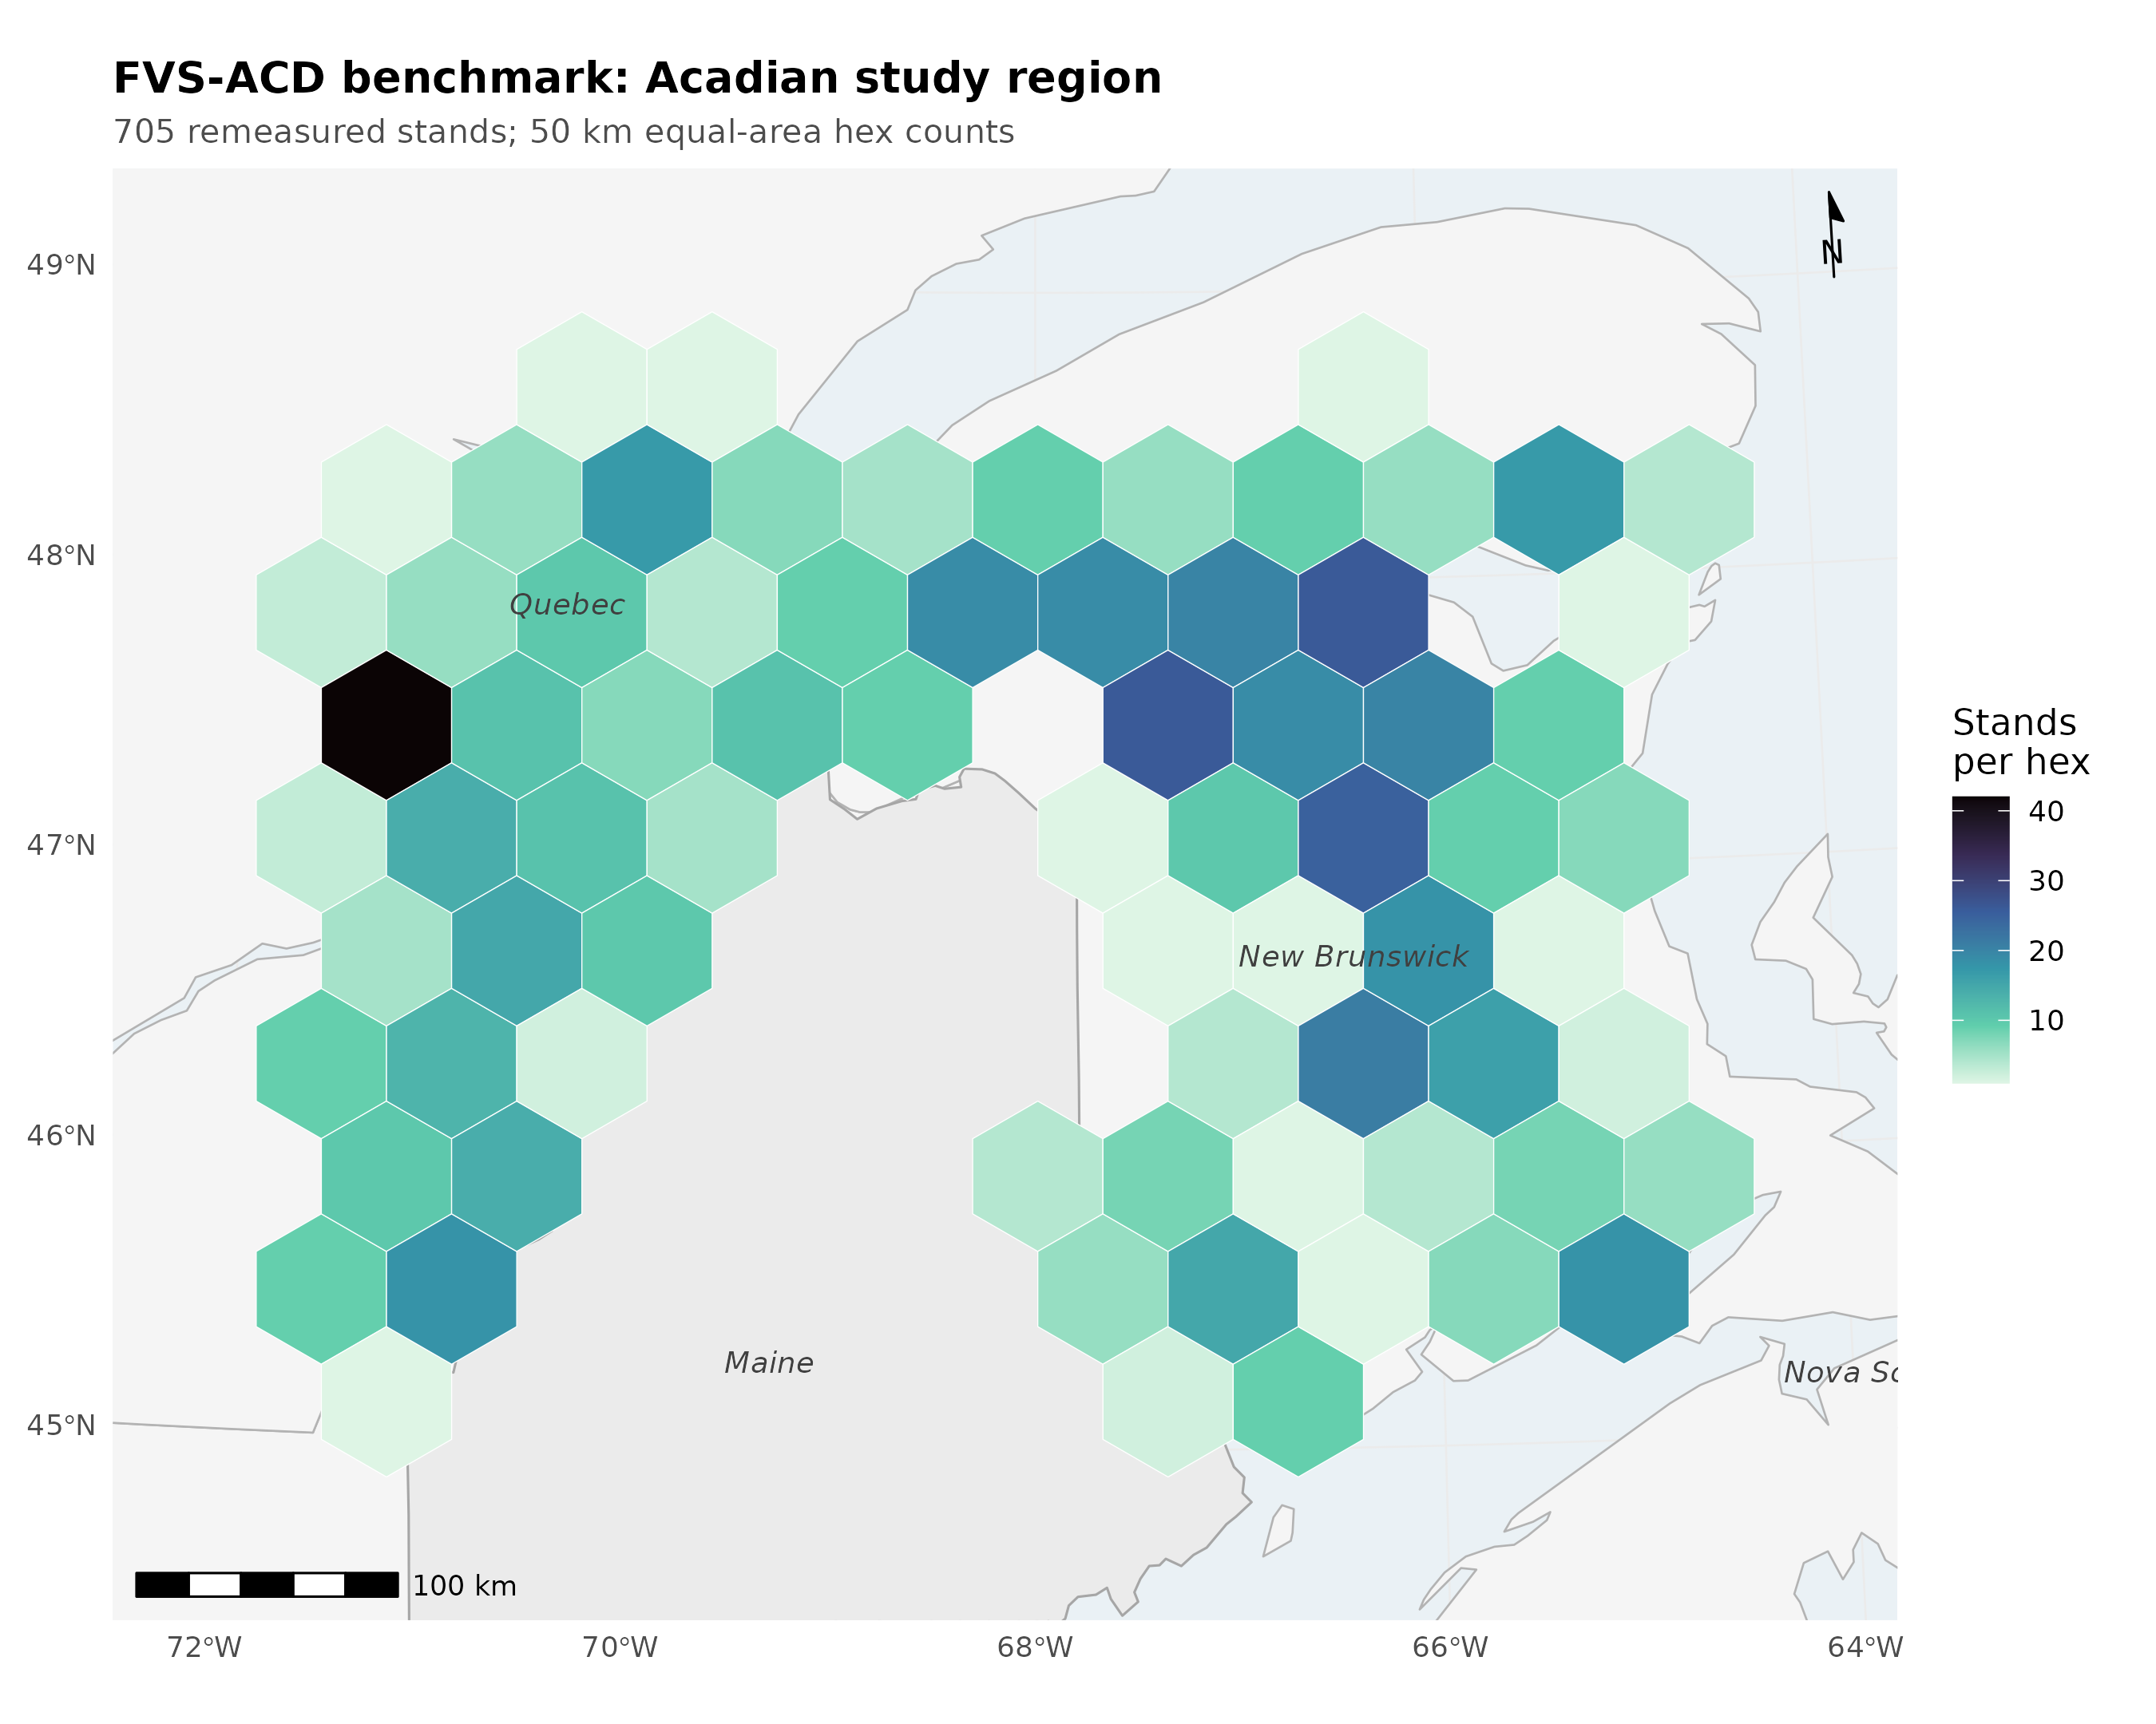
Figure 12. Locator of the Acadian study region with benchmark stand counts aggregated on a 50 km equal-area hex grid (New Brunswick n = 355, Quebec n = 350; true plot coordinates never released).
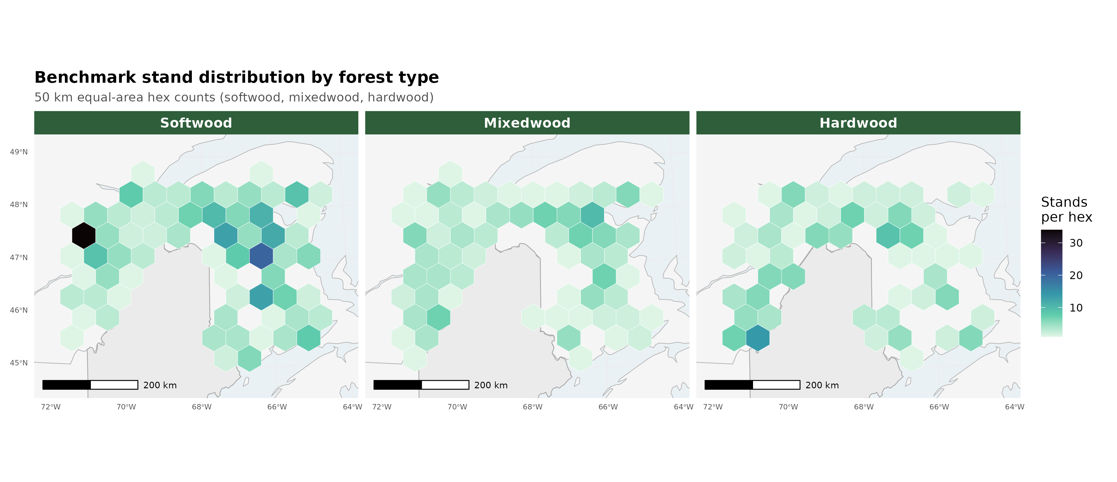
Figure 13. Benchmark stand counts on the same 50 km hex grid split into softwood (n = 321), mixedwood (n = 186), and hardwood (n = 178) panels.
The honest scorecard position. A five-way independent benchmark (v12.5.0, v12.7.0, v12.9.x, v12.10.1, and OSM v2.26.1) on the identical held-out in-domain data (MagPlot New Brunswick n=355 and ESI-covered Quebec n=350, plus recent Maine FIA for the growing-stand cross-check) places v12.10.1 level with v12.9.x on the pooled operational domain, both behind OSM there, and ahead of both on the managed cell. Because the frozen operational harness fully specifies the operational ops, v12.7.1, v12.9.x, and v12.10.1 are byte identical on the pooled base scorecard and differ only in the managed cells; the five-way therefore resolves to three distinct pooled engines, v12.5.0, v12.7.0, and the shared v12.7.1, v12.9.x, and v12.10.1 operational line.
Table 10.1. Pooled operational scorecard, v12.10.1 versus the comparison models (nine NSVB metrics).
model | mean absolute level bias (%) | mean modeling efficiency | TOST level equivalences (of 9)
v12.5.0 | 7.1 | 0.71 | 4
v12.7.0 | 8.0 | 0.73 | 2
v12.9.x | 4.9 | 0.71 | 7
v12.10.1 | 4.9 | 0.71 | 7
OSM v2.26.1 | 3.2 | 0.75 | 8

OSM keeps the best pooled level bias (3.2 versus 4.9), the best mean modeling efficiency (0.75 versus 0.71), and the most TOST level equivalences (8 versus 7 of 9, against four of nine for v12.5.0 and two of nine for v12.7.0). On the frozen harness every model's top height lands in a tight +3.7 to +4.6 percent band, so the apparent top-height over-prediction once read into the older 12.5.0 and 12.7.0 lines was an artifact of the pre-freeze basis and does not survive re-benching; the two older engines separate instead on volume, v12.5.0 a strong total-volume over-predictor (+9.3 percent, mean absolute level bias 7.1) and v12.7.0 a volume under-predictor (-8.3 percent, mean absolute level bias 8.0). v12.10.1 does not claim pooled parity. The point of v12.10.1 is the managed cell. The Chapter 11 gate closes the managed gap sharply in absolute basal-area bias, planted from -24.9 to -4.4 percent, PCT from -15.6 to -1.3 percent, and the managed class as a whole from -19.0 to -2.5 percent, and v12.10.1 beats OSM on every managed class in absolute basal-area bias (managed 2.5 versus 11.2, planted 4.4 versus 20.9, PCT 1.3 versus 5.4). One frozen-basis caveat to flag: gate-on planted total volume now sits at -10.8 percent, because the frozen anchor lowers untreated planted-stand volume so the fixed additive release closes less of the volume gap; the basal-area releases themselves are unchanged. On the pooled domain v12.10.1 and v12.9.x are identical to one decimal, because the modifier touches only managed stands and those are a small share of the in-domain pool, so pooled mean absolute bias (4.9), RMSE, and modeling efficiency all carry over from v12.9.x unchanged and the modifier's effect appears only in the managed cell. On the pooled domain the FVS-ACD advantage is quadratic mean diameter (about +1 percent versus OSM +11 percent), biological realism, transparency, and a climate-ready site driver, not pooled precision.
The forest-type scorecard. The pooled result hides a composition split. Classified by the softwood-basal-area fraction of the initial treelist (softwood at most 25 percent hardwood basal area, hardwood at least 75 percent, mixedwood between), the 705 in-domain stands resolve to softwood 321, mixedwood 186, and hardwood 178, with 20 unclassified stands excluded. The full nine-metric forest-type scorecard follows as signed level bias in percent for each of the five models on the frozen basis; bootstrap 95 percent confidence intervals and the green, yellow, and red flags for every cell are in Figure 7.
Table 10.2a. Softwood forest-type scorecard (n = 321), level bias (percent).
model | BA | SDI | QMD | TOPHT | TOTVOL | MERCHVOL | SAWVOL | BIOMASS | VALUE
v12.5.0 | +0.8 | +3.4 | -5.1 | -0.6 | +0.6 | +0.4 | -0.2 | +1.1 | +0.5
v12.7.0 | -16.0 | -14.2 | -1.5 | -1.4 | -16.4 | -16.5 | -16.9 | -16.2 | -16.4
v12.9.x | -14.0 | -12.8 | +0.1 | -1.2 | -14.1 | -14.2 | -14.7 | -14.1 | -14.1
v12.10.1 | -14.0 | -12.8 | +0.1 | -1.2 | -14.1 | -14.2 | -14.7 | -14.1 | -14.1
OSM | -2.3 | -3.2 | +8.1 | +3.9 | -1.0 | -1.0 | -0.8 | -1.4 | -1.1

Table 10.2b. Mixedwood forest-type scorecard (n = 186), level bias (percent).
model | BA | SDI | QMD | TOPHT | TOTVOL | MERCHVOL | SAWVOL | BIOMASS | VALUE
v12.5.0 | -2.1 | -0.7 | -4.9 | +3.2 | +7.2 | +6.7 | +6.3 | +6.4 | +8.8
v12.7.0 | -17.0 | -16.3 | -1.1 | +2.1 | -9.5 | -10.0 | -10.3 | -10.4 | -8.3
v12.9.x | -12.5 | -12.6 | +0.4 | +2.6 | -4.1 | -4.6 | -4.7 | -5.2 | -2.6
v12.10.1 | -12.5 | -12.6 | +0.4 | +2.6 | -4.1 | -4.6 | -4.7 | -5.2 | -2.6
OSM | -7.7 | -10.0 | +9.1 | +1.8 | -3.9 | -4.2 | -3.5 | -5.2 | -3.0

Table 10.2c. Hardwood forest-type scorecard (n = 178), level bias (percent).
model | BA | SDI | QMD | TOPHT | TOTVOL | MERCHVOL | SAWVOL | BIOMASS | VALUE
v12.5.0 | +15.3 | +18.2 | -7.1 | +12.3 | +31.3 | +30.0 | +30.6 | +30.8 | +32.8
v12.7.0 | -1.9 | -0.3 | -1.4 | +11.4 | +11.4 | +10.2 | +10.8 | +10.6 | +12.7
v12.9.x | +3.9 | +4.3 | +0.6 | +11.7 | +19.0 | +17.6 | +18.4 | +17.9 | +20.4
v12.10.1 | +3.9 | +4.3 | +0.6 | +11.7 | +19.0 | +17.6 | +18.4 | +17.9 | +20.4
OSM | +7.1 | +2.6 | +16.5 | +6.9 | +14.6 | +13.1 | +14.6 | +13.6 | +16.0

Read across composition, the softwood block is the pooled volume story in miniature: the shared newer build under-reads every merchantable output by about 14 percent and flags red on all five, while OSM holds all five within about 1.5 percent of zero and flags green, and structure is clean for the newer build with quadratic mean diameter and top height inside 1.2 percent even as basal area sits at -14.0. Mixedwood is the most balanced stratum, the shared newer build and OSM both inside about 5 percent on every volume metric. Hardwood is the shared frontier, every model over-reading the merchantable outputs, the shared newer build by 18 to 20 percent and OSM by 13 to 16, all red, confirming a composition-driven ceiling for the v13 composition-aware refit rather than a management-modifier problem.
The accuracy-and-precision view (percent RMSE). Percent bias measures only systematic offset, and it inflates on metrics with low means, so a small absolute error reads as a large percentage. To score accuracy and precision together we add the percent RMSE, %RMSE = 100 × RMSE / mean(observed) with RMSE = sqrt(mean((observed − predicted)²)), which penalises both systematic error and scatter and so is the fairer accuracy-and-precision summary. Uncertainty is a within-province stratified bootstrap (2000 replicates), resampling stands within New Brunswick and Quebec.
Table 10.2d. Percent RMSE by model and metric, pooled in-domain set (n = 705). Lower is better.
metric | v12.5.0 | v12.7.0 | v12.9.x | v12.10.1 | OSM
BA | 40.8 | 45.3 | 45.8 | 45.8 | 39.6
SDI | 40.9 | 45.9 | 46.2 | 46.2 | 39.6
QMD | 27.8 | 25.4 | 25.7 | 25.7 | 29.1
TOPHT | 18.8 | 18.2 | 18.4 | 18.4 | 16.1
TOTVOL | 56.0 | 52.3 | 55.2 | 55.2 | 51.1
MERCHVOL | 53.6 | 50.9 | 53.4 | 53.4 | 49.0
SAWVOL | 57.7 | 55.1 | 57.8 | 57.8 | 53.4
BIOMASS | 52.2 | 47.9 | 50.6 | 50.6 | 47.2
VALUE | 62.0 | 55.8 | 59.4 | 59.4 | 56.3

Structure metrics are tight (top height near 18 percent, quadratic mean diameter near 26); the merchantable outputs carry the scatter, total volume, sawlog volume, and value all in the mid-50s to low-60s percent even where mean bias is only a few percent. On the pooled set v12.10.1 total volume is 55.2 percent and value 59.4; OSM is a little lower at 51.1 and 56.3. This reframes the hardwood result. Hardwood error is scatter-dominated, not bias-dominated: v12.10.1 hardwood total volume carries a mean bias of about +19 percent but a %RMSE of about 76 percent, and value about +20 percent bias against about 81 percent %RMSE, with OSM similar (hardwood total-volume %RMSE about 75 percent, value about 80). The percentage bias understates the true error because most of that error is variance, so hardwood is a high-variance frontier shared by all five models rather than a systematic defect of any one build. Figure 11 is the %RMSE scorecard with within-province bootstrap intervals.
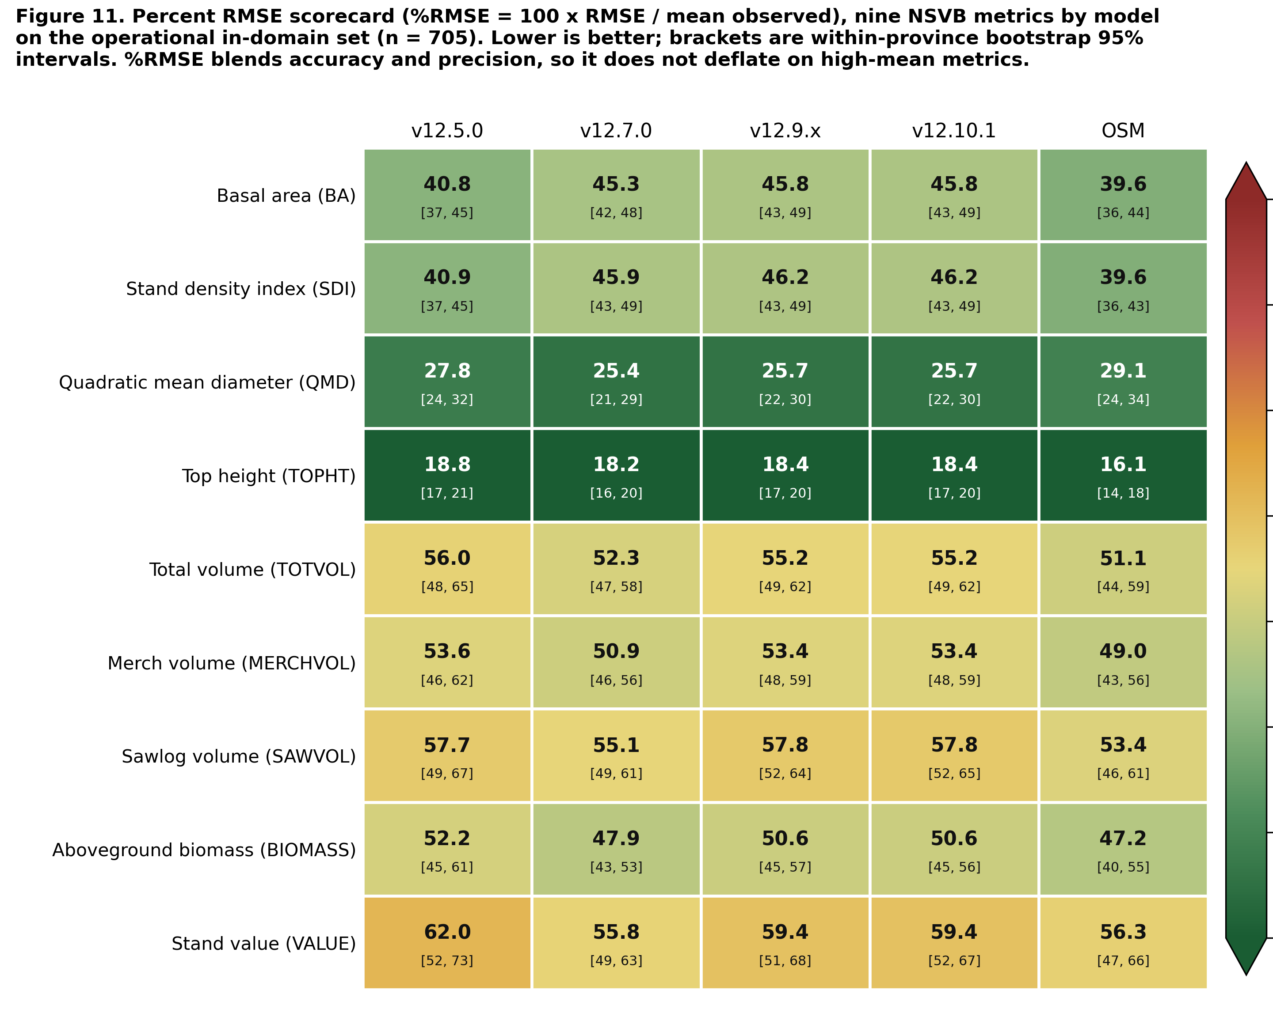
Figure 11. Percent RMSE scorecard, the model by metric heatmap of %RMSE across the nine NSVB metrics for the five models on the pooled in-domain set, with within-province bootstrap intervals in each cell.
Observed-on-predicted regression and the region of equivalence. For each model, metric, and stratum we fit the ordinary least squares regression of observed on predicted, observed = a + b × predicted, and test slope and intercept jointly with a Robinson and Froese (2004) equivalence test (two one-sided tests at alpha = 0.05): the intercept is equivalent to zero when its 90 percent interval lies within plus or minus 25 percent of the mean observed value, and the slope is equivalent to one when its interval lies in 0.75 to 1.25, with overall equivalence requiring both. This regression equivalence complements the paired-difference TOST reported with Table 10.1. Because observed is regressed on predicted, a slope above one means the model under-predicts the high end.
Table 10.2e. Observed-on-predicted regression and equivalence flags, pooled in-domain set (n = 705), key metrics. TRUE means the parameter's 90 percent interval lies inside its region of equivalence.
metric | model | slope b | intercept a | R² | slope equiv | intercept equiv | overall
BA | v12.5.0 | 0.93 | 0.72 | 0.73 | TRUE | TRUE | TRUE
BA | v12.7.0 | 1.21 | -0.81 | 0.71 | FALSE | TRUE | FALSE
BA | v12.9.x | 1.14 | -0.42 | 0.68 | TRUE | TRUE | TRUE
BA | v12.10.1 | 1.14 | -0.42 | 0.68 | TRUE | TRUE | TRUE
BA | OSM | 0.98 | 0.79 | 0.74 | TRUE | TRUE | TRUE
TOTVOL | v12.5.0 | 0.83 | 8.45 | 0.74 | TRUE | TRUE | TRUE
TOTVOL | v12.7.0 | 1.04 | 4.02 | 0.75 | TRUE | TRUE | TRUE
TOTVOL | v12.9.x | 0.99 | 5.08 | 0.71 | TRUE | TRUE | TRUE
TOTVOL | v12.10.1 | 0.99 | 5.08 | 0.71 | TRUE | TRUE | TRUE
TOTVOL | OSM | 0.95 | 2.96 | 0.75 | TRUE | TRUE | TRUE
VALUE | v12.5.0 | 0.81 | 419.6 | 0.73 | TRUE | TRUE | TRUE
VALUE | v12.7.0 | 1.01 | 230.2 | 0.74 | TRUE | TRUE | TRUE
VALUE | v12.9.x | 0.95 | 303.0 | 0.71 | TRUE | TRUE | TRUE
VALUE | v12.10.1 | 0.95 | 303.0 | 0.71 | TRUE | TRUE | TRUE
VALUE | OSM | 0.93 | 177.5 | 0.74 | TRUE | TRUE | TRUE

Across all nine metrics, four of the five models pass the joint equivalence test on every metric (nine of nine). The single exception is v12.7.0 basal area, whose slope of 1.21 sits just outside the 0.75 to 1.25 region once its confidence interval is included; its intercept still passes, and its volume and value slopes are essentially one. Every volume and value cell passes overall equivalence for all five models, with total-volume slopes 0.83 to 1.04 and value slopes 0.81 to 1.01, and the operational build v12.10.1 tracks the 1:1 line with a total-volume slope of 0.99 and a value slope of 0.95. Equivalence is a stricter, more transparent claim than a low p-value on a difference test, stating the size of the departure tolerated up front. Figure 10 is the observed-versus-predicted equivalence plot.
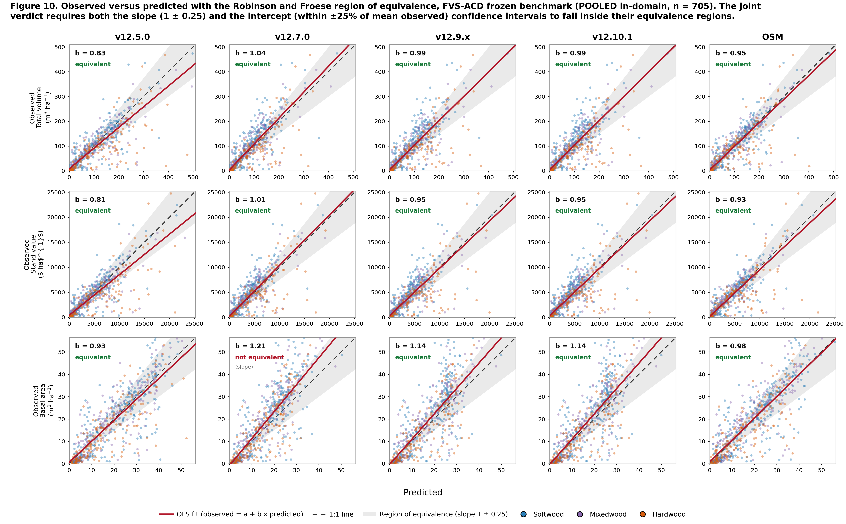
Figure 10. Observed-versus-predicted equivalence plot, faceted with total volume, value, and basal area as rows and the five models as columns. Each panel shows the per-stand cloud coloured by forest type, the 1:1 line, the OLS fit, and the shaded Robinson-Froese region of equivalence, annotated with the slope b and the joint verdict. Pooled in-domain set (n = 705).
The overall composite score. To collapse the nine metrics into one number per model, each model earns a composite score from 0 to 100, higher is better. We compute two composites and lead with the accuracy-and-precision view, because %RMSE (Table 10.2d) scores systematic error and scatter together where bias alone flatters a low-scatter but biased build. The primary composite is built on %RMSE: each metric earns a score of 100 × max(0, 1 − %RMSE / 100), and the composite is the weighted mean of the nine metric scores with total volume and stumpage value carrying the highest weight (total volume 3, value 3, the other three merchantable outputs 2 each, the four structure metrics 1 each, for a weight sum of 16). The complementary composite is the earlier bias-and-efficiency blend: per metric a bias score of 100 × (1 − min(1, |bias| / 20)) blended equally with an efficiency score of 100 × max(0, NSE), combined under the same volume-and-value weighting, with an equal-weight mean carried as a reference. This volume and value first weighting reflects the operational priority that a growth engine reproduce harvest volume and value before stand structure.
Table 10.3a. Primary %RMSE-weighted composite score (0 to 100, higher is better), volume and value weighting, by model and stratum.
model | pooled in-domain | softwood | mixedwood | hardwood
OSM | 53.4 | 61.6 | 59.5 | 34.4
v12.7.0 | 52.1 | 56.3 | 59.1 | 39.2
v12.9.x | 49.8 | 55.3 | 58.2 | 33.4
v12.10.1 | 49.8 | 55.3 | 58.2 | 33.4
v12.5.0 | 49.4 | 61.2 | 57.8 | 23.5

On the pooled set the %RMSE composite ranks OSM first (53.4), v12.7.0 second (52.1), v12.9.x and v12.10.1 tied at 49.8, and v12.5.0 at 49.4. The two views diverge on v12.7.0: it ranks low on the bias composite (Table 10.3b) because it carries real systematic offsets, but rises to second on %RMSE because its predictions are less scattered once systematic and random error are scored together, while v12.10.1 is the least biased of the FVS-ACD engines with slightly more scatter, leading v12.7.0 on bias but tying v12.9.x just behind it on %RMSE. OSM stays first on both. Every model scores far lower on hardwood, the shared high-variance frontier of the %RMSE section above.
Table 10.3b. Complementary bias-and-efficiency composite score (0 to 100, higher is better), primary volume and value weighting, by model and stratum, with the pooled equal-weight composite for reference.
model | pooled in-domain | softwood | mixedwood | hardwood | pooled equal-weight
OSM | 80.9 | 85.3 | 76.1 | 47.0 | 79.3
v12.9.x | 74.3 | 55.7 | 74.8 | 40.4 | 73.0
v12.10.1 | 74.3 | 55.7 | 74.8 | 40.4 | 73.0
v12.5.0 | 64.9 | 87.4 | 71.6 | 26.3 | 67.9
v12.7.0 | 66.5 | 51.3 | 63.7 | 58.5 | 66.4

The pooled ranking is robust at the top and to the choice of weighting: OSM leads and the shared newer build (v12.9.x and v12.10.1, identical on the base) sits second on both the primary volume and value weighting and the equal-weight reference, with only the two oldest engines trading the fourth and fifth positions, v12.7.0 rising above v12.5.0 once volume and value dominate the score. Within forest types the top two are unchanged between weightings in every stratum, while the by-type ordering shifts with composition: softwood is led by v12.5.0 then OSM, mixedwood and the pooled set by OSM, and hardwood by v12.7.0, whose flatter hardwood bias scores best on the one stratum where every newer build over-reads. Figure 8 shows the pooled ranking, the equal-weight reference, and the by-forest-type composites overlaid.
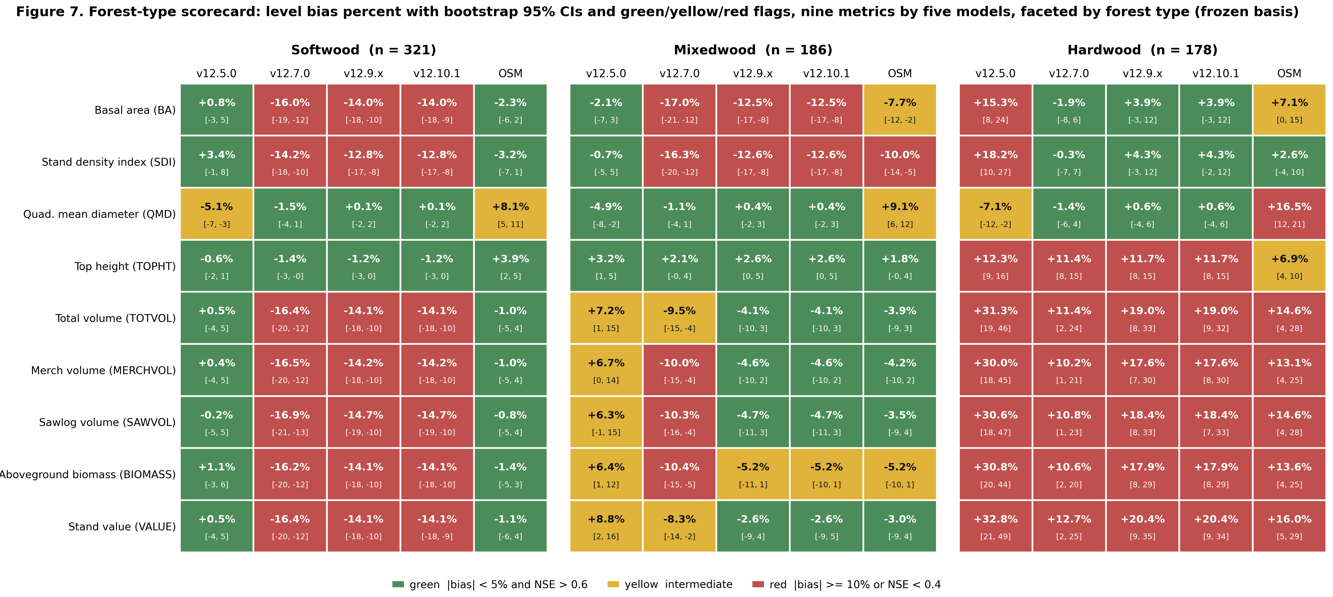
Figure 7. Forest-type scorecard, level bias percent with bootstrap 95 percent CIs and green, yellow, and red flags, nine metrics by five models faceted by forest type (softwood n = 321, mixedwood n = 186, hardwood n = 178) on the frozen basis.
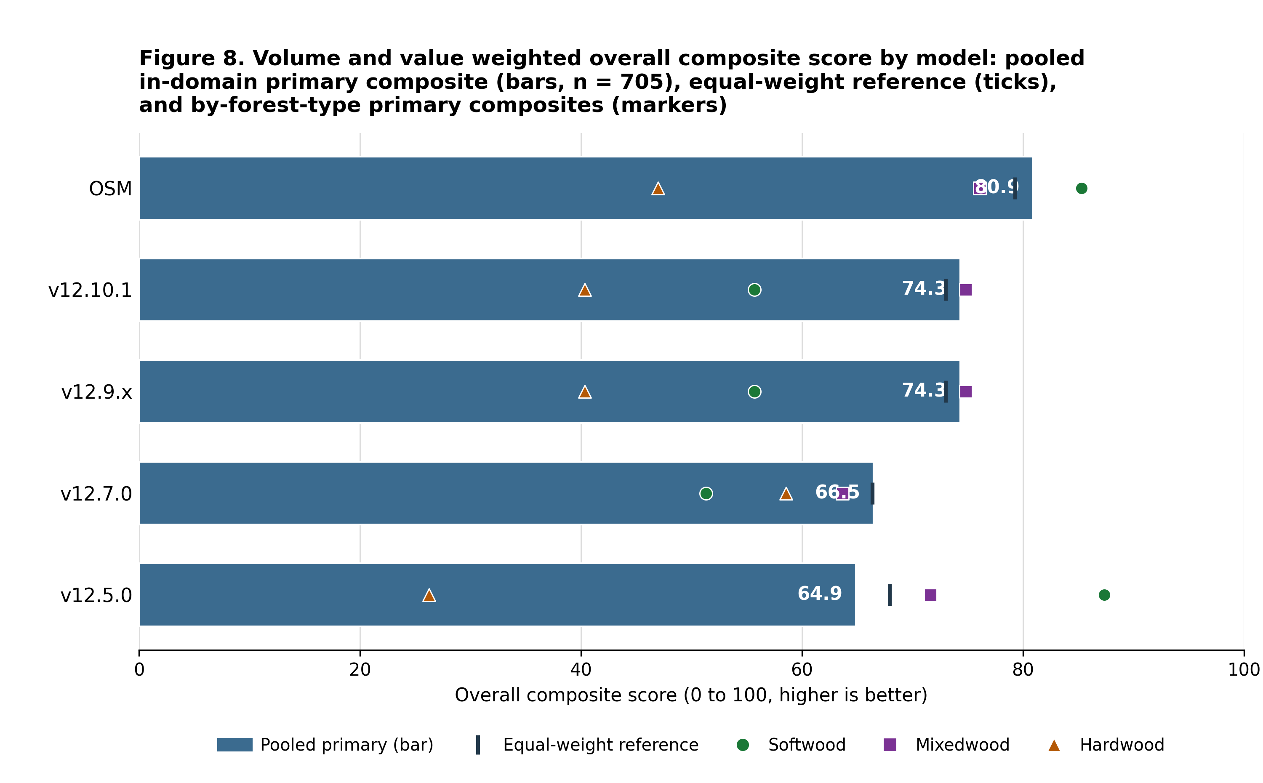
Figure 8. Volume and value weighted overall composite score by model, the pooled in-domain primary composite (total volume and value weighted highest) as ranked bars, the equal-weight composite as a reference tick on each bar, and the by-forest-type primary composites overlaid as markers.
Biological realism (Bakuzis pass). v12.10.1 inherits the v12.9.x self-thinning machinery and, on seeded 160-year projections across the ESI gradient, passes all five relations on the modified Bakuzis matrix (Leary 1997): Eichhorn (volume a function of height), Reineke self-thinning slope (fitted -1.59 against a -1.6 target), site ordering with no overtaking, the yield-density plateau (about 36 m² ha⁻¹), and Sukachev (size versus density). With the management modifier on, a seeded planted-softwood projection still plateaus at every amplitude tested (standard deviation of basal area over the last 20 years about 0.21, flat), and the ceiling rises smoothly with amplitude because basal area at the Reineke limit rises with tree size. By contrast v12.5.0 fails self-thinning outright in the same seeded battery. OSM is now scored on all five relations as well, from a 160-year projection over a real-stand productivity gradient, since it cannot be seeded on the synthetic ESI gradient. The 73 benchmark stands are binned into low, mid, and high terciles on OSM's own site-index height, the real-stand analog of the seeded ESI gradient, and the per-site trajectories are scored with the same relation definitions used for the AcadianGY battery. Over the near-term horizon, to about age 60, OSM over-accumulates basal area relative to FVS-ACD, which self-thins earlier. Over the full 160-year horizon, however, OSM does eventually plateau and self-thin: its mid-site basal area peaks near 36 m² ha⁻¹ and levels to about 35 m² ha⁻¹ on a Reineke slope of about -1.56, so it passes both the yield-density plateau and Reineke self-thinning, and it passes Sukachev. It flags the two cross-site relations, Eichhorn (cross-site coefficient of variation of volume at matched height about 26 percent) and site ordering, and both flags are sensitive to the real-stand substitution: OSM trajectories run on a projection-year axis from heterogeneous real starting conditions rather than an age-aligned bare-ground gradient, so the cross-site tests read on unequal starting ages, and that caveat is reported plainly as a qualifier on both flags. The biological-realism separation between OSM and the v12.7.1 and later builds is therefore not that OSM never plateaus, but that FVS-ACD self-thins earlier and more consistently and holds cleaner cross-site behavior on the seeded gradient.
Table 10.3c. Modified Bakuzis pass and flag matrix (Leary 1997) by model and law-like relation. The AcadianGY builds are scored on the seeded ESI gradient; OSM is scored on all five relations from a 160-year projection over a real-stand productivity gradient (the 73 benchmark stands binned into terciles on OSM's own site-index height), because it cannot be seeded on the synthetic gradient.
relation | v12.5.0 | v12.7.0 | v12.9.x | v12.10.1 | OSM
Eichhorn (V ~ f height) | pass | pass | pass | pass | flag
Reineke slope (target -1.6) | flag | pass (-1.8) | pass (-1.59) | pass (-1.59) | pass (-1.56)
Site ordering (no overtaking) | pass | pass | pass | pass | flag
Yield-density / plateau | flag | pass (37) | pass (36) | pass (36) | pass (36)
Sukachev (size vs density) | flag | pass | pass | pass | pass

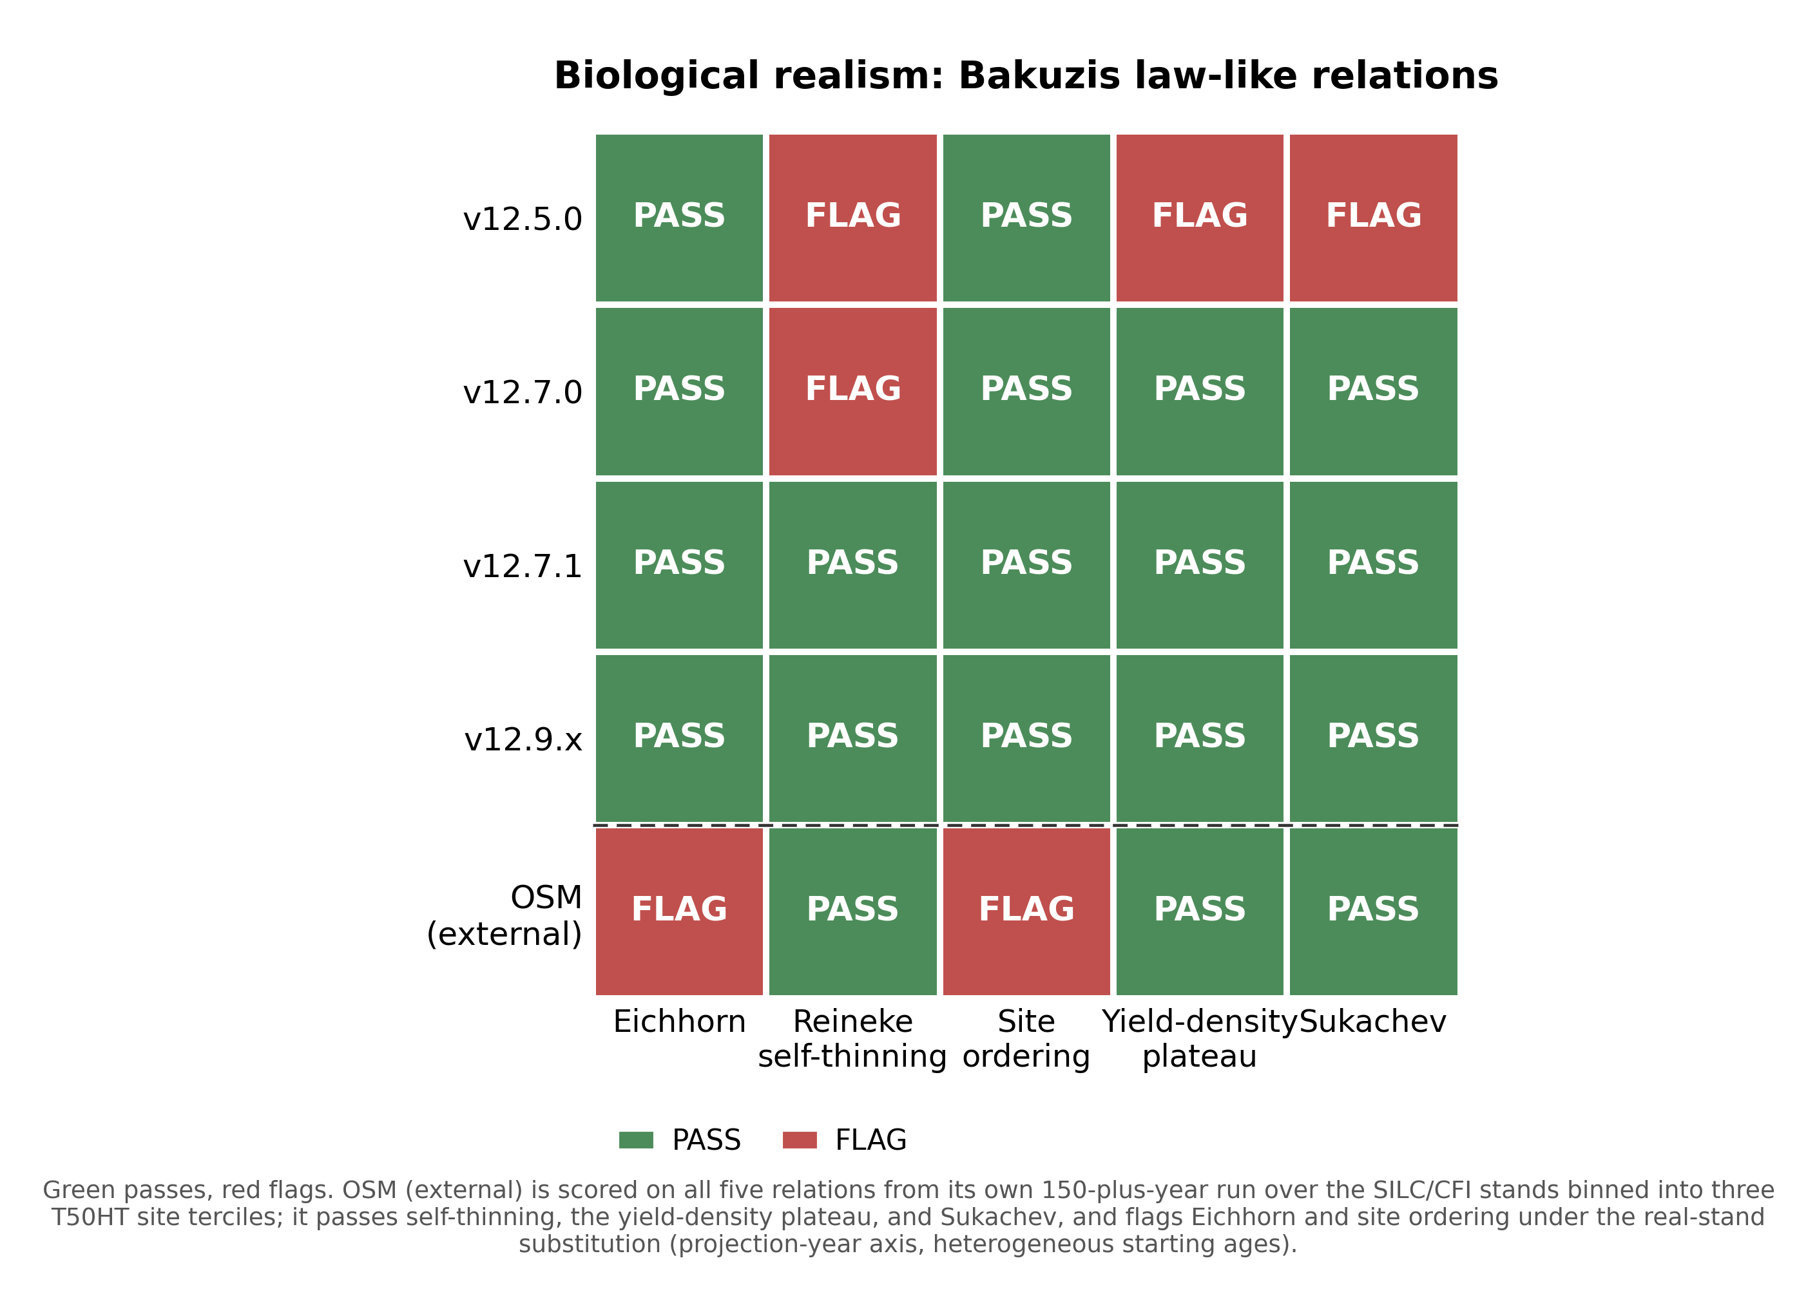
Figure 3. Modified Bakuzis matrix (Leary 1997) of law-like stand relationships, showing the pass and flag pattern for each AcadianGY version and the external OSM entrant on the five relations (Eichhorn, Reineke self-thinning, site ordering, yield-density plateau, and Sukachev). The AcadianGY builds are evaluated on seeded 160-year projections across the ESI productivity gradient; OSM is scored on all five from a 160-year projection over a real-stand productivity gradient, the 73 benchmark stands binned into terciles on OSM's own site-index height, because it cannot be seeded on the synthetic gradient. OSM passes Reineke self-thinning, the yield-density plateau, and Sukachev, and flags the two cross-site relations, Eichhorn and site ordering, both sensitive to the real-stand substitution.
Disclosed ingrowth limit. Observed MagPlot recruitment, tree-id matched across remeasurements, is 39.8 stems ha⁻¹ yr⁻¹ in New Brunswick and 19.7 in Quebec. The shipped expected-value ingrowth hurdle predicts 17.9 and 11.7 stems ha⁻¹ yr⁻¹, about 45 percent of observed in New Brunswick and 59 percent in Quebec. Recruitment responds in the correct direction to density and management (planted and PCT stands, which carry lower residual density, recruit more than unmanaged), and the expected-value hurdle lifted recruitment well off the near-zero floor of the classic 2018 too-infrequent FVS-ACD problem, but a residual under-prediction of the absolute level remains. This is neither the 2018 near-zero failure nor an inflated recruitment; it is a real, moderate under-prediction, disclosed as a limit and a target for the v13 ingrowth refit. It does not change the shipped version and does not touch the managed-cell scorecard, which is a volume and basal-area result on the tag threshold.
Pooled parity was tested and deferred. A top-height anchor-level correction was tested as a reach for pooled parity with OSM and deferred to v13.0. In the shipped config a top-height over-prediction of about +4 percent only partly offsets a basal-area under-prediction of about -10 percent, so FVS-ACD total volume sits modestly under observed on the unmanaged core, about -4 percent, rather than near zero. Correcting top height alone removes the offsetting positive term and drives total volume further below observed rather than toward zero, widening rather than closing the pooled mean absolute bias gap to OSM. True parity therefore needs a joint re-anchor of dominant height and basal area together, recorded as the v13.0 domain-plus-increment refit. The gated lever exists in the source (neutral factor reproduces v12.10.1) but is not adopted for the operational version.

10.3.1 Species composition over time
Stand species composition is defined as the basal-area fraction by species group, using live trees at least 4 cm DBH: softwood versus hardwood, and a three-way split into spruce-fir (Abies + Picea), other softwood, and hardwood. For each benchmark stand we have a starting state (t1) and an observed endpoint (t2) from the MagPlot QC and NB remeasured treelists, and each model predicts the endpoint. Predicted composition for the FVS-ACD flagships (v12.5.0, v12.7.0, v12.10.1) comes from a non-invasive composition re-run of the frozen benchmark harness that emits per-group basal area at t2; the run reproduces the frozen August operational baseline (NB_AFAC 0.579, QC_AFAC 0.111) with zero difference against cb_v12101 on all nine stand totals. OSM predicted composition is taken directly from its head-to-head predicted treelist. The stand set is the frozen scorecard pooled set of 705 unique stands; 25 stands lacked classifiable t1 basal area, leaving 680. Forest type is the committed percent-hardwood rule applied to the t1 treelist (softwood at most 25 percent hardwood BA, hardwood at least 75 percent, else mixedwood). Bias is predicted minus observed softwood fraction in percentage points (pts); the shift ratio is predicted mean shift divided by observed mean shift, so 1.0 is a perfect match and a negative value is a wrong-direction move.
Table 10.4. Observed and predicted softwood basal-area fraction across the remeasurement interval, pooled and by forest type, on the frozen benchmark (n = 680 classifiable stands of the frozen 705). Fractions are percentages; bias and shifts are in percentage points.

Model | Stratum | n | Obs t1 (%) | Obs t2 (%) | Pred t2 (%) | Obs shift (pts) | Pred shift (pts) | Bias (pts) | Direction | Shift ratio
v12.5.0 | Pooled | 680 | 59.9 | 60.7 | 59.5 | +0.82 | -0.45 | -1.27 | wrong | -0.55
v12.5.0 | Softwood | 320 | 94.0 | 92.0 | 92.6 | -1.95 | -1.41 | +0.54 | right | 0.72
v12.5.0 | Mixedwood | 186 | 51.7 | 51.3 | 51.5 | -0.40 | -0.24 | +0.17 | right | 0.59
v12.5.0 | Hardwood | 174 | 6.1 | 13.3 | 7.2 | +7.20 | +1.08 | -6.13 | right | 0.15
v12.7.0 | Pooled | 680 | 59.9 | 60.7 | 59.6 | +0.82 | -0.30 | -1.11 | wrong | -0.37
v12.7.0 | Softwood | 320 | 94.0 | 92.0 | 92.8 | -1.95 | -1.11 | +0.84 | right | 0.57
v12.7.0 | Mixedwood | 186 | 51.7 | 51.3 | 51.6 | -0.40 | -0.11 | +0.30 | right | 0.26
v12.7.0 | Hardwood | 174 | 6.1 | 13.3 | 7.1 | +7.20 | +1.00 | -6.21 | right | 0.14
v12.10.1 | Pooled | 680 | 59.9 | 60.7 | 59.7 | +0.82 | -0.26 | -1.08 | wrong | -0.32
v12.10.1 | Softwood | 320 | 94.0 | 92.0 | 92.9 | -1.95 | -1.06 | +0.89 | right | 0.54
v12.10.1 | Mixedwood | 186 | 51.7 | 51.3 | 51.7 | -0.40 | -0.05 | +0.35 | right | 0.14
v12.10.1 | Hardwood | 174 | 6.1 | 13.3 | 7.1 | +7.20 | +0.98 | -6.22 | right | 0.14
OSM | Pooled | 680 | 59.9 | 60.7 | 60.8 | +0.82 | +0.88 | +0.06 | right | 1.08
OSM | Softwood | 320 | 94.0 | 92.0 | 94.0 | -1.95 | +0.02 | +1.97 | wrong | -0.01
OSM | Mixedwood | 186 | 51.7 | 51.3 | 53.5 | -0.40 | +1.81 | +2.21 | wrong | -4.49
OSM | Hardwood | 174 | 6.1 | 13.3 | 7.6 | +7.20 | +1.46 | -5.74 | right | 0.20

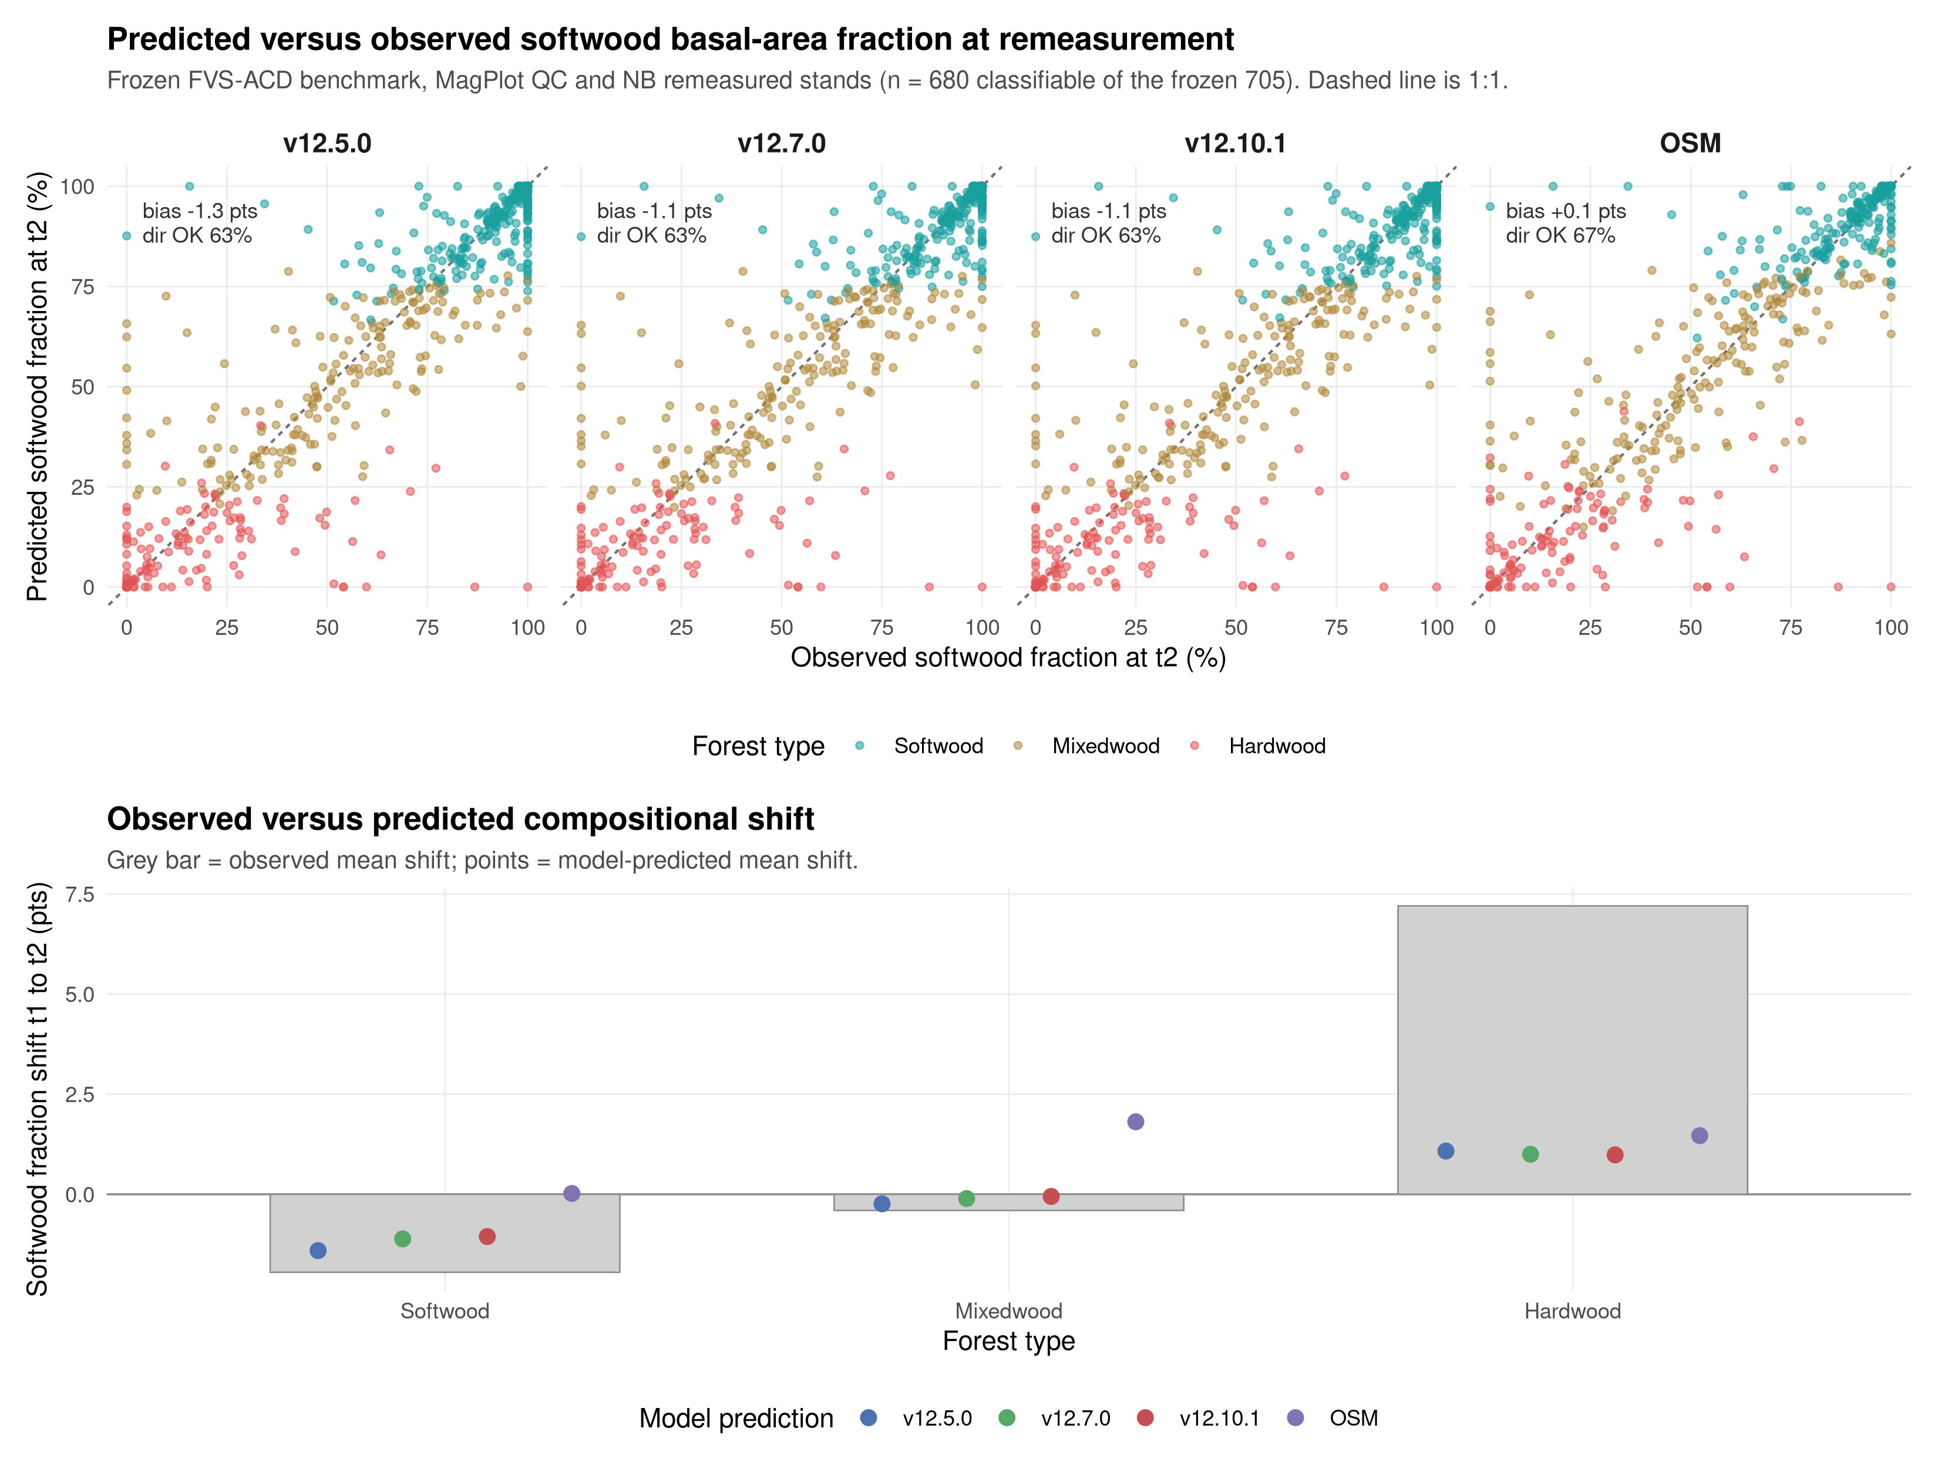
Figure 9. Predicted versus observed softwood basal-area fraction at the remeasurement endpoint (t2) by model, with the 1:1 line (top), and the observed versus predicted mean compositional shift from t1 to t2 by forest type (bottom). Points are colored by committed forest type. Frozen benchmark, MagPlot QC and NB remeasured stands.
Stand composition is nearly stationary across the interval: the pooled mean softwood fraction moves less than one point (59.9% to 60.7%), and the only large observed signal is a +7.2 pt softwood gain in hardwood-dominated stands, partly offset by a -1.9 pt softwood loss in softwood stands. All three FVS-ACD models reproduce the direction of change within softwood and mixedwood stands but under-shift by roughly a third to a half, and they miss the pooled net direction, predicting a small softwood decline (-0.3 to -0.5 pt) against the observed +0.8 pt increase, because they under-represent softwood in-migration into hardwood stands (predicted about +1.0 pt versus observed +7.2 pt, bias near -6 pts). OSM best tracks the pooled net shift (+0.9 pt, ratio 1.08) but overshoots softwood in mixedwood and softwood stands; the spruce-fir split tells the same story, with the observed +7.0 pt spruce-fir gain in hardwood stands under-predicted by every model. Every model holds stand-level softwood fraction within about 1 to 2 pts of observed in softwood and mixedwood types, so overall composition is preserved and the shared weakness is the rate of softwood recolonization of hardwood-dominated stands.

10.4 v12.11: correcting the maturity-dependent long-horizon volume bias (candidate)
A component decomposition completed 18 July 2026 isolated a long-horizon total-volume bias in v12.10.1 that flips sign across the stand-maturity gradient: an under-prediction in developing stands and an over-prediction in mature stands, the net of three separate systematic errors in survivor growth, mortality, and ingrowth rather than a single mechanism (Figure 15). AcadianGY 12.11 is the candidate correction, built and validated but not yet operational. v12.10.1 remains the frozen model of record for the 18 August 2026 Acadian Growth and Yield meeting, and every v12.11 lever is gated off by default, so a gate-off build reproduces v12.10.1 bit for bit: maximum absolute difference 0.000e+00 in diameter increment, height increment, and expansion factor, confirmed on the original benchmark and independently reconfirmed by a red-team review on a novel out-of-sample stand not used in development (10.6). v12.11 addresses the three components not with raw per-tree multipliers but with the stand-constraint approach of Weiskittel, Hann, Kershaw, and Vanclay (2011b), Chapter 10, of conditioning or constraining tree-level predictions on stand-level targets, applied through five gated levers.
Lever 1, recruitment (`ops$ingrowth.mult`), carries a flat basal-area-anchored ingrowth multiplier (pooled about 2.5x) to address the disclosed ingrowth limit (10.3). A gated relative-density taper (`ops$use.ingrowth.rdtaper`) was built to protect mature closed stands from the flat multiplier, but is not enabled in the locked candidate configuration; a separate, always-on density-release logistic (`ops$use.ingrowth.release`) already suppresses recruitment at high relative density regardless of which recruitment lever is active, so the flat multiplier is not applied undamped in closed stands.
Lever 2, mortality (`ops$mort.dens.scale`), attenuates the self-thinning removal fraction in managed stands only: f(RD) = fmin + (1 - fmin)*exp(-k*max(RD - RD0, 0)), where RD = SDI/SDImax, fitted fmin = 0.13, k = 12.4, RD0 = 0.38. Natural, unmanaged stands are untouched, so the Reineke self-thinning slope and the long-horizon density plateau are preserved.
Lever 3, survivor diameter increment, is the direct application of the Chapter 10 stand constraint. Two gated forms were built: 3a, a direct size-by-maturity rein, and 3b, the shipped form, which lowers the activation thresholds on the engine's existing proportional-increment constraint to a stand basal-area-increment target, gated by a quadratic-mean-diameter floor (`ops$ddbh.standcon.qmin` = 22 cm) so the constraint binds only in mature, high-QMD stands and spares developing stands. The QMD floor was added after the component decomposition showed an un-gated 3b suppressed developing-stand growth. Form 3a over-corrects the held-out mature Baxter benchmark (total volume bias -7.2 percent), so 3b is the shipped configuration: 3b tames Baxter from +9.12 to +6.92 percent without a sign flip and improves the managed CTRN (-9.8 to -4.8 percent) and New Brunswick (-4.4 to -1.3 percent) sources (Figures 16 and 17). Those four figures come from the lever-selection run, in which Lever 3b is the only lever active (`v1211_maturity_scorecard.csv`), and they are not the shipped candidate's values. Table 10.5, where all five levers are on, gives CTRN -9.78 to -2.24 and NB MagPlot -11.84 to -5.96. The two sets are consistent and measure different configurations. This configuration selection should be re-examined rather than carried forward as gated. Baxter has since been repaired and rescored (10.5.1): 463 measured stems were recovered from the staged t2 tree list, a group-specific height curve was fitted and validated against them, and scoring observed volume with measured heights where they exist and that curve elsewhere puts base at +2.42 percent and the candidate at +2.07 percent on the same 91 stands (Table 10.5b). The ordering that gated the choice survives the rescore, since every configuration is scored against one observed denominator, but the magnitudes it was argued on have moved by roughly two-thirds. The rescore covers base, candidate, and OSM rather than the 3a form itself, so re-running the held-out gate on the repaired list is the step that remains (10.5.1).
Lever 4, hardwood height conditioned on form and risk (`ops$use.dht.hw.mod`), addresses a missing term in the base height-increment equation (4.7): height drives NSVB volume, and the base model carried no form or risk penalty. Fitted from the Ryan Smith field NHRI form and risk dataset (635 trees across the Smith, Rangeley, AshlandEast, and AshlandWest sites), high-risk trees are about 10 to 11 percent shorter in Betula alleghaniensis Britton and Acer saccharum Marshall (both strongly significant, p < 0.002), a weaker effect in Acer rubrum L. Poor form carries only a small total-height effect, expected because form governs sawlog and merchantable height and defect, a partition already carried downstream by the Smith sawlog-fraction model, not total height. The worst-quality combination, poor form and high risk, in Acer saccharum Marshall gives a 16 percent, about 3.7 m, height deficit at a 23 m mature tree, consistent with an independent field estimate that roughly 4 m of sugar maple height deficit explains about 18 percent of the hardwood volume gap. Quercus rubra L. was not represented in the Smith height set (n = 1, dropped), and its fitted coefficient otherwise rested on the FIA Growth, Removal, and Mortality damage-code proxy that the Smith field data was adopted specifically to avoid; it has accordingly been capped to the Betula alleghaniensis Britton and Acer saccharum Marshall field magnitude pending independent red oak field heights from the Castle inventory (10.6).
The fifth investigated mechanism, crown ratio, proved to already be active rather than a needed new lever. Crown ratio is projected dynamically every cycle by the Russell, Weiskittel, and Kershaw (2014) recession model (4.3) and already feeds diameter and height increment; a changelog note describing disabled crown-ratio imputation was four years stale. A recalibration of the 2014 recession coefficients for the developing end remains a worthwhile future item, carried into the v13 program (10.7) rather than treated as a v12.11 lever.
The candidate clears a four-part guardrail battery ahead of being declared a release candidate. The frozen in-domain FIA NSVB benchmark shows no regression: basal-area bias improves from -11.28 to -7.31 percent and total-volume bias from -4.41 to -1.50 percent, while top-height bias drifts from +4.21 to +5.88 percent, a watch item addressed in 10.6 rather than attributed to a lever. The five Bakuzis relations (Leary 1997) pass in the primary, unmanaged mapping, matching the frozen model. The approximately 160-year density plateau holds, with the standard deviation of basal area over the last 20 years under 1 percent of the mean and no runaway or collapse behavior. The managed out-of-sample comparison against OSM v2.26.1 improves, beating or tying OSM on three of four CTRN and New Brunswick MagPlot cells (10.5).
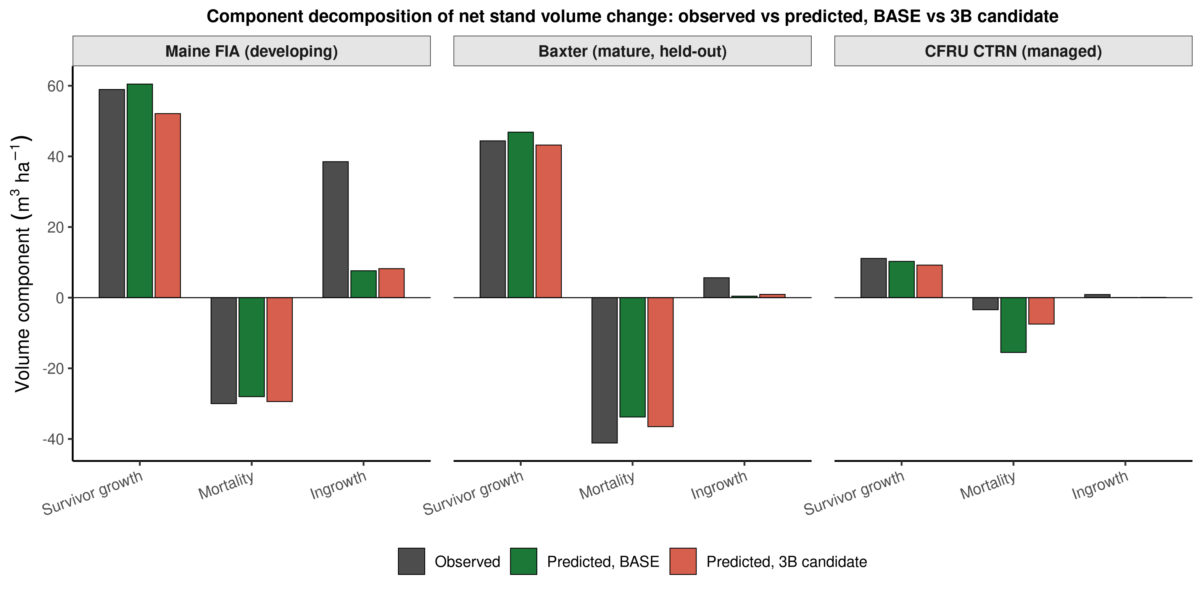
Figure 15. Component decomposition of net stand volume change into survivor growth, mortality, and ingrowth, observed versus predicted under the frozen v12.10.1 base and the v12.11 3B candidate, for a developing (Maine FIA), mature held-out (Baxter), and managed (CFRU CTRN) source. The maturity-dependent bias traces to offsetting errors across these three components rather than a single mechanism.
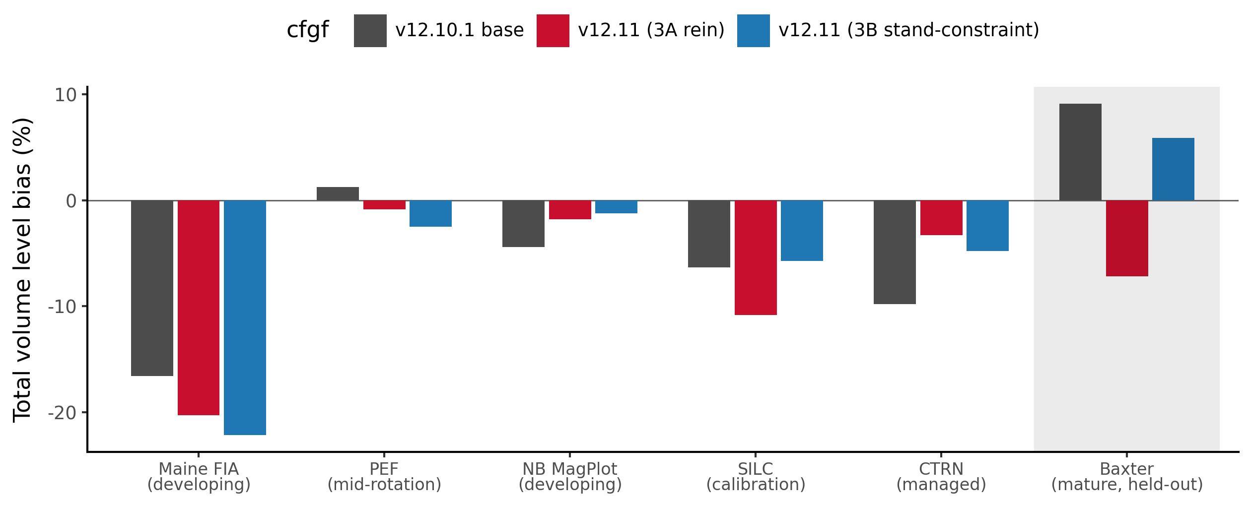
Figure 16. Total volume level bias across the stand-maturity gradient, from developing (Maine FIA) through mid-rotation (PEF) and managed (NB MagPlot, SILC, CTRN) sources to the mature, held-out Baxter benchmark (shaded panel), comparing the frozen v12.10.1 base against the two candidate forms of the Lever 3 stand constraint. 3A is a direct size-by-maturity rein; 3B, the QMD-gated proportional stand constraint, is the shipped v12.11 configuration. 3B moves the held-out Baxter bias toward zero without a sign flip and improves the managed sources, while 3A over-corrects Baxter in the opposite direction. The mature Baxter terminus of this gradient should be read with the height-coverage accounting in 10.5.1. That source has since been repaired and rescored, and its mature over-prediction holds in sign at roughly a quarter of the magnitude plotted here (Table 10.5b), which flattens this end of the gradient without reversing it; the configuration choice gated on it should be re-examined against that table.
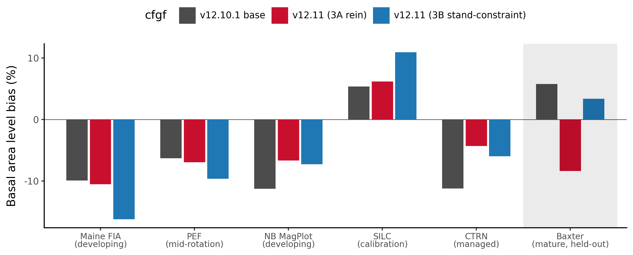
Figure 17. Basal-area level bias across the same stand-maturity gradient and model configurations as Figure 16. As with total volume, 3B moves the held-out Baxter basal-area bias toward zero and improves the managed sources, with two flags carried into 10.5 and 10.6: SILC basal-area bias widens under 3B, and the Quebec managed source (not shown on this developmental figure, added in the 10.5 all-sites refresh) shows the same widening pattern.

10.5 All-sites validation: v12.11 versus base and OSM v2.26.1 (Maine, New Brunswick, Quebec)
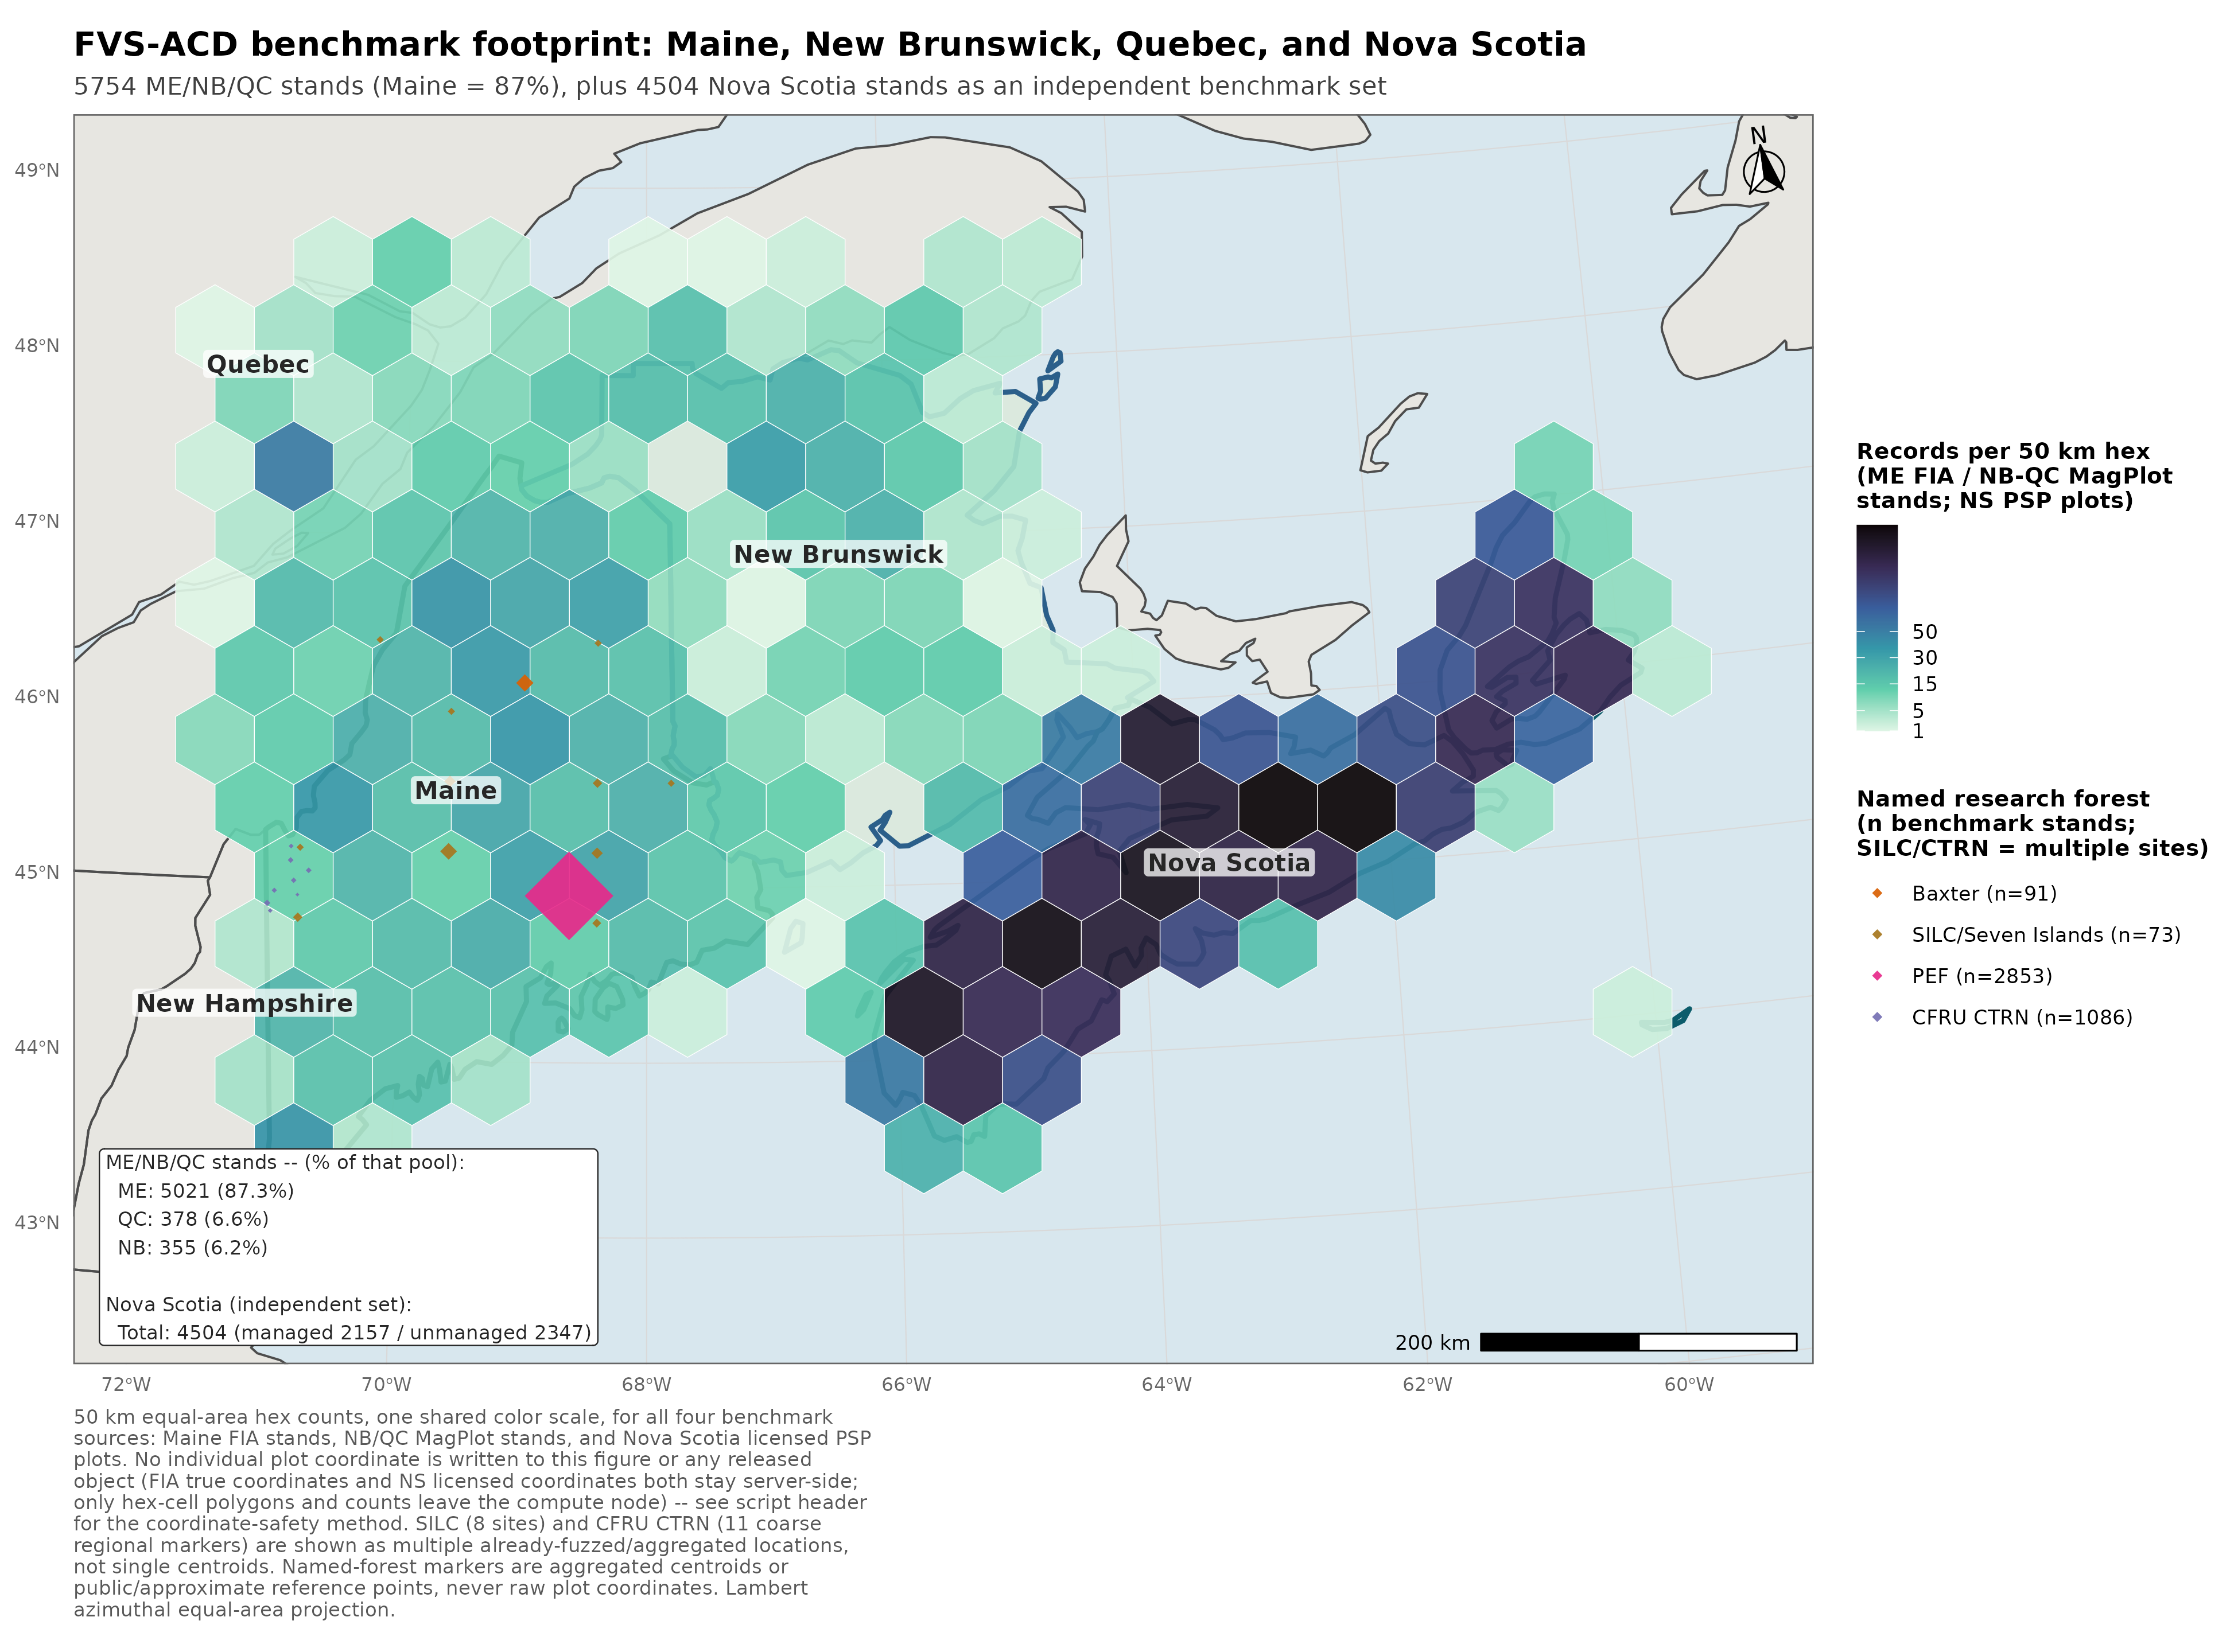
Figure 20. FVS-ACD benchmark footprint across Maine, New Brunswick, Quebec, and Nova Scotia. Maine FIA and NB and QC MagPlot are shown as 50 km equal-area hex stand counts; Nova Scotia is shown the same way, as county-level PSP density on an equal-area hex grid (aggregated, licensed data, never per-plot); SILC/Seven Islands and CFRU CTRN are shown as multiple aggregated locations rather than single centroids; Baxter and PEF remain single aggregated or public-location markers. No true plot coordinate, for any of the four jurisdictions, appears in this figure.
Figure 20. FVS-ACD benchmark footprint across Maine, New Brunswick, Quebec, and Nova Scotia, all four jurisdictions on the same 50 km equal-area hex convention. Coordinate handling follows the hard restriction on FIA true plot coordinates and, for Nova Scotia, the plot-confidentiality terms of its 2016 provincial data license with the University of Maine: no individual plot location, for any of the four jurisdictions, is used anywhere in this pipeline or appears in this figure.
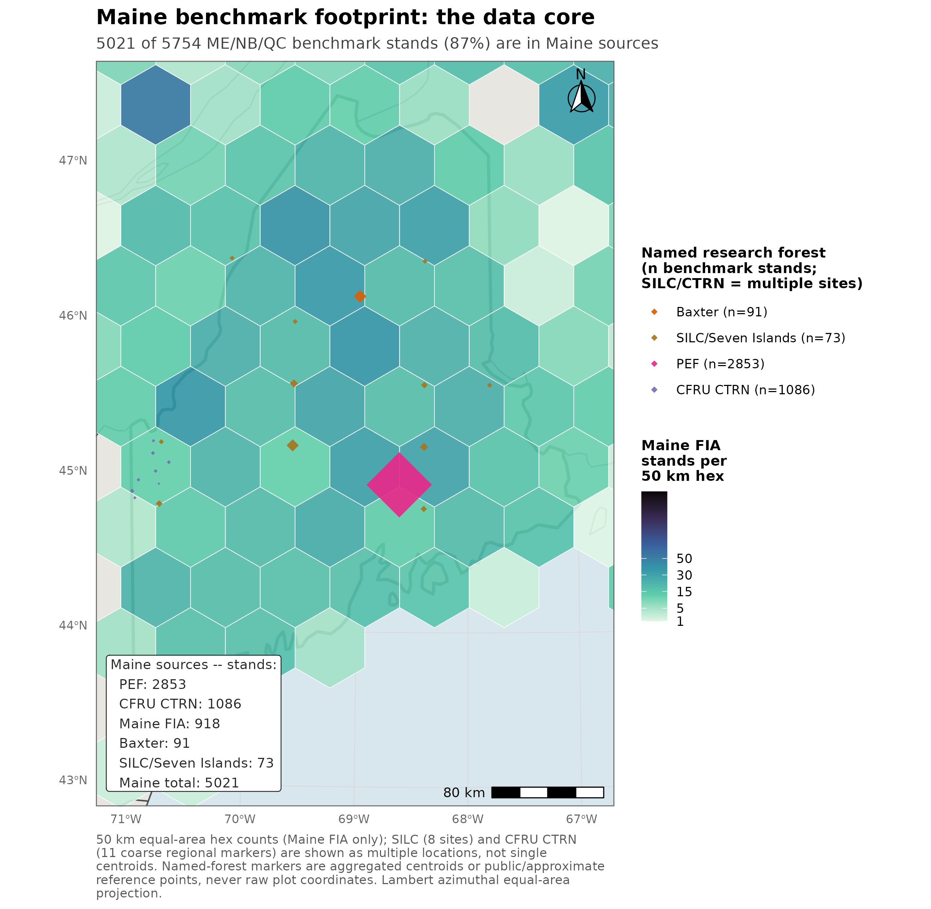
Figure 21. Maine benchmark footprint, the data core: 5,021 of 5,754 pooled ME/NB/QC benchmark stands, 87 percent, are in Maine sources. Nova Scotia, evaluated as an independent benchmark in section 10.7, is not part of this pooled total.
Figure 21. Maine benchmark footprint, the data core of the pooled all-sites total: 5,021 of 5,754 pooled Maine, New Brunswick, and Quebec benchmark stands, 87 percent, are Maine sources. Nova Scotia, evaluated separately in section 10.7 as an independent benchmark, is not part of this pooled total.
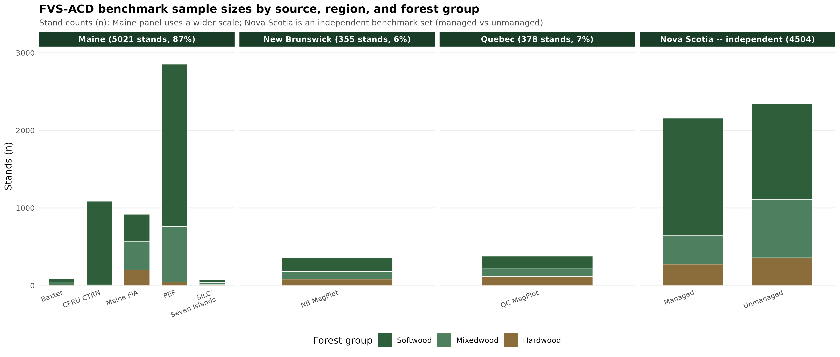
Figure 22. FVS-ACD benchmark sample sizes by source, region, and forest group, stand counts n, with a wider scale on the Maine panel to accommodate its five sources and a fourth Nova Scotia panel (managed versus unmanaged) shown separately as an independent benchmark set.
Figure 22. FVS-ACD benchmark sample sizes by source, region, and forest group. Nova Scotia is shown as a separate managed-versus-unmanaged panel, consistent with its treatment throughout this report as an independent benchmark rather than a pooled all-sites source.
The candidate was rescored against the frozen v12.10.1 base and the current OSM release (v2.26.1) across every independent source available in the Acadian region, NSVB currency throughout: the held-out mature Baxter benchmark, the managed CFRU CTRN and New Brunswick MagPlot networks, the developing Maine FIA network at both whole-plot and FIA subplot (about 0.017 ha) grain, the mid-rotation Penobscot Experimental Forest (PEF), the SILC Seven Islands calibration set, and the managed Quebec MagPlot network. Aggregates only; proprietary tree records and true plot coordinates stayed on Cardinal.
Table 10.5. All-sites total volume and basal-area level bias (percent) and total-volume percent RMSE, v12.11 candidate versus the frozen v12.10.1 base and OSM v2.26.1, by region and source (NSVB currency). The PEF and Baxter total-volume entries are scored on largely imputed heights, 4.02 and 18.45 percent measured coverage, and should be read with 10.5.1; PEF's (developing) label describes the stand condition and is not a validated developing-stand volume score, and the Baxter rows are retained as published alongside the validated height sensitivity in Table 10.5b. The managed CTRN and MagPlot entries carry a comparable exposure, at 51.99 and 32.82 percent measured coverage. Basal-area entries are unaffected by that substitution, which the scoring harness applies to height only.
Region | Source | Grain | Model | n | Total volume bias (%) | Basal area bias (%) | Total volume %RMSE
ME | Baxter (mature, held out) | stand | base | 91 | +9.12 | +5.74 | 48.3
ME | Baxter | stand | v12.11 | 91 | +6.92 | +4.47 | 48.1
ME | Baxter | stand | OSM | 91 | +12.37 | +13.28 | 50.8
ME | CTRN (managed) | stand | base | 1086 | -9.78 | -11.26 | 24.8
ME | CTRN | stand | v12.11 | 1086 | -2.24 | -3.52 | 18.1
ME | CTRN | stand | OSM | 1033 | -4.81 | -4.19 | 20.5
ME | Maine FIA (developing) | subplot (finer, does not transfer) | base | 2858 | -24.90 | -18.37 | 51.1
ME | Maine FIA | subplot | v12.11 | 2858 | -24.82 | -16.86 | 51.3
ME | Maine FIA | whole-plot | base | 918 | -16.60 | -9.93 | 38.7
ME | Maine FIA | whole-plot | v12.11 | 918 | -16.13 | -7.45 | 38.6
ME | Maine FIA | whole-plot | OSM | 918 | -6.29 | -3.16 | 31.9
ME | PEF (developing) | stand | base | 2853 | +1.23 | -6.33 | 18.0
ME | PEF | stand | v12.11 | 2853 | +1.37 | -5.42 | 17.9
ME | PEF | stand | OSM | 2853 | +0.26 | -3.72 | 14.7
ME | SILC Seven Islands (calibration) | stand | base | 73 | -6.34 | +5.35 | 65.0
ME | SILC | stand | v12.11 | 73 | -5.65 | +11.02 | 64.2
ME | SILC | stand | OSM | 69 | -18.07 | -11.17 | 63.0
NB | NB MagPlot (managed) | stand | base | 355 | -11.84 | -8.84 | 48.9
NB | NB MagPlot | stand | v12.11 | 355 | -5.96 | -2.33 | 41.9
NB | NB MagPlot | stand | OSM | 355 | -8.07 | -2.48 | 43.8
QC | QC MagPlot (managed) | stand | base | 378 | +1.23 | -12.95 | 59.3
QC | QC MagPlot | stand | v12.11 | 378 | +9.46 | -4.12 | 58.5

v12.11 wins clearly where it was designed to win. In the managed sources, CTRN and NB MagPlot, bias on both basal area and total volume is roughly halved against the frozen base, with lower percent RMSE, and the candidate beats OSM v2.26.1 outright on both sites. The held-out mature Baxter benchmark moves toward zero (total volume +9.12 to +6.92 percent) and beats OSM by a wide margin (OSM +12.37 percent), although all three of those Baxter readings rest largely on imputed heights, at 18.45 percent measured coverage, and the model ordering among them is more durable than their levels; the repaired and rescored Baxter numbers in Table 10.5b hold that ordering while moving every level toward zero (10.5.1). Two flags accompany the managed win. In Quebec, the management gate over-corrects basal area relative to volume: QC MagPlot basal-area bias improves sharply (-12.95 to -4.12 percent) but total-volume bias worsens from near zero to +9.46 percent. SILC basal-area bias widens as well (+5.35 to +11.02 percent). Where v12.11 does not win: PEF and SILC total volume change little, since PEF runs with the management gate off by source-level convention, and OSM leads on the developing Maine FIA whole-plot comparison (OSM -6.29 percent versus the candidate's -16.13 percent). The PEF half of that explanation is incomplete and is corrected here. PEF's near-zero and nearly flat total volume is largely an artifact of the height imputation described in 10.5.1, since only 1.60 percent of PEF tree records carry a measured height, and rescoring the source on a curve fitted to measured Maine heights moves it from about +1.2 to -3.8 percent. The management-gate convention explains why the candidate moves PEF little; it does not explain the level at which PEF sits, and that level is not evidence that the engine is unbiased on developing stands. The developing end, at both whole-plot and especially FIA subplot grain, remains the acknowledged open gap and the explicit target of the v13.1 hierarchical mortality and ingrowth refit (10.7); no reported subplot or whole-plot Maine FIA number in this section should be read as a claim that the developing end is closed (10.6).

10.5.1 Benchmark integrity: measured-height coverage across the eleven sources
Every total-volume, biomass, and stand-value number in sections 10.4 through 10.8 is produced by applying the same NSVB emulator (7) to the observed and to the predicted tree list, and that emulator substitutes a diameter-only height curve for any tree that carries no measured height. The substitution is not symmetric between the two lists. The observed list carries raw staged heights while the predicted list carries model output, so the curve fires overwhelmingly on the observed side, which places its error in the denominator of the bias ratio, where it does not cancel. The limit is stated once here, in full, and the passages it qualifies point back to this subsection. It changes no number reported in this GTR. It changes how several of them should be read. The companion benchmark report (`FVS-ACD_v12.11_benchmark_report.md`, section 2.1) carries the same accounting and is the source of every figure below.
A coverage census across all eleven staged benchmark sources, run on the analysis cluster (SLURM job 13305450), now gives that exposure directly, and it supersedes the partial accounting this subsection carried earlier, which reached three sources. Coverage is reported as the share of t2 basal area carried by stems with a measured height, at DBH >= 4 cm. The curve ratio is the basal-area-weighted ratio of the diameter-only curve prediction to measured height, computed over the measured stems only, so a ratio below 1.0 means the curve runs short.
Table 10.5a. Measured-height coverage by benchmark source and species group, share of t2 basal area at DBH >= 4 cm, with the ratio of the diameter-only height curve to measured height over the measured stems (coverage census, SLURM job 13305450). Sources are ordered by total coverage.
Source | Coverage, all (%) | Coverage, softwood (%) | Coverage, hardwood (%) | Curve / measured, softwood | Curve / measured, hardwood
PEF | 4.02 | 4.21 | 3.13 | 0.959 | 0.737
Baxter | 18.45 | 17.64 | 20.39 | 0.941 | 0.810
NB and QC MagPlot | 32.82 | 30.50 | 36.30 | 0.946 | 0.780
CFRU CTRN | 51.99 | 51.52 | 78.48 | 0.891 | 0.672
Nova Scotia, long | 73.37 | 71.97 | 76.29 | 1.075 | 0.871
Nova Scotia | 76.15 | 74.94 | 78.96 | 1.080 | 0.879
Maine FIA, whole-plot | 86.93 | 86.67 | 87.27 | 1.030 | 0.819
Maine FIA, long | 99.94 | 99.96 | 99.91 | 0.993 | 0.781
Maine FIA, subplot | 99.94 | 99.96 | 99.90 | 0.988 | 0.777
SILC | 99.87 | 100 | 99.71 | 1.054 | 1.807
SILC, long | 100 | 100 | 100 | 0.890 | 1.087

Three readings follow, and the third was not anticipated.
First, the curve is biased in opposite directions by species group, and it is biased that way everywhere. It runs a few percent tall on softwood and 12 to 33 percent short on hardwood, with the hardwood ratio between 0.672 and 0.879 on every source large enough to be informative. A pooled check therefore reports the curve as nearly unbiased while both species groups carry double-digit errors that offset. Because the curve fires on the observed list, a curve that runs short on hardwood understates observed volume and inflates the reported bias in the positive direction.
Second, PEF and Baxter are the two thinnest sources, at 4.02 and 18.45 percent, which is what the first pass on this question found. The Penobscot Experimental Forest genuinely lacks heights. Its source tree file carries no height column at all, and the separate height file holds 9,412 positive records against 589,718 tree records, 1.60 percent study-wide; the 4.02 percent coverage that reaches the staged extract over-delivers because heights were subsampled on larger trees. Rescoring PEF with a Chapman-Richards curve fitted to 44,582 measured Maine FIA heights moves its total-volume bias from about +1.2 to -3.8 percent. The near-zero PEF total-volume bias in Table 10.5 is therefore largely a property of the imputation, PEF should no longer be cited as evidence that the growth engine is unbiased on developing stands, and its (developing) label in Table 10.5, which describes the stand condition, should not be read as a validated developing-stand volume score. Its basal-area score is unaffected by the substitution, since the scoring harness derives basal area from diameter and expansion factor alone. That is a statement about the harness and not about the model: the engine's own diameter increment function (4.6) takes crown ratio, and therefore height, as an argument, so on a source where essentially every t1 height is model-imputed the predicted basal-area trajectory still rests on imputed heights, although on the engine's own imputation, which the Baxter validation below shows to be the better one.
Third, and this is the material finding, the two thinnest sources are not the ones that matter most. The managed sources on which this section's central claim rests are heavily imputed: CFRU CTRN sits at 51.99 percent coverage and the combined New Brunswick and Quebec MagPlot extract at 32.82 percent, so roughly half and two-thirds of their t2 basal area respectively is scored on the curve. CTRN's hardwood ratio of 0.672 is the most extreme in the benchmark. The managed result in 10.5 and the forest-group result in 10.6 both inherit that exposure, and the pooled hardwood shift that 10.6 attributes to a single Quebec source now has a second candidate explanation of the right sign and the right magnitude, since NB and QC MagPlot hardwood is 36.30 percent covered with the curve running 22 percent short. Separating the two requires rescoring CTRN and the MagPlot sources against a fitted curve, which has not been done and is the open item this accounting leaves. By contrast, SILC and the Maine FIA long and subplot sets are effectively fully measured and carry no exposure at all.
An earlier reading of this subsection described Nova Scotia as the most exposed source in the benchmark, and the census does not support that. Nova Scotia sits seventh of eleven, at 76.15 percent measured coverage on the medium-interval set and 73.37 percent on the long-interval set, above PEF, Baxter, the MagPlot sources, and CTRN. What survives from that reading is the species-group split, which is real and which the pooled figures conceal: weighted by basal area over Nova Scotia's own measured stems, the curve runs 8.0 percent tall on softwood and 12.1 percent short on hardwood on the medium-interval set (7.5 percent tall and 12.9 percent short on the long-interval set), so the two errors offset and the pooled ratio sits near zero. Any Nova Scotia result read by forest group in sections 10.7 and 10.8, rather than pooled, inherits that split. An earlier claim that the curve runs 16 percent tall against Nova Scotia heights remains withdrawn: that figure is not reproducible from the staged lists, it is softwood-specific in direction, and it is wrong in sign for hardwood.
The Baxter sequence is now complete, and it moves the number substantially. The staging defect reported earlier in this subsection has been repaired: the raw file's measured-versus-imputed provenance flag was joined back to the staged t2 tree list, recovering 463 measured stems carrying 18.45 percent of t2 basal area, where the pre-repair extract reported 0.00 percent because the builder never selected the column. That count of 463 stems at 18.45 percent supersedes the 447 stems at 9.91 percent reported here before the repair landed. A group-specific height curve was then fitted and validated against those stems, and the site was rescored. Against the 463, the diameter-only curve is 13.25 percent low overall and 23.16 percent low on hardwood (RMSE 3.92 m), while the fitted group curve reduces that to 6.51 and 3.31 percent (RMSE 3.06 and 2.75 m). Scoring observed volume with measured heights where they exist and the fitted curve elsewhere gives Table 10.5b, on the same 91 stands, with the basal-area control bit-identical at 4.97e-14.
Table 10.5b. Baxter total-volume level bias (percent) under the published height treatment and under the validated one, same 91 held-out mature stands. Read as a sensitivity beside Table 10.5, which is retained unchanged; the differences among the three rows, not their levels, are what this table establishes.
Height treatment | Base v12.10.1 (%) | Candidate v13.1 (%) | OSM v2.26.1 (%)
Diameter-only curve throughout, the published treatment | +9.09 | +8.71 | +12.37
Measured where available, diameter-only curve elsewhere | +6.35 | +5.98 | +9.55
Measured where available, fitted group curve elsewhere | +2.42 | +2.07 | +5.50

One reconciliation belongs with that table, and it is now resolved. The rescore run's own diameter-only baseline reproduces the published base and OSM values of Table 10.5 closely, +9.09 against +9.12 and +12.37 exactly, but reports its candidate at +8.71 against the published +6.92. That 1.79-point gap is a model difference and not a harness disagreement: the rescore was built inside the v13.1 workstream and its scripts read `v131_baxter_results.csv`, so its candidate column is the v13.1 candidate. A v12.11 rescore would read `cand_baxter_results.csv` and has not been run. The column is labelled accordingly above. The published Table 10.5 values are the reported ones and are retained unchanged, and the size of the height correction should be read off the base column, where it is a 6.67-point move, and assumed to carry to the v12.11 candidate in direction and rough magnitude but not exactly. Rerunning the rescore against the v12.11 candidate is a queued item.
All remaining height-treatment rescores are now closed, and one of them changes how a disclosed flag should be read. NB and QC MagPlot are scored from one combined extract split by province, at 32.82 percent measured coverage; both controls reproduce the published bias exactly with basal area bit-identical at 5.7e-14. Under a fitted group curve QC MagPlot moves from the published +9.46 to +0.41 percent on the candidate and from +1.23 to -7.13 on base, so roughly 8.4 points of that cell's volume signal, for both models alike, is the height imputation acting on the most hardwood-heavy source rather than the management gate over-correcting. The flag is not withdrawn, since the candidate still sits 7.5 points above base under either treatment and that separation is the gate's doing, but its magnitude is far smaller than published and section 10.6's hardwood finding now has a quantified second explanation. New Brunswick moves the other way, deepening about 4.1 points on both models. Baxter on the v12.11 candidate is also closed: derived on the harness's own validated observed volumes, the candidate rescores from +6.92 to +0.38 percent, and the same arithmetic reproduces the harness's base, v13.1 and OSM figures exactly. That settles the Lever 3b question in 10.4 rather than leaving it open. Lever 3b was selected because Lever 3a over-corrected Baxter to -7.2 percent; under the corrected treatment 3b sits at +0.38 while 3a would fall near -12.9, so the correction widens the gap that drove the selection. The configuration stands.
The managed-source exposure has since been tested directly and it does not overturn the managed result. CFRU CTRN, at 51.99 percent measured coverage, was rescored under the same treatments (SLURM job 13306328). The control reproduces the published bias exactly for all three models and the basal-area control is bit-identical at 6.4e-14. Substituting the fitted group curve gives base -10.43 against a published -9.78, candidate -2.95 against -2.24, and OSM -5.50 against -4.81, so every model moves about 0.7 points in the same direction and the ordering and margins are unchanged. On the source carrying half the managed evidence the imputation is a shared level effect and not an artifact that produced the managed win. The same run moves the New Brunswick developing set by roughly 6.5 points and moves it downward, base -4.45 to -10.85 and candidate +2.75 to -4.14, so correcting the height treatment deepens the developing-end under-prediction rather than relieving it. Two parts remain open: QC MagPlot managed, the source section 10.6 attributes the pooled hardwood shift to, could not be rescored because its v12.11 result file was not locatable, and the Baxter rescore against the v12.11 candidate failed its reproduction control because the staged Baxter tree list was rebuilt during the staging repair.
The completed sequence corrects two statements this subsection carried earlier. The direction of the Baxter move is now established, and it is downward, because the curve understates observed height and therefore observed volume; the earlier reading left the direction open and allowed that it could go up. The staging repair also turns out to be the larger share of the correction than that reading allowed. The repair alone accounts for about 2.7 of the 6.7-point move and the curve choice for the remaining 4.0, where the earlier reading put the repair at roughly half a point. The -5.2 point estimate withdrawn earlier was computed by substituting a curve into a list from which the measured heights had been discarded, and the validated figure supersedes it.
Two consequences follow. Section 10.4's maturity-gradient reading, and Figures 16 and 17 with it, treat Baxter as the mature anchor; Baxter's mature over-prediction is real but roughly a quarter of the published magnitude, which flattens the mature end of that gradient without reversing it. Baxter also served as the out-of-sample gate that selected Lever 3b over Lever 3a. The ordering that drove that selection survives the rescore, since all three configurations are scored against one observed denominator, but the magnitudes the choice was argued on have moved by several points, so the selection should be re-examined against Table 10.5b rather than simply carried forward.
The imputation error is not uniform across size, and against Maine heights it concentrates in hardwood. Softwood volume error from the diameter-only curve runs -0.4 percent at 4 to 6 cm and -6.6 percent at 12 to 14 cm, turns positive above 22 cm, and reaches +6.5 percent at 36 to 38 cm, while hardwood runs -41.5 percent at 4 to 6 cm, -32.6 percent at 12 to 14 cm, and -8.8 percent above 40 cm. Those figures are referenced to Maine measured heights and should not be carried outside Maine, which matters because the direction reverses by species group and by region.
None of this changes a number reported in this GTR. Four readings change. PEF stops being a developing-end unbiasedness argument. Baxter's published mature over-prediction stands as reported but should be read with the validated sensitivity in Table 10.5b, and the Lever 3b selection gated on it should be re-examined there. The hardwood forest-group signal in section 10.6 acquires a second candidate explanation alongside the single-source Quebec artifact already identified there, now with the coverage figures attached: the NB and QC MagPlot extract is 36.30 percent covered on hardwood, with the curve running 22 percent short over the stems that are covered, and CTRN, at 51.99 percent coverage overall, carries the most extreme hardwood curve ratio in the benchmark at 0.672. And the Nova Scotia forest-group results in section 10.7 carry an imputation split that the pooled figures hide.
Three findings survive this accounting intact, and stating them belongs in the same place as stating the exposure. Basal area, SDI, and quadratic mean diameter never touch the curve, which the bit-identical basal-area control in the Baxter rescore now confirms empirically rather than by construction. The maturity-gradient sign pattern documented in 10.4, under-prediction in developing stands and over-prediction in mature stands, survives and sharpens: its developing end is anchored by the Maine FIA long and subplot sets at 99.94 percent measured coverage, and PEF moving from about +1.2 to -3.8 percent makes that end uniformly negative. Within-source model comparisons are also robust. Base, candidate, and OSM are each scored against the same observed tree list at a given source, so a change in the observed denominator moves all three together, and the model ordering in Table 10.5b is identical under every height treatment, with the candidate ahead of base and both well ahead of OSM. What the height substitution puts at risk is the level of a bias, and with it any claim that a source is unbiased. It puts much less at risk the finding that one configuration sits closer to observed than another on the same stems.

10.6 Forest-group performance: hardwood, mixedwood, and softwood
Section 10.5 stratifies by source. Stratifying instead by forest group, pooled across all seven sources and stand-weighted rather than expansion-factor weighted, so that a small managed source like SILC (35 softwood stands) counts each stand equally alongside a large source like PEF (2,092 softwood stands), sharpens the picture of where v12.11 actually helps. The forest-group threshold is the same rule used throughout this report: softwood at 25 percent or less hardwood basal area at t1, hardwood at 75 percent or more, mixedwood between.
Table 10.6. Forest-group scorecard, pooled across all sources (stand-weighted): total volume and basal area level bias (percent), and total-volume percent RMSE.
Forest group | Model | n | Total volume bias (%) | Basal area bias (%) | Total volume %RMSE
Softwood | base | 3,927 | -5.67 | -9.00 | 26.79
Softwood | v12.11 | 3,927 | -2.86 | -5.45 | 24.25
Softwood | OSM | 3,716 | -1.43 | -3.21 | 21.08
Mixedwood | base | 1,365 | -5.84 | -8.25 | 39.46
Mixedwood | v12.11 | 1,365 | -4.84 | -6.26 | 39.23
Mixedwood | OSM | 1,257 | -4.05 | -3.66 | 33.61
Hardwood | base | 462 | +2.82 | +1.23 | 53.06
Hardwood | v12.11 | 462 | +5.42 | +6.35 | 54.12
Hardwood | OSM | 346 | -10.42 | -4.83 | 41.77

*Data: `figures/_data/v1211_forestgroup_scorecard.csv`. QC MagPlot has no scored OSM comparison, so OSM n runs slightly below base and candidate n in every forest group.*
Softwood is v12.11's clearest, cleanest win. Pooled total-volume bias improves by more than half, -5.67 to -2.86 percent, basal-area bias narrows from -9.00 to -5.45 percent, and percent RMSE drops on both metrics (basal area not shown, total volume 26.79 to 24.25 percent). This is the forest group that carries CTRN's 1,077 softwood stands and most of PEF's 2,092, so it is also the group where the management-gated mortality lever and the recruitment lever get the most exercise, consistent with section 10.5's finding that CTRN, the largest managed softwood-heavy source, is where v12.11's correction lands hardest. OSM still leads on pooled softwood precision (-1.43 percent bias, 21.08 percent RMSE), but the gap between v12.11 and OSM on softwood is now the narrowest of the three forest groups.
Mixedwood improves by a smaller but real margin: total-volume bias -5.84 to -4.84 percent, basal area -8.25 to -6.26 percent. Percent RMSE is nearly flat (39.46 to 39.23 percent), so the mixedwood gain is concentrated in bias reduction rather than a broader tightening of scatter. OSM again holds a modest pooled edge on mixedwood bias (-4.05 percent) and a clearer edge on mixedwood RMSE (33.61 against 39.23 percent).
Hardwood is not the clean cross-source regression the pooled number first suggests. A source-attribution check (`20260722_forestgroup_attribution_check.md`) decomposed the pooled hardwood shift by source and traces most of it to a single source rather than to a hardwood-specific mechanism. The pooled hardwood total-volume bias does widen, base +2.82 to candidate +5.42 percent, basal area +1.23 to +6.35 percent, with percent RMSE ticking up slightly (53.06 to 54.12 percent), but at the source level QC MagPlot alone carries +7.62 of the pooled +2.60-point shift, and QC's shift is not confined to hardwood: in the same scoring run QC's softwood cell moves by +8.79 points and its mixedwood cell by +7.85 points, a uniform +7.6 to +8.8 point shift across all three forest groups. Lever 4, the only lever that touches hardwood specifically, corrects hardwood height for form and risk and is structurally incapable of moving softwood or mixedwood volume at all, so a shift of comparable size and identical direction across all three forest groups in one province is the signature of a source- or harness-level artifact, not a hardwood-specific degradation. Setting QC aside, the true cross-source hardwood signal across the other five sources (n = 347: Baxter, Maine FIA, PEF, SILC, and New Brunswick) is small and mixed in direction: pooled bias moves from a base -0.77 percent to a candidate +1.28 percent, and three of the five non-QC sources, Baxter, Maine FIA, and New Brunswick, actually improve (move closer to zero) under the candidate, while only PEF and the small SILC cell (n = 11) worsen. OSM moves in the opposite direction on the pooled hardwood cell, swinging to a substantial under-prediction, -10.42 percent total volume, a sharper reversal than either FVS-ACD configuration. Hardwood therefore remains, as it was in the legacy v12.10.1 record (sections 10.1 to 10.3), a high-variance frontier every model struggles with, but this benchmark does not show v12.11 cleanly making it worse: softwood is the clear, unambiguous win, mixedwood improves by a smaller real margin, and hardwood is best read as an open question, pending a larger, cleaner hardwood sample than the current 11-to-47-stand non-QC cells provide, rather than a confirmed hardwood-specific regression.
A second candidate explanation belongs alongside the source-attribution one, and it is not exclusive of it. The coverage census reported in 10.5.1 has now measured the MagPlot sources. The combined New Brunswick and Quebec extract carries a measured height on 32.82 percent of t2 basal area and on 36.30 percent of its hardwood basal area, and over the stems that do carry one the substituted diameter-only curve runs 22 percent short on hardwood; QC MagPlot is the most hardwood-heavy source in this benchmark at 30.4 percent hardwood stands. CTRN carries the same signature more sharply, with the most extreme hardwood curve ratio in the benchmark at 0.672. The curve's largest errors sit in hardwood at every size class, running -41.5 percent on volume at 4 to 6 cm and -32.6 percent at 12 to 14 cm against measured Maine heights (10.5.1). Because the curve fires on the observed list, running short on hardwood understates observed hardwood volume and inflates the reported bias upward, which is the sign and roughly the magnitude of the pooled hardwood shift in Table 10.6, so part of that signal may be a scoring artifact. Neither explanation is confirmed, and separating them requires rescoring CTRN and the MagPlot sources against a fitted curve, the open item that 10.5.1 leaves.
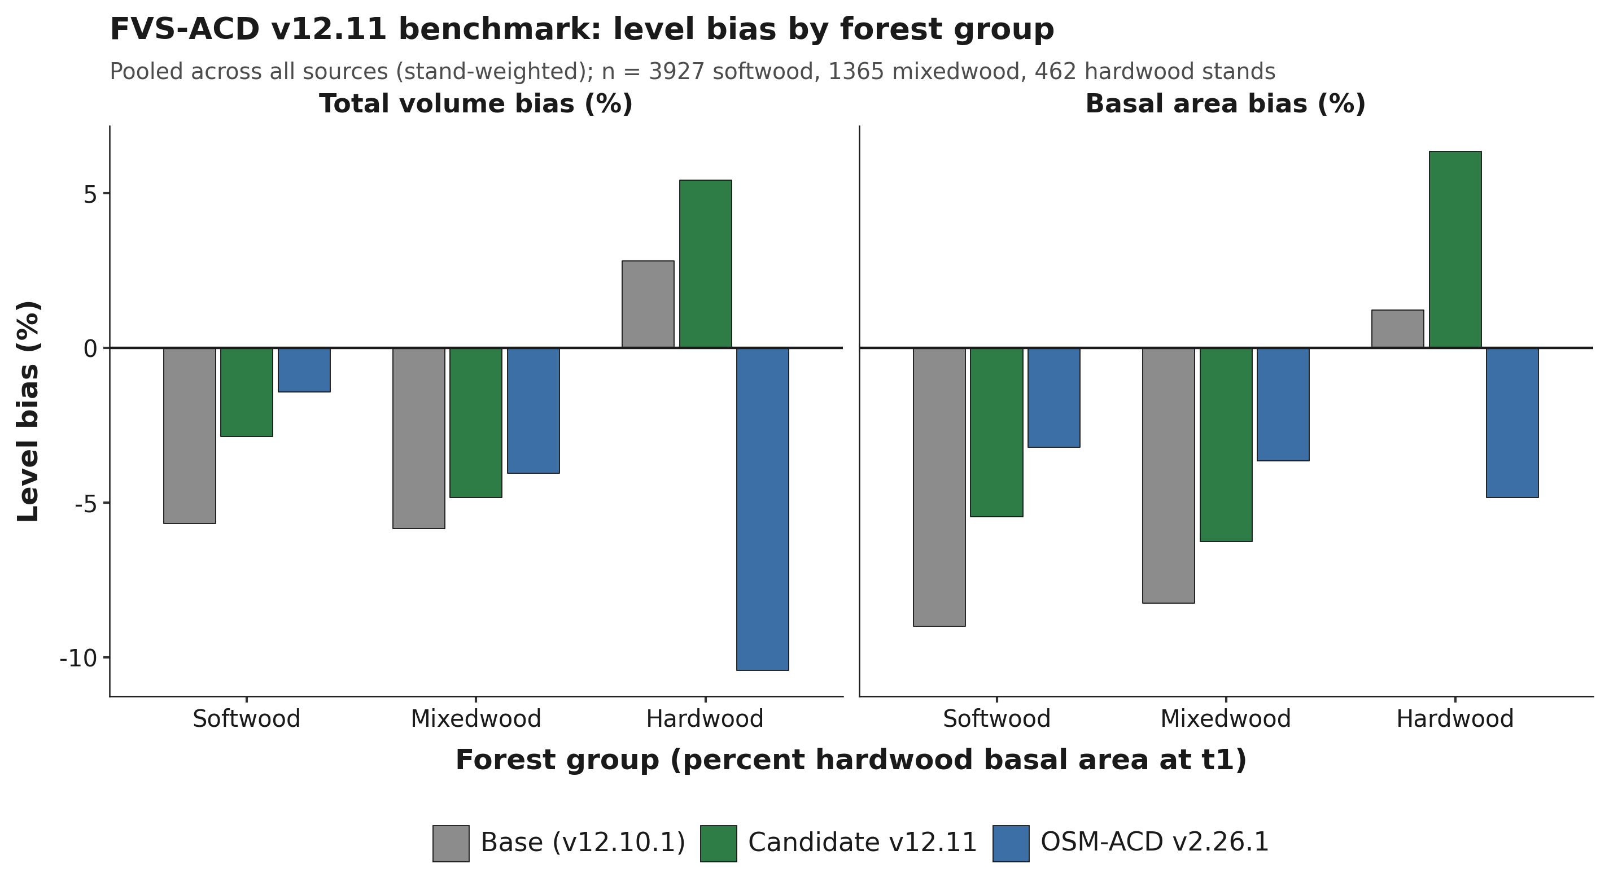
Figure 18. Total-volume and basal-area level bias by forest group, pooled across all sources (stand-weighted), base versus v12.11 candidate versus OSM v2.26.1. n = 3,927 softwood, 1,365 mixedwood, 462 hardwood stands.
Figure 18. Total-volume and basal-area level bias by forest group, pooled across all sources (stand-weighted), base versus v12.11 candidate versus OSM v2.26.1.
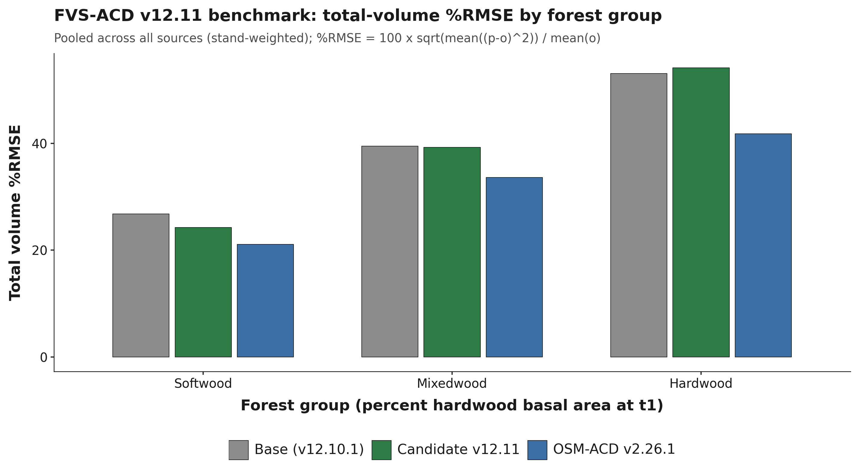
Figure 19. Total-volume percent RMSE by forest group, pooled across all sources (stand-weighted).
Figure 19. Total-volume percent RMSE by forest group, pooled across all sources (stand-weighted). %RMSE = 100 x sqrt(mean((p-o)²)) / mean(o).

10.7 Nova Scotia: an independent-province validation
Nova Scotia is not part of the pooled all-sites benchmark in section 10.5; it is evaluated here as a fully separate, independent province, never used to fit or tune any v12.11 lever, any base-model coefficient, or the ESI site-index anchor. Its Permanent Sample Plot (PSP) network is the Acadian region's longest continuously remeasured forest-inventory record, established in 1965 and carrying up to nine remeasurement occasions per plot, licensed to the University of Maine under a 2016 data-license agreement that keeps individual plot locations confidential (section 10.5 describes how that confidentiality is enforced in the coverage maps). The network is a genuine mix of managed research (thinning-trial) installations and unmanaged operational plots, which makes it the cleanest available test of whether the v12.11 managed-stand levers, fit entirely on Maine, New Brunswick, and Quebec data, generalize to conditions the model has never seen. The medium-interval NS benchmark scored here totals 4,504 stand-pairs, 2,157 managed and 2,347 unmanaged (`figures/_data/bench_ns_scorecard.csv`), scored with the identical frozen harness (`bench_parity_split_ms_v1211.R`, `AcadianGY_12.11.r`) used everywhere else in this report. Because OSM-ACD is itself a native Acadian-zone model, scoring it on NS's own tree lists is a faithful, apples-to-apples third point of comparison alongside base and the v12.11 candidate, not a proxy, and that run is reported alongside base and v12.11 throughout this section. That description holds for the comparison between models and needs one qualification for the volume level all three are compared at. About a quarter of Nova Scotia's t2 basal area carries no measured height and is scored through the substituted diameter-only height curve: the coverage census puts measured height at 76.15 percent of t2 basal area on the medium-interval set and 73.37 percent on the long-interval set, which places Nova Scotia seventh of the eleven benchmark sources rather than the most exposed (Table 10.5a, 10.5.1). The substitution is identical for base, candidate, and OSM, so it is even-handed across models, but it means the absolute total-volume levels in this section are not a clean read on any of the three, and because the curve runs tall on softwood and short on hardwood, the forest-group splits below inherit a split the pooled figures conceal.

10.7.1 Managed-stand levers generalize
On the medium-interval set, the managed-stand levers carry over cleanly to this fully independent province. Managed total-volume bias improves from -58.10 percent (base) to -42.32 percent (v12.11 candidate), a relative reduction of about 27 percent, closely matching the size of the managed-stand improvement seen throughout the rest of this report on data the model was actually fit against. The unmanaged fit is essentially untouched, -6.04 to -6.07 percent total volume, exactly the behavior Lever 2's management gate is designed to produce: it acts only where a stand is flagged managed and leaves natural stands to the unmanaged self-thinning machinery. With OSM now scored on the identical NS pairs, the medium-interval managed comparison is essentially a tie: v12.11 total-volume bias is -42.32 percent against OSM's -41.96 percent, both cutting the base model's -58.10 percent by about 16 points. On unmanaged stands OSM is the more accurate of the two candidates, -2.58 against v12.11's -6.07 percent (base is -6.04 percent), a genuine OSM advantage rather than a rounding difference (10.7.4 gives the full head-to-head).
Table 10.7. Nova Scotia independent-province scorecard, medium-interval pairs: total volume and basal area level bias (percent), base, v12.11 candidate, and OSM-ACD v2.26.1.
Split | Class | n | Model | Total volume bias (%) | Basal area bias (%)
Overall | All | 4,504 | base | -41.28 | -42.54
Overall | All | 4,504 | v12.11 | -30.61 | -33.72
Overall | All | 4,499 | OSM v2.26.1 | -29.22 | -32.95
Managed status | Unmanaged | 2,347 | base | -6.04 | -8.02
Managed status | Unmanaged | 2,347 | v12.11 | -6.07 | -7.26
Managed status | Unmanaged | 2,345 | OSM v2.26.1 | -2.58 | -4.96
Managed status | Managed | 2,157 | base | -58.10 | -58.39
Managed status | Managed | 2,157 | v12.11 | -42.32 | -45.87
Managed status | Managed | 2,154 | OSM v2.26.1 | -41.96 | -45.82
Forest group | Softwood | 2,749 | base | -41.42 | -42.37
Forest group | Softwood | 2,749 | v12.11 | -31.52 | -33.83
Forest group | Softwood | 2,744 | OSM v2.26.1 | -28.46 | -32.05
Forest group | Mixedwood | 1,122 | base | -8.00 | -11.33
Forest group | Mixedwood | 1,122 | v12.11 | -5.32 | -8.42
Forest group | Mixedwood | 1,122 | OSM v2.26.1 | -3.07 | -6.25
Forest group | Hardwood | 633 | base | -66.90 | -68.12
Forest group | Hardwood | 633 | v12.11 | -47.93 | -53.75
Forest group | Hardwood | 633 | OSM v2.26.1 | -51.64 | -56.97

*Data: `figures/_data/bench_ns_scorecard.csv`. OSM v2.26.1 matches 4,499 of the 4,504 stands; the shortfall is under 0.2 percent of the set and does not change any comparison. Forest group and managed status are not independently controlled in this breakdown.*
NS's forest-group pattern echoes the ME/NB/QC forest-group result in section 10.6 in one respect and departs from it in another: softwood and mixedwood both improve substantially under the candidate here, and hardwood improves too (-66.90 to -47.93 percent total volume), the opposite of the pooled ME/NB/QC hardwood signal section 10.6 discusses, though NS hardwood bias remains large in absolute terms and is dominated by the same managed post-disturbance response documented below rather than a clean hardwood-specific comparison. The overall NS bias remains large in both configurations, -41.28 to -30.61 percent total volume, because the pooled figure is dominated by the managed subset's much larger absolute gap, the subject of the site-index and long-interval discussion that follows rather than primarily a forest-group or hardwood issue.

10.7.2 Site index: a real basis, and a transferability caveat for NB/QC's own anchor
NS SITE_INDEX and its research-plot proxy AVGTOPHTM are dominant height in meters read at approximately breast-height age 50, the same basis documented for the model's own ESI-anchored dominant-height input, so there is no species, base-age, or unit mismatch between NS's site index and what the model expects. The mismatch runs the other way: the QC/NB ESI v8 raster that supplies the model's `esi8` input for New Brunswick and Quebec is independently documented (n = 40,596 measured site-index records) to carry a positive bias of +7.0 m against measured site index, Pearson r = 0.146, essentially no per-plot linear skill, and a compressed range relative to true measured site index. The model's per-province height-growth anchor factors, NB_AFAC = 0.579 and QC_AFAC = 0.111 (section 10.2), exist specifically to counteract that raster's inflation for New Brunswick and Quebec; Nova Scotia receives no equivalent correction and is fed its real, uninflated field site index directly into growth terms that are all monotonic in site index, so a lower, truthful input mechanically pushes height, diameter, basal-area increment, and the SDImax self-thinning ceiling down together. This is a genuine model-transferability caveat, not a Nova-Scotia-specific defect: the correction that makes New Brunswick and Quebec height growth track observed data is tuned to cancel a scalar mean bias in a weak raster input, not to recover site-index accuracy at the plot level, and any future region relying on the same NB_AFAC/QC_AFAC pathway, or a newly derived factor for a new region, inherits that same unproven, poorly constrained correction.
Applying a coarse basis-matching adjustment, adding the documented +7.0 m offset to NS's site index so it sits on the same basis the model's anchor was implicitly tuned against, and re-scoring the unmanaged NS subset (the cleanest test, since it carries no disturbance-response confound) moves total-volume bias only from -6.04 to -4.84 percent (base) and -6.07 to -5.04 percent (v12.11 candidate), roughly a 15 to 20 percent relative reduction of an already-small bias, with RMSE essentially unchanged since a flat offset shifts level, not scatter. This directly answers the site-index question: most of Nova Scotia's large absolute under-prediction, -58 percent managed and -41 percent overall on the raw (uncorrected) site index, is not primarily a site-index-basis artifact. The unmanaged subset, where a pure site-index effect would show most cleanly, was only ever -6 to -8 percent biased on total volume and basal area to begin with, and the correction trims about a fifth of that. This finding is stated for the unmanaged subset only, which is the subset that was actually rescored with the corrected site index; the much larger managed and overall biases were not rescored with the corrected input in this pass, so the conclusion that the managed and overall gap is dominated by real, short-term post-disturbance growth response (the target of Lever 2, section 10.4) should be read as the parsimonious working hypothesis this evidence supports, not as a demonstrated result on the managed subset itself.
A second transferability caveat runs alongside the site-index one and is independent of it. The diameter-only height curve that the scoring harness substitutes for any tree lacking a measured height was fitted on Maine data, and its error is neither constant across species groups nor constant across regions. Weighted by basal area over Nova Scotia's own measured stems, the curve runs 8.0 percent tall on softwood and 12.1 percent short on hardwood on the medium-interval set (7.5 percent tall and 12.9 percent short on the long-interval set), so the two errors offset and a pooled check reports the curve as unbiased on Nova Scotia while both species groups carry errors near 10 percent in opposite directions (10.5.1). Exporting either the curve itself or a curve-scored volume result to a new region therefore carries the same unproven assumption the NB_AFAC and QC_AFAC pathway carries above, that a correction fitted in one place transfers to another, and the Nova Scotia evidence shows the assumption failing by species group inside a single province.
Table 10.8. Nova Scotia unmanaged-subset site-index basis correction, total volume and basal area level bias (percent), raw field site index versus a +7.0 m esi8-matched correction, n = 2,347.
Site input | Model | Total volume bias (%) | Basal area bias (%)
Raw (field-measured) | base | -6.04 | -8.02
Esi8-matched (+7.0 m) | base | -4.84 | -7.08
Raw (field-measured) | v12.11 | -6.07 | -7.26
Esi8-matched (+7.0 m) | v12.11 | -5.04 | -6.22

*Data: `20260722_ns_benchmark_philosophy_pass.md`, Task 1. The +7.0 m offset is a point estimate from a validation with RMSE 7.9 m and r = 0.146, a coarse basis-matching adjustment rather than a precise per-plot recalibration.*

10.7.3 Long-interval, first-to-last test: a disturbance-contamination artifact, caught and corrected
Nova Scotia's 1965-present record makes it the only Acadian data source that can test a first-to-last, multi-decade growth trajectory independent of Maine, New Brunswick, and Quebec, directly probing whether the maturity-dependent, sign-flipping long-horizon volume pattern documented in section 10.4 reproduces on genuinely independent data. A disturbance-screening bug was found and fixed during this cycle: the tree-level cut-detection filter compared a string-typed status column against an integer constant, a comparison that is always false in the analysis library used, so the filter silently passed every stand as undisturbed regardless of its actual harvest history. Correcting the filter shows that about 23 percent of the long-interval (over 30 year) bucket contained an undisclosed harvest inside the remeasurement interval. An initial pass, scored before this bug was caught, appeared to show the same maturity-dependent sign flip documented in section 10.4, a swing from under-prediction at short and medium intervals to slight over-prediction at the longest intervals. That result did not survive the corrected, disturbance-clean rescore and is not reported here: the apparent swing traces to the contaminated pairs themselves, since an undisclosed harvest partway through a nominally undisturbed interval truncates realized growth below what an actually undisturbed trajectory would show, which mechanically manufactures an apparent over-prediction signal when those pairs are wrongly scored as clean. The artifact was caught during an internal red-team review before an earlier draft of this report cited any number from it.
The corrected, disturbance-clean rescore is complete. The scoring pipeline ran against a pair set from which every pair carrying a genuine disturbance flag (silviculture treatment or tree-status code) inside its interval has been removed. Total n = 5,348 pairs (4,014 unmanaged, 1,334 managed single-regime), down from 5,485 in the contaminated pass. The over-30-year bucket, entirely unmanaged and disturbance-free by construction (n = 903, mean interval 36.3 years, forest-group split softwood 477, mixedwood 286, hardwood 140), is the clean, disturbance-free long-horizon test. On this bucket, total-volume bias is -0.06 percent (base) and -1.66 percent (v12.11 candidate), essentially zero rather than the over-prediction the contaminated pass appeared to show; basal area remains under-predicted, -18.08 percent (base) and -12.48 percent (v12.11). OSM v2.26.1, scored on this same clean bucket, does not hold that line: its total-volume bias at over 30 years is -9.14 percent, a real drift away from zero rather than the near-zero result v12.11 sustains, the single clearest point of separation between the two models anywhere in this Nova Scotia validation.
Table 10.9. Nova Scotia long-interval rescore, disturbance-clean pair set: total volume and basal area level bias (percent) by interval-length bucket and management status, base and v12.11 n = 5,348, OSM v2.26.1 n = 5,344.
Split | Class | n | Mean interval (yr) | Model | Total volume bias (%) | Basal area bias (%)
Overall | All | 5,348 | 12.0 | base | -39.75 | -43.22
Overall | All | 5,348 | 12.0 | v12.11 | -30.41 | -34.82
Overall | All | 5,344 | 12.0 | OSM v2.26.1 | -31.99 | -34.89
Managed status | Unmanaged | 4,014 | 13.4 | base | -5.52 | -12.19
Managed status | Unmanaged | 4,014 | 13.4 | v12.11 | -6.01 | -9.68
Managed status | Unmanaged | 4,012 | 13.4 | OSM v2.26.1 | -6.86 | -9.70
Managed status | Managed | 1,334 | 7.7 | base | -74.36 | -72.14
Managed status | Managed | 1,334 | 7.7 | v12.11 | -55.07 | -58.25
Managed status | Managed | 1,332 | 7.7 | OSM v2.26.1 | -57.40 | -58.36
Interval length | Under 15 yr | 3,939 | 5.1 | base | -44.04 | -45.27
Interval length | Under 15 yr | 3,939 | 5.1 | v12.11 | -32.38 | -36.24
Interval length | Under 15 yr | 3,935 | 5.1 | OSM v2.26.1 | -32.91 | -35.79
Interval length | 15 to 30 yr | 506 | 21.9 | base | -56.08 | -56.51
Interval length | 15 to 30 yr | 506 | 21.9 | v12.11 | -48.20 | -48.87
Interval length | 15 to 30 yr | 506 | 21.9 | OSM v2.26.1 | -49.56 | -49.13
Interval length | Over 30 yr | 903 | 36.3 | base | -0.06 | -18.08
Interval length | Over 30 yr | 903 | 36.3 | v12.11 | -1.66 | -12.48
Interval length | Over 30 yr | 903 | 36.3 | OSM v2.26.1 | -9.14 | -15.31

*Data: `figures/_data/bench_ns_long_scorecard.csv`, regenerated after the tree-level disturbance-screen fix, and `figures/_data/ns_headtohead.csv` for the OSM v2.26.1 rows; superseded contaminated numbers are retained only in `20260722_ns_benchmark_philosophy_pass.md` for provenance and are not cited in this report. The over-30-year bucket is entirely unmanaged by construction, since no research single-regime interval spans past about 25 years.*
The honest read is that Nova Scotia's clean long record does not independently reproduce the maturity-dependent, sign-flipping over-prediction pattern documented in section 10.4; it is only partially consistent with it. The under-prediction genuinely weakens as intervals lengthen past 30 years, -44.04 percent under 15 years to -56.08 percent at 15 to 30 years to -0.06 percent past 30 years (base numbers; v12.11 tracks the same shape, -32.38, -48.20, -1.66 percent), the qualitative direction the other long-horizon evidence would predict. But it lands near zero rather than flipping positive, and basal area stays under-predicted throughout, including at the longest intervals, rather than showing the companion structural overshoot a genuine height- or form-driven volume catch-up would produce. The two robust Nova Scotia findings from this section stand independent of the long-interval question: the management-gated mortality lever generalizes cleanly to this fully independent province (managed total-volume bias -74.36 to -55.07 percent, base to v12.11, essentially the same relative improvement seen throughout this report; unmanaged bias -5.52 to -6.01 percent, untouched, exactly as Lever 2's management gate is designed to produce), and the site-index transferability caveat from section 10.7.2 (the QC/NB esi8 raster the model's own height anchor was tuned against carries a documented +7.0 m bias against measured site index). OSM v2.26.1, scored on this same clean long-interval set, sharpens rather than changes this read: OSM tracks v12.11 closely at short and medium intervals but does not hold the near-zero over-30-year result, drifting to -9.14 percent where v12.11 stays at -1.66 percent, so the "does not cross into over-prediction" finding above is specific to v12.11 and the frozen base, not a property both benchmarked models share.

10.7.4 OSM-ACD v2.26.1 head-to-head
Nova Scotia's OSM v2.26.1 run gives the first apples-to-apples three-way comparison, frozen base, v12.11 candidate, and OSM, on data none of the three was fit against. Because OSM-ACD is itself a native Acadian-zone model, this is a faithful comparison in a way the esi8-anchor discussion in section 10.7.2 is not: OSM needs no site-index basis correction to run on NS, and its predictions come from the same NS tree lists scored through the identical NSVB metric code used for FVS-ACD throughout this report.
Table 10.10. Nova Scotia three-way head-to-head, total-volume level bias (percent), base, v12.11 candidate, and OSM-ACD v2.26.1, medium- and long-interval sets.
Interval set | Split | n (base / v12.11 / OSM) | Base | v12.11 | OSM v2.26.1
Medium (Table 10.7) | Managed | 2,157 / 2,157 / 2,154 | -58.10 | -42.32 | -41.96
Medium (Table 10.7) | Unmanaged | 2,347 / 2,347 / 2,345 | -6.04 | -6.07 | -2.58
Long (Table 10.9) | Managed | 1,334 / 1,334 / 1,332 | -74.36 | -55.07 | -57.40
Long (Table 10.9) | Unmanaged | 4,014 / 4,014 / 4,012 | -5.52 | -6.01 | -6.86
Long (Table 10.9) | Over 30 yr (unmanaged, disturbance-clean) | 903 / 903 / 903 | -0.06 | -1.66 | -9.14

*Data: `figures/_data/ns_headtohead.csv`, built from `figures/_data/bench_ns_scorecard.csv` and `figures/_data/bench_ns_long_scorecard.csv`. Reproduced from Tables 10.7 and 10.9 in compact form for direct comparison; no new numbers appear in this table.*
The honest read is mixed, not a clean sweep for either model. On managed stands, where both v12.11 and OSM carry explicit management structure, the two are essentially tied at medium intervals, -42.32 against -41.96 percent, and v12.11 modestly edges OSM at long intervals, -55.07 against -57.40 percent; both cut the frozen base's managed bias by roughly the same proportion at each horizon. OSM is the more accurate model on short-interval unmanaged stands, -2.58 against v12.11's -6.07 percent, a genuine and reproducible OSM advantage rather than noise. But at the longest horizons, the over-30-year, disturbance-clean bucket that is Nova Scotia's longest independent record and the single cleanest test available anywhere in this project, v12.11 clearly wins: it holds total-volume bias near zero, -1.66 percent, while OSM drifts to -9.14 percent. That result is consistent with the maturity-gated stand constraint (Lever 3b, section 10.4) doing real work at exactly the horizon it was built for, and it is the one place in this comparison where the two models genuinely diverge rather than tracking each other. Reading Table 10.10 as a whole, neither model dominates: v12.11 clearly beats OSM at the longest horizon on bias, where base is actually closest to zero, and modestly at long-managed, OSM wins clearly at short-unmanaged, and the two are a tie at short-managed. This report states that plainly rather than picking a winner.

10.7.5 Methods and open items
All Nova Scotia numbers in this section come from the site-index re-score, the long-interval disturbance-clean rescore (superseding an earlier run affected by the tree-level disturbance-screen bug described in section 10.7.3), the long-interval scorecard assembly, and the OSM v2.26.1 head-to-head (both the medium-interval and long-interval sets), scored with the unmodified frozen harness and model file used throughout this report. OSM's stand counts run slightly below FVS-ACD's at every split, 4,499 of 4,504 medium-interval stands and 5,344 of 5,348 long-interval stands matched; the shortfall is OSM inventory records it could not build a valid tree list for (mostly sub-1.0 cm DBH records at or below OSM's internal floor), never a scoring exclusion, and is under 0.2 percent of either set. About 9 percent of pre-filter NS pairs are dropped for missing site-index data at the join step; this attrition has not yet been checked for whether it concentrates in a particular disturbance history, region, or plot type, and is disclosed here as an open item rather than a resolved one. Height coverage is a further qualification on this section, and it is now measured rather than open. The coverage census puts measured height at 76.15 percent of t2 basal area on the medium-interval set and 73.37 percent on the long-interval set, at DBH >= 4 cm (Table 10.5a), so the balance is scored on the substituted diameter-only curve; those census figures supersede the locally recomputed 75.9 and 73.1 percent reported here earlier, and 10.5.1 gives the accounting and what it means for the forest-group splits reported above. As with every other number in this report, only aggregates left the Cardinal node; Nova Scotia's individual plot coordinates are additionally restricted under the 2016 provincial licensing agreement and are never used at any point in this pipeline.

10.8 Master scorecard and overall ranking
Sections 10.5, 10.6, and 10.7 each compare base, candidate, and OSM within a single dataset or region. This section pools every already-scored benchmark cell in this project into one master scorecard, stratified by the four determinants that recur across those sections, managed status, forest group, site productivity class, and projection length, and reports one overall ranking built from it. Sixteen determinant cells are defined; thirteen currently have data. The three site-productivity terciles are empty for every dataset in this project, base, candidate, and OSM alike, since no existing benchmark pipeline currently bins stands by site index; this is reported honestly as an open item rather than estimated or dropped silently. All rankings in this section are on total-volume percent RMSE, the primary accuracy metric used throughout sections 10.5 to 10.7; where a cell pools more than one dataset, the pooled percent RMSE is stand-count weighted, consistent with the pooling already used for Table 10.6.
Table 10.11. Managed status: total-volume percent RMSE, stand-weighted where pooled.
Cell | Region | n (base / v12.11 / OSM) | Base | v12.11 | OSM v2.26.1 | Winner
Managed | ME/NB/QC (pooled) | 1,892 / 1,892 / 1,457 | 37.78 | 32.39 | 28.19 | OSM
Managed | NS | 2,157 / 2,157 / 2,154 | 185.89 | 159.46 | 156.13 | OSM
Unmanaged | ME/NB/QC (pooled) | 6,720 / 6,720 / 3,862 | 35.33 | 35.32 | 19.61 | OSM
Unmanaged | NS | 2,347 / 2,347 / 2,345 | 33.20 | 33.31 | 24.77 | OSM

Table 10.12. Forest group: total-volume percent RMSE, stand-weighted where pooled.
Cell | Region | n (base / v12.11 / OSM) | Base | v12.11 | OSM v2.26.1 | Winner
Softwood | ME/NB/QC (pooled) | 3,927 / 3,927 / 3,716 | 26.79 | 24.25 | 21.08 | OSM
Softwood | NS | 2,749 / 2,749 / 2,744 | 198.63 | 179.62 | 171.20 | OSM
Mixedwood | ME/NB/QC (pooled) | 1,365 / 1,365 / 1,257 | 39.46 | 39.23 | 33.61 | OSM
Mixedwood | NS | 1,122 / 1,122 / 1,122 | 46.27 | 36.79 | 37.71 | v12.11
Hardwood | ME/NB/QC (pooled) | 462 / 462 / 346 | 53.06 | 54.12 | 41.77 | OSM
Hardwood | NS | 633 / 633 / 633 | 165.15 | 122.77 | 129.47 | v12.11

Table 10.13. Projection length and site productivity class.
Cell | Region | n (base / v12.11 / OSM) | Base | v12.11 | OSM v2.26.1 | Winner
Under 15 yr | NS | 3,939 / 3,939 / 3,935 | 163.46 | 132.88 | 134.24 | v12.11
15 to 30 yr | NS | 506 / 506 / 506 | 145.83 | 127.29 | 127.57 | v12.11
Over 30 yr | NS | 903 / 903 / 903 | 49.79 | 52.35 | 50.28 | Base
Under 15 / 15-30 / over 30 yr | ME/NB/QC (pooled) | 0 | -- | -- | -- | no data: no ME/NB/QC source carries the remeasurement span this split needs
Low / mid / high SI tercile | ALL | 0 | -- | -- | -- | no data: no dataset in this project is currently binned by site-index tercile

*Data: `figures/_data/master_scorecard.csv` (16 rows per model, 13 with data), pooling `figures/_data/v1211_allsites_scorecard.csv`, `figures/_data/v1211_forestgroup_scorecard.csv`, `figures/_data/bench_ns_scorecard.csv`, and `figures/_data/bench_ns_long_scorecard.csv`, the same source files already cited for Tables 10.5, 10.6, 10.7, and 10.9. Source memo: `20260723_master_scorecard_and_ranking.md`.*
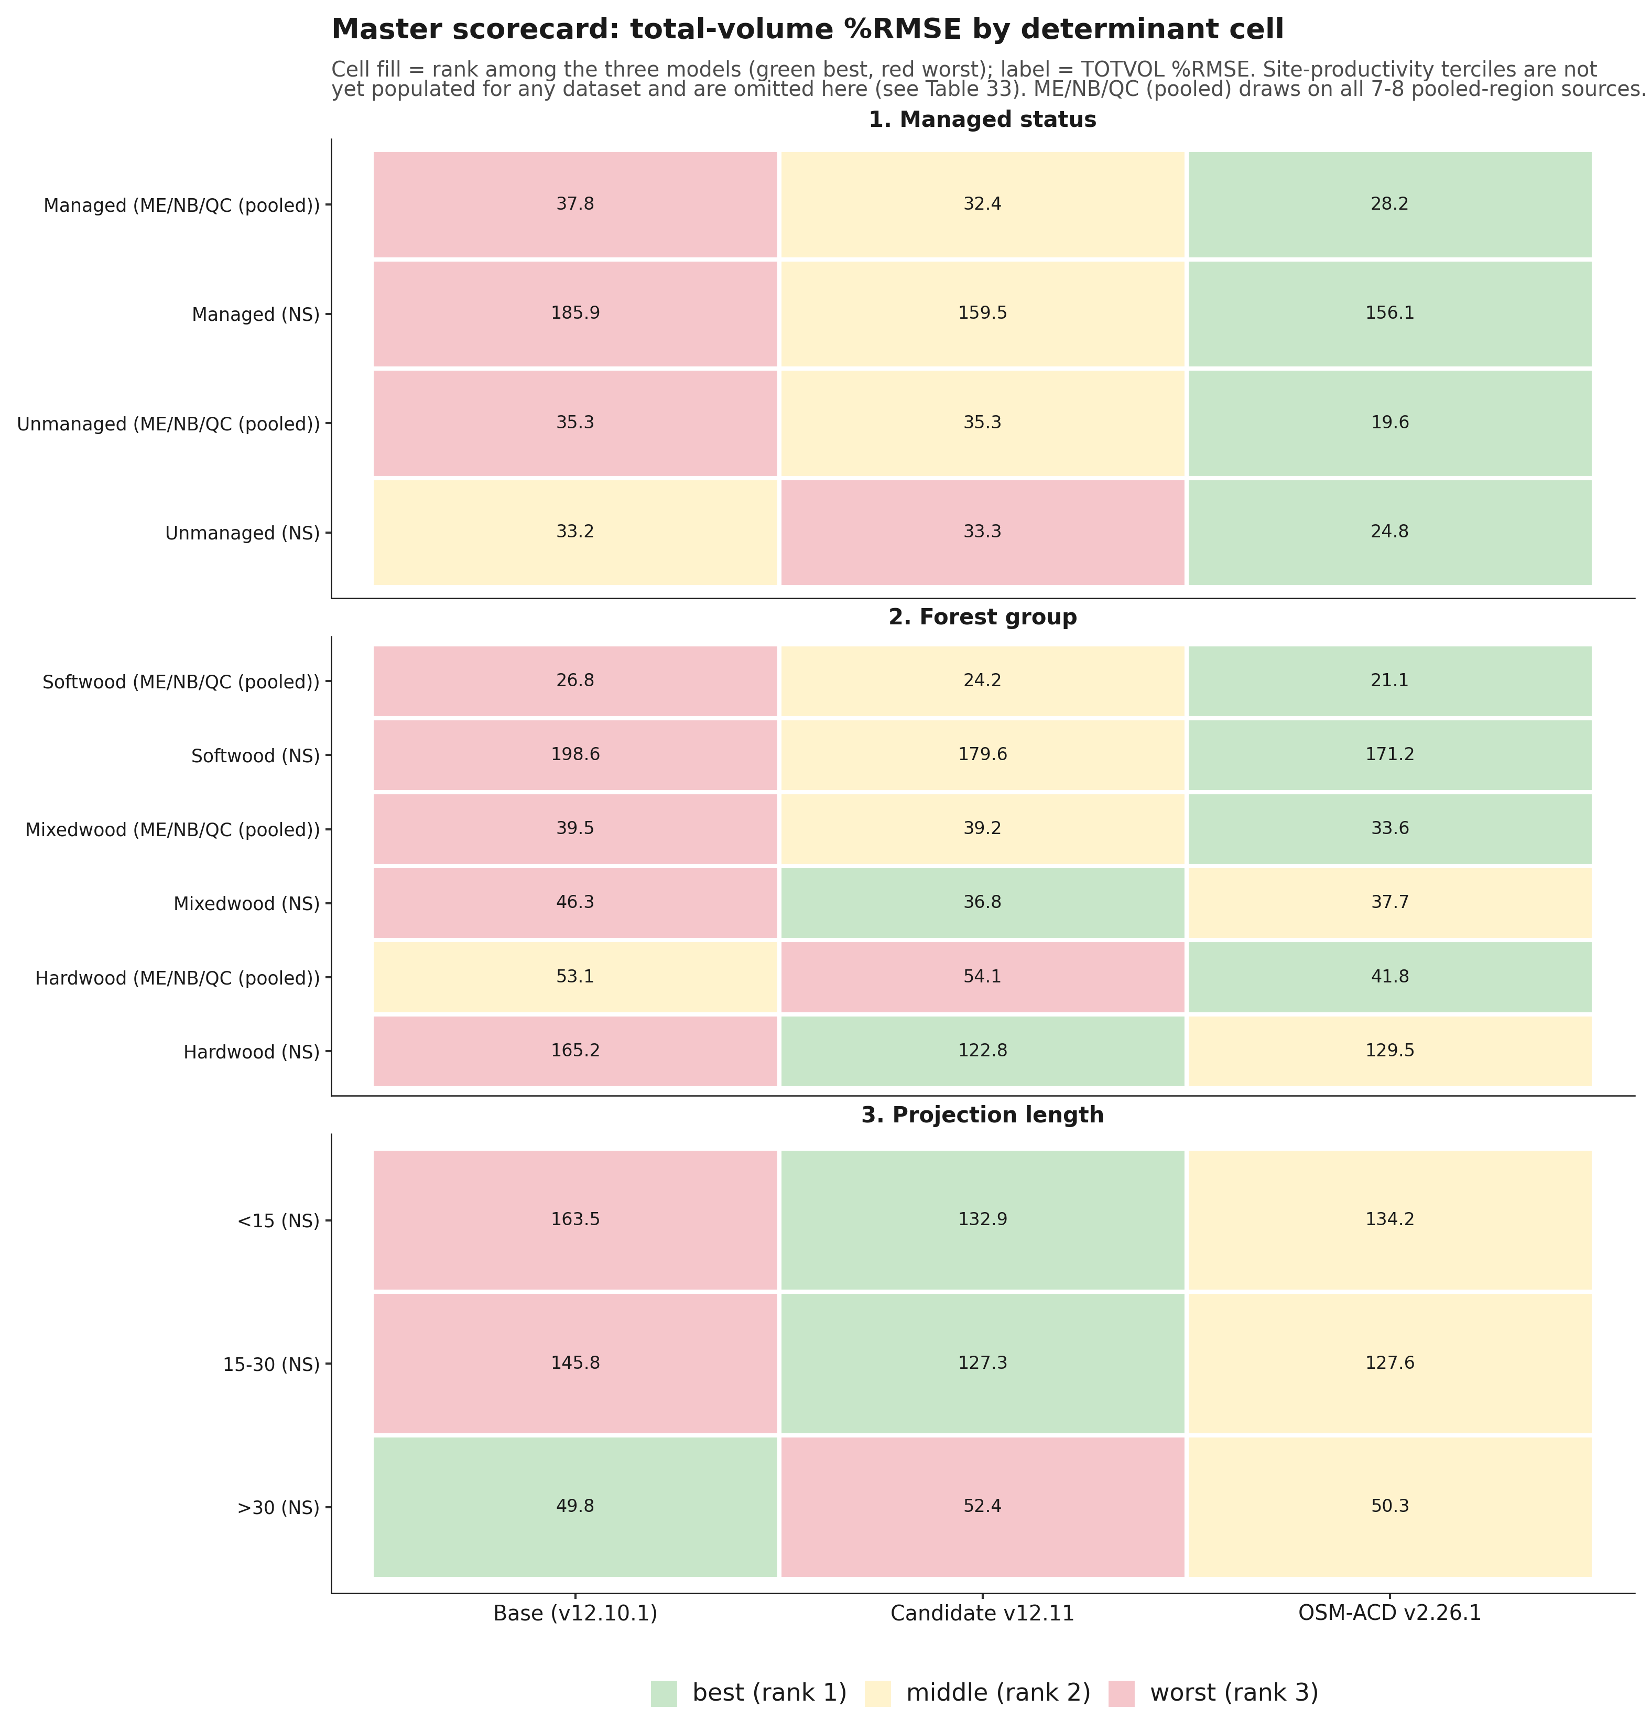
Figure 23. Master scorecard heatmap, total-volume percent RMSE by determinant cell, base versus candidate v12.11 versus OSM v2.26.1, cell fill by rank (green best, red worst).
Figure 23. Master scorecard heatmap, total-volume percent RMSE by determinant cell, base versus candidate v12.11 versus OSM v2.26.1, cell fill by rank.
Read across the three tables, OSM-ACD v2.26.1 wins every managed-status cell in both regions and every softwood and mixedwood ME/NB/QC cell; v12.11 wins mixedwood and hardwood in Nova Scotia and both of NS's shorter projection-length buckets; and base wins only the over-30-year NS bucket, the same result already reported in Table 10.10. Hardwood and the two shorter NS projection-length buckets are v12.11's clearest, most consistent determinant wins, and they pair with section 10.6's finding that softwood is where v12.11 gains the most ground on base without necessarily beating OSM there.
These three tables should not be pooled or mean-ranked directly into an overall score, because doing so counts the same Nova Scotia stands as up to three separate cells, once under managed status, again under forest group, and again under projection length, while the eight independent Maine, New Brunswick, and Quebec sources fold into far fewer cells, five, and zero for projection length, since no ME/NB/QC source carries a long enough remeasurement span for that split. Summed across the 13 scored cells above, that gives Nova Scotia roughly 50 percent of the pooled percent RMSE weight and 8 of 13 votes in a mean-rank composite, against its true, non-overlapping share of about 34 percent of all benchmarked stands. An earlier pass at this section's overall ranking was built exactly that way; it is superseded by the ranking below, which pools the same underlying data by independent source instead.
Table 10.14. Overall ranking under six scenarios: two inclusion rules (all-available-data; common-cells-only, where all three models have a score) crossed with three Nova Scotia treatments (with NS from the original scorecard, without NS, with NS from the long-interval sensitivity scorecard).
Inclusion rule | NS treatment | Model | Mean rank (1 = best) | Sources won | Pooled TOTVOL %RMSE | Pooled bias %
All-available-data | Without NS (8 ME/NB/QC sources) | Base | 2.50 | 1/8 | 35.9 | -11.3
All-available-data | Without NS | v12.11 | 1.50 | 4/8 | 34.7 | -9.6
All-available-data | Without NS | OSM | 1.67 | 3/6 | 22.0 | -2.4
All-available-data | With NS (original scorecard, 9 sources) | Base | 2.56 | 1/9 | 86.2 | -21.6
All-available-data | With NS | v12.11 | 1.56 | 4/9 | 76.6 | -16.8
All-available-data | With NS | OSM | 1.57 | 4/7 | 82.0 | -14.7
All-available-data | With NS-long (sensitivity swap) | Base | 2.56 | 1/9 | 81.1 | -22.2
All-available-data | With NS-long | v12.11 | 1.44 | 5/9 | 70.2 | -17.6
All-available-data | With NS-long | OSM | 1.71 | 3/7 | 75.3 | -17.3
Common-cells-only | Without NS (6 shared sources) | Base | 2.83 | 0/6 | 26.1 | -4.9
Common-cells-only | Without NS | v12.11 | 1.50 | 3/6 | 24.2 | -2.8
Common-cells-only | Without NS | OSM | 1.67 | 3/6 | 22.0 | -2.4
Common-cells-only | With NS (original scorecard, 7 shared sources) | Base | 2.86 | 0/7 | 97.4 | -21.5
Common-cells-only | With NS | v12.11 | 1.57 | 3/7 | 84.6 | -15.5
Common-cells-only | With NS | OSM | 1.57 | 4/7 | 82.0 | -14.7
Common-cells-only | With NS-long (sensitivity swap) | Base | 2.86 | 0/7 | 89.9 | -22.3
Common-cells-only | With NS-long | v12.11 | 1.43 | 4/7 | 75.6 | -16.6
Common-cells-only | With NS-long | OSM | 1.71 | 3/7 | 75.3 | -17.3

*Data: `figures/_data/overall_ranking.csv` (all 18 rows above), `overall_ranking_summary.csv` (the two headline with-NS rows plotted in Figure 24), `overall_ranking_detail.csv` (per-source rank detail, both inclusion rules), and `master_scorecard_sources.csv` (the 28-row non-overlapping per-source input table), all built from `v1211_allsites_scorecard.csv`, `bench_ns_scorecard.csv`, and `bench_ns_long_scorecard.csv`. Bold marks the better model on each metric within each scenario row-pair; a tie is bolded on both. Source memo: `20260723_master_scorecard_and_ranking.md`.*
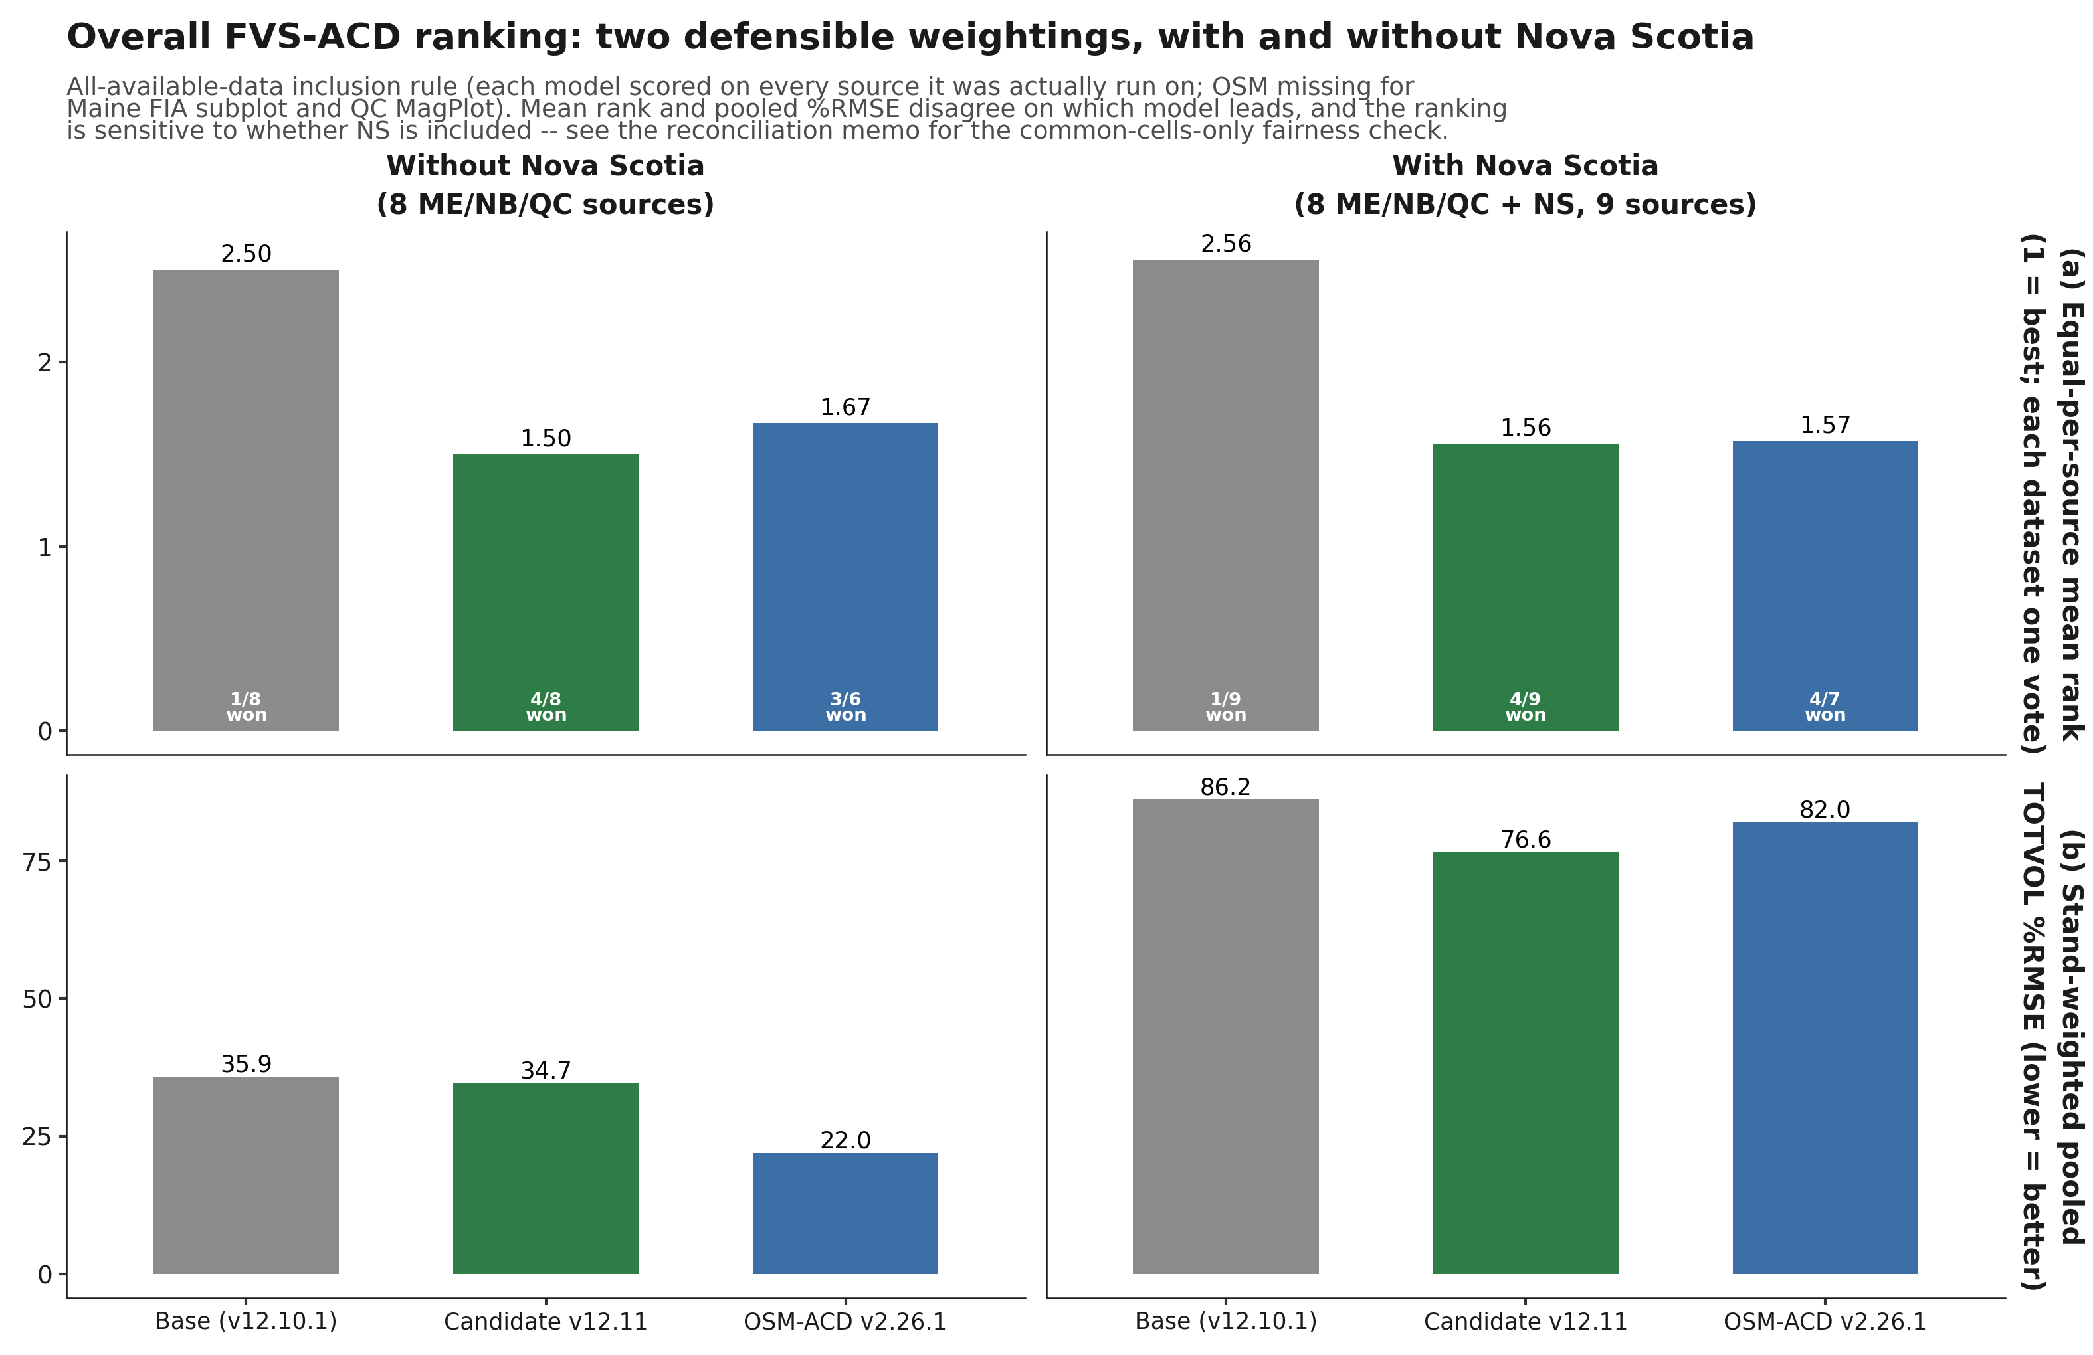
Figure 24. Overall FVS-ACD ranking under two defensible weightings, with and without Nova Scotia: equal-per-source mean rank (top) and stand-weighted pooled total-volume percent RMSE (bottom), base versus candidate v12.11 versus OSM v2.26.1, all-available-data inclusion rule.
Figure 24. Overall FVS-ACD ranking under two defensible weightings, with and without Nova Scotia: equal-per-source mean rank (top) and stand-weighted pooled total-volume percent RMSE (bottom), base versus candidate v12.11 versus OSM v2.26.1.
Neither model is a clean overall winner, and the ranking genuinely depends on the weighting and inclusion rule chosen, a more honest result than a single headline number would give. v12.11 is the more consistent performer of the two candidates: it has the better, or tied, equal-per-source mean rank in all six scenarios, running 1.43 to 1.57, it never finishes clearly last on any metric in any scenario, and it leads the pooled percent RMSE specifically when Nova Scotia and the full eight-source ME/NB/QC set are both included. OSM-ACD v2.26.1 is the more decisive winner where it wins: it leads the fairest, apples-to-apples pooled percent RMSE comparison, common-cells-only, in every Nova Scotia treatment, and on the determinant cross-tab above it sweeps every managed-status cell in both regions and every softwood and mixedwood ME/NB/QC cell, a broad advantage on managed and softwood/mixedwood stands rather than a narrow one. Two qualifications keep this comparison honest. First, OSM has no score for two of the eight ME/NB/QC sources, Maine FIA subplot and QC MagPlot, both comparatively poor-fitting for either FVS build, so any all-available-data scenario evaluates OSM on an easier six-source subset than it evaluates base and v12.11 on their full eight. Second, Nova Scotia itself carries two internally consistent but narrowly disagreeing scorecards, the original benchmark (OSM ahead, 153.05 against v12.11's 156.69) and a long-interval sensitivity build assembled for the projection-length split (v12.11 ahead, 127.35 against OSM's 128.34), reported here side by side rather than resolved silently. Base is a clear third on every metric in every one of the six scenarios without exception.
This reconciled ranking corrects two claims that appeared in earlier drafts of this report. v12.11 does not lead managed status overall; OSM wins the managed-status cell outright in both regions (Table 10.11). And v12.11 does not win the long-horizon bucket outright; base does, holding total-volume bias closest to zero at the over-30-year NS interval (-0.06 percent, against v12.11's -1.66 percent and OSM's -9.14 percent), though v12.11 still clearly outperforms OSM at that same horizon, consistent with section 10.7.4's head-to-head finding. What the reconciled data does support is that v12.11's clearest wins are the two shorter NS projection-length buckets and hardwood and mixedwood in Nova Scotia (Tables 10.12 and 10.13), and, at the source level, CFRU CTRN and NB MagPlot among the managed ME/NB/QC sources (Baxter as well, though that source is mature and held-out rather than actively managed), where v12.11 beats OSM outright under every inclusion rule tested. Every source-level cell pooled into this ranking carries some exposure to the substituted diameter-only height curve, and the coverage census in 10.5.1 quantifies it: PEF and Baxter are thinnest at 4.02 and 18.45 percent measured coverage, the managed CTRN and MagPlot cells that carry v12.11's win sit at 51.99 and 32.82 percent, about a quarter of Nova Scotia's t2 basal area is scored the same way, and SILC and the Maine FIA long and subplot cells are effectively fully measured. All three models are scored against the same observed tree list at each source, so the ranking is more durable than the levels that feed it. The Baxter cell has since been repaired and rescored, and its model ordering is unchanged while every level moves toward zero (Table 10.5b). It should also be read alongside, not instead of, section 10.9's long-horizon Bakuzis finding: this section measures predictive accuracy against held-out or independent data, section 10.9 measures internal biological consistency across a controlled productivity gradient, and a model can rank differently on the two.
This section's numbers reconcile an earlier internal disagreement in this project's working notes. A first computation reported v12.11 leading the mean-rank composite at 1.53 against OSM's 1.72 and base's 2.50, with a pooled percent RMSE of 109.75 against OSM's 121.45 and base's 128.91. A second, rebuilt computation reported the opposite ordering on mean rank, OSM at 1.38 against v12.11's 1.92, while v12.11 narrowly led pooled percent RMSE at 74.59 against OSM's 75.20. Neither of those two computations reproduces from the source data pooled at the independent, non-overlapping source level; both were built on the four-determinant cross-tab, which triple-counts Nova Scotia as described above. This section replaces both with the six-scenario, per-source ranking in Table 10.14, verified end to end against `v1211_allsites_scorecard.csv`, `bench_ns_scorecard.csv`, and `bench_ns_long_scorecard.csv` and documented in full in `20260723_master_scorecard_and_ranking.md`. Those numbers are the authoritative overall ranking for this report going forward.

10.9 Long-horizon Bakuzis across the productivity and species gradient
The guardrail Bakuzis check in section 10.3 (Table 10.3c) scores a single softwood synthetic stand over a 160-year, ESI 12/16/20 gradient and answers whether v12.11 broke anything on one stand type. This companion check asks whether biological realism holds across the productivity gradient and across the species-composition gradient the Acadian region actually contains, softwood, mixedwood, and hardwood, and adds OSM-ACD v2.26.1 as a third point of comparison from its own existing long-horizon run. Three seeded 40-tree stands (3,000 stems ha⁻¹ initial DBH 5 to 13 cm, identical structure and RNG seed across models so only the model and species mix differ) were projected across the same ESI(csi) 12/16/20 gradient for 160 years: softwood (Abies balsamea (L.) Mill., Picea rubens Sarg., Picea mariana (Mill.) Britton, Sterns & Poggenb., Picea glauca (Moench) Voss), mixedwood (A. balsamea, P. rubens, Acer rubrum L., Acer saccharum Marshall), and hardwood (A. rubrum, A. saccharum, Betula alleghaniensis Britton, Betula papyrifera Marshall). OSM cannot be seeded on the synthetic gradient, so it is reused unchanged from its existing 159-year run on 70 real SILC/CFI stands, binned into low, mid, and high site terciles on OSM's own T50HT site-index proxy (mean 12.4, 16.4, and 19.2 m), the closest available analog to the FVS ESI gradient; this is a genuine asymmetry in the evidence base, a controlled synthetic gradient for base and candidate against real, previously disturbed stands for OSM, stated here rather than smoothed over.
Table 10.15. Long-horizon Bakuzis matrix, worst case across softwood, mixedwood, and hardwood stand starts (base and candidate) versus the pooled real-stand OSM run, 160-year (FVS) and 159-year (OSM) horizons.
Relation | Base (frozen v12.10.1) | Candidate v12.11 (unmanaged) | OSM-ACD v2.26.1
Eichhorn (volume-height, CV%) | pass (11.0 to 14.2%) | pass (11.0 to 14.1%) | flag (26.3%)
Reineke self-thinning (slope) | pass (-1.59 to -1.50) | pass (-1.62 to -1.49) | pass (-1.56)
Site ordering (HT / VOL inversions) | flag (0 to 4 / 0 to 4) | flag (0 to 4 / 0 to 4) | flag (42 / 105)
Yield-density plateau (BA₁₆₀, m² ha⁻¹) | pass (32.0 to 36.1) | pass (31.6 to 35.3) | pass (34.7)
Sukachev (QMD rises as TPH falls) | pass | pass | pass

*Data: `figures/_data/bakuzis_longterm.csv` (headline rows first, then full per-stand-type detail, then the OSM row). Source memo: `20260723_bakuzis_longterm.md`. OSM's run is reused unchanged (run 15 July 2026, predates this benchmark cycle).*
Candidate v12.11 holds the same pass/flag pattern as base on every relation and every stand type: where base passes, the candidate passes, and the one flag, site ordering, is present in base too, at nearly the same ages and magnitude, so it is not a candidate-introduced regression. Read stand type by stand type, the site-ordering flag traces to a single, narrow cause: on the mixedwood stand only, at ages 46 to 52 (base) or 46 to 49 (candidate), the mid-productivity site's height and volume trajectories edge fractionally above the high-productivity site's for a handful of years (base age 49: height 12.84 m at ESI 16 versus 12.60 m at ESI 20, a 1.9 percent crossing; volume 138.7 versus 137.8 m³ ha⁻¹, a 0.6 percent crossing), then the ordering re-establishes itself and holds for the remaining roughly 110 years of the run. Softwood and hardwood both pass with zero inversions in both models. This reads as a pre-existing, self-correcting behavior of the shared growth engine on this specific softwood-hardwood mix, likely a transient mortality or ingrowth-timing asynchrony between site classes near stand establishment, not a structural site-effect problem the candidate's levers introduced or worsened. OSM's site-ordering flag is a different order of severity: 42 height inversions and 105 volume inversions over the run, and at the 159-year endpoint the poorest site tercile ends with more standing basal area, stand density index, and quadratic mean diameter than either the mid or high tercile, a persistent, endpoint-level inversion rather than a brief mid-rotation crossing; some of this may reflect genuine disturbance or measurement history in the underlying real SILC/CFI stands rather than a pure OSM artifact, a caveat the objective test cannot itself distinguish and which is stated rather than suppressed. Eichhorn separates the same way: both FVS configurations pass cleanly on all three stand types (coefficient of variation of volume at matched height bins, both comfortably under the 15 percent threshold), while OSM flags this relation at 26.3 percent CV, meaning OSM's volume-height relationship is noticeably more site-dependent across its real-stand terciles than either FVS configuration is across the seeded gradient. Reineke self-thinning and Sukachev are where all three models agree most closely.
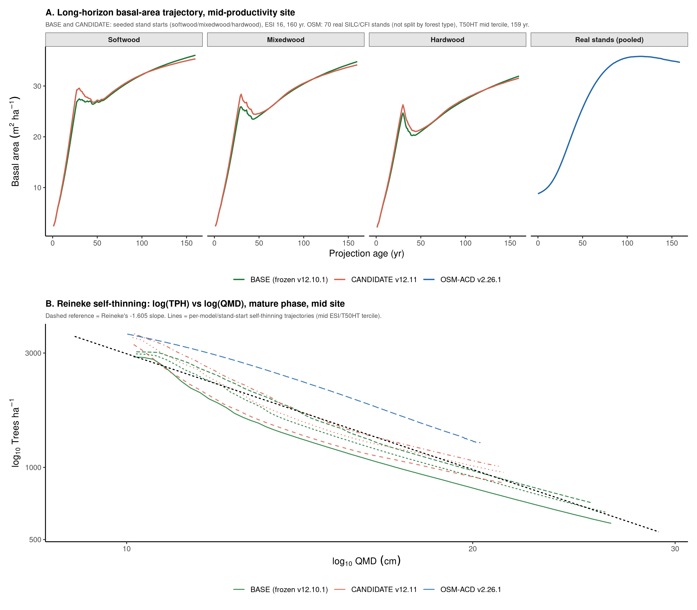
Figure 25. Long-horizon Bakuzis evidence: (A) mid-productivity-site basal-area trajectory over the full 160-year (FVS) and 159-year (OSM) horizon, by stand type, base versus candidate versus OSM's pooled real-stand run; (B) Reineke self-thinning lines (log trees per hectare versus log quadratic mean diameter) for every model by stand-type combination at the mid-productivity site against the theoretical -1.605 reference slope.
Figure 25. Long-horizon Bakuzis evidence across the 160-year (FVS) and 159-year (OSM) horizons: (A) mid-productivity-site basal-area trajectory by stand type, base versus candidate versus OSM's pooled real-stand run; (B) Reineke self-thinning lines for every model by stand-type combination at the mid-productivity site against the theoretical -1.605 reference slope.
Both FVS configurations score better on this internal-consistency test than OSM, which flags Eichhorn and carries a persistent, endpoint-level site-ordering inversion on its real-stand run. This finding is read alongside, not instead of, section 10.8's master scorecard and reconciled overall ranking: section 10.8 measures predictive accuracy against held-out or independent data, this section measures internal biological consistency across a controlled productivity gradient, and a model can rank differently on the two.

10.10 Red-team review and watch items
An independent red-team review (22 July 2026) read the candidate report, the Lever 4 coefficient fit, the crown-ratio investigation, and the guardrail results, then independently re-derived or stress-tested every claim rather than restating it: twelve findings in total (one blocker, five majors, three minors, one cosmetic item, and one process note; full detail in `20260721_v1211_redteam.md`). The review's verdict was to finalize with fixes, not as-is. The lever architecture, the gating discipline, and the byte-identical gate-off guarantee are sound and independently reproduce on a second, novel stand, but several headline claims required correction before appearing in this report.
Top-height drift is anchor calibration, not a lever effect. Running six lever configurations, anchor alone, anchor plus recruitment, plus the mortality gate, plus the stand constraint, plus Lever 4, and all four candidate levers together, on an identical 60-year mixed managed stand gave bit-identical top height, 20.269 m at year 60, in all six. Basal area varied meaningfully across the same six configurations (22.37 to 21.64 m² ha⁻¹), confirming the levers do change tree-level dynamics; top height simply does not depend on any of them once the ESI dominant-height anchor's clamp is not saturated, because the anchor's target height is a function of climate site index and stand age only. The in-domain top-height difference reported in the guardrail battery (+4.21 to +5.88 percent) accordingly traces to the ESI dominant-height anchor calibration and the per-province AFAC assembly of the scored population, not to Lever 4 or the recruitment change, and is stated that way here rather than as a lever interaction.
The developing-end fix does not transfer to subplot grain. The recruitment lever closes little of the developing-end gap at the FIA subplot grain, moving total-volume bias only from -24.90 to -24.82 percent (Table 10.5), against a more visible improvement at whole-plot aggregation, -16.60 to -16.13 percent. This is consistent with recruitment being a spatially patchy process that a single stand-level multiplier cannot represent at fine grain. The developing end is improved at whole-plot aggregation and essentially unchanged at subplot grain; it is not fixed, and this report does not lead with a developing-end-fixed claim.
Lever 4 at scoring is a species-average correction, not a tree-specific one. Every reported Lever 4 guardrail and benchmark number was scored against SPLIT-synthesized rather than field-observed form and risk. SPLIT fractionally splits each hardwood tree into pseudo-records weighted by the Smith Table A.9 marginal form and risk frequencies, so every stem of a species receives the same expansion-factor- weighted height derate regardless of its individual size, vigor, or condition; `dht_hw_mod()` does not use its DBH argument in the multiplier. Lever 4 is correctly described as a species-average height correction validated at that level, not as tree-level risk conditioning, and the Quercus rubra L. coefficient, the largest and least field-validated of the six species terms, has been capped to the Betula alleghaniensis Britton and Acer saccharum Marshall field magnitude pending independent red oak field heights (10.4).
The byte-identical gate-off guarantee is independently proven. This central claim, that v12.11 with every lever off reproduces v12.10.1 exactly, was reconfirmed this review on a novel hardwood-heavy stand not used in any prior smoke test (mixed red spruce, sugar maple, yellow birch, and red maple, climate site index 20, a 30-year projection): maximum absolute difference in diameter increment, height increment, and expansion factor was 0.000e+00, with no row-count difference, matching the original benchmark reconfirmation.
Three further findings do not change any number reported in this GTR but are carried forward as watch items rather than blockers. The ESI-anchored dominant-height mechanism was found to bypass the tree height cap at long horizons on good sites, a pre-existing v12.7.0 behavior, not introduced by v12.11; the fix is a gated re-clamp (`ops$use.htcap.postanchor`) that touches only the `use.esi.domht` path, which is off in all benchmark scoring reported here, so it changes no number in this report. The management-gated mortality attenuation (Lever 2) can permit a large transient density overshoot in already-overstocked managed stands before the hard SDImax ceiling corrects it, a multi-decade transient over-prediction risk for a neglected, overdue-for-thinning stand, precisely the use case Lever 2 targets; a rate limiter on the attenuated mortality fraction is the proposed fix. The Lever 3b stand constraint has no cohort or size-class exemption, so a stand-wide quadratic-mean-diameter floor can throttle a vigorous regenerating cohort inside an otherwise mature stand; exempting small trees from the reallocation pool is the proposed fix. All three are carried into the v13 program (10.7).
A further watch item, raised after that review and documented in full in 10.5.1, is the most consequential of the ones listed here because it touches the evidence base itself. The scoring harness substitutes a diameter-only height curve for every tree lacking a measured height, and a coverage census across all eleven benchmark sources (SLURM job 13305450) has now quantified the exposure, closing the census that was listed here earlier as the first v13.1 item. PEF carries a measured height on 1.60 percent of its tree records study-wide and 4.02 percent of staged t2 basal area. Baxter carried a staging defect that dropped its measured stems from the staged list entirely; that defect has since been repaired, recovering 463 stems holding 18.45 percent of t2 basal area. Nova Scotia scores about a quarter of its t2 basal area on the curve, which runs 8.0 percent tall on softwood and 12.1 percent short on hardwood there, but it is seventh of eleven on coverage rather than the most exposed source, as an earlier version of this watch item had it.
The material finding of the census is that the thinnest sources are not the ones that matter most. The managed sources carrying the candidate's central claim are the heavily imputed ones, CFRU CTRN at 51.99 percent coverage and the New Brunswick and Quebec MagPlot extract at 32.82 percent, and the curve runs 12 to 33 percent short on hardwood on every source while running slightly tall on softwood, so a pooled check conceals it. Three items follow, and all are carried forward. PEF is withdrawn as evidence that the engine is unbiased on developing stands. The selection of Lever 3b over Lever 3a, gated on the held-out Baxter number, should be re-examined against Table 10.5b: the staging repair, the curve validation against the 463 measured stems, and the rescore are complete, the ordering that drove the selection survives them, and the magnitudes the selection was argued on have moved by roughly two-thirds. And the hardwood forest-group finding in 10.6 now has a second candidate explanation of the right sign and magnitude alongside the single-source Quebec artifact, which leaves one open item in place of the census: rescoring CTRN and the MagPlot sources against a fitted curve. What the height substitution does not put at risk, and this is stated in 10.5.1 with its evidence, is the maturity-gradient sign pattern of 10.4, which the PEF rescore sharpens, the basal area, SDI, and quadratic mean diameter metrics, which never touch the curve and which the bit-identical basal-area control in the Baxter rescore now confirms empirically, or the within-source model comparisons, since all three models are scored against the same observed tree list at each source.

10.7 Planned v13
The v13 program addresses the disclosed limits above rather than the operational cell v12.10.1 already wins. It moves from gated levers on fixed equations to refitted, site-driven, region-and-composition-aware component equations with uncertainty, each step gated by the same multi-dimensional scorecard against the prior version and OSM. The program is planned in four releases and none is gated as of this writing, so nothing below is a result. It is the roadmap, not a claim.
The first release, v13.0, was a joint dominant-height and basal-area re-anchor aimed at the partial error cancellation that leaves total volume modestly under observed on the unmanaged core (section 10.3), where the top-height over-prediction and the basal-area under-prediction partly offset each other. A one-sided top-height lever tested earlier drove volume further negative, and a narrow height re-anchor fix run this cycle, a blend sweep across weights 0.50 to 1.00, parked at every setting: none reached pooled parity without reopening the offset, so the v13.0 height path is exhausted for now and stays parked. The validated basal-area increment correction, individually unbiased on the expanded Maine, New Hampshire, and Vermont remeasurement data, is retained and carried forward into the v13.1 cycle. v12.10.1 remains the frozen operational baseline.
The second release, v13.1, is a Bayesian hierarchical refit of mortality and ingrowth with region, ecoregion, and forest-type random effects and the brms maximum-SDI posterior as the self-thinning asymptote. Fitting the two components as a system with shared random effects estimates directly the regional and composition structure now carried by the gated SDImax multiplier and the two-segment relative-density knob, so the growing and mature tails become separable by construction, and it targets the disclosed ingrowth limit (section 10.3) by matching observed recruitment (about 40 stems ha⁻¹ yr⁻¹ in New Brunswick, 20 in Quebec) rather than under-predicting it, and it now also carries the retained basal-area increment correction from the v13.0 cycle. The hierarchical fits carry parameter and residual uncertainty into prediction intervals, a scorecard dimension v12 does not satisfy. The refit is running on the cluster with convergence pending; no v13.1 scorecard numbers exist yet.
The v12.11 candidate (10.4 to 10.6) sharpens this target further. The Quebec management-gate over-correction on total volume, the SILC basal-area widening, and the developing-end gap at both whole-plot and FIA subplot grain are recruitment and management-structure issues that the v13.1 refit addresses directly, and the Lever 2 transient density overshoot and the Lever 3b cohort-exemption gap identified by the v12.11 red-team review are carried forward as v13 refinements alongside the crown-ratio recession recalibration already planned for the developing end. As with the rest of the v13 program, v13.1 is the next step and is not yet gated; no scorecard numbers exist for it, and v12.10.1 remains the recommended operational version until it is.
The third release, v13.2, carries management as a growth-scale release estimated per tree, so the additive stand-level release of v12.10.1 (section 10.3) is reproduced through the full engine by a fitted per-tree amplitude rather than a post-hoc net release applied at the stand level.
The fourth release, v13.3, adds a climate-scenario mode driven by the current and future site-productivity surfaces, kept separate from the validated base so that projections can be run under alternative climate normals without ever benchmarking on a projected surface.
Until v13 is gated, v12.10.1 is the recommended operational version for inventory projection, with v12.7.1 retained for long-horizon carbon and old-growth work on the specific hardwood population where the v12.9.x flat multiplier under-shoots the realistic plateau. AcadianGY 12.11 (10.4 to 10.6) is a validated candidate that corrects the maturity-dependent long-horizon volume bias and is available for evaluation ahead of adoption, but it is not yet the operational or default version.

11. Literature Cited
Castle, M., Weiskittel, A., Wagner, R.G., Ducey, M.J., Frank, J., and Pelletier, G. 2018. Evaluating the influence of stem form and damage on individual-tree diameter increment and survival in the Acadian Region: implications for predicting future value of northern commercial hardwood stands. Canadian Journal of Forest Research 48: 1007-1019.
Chen, C. (Cen Chen), Weiskittel, A., Bataineh, M., and MacLean, D.A. 2018. Refining the Forest Vegetation Simulator for projecting the effects of spruce budworm defoliation in the Acadian Region of North America. The Forestry Chronicle 94(3): 240-253. doi:10.5558/tfc2018-037. The in-text callout "Cen et al. 2018" uses the first author's given name; reconcile it to Chen et al. 2018.
Chen, C., Kershaw, J.A., Weiskittel, A.R., and McGarrigle, E. 2023. Can a multistage approach improve individual tree mortality predictions across the complex mixed-species and managed forests of eastern North America? Forest Ecosystems 10: 100086. Cited in the text as Chen et al., in preparation.
Dixon, G.E. (comp.). 2002 (revised regularly). Essential FVS: A User's Guide to the Forest Vegetation Simulator. Internal report. USDA Forest Service, Forest Management Service Center, Fort Collins, CO.
FVS Staff. 2008 (revised August 2023). Northeast (NE) Variant Overview: Forest Vegetation Simulator. USDA Forest Service, Forest Management Service Center, Fort Collins, CO.
Kuehne, C., Weiskittel, A.R., Wagner, R.G., and Roth, B.E. 2016. Development and evaluation of individual tree- and stand-level approaches for predicting spruce-fir response to commercial thinning in Maine, USA. Forest Ecology and Management 376: 84-95.
Kuehne, C., Weiskittel, A.R., and Kershaw, J.A. 2022. Development and evaluation of refined annualized individual tree diameter and height increment equations for the Acadian variant of the Forest Vegetation Simulator. Mathematical and Computational Forestry and Natural Resource Sciences 14: 9-31.
Leary, R.A. 1997. Testing models of unthinned red pine plantation dynamics using a modified Bakuzis matrix of stand properties. Ecological Modelling 98: 35-46.
Li, R., Weiskittel, A.R., and Kershaw, J.A., Jr. 2011. Modeling annualized occurrence, frequency, and composition of ingrowth using mixed-effects zero-inflated models and permanent plots in the Acadian Forest Region of North America. Canadian Journal of Forest Research 41(10): 2077-2089. doi:10.1139/x11-117.
Li, R., Weiskittel, A., Dick, A.R., Kershaw, J.A., and Seymour, R.S. 2012. Regional stem taper equations for eleven conifer species in the Acadian Region of North America: development and assessment. Northern Journal of Applied Forestry 29(1): 5-14.
Loo, J., and Ives, N. 2003. The Acadian forest: historical condition and human impacts. The Forestry Chronicle 79(3): 462-474.
Rijal, B., Weiskittel, A.R., and Kershaw, J.A. 2012a. Development of regional height to diameter equations for 15 tree species in the North American Acadian Region. Forestry: An International Journal of Forest Research 85(3): 379-390.
Rijal, B., Weiskittel, A.R., and Kershaw, J.A. 2012b. Development of height to crown base models for thirteen tree species of the North American Acadian Region. The Forestry Chronicle 88(1): 60-73. doi:10.5558/tfc2012-011.
Russell, M.B., and Weiskittel, A.R. 2011. Maximum and largest crown width equations for 15 tree species in Maine. Northern Journal of Applied Forestry 28(2): 84-91.
Russell, M.B., Weiskittel, A.R., and Kershaw, J.A. 2014. Comparing strategies for modeling individual-tree height and height-to-crown base increment in mixed-species Acadian forests of northeastern North America. European Journal of Forest Research 133: 1121-1135.
Weiskittel, A.R., Crookston, N.L., and Radtke, P.J. 2011a. Linking climate, gross primary productivity, and site index across forests of the western United States. Canadian Journal of Forest Research 41: 1710-1721.
Weiskittel, A.R., Hann, D.W., Kershaw, J.A., Jr., and Vanclay, J.K. 2011b. Forest Growth and Yield Modeling. Wiley-Blackwell, Chichester, UK. 415 p. Citation added this revision (22 July 2026) for the Chapter 10 stand-level constraint framing behind the v12.11 candidate levers (10.4); the team should confirm the specific chapter section and page range before publication. The "2011a/b" split disambiguates this entry from the Weiskittel, Crookston, and Radtke (2011) site-index paper above, both published in 2011 with Weiskittel as first author; the in-text citation in section 3.4 has been updated to 2011a accordingly.
Weiskittel, A.R., and Li, R. 2012. Bark ratio (diameter outside bark to diameter inside bark) conversion for the primary Acadian species. The Acadian bark relationships trace to Li, R., and Weiskittel, A.R. 2011, Estimating and predicting bark thickness for seven conifer species in the Acadian Region of North America using a mixed-effects modeling approach: comparison of model forms and subsampling strategies, European Journal of Forest Research 130(2): 219-233 (doi:10.1007/s10342-010-0423-y), and to the bark component of Li et al. (2012); the exact author order and year of the in-text "Weiskittel and Li 2012" callout remain to be confirmed with the team.
Weiskittel, A.R., Kershaw, J.A., Jr., and Hennigar, C. 2012. Stand- and tree-level mortality models for the Acadian variant of the Forest Vegetation Simulator. University of Maine Cooperative Forestry Research Unit (CFRU), Orono, ME. Internal CFRU and Acadian model documentation: a targeted CrossRef and literature search (15 July 2026) found no standalone peer-reviewed article, consistent with the AcadianGY source, which carries these mortality equations without a journal citation. Cite as CFRU documentation; no DOI. The team should supply the exact CFRU annual report year and page range if a formal citation is required.
Weiskittel, A.R., Kershaw, J.A., Jr., and Rijal, B. 2013. Refit of the Acadian height-to-crown-base model with species random effects. University of Maine Cooperative Forestry Research Unit (CFRU), Orono, ME. Confirmed internal work, not a standalone article: a CrossRef search (15 July 2026) found no 2013 publication under this title, and the AcadianGY source dates this species-random-effect refit to September 2012. The published base model is Rijal et al. 2012b (doi:10.5558/tfc2012-011, above); cite this entry as the internal refit of that model.
Weiskittel, A.R., and Kuehne, C. 2019. Evaluating and modeling variation in site-level maximum carrying capacity of mixed-species forest stands in the Acadian Region of northeastern North America. The Forestry Chronicle 95(3): 171-182.

12. Appendices
Appendices A and B below are populated directly from the AcadianGY 12.9.0 source (`scripts/AcadianGY_12.9.0.r`), extracted programmatically from the working parameter tables so the values match the running model exactly. Appendix C is the keyword and database usage reference, modeled on the Essential FVS keyword reference (Dixon 2002) and offered as a usage overview to be finalized with the FVS software team. Appendix D is the validation appendix, compiled directly from the frozen five-way benchmark results (n = 705 in-domain stands) so every number matches the frozen operational harness reported in section 10 and in the companion benchmarking report, now `FVS-ACD_v12.11_benchmark_report.md`, which carries that frozen five-way record forward in full in its section 7 and supersedes the earlier `FVS-ACD_v12.10.1_benchmark_report_FINAL_20260710.md`. Readers following that pointer should read its section 2.1, the height-coverage accounting summarized in 10.5.1, alongside the tables. Formatting note: several Appendix B tables have 9 to 12 columns and render narrow in a portrait Word layout (see rendered docx); the final typeset GTR should set these in landscape orientation or a smaller table font rather than leaving them word-wrapped as in this draft.

Appendix A. Species Code and Attribute Table
Alpha species codes as parameterized in AcadianGY 12.9.0 (`sp.attr`), with common and scientific names, FIA species code, PLANTS symbol, type (HW = hardwood, SW = softwood), specific gravity (`sg`), green wood density (`wd`, g per cm3), and shade, drought, and waterlog tolerance scores (0 to 5 scale, internal Acadian model compilation). `sp.grp.ingrowth` is the crown, ingrowth, and background-mortality parameter group the species maps to in Appendix B. 37 rows total: 35 distinct named species plus the OH (other hardwood) and OS (other softwood) composite groups, and a final `99` fallback row used when an input species code matches none of the above. RN and PC are retained aliases, not distinct species: RN is the FVS-NE alpha code for red pine (identical parameters to RP), and PC and PR are both carried as pin cherry with identical parameters, an inherited duplicate kept in the source table for input compatibility.

Code | Common name | Scientific name | FIA code | PLANTS | Type | sg | wd | Shade | Drought | Waterlog | sp.grp.ingrowth
AB | American beech | Fagus grandifolia | 531 | FAGR | HW | 0.64 | 0.56 | 4.75 | 1.5 | 1.5 | AB
AS | Ash (unspecified) | Fraxinus spp. | 540 | FRAXI | HW | 0.57 | 0.51 | 2.84 | 2.74 | 3.02 | OH
BA | Black ash | Fraxinus nigra | 543 | FRNI | HW | 0.5 | 0.45 | 2.96 | 2 | 3.5 | OH
BC | Black cherry | Prunus serotina | 762 | PRSE2 | HW | 0.5 | 0.47 | 2.46 | 3.02 | 1.06 | OH
BF | Balsam fir | Abies balsamea | 12 | ABBA | SW | 0.35 | 0.33 | 5.01 | 1 | 2 | BF
BP | Balsam poplar | Populus balsamifera | 741 | POBA2 | HW | 0.34 | 0.31 | 1.27 | 1.77 | 2.63 | OH
BS | Black spruce | Picea mariana | 95 | PIMA | SW | 0.46 | 0.38 | 4.08 | 2 | 2 | SPR
BT | Bigtooth aspen | Populus grandidentata | 743 | POGR4 | HW | 0.39 | 0.36 | 1.21 | 2.5 | 2 | OH
EC | Eastern cottonwood | Populus deltoides | 742 | PODE3 | HW | 0.4 | 0.37 | 1.76 | 1.57 | 3.03 | OH
EH | Eastern hemlock | Tsuga canadensis | 261 | TSCA | SW | 0.4 | 0.38 | 4.83 | 1 | 1.25 | OS
GA | Green ash | Fraxinus pennsylvanica | 544 | FRPE | HW | 0.56 | 0.53 | 3.11 | 3.85 | 2.98 | OH
GB | Gray birch | Betula populifolia | 379 | BEPO | HW | 0.48 | 0.45 | 1.5 | 2.34 | 1 | BCH
HH | Eastern hophornbeam | Ostrya virginiana | 701 | OSVI | HW | 0.78 | 0.63 | 4.58 | 3.25 | 1.07 | OH
JP | Jack pine | Pinus banksiana | 105 | PIBA2 | SW | 0.43 | 0.4 | 1.36 | 4 | 1 | OS
NS | Norway spruce | Picea abies | 91 | PIAB | SW | 0.43 | 0.3702 | 4.45 | 1.75 | 1.22 | OS
OH | Other hardwood (group) | n/a (composite group) | 998 | n/a | HW | 0.5121 | 0 | 2.29 | 0 | 0 | OH
OS | Other softwood (group) | n/a (composite group) | 298 | n/a | SW | 0.445 | 0 | 2.27 | 0 | 0 | OS
PB | Paper birch | Betula papyrifera | 375 | BEPA | HW | 0.55 | 0.48 | 1.54 | 2.02 | 1.25 | BCH
PC | Pin cherry [alias of PR] | Prunus pensylvanica | 761 | PRPE2 | HW | 0.38 | 0.36 | 2.26 | 0 | 0 | OH
PR | Pin cherry | Prunus pensylvanica | 761 | PRPE2 | HW | 0.38 | 0.36 | 2.26 | 0 | 0 | OH
QA | Quaking aspen | Populus tremuloides | 746 | POTR5 | HW | 0.38 | 0.35 | 1.21 | 1.77 | 1.77 | QA
RB | River birch | Betula nigra | 373 | BENI | HW | 0.62 | 0.49 | 1.45 | 1.53 | 2.85 | BCH
RM | Red maple | Acer rubrum | 316 | ACRU | HW | 0.54 | 0.49 | 3.44 | 1.84 | 3.08 | RM
RP | Red pine | Pinus resinosa | 125 | PIRE | SW | 0.46 | 0.41 | 1.89 | 3 | 1 | OS
RN | Red pine [FVS-NE alias of RP] | Pinus resinosa | 125 | PIRE | SW | 0.46 | 0.41 | 1.89 | 3 | 1 | OS
RO | Northern red oak | Quercus rubra | 833 | QURU | HW | 0.63 | 0.56 | 2.75 | 2.88 | 1.12 | OH
RS | Red spruce | Picea rubens | 97 | PIRU | SW | 0.4 | 0.37 | 4.39 | 2.5 | 2 | SPR
SB | Sweet birch | Betula lenta | 372 | BELE | HW | 0.65 | 0.6 | 2.58 | 3 | 1 | BCH
SM | Sugar maple | Acer saccharum | 318 | ACSA3 | HW | 0.63 | 0.56 | 4.76 | 2.25 | 1.09 | SM
ST | Striped maple | Acer pensylvanicum | 315 | ACPE | HW | 0.46 | 0.44 | 3.56 | 2 | 1 | OH
TA | Tamarack (eastern larch) | Larix laricina | 71 | LALA | SW | 0.53 | 0.49 | 0.98 | 2 | 3 | OS
WA | White ash | Fraxinus americana | 541 | FRAM2 | HW | 0.6 | 0.55 | 2.46 | 2.38 | 2.59 | OH
WC | Northern white cedar | Thuja occidentalis | 241 | THOC2 | SW | 0.31 | 0.29 | 3.45 | 2.71 | 1.46 | WC
WP | Eastern white pine | Pinus strobus | 129 | PIST | SW | 0.35 | 0.34 | 3.21 | 2.29 | 1.03 | WP
WS | White spruce | Picea glauca | 94 | PIGL | SW | 0.4 | 0.33 | 4.15 | 2.88 | 1.02 | SPR
YB | Yellow birch | Betula alleghaniensis | 371 | BEAL2 | HW | 0.62 | 0.55 | 3.17 | 3 | 2 | BCH
99 | Other (unmatched-species fallback) | n/a | n/a | n/a | HW | 0.3 | 0.3 | 3 | 0 | 0 | OH

Specific gravity and green wood density source Miles and Smith (2009), USDA FS-NRS-38, as compiled in the Acadian parameter set.

A.1 sp.grp.ingrowth groups
Group | Description
AB | American beech group
BF | Balsam fir
BCH | Birch group (paper, gray, river, sweet, yellow)
OH | Other hardwood (composite)
OS | Other softwood (composite)
QA | Quaking aspen
RM | Red maple
SM | Sugar maple
SPR | Spruce group (black, red, white)
WC | Northern white cedar
WP | Eastern white pine

Appendix B. Component Parameter Tables
All tables below are extracted directly from the AcadianGY 12.9.0 R source (`scripts/AcadianGY_12.9.0.r`) and correspond one-to-one with the working parameter objects the model uses at runtime (`sp.attr`, `mcw.spp`, `ht.pred.spp`, etc., named in each subsection). Species-level diameter increment and height increment random effects (section 4.6, 4.7) are not reproduced here; the fixed-effect coefficients are given in the main text and the full species random-effect tables are published in Kuehne et al. (2022) Tables S3 and S5.

B.1 Height-diameter species parameters (section 4.1, `ht.pred.spp`)
Species random-effect terms c0.spp and c3.spp added to the fixed c0 and c3 in the total height equation (Rijal et al. 2012a); nomatch defaults to OH. Fixed parameters: c0 = 12.44847305, c1 = 0.801705832, c2 = 0.043617034, c3 = 1.048674338, c4 = 0.011483716, c5 = -0.007550999.
Code | Common name | c0.spp | c3.spp
AB | American beech | -1.633 | -0.1238
AE | American elm | -0.692 | 0.03461
AH | American hornbeam | -5.98 | -0.03278
AI | Ailanthus (tree-of-heaven) | -6.45 | -0.0984
AP | Apple spp. | -12.07 | -0.476
AS | Ash (unspecified) | 6.698 | -0.1253
BA | Black ash | -1.617 | -0.1416
BC | Black cherry | -4.527 | -0.1726
BE | Boxelder | -1.606 | -0.4246
BF | Balsam fir | 1.775 | 0.1572
BL | Black willow | -9.828 | -0.2926
BN | Butternut | 0.8612 | -0.1032
BO | Black oak | 1.17 | -0.04312
BP | Balsam poplar | 2.522 | -0.06336
BR | Bur oak | 5.443 | 0.3544
BS | Black spruce | 3.886 | 0.1887
BT | Bigtooth aspen | 5.283 | -0.06706
BW | American basswood | 2.525 | 0.1539
EC | Eastern cottonwood | 7.088 | 0.1821
EH | Eastern hemlock | 0.06435 | 0.2607
EL | Elm spp. (other) | -0.4602 | 0.1942
GA | Green ash | -1.473 | -0.07439
GB | Gray birch | -1.039 | -0.2387
HH | Eastern hophornbeam | -2.454 | -0.1764
HK | Hackberry | -0.1392 | -0.1071
HT | Hackberry/hickory (unresolved short code) | -0.4984 | 0.0005085
JP | Jack pine | 12.2 | 0.5071
NC | Non-commercial hardwood / northern white cedar fallback (context-dependent) | -0.1548 | 0.05067
NS | Norway spruce | 10.76 | 0.7615
OH | Other hardwood (group) | -0.1523 | -0.07739
OP | Other pine species | -1.252 | 0.197
OS | Other softwood (group) | 6.644 | 0.155
PB | Paper birch | 2.856 | -0.05313
PI | Other spruce species | 6.119 | 0.3962
PL | Pin oak (short-code variant, unresolved) | -12.58 | -0.3544
PP | Pitch pine | -2.035 | 0.02845
PR | Pin cherry | -5.279 | -0.2767
PY | Swamp cottonwood | 2.4 | -0.03028
QA | Quaking aspen | 5.285 | -0.01669
RC | Eastern redcedar | -13.36 | -0.365
RL | Slippery elm | -13.46 | -0.3733
RM | Red maple | 1.134 | -0.1249
RN | Red pine [FVS-NE alias of RP] | 2.354 | 0.4332
RO | Northern red oak | 0.5672 | 5.492e-05
RS | Red spruce | 3.289 | 0.1978
SB | Sweet birch | 5.059 | 0.2633
SC | Scotch pine (short-code variant of SP) | -1.777 | 0.273
SE | Sourwood (unresolved short code, context sweetgum/sourwood group) | -1.204 | -0.2175
SH | Shagbark hickory | 3.424 | 0.008524
SM | Sugar maple | 1.831 | -0.1509
SO | Scarlet oak | -0.3376 | 0.002666
ST | Striped maple | -4.215 | -0.1585
SV | Silver maple | -1.668 | -0.1804
SW | Swamp white oak (short-code variant) | 1.308 | 0.03166
TA | Tamarack (eastern larch) | 3.039 | -0.07014
WA | White ash | 1.586 | -0.1526
WC | Northern white cedar | -2.638 | 0.1571
WO | White oak | -0.1796 | 0.05001
WP | Eastern white pine | 1.892 | 0.2179
WS | White spruce | 2.831 | 0.2849
YB | Yellow birch | -1.135 | -0.1796

B.2 Height-to-crown-base species parameters (section 4.3, `hcb.pred.spp`)
Species random-effect term a0.spp added to the fixed intercept in the HCB equation (Rijal et al. 2012b, refit with species random effect per Weiskittel et al. 2013); nomatch defaults to OH. Fixed parameters: a0 = 0.29070, a1 = 0.00636, a2 = -0.02288, a3 = 0.08232, a4 = -0.03086, a5 = -0.01701. The crown-recession equation (dHCB, Russell et al. 2014) uses the same fixed parameters for all species (no species-specific table in the source); shade tolerance from Appendix A enters the shade term directly.
Code | Common name | a0.spp
AB | American beech | -0.2184
AI | Ailanthus (tree-of-heaven) | 0.08171
AP | Apple spp. | 0.1775
BA | Black ash | 0.1127
BC | Black cherry | -0.1988
BF | Balsam fir | 0.09359
BP | Balsam poplar | -0.1367
BR | Bur oak | 0.0156
BS | Black spruce | -0.2278
BT | Bigtooth aspen | 0.01004
EC | Eastern cottonwood | 0.5073
EH | Eastern hemlock | 0.4039
GB | Gray birch | -0.1816
HK | Hackberry | 0.1146
JP | Jack pine | -0.2708
NC | Non-commercial hardwood / northern white cedar fallback (context-dependent) | -0.2051
NS | Norway spruce | 0.9556
OH | Other hardwood (group) | -0.04289
OP | Other pine species | -0.718
PB | Paper birch | -0.1809
PI | Other spruce species | 0.5486
PR | Pin cherry | -0.2709
QA | Quaking aspen | 0.06083
RM | Red maple | -0.2025
RN | Red pine [FVS-NE alias of RP] | -0.1505
RO | Northern red oak | -0.3702
RS | Red spruce | -0.1213
SC | Scotch pine (short-code variant of SP) | 0.2442
SE | Sourwood (unresolved short code, context sweetgum/sourwood group) | 0.243
SM | Sugar maple | -0.1638
TA | Tamarack (eastern larch) | -0.304
WA | White ash | -0.1483
WC | Northern white cedar | 0.4196
WO | White oak | 0.1672
WP | Eastern white pine | -0.1467
WS | White spruce | 0.1003
YB | Yellow birch | 0.003235

B.3 Crown width species parameters (section 4.4, `mcw.spp`, `lcw.spp`)
Maximum crown width mcw = a1 * DBH^a2 (open-grown, 99th-quantile) and largest crown width lcw = mcw / (b1 * DBH^b2), Russell and Weiskittel (2011), 15 species plus NC, OH, OS, and a `99` fallback. RB shares BF, GB, and RO's grouped coefficients where noted; nomatch defaults to `99`.
Code | Common name | a1 (mcw) | a2 (mcw) | b1 (lcw) | b2 (lcw)
BF | Balsam fir | 1.37 | 0.572 | 1.49 | 0.105
BS | Black spruce | 0.535 | 0.742 | 1 | 0.174
EH | Eastern hemlock | 2.44 | 0.408 | 1.9 | -0.057
WP | Eastern white pine | 1.24 | 0.585 | 1 | 0.147
NC | Non-commercial hardwood / northern white cedar fallback (context-dependent) | 1.63 | 0.436 | 2.19 | -0.08
RS | Red spruce | 1.8 | 0.461 | 4.33 | -0.264
WS | White spruce | 1.5 | 0.496 | 2.09 | -0.069
AB | American beech | 2.93 | 0.434 | 1 | 0.194
GB | Gray birch | 2.24 | 0.382 | 3.1 | -0.214
RB | River birch | 2.24 | 0.382 | 3.1 | -0.214
RO | Northern red oak | 4.08 | 0.31 | 4.1 | -0.272
PB | Paper birch | 1.48 | 0.623 | 2.1 | -0.035
QA | Quaking aspen | 1.31 | 0.586 | 2.65 | 0.157
RM | Red maple | 2.17 | 0.491 | 2.63 | -0.132
SM | Sugar maple | 3.31 | 0.356 | 1 | 0.161
YB | Yellow birch | 4.04 | 0.308 | 4.23 | -0.264
OH | Other hardwood (group) | 4.04 | 0.308 | 2.65 | 0.157
OS | Other softwood (group) | 1.597 | 0.514 | 2.328 | 0.02784
99 | Other (unmatched-species fallback) | 2.243 | 0.4627 | 2.793 | -0.09011

B.4 Bark ratio / DOB-to-DIB species parameters (section 4.2, `bark.ratio.spp`)
Weiskittel and Li (2012). Where pcnt.bark > 0, DIB = DOB * (1 - pcnt.bark/100) (fixed percent-bark species); otherwise DIB = b0 * DOB^b1.
Code | Common name | pcnt.bark | b0 | b1
AB | American beech | 7 | 1 | 1
BC | Black cherry | 10 | 1 | 1
BF | Balsam fir | 0 | 0.878 | 1.025
BP | Balsam poplar | 0 | 0.8737 | 1.012
BA | Black ash | 0 | 0.8499 | 1.041
BS | Black spruce | 0 | 0.871 | 1.026
BT | Bigtooth aspen | 15 | 1 | 1
EH | Eastern hemlock | 0 | 0.8916 | 1.012
GA | Green ash | 13 | 1 | 1
GB | Gray birch | 12 | 1 | 1
JP | Jack pine | 0 | 0.916 | 1.01
NS | Norway spruce | 0 | 0.8558 | 1.036
PB | Paper birch | 0 | 0.8969 | 1.018
QA | Quaking aspen | 0 | 0.8449 | 1.033
RM | Red maple | 0 | 0.9214 | 1.012
RO | Northern red oak | 11 | 1 | 1
RP | Red pine | 0 | 0.928 | 0.999
RS | Red spruce | 0 | 0.864 | 1.029
SB | Sweet birch | 12 | 1 | 1
SM | Sugar maple | 0 | 0.9383 | 1.006
TL | Tamarack (alias of TA in taper table) | 0 | 1.511 | 0.8134
TA | Tamarack (eastern larch) | 0 | 1.511 | 0.8134
WA | White ash | 0 | 0.8834 | 1.019
WC | Northern white cedar | 0 | 0.7797 | 1.057
NC | Non-commercial hardwood / northern white cedar fallback (context-dependent) | 0 | 0.7797 | 1.057
WP | Eastern white pine | 0 | 0.926 | 1
WS | White spruce | 0 | 0.886 | 1.022
YB | Yellow birch | 0 | 0.8688 | 1.028
OH | Other hardwood (group) | 0 | 0.8923 | 1.019
OS | Other softwood (group) | 0 | 0.8873 | 1.019
99 | Other (unmatched-species fallback) | 0 | 0.8898 | 1.019

B.5 Tree-level background mortality species parameters (section 5, `tree.mort.spp`)
Weiskittel et al. (2012). Tree survival is logistic in DBH and DBH^2 (b0, b1, b2); d.jump, scale, and shape parameterize the associated Weibull-form diameter-jump term. This table is broader than Appendix A (48 rows) because several species collapse to shared coefficient sets across related taxa (for example AH, BE, NM, SH, SV all share the generic hardwood-group coefficients).
Code | Common name | b0 | b1 | b2 | d.jump | scale | shape
AB | American beech | 2.153 | -0.02698 | 0.0002203 | 41 | 20 | 4.5
AE | American elm | 2.948 | -0.1018 | 0.001828 | 22.5 | 40 | 2
AH | American hornbeam | 4.552 | -0.4627 | 0.0126 | 12 | 15 | 4.5
AP | Apple spp. | 5.643 | -0.4645 | 0.01327 | 16 | 10.6 | 4.1
BA | Black ash | 1.718 | 0.0393 | -0.002351 | 39 | 37 | 4.25
BC | Black cherry | 4.863 | -0.3696 | 0.01098 | 9.2 | 31 | 3.63
BE | Boxelder | 4.552 | -0.2313 | 0.0126 | 14 | 20 | 4.5
BF | Balsam fir | 2.574 | -0.08519 | 0.001597 | 53 | 40.6 | 1.51
BL | Black willow | -3.518 | 0.5008 | -0.01144 | 10 | 10 | 2
BN | Butternut | 9.614 | -0.8619 | 0.02159 | 15 | 27.5 | 1.5
BO | Black oak | 2.74 | -0.04031 | 0.001485 | 40 | 40 | 2
BP | Balsam poplar | 1.88 | -0.3915 | 0.0298 | 33 | 33.6 | 4.75
BS | Black spruce | 1.957 | 0.05354 | -0.001038 | 34 | 22 | 3.75
BT | Bigtooth aspen | 2.179 | -0.01254 | 0.000853 | 40 | 30 | 3
BW | American basswood | -1.415 | 0.3205 | -0.002971 | 15 | 30 | 3
CC | Choke cherry | 4.863 | -0.3696 | 0.01098 | 10 | 20 | 3.63
EC | Eastern cottonwood | -0.4585 | 0.1993 | -0.002845 | 40.6 | 11 | 4.28
EH | Eastern hemlock | 4.521 | -0.06704 | 0.001204 | 50 | 40 | 3.5
GA | Green ash | 7.206 | -0.224 | 0.007037 | 34 | 39.6 | 3.41
GB | Gray birch | 0.1923 | 0.1517 | -0.003927 | 16 | 8.2 | 3.83
HH | Eastern hophornbeam | 2.967 | -0.101 | 0.007167 | 18 | 24 | 2
JP | Jack pine | -0.4488 | 0.194 | -0.001954 | 30 | 20 | 3
NM | Norway maple | 4.552 | -0.2313 | 0.0126 | 24 | 40 | 4.5
NS | Norway spruce | 17.48 | -1.809 | 0.0617 | 15 | 35 | 2
OH | Other hardwood (group) | 4.552 | -0.5205 | 0.0126 | 12 | 10 | 4.5
PB | Paper birch | 2.586 | -0.05185 | 0.002185 | 26.4 | 41.2 | 1.88
PP | Pitch pine | 12.16 | -1.048 | 0.02331 | 25.8 | 41.6 | 4.41
PR | Pin cherry | -1.217 | 0.3211 | -0.009715 | 10 | 40 | 2
QA | Quaking aspen | -0.4585 | 0.1993 | -0.002845 | 60.6 | 11 | 4.28
RM | Red maple | 2.167 | 0.05573 | -0.001044 | 60.2 | 40.6 | 4.38
RO | Northern red oak | 3.12 | -0.04129 | 0.002298 | 41 | 40.4 | 3.27
RP | Red pine | 1.136 | 0.1436 | 0.001844 | 30 | 30 | 3
RS | Red spruce | 2.042 | 0.04257 | -0.0004902 | 41 | 32 | 4.8
SB | Sweet birch | 44.26 | -2.425 | 0.1388 | 22 | 35.6 | 4.57
SH | Shagbark hickory | 4.552 | -0.2313 | 0.0126 | 15 | 10 | 4.5
SM | Sugar maple | 2.707 | 0.008626 | 0.0007235 | 54.4 | 42 | 1.33
SP | Shortleaf pine (context) / scotch pine (bark table context) | 5 | -0.3 | 0.01 | 20 | 40 | 3
ST | Striped maple | 4.552 | -0.4627 | 0.0126 | 4.4 | 24.4 | 4.51
SV | Silver maple | 4.552 | -0.2313 | 0.0126 | 24 | 40 | 4.5
TA | Tamarack (eastern larch) | 1.427 | 0.08863 | -0.002123 | 30 | 33.6 | 4.5
WA | White ash | 1.004 | 0.1654 | -0.0005815 | 21 | 40 | 4
WC | Northern white cedar | 3.648 | -0.06067 | 0.0008508 | 40 | 45 | 5
WL | Willow spp. | -3.518 | 0.5008 | -0.01144 | 10 | 10 | 2
WO | White oak | -4.864 | 0.6251 | -0.006442 | 18 | 40 | 4
WP | Eastern white pine | 3.338 | -0.02945 | 0.0009562 | 61.2 | 41.2 | 2.87
WS | White spruce | 0.5438 | 0.1052 | 0.0006333 | 19 | 54 | 2
YB | Yellow birch | 2.697 | -0.001251 | 0.0007521 | 48 | 60 | 2
99 | Other (unmatched-species fallback) | 2.697 | -0.001251 | 0.0007521 | 48 | 60 | 2

B.6 Regional stand-mortality parameters (section 5, `stand.mort.prob.region`, `stand.mort.ba.region`)
Weiskittel et al. (2012), region-specific coefficients (ME, NB, NS, QC). Stand mortality probability: prob = exp(k)/(1+exp(k)), k = b0 + b1*BA + b2*BA^2 + b3*BAG + b4*QMD + b5*BA.BF + b6*BA.IH, evaluated against the region's `cut` threshold. Stand mortality basal area: BA.mort = (b0 + b1*pBA.bf + b2*pBA.ih) * BA^(b3 + b4*BAG); BF.mort = b5*BA.BF^b6 + b7*(QMD.BF/QMD).
Stand mortality probability:
Region | b0 | b1 | b2 | b3 | b4 | b5 | b6 | cut
ME | 0.6907 | 0.1492 | -0.001856 | -2.557 | -0.05508 | 0.06415 | 0.04327 | 0.872
NB | 0.6991 | 0.1251 | -0.001856 | -2.557 | -0.05508 | 0.06415 | 0.04327 | 0.7268
NS | 0.2757 | 0.1499 | -0.001856 | -2.557 | -0.05508 | 0.06415 | 0.04327 | 0.9148
QC | 1.047 | 0.1617 | -0.001856 | -2.557 | -0.05508 | 0.06415 | 0.04327 | 0.7352

Stand mortality basal area:
Region | b0 | b1 | b2 | b3 | b4 | b5 | b6 | b7
ME | 0.1858 | 0.2315 | 0.0202 | 0.5674 | -2.037 | 0.06815 | 0.3345 | 0.09951
NB | 0.5988 | 0.2315 | 0.0202 | 0.1889 | -2.037 | 0.1461 | 0.3285 | 0.09951
NS | 0.1302 | 0.2315 | 0.0202 | 0.5894 | -2.037 | 0.08678 | 0.2244 | 0.09951
QC | 0.1068 | 0.2315 | 0.0202 | 0.681 | -2.037 | 0.01172 | 0.4941 | 0.09951

B.7 Modifiers (section 8)
Thinning. Post-commercial-thinning diameter-increment modifier, Weiskittel, Hennigar, and Kershaw (2015) (the source code cites this reference; the main-text section 8 citation of Kuehne et al. 2016 for the same modifier should be reconciled against the code header before final publication). Defined only for BF and RS (all other species: modifier = 1). ddbh.thin.mod = 1 + exp(y0 + y1/((100*ba.perc.rmv*qmd.ratio)+0.01)) * y2^tst * y3^... (tst = years since thinning).
Species | y0 | y1 | y2 | y3
BF | -0.2566 | -22.7609 | 0.7745 | 1.0511
RS | -0.5010 | -20.1147 | 0.8067 | 1.1905

Spruce budworm (Cen et al. 2018), region ME and NB only. Plot SBW mortality modifier region parameters:
Region | b1 | b2 | b3 | b4
ME | -2.638 | 0.0114 | -0.0076 | 0.0074
NB | -3.089 | 0.0071 | -0.0037 | 0

Tree SBW survival modifier, region-species parameters (BF, BS, RS, WS by region):
Region | Code | b1 | b2 | b3 | b4 | b5 | b6 | b7 | b8
ME | BF | -6.521 | -0.4866 | -0.0355 | 0.0316 | 1.509 | -0.0175 | 0.0274 | 0.004
ME | BS | -6.521 | -0.4866 | -0.1231 | 0.0316 | 1.509 | -0.0175 | 0.0274 | 0.0056
ME | RS | -6.521 | -0.4866 | -0.1231 | 0.0316 | 1.509 | -0.0175 | 0.0274 | 0.0056
ME | WS | -6.521 | -0.4866 | -0.1755 | 0.0316 | 1.509 | -0.0175 | 0.0274 | 0.0207
NB | BF | -6.831 | 0 | -0.2285 | 0.2025 | 2.17 | 0 | 0 | 0.0029
NB | BS | -6.831 | 0 | -0.2285 | 0.2025 | 2.081 | 0 | 0 | 0.0101
NB | RS | -6.831 | 0 | -0.2285 | 0.2025 | 2.081 | 0 | 0 | 0.0101
NB | WS | -6.831 | 0 | -0.2285 | 0.2025 | 1.58 | 0 | 0 | 0.0021

Hardwood form and risk (Castle et al. 2017/2018), four species (RO, SM, YB, RM) plus OH default (no modifier). Form prediction parameters (straight-tree merchantability, log-sweep, major-stem-type, and log-form probabilities):
Code | stm.b0 | stm.b1 | stm.b2 | lsw.b0 | lsw.b1 | lsw.b2 | mst.b0 | mst.b2 | lf.b0 | lf.b1 | lf.b2
RO | -0.9491 | 0.0174 | -0.2826 | -1.114 | -0.0322 | 0.791 | -0.411 | -0.5009 | -4.068 | 0.0322 | 0.1139
SM | -0.9491 | 0.0174 | 0.7541 | -1.114 | -0.0322 | -0.2325 | -0.411 | -1.135 | -4.068 | 0.0322 | 0.6278
YB | -0.9491 | 0.0174 | -0.0208 | -1.114 | -0.0322 | 0.298 | -0.411 | -0.7557 | -4.068 | 0.0322 | 1.068
RM | -0.9491 | 0.0174 | 0 | -1.114 | -0.0322 | 0 | -0.411 | 0 | -4.068 | 0.0322 | 0
OH | 0 | 0 | 0 | 0 | 0 | 0 | 0 | 0 | 0 | 0 | 0

Risk (defect/decay) prediction parameters:
Code | hr.b0 | hr.b1 | hr.b2 | hr.b3
RO | -0.6886 | -0.0001 | -0.0184 | -0.0393
SM | -0.6886 | -0.0001 | -0.1513 | -0.0164
YB | -0.6886 | -0.0001 | -0.9851 | 0.0196
RM | -0.6886 | -0.0001 | 0 | 0
OH | 0 | 0 | 0 | 0

Hardwood form/risk survival modifier species parameters (`tsurv.hw.spp`):
Code | b0 | b1
QA | -2.791 | 0.0791
RM | -3.981 | 0.8343
RO | -0.7937 | 0.8944
YB | 5.253 | 0.1528
PB | 0 | 0

B.8 Ingrowth parameters (section 6)
Li et al. (2011), ten sp.grp.ingrowth groups. Composition (count) model:
Group | b0 | b1 | b2 | b3 | b4
BCH | -2.564 | 0.002 | 2.662 | -0.001 | -0.0127
BF | -3.029 | 0.0027 | 2.778 | 0.0211 | 0.0221
RM | -0.6566 | 0.0123 | 1.767 | -0.0421 | -0.0283
SPR | -1.25 | -0.0132 | 2.047 | -0.0514 | 0.0351
WP | -5.107 | -0.0117 | 3.882 | 0.0501 | 0.0726
OH | -2.983 | -0.002 | 2.484 | 0.0673 | -0.0167
OS | -4.718 | 0.007 | 3.227 | 0.1 | 0.0188
AB | -2.983 | -0.002 | 2.484 | 0.0673 | -0.0167
QA | -2.983 | -0.002 | 2.484 | 0.0673 | -0.0167
SM | -2.983 | -0.002 | 2.484 | 0.0673 | -0.0167
WC | -4.718 | 0.007 | 3.227 | 0.1 | 0.0188

Occurrence probability model parameters (two candidate model forms retained, GNLS and NLME; production default noted in `ops$ingrowth.model.type`):

Model | a1 | a2 | a3 | a4 | a5 | a6 | a7 | b1 | b2 | b3 | b4 | b5 | b6 | b7
GNLS | -0.2116 | -0.0255 | -0.1396 | -0.0054 | 0.0433 | 0.0409 | 0 | 3.898 | -0.0257 | -0.3668 | 0.0002 | 0.0216 | -0.0514 | 0
NLME | -0.08217 | 0.1113 | -1.24 | -0.2319 | 0.03673 | -0.7745 | -0.1301 | 2.847 | -0.03114 | -0.2891 | 0.00335 | 0.2248 | -0.08223 | -0.03548

B.9 Taper species parameters (section 7)
Kozak variable-exponent taper (Li et al. 2012, conifers; Weiskittel and Li 2012, hardwoods), separate outside-bark (ob) and inside-bark (ib) coefficient sets where both exist; nomatch defaults to ib/OS.
Bark | Code | a0 | a1 | a2 | b1 | b2 | b3 | b4 | b5 | b6 | b7
ob | AB | 1.0694 | 0.9975 | -0.012828 | 0.3921 | -1.0546 | 0.77584 | 4.1035 | 0.1186 | -1.0807 | 0
ob | BC | 0.98022 | 0.99008 | 0.021502 | 0.60928 | -0.54627 | 0.52219 | 1.6561 | 0.040879 | -0.30281 | 0
ib | BF | 0.88075 | 1.0149 | 0.019588 | 0.41952 | -0.67233 | 0.5433 | 1.4818 | 0.064704 | -0.34685 | 0
ob | BF | 0.87046 | 0.99815 | 0.058482 | 0.30254 | -0.60579 | 0.58886 | 0.88266 | 0.10328 | -0.57433 | 0
ob | BP | 1.0036 | 0.74425 | 0.28764 | 0.6634 | -2.0048 | 0.7508 | 3.9248 | 0.027679 | -0.13093 | 0
ob | BA | 1.0036 | 0.74425 | 0.28764 | 0.6634 | -2.0048 | 0.7508 | 3.9248 | 0.027679 | -0.13093 | 0
ib | BS | 0.80473 | 1.008 | 0.056011 | 0.35534 | -0.4132 | 0.41527 | 1.1165 | 0.099017 | -0.40992 | 0.11395
ob | BS | 0.89638 | 0.97916 | 0.070704 | 0.28821 | -0.30358 | 0.43523 | 0.28709 | 0.086104 | -0.40775 | 0.37111
ob | BT | 1.0201 | 1.0055 | -0.011031 | 0.51045 | -1.3264 | 0.55687 | 7.2108 | 0.07115 | -0.57184 | 0
ib | EH | 0.96024 | 1.0082 | -0.025168 | 0.82526 | 1.9625 | 0.41523 | -5.0616 | 0.0098395 | -0.095533 | 0
ob | EH | 0.84641 | 0.98432 | 0.080752 | 0.44544 | -0.67147 | 0.50495 | 2.4894 | 0.12415 | -0.72295 | 0
ob | GA | 1.0852 | 1.1862 | -0.22619 | 0.51988 | 1.4303 | -0.34945 | 3.1953 | 0.13917 | -0.29672 | 0
ob | GB | 1.0264 | 0.88356 | 0.13075 | 0.61135 | -0.11419 | 0.28832 | 2.6574 | 0.059005 | -0.17513 | 0
ib | JP | 0.93155 | 1.0082 | -0.0041774 | 0.4313 | -0.86367 | 0.5117 | 2.2325 | 0.059865 | -0.3319 | 0.039631
ob | JP | 0.84248 | 0.9928 | 0.073943 | 0.37222 | -0.72323 | 0.45343 | 1.3375 | 0.073373 | -0.31053 | 0.3964
ib | NS | 0.93088 | 0.97361 | 0.035229 | 0.65078 | -0.30356 | 0.37833 | 1.1882 | 0.031116 | -0.031728 | 0
ob | NS | 0.95095 | 0.99162 | 0.035718 | 0.50748 | -0.44047 | 0.40586 | 1.285 | 0.014396 | -0.078589 | 0.16973
ib | PB | 0.71612 | 0.98112 | 0.13825 | 0.47822 | 0.30915 | 0.32663 | -0.30206 | 0.085859 | -0.27866 | 0
ob | PB | 0.71612 | 0.98112 | 0.13825 | 0.47822 | 0.30915 | 0.32663 | -0.30206 | 0.085859 | -0.27866 | 0
ob | QA | 0.5587 | 0.90478 | 0.30751 | 0.71313 | -0.58835 | 0.4292 | 2.8516 | 0.038161 | -0.13426 | 0
ib | RM | 0.74583 | 1.0092 | 0.089093 | 0.58616 | -0.86591 | 0.65392 | 3.0604 | 0.082762 | -0.6486 | 0
ob | RM | 0.74583 | 1.0092 | 0.089093 | 0.58616 | -0.86591 | 0.65392 | 3.0604 | 0.082762 | -0.6486 | 0
ob | RO | 1.1751 | 1.0225 | -0.069889 | 0.45057 | -0.90288 | 0.58125 | 3.6267 | 0.16561 | -1.1143 | 0
ib | RP | 0.97179 | 1.0011 | -0.015979 | 0.51143 | -0.974 | 0.25844 | 4.7532 | 0.058462 | -0.12372 | 0
ob | RP | 1.0647 | 0.9949 | -0.012383 | 0.45896 | -1.0458 | 0.36145 | 4.0005 | 0.054337 | -0.12803 | 0
ib | RS | 0.89798 | 1.0058 | 0.016673 | 0.49501 | -0.63375 | 0.38363 | 1.4138 | 0.08867 | -0.29754 | 0.15192
ob | RS | 0.88689 | 0.99543 | 0.054137 | 0.41116 | -0.65802 | 0.41821 | 1.0911 | 0.10238 | -0.40367 | 0.10484
ob | SB | 0.84711 | 0.98754 | 0.076969 | 0.93226 | -0.95458 | 0.48554 | 3.0295 | 0.076761 | -0.2384 | 0
ob | SM | 1.0517 | 0.9613 | 0.038604 | 0.85564 | -0.24972 | 0.41494 | 1.2548 | 0.0413 | -0.1135 | 0
ob | TL | 0.76298 | 0.97932 | 0.12279 | 0.24594 | -0.5649 | 0.66679 | -0.072878 | 0.14365 | -0.79119 | 0
ob | TA | 0.76298 | 0.97932 | 0.12279 | 0.24594 | -0.5649 | 0.66679 | -0.072878 | 0.14365 | -0.79119 | 0
ob | WA | 0.85507 | 0.97689 | 0.077036 | 0.78191 | -0.79176 | 0.4767 | 3.5004 | 0.085904 | -0.48797 | 0
ib | WC | 0.86119 | 0.98152 | 0.05682 | 0.40718 | -0.054826 | 0.47809 | -1.3251 | 0.15385 | -0.53688 | 0
ib | NC | 0.86119 | 0.98152 | 0.05682 | 0.40718 | -0.054826 | 0.47809 | -1.3251 | 0.15385 | -0.53688 | 0
ob | WC | 0.87698 | 0.97219 | 0.090503 | 0.31964 | -0.49578 | 0.54661 | -0.054012 | 0.13167 | -0.45477 | 0
ob | NC | 0.87698 | 0.97219 | 0.090503 | 0.31964 | -0.49578 | 0.54661 | -0.054012 | 0.13167 | -0.45477 | 0
ib | WP | 1.0488 | 1.0078 | -0.045954 | 0.38085 | -0.85956 | 0.34381 | 4.6084 | 0.11185 | -0.55232 | 0
ob | WP | 0.96198 | 0.98598 | 0.033318 | 0.38342 | -0.75366 | 0.39253 | 3.4224 | 0.1006 | -0.48562 | 0
ib | WS | 0.75826 | 0.98482 | 0.099562 | 0.36505 | -0.51501 | 0.55914 | 0.75846 | 0.070119 | -0.44928 | 0.0783
ob | WS | 0.72506 | 0.99993 | 0.11891 | 0.28603 | -0.41705 | 0.58123 | -0.56275 | 0.10138 | -0.56377 | 0.096122
ob | YB | 1.1264 | 0.94851 | 0.037132 | 0.76625 | -0.028148 | 0.2334 | 4.857 | 0.075318 | -0.20505 | 0
ob | OH | 0.94721 | 0.97135 | 0.063182 | 0.63361 | -0.54916 | 0.43901 | 3.1876 | 0.079154 | -0.41278 | 0
ob | OS | 0.88048 | 0.98853 | 0.066079 | 0.36555 | -0.60725 | 0.48683 | 1.2824 | 0.09412 | -0.44738 | 0
ib | OS | 0.89648 | 1.0019 | 0.020707 | 0.39152 | -0.39564 | -0.011787 | 1.3351 | 0.076312 | -0.28699 | 0

Westfall and Scott taper (Westfall and Scott 2010), alternate taper system; nomatch defaults to `99` (all-species composite).
Code | th1 | th2 | a1 | a2 | gm1 | gm2 | phi | lmd | bet1 | bet2
SM | 6.579 | 0.0111 | 1.0682 | 1.1833 | 0.1031 | 0.2624 | 0.1516 | 1.1482 | 0.6637 | 3.0996
YB | 7.5437 | 0.0103 | 0.9961 | 1.1042 | 0.1313 | 0.3539 | 0.2091 | 0.9478 | 0.5995 | 3.4205
PB | 7.5437 | 0.0103 | 0.9961 | 1.1042 | 0.1313 | 0.3539 | 0.2091 | 0.9478 | 0.5995 | 3.4205
GB | 7.5437 | 0.0103 | 0.9961 | 1.1042 | 0.1313 | 0.3539 | 0.2091 | 0.9478 | 0.5995 | 3.4205
SB | 7.5437 | 0.0103 | 0.9961 | 1.1042 | 0.1313 | 0.3539 | 0.2091 | 0.9478 | 0.5995 | 3.4205
RM | 7.5707 | 0.0105 | 1.5273 | 0.7684 | 0.0931 | 0.4223 | 0.1441 | 1.391 | 0.6453 | 4.0737
GA | 3.3085 | 0.0276 | 1.2634 | 0.9088 | 0.1098 | 0.5198 | 0.184 | 1.7842 | 0.6719 | 5.1178
WA | 3.3085 | 0.0276 | 1.2634 | 0.9088 | 0.1098 | 0.5198 | 0.184 | 1.7842 | 0.6719 | 5.1178
BT | 3.3085 | 0.0276 | 1.2634 | 0.9088 | 0.1098 | 0.5198 | 0.184 | 1.7842 | 0.6719 | 5.1178
QA | 3.3085 | 0.0276 | 1.2634 | 0.9088 | 0.1098 | 0.5198 | 0.184 | 1.7842 | 0.6719 | 5.1178
BP | 3.3085 | 0.0276 | 1.2634 | 0.9088 | 0.1098 | 0.5198 | 0.184 | 1.7842 | 0.6719 | 5.1178
AB | 8.9843 | 0.0107 | 0.7621 | 1.3734 | 0.0956 | 0.165 | 0.1924 | 1.2237 | 0.4626 | 1.0954
RO | 12.834 | 0.0125 | 0.9038 | 1.095 | 0.0935 | 0.3971 | 0.2038 | 1.0457 | 0.5508 | 3.4681
BC | 3.2042 | 0.0479 | 1.2507 | 0.8075 | 0.08 | 0.417 | 0.2227 | 2.7226 | 0.7065 | 4.6476
BF | 5.3693 | 0.0171 | 1.4212 | 0.3003 | 0.089 | 0.6485 | 0.1916 | 1.8873 | 0.4764 | 2.6383
RS | 6.8745 | 0.011 | 1.1241 | 0.4107 | 0.1376 | 0.4842 | 0.2038 | 1.2598 | 0.4986 | 2.7865
BS | 6.8745 | 0.011 | 1.1241 | 0.4107 | 0.1376 | 0.4842 | 0.2038 | 1.2598 | 0.4986 | 2.7865
WS | 6.8745 | 0.011 | 1.1241 | 0.4107 | 0.1376 | 0.4842 | 0.2038 | 1.2598 | 0.4986 | 2.7865
WP | 7.1438 | 0.0123 | 0.8978 | 0.7872 | 0.0989 | 0.4985 | 0.2049 | 0.9247 | 0.5715 | 2.0482
TA | 5.2913 | 0.0411 | 1.1291 | 0.6831 | 0.0745 | 0.5798 | 0.1896 | 1.5776 | 0.6616 | 6.0645
NS | 5.2913 | 0.0411 | 1.1291 | 0.6831 | 0.0745 | 0.5798 | 0.1896 | 1.5776 | 0.6616 | 6.0645
JP | 5.2913 | 0.0411 | 1.1291 | 0.6831 | 0.0745 | 0.5798 | 0.1896 | 1.5776 | 0.6616 | 6.0645
WC | 5.4 | 0.0256 | 1.9295 | 0.8142 | 0.0943 | 0.9642 | 0.2761 | 1.8605 | 1.3432 | 1.3438
RP | 7.6044 | 0.0148 | 1.2379 | 0.3304 | 0.0759 | 0.6611 | 0.3008 | 1.1569 | 0.5462 | 3.0627
EH | 7.2442 | 0.0152 | 1.4008 | 0.8306 | 0.0856 | 0.4724 | 0.2011 | 1.5776 | 0.6616 | 6.0645
OH | 9.0505 | 0.0241 | 1.298 | 0.7684 | 0.0684 | 0.4555 | 0.1769 | 1.6684 | 0.5408 | 4.1821
OS | 6.4182 | 0.019586 | 1.3058 | 0.59379 | 0.093686 | 0.61553 | 0.22399 | 1.4626 | 0.68527 | 2.8423
99 | 7.115 | 0.016837 | 1.1484 | 0.85719 | 0.10123 | 0.46091 | 0.19561 | 1.3514 | 0.63404 | 3.3026

B.10 Honer volume species parameters (section 7)
Legacy total-tree cubic-volume equation, retained for cross-checking against the taper-integrated and NSVB-emulator volumes; columns p1.ht through p3.d are carried in the source table but not used in the current volume calculation.
Code | Common name | a | b | b2
WP | Eastern white pine | 0.691 | 363.7 | 0.184
RP | Red pine | 0.71 | 355.6 | 0.184
JP | Jack pine | 0.897 | 348.5 | 0.184
TA | Tamarack (eastern larch) | 0.897 | 348.5 | 0.184
LP | Loblolly pine (Honer volume table only, out of Acadian range) | 0.694 | 343.9 | 0.184
BS | Black spruce | 1.588 | 333.4 | 0.184
RS | Red spruce | 1.226 | 315.8 | 0.184
WS | White spruce | 1.44 | 342.2 | 0.184
BF | Balsam fir | 2.139 | 301.6 | 0.184
NC | Non-commercial hardwood / northern white cedar fallback (context-dependent) | 4.167 | 244.9 | 0.184
WC | Northern white cedar | 4.167 | 244.9 | 0.184
EH | Eastern hemlock | 1.112 | 350.1 | 0.184
QA | Quaking aspen | -0.312 | 436.7 | 0.184
BP | Balsam poplar | 0.42 | 394.6 | 0.184
BT | Bigtooth aspen | 0.42 | 394.6 | 0.184
PB | Paper birch | 2.222 | 300.4 | 0.184
GB | Gray birch | 2.222 | 300.4 | 0.184
SB | Sweet birch | 2.222 | 300.4 | 0.184
YB | Yellow birch | 1.449 | 344.8 | 0.184
RM | Red maple | 1.046 | 384 | 0.184
SM | Sugar maple | 1.046 | 384 | 0.184
BW | American basswood | 0.948 | 401.5 | 0.184
AB | American beech | 0.959 | 334.8 | 0.184
WA | White ash | 0.959 | 334.8 | 0.184
BC | Black cherry | 0.033 | 393.3 | 0.184
RO | Northern red oak | 1.512 | 336.5 | 0.184
OH | Other hardwood (group) | 1.512 | 336.5 | 0.184

Appendix C. Keyword and Database Usage
This appendix is a usage overview of how the Acadian variant is invoked and driven through the standard Forest Vegetation Simulator keyword and database machinery, modeled on the structure of the Essential FVS keyword reference (Dixon 2002); it is to be finalized with the FVS software team, and the example records below are illustrative of the conventions rather than a validated production keyword set.

C.1 Invoking the Acadian (ACD) variant
The variant code is ACD. FVS is distributed as one executable per variant, so the Acadian variant is selected by running the ACD build, or equivalently by choosing the Acadian (ACD) variant in the FVS user interface, in FVSOnline, or in an rFVS or fvsOL session, before the run stream is read. A single run uses one variant. All Acadian inputs and outputs are metric internally (DBH in cm, height in m, basal area in m² ha⁻¹, density in trees ha⁻¹), in contrast with the imperial defaults of most CONUS variants. As a matter of reproducibility, record the variant and revision with every run (for example, FVS-ACD built on AcadianGY 12.10.1, the current operational version documented here).

C.2 Keyword file structure
FVS is driven by a keyword (.key) file, a sequence of fixed-form records read in order. Each record carries a keyword in the first field (columns 1 to 10) and up to seven numeric parameter fields in the following 10-column fields; supplemental data that some keywords require (SQL text, tree records, event lists) follow on subsequent lines and are closed by an end record. Keywords group by function: stand identification and inventory (StdIdent, StandCN, MgmtId, InvYear), time control (TimeInt, NumCycl), the database extension block (Database ... End), management activities (thinning and regeneration), and output requests (Summary, TreeList, Compute). A comment begins with an exclamation mark. The run stream is closed with Process and Stop.
An annotated example keyword set for a basic one-year-cycle Acadian projection:
``` StdIdent ACD0001 Example Acadian spruce-fir stand StandCN ACD0001 MgmtId NONE InvYear 2026 ! inventory (start) year TimeInt 0 1 ! all cycles one year long (Acadian one-year cycle) NumCycl 20 ! project 20 cycles, that is 20 years ! --- input from the FVS database --- Database DSNIn AcadianInput.db StandSQL SELECT * FROM FVS_StandInit WHERE Stand_ID = '%StandID%' EndSQL TreeSQL SELECT * FROM FVS_TreeInit WHERE Stand_ID = '%StandID%' EndSQL ! --- output to the FVS database --- DSNOut AcadianOutput.db Summary 2 ! stand summary table to the database TreeLiSt 0 ! tree list to the database, all cycles End ! close the Database block Process Stop ```
The StandSQL and TreeSQL queries pull the stand-level and tree-level records for the stand from the input database; the Summary and TreeLiSt requests inside the Database block route the summary and tree-list output to the output database. Site productivity (the Acadian ESI, section C.4) and region code travel in the stand record, so a basic run needs no separate site-index keyword.

C.3 The FVS database extension: input
FVS reads its input either from a formatted tree-list file or, as in the example above, through the database extension. Two tables carry the input. The stand table (FVS_StandInit) holds one row per stand with the stand-level attributes: stand identifier, inventory year, location and region, site productivity, sampling design (basal-area factor or fixed plot size), aspect, slope, and elevation. The tree table (FVS_TreeInit) holds one row per sample tree with the stand identifier, plot identifier, tree count or expansion factor, species code, diameter (DBH), total height where measured, height to crown base or crown ratio where measured, and any tree history or damage codes. For the Acadian variant the species field uses the alpha Acadian codes of Appendix A (species outside the set map to OH or OS by type), diameters are in cm and heights in m, and missing heights and crown ratios are filled by the variant's height-diameter and height-to-crown-base equations (sections 4.1 and 4.3).

C.4 The FVS database extension: output
Output is requested with keywords inside the Database block and written to the output database. The summary table (FVS_Summary and FVS_Summary2) carries one row per stand and cycle with stand-level state and periodic values: trees ha⁻¹, basal area, quadratic mean diameter, top height, stand density index and relative density, and merchantable and total volume. The tree list (FVS_TreeList) carries one row per tree record per cycle with the projected diameter, height, crown ratio, and per-tree volume, so composition and size structure can be tracked through time (as in the species-composition analysis of section 10.3.1). User-defined variables can be emitted through Compute variables and the FVS_Compute table. For the Acadian variant the volume and biomass columns are reported on the FIA National Scale Volume and Biomass (NSVB) system (section 7).

C.5 Where the Acadian variant differs in inputs and outputs
The Acadian variant departs from a typical CONUS variant in five ways that touch keyword and database usage. First, productivity enters as the Ecological Site Index (ESI, section 3.4), a climate-and-soil driven site driver supplied per stand through the site-productivity slot of the stand record rather than a mapped habitat type or a species site index; the legacy Climate Site Index is accepted in the same slot. Second, there is no habitat-type code, and Level 3 ecoregion is an optional stratifier for maximum density only (sections 3.3 and 3.5). Third, the region code (ME, NB, NS, QC) travels in the stand record and selects the regional mortality and spruce budworm modifier parameter sets. Fourth, inputs and outputs are metric. Fifth, the reported volume and biomass are on the NSVB basis (gross cubic volume, net merchantable and sawlog volume, and aboveground dry biomass, section 7), so the volume columns in the summary and tree-list output are NSVB responses rather than the legacy single form-factor merchantable volume. The projection cycle is one year (section 9); reporting frequency is user-selectable through TimeInt and the output keywords.

Appendix D. Validation Tables
This appendix compiles the frozen five-way benchmark results behind section 10 so every number matches the frozen operational harness exactly. The benchmark is the n = 705 in-domain remeasured stands (New Brunswick n = 355, Quebec n = 350), each stand projected over its own observed remeasurement window and scored on the nine FIA National Scale Volume and Biomass (NSVB) metrics: basal area (BA), stand density index (SDI), quadratic mean diameter (QMD), top height (TOPHT), total volume (TOTVOL), merchantable volume (MERCHVOL), sawlog volume (SAWVOL), aboveground biomass (BIOMASS), and stand value (VALUE). Because the frozen operational harness fully specifies the operational configuration, v12.7.1, v12.9.x, and v12.10.1 (management gate off) are byte identical on the pooled base scorecard; they differ only in the managed cells, shown in Table D5. OSM is v2.26.1. Height coverage on the New Brunswick and Quebec MagPlot sources behind this appendix is 32.82 percent of t2 basal area overall and 36.30 percent on hardwood, measured in the coverage census (Table 10.5a, 10.5.1), so the volume, biomass, and value metrics below carry a substantial and now quantified exposure to the substituted diameter-only height curve, which runs about 22 percent short on hardwood over the stems that do carry a measured height; basal area, SDI, and quadratic mean diameter do not, since the harness derives them from diameter and expansion factor alone.
Table D1. Pooled five-way level bias (percent) on the nine NSVB metrics, frozen operational harness (n = 705). Positive is over-prediction of the remeasured state.
Metric | v12.5.0 | v12.7.0 | v12.9.x | v12.10.1 | OSM
Basal area (BA) | +2.9 | -13.4 | -9.9 | -9.9 | -2.0
Stand density index (SDI) | +5.1 | -12.1 | -9.4 | -9.4 | -4.1
Quadratic mean diameter (QMD) | -4.9 | -0.7 | +1.0 | +1.0 | +11.0
Top height (TOPHT) | +4.6 | +3.7 | +4.0 | +4.0 | +4.4
Total volume (TOTVOL) | +9.3 | -8.3 | -3.9 | -3.9 | +1.6
Merch volume (MERCHVOL) | +8.4 | -9.1 | -4.8 | -4.8 | +1.0
Sawlog volume (SAWVOL) | +7.8 | -9.5 | -5.2 | -5.2 | +1.5
Aboveground biomass (BIOMASS) | +9.7 | -8.1 | -3.9 | -3.9 | +1.1
Stand value (VALUE) | +11.0 | -6.7 | -2.1 | -2.1 | +2.6

Table D2. Pooled rollup on the frozen harness (n = 705): mean absolute level bias across the nine metrics, mean Nash-Sutcliffe modeling efficiency (NSE), total-volume RMSE, and the count of the nine metrics passing the TOST level equivalence.
Model | Mean abs level bias (%) | Mean NSE | RMSE total volume (m³ ha⁻¹) | TOST level equivalences (of 9)
v12.5.0 | 7.1 | 0.71 | 53.1 | 4
v12.7.0 | 8.0 | 0.73 | 49.6 | 2
v12.9.x | 4.9 | 0.71 | 52.3 | 7
v12.10.1 | 4.9 | 0.71 | 52.3 | 7
OSM | 3.2 | 0.75 | 48.5 | 8

Table D3. Pooled percent RMSE (%RMSE) by model and metric on the frozen harness (n = 705). Lower is better; %RMSE penalizes systematic offset and scatter together and is dimensionless.
Metric | v12.5.0 | v12.7.0 | v12.9.x | v12.10.1 | OSM
Basal area (BA) | 40.8 | 45.3 | 45.8 | 45.8 | 39.6
Stand density index (SDI) | 40.9 | 45.9 | 46.2 | 46.2 | 39.6
Quadratic mean diameter (QMD) | 27.8 | 25.4 | 25.7 | 25.7 | 29.1
Top height (TOPHT) | 18.8 | 18.2 | 18.4 | 18.4 | 16.1
Total volume (TOTVOL) | 56.0 | 52.3 | 55.2 | 55.2 | 51.1
Merch volume (MERCHVOL) | 53.6 | 50.9 | 53.4 | 53.4 | 49.0
Sawlog volume (SAWVOL) | 57.7 | 55.1 | 57.8 | 57.8 | 53.4
Aboveground biomass (BIOMASS) | 52.2 | 47.9 | 50.6 | 50.6 | 47.2
Stand value (VALUE) | 62.0 | 55.8 | 59.4 | 59.4 | 56.3

Table D4. Forest-type scorecard, signed level bias (percent) by model and metric on the frozen harness, for the softwood (n = 321), mixedwood (n = 186), and hardwood (n = 178) strata (20 unclassified stands excluded). Forest type is the committed percent-hardwood rule on the initial treelist (softwood at most 25% hardwood BA, hardwood at least 75%, mixedwood between).
Softwood (n = 321):
Model | BA | SDI | QMD | TOPHT | TOTVOL | MERCHVOL | SAWVOL | BIOMASS | VALUE
v12.5.0 | +0.8 | +3.4 | -5.1 | -0.6 | +0.6 | +0.4 | -0.2 | +1.1 | +0.5
v12.7.0 | -16.0 | -14.2 | -1.5 | -1.4 | -16.4 | -16.5 | -16.9 | -16.2 | -16.4
v12.9.x | -14.0 | -12.8 | +0.1 | -1.2 | -14.1 | -14.2 | -14.7 | -14.1 | -14.1
v12.10.1 | -14.0 | -12.8 | +0.1 | -1.2 | -14.1 | -14.2 | -14.7 | -14.1 | -14.1
OSM | -2.3 | -3.2 | +8.1 | +3.9 | -1.0 | -1.0 | -0.8 | -1.4 | -1.1

Mixedwood (n = 186):
Model | BA | SDI | QMD | TOPHT | TOTVOL | MERCHVOL | SAWVOL | BIOMASS | VALUE
v12.5.0 | -2.1 | -0.7 | -4.9 | +3.2 | +7.2 | +6.7 | +6.3 | +6.4 | +8.8
v12.7.0 | -17.0 | -16.3 | -1.1 | +2.1 | -9.5 | -10.0 | -10.3 | -10.4 | -8.3
v12.9.x | -12.5 | -12.6 | +0.4 | +2.6 | -4.1 | -4.6 | -4.7 | -5.2 | -2.6
v12.10.1 | -12.5 | -12.6 | +0.4 | +2.6 | -4.1 | -4.6 | -4.7 | -5.2 | -2.6
OSM | -7.7 | -10.0 | +9.1 | +1.8 | -3.9 | -4.2 | -3.5 | -5.2 | -3.0

Hardwood (n = 178):
Model | BA | SDI | QMD | TOPHT | TOTVOL | MERCHVOL | SAWVOL | BIOMASS | VALUE
v12.5.0 | +15.3 | +18.2 | -7.1 | +12.3 | +31.3 | +30.0 | +30.6 | +30.8 | +32.8
v12.7.0 | -1.9 | -0.3 | -1.4 | +11.4 | +11.4 | +10.2 | +10.8 | +10.6 | +12.7
v12.9.x | +3.9 | +4.3 | +0.6 | +11.7 | +19.0 | +17.6 | +18.4 | +17.9 | +20.4
v12.10.1 | +3.9 | +4.3 | +0.6 | +11.7 | +19.0 | +17.6 | +18.4 | +17.9 | +20.4
OSM | +7.1 | +2.6 | +16.5 | +6.9 | +14.6 | +13.1 | +14.6 | +13.6 | +16.0

Hardwood is the high-variance frontier shared by every model, including OSM; v12.9.x and v12.10.1 are identical in every forest-type cell because the management gate does not touch the unmanaged stands that dominate each stratum.
Table D5. Management-class basal-area and total-volume level bias (percent) on the frozen harness, showing the effect of the v12.10.1 Chapter 11 direct-effect gate (v12.9.x is gate off, v12.10.1 is gate on). The gate touches only planted and PCT stands, so the unmanaged cell confirms the two builds are identical there.
Class (n) | Metric | v12.5.0 | v12.7.0 | v12.9.x | v12.10.1 | OSM
Unmanaged (266) | BA | +2.5 | -13.7 | -9.9 | -9.9 | -2.0
Unmanaged (266) | TOTVOL | +7.5 | -9.7 | -5.3 | -5.3 | -1.6
Planted (51) | BA | -14.5 | -28.2 | -24.9 | -4.4 | -20.9
Planted (51) | TOTVOL | -14.0 | -28.0 | -23.7 | -10.8 | -19.7
PCT (95) | BA | -3.2 | -17.2 | -15.6 | -1.3 | -5.4
PCT (95) | TOTVOL | +1.9 | -13.6 | -11.3 | -2.0 | -0.1
Managed (146) | BA | -7.4 | -21.3 | -19.0 | -2.5 | -11.2
Managed (146) | TOTVOL | -4.0 | -19.0 | -15.9 | -5.3 | -7.4

Table D6. Observed-on-predicted regression and Robinson-Froese (2004) equivalence, pooled in-domain set (n = 705), all nine metrics. The regression is observed = a + b x predicted; the slope b and intercept a are equivalent to 1 and 0 respectively when their 90% confidence interval falls inside the region of equivalence (slope [0.75, 1.25]; intercept plus or minus 25% of the mean observed). Overall is TRUE only when both pass. A slope above one means the model under-predicts the high end.
Metric | Model | Slope b | Intercept a | R² | Overall equiv
BA | v12.5.0 | 0.93 | 0.72 | 0.73 | TRUE
BA | v12.7.0 | 1.21 | -0.81 | 0.71 | FALSE
BA | v12.9.x | 1.14 | -0.42 | 0.68 | TRUE
BA | v12.10.1 | 1.14 | -0.42 | 0.68 | TRUE
BA | OSM | 0.98 | 0.79 | 0.74 | TRUE
SDI | v12.5.0 | 0.93 | 9.64 | 0.69 | TRUE
SDI | v12.7.0 | 1.17 | -14.74 | 0.65 | TRUE
SDI | v12.9.x | 1.13 | -10.80 | 0.63 | TRUE
SDI | v12.10.1 | 1.13 | -10.80 | 0.63 | TRUE
SDI | OSM | 1.00 | 20.29 | 0.71 | TRUE
QMD | v12.5.0 | 1.09 | -0.58 | 0.74 | TRUE
QMD | v12.7.0 | 1.03 | -0.36 | 0.77 | TRUE
QMD | v12.9.x | 0.99 | 0.00 | 0.77 | TRUE
QMD | v12.10.1 | 0.99 | 0.00 | 0.77 | TRUE
QMD | OSM | 0.81 | 1.52 | 0.79 | TRUE
TOPHT | v12.5.0 | 0.92 | 0.55 | 0.82 | TRUE
TOPHT | v12.7.0 | 0.93 | 0.40 | 0.82 | TRUE
TOPHT | v12.9.x | 0.93 | 0.46 | 0.82 | TRUE
TOPHT | v12.10.1 | 0.93 | 0.46 | 0.82 | TRUE
TOPHT | OSM | 1.03 | -1.01 | 0.86 | TRUE
TOTVOL | v12.5.0 | 0.83 | 8.45 | 0.74 | TRUE
TOTVOL | v12.7.0 | 1.04 | 4.02 | 0.75 | TRUE
TOTVOL | v12.9.x | 0.99 | 5.08 | 0.71 | TRUE
TOTVOL | v12.10.1 | 0.99 | 5.08 | 0.71 | TRUE
TOTVOL | OSM | 0.95 | 2.96 | 0.75 | TRUE
MERCHVOL | v12.5.0 | 0.84 | 7.59 | 0.75 | TRUE
MERCHVOL | v12.7.0 | 1.06 | 3.37 | 0.75 | TRUE
MERCHVOL | v12.9.x | 1.00 | 4.11 | 0.72 | TRUE
MERCHVOL | v12.10.1 | 1.00 | 4.11 | 0.72 | TRUE
MERCHVOL | OSM | 0.96 | 2.60 | 0.76 | TRUE
SAWVOL | v12.5.0 | 0.85 | 5.73 | 0.75 | TRUE
SAWVOL | v12.7.0 | 1.05 | 3.15 | 0.76 | TRUE
SAWVOL | v12.9.x | 1.00 | 3.30 | 0.72 | TRUE
SAWVOL | v12.10.1 | 1.00 | 3.30 | 0.72 | TRUE
SAWVOL | OSM | 0.96 | 1.84 | 0.77 | TRUE
BIOMASS | v12.5.0 | 0.80 | 8.51 | 0.71 | TRUE
BIOMASS | v12.7.0 | 1.03 | 3.73 | 0.72 | TRUE
BIOMASS | v12.9.x | 0.96 | 5.58 | 0.68 | TRUE
BIOMASS | v12.10.1 | 0.96 | 5.58 | 0.68 | TRUE
BIOMASS | OSM | 0.93 | 4.52 | 0.73 | TRUE
VALUE | v12.5.0 | 0.81 | 419.60 | 0.73 | TRUE
VALUE | v12.7.0 | 1.01 | 230.17 | 0.74 | TRUE
VALUE | v12.9.x | 0.95 | 302.98 | 0.71 | TRUE
VALUE | v12.10.1 | 0.95 | 302.98 | 0.71 | TRUE
VALUE | OSM | 0.93 | 177.51 | 0.74 | TRUE

Four of the five models pass the joint equivalence test on all nine metrics; the single exception is v12.7.0 basal area, whose slope of 1.21 sits just outside the [0.75, 1.25] region once its confidence interval is included. Every volume and value cell passes overall equivalence for all five models, and the operational build v12.10.1 has TOTVOL slope 0.99 and VALUE slope 0.95.
Table D7. Overall composite score on the %RMSE basis (primary volume-and-value weighting and equal weighting), by stratum, frozen harness. Each metric earns a 0 to 100 score from its %RMSE (score = 100 x max(0, 1 - %RMSE/100)); the primary composite weights TOTVOL and VALUE 3, MERCHVOL, SAWVOL, and BIOMASS 2, and BA, SDI, QMD, and TOPHT 1 (weights sum to 16). Higher is better.
Primary (volume-and-value weighting):
Model | Pooled | Softwood | Mixedwood | Hardwood
v12.5.0 | 49.4 | 61.2 | 57.8 | 23.5
v12.7.0 | 52.1 | 56.3 | 59.1 | 39.2
v12.9.x | 49.8 | 55.3 | 58.2 | 33.4
v12.10.1 | 49.8 | 55.3 | 58.2 | 33.4
OSM | 53.4 | 61.6 | 59.5 | 34.4

Equal weighting:
Model | Pooled | Softwood | Mixedwood | Hardwood
v12.5.0 | 54.5 | 63.9 | 62.1 | 32.9
v12.7.0 | 55.9 | 59.5 | 62.4 | 45.5
v12.9.x | 54.2 | 58.6 | 61.9 | 40.9
v12.10.1 | 54.2 | 58.6 | 61.9 | 40.9
OSM | 57.6 | 64.0 | 63.3 | 42.1

Table D8. Overall composite score on the bias-and-NSE basis (primary volume-and-value weighting and equal weighting), by stratum, frozen harness. This is the prior composite carried alongside the %RMSE composite of Table D7 so the change of basis is visible. Higher is better.
Primary (volume-and-value weighting):
Model | Pooled | Softwood | Mixedwood | Hardwood
v12.5.0 | 64.9 | 87.4 | 71.6 | 26.3
v12.7.0 | 66.5 | 51.3 | 63.7 | 58.5
v12.9.x | 74.3 | 55.7 | 74.8 | 40.4
v12.10.1 | 74.3 | 55.7 | 74.8 | 40.4
OSM | 80.9 | 85.3 | 76.1 | 47.0

Equal weighting:
Model | Pooled | Softwood | Mixedwood | Hardwood
v12.5.0 | 67.9 | 86.0 | 73.9 | 31.8
v12.7.0 | 66.4 | 54.8 | 62.9 | 62.9
v12.9.x | 73.0 | 58.8 | 72.7 | 48.3
v12.10.1 | 73.0 | 58.8 | 72.7 | 48.3
OSM | 79.3 | 83.0 | 74.0 | 51.6

The ranking moves with the basis. On the bias basis OSM leads and the v12.9.x and v12.10.1 line ranks second pooled; on the %RMSE basis, which scores systematic and random error together, OSM stays first but v12.7.0 rises (its scatter is competitive despite real offsets) and the operational line ties v12.7.0 near rank three. Every model scores far lower on hardwood than on softwood or mixedwood, the shared frontier.
Table D9. Observed and predicted softwood basal-area fraction across the remeasurement interval, pooled and by forest type, frozen benchmark (n = 680 classifiable stands of the frozen 705). Fractions are percentages; bias and shifts are in percentage points (pts). The shift ratio is predicted mean shift divided by observed mean shift (1.0 is a perfect match, negative is a wrong-direction move). This reproduces the section 10.3.1 table.
Model | Stratum | n | Obs t1 (%) | Obs t2 (%) | Pred t2 (%) | Obs shift (pts) | Pred shift (pts) | Bias (pts) | Direction | Shift ratio
v12.5.0 | Pooled | 680 | 59.9 | 60.7 | 59.5 | +0.82 | -0.45 | -1.27 | wrong | -0.55
v12.5.0 | Softwood | 320 | 94.0 | 92.0 | 92.6 | -1.95 | -1.41 | +0.54 | right | 0.72
v12.5.0 | Mixedwood | 186 | 51.7 | 51.3 | 51.5 | -0.40 | -0.24 | +0.17 | right | 0.59
v12.5.0 | Hardwood | 174 | 6.1 | 13.3 | 7.2 | +7.20 | +1.08 | -6.13 | right | 0.15
v12.7.0 | Pooled | 680 | 59.9 | 60.7 | 59.6 | +0.82 | -0.30 | -1.11 | wrong | -0.37
v12.7.0 | Softwood | 320 | 94.0 | 92.0 | 92.8 | -1.95 | -1.11 | +0.84 | right | 0.57
v12.7.0 | Mixedwood | 186 | 51.7 | 51.3 | 51.6 | -0.40 | -0.11 | +0.30 | right | 0.26
v12.7.0 | Hardwood | 174 | 6.1 | 13.3 | 7.1 | +7.20 | +1.00 | -6.21 | right | 0.14
v12.10.1 | Pooled | 680 | 59.9 | 60.7 | 59.7 | +0.82 | -0.26 | -1.08 | wrong | -0.32
v12.10.1 | Softwood | 320 | 94.0 | 92.0 | 92.9 | -1.95 | -1.06 | +0.89 | right | 0.54
v12.10.1 | Mixedwood | 186 | 51.7 | 51.3 | 51.7 | -0.40 | -0.05 | +0.35 | right | 0.14
v12.10.1 | Hardwood | 174 | 6.1 | 13.3 | 7.1 | +7.20 | +0.98 | -6.22 | right | 0.14
OSM | Pooled | 680 | 59.9 | 60.7 | 60.8 | +0.82 | +0.88 | +0.06 | right | 1.08
OSM | Softwood | 320 | 94.0 | 92.0 | 94.0 | -1.95 | +0.02 | +1.97 | wrong | -0.01
OSM | Mixedwood | 186 | 51.7 | 51.3 | 53.5 | -0.40 | +1.81 | +2.21 | wrong | -4.49
OSM | Hardwood | 174 | 6.1 | 13.3 | 7.6 | +7.20 | +1.46 | -5.74 | right | 0.20

Table D10. Modified Bakuzis matrix (Leary 1997), the quantitative basis behind Figure 3 and Table 10.3c. Values in parentheses are the diagnostic quantities: Eichhorn coefficient of variation of volume at matched height, fitted Reineke self-thinning slope, count of site-ordering inversions, and the yield-density plateau basal area. The AcadianGY builds are scored on the seeded productivity-gradient battery; OSM is scored on all five relations from a 160-year projection over a real-stand productivity gradient, the 73 benchmark stands binned into terciles on OSM's own site-index height. v12.10.1 is Bakuzis identical to v12.9.x (it inherits the same self-thinning machinery), so v12.7.1 and v12.9.x bracket the operational line here.
Model | Eichhorn (CV %) | Reineke slope | Site ordering (inversions) | Yield-density plateau BAmax (m² ha⁻¹) | BA at 160 yr (m² ha⁻¹) | Sukachev
v12.5.0 | pass (13.3) | flag | pass (0) | flag (64.9) | 64.9 | flag
v12.7.0 | pass (11.2) | flag (-1.8) | pass (0) | pass (37.1) | 37.1 | pass
v12.7.1 | pass (11.0) | pass (-1.59) | pass (0) | pass (36.1) | 36.1 | pass
v12.9.x | pass (11.0) | pass (-1.59) | pass (0) | pass (36.1) | 36.1 | pass
OSM | flag (26.3) | pass (-1.56) | flag (42 ht, 105 vol) | pass (35.8) | 34.7 | pass

v12.5.0 fails the two size-density relations outright, with basal area still at 64.9 m² ha⁻¹ at age 160, while the v12.7.1 and later builds plateau near 36 m² ha⁻¹ on a Reineke slope of -1.59 against the -1.6 target. OSM, scored on all five over the real-stand gradient, passes both size-density relations over the full horizon: its mid-site basal area peaks near 35.8 m² ha⁻¹ and levels to 34.7 by age 160 on a Reineke slope of -1.56, and it passes Sukachev. It flags the two cross-site relations, Eichhorn (CV 26.3 percent) and site ordering (42 height and 105 volume inversions), both sensitive to the real-stand substitution, which runs OSM on a projection-year axis from heterogeneous starting conditions rather than an age-aligned bare-ground gradient.

