CENTER FOR RESEARCH ON SUSTAINABLE FORESTS
FVS-ACD v12.10.1 benchmark report
Independent five-way benchmark of the frozen v12.10.1 operational baseline

Aaron Weiskittel
Center for Research on Sustainable Forests, University of Maine
Cooperative Forestry Research Unit
August 2026

 |  | 
Suggested citation: Weiskittel, A. 2026. FVS-ACD v12.10.1 benchmark report: independent five-way benchmark of the frozen operational baseline. CRSF and CFRU, University of Maine, Orono, ME.

Finalized 10 July 2026 for the 18 August 2026 Acadian Growth and Yield meeting with Chris Hennigar. This report consolidates the v12.10.1 full independent five-way benchmark, the operational-domain re-scoring, the five-way scorecard with equivalence testing and Bakuzis relations, the Chapter 11 management-modifier scorecard, and the OSM matched-stand comparison into a single record. All computation ran on Cardinal (~/magplot/verify and ~/silc_cfi); only aggregates appear here and true plot coordinates never left the node. Volume, biomass, and value are on the shared FIA NSVB system throughout.

Verdict up front
FVS-ACD v12.10.1 is the frozen August operational baseline. It couples the v12.9.x base (FIA NSVB volume and biomass, coupled two-segment relative-density mortality with density-released ingrowth, composition- and ecoregion-aware brms SDImax, and the ESI-consistent dominant-height anchor recalibration) with the Chapter 11 direct-effect management modifiers: a robust additive release fitted at planted +3.8 and PCT +2.4 m² ha⁻¹ basal area, clamp-free and gated off by default.
On the operational inventory domain OSM v2.26.1 and FVS-ACD are close, and on the pooled cell OSM is the stronger model. OSM leads pooled mean absolute level bias about 3.2 versus 4.9 percent, mean modeling efficiency about 0.75 versus 0.71, and holds the most TOST level equivalences (8 of 9). FVS-ACD does not lead on pooled precision. Its advantages are elsewhere: the frozen build plateaus at the realistic maximum and passes all five Bakuzis relations on the seeded productivity gradient. OSM, projected 160 years over a real-stand productivity gradient because it cannot be seeded on the synthetic ESI gradient, is now scored on all five as well: it passes Reineke self-thinning, the yield-density plateau, and Sukachev, and flags the two cross-site relations, Eichhorn and site ordering, both of which are sensitive to the real-stand substitution. The FVS-ACD biological-realism edge is therefore earlier and more consistent self-thinning and cross-site behavior, not a claim that OSM never plateaus. FVS-ACD also carries a durable quadratic mean diameter advantage, a validated and climate-ready ESI site driver, and full transparency in R. Inside the operational domain the pooled near-parity on volume rests on an offsetting bias signature, with basal area about -10 percent, top height about +4 percent, and total volume about -2.2 percent by cancellation.
Management is where v12.10.1 earns its place. On the managed stands, out of sample, the additive release beats OSM: managed mean absolute bias 0.9 versus OSM 8.3, planted 4.0 versus OSM 16.7, and PCT 3.8 versus OSM 3.7 across the harder New Brunswick to Quebec province block. The limit that remains is ingrowth. Recruitment across the tag threshold is under-predicted, about 45 percent of observed in New Brunswick and about 59 percent in Quebec, though it responds in the correct direction to density and management. v13 is the fall arc and appears here as roadmap only. It is in progress, not gated, and no v13 scorecard numbers exist yet.

Evidence

Benchmark dataset
The frozen evaluation benchmark comprises n=705 remeasured stands drawn from the permanent-plot networks of the two Canadian jurisdictions that anchor the Acadian region, New Brunswick (n=355) and Quebec (n=350). Forest-type composition, assigned from the hardwood share of stand basal area (softwood at 25 percent or less hardwood, hardwood at 75 percent or more, mixedwood between), is 321 softwood, 186 mixedwood, and 178 hardwood stands, with the remaining 20 stands unclassified. Each stand carries an observed initial and remeasured state together with the predicted remeasured state from every model variant, evaluated on the nine FIA National Scale Volume and Biomass (NSVB) metrics: basal area, stand density index, quadratic mean diameter, top height, total volume, merchantable volume, sawlog volume, aboveground biomass, and stumpage value.
The benchmark is built from remeasurement pairs whose interval ranges from 4 to 14 years, with a median of 5 years and a mean near 7, so each prediction is a growth-and-yield projection over the stand's own observed remeasurement window rather than a fixed horizon. Total, merchantable, and sawlog volume and aboveground biomass are placed on the NSVB basis so that observed and predicted state are compared in a common estimation framework. Evaluation is restricted to the operational in-domain set, a stand retained when it falls within the Ecological Site Index (ESI) coverage or lies in New Brunswick; every stand in the frozen benchmark satisfies this condition, all 705 ESI-covered, which keeps the comparison inside the region and site conditions the model was calibrated to represent.
The spatial extent and forest-type distribution of the benchmark are shown in Figure 12, a locator of the Acadian study region with stand counts on a 50 km equal-area hex grid, and Figure 13, the same aggregation split into softwood, mixedwood, and hardwood panels. Plot coordinates are restricted and were used only server-side to build the aggregated hex counts; no true coordinate appears in any released figure, table, or file, and the maps and count summaries carry aggregated hex polygons and stand counts only.

Version and configuration confirmed
The scored operational build is the v12.9.x base plus the gated Chapter 11 management modifiers, tag AcadianV12.10.1. Relative to the earlier v12.10.0, the planted and PCT diameter-growth multipliers no longer pin to the 0.7 to 1.6 guard clamp. The direct effect is now expressed as a robust additive release, planted +3.8 and PCT +2.4 m² ha⁻¹ basal area on ten percent trimmed means of per-stand observed minus predicted-untreated increment, with proportional releases in the other eight metrics. The equivalent net multiplier is about 3.0 planted and 2.3 PCT, above the old 1.6 ceiling, which is why the clamped version still under-predicted planted stands. The modifier is gated by ops$use.mgmt.mod and applies only to planted and PCT stands. With the gate off the run is byte identical to v12.9.x (maximum diameter difference 0.0), and the 266 unmanaged stands are unchanged.

Pooled five-way scorecard
The independent in-domain evaluation set is MagPlot New Brunswick (n=355) and ESI-covered Quebec (n=350), total n=705, scored with the corrected single-keyed-merge scorer. The frozen operational scores in this section come from cb_v12101_results.csv scored on the in-domain operational set (n=705). The five-way scoring runs the identical metric code over every model. OSM is scored on all nine metrics by pushing the OSM projected treelist through the same NSVB harness with the observed side identical across models, so OSM is reconstructed on the same NSVB basis instead of carrying a reduced metric set. All five models sit at observed-on-predicted correlation about 0.85 to 0.87 pooled. The earlier negative-modeling-efficiency artifact on OSM was an index-join misalignment and is resolved.
Level bias (percent), all nine NSVB metrics, predicted versus observed:
metric | v12.5.0 | v12.7.0 | v12.9.x | v12.10.1 | OSM
basal area | +2.9 | -13.4 | -9.9 | -9.9 | -2.0
stand density index | +5.1 | -12.1 | -9.4 | -9.4 | -4.1
quadratic mean diameter | -4.9 | -0.7 | +1.0 | +1.0 | +11.0
top height | +4.6 | +3.7 | +4.0 | +4.0 | +4.4
total volume | +9.3 | -8.3 | -3.9 | -3.9 | +1.6
merch volume | +8.4 | -9.1 | -4.8 | -4.8 | +1.0
sawlog volume | +7.8 | -9.5 | -5.2 | -5.2 | +1.5
aboveground biomass | +9.7 | -8.1 | -3.9 | -3.9 | +1.1
stand value | +11.0 | -6.7 | -2.1 | -2.1 | +2.6
Summary rollup, pooled:
model | mean abs level bias (%) | mean NSE | RMSE total volume (m³ ha⁻¹) | TOST level equiv (of 9)
v12.5.0 | 7.1 | 0.71 | 53.1 | 4
v12.7.0 | 8.0 | 0.73 | 49.6 | 2
v12.9.x | 4.9 | 0.71 | 52.3 | 7
v12.10.1 | 4.9 | 0.71 | 52.3 | 7
OSM v2.26.1 | 3.2 | 0.75 | 48.5 | 8
TOST level equivalence is recomputed on the frozen scores. OSM carries the most equivalences (8 of 9), v12.7.0 the fewest (2 of 9), and because v12.9.x and v12.10.1 are pooled-identical they carry the same count as each other (7 of 9). v12.5.0 sits at 4 of 9. v12.10.1 does not gain an equivalence over v12.9.x, since the two builds are identical on the pooled base scorecard.
A harness note belongs with this pooled scorecard. Because the bench applies the operational ops uniformly, v12.7.1, v12.9.x, and v12.10.1 are byte-identical on the pooled base scorecard and differ only in the managed cells. The five-way therefore has three distinct engines at pooled scale: v12.5.0, v12.7.0, and the shared newer build (v12.7.1 / v12.9.x / v12.10.1).
At pooled scale v12.10.1 is identical to v12.9.x to three digits on every metric, because the Chapter 11 management modifier moves only the managed cells and that shift is invisible when averaged over a set that is mostly unmanaged. Level bias, RMSE, and mean NSE are the same for the two builds. The modifier's benefit does not appear in the pooled rollup at all. It appears in the by-class managed, planted, and PCT table below. OSM keeps the best pooled bias and efficiency. The durable FVS-ACD advantage on the pooled domain is quadratic mean diameter, about +1 percent versus OSM +11 percent, together with biological realism, transparency, and the climate-ready site driver. On increment, no model is broadly equivalent within plus or minus 25 percent of the observed periodic annual increment. Net increment on these mature, slow stands is small and hard to hit, which points to increment as the remaining work and the target of v13.

Operational domain of applicability
FVS-ACD v12.10.1 is calibrated and evaluated for the Acadian-core operational domain: stands on the operational ESI site surface with a finite ESI value that also sit in the Acadian set of EPA Level III ecoregions (Atlantic Highlands 5.3.1, Northeastern Highlands 8.1.7, Acadian Plains and Hills 8.1.8, and the associated 8.1.1 unit). This is a domain restriction applied on top of the frozen configuration, and it changes no equation and no parameter. It states where the model is intended to be used and treats the Quebec edge as a stated boundary, consistent with Hennigar 2018. On the US remeasurement fit set this domain contains essentially the entire Maine, New Hampshire, and Vermont sample (about 13,900 of 14,200 clean pairs), so the mask does not drop hard US cases. Its operational effect is at the Canadian edge.
Recomputed on Cardinal on 7 July 2026 using the per-stand EPA Level III ecoregion join, the mask keeps 492 of 733 MagPlot benchmark stands in domain (New Brunswick 259, plus 233 Quebec stands inside the Acadian ecoregions):
metric | units | subset | n | obs mean | pred mean | bias (%) | RMSE | NSE
basal area | m² ha⁻¹ | in domain | 492 | 18.47 | 16.66 | -9.81 | 8.95 | 0.616
basal area | m² ha⁻¹ | all plots | 733 | 19.44 | 17.25 | -11.28 | 9.09 | 0.626
top height | m | in domain | 492 | 13.14 | 13.71 | +4.38 | 2.50 | 0.788
top height | m | all plots | 733 | 13.28 | 13.84 | +4.21 | 2.42 | 0.799
total volume | m³ ha⁻¹ | in domain | 492 | 92.94 | 90.87 | -2.23 | 57.02 | 0.602
total volume | m³ ha⁻¹ | all plots | 733 | 97.84 | 93.52 | -4.41 | 54.68 | 0.688
The restriction tightens pooled volume bias (total volume -2.23 percent in domain versus -4.41 percent on all plots) and leaves the offsetting height-over and basal-area-under signature intact, which is the pooled-parity offset the v13.0 joint re-anchor targets. Quadratic mean diameter stays near unbiased in domain (-0.04 percent). The all-plots numbers are retained alongside the in-domain numbers so nothing is hidden.

By jurisdiction and by forest type
Total volume level bias (percent) by jurisdiction:
model | New Brunswick (n=355) | Quebec (n=350)
v12.5.0 | -1.6 | +18.7
v12.7.0 | -13.4 | -3.9
v12.9.x | -11.8 | +2.9
v12.10.1 | -11.8 | +2.9
OSM v2.26.1 | -8.0 | +9.8
This table is the gate-off base scorecard split by province, so v12.9.x and v12.10.1 are identical, and the managed release appears in the management-class table rather than here. In the New Brunswick core OSM total volume of -8.0 percent is closest to zero, with the shared newer build at -11.8 and v12.7.0 at -13.4. In Quebec the shared newer build (+2.9) is closer to zero than OSM (+9.8), while v12.5.0 over-reads at +18.7. The Quebec figures carry the out-of-domain top-height over-read and are reported as an edge.
Total volume level bias (percent) by forest type (percent hardwood basal area at first measurement; softwood under 25, mixedwood 25 to 75, hardwood over 75):
forest type | n | v12.5.0 | v12.7.0 | v12.9.x | v12.10.1 | OSM
softwood | 321 | +0.6 | -16.4 | -14.1 | -14.1 | -1.0
mixedwood | 186 | +7.2 | -9.5 | -4.1 | -4.1 | -3.9
hardwood | 178 | +31.3 | +11.4 | +19.0 | +19.0 | +14.6
This is the gate-off base scorecard, so v12.9.x and v12.10.1 are identical in every forest-type cell. Softwood volume is under-predicted by the shared newer build (-14.1) while OSM sits near zero (-1.0). Mixedwood is close for both the newer build (-4.1) and OSM (-3.9). Hardwood is the shared frontier for every model, the newer build at +19.0 and OSM at +14.6 percent, and is a target for the v13 composition-aware refit, not a management-modifier problem.
The full nine-metric forest-type scorecard is below, one table per forest type as signed level bias in percent for each of the five models on the frozen basis. Bootstrap 95 percent confidence intervals and the green, yellow, and red flags for every cell are in Figure 7. The forest-type strata exclude the 20 stands whose initial treelist could not be classified, leaving softwood 321, mixedwood 186, and hardwood 178; the total-volume rows reproduce the summary above.
Softwood (n = 321), level bias (percent).
metric | v12.5.0 | v12.7.0 | v12.9.x | v12.10.1 | OSM
basal area | +0.8 | -16.0 | -14.0 | -14.0 | -2.3
stand density index | +3.4 | -14.2 | -12.8 | -12.8 | -3.2
quadratic mean diameter | -5.1 | -1.5 | +0.1 | +0.1 | +8.1
top height | -0.6 | -1.4 | -1.2 | -1.2 | +3.9
total volume | +0.6 | -16.4 | -14.1 | -14.1 | -1.0
merchantable volume | +0.4 | -16.5 | -14.2 | -14.2 | -1.0
sawlog volume | -0.2 | -16.9 | -14.7 | -14.7 | -0.8
aboveground biomass | +1.1 | -16.2 | -14.1 | -14.1 | -1.4
stand value | +0.5 | -16.4 | -14.1 | -14.1 | -1.1
Mixedwood (n = 186), level bias (percent).
metric | v12.5.0 | v12.7.0 | v12.9.x | v12.10.1 | OSM
basal area | -2.1 | -17.0 | -12.5 | -12.5 | -7.7
stand density index | -0.7 | -16.3 | -12.6 | -12.6 | -10.0
quadratic mean diameter | -4.9 | -1.1 | +0.4 | +0.4 | +9.1
top height | +3.2 | +2.1 | +2.6 | +2.6 | +1.8
total volume | +7.2 | -9.5 | -4.1 | -4.1 | -3.9
merchantable volume | +6.7 | -10.0 | -4.6 | -4.6 | -4.2
sawlog volume | +6.3 | -10.3 | -4.7 | -4.7 | -3.5
aboveground biomass | +6.4 | -10.4 | -5.2 | -5.2 | -5.2
stand value | +8.8 | -8.3 | -2.6 | -2.6 | -3.0
Hardwood (n = 178), level bias (percent).
metric | v12.5.0 | v12.7.0 | v12.9.x | v12.10.1 | OSM
basal area | +15.3 | -1.9 | +3.9 | +3.9 | +7.1
stand density index | +18.2 | -0.3 | +4.3 | +4.3 | +2.6
quadratic mean diameter | -7.1 | -1.4 | +0.6 | +0.6 | +16.5
top height | +12.3 | +11.4 | +11.7 | +11.7 | +6.9
total volume | +31.3 | +11.4 | +19.0 | +19.0 | +14.6
merchantable volume | +30.0 | +10.2 | +17.6 | +17.6 | +13.1
sawlog volume | +30.6 | +10.8 | +18.4 | +18.4 | +14.6
aboveground biomass | +30.8 | +10.6 | +17.9 | +17.9 | +13.6
stand value | +32.8 | +12.7 | +20.4 | +20.4 | +16.0
Read down the metrics, the softwood column is the pooled volume story in miniature: v12.10.1 under-reads every merchantable output by about 14 percent and flags red on all five, while OSM holds all five within about 1.5 percent of zero and flags green; structure is clean for the shared newer build, with quadratic mean diameter and top height inside 1.2 percent even as basal area sits at -14.0. Mixedwood is the most balanced stratum, the shared newer build and OSM both inside about 5 percent on every volume metric and green or yellow throughout. Hardwood is the shared frontier, every model over-reading the merchantable outputs, the shared newer build by 18 to 20 percent and OSM by 13 to 16, all red, which confirms a composition-driven ceiling for the v13 refit rather than a management-modifier problem.

Accuracy and precision: percent RMSE
Percent bias measures only systematic offset, and it inflates on metrics with low means, so a small absolute error reads as a large percentage. To score accuracy and precision together we add the root mean squared error and its scale-free form, the percent RMSE, RMSE = sqrt(mean((observed − predicted)²)) and %RMSE = 100 × RMSE / mean(observed). Unlike percent bias, %RMSE penalises both systematic error and scatter, so it does not deflate on high-mean metrics and does not inflate on low-mean ones, which makes it the fairer accuracy-and-precision summary. Uncertainty on %RMSE is a within-province stratified bootstrap (2000 replicates, seed 42), resampling stands within New Brunswick and Quebec so the interval respects the two-province design. We report %RMSE alongside the mean bias percent kept for continuity, the mean absolute error, and the Nash-Sutcliffe efficiency.
Percent RMSE by model and metric on the pooled in-domain set (n=705), lower is better, is:
metric | v12.5.0 | v12.7.0 | v12.9.x | v12.10.1 | OSM
basal area | 40.8 | 45.3 | 45.8 | 45.8 | 39.6
stand density index | 40.9 | 45.9 | 46.2 | 46.2 | 39.6
quadratic mean diameter | 27.8 | 25.4 | 25.7 | 25.7 | 29.1
top height | 18.8 | 18.2 | 18.4 | 18.4 | 16.1
total volume | 56.0 | 52.3 | 55.2 | 55.2 | 51.1
merch volume | 53.6 | 50.9 | 53.4 | 53.4 | 49.0
sawlog volume | 57.7 | 55.1 | 57.8 | 57.8 | 53.4
aboveground biomass | 52.2 | 47.9 | 50.6 | 50.6 | 47.2
stand value | 62.0 | 55.8 | 59.4 | 59.4 | 56.3
Structure metrics are tight, top height near 18 percent and quadratic mean diameter near 26. The merchantable-output metrics carry the scatter: total volume, sawlog volume, and value all sit in the mid-50s to low-60s percent even where mean bias is only a few percent, which is the point of the metric. On the pooled set v12.10.1 total volume is 55.2 percent (95 percent interval 49.1 to 61.7) and value is 59.4 percent (52.1 to 67.0); OSM is a little lower at 51.1 and 56.3 percent. Figure 11 is the %RMSE scorecard, the model by metric heatmap of %RMSE on the pooled set with within-province bootstrap intervals in each cell.
The hardwood reframe follows directly. Hardwood error is scatter-dominated, not bias-dominated. On the hardwood stratum v12.10.1 total volume carries a mean bias of about +19 percent but a %RMSE of about 76 percent, and stand value about +20 percent bias against about 81 percent %RMSE; OSM is similar, with hardwood total-volume %RMSE about 75 percent and value about 80 percent. Every model shows the same pattern, the percentage bias understating the true error because most of that error is variance, not offset. Hardwood is a high-variance frontier shared by all five models, not a systematic defect of any one build, and reporting %RMSE rather than bias alone keeps that honest.

Observed-on-predicted regression and the region of equivalence
For each model, metric, and stratum we fit the ordinary least squares regression of observed on predicted, observed = a + b × predicted, and report the slope b, the intercept a, and R². A slope of one and an intercept of zero mark a model that tracks the 1:1 line. We test that jointly with a Robinson and Froese (2004) style equivalence test, two one-sided tests at alpha = 0.05, checking that the 90 percent confidence interval of each parameter falls entirely inside a stated region of equivalence: the intercept region is plus or minus 25 percent of the mean observed value for that metric and stratum, and the slope region is the interval 0.75 to 1.25. The model is declared equivalent only when both the intercept and the slope pass. This regression equivalence is a complement to the paired-difference TOST reported with the pooled scorecard; here the test is on the shape of the observed-on-predicted fit rather than the mean difference. Because observed is regressed on predicted, a slope above one means the model under-predicts the high end and a slope below one means it over-predicts it.
Observed-on-predicted regression and equivalence flags on the pooled in-domain set (n=705), key metrics. TRUE means the parameter's 90 percent interval lies inside its region of equivalence.
metric | model | slope b | intercept a | R² | slope equiv | intercept equiv | overall
BA | v12.5.0 | 0.93 | 0.72 | 0.73 | TRUE | TRUE | TRUE
BA | v12.7.0 | 1.21 | -0.81 | 0.71 | FALSE | TRUE | FALSE
BA | v12.9.x | 1.14 | -0.42 | 0.68 | TRUE | TRUE | TRUE
BA | v12.10.1 | 1.14 | -0.42 | 0.68 | TRUE | TRUE | TRUE
BA | OSM | 0.98 | 0.79 | 0.74 | TRUE | TRUE | TRUE
TOTVOL | v12.5.0 | 0.83 | 8.45 | 0.74 | TRUE | TRUE | TRUE
TOTVOL | v12.7.0 | 1.04 | 4.02 | 0.75 | TRUE | TRUE | TRUE
TOTVOL | v12.9.x | 0.99 | 5.08 | 0.71 | TRUE | TRUE | TRUE
TOTVOL | v12.10.1 | 0.99 | 5.08 | 0.71 | TRUE | TRUE | TRUE
TOTVOL | OSM | 0.95 | 2.96 | 0.75 | TRUE | TRUE | TRUE
VALUE | v12.5.0 | 0.81 | 419.6 | 0.73 | TRUE | TRUE | TRUE
VALUE | v12.7.0 | 1.01 | 230.2 | 0.74 | TRUE | TRUE | TRUE
VALUE | v12.9.x | 0.95 | 303.0 | 0.71 | TRUE | TRUE | TRUE
VALUE | v12.10.1 | 0.95 | 303.0 | 0.71 | TRUE | TRUE | TRUE
VALUE | OSM | 0.93 | 177.5 | 0.74 | TRUE | TRUE | TRUE
Across all nine metrics on the pooled set, four of the five models pass the joint equivalence test on every metric, nine of nine. The single exception is v12.7.0 basal area, where the slope of 1.21 sits just outside the 0.75 to 1.25 region once its confidence interval is included, so basal area is flagged not equivalent for that build; its intercept still passes, and its volume and value slopes are essentially one. Every volume and value cell passes overall equivalence for all five models: total-volume slopes run 0.83 to 1.04 and value slopes 0.81 to 1.01, and the operational build v12.10.1 has a total-volume slope of 0.99 and a value slope of 0.95, both equivalent to one. Figure 10 is the observed-versus-predicted equivalence plot, faceted with total volume, value, and basal area as rows and the five models as columns, each panel showing the per-stand cloud coloured by forest type, the 1:1 line, the OLS fit, and the shaded region of equivalence, annotated with the slope and the joint verdict.
The equivalence test confirms what %RMSE and bias together imply. On total volume and stand value, the outputs that matter most for management, every model tracks the 1:1 line within a region we are willing to treat as practically equivalent, and the operational build does so with slopes near one and no systematic tilt. The one flag, v12.7.0 basal area, is a slope that runs slightly steep rather than a location error, consistent with that build's known basal-area behaviour. Equivalence is a stricter and more transparent claim than a low p-value on a difference test: it states the size of the departure we would tolerate up front and then shows the models fall inside it.

Weighted overall composite score
To collapse the nine metrics into one number per model, each model earns a composite score from 0 to 100, higher is better. We compute two composites and lead with the accuracy-and-precision view, because %RMSE scores systematic error and scatter together where bias alone flatters a low-scatter but biased build. The primary composite is built on %RMSE: each metric earns a score of 100 × max(0, 1 − %RMSE / 100), so a metric with %RMSE of 0 scores 100 and one at 100 percent or worse scores 0, and the composite is the weighted mean of the nine metric scores with total volume and stumpage value carrying the highest weight (total volume 3, value 3, merchantable and sawlog volume and biomass 2 each, the four structure metrics 1 each, for a weight sum of 16). The complementary composite is the earlier bias-and-efficiency blend: per metric a bias score of 100 × (1 − min(1, |bias| / 20)) rewards accuracy and an efficiency score of 100 × max(0, NSE) rewards per-stand fit, blended equally, then combined under the same volume-and-value weighting, with an equal-weight mean carried as a reference column. Both composites are computed on the pooled in-domain set and on each forest type.
On the pooled in-domain set the primary %RMSE-weighted composite ranking is:
rank | model | %RMSE composite (primary)
1 | OSM | 53.4
2 | v12.7.0 | 52.1
3 | v12.9.x | 49.8
3 | v12.10.1 | 49.8
5 | v12.5.0 | 49.4
The primary %RMSE composite per model, pooled and by forest type, is:
model | pooled in-domain | softwood | mixedwood | hardwood
v12.5.0 | 49.4 | 61.2 | 57.8 | 23.5
v12.7.0 | 52.1 | 56.3 | 59.1 | 39.2
v12.9.x | 49.8 | 55.3 | 58.2 | 33.4
v12.10.1 | 49.8 | 55.3 | 58.2 | 33.4
OSM | 53.4 | 61.6 | 59.5 | 34.4
Every model scores far lower on hardwood than on softwood or mixedwood, the shared high-variance frontier of the %RMSE section above rather than a defect of any one build. The two views diverge on v12.7.0. It ranks low on the bias composite because it carries real systematic offsets (basal area bias -13.4 percent), but rises to second on the %RMSE composite because once systematic and random error are scored together its predictions are less scattered. The operational build v12.10.1 is the least biased of the FVS-ACD engines with slightly more scatter, so it leads v12.7.0 on the bias composite but ties v12.9.x just behind it on %RMSE. OSM stays first on both.
The complementary bias-and-efficiency composite is kept so the change of basis is visible. On the pooled in-domain set the bias ranking, on the primary volume and value weighting with the equal-weight composite for reference, is:
rank | model | primary (volume + value) | equal-weight reference
1 | OSM | 80.9 | 79.3
2 | v12.9.x | 74.3 | 73.0
2 | v12.10.1 | 74.3 | 73.0
4 | v12.7.0 | 66.5 | 66.4
5 | v12.5.0 | 64.9 | 67.9
The primary composite per model, pooled and by forest type, is:
model | pooled in-domain | softwood | mixedwood | hardwood
v12.5.0 | 64.9 | 87.4 | 71.6 | 26.3
v12.7.0 | 66.5 | 51.3 | 63.7 | 58.5
v12.9.x | 74.3 | 55.7 | 74.8 | 40.4
v12.10.1 | 74.3 | 55.7 | 74.8 | 40.4
OSM | 80.9 | 85.3 | 76.1 | 47.0
The ranking is robust at the top and to the choice of weighting. OSM leads and the shared newer build (v12.9.x and v12.10.1, identical on the base) sits second on both the primary volume and value weighting and the equal-weight reference; only the two oldest engines trade the fourth and fifth positions, v12.7.0 rising above v12.5.0 once volume and value dominate the score, which is precisely the operational contrast the primary weighting is meant to surface. Within forest types the top two are unchanged in every stratum. The by-type ordering shifts with composition, as expected from the bias tables: softwood is led by v12.5.0 then OSM, mixedwood and the pooled set by OSM, and hardwood by v12.7.0, whose flatter hardwood bias scores best on the one stratum where every newer build over-reads. Figure 8 shows the pooled ranking, the equal-weight reference, and the by-forest-type composites overlaid.

Species composition over time
Stand species composition is defined as the basal-area fraction by species group, using live trees at least 4 cm DBH: softwood versus hardwood, and a three-way split into spruce-fir (Abies + Picea), other softwood, and hardwood. For each benchmark stand we have a starting state (t1) and an observed endpoint (t2) from the MagPlot QC and NB remeasured treelists, and each model predicts the endpoint. Predicted composition for the FVS-ACD flagships (v12.5.0, v12.7.0, v12.10.1) comes from a non-invasive composition re-run of the frozen benchmark harness that emits per-group basal area at t2; the run reproduces the frozen August operational baseline (NB_AFAC 0.579, QC_AFAC 0.111) with zero difference against cb_v12101 on all nine stand totals. OSM predicted composition is taken directly from its head-to-head predicted treelist. The stand set is the frozen scorecard pooled set of 705 unique stands; 25 stands lacked classifiable t1 basal area, leaving 680. Forest type is the committed percent-hardwood rule applied to the t1 treelist (softwood at most 25 percent hardwood BA, hardwood at least 75 percent, else mixedwood). Bias is predicted minus observed softwood fraction in percentage points (pts); the shift ratio is predicted mean shift divided by observed mean shift, so 1.0 is a perfect match and a negative value is a wrong-direction move.
Observed and predicted softwood basal-area fraction across the remeasurement interval, pooled and by forest type, on the frozen benchmark (n = 680 classifiable stands of the frozen 705, fractions in percent, bias and shifts in percentage points), is:
Model | Stratum | n | Obs t1 (%) | Obs t2 (%) | Pred t2 (%) | Obs shift (pts) | Pred shift (pts) | Bias (pts) | Direction | Shift ratio
v12.5.0 | Pooled | 680 | 59.9 | 60.7 | 59.5 | +0.82 | -0.45 | -1.27 | wrong | -0.55
v12.5.0 | Softwood | 320 | 94.0 | 92.0 | 92.6 | -1.95 | -1.41 | +0.54 | right | 0.72
v12.5.0 | Mixedwood | 186 | 51.7 | 51.3 | 51.5 | -0.40 | -0.24 | +0.17 | right | 0.59
v12.5.0 | Hardwood | 174 | 6.1 | 13.3 | 7.2 | +7.20 | +1.08 | -6.13 | right | 0.15
v12.7.0 | Pooled | 680 | 59.9 | 60.7 | 59.6 | +0.82 | -0.30 | -1.11 | wrong | -0.37
v12.7.0 | Softwood | 320 | 94.0 | 92.0 | 92.8 | -1.95 | -1.11 | +0.84 | right | 0.57
v12.7.0 | Mixedwood | 186 | 51.7 | 51.3 | 51.6 | -0.40 | -0.11 | +0.30 | right | 0.26
v12.7.0 | Hardwood | 174 | 6.1 | 13.3 | 7.1 | +7.20 | +1.00 | -6.21 | right | 0.14
v12.10.1 | Pooled | 680 | 59.9 | 60.7 | 59.7 | +0.82 | -0.26 | -1.08 | wrong | -0.32
v12.10.1 | Softwood | 320 | 94.0 | 92.0 | 92.9 | -1.95 | -1.06 | +0.89 | right | 0.54
v12.10.1 | Mixedwood | 186 | 51.7 | 51.3 | 51.7 | -0.40 | -0.05 | +0.35 | right | 0.14
v12.10.1 | Hardwood | 174 | 6.1 | 13.3 | 7.1 | +7.20 | +0.98 | -6.22 | right | 0.14
OSM | Pooled | 680 | 59.9 | 60.7 | 60.8 | +0.82 | +0.88 | +0.06 | right | 1.08
OSM | Softwood | 320 | 94.0 | 92.0 | 94.0 | -1.95 | +0.02 | +1.97 | wrong | -0.01
OSM | Mixedwood | 186 | 51.7 | 51.3 | 53.5 | -0.40 | +1.81 | +2.21 | wrong | -4.49
OSM | Hardwood | 174 | 6.1 | 13.3 | 7.6 | +7.20 | +1.46 | -5.74 | right | 0.20
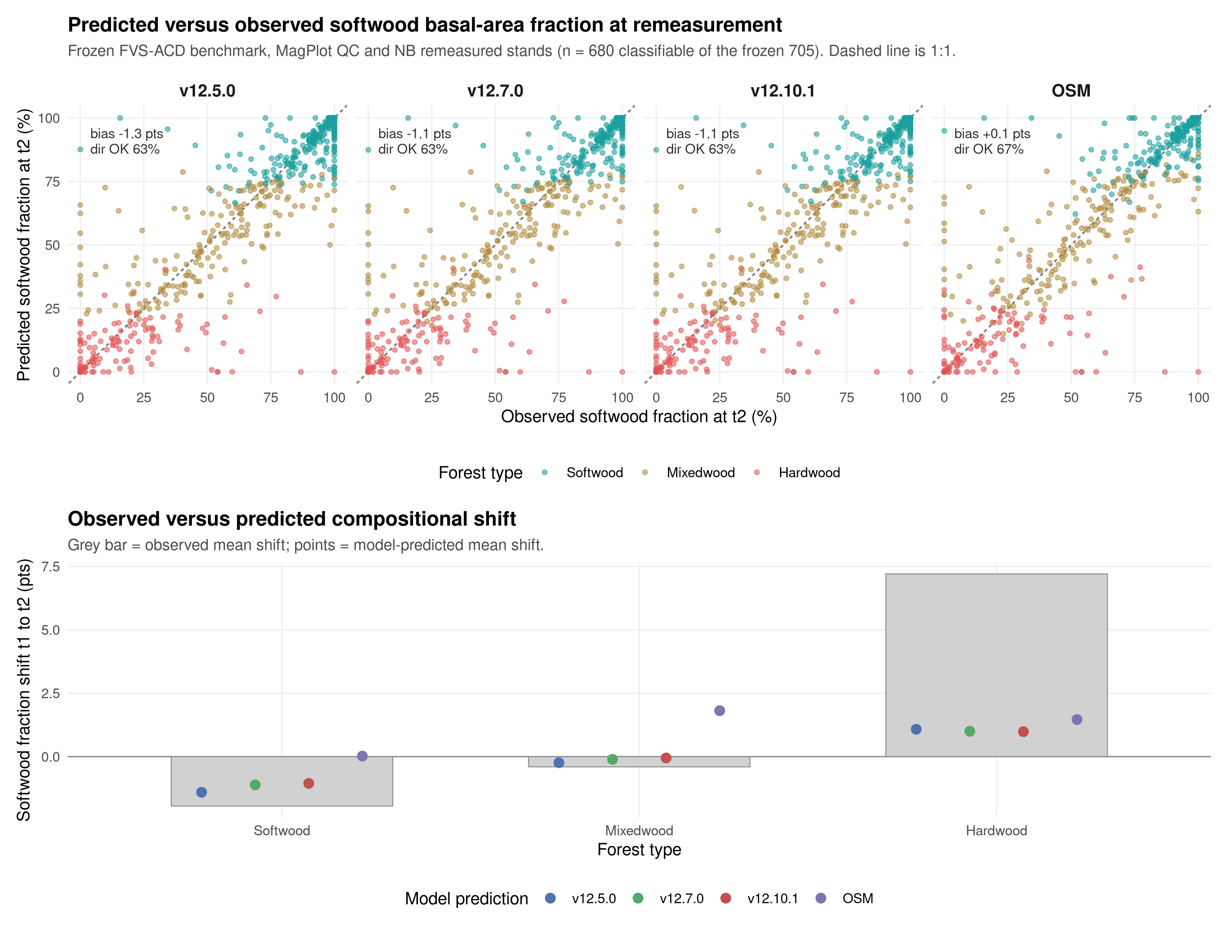
Figure 9. Predicted versus observed softwood basal-area fraction at the remeasurement endpoint (t2) by model, with the 1:1 line (top), and the observed versus predicted mean compositional shift from t1 to t2 by forest type (bottom). Points are colored by committed forest type. Frozen benchmark, MagPlot QC and NB remeasured stands.
Stand composition is nearly stationary across the interval: the pooled mean softwood fraction moves less than one point (59.9% to 60.7%), and the only large observed signal is a +7.2 pt softwood gain in hardwood-dominated stands, partly offset by a -1.9 pt softwood loss in softwood stands. All three FVS-ACD models reproduce the direction of change within softwood and mixedwood stands but under-shift by roughly a third to a half, and they miss the pooled net direction, predicting a small softwood decline (-0.3 to -0.5 pt) against the observed +0.8 pt increase, because they under-represent softwood in-migration into hardwood stands (predicted about +1.0 pt versus observed +7.2 pt, bias near -6 pts). OSM best tracks the pooled net shift (+0.9 pt, ratio 1.08) but overshoots softwood in mixedwood and softwood stands; the spruce-fir split tells the same story, with the observed +7.0 pt spruce-fir gain in hardwood stands under-predicted by every model. Every model holds stand-level softwood fraction within about 1 to 2 pts of observed in softwood and mixedwood types, so overall composition is preserved and the shared weakness is the rate of softwood recolonization of hardwood-dominated stands.

Management class, the headline
In-sample level bias (percent), the cells the modifier targets:
class | n | metric | v12.9.x | v12.10.1 | OSM
NONE | 266 | basal area | -9.9 | -9.9 | -2.0
NONE | 266 | total volume | -5.3 | -5.3 | -1.6
PLANTED | 51 | basal area | -24.9 | -4.4 | -20.9
PLANTED | 51 | total volume | -23.7 | -10.8 | -19.7
PCT | 95 | basal area | -15.6 | -1.3 | -5.4
PCT | 95 | total volume | -11.3 | -2.0 | -0.1
MANAGED | 146 | basal area | -19.0 | -2.5 | -11.2
MANAGED | 146 | total volume | -15.9 | -5.3 | -7.4
The unmanaged cell is byte identical between v12.9.x and v12.10.1, which confirms the gate. The gate closes the managed basal-area gap sharply, with planted basal area moving from -24.9 to -4.4, PCT from -15.6 to -1.3, and pooled managed from -19.0 to -2.5 percent. On absolute basal-area bias v12.10.1 beats OSM in every managed class: managed 2.5 versus OSM 11.2, planted 4.4 versus 20.9, and PCT 1.3 versus 5.4. The PCT basal-area residual the red team deferred is closed by the additive form (-1.3 versus OSM -5.4). One frozen-basis shift should be flagged on the volume side. Gate-on planted total volume is -10.8 instead of near zero, because the frozen afac lowers untreated planted-stand volume so the fixed additive release closes less of the volume gap. The basal-area releases are unchanged.
The out-of-sample result is the one that carries the most weight. Mean absolute level bias across the nine metrics under leave one installation out cross validation, with the MagPlot installation as the fold unit:
class | n | v12.9.x | v12.10.1 | OSM
PLANTED | 51 | 19.3 | 4.0 | 16.7
PCT | 95 | 10.4 | 1.5 | 3.7
MANAGED | 146 | 13.2 | 0.9 | 8.3
Under the harsher leave one province out block, managed is 0.9, planted 5.7 versus OSM 16.7, and PCT 3.8 versus OSM 3.7, close but marginally behind across the border. Under a managed split half over 200 reps v12.10.1 averages 5.2 and beats OSM in 79 percent of reps and v12.9.x in 92 percent. The additive fold coefficients are stable across folds (planted basal-area release 3.85 to 4.40, PCT 2.45 to 2.76), unlike the clamped multiplier that pinned at 1.6 in every fold. The direct-effect release follows Chapter 11 of Weiskittel, Hann, Kershaw and Vanclay (2011). The multi-step method of Wang (1990) holds the untreated equations fixed and fits the modifier on observed minus predicted-untreated increment, with planted treated as a Type 2 sustained effect and PCT as a Type 1 transient release. Mortality is deliberately left without a multiplicative modifier to avoid distorting the logistic asymptote. One caveat travels with these out-of-sample managed and planted results. They rest on thin planted and precommercial-thinning samples, and the leave-one-province-out transfer across the New Brunswick to Quebec border leans on a small number of managed installations per province, which is the gap the v13 provincial managed-remeasurement data ask is meant to close.

Biological realism and long-horizon behavior
Bakuzis relations on the modified Bakuzis matrix, each scored against the named law-like relations. The AcadianGY builds are scored from seeded 160-year projections across an ESI productivity gradient (ESI 12, 16, and 20 seeded to age 160). OSM cannot be seeded on that synthetic gradient, so it is projected 160 years over a real-stand productivity gradient, the 73 benchmark stands binned into low, mid, and high terciles on OSM's own site-index height, and scored on all five relations from that run:
relation | v12.5.0 | v12.7.0 | v12.9.x | v12.10.1 | OSM
Eichhorn (V ~ f height) | pass | pass | pass | pass | flag
Reineke slope (target -1.6) | flag | pass (-1.8) | pass (-1.59) | pass (-1.59) | pass (-1.56)
Site ordering (no overtaking) | pass | pass | pass | pass | flag
Yield-density / plateau | flag | pass (37) | pass (36) | pass (36) | pass (36)
Sukachev (size vs density) | flag | pass | pass | pass | pass
v12.10.1 inherits the v12.9.x self-thinning machinery and passes all five relations on the seeded gradient. OSM is now scored on all five as well, from a 160-year projection over a real-stand productivity gradient, since it cannot be seeded on the synthetic ESI gradient. The 73 benchmark stands are binned into low, mid, and high terciles on OSM's own site-index height, the real-stand analog of the seeded ESI gradient, and the per-site trajectories are scored with the same relation definitions used for the AcadianGY battery.
Over the near-term horizon, to about age 60, OSM over-accumulates basal area relative to FVS-ACD, which self-thins earlier. Over the full 160-year horizon, however, OSM does eventually plateau and self-thin: its mid-site basal area peaks near 36 m² ha⁻¹ and levels to about 35 m² ha⁻¹, and its density frontier follows a Reineke slope of about -1.56, so OSM passes both the yield-density plateau and Reineke self-thinning, and it passes Sukachev. It flags the two cross-site relations, Eichhorn (cross-site coefficient of variation of volume at matched height about 26 percent) and site ordering, and both flags are sensitive to the real-stand substitution: OSM trajectories run on a projection-year axis from heterogeneous real starting conditions rather than an age-aligned bare-ground gradient, so the cross-site tests read on unequal starting ages. That caveat is reported plainly and it qualifies both cross-site flags. The biological-realism separation between OSM and the v12.7.1 and later builds is therefore not that OSM never plateaus, but that FVS-ACD self-thins earlier and more consistently and holds cleaner cross-site behavior on the seeded gradient. Figure 3 carries the full matrix with the OSM column. With the management modifier on, a seeded 160-year projection of a planted softwood stand still plateaus at every amplitude tested (standard deviation of basal area over the last 20 years about 0.21 m² ha⁻¹, flat), and the ceiling rises smoothly with amplitude (36.3, 41.6, 43.6, 45.6, 47.3 m² ha⁻¹ at amplitudes 1.0, 1.6, 2.0, 2.5, 3.0) because basal area at the Reineke limit rises with tree size. The operational engine amplitude is set to 2.0. The modifier accelerates the approach and lifts the ceiling to a productive planted-conifer level without breaking self-thinning. v12.5.0 still fails self-thinning outright, running to 62 to 65 m² ha⁻¹ with thousands of stems still alive. On the matched-stand test, over the near-term horizon OSM over-accumulates relative to FVS-ACD. On the same nine Seven Islands stands from an identical start (FVS-ACD 31.4, OSM 31.9 m² ha⁻¹ at year 0), FVS-ACD peaks near 33 m² ha⁻¹ by age 10 to 20 and self-thins to 27 by age 60, while OSM reaches about 42 m² ha⁻¹ at age 60, a 35 percent divergence at that age in the mortality and self-thinning timing. Over the longer horizon OSM does plateau and self-thin, so the age-60 snapshot captures the timing difference, that FVS-ACD self-thins earlier and more consistently, not a permanent divergence.

v13 roadmap
v13 is the fall arc. It is in progress, not gated, and appears here as roadmap only. No v13 scorecard numbers exist yet and none are reported.
v13.0 was a joint dominant-height and basal-area re-anchor aimed at the pooled offset. The shipped v12.10.1 is under on volume by about 4 percent through a partial error cancellation, a top-height over-prediction of about +4 percent set against a basal-area under-prediction of about -10 percent, and correcting either anchor alone drives volume further off rather than to parity. A one-sided top-height correction tested earlier pushed pooled total volume further negative while collapsing Quebec modeling efficiency to 0.134. This cycle a narrow height re-anchor fix was run as a blend sweep across weights 0.50 to 1.00, and every setting in the sweep parked: none reached pooled parity without reopening the offset, so the v13.0 height path is exhausted for now and stays parked. The basal-area increment anchor, individually unbiased in the Maine, New Hampshire, and Vermont domain (basal-area increment ratio 1.00 on 13,894 remeasurement pairs), is validated and retained for the v13.1 cycle. The shipped v12.10.1 stays the frozen August operational baseline.
v13.1 is a hierarchical mortality and ingrowth refit. It targets the composition-driven hardwood over-prediction that every model shares and the ingrowth under-prediction documented below, moving the management effect from a bounded engine amplitude into the fit as a predictor, and it now carries the retained basal-area increment correction from the v13.0 cycle. The refit is running on the cluster with convergence pending; no v13.1 scorecard numbers exist yet.

Honest limits
Three limits are stated plainly and carried on the biological-realism slide.
Pooled precision belongs to OSM on the operational domain. OSM leads pooled mean absolute bias (3.2 versus 4.9), mean modeling efficiency (0.75 versus 0.71), and holds the most TOST equivalences (8 of 9). The FVS-ACD in-domain near-parity on volume is an offsetting cancellation of a basal-area under-prediction and a top-height over-prediction, not independent accuracy on each component. This is an equation-level limit and the v13.0 joint re-anchor target, and it cannot be closed by an anchor scale on one side. The pooled precision gaps here are small relative to the stand-level RMSE and are reported without a formal paired difference test or a multiplicity adjustment across the nine correlated NSVB metrics, so they should be read as OSM modestly ahead on the pooled domain rather than as a decisive, individually significant gap on any one metric.
Ingrowth is under-predicted. Recruitment across the tag threshold is a disclosed limit, not a scored win. The direction is correct but the absolute level is low:
province | class | predicted (stems ha⁻¹ yr⁻¹) | observed (stems ha⁻¹ yr⁻¹) | ratio
New Brunswick | all | 17.9 | 39.8 | 0.45
New Brunswick | unmanaged | 16.2
New Brunswick | PCT | 19.5
New Brunswick | planted | 21.5
Quebec | all | 11.7 | 19.7 | 0.59
Quebec | unmanaged | 10.6
Quebec | PCT | 14.5
Quebec | planted | 15.9
This is a real, moderate under-prediction, about 45 percent of observed in New Brunswick and 59 percent in Quebec. It is not the 2018 near-zero recruitment failure, and it is not an inflated recruitment. Recruitment responds in the correct direction to density and management, since planted and PCT stands carry lower residual density and recruit more than unmanaged stands, so the density-released ingrowth term behaves as intended and the additive management release does not distort recruitment. It is an equation-level limit and a v13.1 target.
PCT parity with OSM is a within-core result. It holds under the province block at 4.1 versus OSM 3.7, close but marginally behind across the New Brunswick to Quebec border, so the conservative call keeps the Quebec edge out of domain. The Quebec pooled and top-height figures carry that out-of-domain edge. At the Quebec edge ESI over-reads height productivity, with ESI still reading 18 to 19 and implying an asymptote near 36 m while the stands top out near 22 m and are not growing. This is a site-metric mismatch that no model fit on in-domain data can reproduce, which is why the boundary is declared rather than scored as a failure.

Figures
Figures are rendered separately through advanced-viz and are not generated in this report. The report should carry the following four to six.
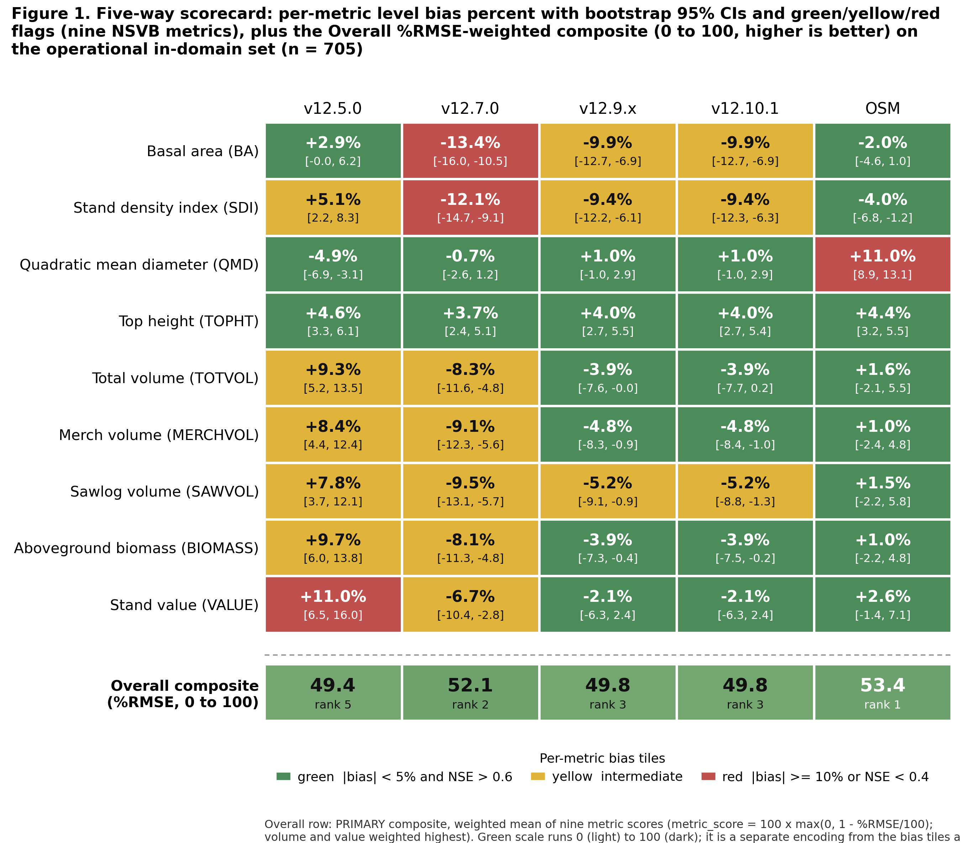
Figure 1. Five-way scorecard heatmap of level bias and modeling efficiency across the nine NSVB metrics for v12.5.0, v12.7.0, v12.9.x, v12.10.1, and OSM v2.26.1 on the pooled in-domain set, with an added Overall composite strip beneath the per-metric bias tiles showing each model's %RMSE-weighted composite (0 to 100) on its own scale, separated from the bias-flag tiles.
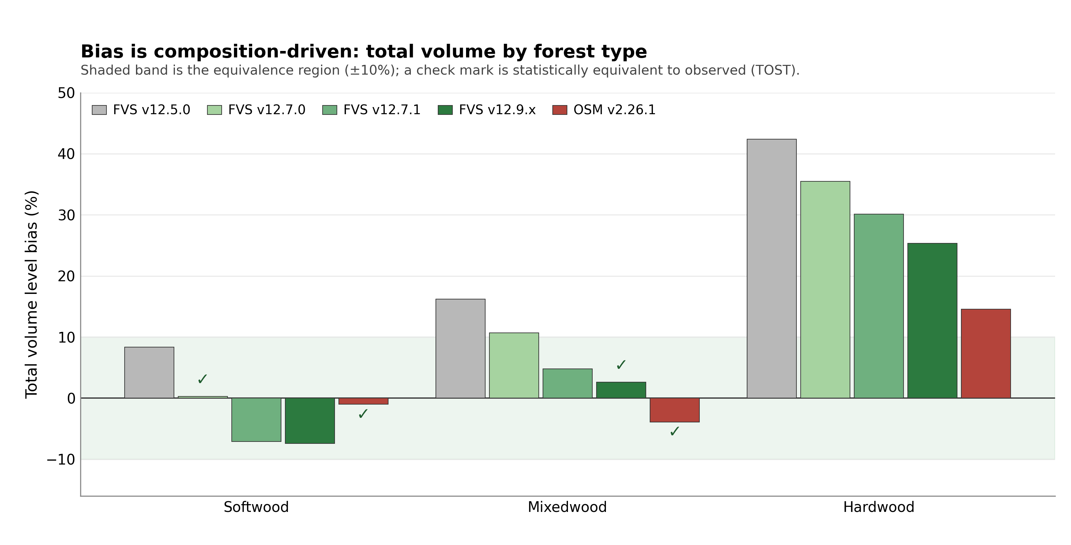
Figure 2. Total volume level bias by forest type (softwood, mixedwood, hardwood) for the five models, showing the composition-driven hardwood frontier shared by every model.
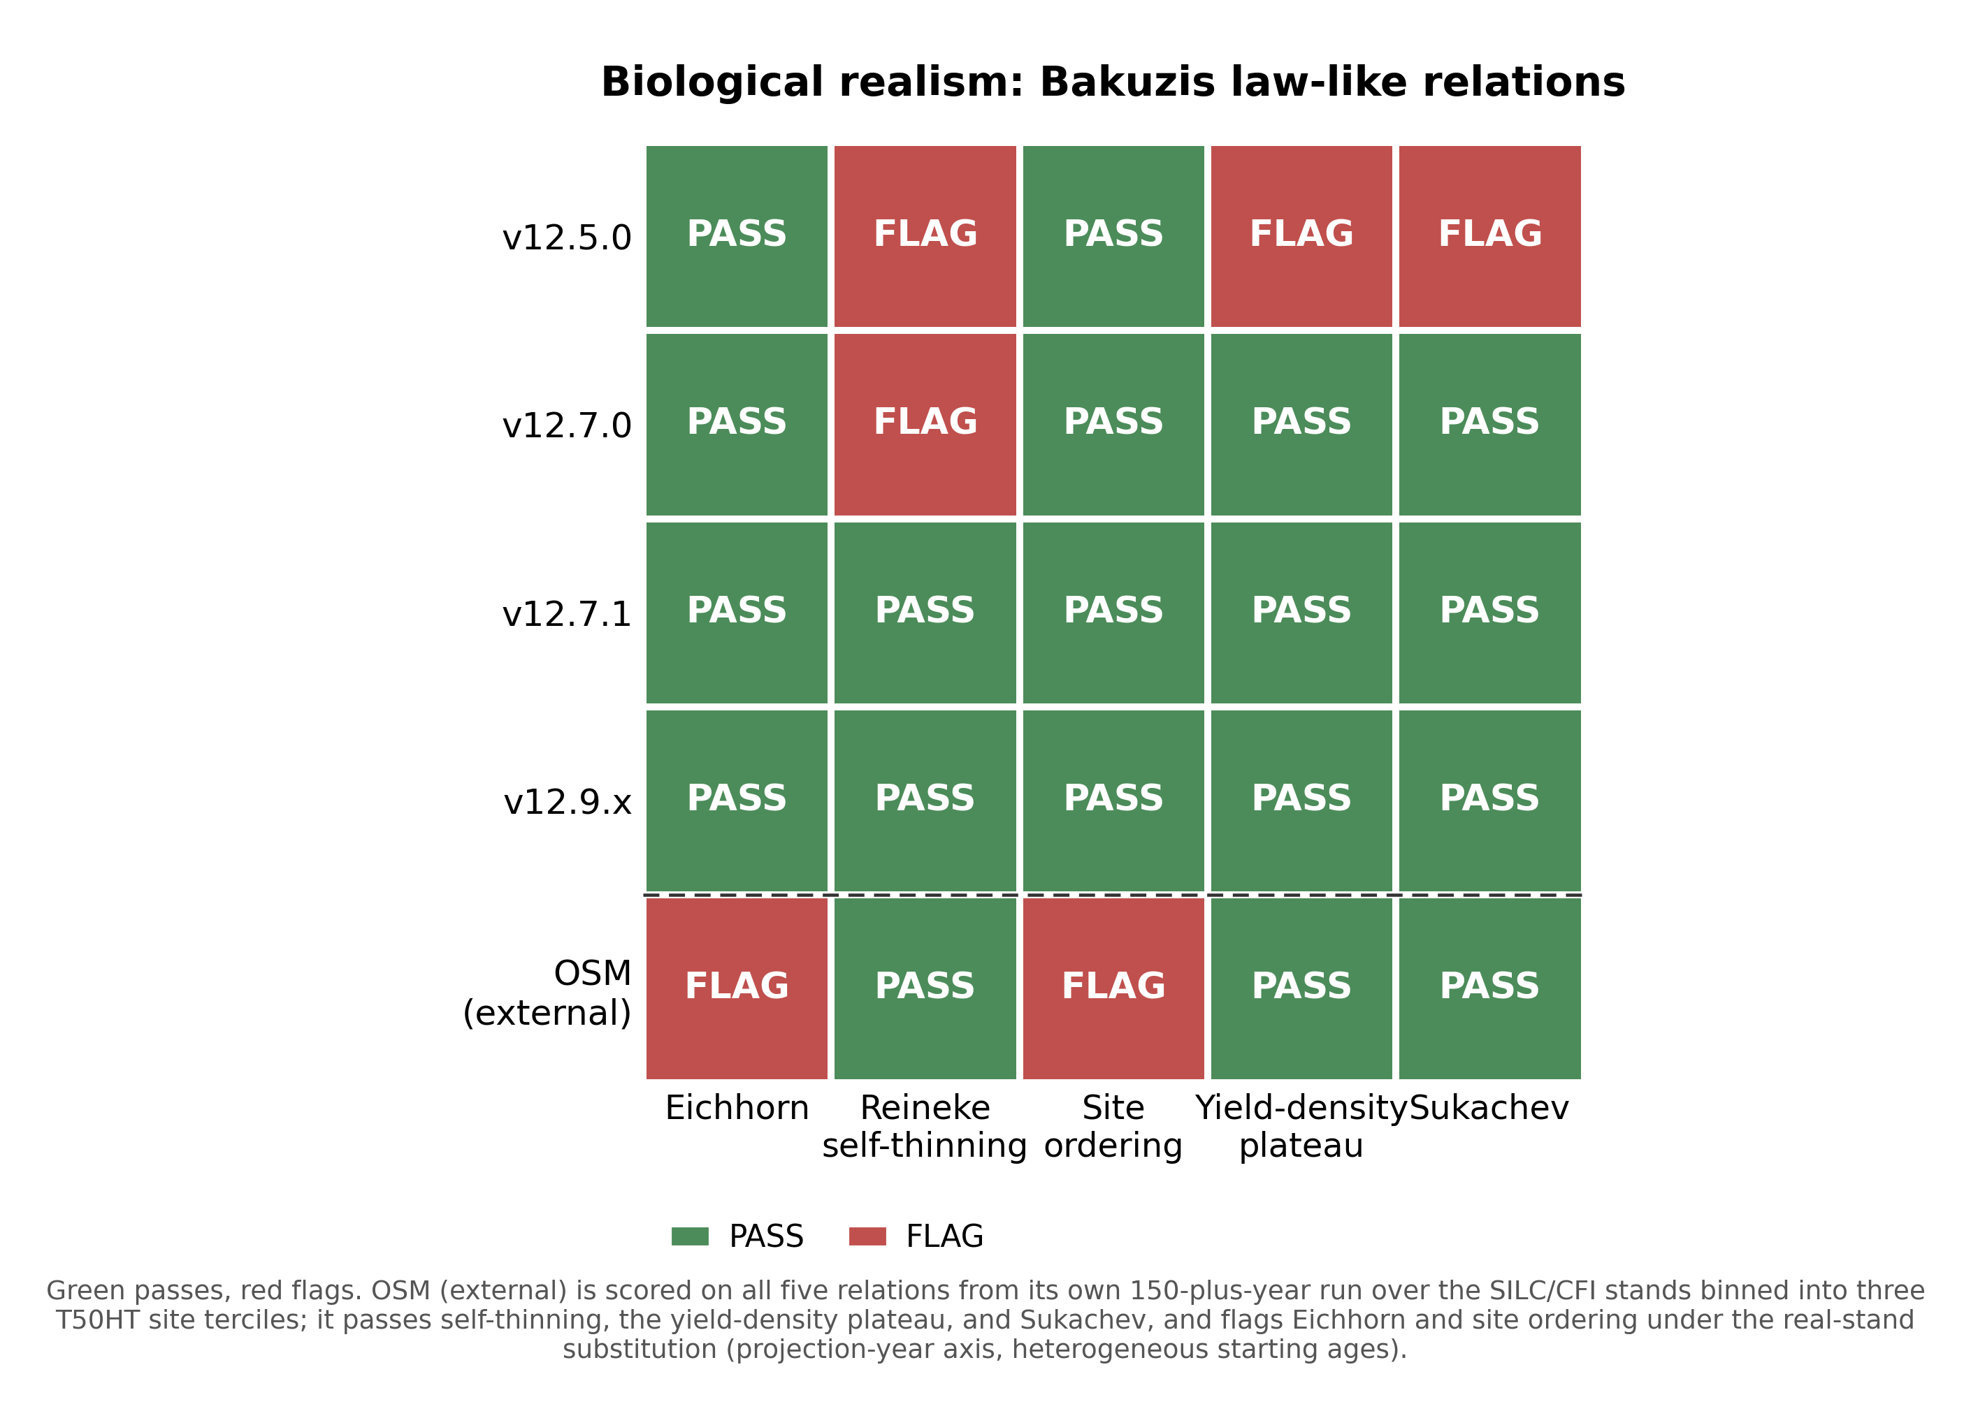
Figure 3. Bakuzis relations pass and flag matrix by model, the five law-like relations against the five entrants.
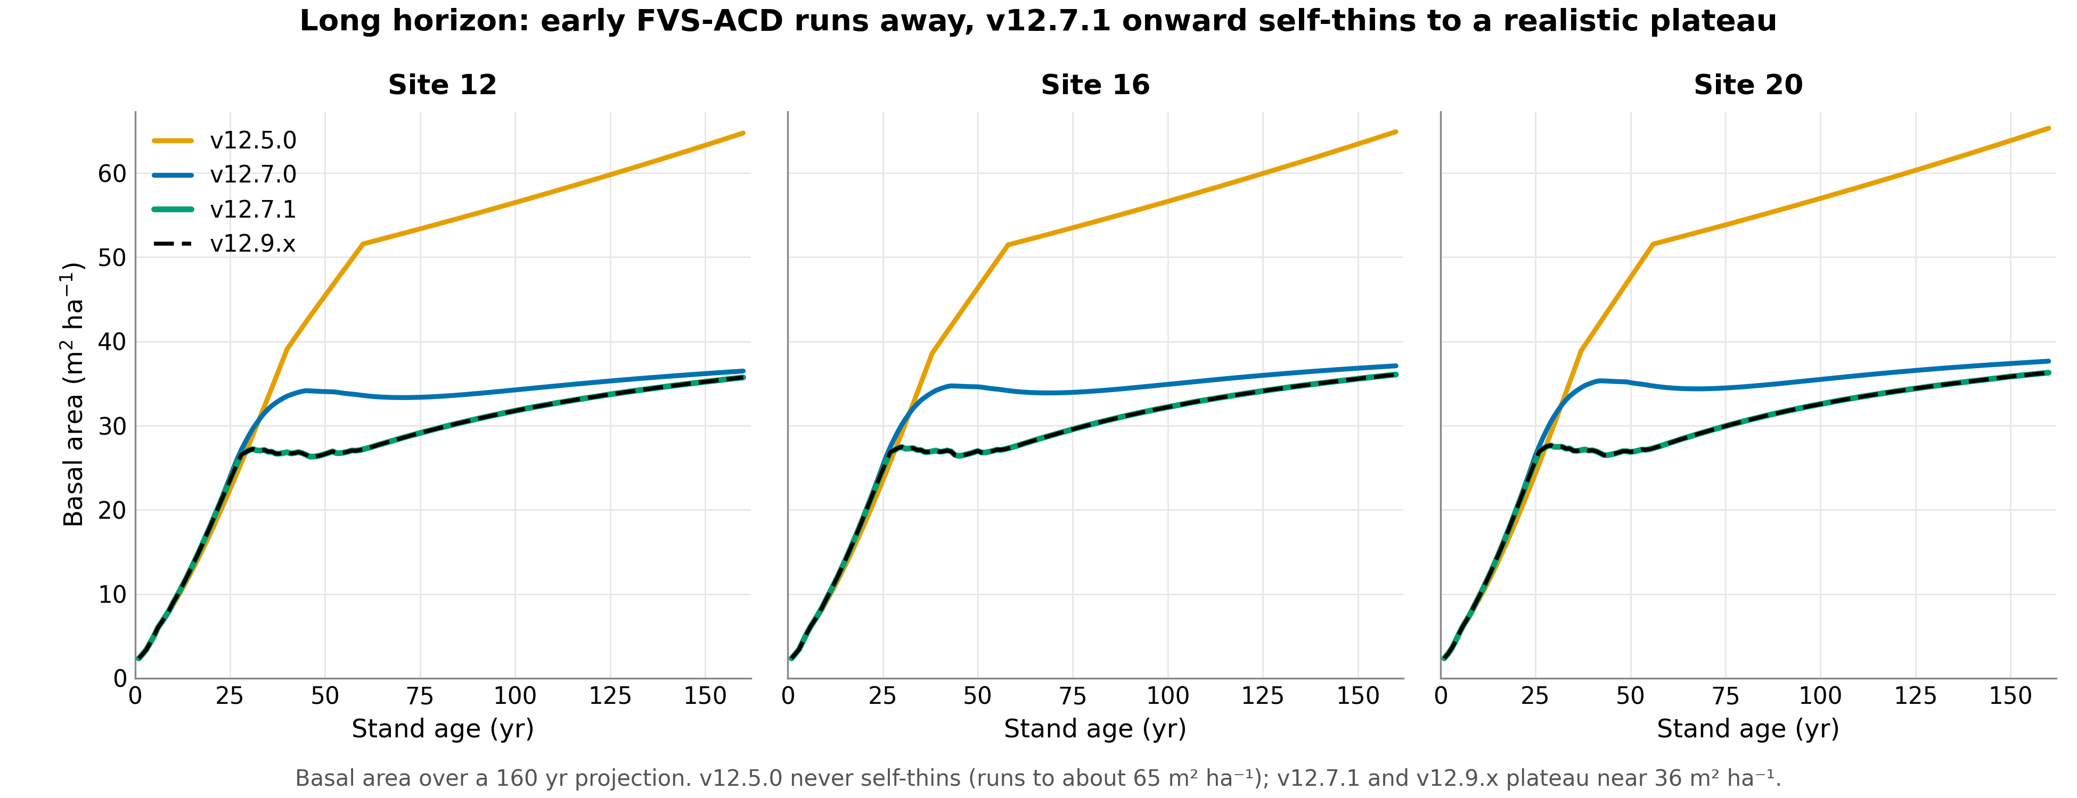
Figure 4. Self-thinning trajectories on matched Seven Islands stands over the first 60 years from an identical start, FVS-ACD plateauing and declining by age 60 while OSM is still accumulating. OSM plateaus and self-thins later over the full horizon, so the age-60 snapshot shows the timing difference, that FVS-ACD self-thins earlier and more consistently, rather than a permanent divergence.
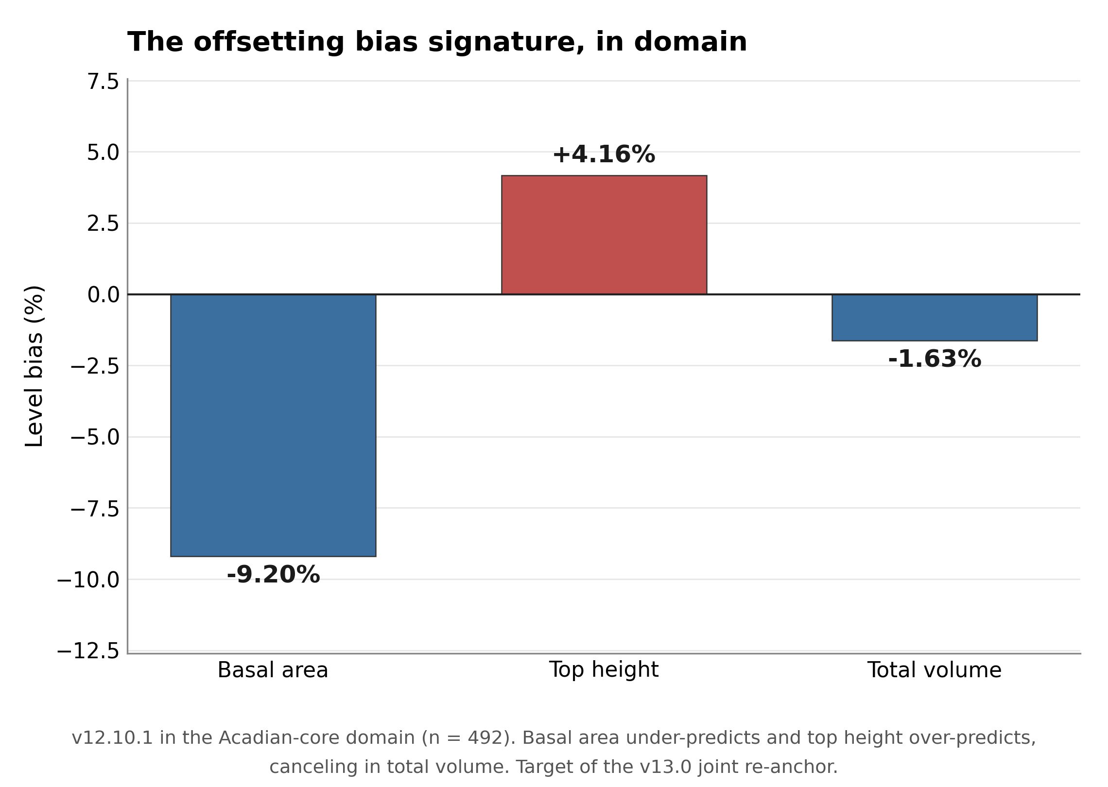
Figure 5. The offsetting bias signature in domain, basal area about -9 percent under and top height about +4 percent over canceling to total volume about -1.6 percent.
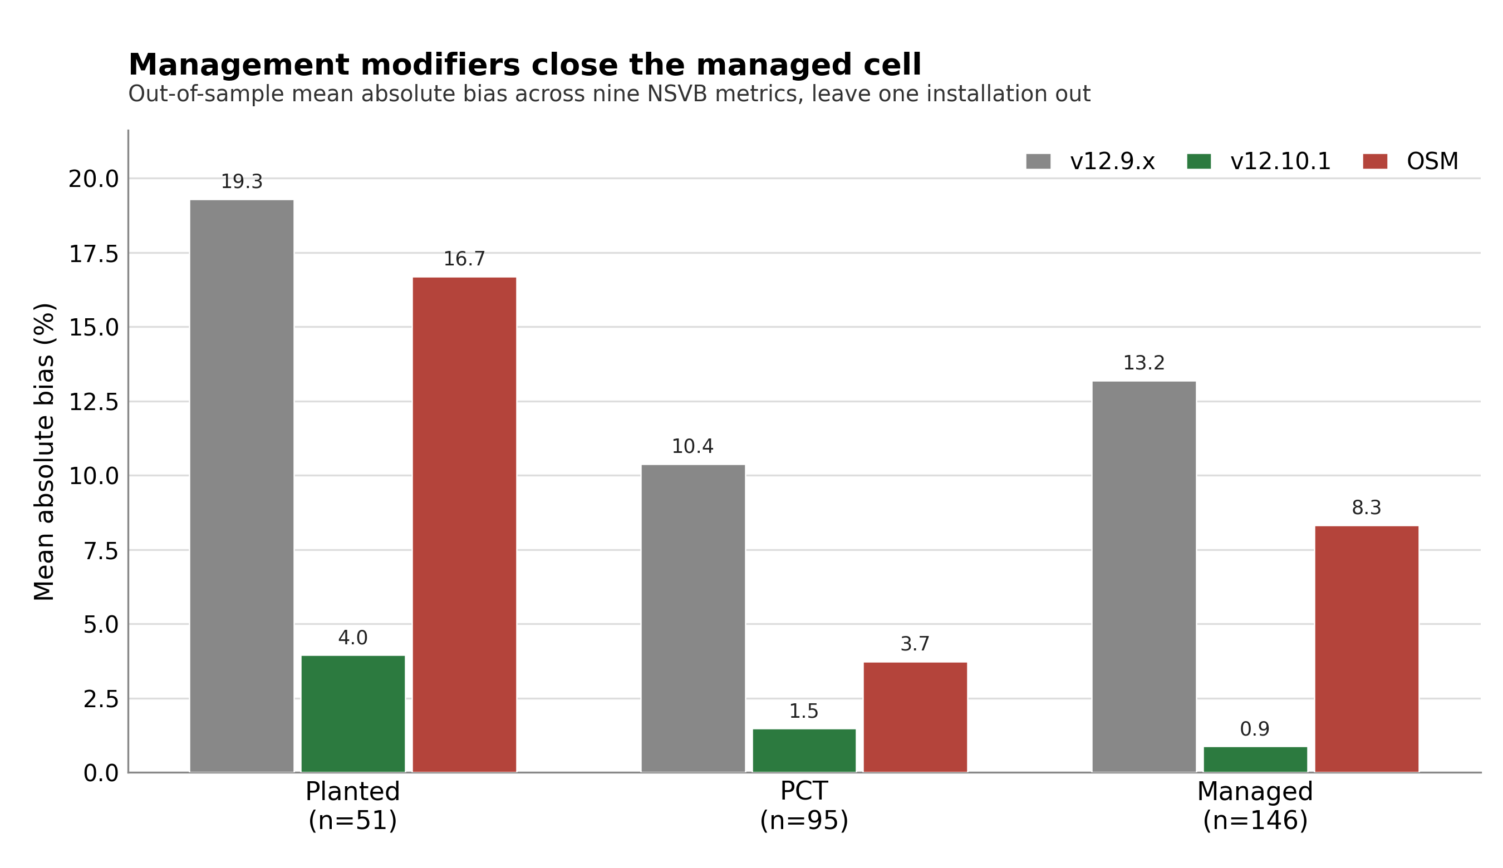
Figure 6. Managed-cell out-of-sample mean absolute bias by management class under leave one installation out, v12.9.x, v12.10.1, and OSM for planted, PCT, and managed.
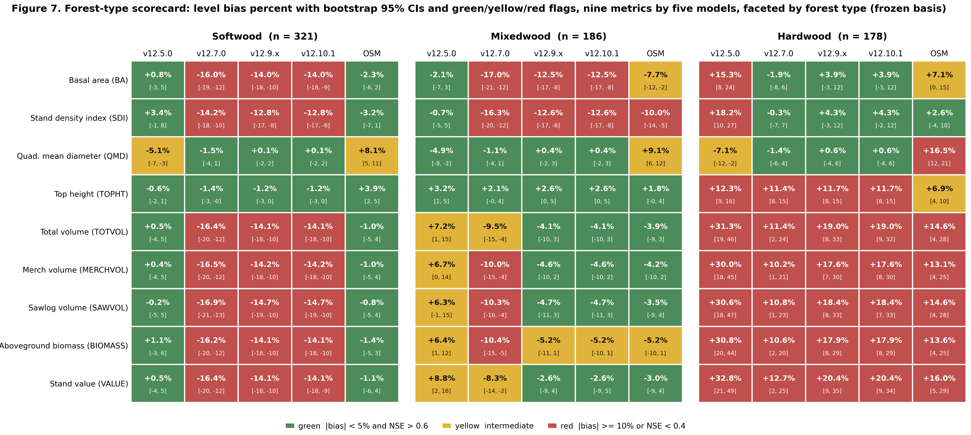
Figure 7. Forest-type scorecard, level bias percent with bootstrap 95 percent CIs and green, yellow, and red flags, nine metrics by five models faceted by forest type (softwood n = 321, mixedwood n = 186, hardwood n = 178) on the frozen basis.
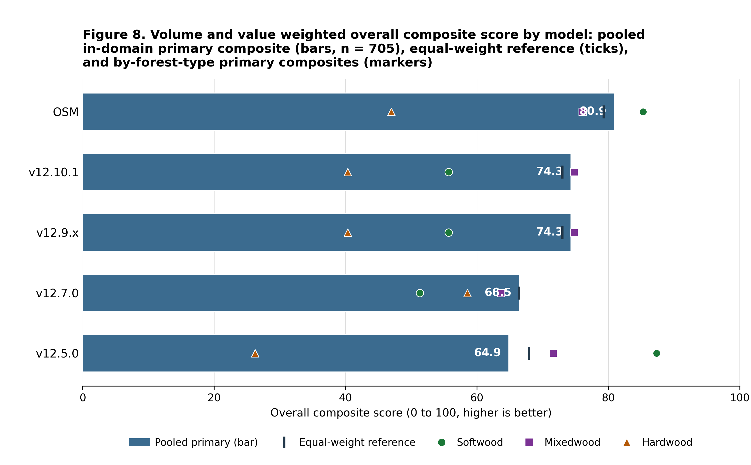
Figure 8. Volume and value weighted overall composite score by model, the pooled in-domain primary composite (total volume and value weighted highest) as ranked bars, the equal-weight composite as a reference tick on each bar, and the by-forest-type primary composites overlaid as markers.
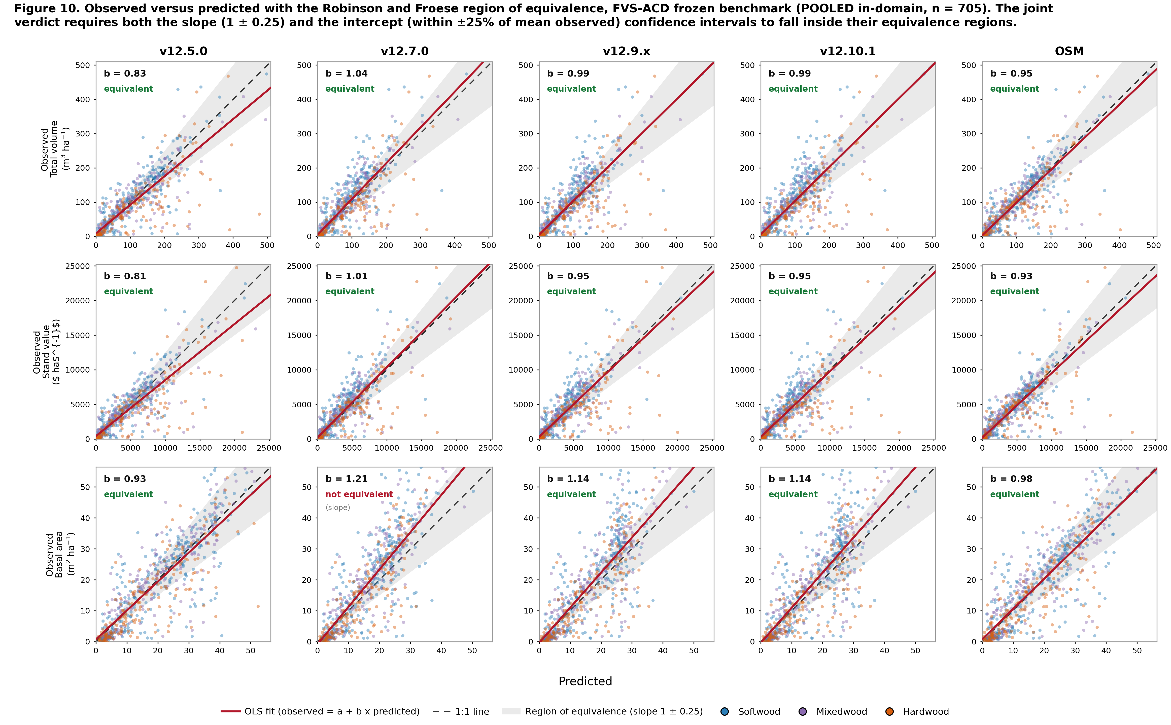
Figure 10. Observed-versus-predicted equivalence plot, faceted with total volume, value, and basal area as rows and the five models as columns. Each panel shows the per-stand cloud coloured by forest type, the 1:1 line, the OLS fit, and the shaded Robinson-Froese region of equivalence, annotated with the slope b and the joint verdict. Pooled in-domain set (n = 705).
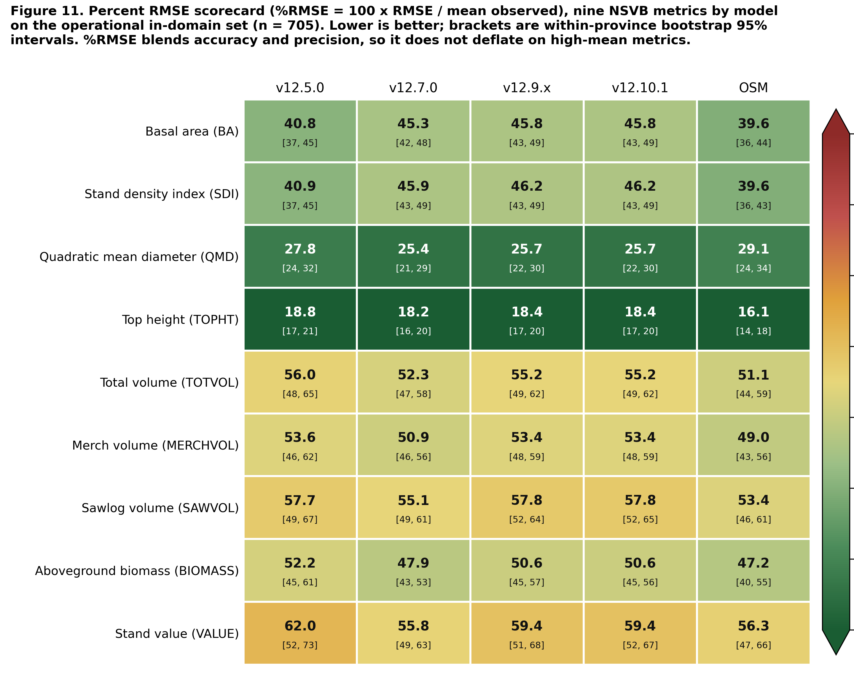
Figure 11. Percent RMSE scorecard, the model by metric heatmap of %RMSE across the nine NSVB metrics for the five models on the pooled in-domain set, with within-province bootstrap intervals in each cell.
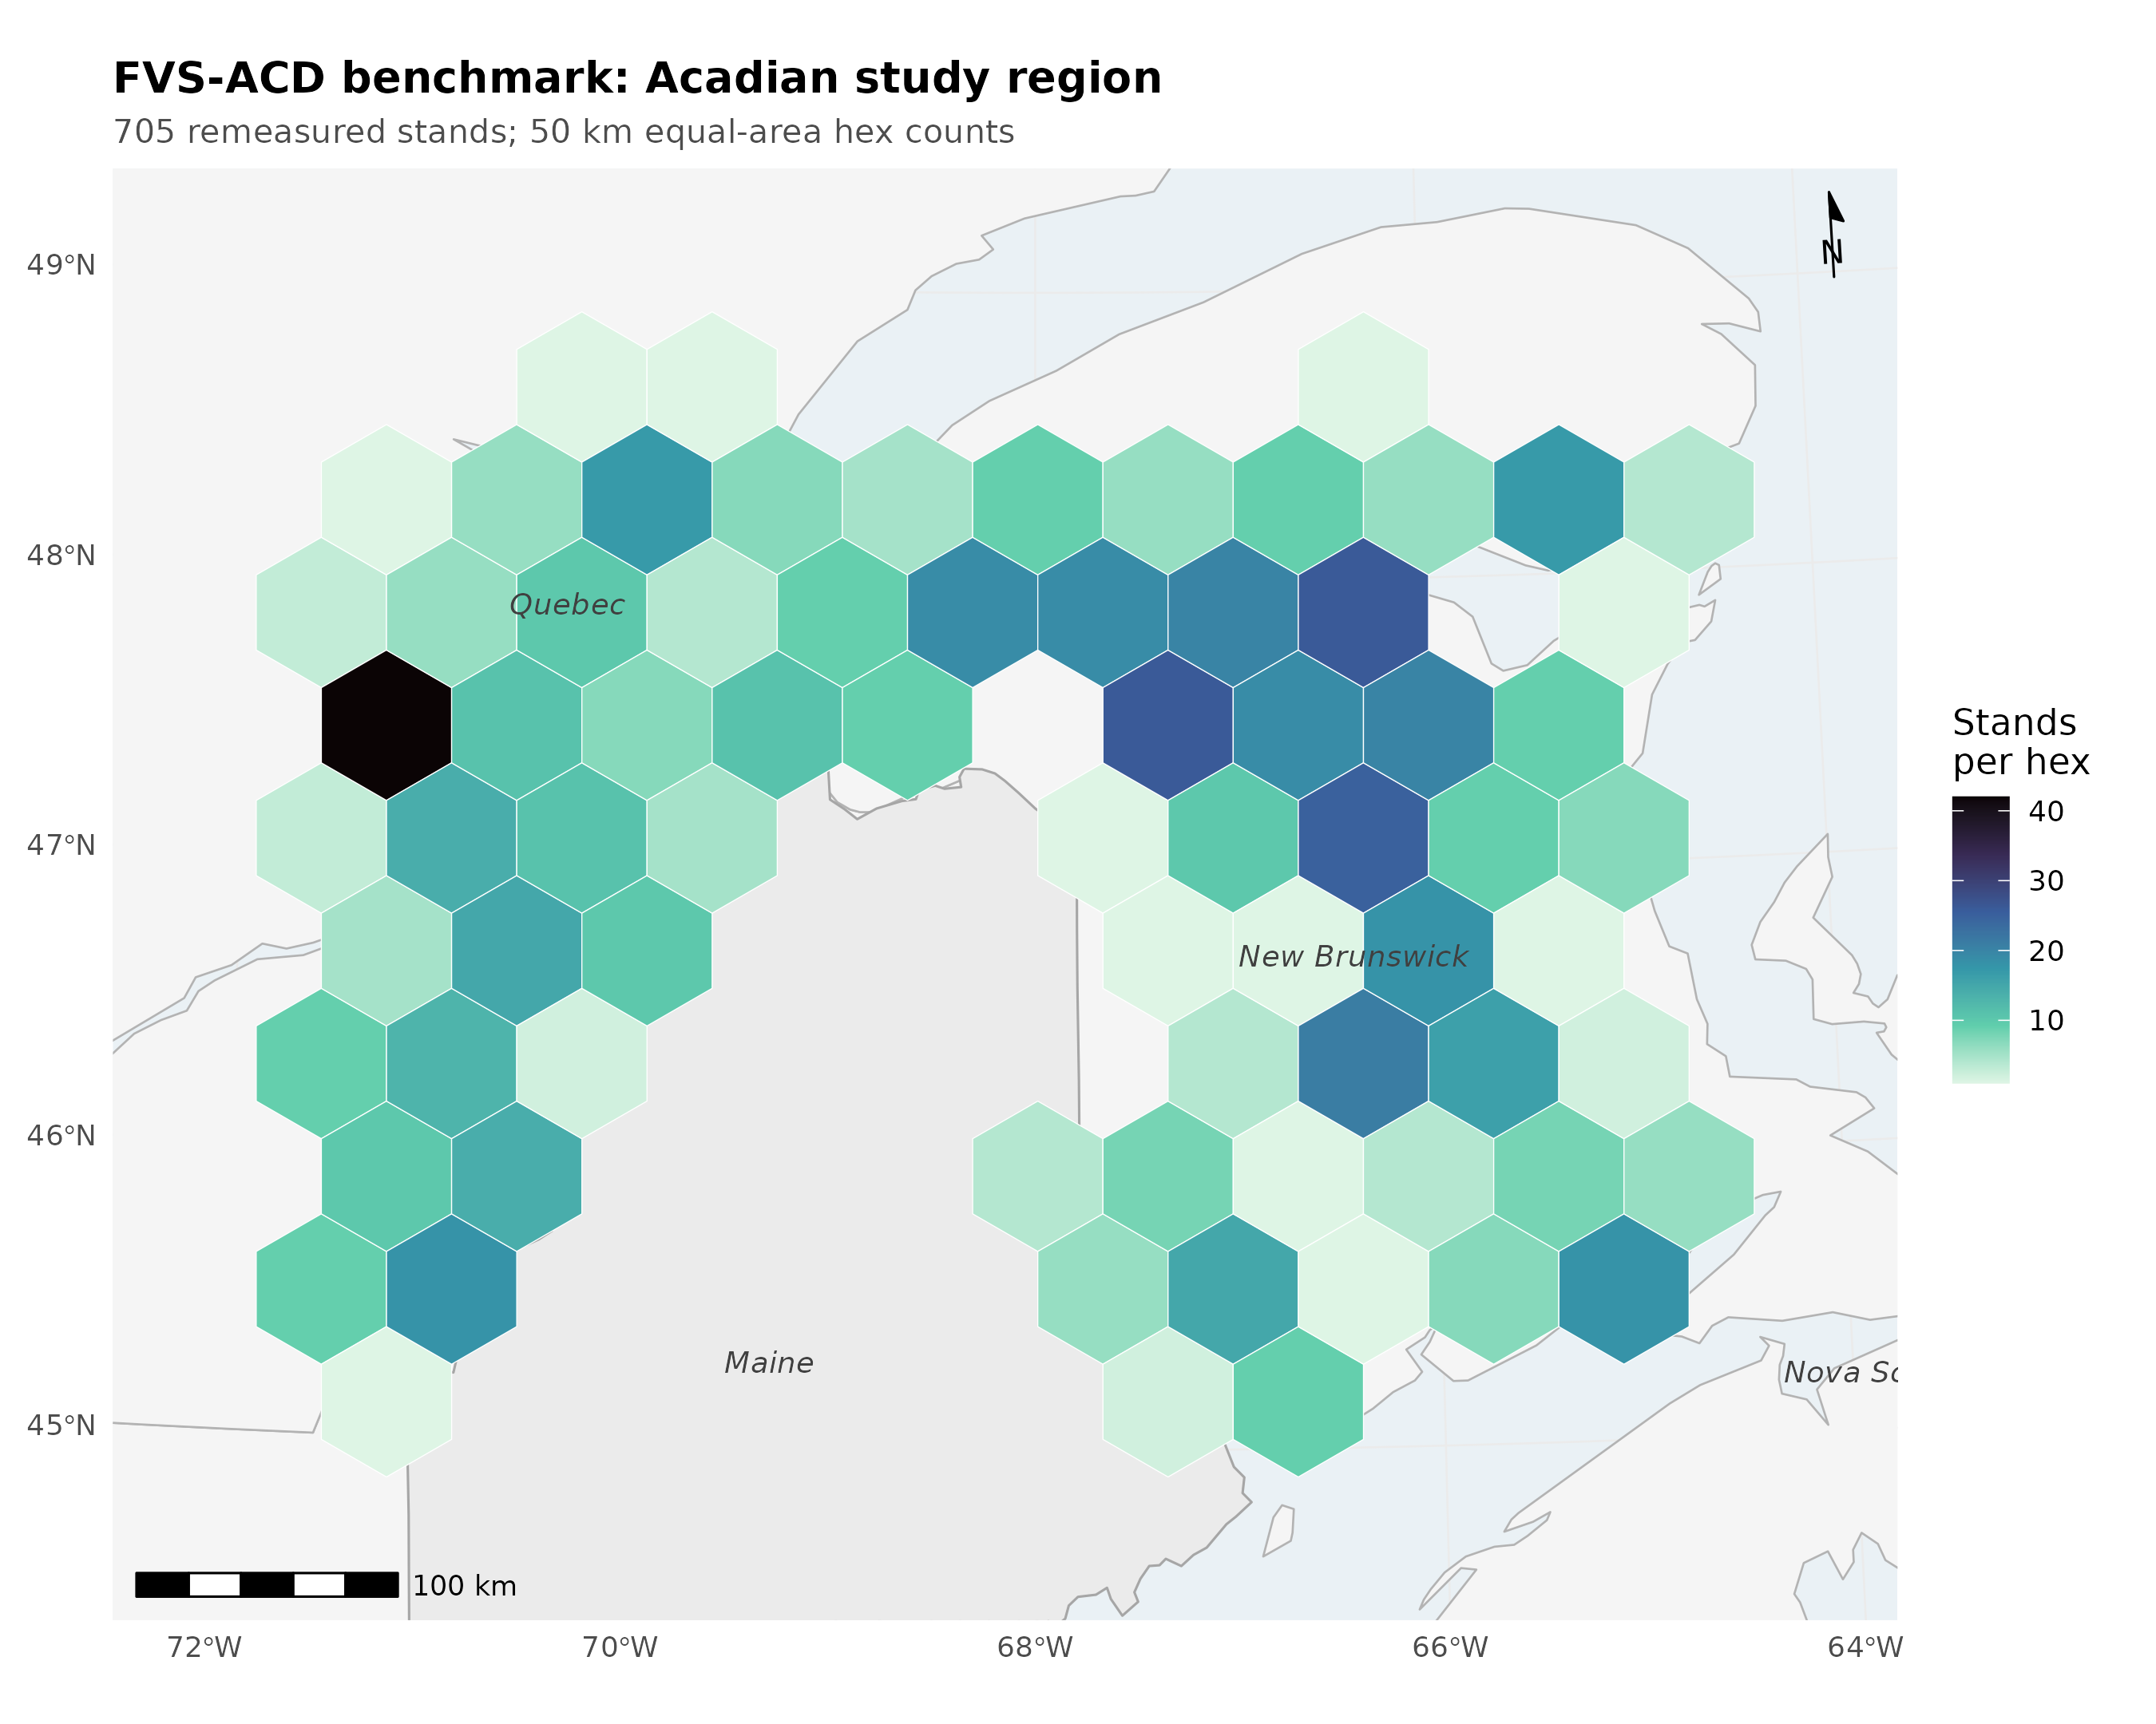
Figure 12. Locator of the Acadian study region with benchmark stand counts aggregated on a 50 km equal-area hex grid (New Brunswick n = 355, Quebec n = 350; true plot coordinates never released).
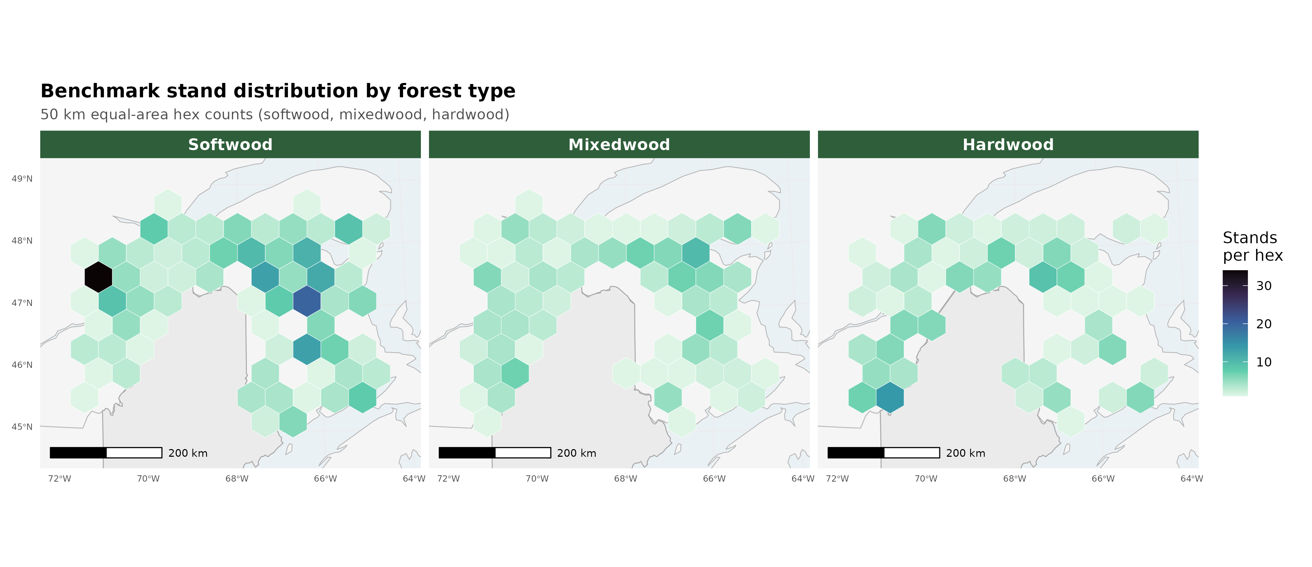
Figure 13. Benchmark stand counts on the same 50 km hex grid split into softwood (n = 321), mixedwood (n = 186), and hardwood (n = 178) panels.

Methods and provenance
Scoring used the corrected single-keyed-merge scorer, one wide table keyed by stand and deduplicated on both sides, with a per-model observed-on-predicted correlation as the alignment check. The earlier negative-modeling-efficiency artifact on OSM was an index-join misalignment and is resolved. Volume, biomass, and value are on the shared FIA NSVB emulator (log of gross variable on log of squared diameter times height by species group with Duan smearing), which carries about zero aggregate bias against raw FIA NSVB and so does not advantage any model. Equivalence testing follows Schuirmann TOST and Robinson and Froese (2004): a region of plus or minus 10 percent of the observed mean for level metrics and plus or minus 25 percent for increment, with equivalence declared when the 90 percent confidence interval of the mean paired difference lies inside the region. OSM is v2.26.1, dated 12 May 2026, confirmed as the latest release.
One data-provenance caveat should be noted. The scorecard baseline cb_v12102 was generated from AcadianGY_12.9.2.r plus the operational ops recipe. A standalone AcadianGY_12.10.1.r file exists but does not reproduce cb_v12102 exactly, so the canonical operational definition of v12.10.1 is the 12.9.2 model plus the recorded recipe, pending a file reconciliation.
Cardinal locations. Scorecard and cross-validation code under ~/magplot/verify: scorecard_v1210.R (five-way single-keyed-merge scorer), scorecard_clean.R (base scorer), scripts/v12101_domain_scorecard.R (7 July operational-domain recompute), mgmt_cv_robust.R and mgmt_finalfit.R (additive release and out-of-sample battery), bakuzis_allmodels.R (Bakuzis relations), and mgmt_plateau_sweep.R (plateau and gate-off identity). Inputs Wfull.rds (705 keyed table across five models and nine metrics), the per-stand cb result files, osm_h2h_metrics.csv, magp_qcnb_ecol3_v2.csv (ecoregion join keyed by stand and province), and the mgmt_scorecard and mgmt_gap_closure robust outputs. The OSM matched-stand long-horizon evidence is in ~/silc_cfi (osm_match_run.py, osm_pair3.R, fvsacd_vs_osm_matched.csv). True plot coordinates never left the node; only aggregates appear in this report.

