FVS-ACD v12.10.1 benchmark report
Finalized 10 July 2026 for the 18 August 2026 Acadian Growth and Yield meeting with Chris Hennigar. This report consolidates the v12.10.1 full independent five-way benchmark, the operational-domain re-scoring, the five-way scorecard with equivalence testing and Bakuzis relations, the Chapter 11 management-modifier scorecard, and the OSM matched-stand comparison into a single record. All computation ran on Cardinal (~/magplot/verify and ~/silc_cfi); only aggregates appear here and true plot coordinates never left the node. Plaintext math, no em dashes. Volume, biomass, and value are on the shared FIA NSVB system throughout.

Verdict up front
FVS-ACD v12.10.1 is the frozen August operational baseline. It couples the v12.9.x base (FIA NSVB volume and biomass, coupled two-segment relative-density mortality with density-released ingrowth, composition- and ecoregion-aware brms SDImax, and the ESI-consistent dominant-height anchor recalibration) with the Chapter 11 direct-effect management modifiers: a robust additive release fitted at planted +3.8 and PCT +2.4 m² ha⁻¹ basal area, clamp-free and gated off by default.
On the operational inventory domain OSM v2.26.1 and FVS-ACD are close, and on the pooled cell OSM is the stronger model. OSM leads pooled mean absolute level bias about 3.2 versus 4.9 percent, mean modeling efficiency about 0.75 versus 0.71, and holds the most TOST level equivalences (8 of 9). FVS-ACD does not lead on pooled precision. Its advantages are elsewhere: the frozen build plateaus at the realistic maximum and passes all five Bakuzis relations in the seeded-gradient battery, which scores only the AcadianGY builds, so OSM enters the long-horizon comparison through the matched-stand trajectory instead of the same seeded battery. FVS-ACD also carries durable long-horizon self-thinning, a durable quadratic mean diameter advantage, a validated and climate-ready ESI site driver, and full transparency in R. Inside the operational domain the pooled near-parity on volume rests on an offsetting bias signature, with basal area about -10 percent, top height about +4 percent, and total volume about -2.2 percent by cancellation.
Management is where v12.10.1 earns its place. On the managed stands, out of sample, the additive release beats OSM: managed mean absolute bias 0.9 versus OSM 8.3, planted 4.0 versus OSM 16.7, and PCT 3.8 versus OSM 3.7 across the harder New Brunswick to Quebec province block. The limit that remains is ingrowth. Recruitment across the tag threshold is under-predicted, about 45 percent of observed in New Brunswick and about 59 percent in Quebec, though it responds in the correct direction to density and management. v13 is the fall arc and appears here as roadmap only. It is in progress, not gated, and no v13 scorecard numbers exist yet.

Evidence

Version and configuration confirmed
The scored operational build is the v12.9.x base plus the gated Chapter 11 management modifiers, tag AcadianV12.10.1. Relative to the earlier v12.10.0, the planted and PCT diameter-growth multipliers no longer pin to the 0.7 to 1.6 guard clamp. The direct effect is now expressed as a robust additive release, planted +3.8 and PCT +2.4 m² ha⁻¹ basal area on ten percent trimmed means of per-stand observed minus predicted-untreated increment, with proportional releases in the other eight metrics. The equivalent net multiplier is about 3.0 planted and 2.3 PCT, above the old 1.6 ceiling, which is why the clamped version still under-predicted planted stands. The modifier is gated by ops$use.mgmt.mod and applies only to planted and PCT stands. With the gate off the run is byte identical to v12.9.x (maximum diameter difference 0.0), and the 266 unmanaged stands are unchanged.

Pooled five-way scorecard
The independent in-domain evaluation set is MagPlot New Brunswick (n=355) and ESI-covered Quebec (n=350), total n=705, scored with the corrected single-keyed-merge scorer. The frozen operational scores in this section come from cb_v12101_results.csv scored on the in-domain operational set (n=705). The five-way scoring runs the identical metric code over every model. OSM is scored on all nine metrics by pushing the OSM projected treelist through the same NSVB harness with the observed side identical across models, so OSM is reconstructed on the same NSVB basis instead of carrying a reduced metric set. All five models sit at observed-on-predicted correlation about 0.85 to 0.87 pooled. The earlier negative-modeling-efficiency artifact on OSM was an index-join misalignment and is resolved.
Level bias (percent), all nine NSVB metrics, predicted versus observed:
metric | v12.5.0 | v12.7.0 | v12.9.x | v12.10.1 | OSM
basal area | +2.9 | -13.4 | -9.9 | -9.9 | -2.0
stand density index | +5.1 | -12.1 | -9.4 | -9.4 | -4.1
quadratic mean diameter | -4.9 | -0.7 | +1.0 | +1.0 | +11.0
top height | +4.6 | +3.7 | +4.0 | +4.0 | +4.4
total volume | +9.3 | -8.3 | -3.9 | -3.9 | +1.6
merch volume | +8.4 | -9.1 | -4.8 | -4.8 | +1.0
sawlog volume | +7.8 | -9.5 | -5.2 | -5.2 | +1.5
aboveground biomass | +9.7 | -8.1 | -3.9 | -3.9 | +1.1
stand value | +11.0 | -6.7 | -2.1 | -2.1 | +2.6

Summary rollup, pooled:
model | mean abs level bias (%) | mean NSE | RMSE total volume (m³ ha⁻¹) | TOST level equiv (of 9)
v12.5.0 | 7.1 | 0.71 | 53.1 | 4
v12.7.0 | 8.0 | 0.73 | 49.6 | 2
v12.9.x | 4.9 | 0.71 | 52.3 | 7
v12.10.1 | 4.9 | 0.71 | 52.3 | 7
OSM v2.26.1 | 3.2 | 0.75 | 48.5 | 8

TOST level equivalence is recomputed on the frozen scores. OSM carries the most equivalences (8 of 9), v12.7.0 the fewest (2 of 9), and because v12.9.x and v12.10.1 are pooled-identical they carry the same count as each other (7 of 9). v12.5.0 sits at 4 of 9. v12.10.1 does not gain an equivalence over v12.9.x, since the two builds are identical on the pooled base scorecard.
A harness note belongs with this pooled scorecard. Because the bench applies the operational ops uniformly, v12.7.1, v12.9.x, and v12.10.1 are byte-identical on the pooled base scorecard and differ only in the managed cells. The five-way therefore has three distinct engines at pooled scale: v12.5.0, v12.7.0, and the shared newer build (v12.7.1 / v12.9.x / v12.10.1).
At pooled scale v12.10.1 is identical to v12.9.x to three digits on every metric, because the Chapter 11 management modifier moves only the managed cells and that shift is invisible when averaged over a set that is mostly unmanaged. Level bias, RMSE, and mean NSE are the same for the two builds. The modifier's benefit does not appear in the pooled rollup at all. It appears in the by-class managed, planted, and PCT table below. OSM keeps the best pooled bias and efficiency. The durable FVS-ACD advantage on the pooled domain is quadratic mean diameter, about +1 percent versus OSM +11 percent, together with biological realism, transparency, and the climate-ready site driver. On increment, no model is broadly equivalent within plus or minus 25 percent of the observed periodic annual increment. Net increment on these mature, slow stands is small and hard to hit, which points to increment as the remaining work and the target of v13.

Operational domain of applicability
FVS-ACD v12.10.1 is calibrated and evaluated for the Acadian-core operational domain: stands on the operational ESI site surface with a finite ESI value that also sit in the Acadian set of EPA Level III ecoregions (Atlantic Highlands 5.3.1, Northeastern Highlands 8.1.7, Acadian Plains and Hills 8.1.8, and the associated 8.1.1 unit). This is a domain restriction applied on top of the frozen configuration, and it changes no equation and no parameter. It states where the model is intended to be used and treats the Quebec edge as a stated boundary, consistent with Hennigar 2018. On the US remeasurement fit set this domain contains essentially the entire Maine, New Hampshire, and Vermont sample (about 13,900 of 14,200 clean pairs), so the mask does not drop hard US cases. Its operational effect is at the Canadian edge.
Recomputed on Cardinal on 7 July 2026 using the per-stand EPA Level III ecoregion join, the mask keeps 492 of 733 MagPlot benchmark stands in domain (New Brunswick 259, plus 233 Quebec stands inside the Acadian ecoregions):
metric | units | subset | n | obs mean | pred mean | bias (%) | RMSE | NSE
basal area | m² ha⁻¹ | in domain | 492 | 18.47 | 16.66 | -9.81 | 8.95 | 0.616
basal area | m² ha⁻¹ | all plots | 733 | 19.44 | 17.25 | -11.28 | 9.09 | 0.626
top height | m | in domain | 492 | 13.14 | 13.71 | +4.38 | 2.50 | 0.788
top height | m | all plots | 733 | 13.28 | 13.84 | +4.21 | 2.42 | 0.799
total volume | m³ ha⁻¹ | in domain | 492 | 92.94 | 90.87 | -2.23 | 57.02 | 0.602
total volume | m³ ha⁻¹ | all plots | 733 | 97.84 | 93.52 | -4.41 | 54.68 | 0.688

The restriction tightens pooled volume bias (total volume -2.23 percent in domain versus -4.41 percent on all plots) and leaves the offsetting height-over and basal-area-under signature intact, which is the pooled-parity offset the v13.0 joint re-anchor targets. Quadratic mean diameter stays near unbiased in domain (-0.04 percent). The all-plots numbers are retained alongside the in-domain numbers so nothing is hidden.

By jurisdiction and by forest type
Total volume level bias (percent) by jurisdiction:
model | New Brunswick (n=355) | Quebec (n=350)
v12.5.0 | -1.6 | +18.7
v12.7.0 | -13.4 | -3.9
v12.9.x | -11.8 | +2.9
v12.10.1 | -11.8 | +2.9
OSM v2.26.1 | -8.0 | +9.8

This table is the gate-off base scorecard split by province, so v12.9.x and v12.10.1 are identical, and the managed release appears in the management-class table rather than here. In the New Brunswick core OSM total volume of -8.0 percent is closest to zero, with the shared newer build at -11.8 and v12.7.0 at -13.4. In Quebec the shared newer build (+2.9) is closer to zero than OSM (+9.8), while v12.5.0 over-reads at +18.7. The Quebec figures carry the out-of-domain top-height over-read and are reported as an edge.
Total volume level bias (percent) by forest type (percent hardwood basal area at first measurement; softwood under 25, mixedwood 25 to 75, hardwood over 75):
forest type | n | v12.5.0 | v12.7.0 | v12.9.x | v12.10.1 | OSM
softwood | 321 | +0.6 | -16.4 | -14.1 | -14.1 | -1.0
mixedwood | 186 | +7.2 | -9.5 | -4.1 | -4.1 | -3.9
hardwood | 178 | +31.3 | +11.4 | +19.0 | +19.0 | +14.6

This is the gate-off base scorecard, so v12.9.x and v12.10.1 are identical in every forest-type cell. Softwood volume is under-predicted by the shared newer build (-14.1) while OSM sits near zero (-1.0). Mixedwood is close for both the newer build (-4.1) and OSM (-3.9). Hardwood is the shared frontier for every model, the newer build at +19.0 and OSM at +14.6 percent, and is a target for the v13 composition-aware refit, not a management-modifier problem.

Management class, the headline
In-sample level bias (percent), the cells the modifier targets:
class | n | metric | v12.9.x | v12.10.1 | OSM
NONE | 266 | basal area | -9.9 | -9.9 | -2.0
NONE | 266 | total volume | -5.3 | -5.3 | -1.6
PLANTED | 51 | basal area | -24.9 | -4.4 | -20.9
PLANTED | 51 | total volume | -23.7 | -10.8 | -19.7
PCT | 95 | basal area | -15.6 | -1.3 | -5.4
PCT | 95 | total volume | -11.3 | -2.0 | -0.1
MANAGED | 146 | basal area | -19.0 | -2.5 | -11.2
MANAGED | 146 | total volume | -15.9 | -5.3 | -7.4

The unmanaged cell is byte identical between v12.9.x and v12.10.1, which confirms the gate. The gate closes the managed basal-area gap sharply, with planted basal area moving from -24.9 to -4.4, PCT from -15.6 to -1.3, and pooled managed from -19.0 to -2.5 percent. On absolute basal-area bias v12.10.1 beats OSM in every managed class: managed 2.5 versus OSM 11.2, planted 4.4 versus 20.9, and PCT 1.3 versus 5.4. The PCT basal-area residual the red team deferred is closed by the additive form (-1.3 versus OSM -5.4). One frozen-basis shift should be flagged on the volume side. Gate-on planted total volume is -10.8 instead of near zero, because the frozen afac lowers untreated planted-stand volume so the fixed additive release closes less of the volume gap. The basal-area releases are unchanged.
The out-of-sample result is the one that carries the most weight. Mean absolute level bias across the nine metrics under leave one installation out cross validation, with the MagPlot installation as the fold unit:
class | n | v12.9.x | v12.10.1 | OSM
PLANTED | 51 | 19.3 | 4.0 | 16.7
PCT | 95 | 10.4 | 1.5 | 3.7
MANAGED | 146 | 13.2 | 0.9 | 8.3

Under the harsher leave one province out block, managed is 0.9, planted 5.7 versus OSM 16.7, and PCT 3.8 versus OSM 3.7, close but marginally behind across the border. Under a managed split half over 200 reps v12.10.1 averages 5.2 and beats OSM in 79 percent of reps and v12.9.x in 92 percent. The additive fold coefficients are stable across folds (planted basal-area release 3.85 to 4.40, PCT 2.45 to 2.76), unlike the clamped multiplier that pinned at 1.6 in every fold. The direct-effect release follows Chapter 11 of Weiskittel, Hann, Kershaw and Vanclay (2011). The multi-step method of Wang (1990) holds the untreated equations fixed and fits the modifier on observed minus predicted-untreated increment, with planted treated as a Type 2 sustained effect and PCT as a Type 1 transient release. Mortality is deliberately left without a multiplicative modifier to avoid distorting the logistic asymptote. One caveat travels with these out-of-sample managed and planted results. They rest on thin planted and precommercial-thinning samples, and the leave-one-province-out transfer across the New Brunswick to Quebec border leans on a small number of managed installations per province, which is the gap the v13 provincial managed-remeasurement data ask is meant to close.

Biological realism and long-horizon behavior
Bakuzis relations from seeded 160-year projections across an ESI productivity gradient (ESI 12, 16, and 20 seeded to age 160), each scored against the named law-like relations on the modified Bakuzis matrix:
relation | v12.5.0 | v12.7.0 | v12.9.x | v12.10.1 | OSM
Eichhorn (V ~ f height) | pass | pass | pass | pass | pass
Reineke slope (target -1.6) | flag | pass (-1.8) | pass (-1.59) | pass (-1.59) | flag
Site ordering (no overtaking) | pass | pass | pass | pass | pass
Yield-density / plateau | flag | pass (37) | pass (36) | pass (36) | flag
Sukachev (size vs density) | flag | pass | pass | pass | pass

v12.10.1 inherits the v12.9.x self-thinning machinery and passes all five relations. OSM is not scored in this seeded-gradient Bakuzis battery, which runs only the AcadianGY builds. OSM's non-plateau finding comes from the matched-stand Seven Islands test below, so the Bakuzis passes are a direct FVS-ACD result and OSM enters the long-horizon comparison through the matched-stand trajectory instead of the same matrix. With the management modifier on, a seeded 160-year projection of a planted softwood stand still plateaus at every amplitude tested (standard deviation of basal area over the last 20 years about 0.21 m² ha⁻¹, flat), and the ceiling rises smoothly with amplitude (36.3, 41.6, 43.6, 45.6, 47.3 m² ha⁻¹ at amplitudes 1.0, 1.6, 2.0, 2.5, 3.0) because basal area at the Reineke limit rises with tree size. The operational engine amplitude is set to 2.0. The modifier accelerates the approach and lifts the ceiling to a productive planted-conifer level without breaking self-thinning. v12.5.0 still fails self-thinning outright, running to 62 to 65 m² ha⁻¹ with thousands of stems still alive. On a matched-stand test OSM does not plateau over the tested horizon. On the same nine Seven Islands stands from an identical start (FVS-ACD 31.4, OSM 31.9 m² ha⁻¹ at year 0), FVS-ACD peaks near 33 m² ha⁻¹ by age 10 to 20 and self-thins to 27 by age 60, while OSM accumulates monotonically to about 42 m² ha⁻¹, a 35 percent divergence by age 60 localized entirely to the mortality and self-thinning mechanism.

v13 roadmap
v13 is the fall arc. It is in progress, not gated, and appears here as roadmap only. No v13 scorecard numbers exist yet and none are reported.
v13.0 is a joint dominant-height and basal-area re-anchor. Both increment anchors have been fit and are individually unbiased in the Maine, New Hampshire, and Vermont domain, with a dominant-height increment ratio of 1.00 and a basal-area increment ratio of 1.00 on 13,894 remeasurement pairs. The model variant is being built and scored. This is the fix for the pooled offset. The shipped v12.10.1 is under on volume by about 4 percent through a partial error cancellation, a top-height over-prediction of about +4 percent set against a basal-area under-prediction of about -10 percent, and correcting either anchor alone drives volume further off rather than to parity. A one-sided top-height correction was tested this cycle and pushed pooled total volume further negative while collapsing Quebec modeling efficiency to 0.134, so it was deferred. Only a joint re-anchor of both increment anchors together reaches true parity, which is what v13.0 is fitting.
v13.1 is a hierarchical mortality and ingrowth refit and is being refit. It targets the composition-driven hardwood over-prediction that every model shares and the ingrowth under-prediction documented below, moving the management effect from a bounded engine amplitude into the fit as a predictor.

Honest limits
Three limits are stated plainly and carried on the biological-realism slide.
Pooled precision belongs to OSM on the operational domain. OSM leads pooled mean absolute bias (3.2 versus 4.9), mean modeling efficiency (0.75 versus 0.71), and holds the most TOST equivalences (8 of 9). The FVS-ACD in-domain near-parity on volume is an offsetting cancellation of a basal-area under-prediction and a top-height over-prediction, not independent accuracy on each component. This is an equation-level limit and the v13.0 joint re-anchor target, and it cannot be closed by an anchor scale on one side. The pooled precision gaps here are small relative to the stand-level RMSE and are reported without a formal paired difference test or a multiplicity adjustment across the nine correlated NSVB metrics, so they should be read as OSM modestly ahead on the pooled domain rather than as a decisive, individually significant gap on any one metric.
Ingrowth is under-predicted. Recruitment across the tag threshold is a disclosed limit, not a scored win. The direction is correct but the absolute level is low:
province | class | predicted (stems ha⁻¹ yr⁻¹) | observed (stems ha⁻¹ yr⁻¹) | ratio
New Brunswick | all | 17.9 | 39.8 | 0.45
New Brunswick | unmanaged | 16.2
New Brunswick | PCT | 19.5
New Brunswick | planted | 21.5
Quebec | all | 11.7 | 19.7 | 0.59
Quebec | unmanaged | 10.6
Quebec | PCT | 14.5
Quebec | planted | 15.9

This is a real, moderate under-prediction, about 45 percent of observed in New Brunswick and 59 percent in Quebec. It is not the 2018 near-zero recruitment failure, and it is not an inflated recruitment. Recruitment responds in the correct direction to density and management, since planted and PCT stands carry lower residual density and recruit more than unmanaged stands, so the density-released ingrowth term behaves as intended and the additive management release does not distort recruitment. It is an equation-level limit and a v13.1 target.
PCT parity with OSM is a within-core result. It holds under the province block at 4.1 versus OSM 3.7, close but marginally behind across the New Brunswick to Quebec border, so the conservative call keeps the Quebec edge out of domain. The Quebec pooled and top-height figures carry that out-of-domain edge. At the Quebec edge ESI over-reads height productivity, with ESI still reading 18 to 19 and implying an asymptote near 36 m while the stands top out near 22 m and are not growing. This is a site-metric mismatch that no model fit on in-domain data can reproduce, which is why the boundary is declared rather than scored as a failure.

Figures
Figures are rendered separately through advanced-viz and are not generated in this report. The report should carry the following four to six.
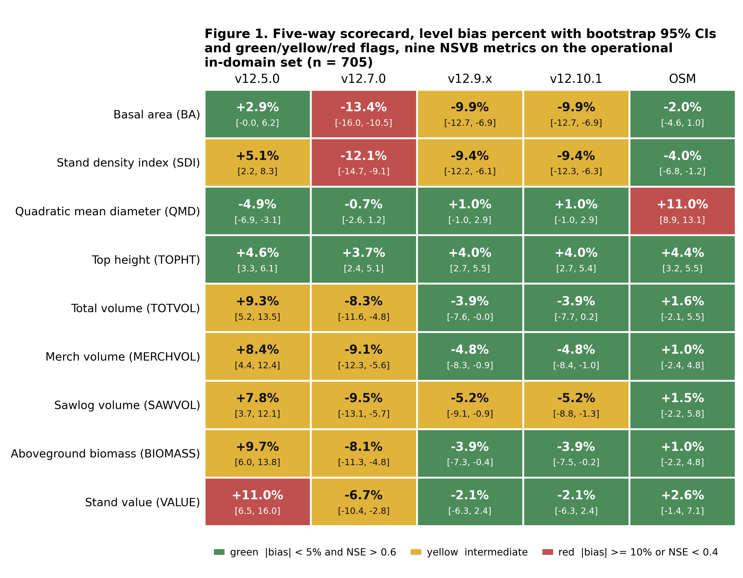
Figure 1. Five-way scorecard heatmap of level bias and modeling efficiency across the nine NSVB metrics for v12.5.0, v12.7.0, v12.9.x, v12.10.1, and OSM v2.26.1 on the pooled in-domain set.
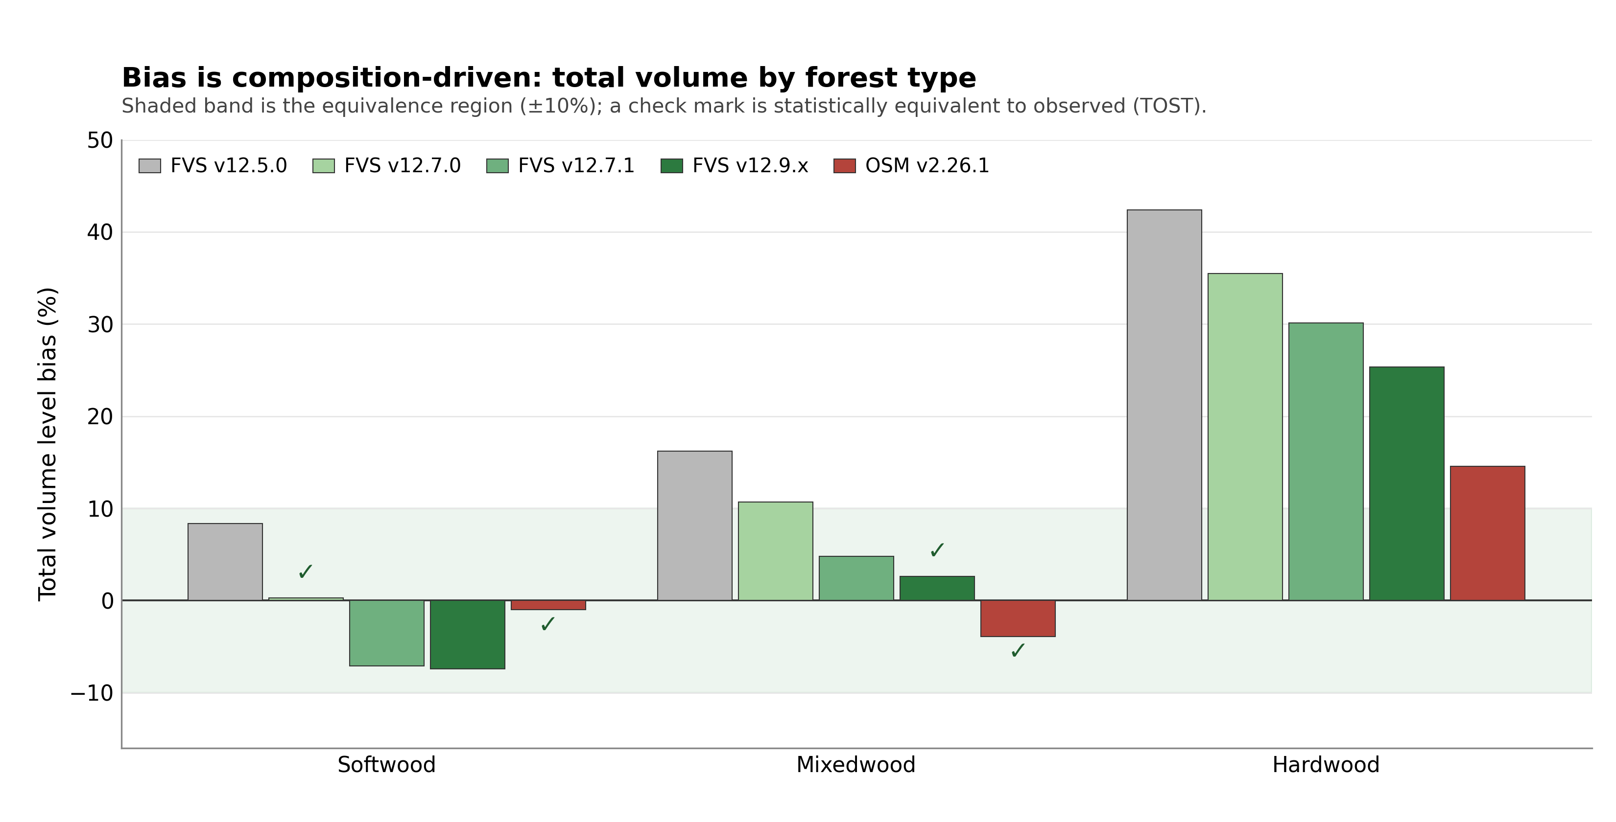
Figure 2. Total volume level bias by forest type (softwood, mixedwood, hardwood) for the five models, showing the composition-driven hardwood frontier shared by every model.
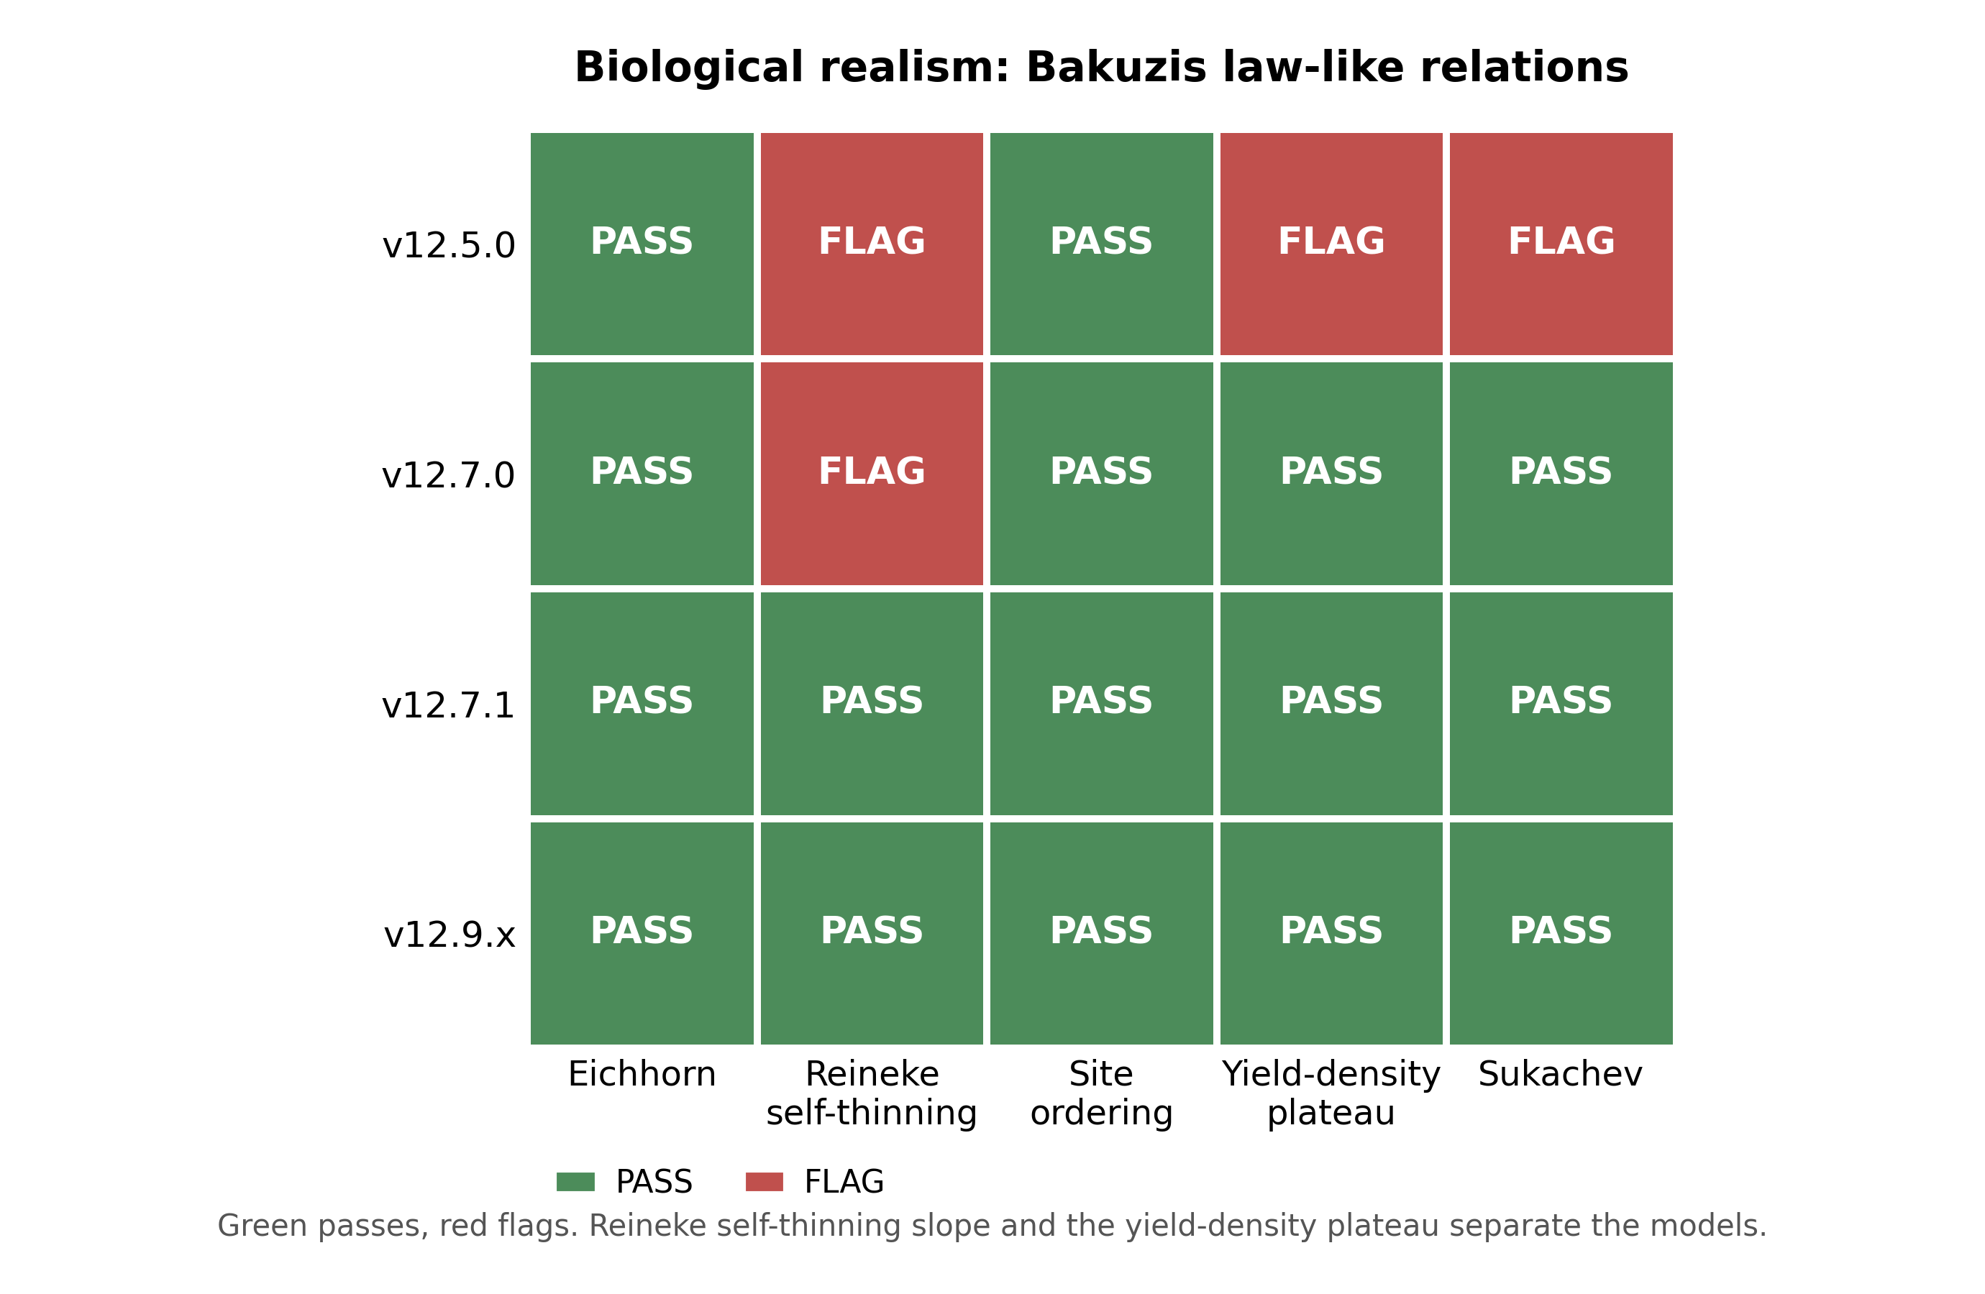
Figure 3. Bakuzis relations pass and flag matrix by model, the five law-like relations against the five entrants.
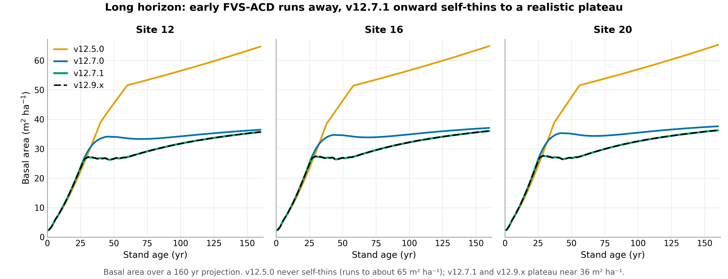
Figure 4. Long-horizon self-thinning trajectories on matched Seven Islands stands, FVS-ACD plateau and decline against OSM monotonic accumulation over 60 years from an identical start.
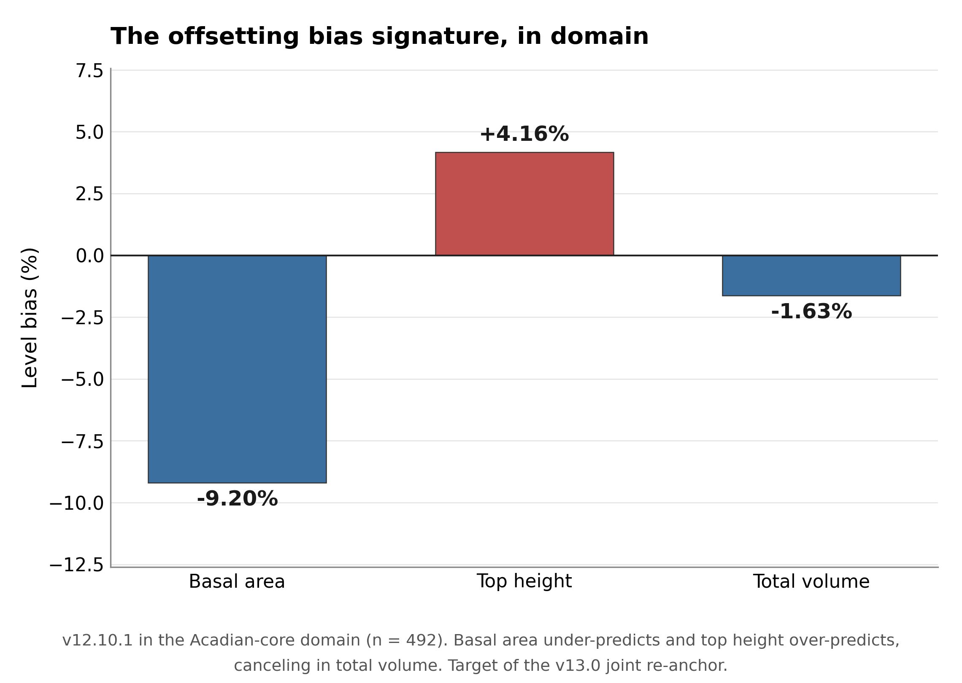
Figure 5. The offsetting bias signature in domain, basal area about -9 percent under and top height about +4 percent over canceling to total volume about -1.6 percent.
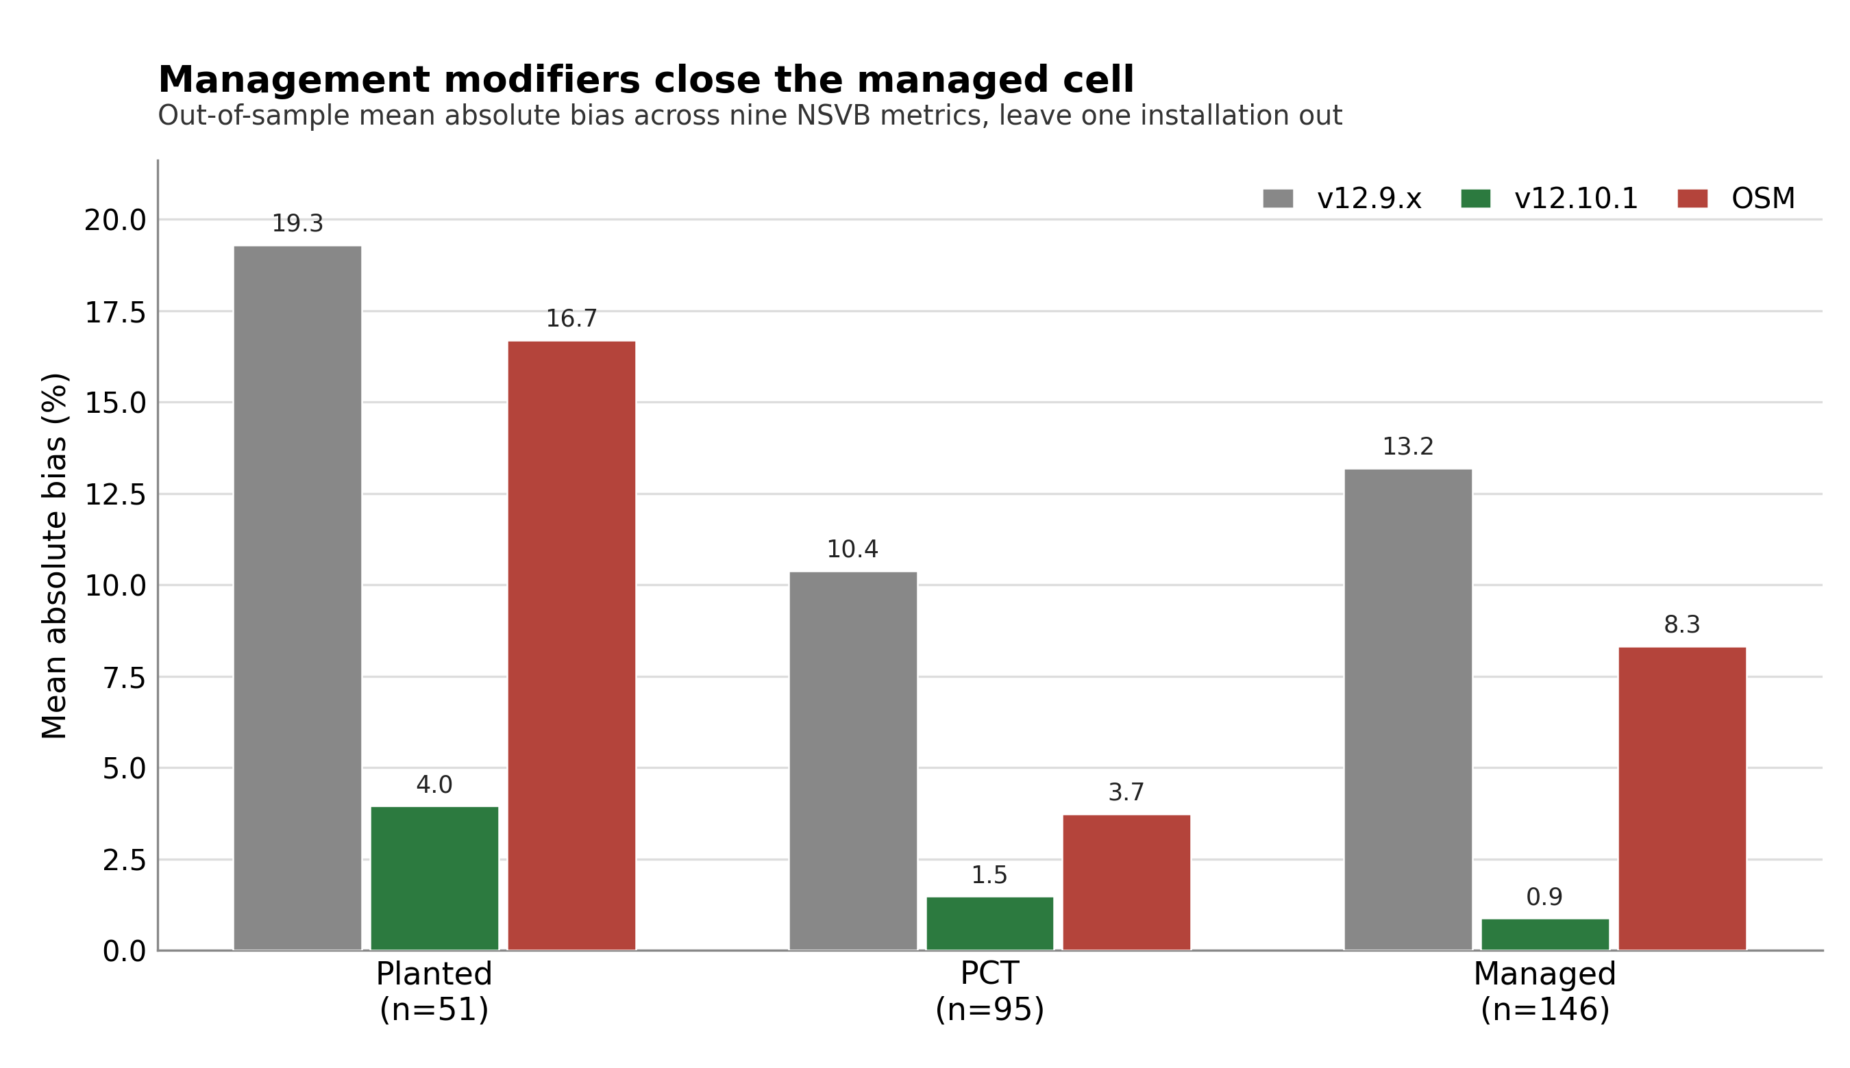
Figure 6. Managed-cell out-of-sample mean absolute bias by management class under leave one installation out, v12.9.x, v12.10.1, and OSM for planted, PCT, and managed.

Methods and provenance
Scoring used the corrected single-keyed-merge scorer, one wide table keyed by stand and deduplicated on both sides, with a per-model observed-on-predicted correlation as the alignment check. The earlier negative-modeling-efficiency artifact on OSM was an index-join misalignment and is resolved. Volume, biomass, and value are on the shared FIA NSVB emulator (log of gross variable on log of squared diameter times height by species group with Duan smearing), which carries about zero aggregate bias against raw FIA NSVB and so does not advantage any model. Equivalence testing follows Schuirmann TOST and Robinson and Froese (2004): a region of plus or minus 10 percent of the observed mean for level metrics and plus or minus 25 percent for increment, with equivalence declared when the 90 percent confidence interval of the mean paired difference lies inside the region. OSM is v2.26.1, dated 12 May 2026, confirmed as the latest release.
One data-provenance caveat should be noted. The scorecard baseline cb_v12102 was generated from AcadianGY_12.9.2.r plus the operational ops recipe. A standalone AcadianGY_12.10.1.r file exists but does not reproduce cb_v12102 exactly, so the canonical operational definition of v12.10.1 is the 12.9.2 model plus the recorded recipe, pending a file reconciliation.
Cardinal locations. Scorecard and cross-validation code under ~/magplot/verify: scorecard_v1210.R (five-way single-keyed-merge scorer), scorecard_clean.R (base scorer), scripts/v12101_domain_scorecard.R (7 July operational-domain recompute), mgmt_cv_robust.R and mgmt_finalfit.R (additive release and out-of-sample battery), bakuzis_allmodels.R (Bakuzis relations), and mgmt_plateau_sweep.R (plateau and gate-off identity). Inputs Wfull.rds (705 keyed table across five models and nine metrics), the per-stand cb result files, osm_h2h_metrics.csv, magp_qcnb_ecol3_v2.csv (ecoregion join keyed by stand and province), and the mgmt_scorecard and mgmt_gap_closure robust outputs. The OSM matched-stand long-horizon evidence is in ~/silc_cfi (osm_match_run.py, osm_pair3.R, fvsacd_vs_osm_matched.csv). True plot coordinates never left the node; only aggregates appear in this report.

