GENERAL TECHNICAL REPORT
FVS-ACD (Acadian Variant) Overview of the Forest Vegetation Simulator

Aaron Weiskittel
Center for Research on Sustainable Forests, University of Maine
Cooperative Forestry Research Unit
August 2026

 |  | 
Suggested citation: Weiskittel, A. 2026. FVS-ACD (Acadian variant) overview: Forest Vegetation Simulator. CRSF and CFRU, University of Maine, Orono, ME.

DRAFT variant overview / General Technical Report scaffold. 29 June 2026, updated 7 July 2026.
Structured after the USDA Forest Service Northeast (NE) Variant Overview (FVS Staff 2008, rev. August 2023) so it can become the official FVS-ACD variant documentation. Equation content is drawn from the Acadian GY Model Documentation (Weiskittel and team, 2025-05-20) and the AcadianGY source, built on the 12.7.1 development line. AcadianGY 12.10.1 is the current operational and production version, documented here. The geographic range map, the keyword and database usage reference (Appendix C), the Literature Cited, and the Appendix C and D validation and keyword material are drafted in this revision, with the keyword reference flagged as a usage overview to be finalized with the FVS software team; the species and component parameter tables (Appendices A and B) are populated directly from the AcadianGY source and are unchanged from v12.9.0 through v12.10.1, since the later refinements touch mortality, ingrowth, self-thinning, and the management modifiers, not the species-level growth, crown, taper, or volume parameters. This draft will be rendered to a formatted Word/PDF GTR. Updated 7 July 2026 to document v12.10.1 as the operational version, with the version lineage through 12.5.0, 12.7.0/12.7.1, 12.9.x, and 12.10.1, the five-way independent scorecard and honest scorecard position, the Bakuzis biological-realism pass, the disclosed ingrowth limit, and the planned v13 program.

Authors and Contributors
Aaron Weiskittel and the University of Maine Cooperative Forestry Research Unit (CFRU) developed the Acadian growth-and-yield model. Ben Rice (Midgard Natural Resources) maintains the FVS-ACD implementation and benchmarking. Component equations are credited to their authors throughout (Kuehne, Russell, Rijal, Li, Chen, Castle, Cen, and others; see Literature Cited). This overview documents the FVS-ACD variant as implemented in AcadianGY 12.10.1, the current operational version.
Suggested citation: Weiskittel, A. 2026. FVS-ACD (Acadian variant) overview: Forest Vegetation Simulator. CRSF and CFRU, University of Maine, Orono, ME. [pages].

Table of Contents
1. Introduction
2. Geographic Range
3. Control Variables (region codes, species, ecoregion, site index, maximum density)
4. Growth Relationships (height-diameter, bark, crown ratio and recession, crown width, CCF, diameter increment, height increment, stand basal-area increment)
5. Mortality Model
6. Regeneration and Ingrowth
7. Volume and Taper
8. Modifiers (thinning, spruce budworm, hardwood form and risk)
9. Model Application (site index rasters, cycle length, usage)
10. Version Lineage, Current Operational Version (12.10.1), and Validation
11. Literature Cited
12. Appendices (species list, parameter tables)

Quick Guide to Default Settings
Parameter | Default
Projection cycle length | 1 year (FVS reporting frequency user-selectable)
Region code | ME (northern New England); also NB, NS, QC
Site productivity | Climate Site Index (CSI, m); modern ESI accepted in the same input (12.6.x)
Maximum stand density index | Composition-based, Weiskittel and Kuehne (2019); see 3.5
Species | 37 Acadian species codes plus OH (other hardwood) and OS (other softwood)
Minimum DBH | 2.5 cm for height prediction; ingrowth threshold DBH user-set
Units | Metric internally (DBH cm, height m, BA m² ha⁻¹, trees ha⁻¹)
Volume | Kozak variable-exponent taper; Westfall and Scott

1. Introduction
The Acadian forest region spans northern New England and Atlantic Canada. It is a transitional mixed conifer and hardwood type, sitting between the northern hardwood forests to the south and the boreal forest to the north (Loo and Ives 2003). The Acadian growth-and-yield model, developed by the CFRU team led by Aaron Weiskittel, is the regionally specific model for this setting, and FVS-ACD is its implementation within the Forest Vegetation Simulator framework. It departs from the FVS Northeast (NE) variant in two respects. Its core growth, mortality, height, crown, ingrowth, and taper relationships were fit on Acadian data, with the Kuehne et al. (2022) increment equations alone drawing on more than 2.5 million diameter and a million height observations, and it is driven by a climate-based site index in place of a traditional site index. FVS-ACD is a one-year-cycle, individual-tree, distance-independent model and, like the other variants, supports the FVS extensions.

2. Geographic Range
The Acadian variant applies to northern New England (Maine, New Hampshire, Vermont) and Atlantic Canada (New Brunswick, Nova Scotia) plus southern Quebec, the region for which the component equations were fit. Region codes select the regional mortality and modifier parameters (ME, NB, NS, QC).
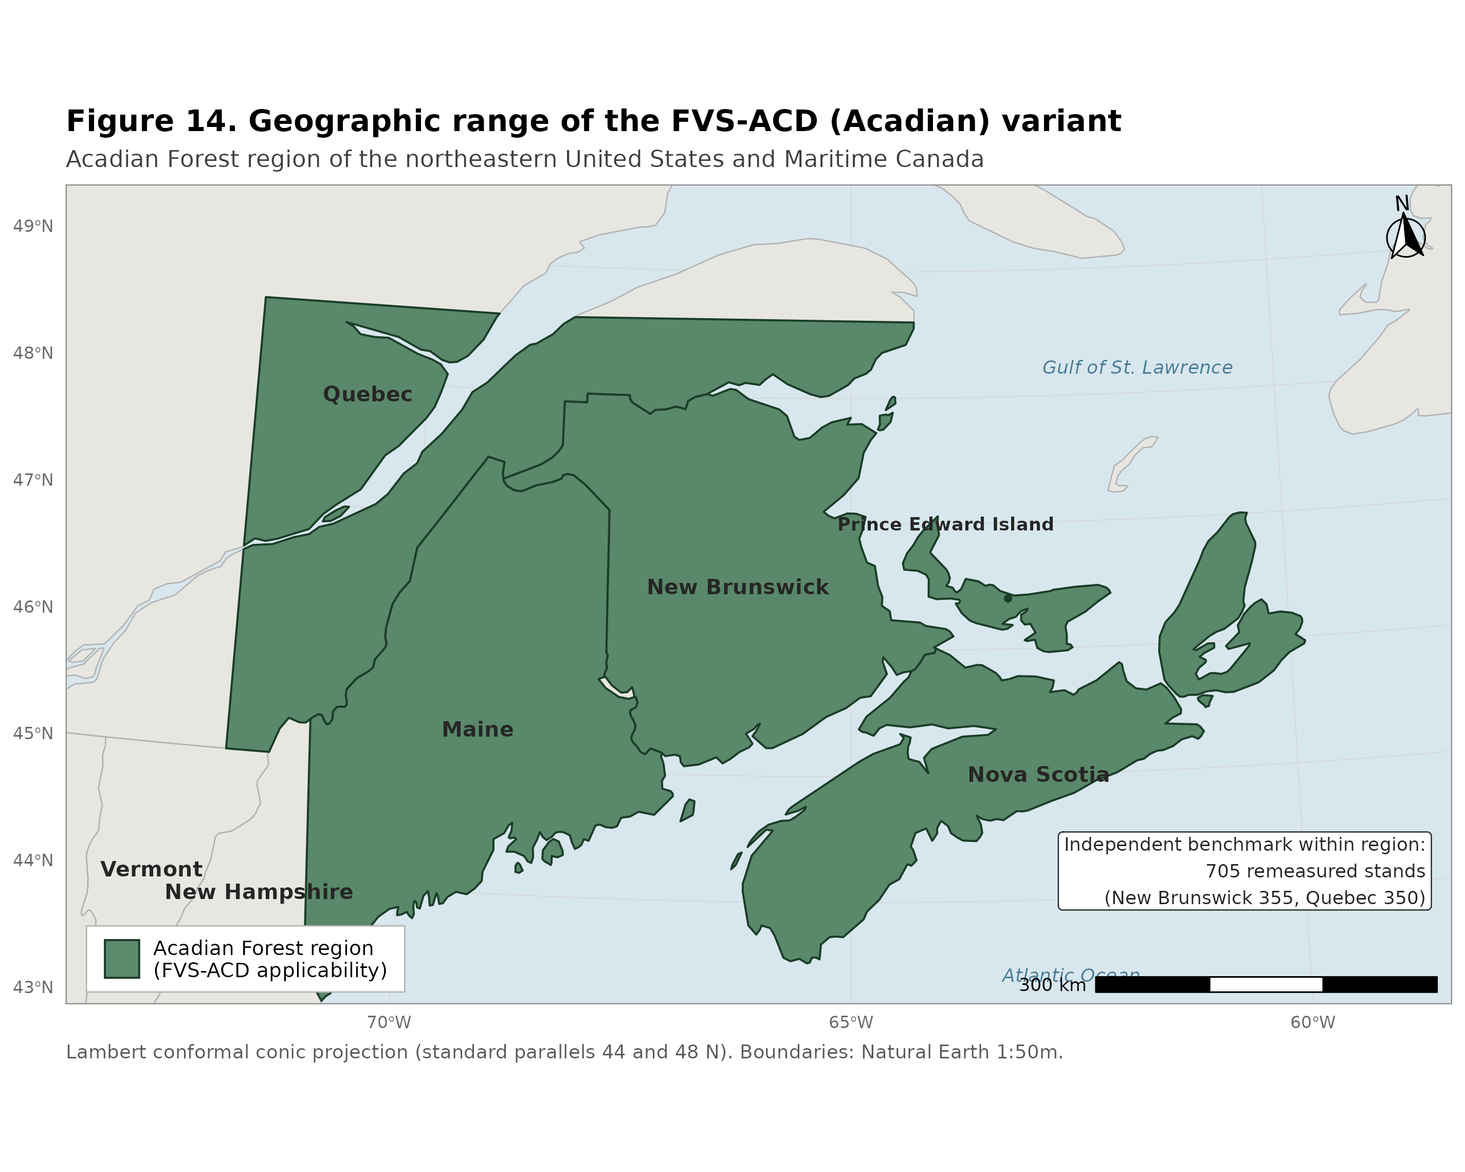
Geographic range of the Acadian variant (FVS-ACD).
Figure 14. Geographic range of the Acadian variant (FVS-ACD): northern New England (Maine, New Hampshire, Vermont), Atlantic Canada (New Brunswick and Nova Scotia), and southern Quebec, the region for which the component equations were fit and over which the region codes (ME, NB, NS, QC) select the regional mortality and modifier parameter sets.

3. Control Variables

3.1 Region codes
ME (default, northern New England), NB (New Brunswick), NS (Nova Scotia), QC (Quebec). Region selects the regional parameter sets for stand and tree mortality and the spruce budworm modifier.

3.2 Species codes
37 rows are parameterized in sp.attr (35 distinct named species plus the OH other-hardwood and OS other-softwood composite groups, and a 99 fallback row). Species not in the parameter set map to OH or OS by softwood/hardwood type. Full species code table with scientific names, FIA and PLANTS codes, specific gravity, and shade/drought/waterlog tolerance in Appendix A; component parameter tables (height, HCB, crown width, bark ratio, mortality, modifiers, ingrowth, taper, volume) by sp.grp.ingrowth and by individual species in Appendix B.

3.3 Habitat / ecological unit
FVS-ACD does not use habitat type codes; site productivity enters through the climate site index (3.4). Level 3 ecoregion is available as an optional stratifier for maximum density (3.5).

3.4 Site index
The Acadian model uses Climate Site Index (CSI, m), a climate-and-soil-driven productivity surface (Weiskittel et al. 2011), fit by random forest on seven climatic variables (most important: mean temperature of the warmest month, the warmest-to-coldest month temperature difference, and the growing-season-to-annual precipitation ratio). CSI is a user input and is available as raster surfaces for current and future (2030, 2060, 2090) climate normals. CSI enters total height, diameter increment, stand basal-area increment, height increment, mortality, ingrowth, and maximum SDI.
Operational note (12.7.0). The production model uses the validated modern Ecological Site Index (ESI) as the site driver, supplied through the same input slot. ESI tracks measured site index well (R^2 0.91). A controlled full-set test showed that ESI and the legacy climate site index give the same regional volume and value, with an all-region basal-area bias of +1.4 percent under both. The ESI gain therefore does not appear in volume or value bias. It appears in dominant-height behavior and biological realism, since ESI anchors the stand dominant height onto a fitted Chapman-Richards curve (k = 0.0039, p = 0.726, base age 50; section 4.1 note), which removes the Bakuzis height site-ordering inversions. The ESI surface is supplied as a raster (Acadian ESI v8). The earlier AcadianSIm climate surfaces are a separate future-climate product and are not the operational site driver.

3.5 Maximum density (maximum SDI)
Stand density index is additive at the plot level, SDI = sum over trees of (DBH/25.4)^1.6 * TPH, with DBH in cm and trees ha⁻¹. Maximum SDI follows Weiskittel and Kuehne (2019), a composition- and structure-based function:
SDImax = 475.2079 - 1.5908*HW.ba.percent - 236.9051*log(meanSG) + 50.3299*sqrt(DBHrange)
+ 13.5202*spp.div + 0.0685*Elev - 2.8537*sqrt(Elev) + 222.7836*(1/CSI)
where HW.ba.percent is percent hardwood basal area, meanSG is basal-area-weighted mean specific gravity (capped at 0.80), DBHrange is the plot DBH range, spp.div is species count, and Elev is elevation (m). A fallback SDImax2 = 1347.445 - 1003.870*meanSG is used where the primary function is undefined. Relative density is SDI/SDImax.
Version 12.6.x note: a brms re-estimation of plot-level SDImax across northern New England found SDImax is essentially independent of site index (correlation with CSI and ESI near 0) and is primarily a function of forest type (softwood ceilings near 1050 to 1100, northern hardwood near 900, wet hardwood near 750), which the composition terms above already approximate through mean specific gravity. A site-independent SDImax (dropping the 222.78/CSI term, recentred) is available behind a flag.
Version 12.9.0 note: a CONUS-scale brms re-estimation (independent of the northern New England one above) confirmed forest type dominates the variance in plot-level maximum SDI (R-squared 0.21) far more than site index alone (R-squared 0.02), and that a localized, forest-type-and-ecoregion-aware maximum predicts observed self-thinning roughly twice as well as a generic species-table constant. Applied to AcadianGY, the diagnostic finding was that the Weiskittel-Kuehne SDImax equation above already handles composition well through the percent-hardwood and specific-gravity terms, but under-corrects specifically for hardwood-dominated stands in Quebec outside the Acadian-core ecoregion (CEC North American Level III: Acadian Plains and Hills, Maritime Lowlands). v12.9.0 adds a gated multiplier to SDImax (ops$sdimax.fortype.tight.mult, default 0.65 to 0.70), active only when a stand is simultaneously Quebec, outside the Acadian core, and hardwood-dominated by BA-weighted dominant species group. See section 10 and 20260701_v129_full_validation.md for the full derivation and validation.

4. Growth Relationships

4.1 Height-diameter (total tree height)
HTPred, after Rijal et al. (2012a) modified for additional species:
ht = 1.37 + ((c0 + c0.spp) + CSI^c1) * (1 - exp(-c2*DBH))^(c3 + c3.spp + c4*log(CCF+1) + c5*BAL)
CSI enters the asymptote (the CSI^c1 term). c0 to c5 are fixed; c0.spp and c3.spp are species random effects. Used to fill missing or invalid heights. Species parameter table in Appendix B.1.

4.2 Bark ratio
DOBtoDIB (Weiskittel and Li 2012) converts diameter outside to inside bark. Form and species parameters in Appendix B.4.

4.3 Crown ratio and crown recession
Height to crown base, HCBPred (Rijal et al. 2012b, refit with species random effect, Weiskittel et al. 2013):
hcb = HT / (1 + exp((a0 + a0.spp) + a1*DBH + a2*HT + a3*DHR + a4*log(CCF+1) + a5*(BAL+1)))
Crown recession, dHCB (Russell et al. 2014):
dHCB = (CL + dHT) / (1 + exp(b1 + b2*log(CR+0.01) + b3*log(CCF+1) + b4*log(1.01-CR)
+ b5*shade^2 + b6*log(shade*CR)))
HCB species random-effect table (a0.spp) in Appendix B.2. The crown-recession equation uses fixed parameters for all species (no separate species table in the source); shade tolerance is read from Appendix A.

4.4 Crown width
Maximum crown width mcw = a1DBH^a2 (open-grown, Russell and Weiskittel 2011, 99th-quantile); largest crown width lcw = mcw / (b1DBH^b2) for forested conditions. Species parameters in Appendix B.3.

4.5 Crown competition factor
CCF is the sum of tree maximum crown areas per plot, used in height, height-to-crown-base, crown recession, increment, and ingrowth.

4.6 Diameter increment
dDBH, Kuehne et al. (2022), species as a random effect, fit on > 2.5 million observations:
dDBH = exp((b0+b0.SPP) + b1*log(DBH) + (b2+b2.SPP)*DBH + (b3+b3.SPP)*log(CR)
+ (b4+b4.SPP)*log(BAL.SW+0.1) + b5*BAL.HW + b8*log(CSI))
Fixed-effect coefficients (Kuehne et al. 2022, Table 6): b0 = -1.64234, b1 (ln DBH) = 0.376978, b2 (DBH) = -0.025684, b3 (ln CR) = 0.713456, b4 (ln BAL.SW+0.1) = -0.065750, b5 (BAL.HW) = -0.017740, b8 (ln CSI) = 0.135377. Species random effects apply to the intercept, DBH, ln(CR), and ln(BAL.SW+0.1). Competition is one-sided and asymmetric (basal area in larger softwoods and hardwoods); two-sided metrics (SDI, relative density) were no more effective. On independent FIA data the equation is nearly unbiased (mean bias -1.2 percent) and improves on the prior FVS-ACD diameter and basal-area increment submodels by 11 to 13 percent in mean absolute bias. Tree diameter increment is constrained by the stand basal-area increment (4.8). Full species random-effect tables in Kuehne et al. (2022) Table S3.

4.7 Height increment
dHT, Kuehne et al. (2022), more conservative than the earlier Russell et al. (2014) form (addresses the FVS-NE over-prediction expectation):
dHT = exp((b0+b0.SPP) + b1*log(HT) + (b2+b2.SPP)*HT + b3*CR + b4*(CCFL/100) + b7*CSI^2)
Fixed-effect coefficients (Kuehne et al. 2022, Table 8): b0 = -2.19445, b1 (ln HT) = 0.426404, b2 (HT) = -0.064710, b3 (CR) = 0.394837, b4 (CCFL/100) = -0.011430, b7 (CSI^2) = 0.000294. Species random effects apply to the intercept and HT. The new dHT improves on the prior Russell et al. (2014) submodel substantially (mean absolute bias down 41 to 74 percent), the largest accuracy gain of the two increment refits. Full species random-effect tables in Kuehne et al. (2022) Table S5.

4.8 Stand basal-area increment
Chen et al. (in prep.), added at v12.3.0, applied at the stand level as a cap on summed tree diameter increment:
dBA = rt*Ba*(1 - Ba/k); rt = q0 + q1*log(RD+1e-6) + q2*log(CSI) + q3*log(pHW.ba*100+1e-6)
+ q4*log(CSI*RD+1e-6)
Applied only when summed predicted tree BA increment exceeds the stand prediction, and capped at 0.227 percent of plot BA (5th percentile, Maine FIA). RD is relative density SDI/SDImax. This is the density-dependent brake on growth.

5. Mortality Model
Stand- and tree-level mortality, Weiskittel et al. (2012). The multi-stage approach of Chen et al. (2023) was evaluated in beta and was not superior, so the model uses the 2012 formulation (see the v12 history memo).
Stand mortality probability: prob = exp(k)/(1+exp(k)), k = b0 + b1BA + b2BA^2 + b3BAG + b4QMD + b5BA.BF + b6BA.IH. Stand mortality basal area: BA.mort = (b0 + b1pBA.bf + b2pBA.ih)BA^(b3 + b4BAG); BF.mort = b5BA.BF^b6 + b7(QMD.BF/QMD). Tree survival: logistic in DBH and DBH^2. Stand mortality is distributed across trees in proportion to tree mortality probability. Region-specific parameters (ME, NB, NS, QC) in Appendix B.6; tree-level background mortality species parameters (the DBH/DBH^2 survival logistic and the Weibull-form diameter-jump term) in Appendix B.5.
Operational note: the production model uses the 2012 stand and tree mortality with SDImax-ceiling self-thinning (ops$use.sdimort) active, a density-frontier mortality that holds post-step SDI at or below SDImax and improves the Bakuzis self-thinning slope. A size-dependent MORTCAL corrector (ops$use.mortcal) is available but trades stem-count accuracy and ships off. The principled next-version fix is a regional refit of the 2012 stand-mortality coefficients.
Coupled self-thinning and density-released ingrowth (12.7.1). The 12.7.0 self-thinning used a single slope above a relative-density onset, which on long-horizon projection never plateaued (basal area climbed past 36 m² ha⁻¹ and was still rising at age 120). Version 12.7.1 replaces it with a coupled two-segment relative-density mortality. Let RD = SDI/SDImax. Mortality is zero below RD 0.30, rises on a gentle slope from 0.30 to a break at 0.62 (ops$sdimort.onset, ops$sdimort.break, ops$sdimort.beta.gentle), and rises on a steep slope above the break (ops$sdimort.beta.steep), so a fully stocked stand self-thins along the SDImax line. It is coupled with a density-released ingrowth (section 6). Through a logistic in RD, recruitment is suppressed at high RD and released below about RD 0.58. The biological rationale is the build, self-thin, and rebound dynamic of a stand that grows to its maximum, self-thins along the density frontier, and rebounds as ingrowth releases when density falls, the process underlying a shifting-mosaic steady state. On a 160-year projection of a young dense spruce-fir stand across the site gradient, basal area builds and plateaus at about 33 to 34 m² ha⁻¹ by mid-rotation and then levels, inside the realistic fully-stocked Acadian spruce-fir range (about 28 to 34), replacing the 12.7.0 runaway climb. The decline-and-rebound is critically damped at the single-stand deterministic scale. Because mature Quebec-edge stands and moderately dense New Brunswick stands overlap in relative density, this relative-density lever reduces the mature-stand over-prediction while modestly deepening the growing-stand under-prediction; separating the two is the next-version regional and composition-aware mortality target.
Regional and composition-aware SDImax gate (12.9.0). Closer diagnosis showed that the 12.7.1 mature-stand residual is not a Quebec-wide phenomenon. It concentrates in hardwood-dominated Quebec stands outside the Acadian-core ecoregion, whereas softwood-dominated Quebec stands and all of New Brunswick were already close to unbiased. v12.9.0 adds a gated multiplier to the SDImax term used by this self-thinning mechanism (section 3.5), active only when a stand is simultaneously province Quebec, ecoregion outside the Acadian core, and hardwood-dominated. This raises the effective self-thinning intensity for that specific population and closes the target cell's total-volume bias from +56.7 to +10.4 percent, with no effect on New Brunswick or on the independent recent Maine FIA growing-stand check (see section 10). The mechanism adds to the coupled self-thinning above rather than replacing it, scaling SDImax before the RD = SDI/SDImax ratio that drives the two-segment mortality curve.

6. Regeneration and Ingrowth
Full ingrowth model, Li et al. (2011), for ten species groups (BCH birch, BF, RM, SPR spruce, WP, OH, AB, QA, SM, WC). A hurdle model: occurrence probability P(occur) and count E[count] = exp(eta), both functions of BA, percent hardwood, TPH, CSI, minimum DBH, and QMD. The occurrence is gated by a cut-point (CutPoint, default 0.95). FVS-ACD also retains FVS resprouting after simulated harvest. Composition and occurrence-probability parameters by species group in Appendix B.8.
Version 12.6.1 note: the 0.95 occurrence gate suppresses recruitment on most plot-years and is the source of the under-recruitment behind the stem-count deficit. v12.6.1 makes the statistically correct expected-value recruitment the default, E[ingrowth] = P(occur) * E[count] (set CutPoint to 0), with a calibration multiplier. This is the dominant lever on stem count and QMD but, by global sensitivity analysis, does not materially change stand value (the recruits are small).
Version 12.7.1 note (density-released ingrowth): observed recruitment, tree-ID matched on the raw MagPlot records, is about 40 stems per ha per year in New Brunswick and about 20 in Quebec. v12.7.1 couples the expected-value recruitment to relative density through a logistic in RD (ops$use.ingrowth.release, ops$ingrowth.rd.center 0.58, ops$ingrowth.rd.k): recruitment is suppressed at high relative density and released below about RD 0.58. Coupled with the two-segment self-thinning mortality (section 5), this produces the build, self-thin, and rebound stand dynamic.

7. Volume and Taper
Stem taper: Kozak variable-exponent taper and Westfall and Scott (Li et al. 2012, Weiskittel and Li 2012). Bark thickness via DOBtoDIB. Merchantable volume and product specifications follow the FVS volume framework; for value work, sawlog (International 1/4-inch board feet) and pulp (cords) are split by species and size. Kozak and Westfall-Scott taper species parameters in Appendix B.9, legacy Honer volume species parameters in Appendix B.10, bark ratio in Appendix B.4.
Operational note (12.7.x): all volume and biomass in the benchmarking and validation are reported on the FIA National Scale Volume and Biomass (NSVB) system, applied through an emulator that predicts the NSVB responses (gross cubic volume, net merchantable volume, net sawlog volume, and aboveground dry biomass) from log(DIA squared times HT) by species group with Duan smearing, with R-squared 0.96 to 0.99 against the FIA NSVB outputs. This puts observed and predicted tree lists on a single, current volume-and-biomass currency and replaces the earlier single form-factor merchantable volume used for increment scoring.

8. Modifiers
Thinning (Kuehne et al. 2016; note the source code header instead credits Weiskittel, Hennigar, and Kershaw 2015 for this modifier, a citation discrepancy to reconcile before publication): diameter growth, mortality, height growth, and crown recession modifiers keyed on removal intensity and timing. Spruce budworm (Cen et al. 2018): balsam fir and spruce mortality, diameter and height growth, keyed on cumulative defoliation, region ME and NB. Hardwood form and risk (Castle et al. 2018): mortality and diameter growth modifiers for selected hardwoods. All parameter tables in Appendix B.7.
Direct-effect management modifiers (12.10.1). The current operational version adds the Chapter 11 direct-effect management modifiers as gated additive releases on planted and precommercial-thinning (PCT) stands. The direct effect is expressed as a robust additive term on the class of per-stand observed minus predicted-untreated increment, in place of a diameter-growth multiplier pinned to a guard clamp (planted +3.83 m² ha⁻¹ basal area, PCT +2.41 m² ha⁻¹, with proportional releases in the other metrics). It is gated by ops$use.mgmt.mod and applies only to planted and PCT stands, so the gate-off run is byte identical to v12.9.x on unmanaged stands. The release is a diameter-growth term and not a mortality term, is physically bounded within the unmanaged density envelope, and does not break the self-thinning plateau. See section 10.3 for the fit and validation.

9. Model Application
CSI is supplied by the user or sampled from the raster surfaces (current and 2030/2060/2090 climate normals); recent testing finds the 2030 surface reasonable. Cycle length is one year. The model is run from a tree list through the FVS interface or the AcadianGY R driver (make_stand, make_acd_tree, make_ops, AcadianGYOneStand). The keyword and database usage reference for the variant is given in Appendix C.

10. Version lineage, current operational version (12.10.1), and validation
AcadianGY 12.10.1 is the current operational and production version, frozen as the operational release for the 18 August 2026 Acadian Growth and Yield meeting. Version 13 is in progress, but no v13 version is gated, so nothing in the v13 program below is a claimed result. v12.10.1 is the endpoint of a single development line that began with 12.5.0 and added one gated refinement at a time. Each refinement is individually isolated, so that with its flag in the legacy position the build reproduces the prior version bit for bit. The operational configuration is the Kuehne et al. (2022) diameter and height increment equations (4.6, 4.7) as the growth base; the validated ESI v8 as the site driver with the fitted ESI-consistent dominant-height anchor recalibration active (3.4, 4.1), which delivers the clean Bakuzis site ordering (10.2); a further top-height anchor-level parity correction available behind a gate but shipping off in the current config, deferred to v13.0 (see 10.3); FIA NSVB volume and biomass (7); expected-value, density-released ingrowth (6); the coupled two-segment relative-density self-thinning (5); the regional and composition-aware SDImax gate for the Quebec hardwood edge (5, 3.5); and the Chapter 11 direct-effect management modifiers as gated additive releases on planted and precommercial-thinning stands (8, and section 10.3 below).
The version lineage, in order of development:
1. 12.5.0, the prior operational and production base. Kuehne et al. (2022) increment equations, climate site index, and the 2012 stand and tree mortality. On long-horizon projection it does not self-thin, with basal area climbing past 62 m² ha⁻¹ at age 120, and is not recommended for mature-stand or long-horizon use.
2. 12.7.0 and 12.7.1. The 12.7.x line added the validated ESI v8 site driver and the ESI-anchored dominant height, FIA NSVB volume and biomass through the emulator (R-squared 0.96 to 0.99 against FIA NSVB), the coupled two-segment relative-density self-thinning, and the density-released ingrowth. Together these make the long-horizon basal-area trajectory plateau at the biologically correct Acadian maximum (about 33 to 34 m² ha⁻¹) rather than running away, couple recruitment to relative density so that a stand builds, self-thins along the density frontier, and rebounds as ingrowth releases, and put observed and predicted tree lists on a single current volume and biomass currency.
3. 12.9.x. A CONUS-scale brms re-estimation of plot-level maximum SDI (independent of the earlier northern New England one) confirmed that composition and ecoregion, not site index, dominate the variance in the self-thinning ceiling. v12.9.x adds a gated multiplier to SDImax active only when a stand is simultaneously Quebec, outside the Acadian-core ecoregion, and hardwood-dominated. This closes the remaining mature-stand over-prediction in exactly that population, with an independent recent-FIA cross-check confirming zero effect on New Brunswick or Maine (the province term in the gate excludes Maine by construction).
4. 12.10.1. Chapter 11 direct-effect management modifiers, expressed as gated additive releases on planted and precommercial-thinning (PCT) stands (section 10.3). The modifier is gated by ops$use.mgmt.mod and touches only planted and PCT stands; the gate-off run is byte identical to v12.9.x on the 266 unmanaged stands. This is the current operational version.
Every refinement is gated, and with the flags in their legacy position the build reproduces the base bit for bit, so each is individually isolated and validated. v12.10.1 with its management gate off reproduces v12.9.x exactly, and v12.9.x with its own gate unset reproduces 12.7.1 exactly.
Provenance note on the operational build. The operational scorecard baseline documented in this section was produced from the AcadianGY_12.9.2.r source plus the recorded operational ops recipe, the gated management release applied through make_ops on the v12.9.x engine. A standalone AcadianGY_12.10.1.r script that folds that recipe into the source now exists in the repository and carries the AcadianV12.10.1 version tag; it is being reconciled against the recipe-driven baseline to confirm it reproduces the scored results byte for byte before it supersedes the recipe as the canonical operational file.

10.1 Four-model independent scorecard (1 July 2026)
A multi-dimensional scorecard (quantitative bias, RMSE, modeling efficiency, and periodic annual increment; qualitative Bakuzis biological realism, long-horizon trajectory shape, transparency, data requirements, usability, and uncertainty characterization) was run on AcadianGY 12.5.0, 12.7.0, 12.7.1, and the current OSM-ACD release (v2.26.1, confirmed current against the OSM-Contributors GitHub organization and the Forus Research download page), on identical independent in-domain data. The full scorecard is 20260701_four_model_scorecard.md; figures five_model_scorecard_heatmap.png and five_model_scorecard_radar.png (v12.9.0 added as a fifth model, section 10.2).
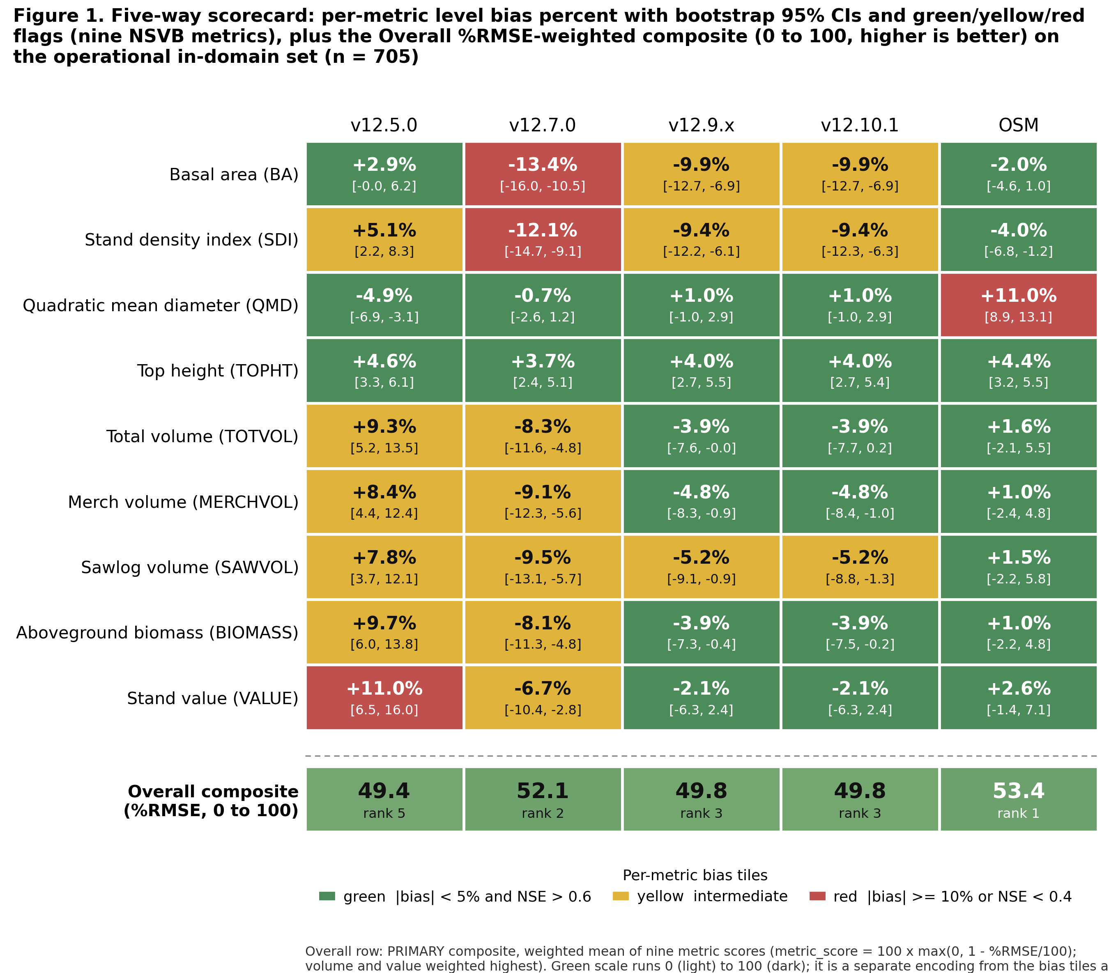
The headline finding is that OSM-ACD carries the lowest pooled level bias of the four models on every metric and, once it is scored on all nine NSVB metrics through the same emulator harness as FVS-ACD, also carries the highest pooled modeling efficiency. An earlier read that showed a negative Nash-Sutcliffe efficiency for OSM on every metric was an index-join artifact. OSM output had been matched to the observed tree lists on a mismatched key rather than reflecting a real lack of per-stand skill. Rescoring OSM through the common NSVB harness resolves it, and OSM's pooled modeling efficiency is positive and leads the set. FVS-ACD leads OSM on biological realism, the climate-ready site driver, and quadratic mean diameter, not on pooled level bias or modeling efficiency. All three AcadianGY versions explain 55 to 78 percent of out-of-sample variance on every metric. AcadianGY 12.5.0 fails the Bakuzis self-thinning check outright, with long-horizon basal area still climbing past 62 m² ha⁻¹ at age 120 and several thousand stems per hectare still alive, and is not recommended for mature-stand or long-horizon use. Of the FVS-ACD versions, AcadianGY 12.7.1 has the best combined quantitative and qualitative profile prior to the 12.9.0 refinement below.

10.2 v12.9.0: a targeted SDImax correction for the Quebec hardwood edge
The scorecard in 10.1 localized 12.7.1's remaining structural gap to a specific population: stands that are simultaneously Quebec (province), outside the Acadian-core ecoregion (CEC North American Level III: Acadian Plains and Hills, Maritime Lowlands are the core; Northern Appalachian and Atlantic Maritime Highlands, Algonquin and Southern Laurentians, Central Laurentians and Mecatina Plateau, and Eastern Great Lakes Lowlands are outside it), and hardwood-dominated (BA-weighted dominant species group sugar maple, birch, aspen, other hardwood, or American beech). Softwood-dominated Quebec stands, and every New Brunswick stand regardless of composition, were already close to unbiased and are untouched by the v12.9.0 gate.
Development process, briefly (full derivation 20260701_v129_full_validation.md, 20260701_v129_ooda_stress_test.md): a region-only multiplier was tried first and found to be a pure trade-off (fixing basal area worsened volume and vice versa, with no setting fixing both). An ESI-based spatial cluster was tried and found weak, because ESI v8 coverage of Quebec is patchy. Forest type (BA-weighted dominant species group) located the real signal. True ecoregion sharpened it further. An ecoregion-only gate (no province term) closed the Quebec target as well as the final version, but an independent cross-check against the recent Maine FIA growing-stand stratum caught a real regression: the correction leaked onto Maine's own hardwood stands sharing the same ecoregion as the Quebec problem stands, worsening the FIA annual-increment check from -52 to -83 to -93 percent. Restoring province as a third gate dimension eliminated this by construction, since no Maine plot can ever satisfy a Quebec-only gate.
Validation, in-domain MagPlot (n = 733) and independent recent Maine FIA (n = 788), predicted versus observed t2 level bias:
• Target cell (Quebec, outside Acadian core, hardwood-dominated, n = 163): total volume +56.7 to +10.4 percent, stand value to +4.4 percent. Basal area, already under-predicted in 12.7.1, deepens further (-9.3 to -18.1 percent), the SDImax-driven trade-off confined now to exactly the population needing it.
• New Brunswick: unchanged from 12.7.1 in every metric.
• Recent Maine FIA: unchanged from 12.7.1 (basal-area level -2.2 percent, annual increment -0.085 m² ha⁻¹ yr⁻¹), confirming the gate cannot affect Maine plots.
• A stand-level split-half robustness check (163 target-cell stands, two random halves) confirmed the correction is not driven by a handful of outlier stands.
Known residual: a seeded 160-year trajectory of the corrected hardwood population plateaus at about 21 m² ha⁻¹, below the realistic 28 to 32 m² ha⁻¹ target for that composition (the same composition, uncorrected, plateaus at 31 to 32). A correction calibrated on a 5 to 15 year remeasurement window, carried through a full rotation, under-shoots the long-horizon asymptote. v12.9.0 is recommended for short-to-mid rotation inventory projection; v12.7.1 remains the recommended version for carbon and old-growth applications on this specific population until a tapered version of the correction, relaxing toward the true asymptote rather than applying a flat multiplier throughout the rotation, is fit.
Independent validation, and what carries to the frozen harness. This subsection is the development-era 12.7.0 to 12.7.1 self-thinning validation. It was run on a non-frozen dominant-height calibration and on populations, recent Maine FIA (n=788) and the ESI-covered Quebec edge (n=378), that are not in the frozen per-stand MagPlot files behind the section 10.3 five-way, so it has not been, and cannot cheaply be, re-benched on the frozen operational harness. Its results split by whether they depend on the dominant-height anchor factor (afac). A code-level check of the frozen harness confirms the afac enters at one point only, the dominant-height increment multiplier (dht.mult, operationally NB 0.579 and QC 0.111), and never touches the diameter-increment path or the density-dependent mortality that sets trees per hectare and quadratic mean diameter. The self-thinning results reported here are therefore density-frontier quantities that do not depend on the afac and carry to the frozen harness unchanged: the Reineke slopes, the plateau-versus-runaway trajectory finding, and the 12.7.0 to 12.7.1 self-thinning improvement. The level-bias figures that follow, and any dominant-height or NSVB-volume number in particular, were computed at the development afac and are not frozen-consistent; they are the original developmental record, not frozen results. The authoritative frozen scorecard is the five-way in section 10.3.
On genuinely independent, in-domain data, the full FIA NSVB metric set, predicted versus observed t2 level bias, New Brunswick (n=355) and the ESI-covered Quebec edge (n=378), 12.7.0 to 12.7.1:
• New Brunswick total volume -3.9 to -9.8 percent, biomass -1.4 to -7.3, value -4.5 to -10.2; basal area -3.5 to -8.5.
• Quebec edge total volume +23.3 to +14.4 percent, biomass +19.1 to +10.2, value +27.3 to +18.3; basal area -2.1 to -9.3.
Top-height (dominant-height) bias is deliberately not tabulated here. It is the single metric the afac scales directly, so the development-era figures ran warm and are not frozen-consistent. On the frozen operational harness the dominant-height afac (NB 0.579, QC 0.111) brings every build's dominant height into the tight +3.7 to +4.6 percent band reported for the five-way in section 10.3; that band, not the development-era top-height numbers, is the operational result.
The coupled self-thinning reduces the mature-stand Quebec-edge volume and biomass over-prediction by roughly a third to a half. New Brunswick and Quebec stands overlap in relative density, so the same relative-density mortality that self-thins the dense Quebec stands also deepens the moderately dense New Brunswick under-prediction; the two are ends of one lever and are the next-version regional and composition-aware mortality target.
Recent Maine FIA (post-2010, independent in time, n=788): basal-area level bias +0.7 percent in 12.7.0 to -2.2 percent in 12.7.1 (still near-unbiased); annual basal-area increment +11 percent (over) in 12.7.0 to 52 percent under (still positive net growth) in 12.7.1. On independent New Brunswick MagPlot, the v12.7 generation is +0.05 m3/ha/yr on a shared form-factor volume harness, near zero and at least as good as the 2018 OSM-ACD (-0.23) and FVS-ACD v10.6 (-0.18); the 2018 conclusion that OSM clearly beat FVS-ACD does not hold for v12.7 on independent New Brunswick data.
Biological realism (Bakuzis matrix): site ordering clean (0 of 125 inversions, the dominant-height anchor), Reineke self-thinning slopes -1.28 to -1.35, one moderate Eichhorn flag. Observed ingrowth about 40 stems per ha per year in New Brunswick and 20 in Quebec, matched by the density-released form. The Reineke self-thinning slopes are a property of the density frontier, the slope of log(TPH) on log(QMD), and as noted above do not depend on the dominant-height afac, so they stand on the frozen harness unchanged.

10.3 v12.10.1: direct-effect management modifiers, the current operational version
v12.10.1 adds the Chapter 11 direct-effect management modifiers as gated additive releases on planted and precommercial-thinning (PCT) stands, the current operational version. Relative to the v12.10.0 prototype, the planted and PCT diameter-growth multipliers no longer pin to the old 0.7 to 1.6 guard clamp. The direct effect is re-expressed as a robust additive release, planted +3.83 m² ha⁻¹ basal area and PCT +2.41 m² ha⁻¹ (ten percent trimmed means over the class of per-stand observed minus predicted-untreated increment, with proportional releases in the other metrics), which is equivalent to a net multiplier of about 3.0 planted and 2.3 PCT, above the old 1.6 ceiling, which is why the clamped version still under-predicted planted. The modifier is gated by ops$use.mgmt.mod and applies only to planted and PCT stands; the gate-off run is byte identical to v12.9.x on the 266 unmanaged stands. The additive fold coefficients move with the data (planted basal-area release 3.85 to 4.40, PCT 2.45 to 2.76 across cross-validation folds), so it is a fitted release, not a clamped constant. It is physically bounded: managed predicted SDI stays inside the unmanaged envelope, the release is a diameter-growth term rather than a mortality term, and the self-thinning plateau holds at every amplitude tested.
Benchmark dataset. The frozen evaluation benchmark comprises n = 705 remeasured stands drawn from the permanent-plot networks of the two Canadian jurisdictions that anchor the Acadian region, New Brunswick (n = 355) and Quebec (n = 350). Forest-type composition, assigned from the hardwood share of stand basal area (softwood at 25 percent or less hardwood, hardwood at 75 percent or more, mixedwood between), is 321 softwood, 186 mixedwood, and 178 hardwood stands, with 20 stands unclassified. Each stand carries an observed initial and remeasured state together with the predicted remeasured state from every variant, evaluated on the nine FIA National Scale Volume and Biomass (NSVB) metrics. The benchmark is built from remeasurement pairs whose interval ranges from 4 to 14 years, with a median of 5 years and a mean near 7, so each prediction is a projection over the stand's own observed remeasurement window rather than a fixed horizon, and total, merchantable, and sawlog volume and aboveground biomass are placed on the NSVB basis so observed and predicted state share a common estimation framework. Evaluation is restricted to the operational in-domain set, a stand retained when it falls within the Ecological Site Index (ESI) coverage or lies in New Brunswick; all 705 frozen stands are ESI-covered. The spatial extent and forest-type distribution are shown in Figure 12, a locator of the study region with stand counts on a 50 km equal-area hex grid, and Figure 13, the same aggregation split into softwood, mixedwood, and hardwood panels. Plot coordinates are restricted and were used only server-side to build the aggregated hex counts; no true coordinate appears in any released figure, table, or file.
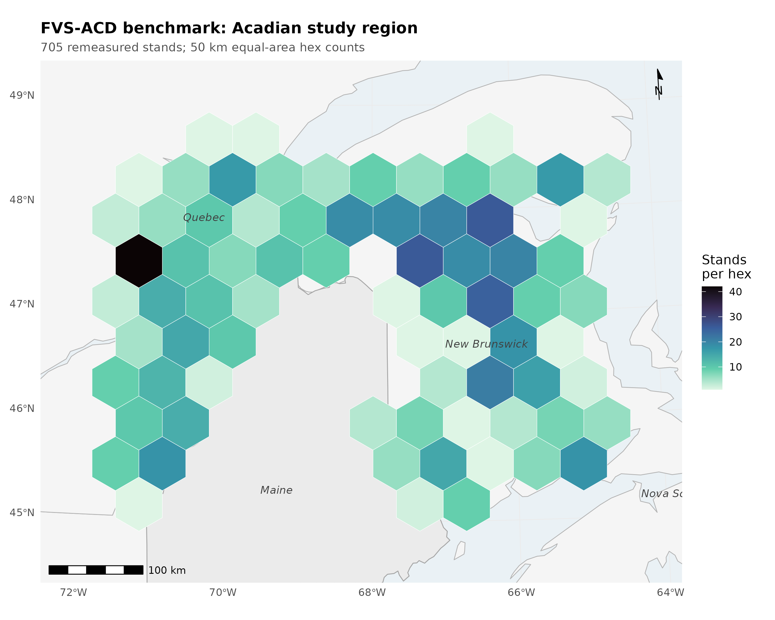
Figure 12. Locator of the Acadian study region with benchmark stand counts aggregated on a 50 km equal-area hex grid (New Brunswick n = 355, Quebec n = 350; true plot coordinates never released).
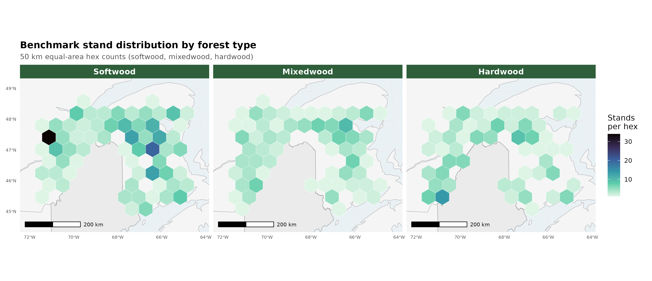
Figure 13. Benchmark stand counts on the same 50 km hex grid split into softwood (n = 321), mixedwood (n = 186), and hardwood (n = 178) panels.
The honest scorecard position. A five-way independent benchmark (v12.5.0, v12.7.0, v12.9.x, v12.10.1, and OSM v2.26.1) on the identical held-out in-domain data (MagPlot New Brunswick n=355 and ESI-covered Quebec n=350, plus recent Maine FIA for the growing-stand cross-check) places v12.10.1 level with v12.9.x on the pooled operational domain, both behind OSM there, and ahead of both on the managed cell. Because the frozen operational harness fully specifies the operational ops, v12.7.1, v12.9.x, and v12.10.1 are byte identical on the pooled base scorecard and differ only in the managed cells; the five-way therefore resolves to three distinct pooled engines, v12.5.0, v12.7.0, and the shared v12.7.1, v12.9.x, and v12.10.1 operational line.
Table 10.1. Pooled operational scorecard, v12.10.1 versus the comparison models (nine NSVB metrics).
model | mean absolute level bias (%) | mean modeling efficiency | TOST level equivalences (of 9)
v12.5.0 | 7.1 | 0.71 | 4
v12.7.0 | 8.0 | 0.73 | 2
v12.9.x | 4.9 | 0.71 | 7
v12.10.1 | 4.9 | 0.71 | 7
OSM v2.26.1 | 3.2 | 0.75 | 8
OSM keeps the best pooled level bias (3.2 versus 4.9), the best mean modeling efficiency (0.75 versus 0.71), and the most TOST level equivalences (8 versus 7 of 9, against four of nine for v12.5.0 and two of nine for v12.7.0). On the frozen harness every model's top height lands in a tight +3.7 to +4.6 percent band, so the apparent top-height over-prediction once read into the older 12.5.0 and 12.7.0 lines was an artifact of the pre-freeze basis and does not survive re-benching; the two older engines separate instead on volume, v12.5.0 a strong total-volume over-predictor (+9.3 percent, mean absolute level bias 7.1) and v12.7.0 a volume under-predictor (-8.3 percent, mean absolute level bias 8.0). v12.10.1 does not claim pooled parity. The point of v12.10.1 is the managed cell. The Chapter 11 gate closes the managed gap sharply in absolute basal-area bias, planted from -24.9 to -4.4 percent, PCT from -15.6 to -1.3 percent, and the managed class as a whole from -19.0 to -2.5 percent, and v12.10.1 beats OSM on every managed class in absolute basal-area bias (managed 2.5 versus 11.2, planted 4.4 versus 20.9, PCT 1.3 versus 5.4). One frozen-basis caveat to flag: gate-on planted total volume now sits at -10.8 percent, because the frozen anchor lowers untreated planted-stand volume so the fixed additive release closes less of the volume gap; the basal-area releases themselves are unchanged. On the pooled domain v12.10.1 and v12.9.x are identical to one decimal, because the modifier touches only managed stands and those are a small share of the in-domain pool, so pooled mean absolute bias (4.9), RMSE, and modeling efficiency all carry over from v12.9.x unchanged and the modifier's effect appears only in the managed cell. On the pooled domain the FVS-ACD advantage is quadratic mean diameter (about +1 percent versus OSM +11 percent), biological realism, transparency, and a climate-ready site driver, not pooled precision.
The forest-type scorecard. The pooled result hides a composition split. Classified by the softwood-basal-area fraction of the initial treelist (softwood at most 25 percent hardwood basal area, hardwood at least 75 percent, mixedwood between), the 705 in-domain stands resolve to softwood 321, mixedwood 186, and hardwood 178, with 20 unclassified stands excluded. The full nine-metric forest-type scorecard follows as signed level bias in percent for each of the five models on the frozen basis; bootstrap 95 percent confidence intervals and the green, yellow, and red flags for every cell are in Figure 7.
Table 10.2a. Softwood forest-type scorecard (n = 321), level bias (percent).
model | BA | SDI | QMD | TOPHT | TOTVOL | MERCHVOL | SAWVOL | BIOMASS | VALUE
v12.5.0 | +0.8 | +3.4 | -5.1 | -0.6 | +0.6 | +0.4 | -0.2 | +1.1 | +0.5
v12.7.0 | -16.0 | -14.2 | -1.5 | -1.4 | -16.4 | -16.5 | -16.9 | -16.2 | -16.4
v12.9.x | -14.0 | -12.8 | +0.1 | -1.2 | -14.1 | -14.2 | -14.7 | -14.1 | -14.1
v12.10.1 | -14.0 | -12.8 | +0.1 | -1.2 | -14.1 | -14.2 | -14.7 | -14.1 | -14.1
OSM | -2.3 | -3.2 | +8.1 | +3.9 | -1.0 | -1.0 | -0.8 | -1.4 | -1.1
Table 10.2b. Mixedwood forest-type scorecard (n = 186), level bias (percent).
model | BA | SDI | QMD | TOPHT | TOTVOL | MERCHVOL | SAWVOL | BIOMASS | VALUE
v12.5.0 | -2.1 | -0.7 | -4.9 | +3.2 | +7.2 | +6.7 | +6.3 | +6.4 | +8.8
v12.7.0 | -17.0 | -16.3 | -1.1 | +2.1 | -9.5 | -10.0 | -10.3 | -10.4 | -8.3
v12.9.x | -12.5 | -12.6 | +0.4 | +2.6 | -4.1 | -4.6 | -4.7 | -5.2 | -2.6
v12.10.1 | -12.5 | -12.6 | +0.4 | +2.6 | -4.1 | -4.6 | -4.7 | -5.2 | -2.6
OSM | -7.7 | -10.0 | +9.1 | +1.8 | -3.9 | -4.2 | -3.5 | -5.2 | -3.0
Table 10.2c. Hardwood forest-type scorecard (n = 178), level bias (percent).
model | BA | SDI | QMD | TOPHT | TOTVOL | MERCHVOL | SAWVOL | BIOMASS | VALUE
v12.5.0 | +15.3 | +18.2 | -7.1 | +12.3 | +31.3 | +30.0 | +30.6 | +30.8 | +32.8
v12.7.0 | -1.9 | -0.3 | -1.4 | +11.4 | +11.4 | +10.2 | +10.8 | +10.6 | +12.7
v12.9.x | +3.9 | +4.3 | +0.6 | +11.7 | +19.0 | +17.6 | +18.4 | +17.9 | +20.4
v12.10.1 | +3.9 | +4.3 | +0.6 | +11.7 | +19.0 | +17.6 | +18.4 | +17.9 | +20.4
OSM | +7.1 | +2.6 | +16.5 | +6.9 | +14.6 | +13.1 | +14.6 | +13.6 | +16.0
Read across composition, the softwood block is the pooled volume story in miniature: the shared newer build under-reads every merchantable output by about 14 percent and flags red on all five, while OSM holds all five within about 1.5 percent of zero and flags green, and structure is clean for the newer build with quadratic mean diameter and top height inside 1.2 percent even as basal area sits at -14.0. Mixedwood is the most balanced stratum, the shared newer build and OSM both inside about 5 percent on every volume metric. Hardwood is the shared frontier, every model over-reading the merchantable outputs, the shared newer build by 18 to 20 percent and OSM by 13 to 16, all red, confirming a composition-driven ceiling for the v13 composition-aware refit rather than a management-modifier problem.
The accuracy-and-precision view (percent RMSE). Percent bias measures only systematic offset, and it inflates on metrics with low means, so a small absolute error reads as a large percentage. To score accuracy and precision together we add the percent RMSE, %RMSE = 100 × RMSE / mean(observed) with RMSE = sqrt(mean((observed − predicted)²)), which penalises both systematic error and scatter and so is the fairer accuracy-and-precision summary. Uncertainty is a within-province stratified bootstrap (2000 replicates), resampling stands within New Brunswick and Quebec.
Table 10.2d. Percent RMSE by model and metric, pooled in-domain set (n = 705). Lower is better.
metric | v12.5.0 | v12.7.0 | v12.9.x | v12.10.1 | OSM
BA | 40.8 | 45.3 | 45.8 | 45.8 | 39.6
SDI | 40.9 | 45.9 | 46.2 | 46.2 | 39.6
QMD | 27.8 | 25.4 | 25.7 | 25.7 | 29.1
TOPHT | 18.8 | 18.2 | 18.4 | 18.4 | 16.1
TOTVOL | 56.0 | 52.3 | 55.2 | 55.2 | 51.1
MERCHVOL | 53.6 | 50.9 | 53.4 | 53.4 | 49.0
SAWVOL | 57.7 | 55.1 | 57.8 | 57.8 | 53.4
BIOMASS | 52.2 | 47.9 | 50.6 | 50.6 | 47.2
VALUE | 62.0 | 55.8 | 59.4 | 59.4 | 56.3
Structure metrics are tight (top height near 18 percent, quadratic mean diameter near 26); the merchantable outputs carry the scatter, total volume, sawlog volume, and value all in the mid-50s to low-60s percent even where mean bias is only a few percent. On the pooled set v12.10.1 total volume is 55.2 percent and value 59.4; OSM is a little lower at 51.1 and 56.3. This reframes the hardwood result. Hardwood error is scatter-dominated, not bias-dominated: v12.10.1 hardwood total volume carries a mean bias of about +19 percent but a %RMSE of about 76 percent, and value about +20 percent bias against about 81 percent %RMSE, with OSM similar (hardwood total-volume %RMSE about 75 percent, value about 80). The percentage bias understates the true error because most of that error is variance, so hardwood is a high-variance frontier shared by all five models rather than a systematic defect of any one build. Figure 11 is the %RMSE scorecard with within-province bootstrap intervals.
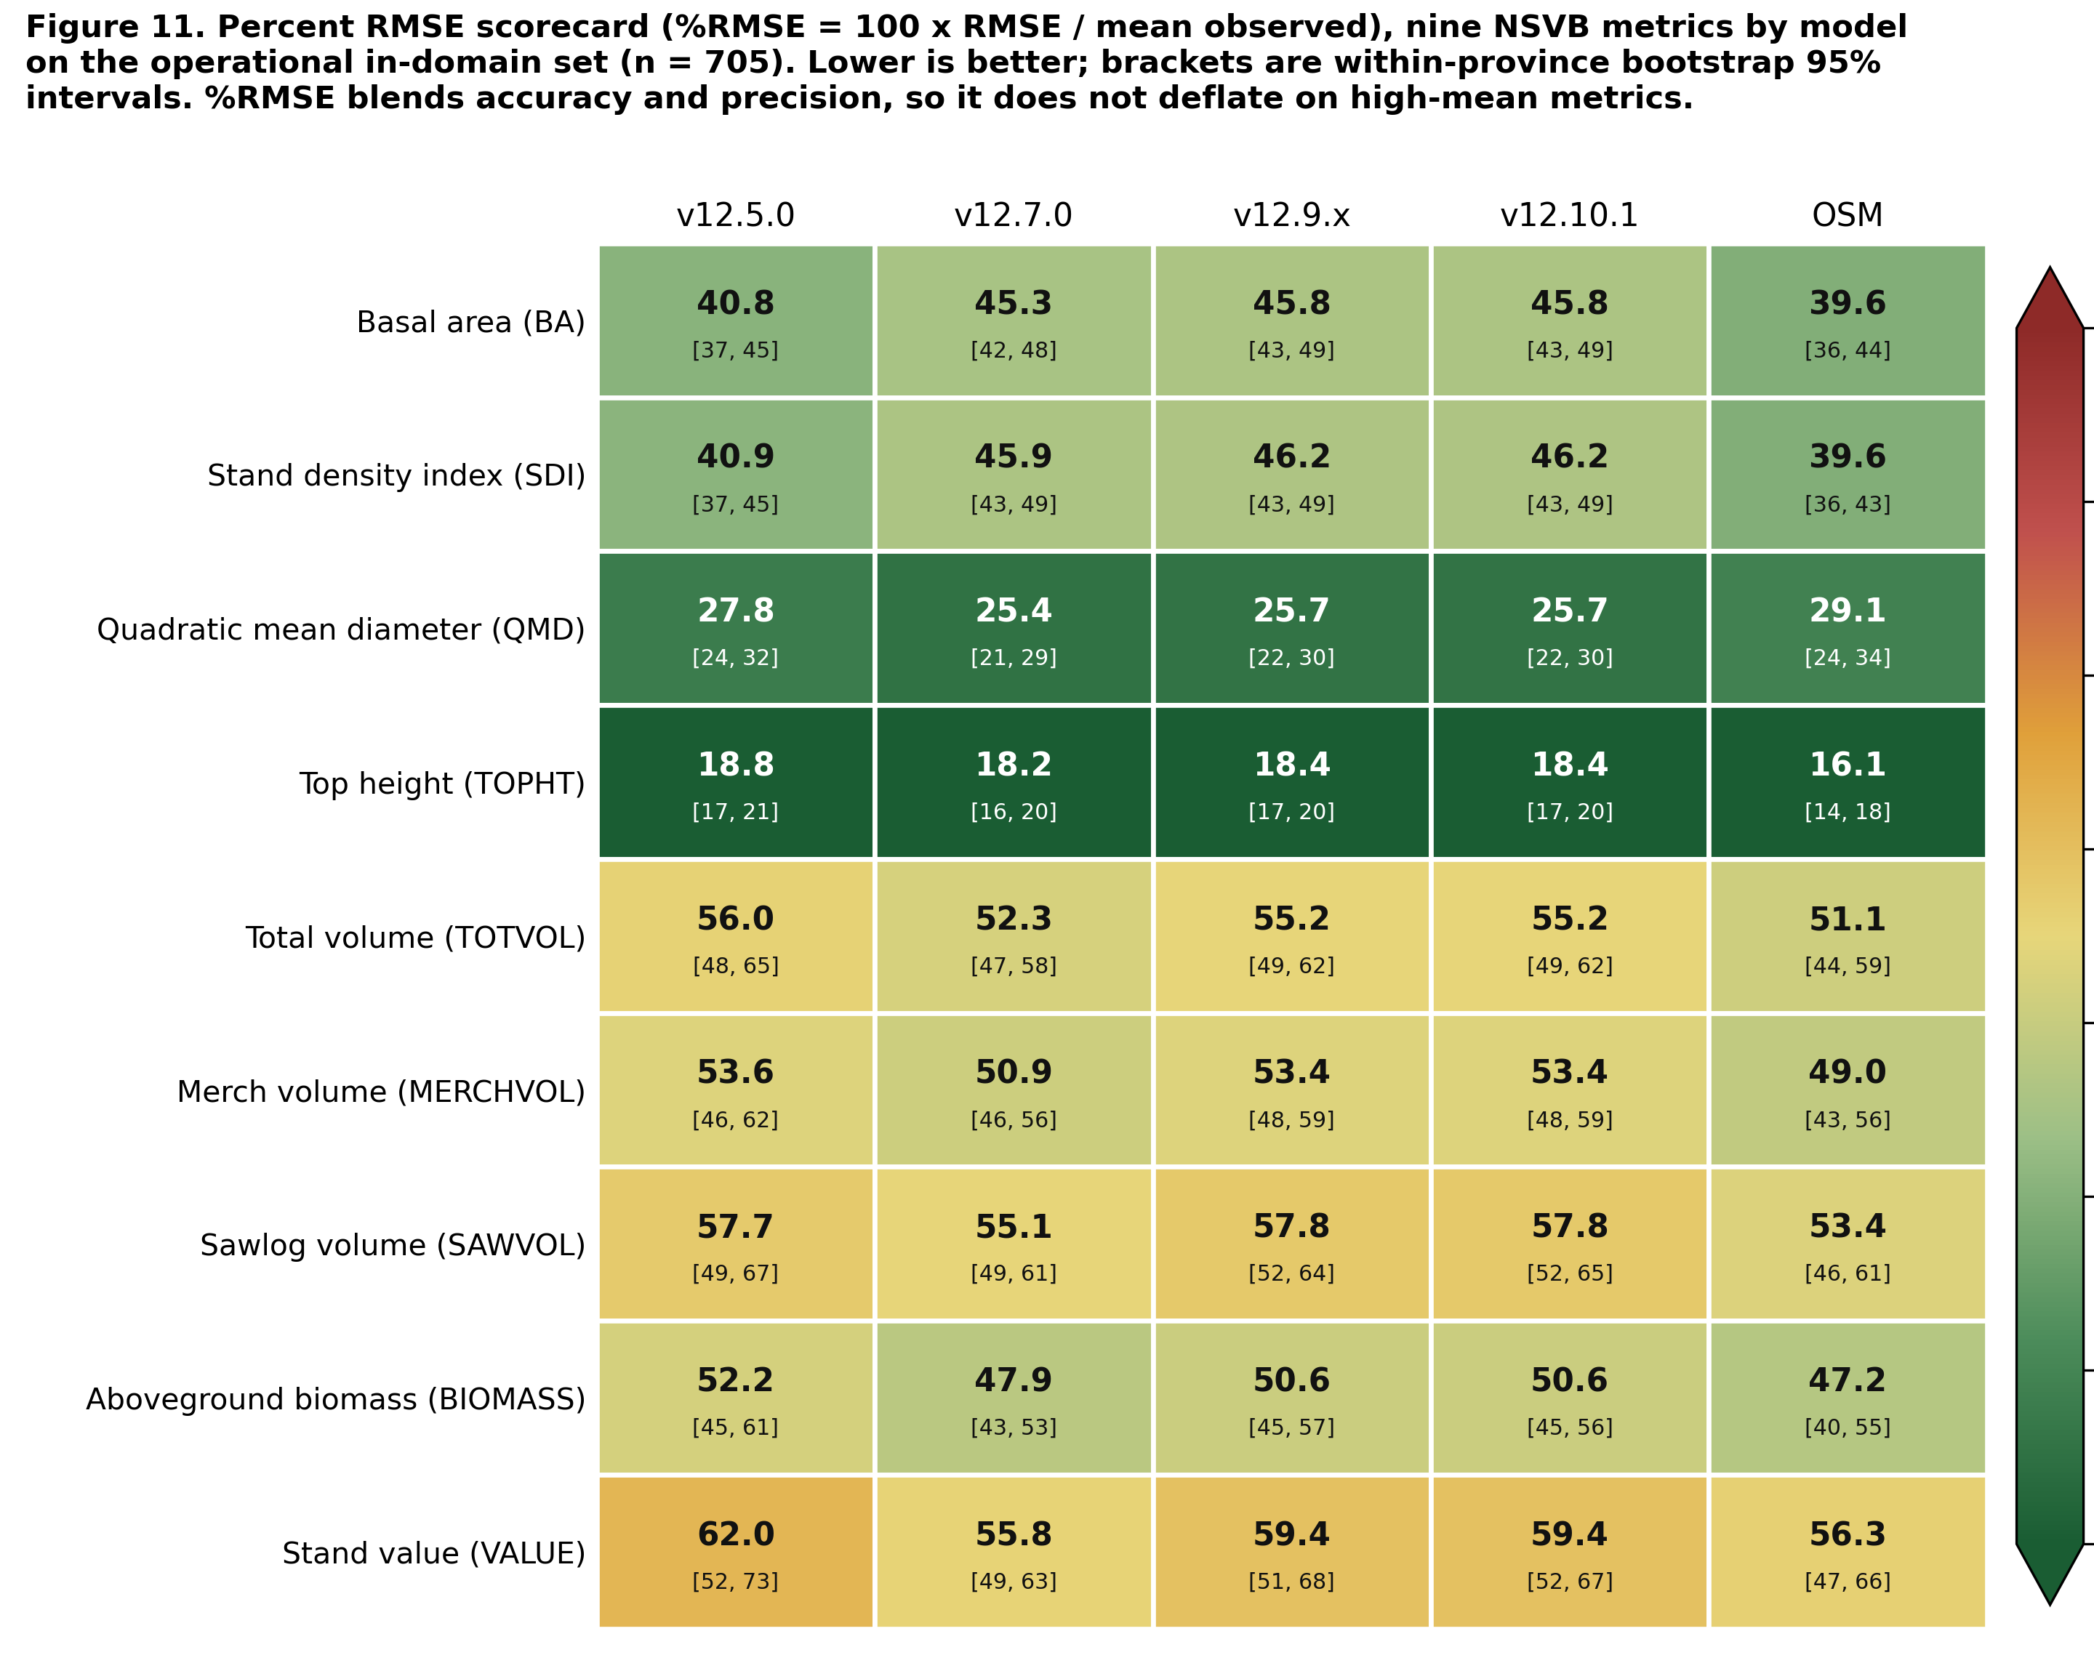
Figure 11. Percent RMSE scorecard, the model by metric heatmap of %RMSE across the nine NSVB metrics for the five models on the pooled in-domain set, with within-province bootstrap intervals in each cell.
Observed-on-predicted regression and the region of equivalence. For each model, metric, and stratum we fit the ordinary least squares regression of observed on predicted, observed = a + b × predicted, and test slope and intercept jointly with a Robinson and Froese (2004) equivalence test (two one-sided tests at alpha = 0.05): the intercept is equivalent to zero when its 90 percent interval lies within plus or minus 25 percent of the mean observed value, and the slope is equivalent to one when its interval lies in 0.75 to 1.25, with overall equivalence requiring both. This regression equivalence complements the paired-difference TOST reported with Table 10.1. Because observed is regressed on predicted, a slope above one means the model under-predicts the high end.
Table 10.2e. Observed-on-predicted regression and equivalence flags, pooled in-domain set (n = 705), key metrics. TRUE means the parameter's 90 percent interval lies inside its region of equivalence.
metric | model | slope b | intercept a | R² | slope equiv | intercept equiv | overall
BA | v12.5.0 | 0.93 | 0.72 | 0.73 | TRUE | TRUE | TRUE
BA | v12.7.0 | 1.21 | -0.81 | 0.71 | FALSE | TRUE | FALSE
BA | v12.9.x | 1.14 | -0.42 | 0.68 | TRUE | TRUE | TRUE
BA | v12.10.1 | 1.14 | -0.42 | 0.68 | TRUE | TRUE | TRUE
BA | OSM | 0.98 | 0.79 | 0.74 | TRUE | TRUE | TRUE
TOTVOL | v12.5.0 | 0.83 | 8.45 | 0.74 | TRUE | TRUE | TRUE
TOTVOL | v12.7.0 | 1.04 | 4.02 | 0.75 | TRUE | TRUE | TRUE
TOTVOL | v12.9.x | 0.99 | 5.08 | 0.71 | TRUE | TRUE | TRUE
TOTVOL | v12.10.1 | 0.99 | 5.08 | 0.71 | TRUE | TRUE | TRUE
TOTVOL | OSM | 0.95 | 2.96 | 0.75 | TRUE | TRUE | TRUE
VALUE | v12.5.0 | 0.81 | 419.6 | 0.73 | TRUE | TRUE | TRUE
VALUE | v12.7.0 | 1.01 | 230.2 | 0.74 | TRUE | TRUE | TRUE
VALUE | v12.9.x | 0.95 | 303.0 | 0.71 | TRUE | TRUE | TRUE
VALUE | v12.10.1 | 0.95 | 303.0 | 0.71 | TRUE | TRUE | TRUE
VALUE | OSM | 0.93 | 177.5 | 0.74 | TRUE | TRUE | TRUE
Across all nine metrics, four of the five models pass the joint equivalence test on every metric (nine of nine). The single exception is v12.7.0 basal area, whose slope of 1.21 sits just outside the 0.75 to 1.25 region once its confidence interval is included; its intercept still passes, and its volume and value slopes are essentially one. Every volume and value cell passes overall equivalence for all five models, with total-volume slopes 0.83 to 1.04 and value slopes 0.81 to 1.01, and the operational build v12.10.1 tracks the 1:1 line with a total-volume slope of 0.99 and a value slope of 0.95. Equivalence is a stricter, more transparent claim than a low p-value on a difference test, stating the size of the departure tolerated up front. Figure 10 is the observed-versus-predicted equivalence plot.
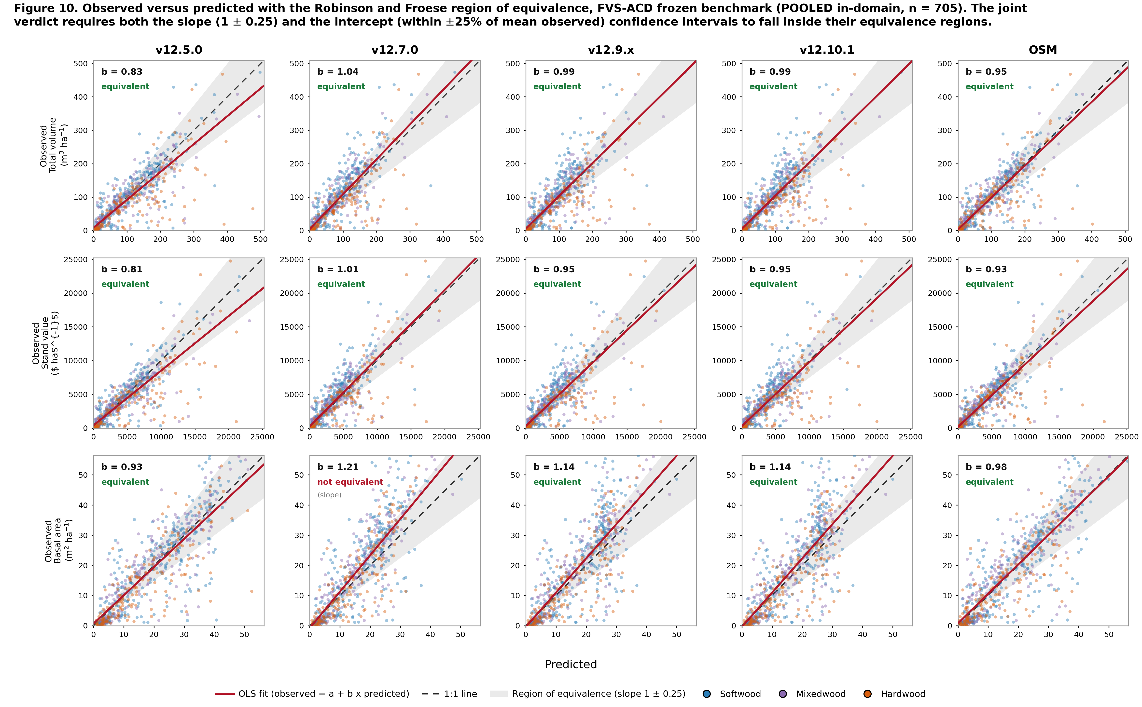
Figure 10. Observed-versus-predicted equivalence plot, faceted with total volume, value, and basal area as rows and the five models as columns. Each panel shows the per-stand cloud coloured by forest type, the 1:1 line, the OLS fit, and the shaded Robinson-Froese region of equivalence, annotated with the slope b and the joint verdict. Pooled in-domain set (n = 705).
The overall composite score. To collapse the nine metrics into one number per model, each model earns a composite score from 0 to 100, higher is better. We compute two composites and lead with the accuracy-and-precision view, because %RMSE (Table 10.2d) scores systematic error and scatter together where bias alone flatters a low-scatter but biased build. The primary composite is built on %RMSE: each metric earns a score of 100 × max(0, 1 − %RMSE / 100), and the composite is the weighted mean of the nine metric scores with total volume and stumpage value carrying the highest weight (total volume 3, value 3, the other three merchantable outputs 2 each, the four structure metrics 1 each, for a weight sum of 16). The complementary composite is the earlier bias-and-efficiency blend: per metric a bias score of 100 × (1 − min(1, |bias| / 20)) blended equally with an efficiency score of 100 × max(0, NSE), combined under the same volume-and-value weighting, with an equal-weight mean carried as a reference. This volume and value first weighting reflects the operational priority that a growth engine reproduce harvest volume and value before stand structure.
Table 10.3a. Primary %RMSE-weighted composite score (0 to 100, higher is better), volume and value weighting, by model and stratum.
model | pooled in-domain | softwood | mixedwood | hardwood
OSM | 53.4 | 61.6 | 59.5 | 34.4
v12.7.0 | 52.1 | 56.3 | 59.1 | 39.2
v12.9.x | 49.8 | 55.3 | 58.2 | 33.4
v12.10.1 | 49.8 | 55.3 | 58.2 | 33.4
v12.5.0 | 49.4 | 61.2 | 57.8 | 23.5
On the pooled set the %RMSE composite ranks OSM first (53.4), v12.7.0 second (52.1), v12.9.x and v12.10.1 tied at 49.8, and v12.5.0 at 49.4. The two views diverge on v12.7.0: it ranks low on the bias composite (Table 10.3b) because it carries real systematic offsets, but rises to second on %RMSE because its predictions are less scattered once systematic and random error are scored together, while v12.10.1 is the least biased of the FVS-ACD engines with slightly more scatter, leading v12.7.0 on bias but tying v12.9.x just behind it on %RMSE. OSM stays first on both. Every model scores far lower on hardwood, the shared high-variance frontier of the %RMSE section above.
Table 10.3b. Complementary bias-and-efficiency composite score (0 to 100, higher is better), primary volume and value weighting, by model and stratum, with the pooled equal-weight composite for reference.
model | pooled in-domain | softwood | mixedwood | hardwood | pooled equal-weight
OSM | 80.9 | 85.3 | 76.1 | 47.0 | 79.3
v12.9.x | 74.3 | 55.7 | 74.8 | 40.4 | 73.0
v12.10.1 | 74.3 | 55.7 | 74.8 | 40.4 | 73.0
v12.5.0 | 64.9 | 87.4 | 71.6 | 26.3 | 67.9
v12.7.0 | 66.5 | 51.3 | 63.7 | 58.5 | 66.4
The pooled ranking is robust at the top and to the choice of weighting: OSM leads and the shared newer build (v12.9.x and v12.10.1, identical on the base) sits second on both the primary volume and value weighting and the equal-weight reference, with only the two oldest engines trading the fourth and fifth positions, v12.7.0 rising above v12.5.0 once volume and value dominate the score. Within forest types the top two are unchanged between weightings in every stratum, while the by-type ordering shifts with composition: softwood is led by v12.5.0 then OSM, mixedwood and the pooled set by OSM, and hardwood by v12.7.0, whose flatter hardwood bias scores best on the one stratum where every newer build over-reads. Figure 8 shows the pooled ranking, the equal-weight reference, and the by-forest-type composites overlaid.
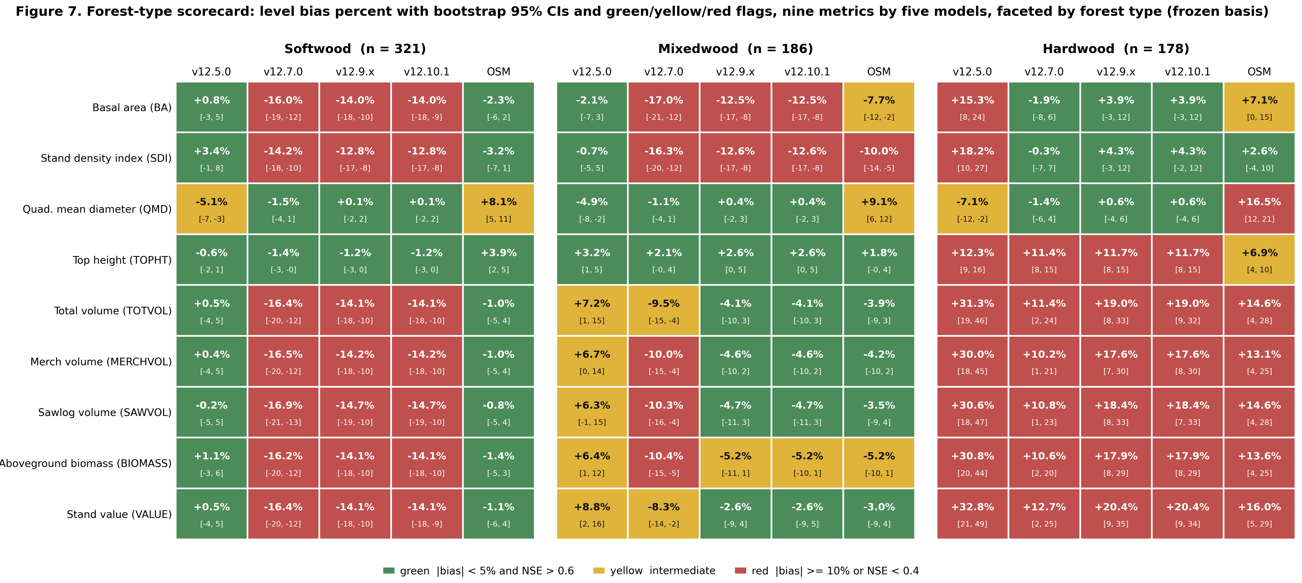
Figure 7. Forest-type scorecard, level bias percent with bootstrap 95 percent CIs and green, yellow, and red flags, nine metrics by five models faceted by forest type (softwood n = 321, mixedwood n = 186, hardwood n = 178) on the frozen basis.
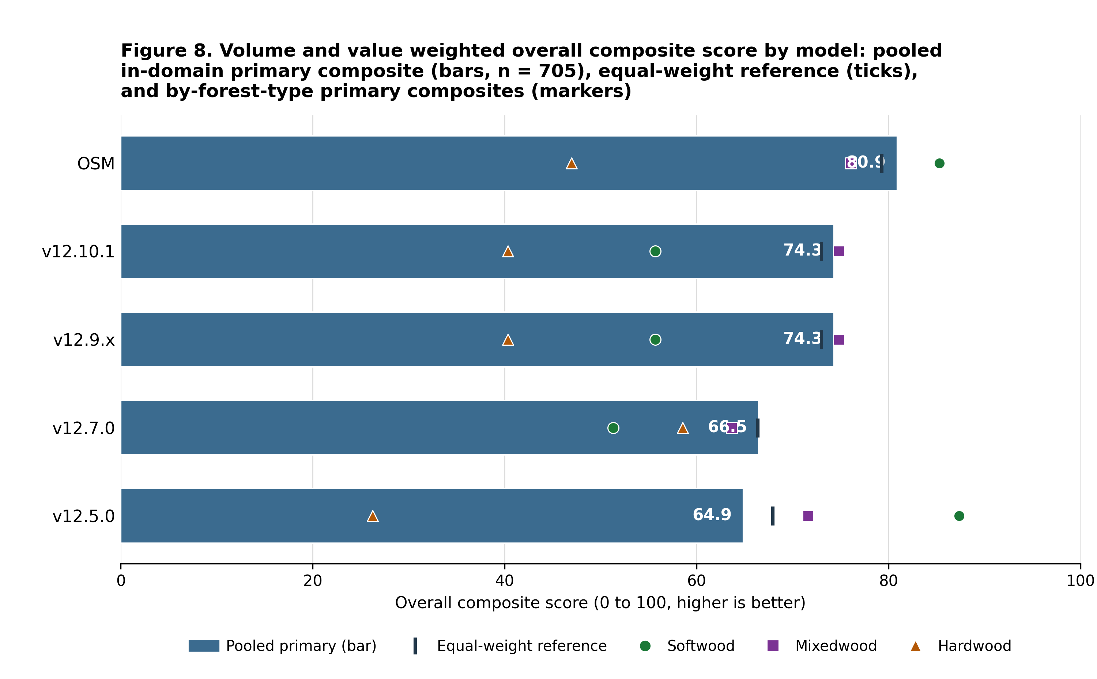
Figure 8. Volume and value weighted overall composite score by model, the pooled in-domain primary composite (total volume and value weighted highest) as ranked bars, the equal-weight composite as a reference tick on each bar, and the by-forest-type primary composites overlaid as markers.
Biological realism (Bakuzis pass). v12.10.1 inherits the v12.9.x self-thinning machinery and, on seeded 160-year projections across the ESI gradient, passes all five relations on the modified Bakuzis matrix (Leary 1997): Eichhorn (volume a function of height), Reineke self-thinning slope (fitted -1.59 against a -1.6 target), site ordering with no overtaking, the yield-density plateau (about 36 m² ha⁻¹), and Sukachev (size versus density). With the management modifier on, a seeded planted-softwood projection still plateaus at every amplitude tested (standard deviation of basal area over the last 20 years about 0.21, flat), and the ceiling rises smoothly with amplitude because basal area at the Reineke limit rises with tree size. By contrast v12.5.0 fails self-thinning outright in the same seeded battery. OSM now enters the matrix as an external entrant, scored where its long-horizon behavior is observable on the matched-stand Seven Islands trajectory. It flags both size-density relations, Reineke self-thinning and the yield-density plateau, because its stand-level basal area never plateaus and never self-thins, accumulating monotonically from about 32 to 42 m² ha⁻¹ by age 60 while the AcadianGY builds peak near 33 and self-thin back to about 27; that non-plateau accumulation is the central point of biological-realism separation between OSM and the v12.7.1 and later builds. OSM is marked not scored, rather than passed, on Eichhorn, site ordering, and Sukachev, each of which is defined only on the seeded cross-site productivity gradient that an external model cannot be run on, so no honest pass or flag can be assigned there.
Table 10.3c. Modified Bakuzis pass and flag matrix (Leary 1997) by model and law-like relation. OSM is scored only on the two size-density relations observable from its matched-stand trajectory and marked not scored on the three relations defined only on the seeded gradient.
relation | v12.5.0 | v12.7.0 | v12.9.x | v12.10.1 | OSM
Eichhorn (V ~ f height) | pass | pass | pass | pass | not scored
Reineke slope (target -1.6) | flag | pass (-1.8) | pass (-1.59) | pass (-1.59) | flag
Site ordering (no overtaking) | pass | pass | pass | pass | not scored
Yield-density / plateau | flag | pass (37) | pass (36) | pass (36) | flag
Sukachev (size vs density) | flag | pass | pass | pass | not scored
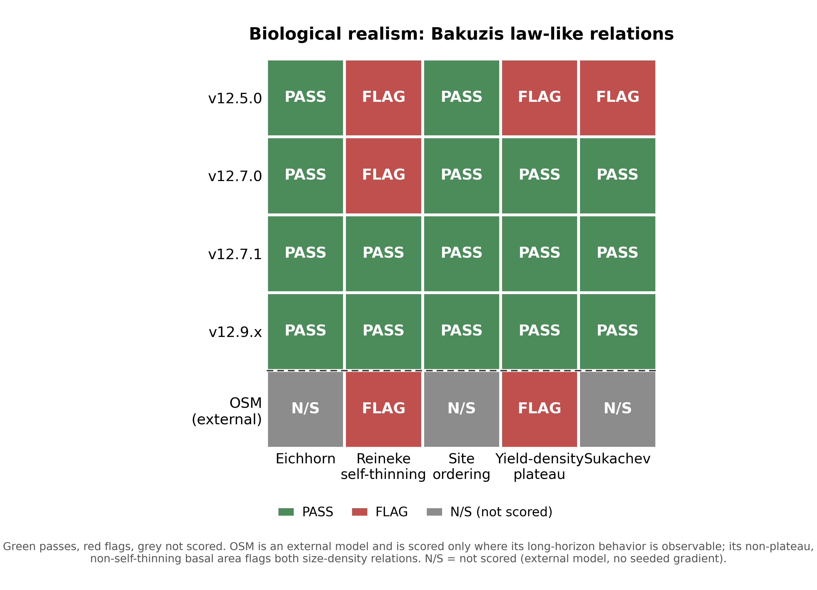
Modified Bakuzis law-like relations matrix by model.
Figure 3. Modified Bakuzis matrix (Leary 1997) of law-like stand relationships evaluated on seeded 160-year projections across the ESI productivity gradient, showing the pass and flag pattern for each AcadianGY version and the external OSM entrant on the five relations (Eichhorn, Reineke self-thinning, site ordering, yield-density plateau, and Sukachev). OSM is scored only on the two size-density relations observable from its matched-stand trajectory and marked not scored on the three relations defined only on the seeded gradient.
Disclosed ingrowth limit. Observed MagPlot recruitment, tree-id matched across remeasurements, is 39.8 stems ha⁻¹ yr⁻¹ in New Brunswick and 19.7 in Quebec. The shipped expected-value ingrowth hurdle predicts 17.9 and 11.7 stems ha⁻¹ yr⁻¹, about 45 percent of observed in New Brunswick and 59 percent in Quebec. Recruitment responds in the correct direction to density and management (planted and PCT stands, which carry lower residual density, recruit more than unmanaged), and the expected-value hurdle lifted recruitment well off the near-zero floor of the classic 2018 too-infrequent FVS-ACD problem, but a residual under-prediction of the absolute level remains. This is neither the 2018 near-zero failure nor an inflated recruitment; it is a real, moderate under-prediction, disclosed as a limit and a target for the v13 ingrowth refit. It does not change the shipped version and does not touch the managed-cell scorecard, which is a volume and basal-area result on the tag threshold.
Pooled parity was tested and deferred. A top-height anchor-level correction was tested as a reach for pooled parity with OSM and deferred to v13.0. In the shipped config a top-height over-prediction of about +4 percent only partly offsets a basal-area under-prediction of about -10 percent, so FVS-ACD total volume sits modestly under observed on the unmanaged core, about -4 percent, rather than near zero. Correcting top height alone removes the offsetting positive term and drives total volume further below observed rather than toward zero, widening rather than closing the pooled mean absolute bias gap to OSM. True parity therefore needs a joint re-anchor of dominant height and basal area together, recorded as the v13.0 domain-plus-increment refit. The gated lever exists in the source (neutral factor reproduces v12.10.1) but is not adopted for the operational version.

10.3.1 Species composition over time
Stand species composition is defined as the basal-area fraction by species group, using live trees at least 4 cm DBH: softwood versus hardwood, and a three-way split into spruce-fir (Abies + Picea), other softwood, and hardwood. For each benchmark stand we have a starting state (t1) and an observed endpoint (t2) from the MagPlot QC and NB remeasured treelists, and each model predicts the endpoint. Predicted composition for the FVS-ACD flagships (v12.5.0, v12.7.0, v12.10.1) comes from a non-invasive composition re-run of the frozen benchmark harness that emits per-group basal area at t2; the run reproduces the frozen August operational baseline (NB_AFAC 0.579, QC_AFAC 0.111) with zero difference against cb_v12101 on all nine stand totals. OSM predicted composition is taken directly from its head-to-head predicted treelist. The stand set is the frozen scorecard pooled set of 705 unique stands; 25 stands lacked classifiable t1 basal area, leaving 680. Forest type is the committed percent-hardwood rule applied to the t1 treelist (softwood at most 25 percent hardwood BA, hardwood at least 75 percent, else mixedwood). Bias is predicted minus observed softwood fraction in percentage points (pts); the shift ratio is predicted mean shift divided by observed mean shift, so 1.0 is a perfect match and a negative value is a wrong-direction move.
Table 10.4. Observed and predicted softwood basal-area fraction across the remeasurement interval, pooled and by forest type, on the frozen benchmark (n = 680 classifiable stands of the frozen 705). Fractions are percentages; bias and shifts are in percentage points.
Model | Stratum | n | Obs t1 (%) | Obs t2 (%) | Pred t2 (%) | Obs shift (pts) | Pred shift (pts) | Bias (pts) | Direction | Shift ratio
v12.5.0 | Pooled | 680 | 59.9 | 60.7 | 59.5 | +0.82 | -0.45 | -1.27 | wrong | -0.55
v12.5.0 | Softwood | 320 | 94.0 | 92.0 | 92.6 | -1.95 | -1.41 | +0.54 | right | 0.72
v12.5.0 | Mixedwood | 186 | 51.7 | 51.3 | 51.5 | -0.40 | -0.24 | +0.17 | right | 0.59
v12.5.0 | Hardwood | 174 | 6.1 | 13.3 | 7.2 | +7.20 | +1.08 | -6.13 | right | 0.15
v12.7.0 | Pooled | 680 | 59.9 | 60.7 | 59.6 | +0.82 | -0.30 | -1.11 | wrong | -0.37
v12.7.0 | Softwood | 320 | 94.0 | 92.0 | 92.8 | -1.95 | -1.11 | +0.84 | right | 0.57
v12.7.0 | Mixedwood | 186 | 51.7 | 51.3 | 51.6 | -0.40 | -0.11 | +0.30 | right | 0.26
v12.7.0 | Hardwood | 174 | 6.1 | 13.3 | 7.1 | +7.20 | +1.00 | -6.21 | right | 0.14
v12.10.1 | Pooled | 680 | 59.9 | 60.7 | 59.7 | +0.82 | -0.26 | -1.08 | wrong | -0.32
v12.10.1 | Softwood | 320 | 94.0 | 92.0 | 92.9 | -1.95 | -1.06 | +0.89 | right | 0.54
v12.10.1 | Mixedwood | 186 | 51.7 | 51.3 | 51.7 | -0.40 | -0.05 | +0.35 | right | 0.14
v12.10.1 | Hardwood | 174 | 6.1 | 13.3 | 7.1 | +7.20 | +0.98 | -6.22 | right | 0.14
OSM | Pooled | 680 | 59.9 | 60.7 | 60.8 | +0.82 | +0.88 | +0.06 | right | 1.08
OSM | Softwood | 320 | 94.0 | 92.0 | 94.0 | -1.95 | +0.02 | +1.97 | wrong | -0.01
OSM | Mixedwood | 186 | 51.7 | 51.3 | 53.5 | -0.40 | +1.81 | +2.21 | wrong | -4.49
OSM | Hardwood | 174 | 6.1 | 13.3 | 7.6 | +7.20 | +1.46 | -5.74 | right | 0.20
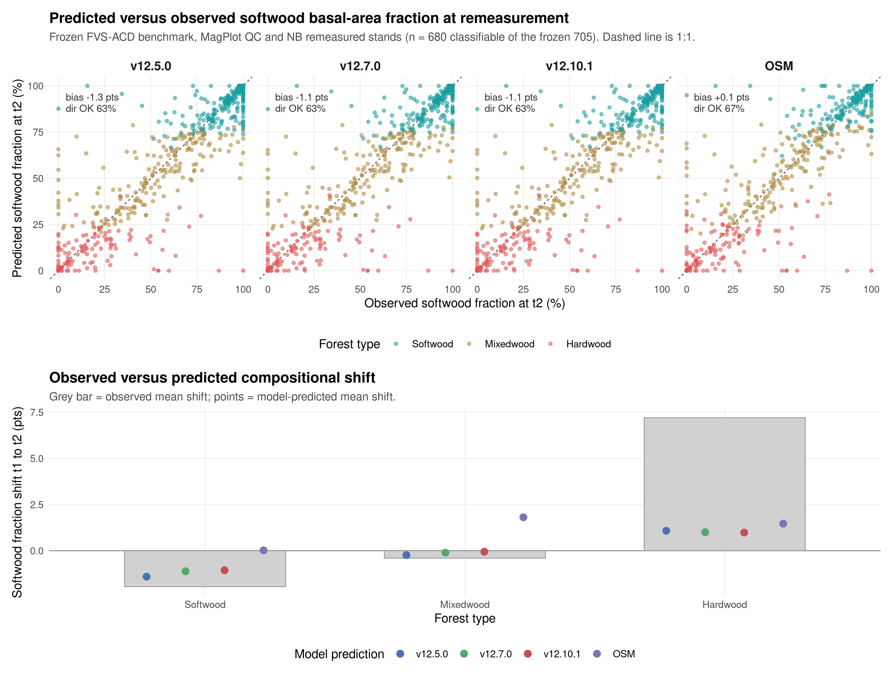
Figure 9. Predicted versus observed softwood basal-area fraction at the remeasurement endpoint (t2) by model, with the 1:1 line (top), and the observed versus predicted mean compositional shift from t1 to t2 by forest type (bottom). Points are colored by committed forest type. Frozen benchmark, MagPlot QC and NB remeasured stands.
Stand composition is nearly stationary across the interval: the pooled mean softwood fraction moves less than one point (59.9% to 60.7%), and the only large observed signal is a +7.2 pt softwood gain in hardwood-dominated stands, partly offset by a -1.9 pt softwood loss in softwood stands. All three FVS-ACD models reproduce the direction of change within softwood and mixedwood stands but under-shift by roughly a third to a half, and they miss the pooled net direction, predicting a small softwood decline (-0.3 to -0.5 pt) against the observed +0.8 pt increase, because they under-represent softwood in-migration into hardwood stands (predicted about +1.0 pt versus observed +7.2 pt, bias near -6 pts). OSM best tracks the pooled net shift (+0.9 pt, ratio 1.08) but overshoots softwood in mixedwood and softwood stands; the spruce-fir split tells the same story, with the observed +7.0 pt spruce-fir gain in hardwood stands under-predicted by every model. Every model holds stand-level softwood fraction within about 1 to 2 pts of observed in softwood and mixedwood types, so overall composition is preserved and the shared weakness is the rate of softwood recolonization of hardwood-dominated stands.

10.4 Planned v13
The v13 program addresses the disclosed limits above rather than the operational cell v12.10.1 already wins. It moves from gated levers on fixed equations to refitted, site-driven, region-and-composition-aware component equations with uncertainty, each step gated by the same multi-dimensional scorecard against the prior version and OSM. The program is planned in four releases and none is gated as of this writing, so nothing below is a result. It is the roadmap, not a claim.
The first release, v13.0, was a joint dominant-height and basal-area re-anchor aimed at the partial error cancellation that leaves total volume modestly under observed on the unmanaged core (section 10.3), where the top-height over-prediction and the basal-area under-prediction partly offset each other. A one-sided top-height lever tested earlier drove volume further negative, and a narrow height re-anchor fix run this cycle, a blend sweep across weights 0.50 to 1.00, parked at every setting: none reached pooled parity without reopening the offset, so the v13.0 height path is exhausted for now and stays parked. The validated basal-area increment correction, individually unbiased on the expanded Maine, New Hampshire, and Vermont remeasurement data, is retained and carried forward into the v13.1 cycle. v12.10.1 remains the frozen operational baseline.
The second release, v13.1, is a Bayesian hierarchical refit of mortality and ingrowth with region, ecoregion, and forest-type random effects and the brms maximum-SDI posterior as the self-thinning asymptote. Fitting the two components as a system with shared random effects estimates directly the regional and composition structure now carried by the gated SDImax multiplier and the two-segment relative-density knob, so the growing and mature tails become separable by construction, and it targets the disclosed ingrowth limit (section 10.3) by matching observed recruitment (about 40 stems ha⁻¹ yr⁻¹ in New Brunswick, 20 in Quebec) rather than under-predicting it, and it now also carries the retained basal-area increment correction from the v13.0 cycle. The hierarchical fits carry parameter and residual uncertainty into prediction intervals, a scorecard dimension v12 does not satisfy. The refit is running on the cluster with convergence pending; no v13.1 scorecard numbers exist yet.
The third release, v13.2, carries management as a growth-scale release estimated per tree, so the additive stand-level release of v12.10.1 (section 10.3) is reproduced through the full engine by a fitted per-tree amplitude rather than a post-hoc net release applied at the stand level.
The fourth release, v13.3, adds a climate-scenario mode driven by the current and future site-productivity surfaces, kept separate from the validated base so that projections can be run under alternative climate normals without ever benchmarking on a projected surface.
Until v13 is gated, v12.10.1 is the recommended operational version for inventory projection, with v12.7.1 retained for long-horizon carbon and old-growth work on the specific hardwood population where the v12.9.x flat multiplier under-shoots the realistic plateau.

11. Literature Cited
Castle, M., Weiskittel, A., Wagner, R.G., Ducey, M.J., Frank, J., and Pelletier, G. 2018. Evaluating the influence of stem form and damage on individual-tree diameter increment and survival in the Acadian Region: implications for predicting future value of northern commercial hardwood stands. Canadian Journal of Forest Research 48: 1007-1019.
Chen, C. (Cen Chen), Weiskittel, A., Bataineh, M., and MacLean, D.A. 2018. Refining the Forest Vegetation Simulator for projecting the effects of spruce budworm defoliation in the Acadian Region of North America. The Forestry Chronicle 94(3): 240-253. doi:10.5558/tfc2018-037. The in-text callout "Cen et al. 2018" uses the first author's given name; reconcile it to Chen et al. 2018.
Chen, C., Kershaw, J.A., Weiskittel, A.R., and McGarrigle, E. 2023. Can a multistage approach improve individual tree mortality predictions across the complex mixed-species and managed forests of eastern North America? Forest Ecosystems 10: 100086. Cited in the text as Chen et al., in preparation.
Dixon, G.E. (comp.). 2002 (revised regularly). Essential FVS: A User's Guide to the Forest Vegetation Simulator. Internal report. USDA Forest Service, Forest Management Service Center, Fort Collins, CO.
FVS Staff. 2008 (revised August 2023). Northeast (NE) Variant Overview: Forest Vegetation Simulator. USDA Forest Service, Forest Management Service Center, Fort Collins, CO.
Kuehne, C., Weiskittel, A.R., Wagner, R.G., and Roth, B.E. 2016. Development and evaluation of individual tree- and stand-level approaches for predicting spruce-fir response to commercial thinning in Maine, USA. Forest Ecology and Management 376: 84-95.
Kuehne, C., Weiskittel, A.R., and Kershaw, J.A. 2022. Development and evaluation of refined annualized individual tree diameter and height increment equations for the Acadian variant of the Forest Vegetation Simulator. Mathematical and Computational Forestry and Natural Resource Sciences 14: 9-31.
Leary, R.A. 1997. Testing models of unthinned red pine plantation dynamics using a modified Bakuzis matrix of stand properties. Ecological Modelling 98: 35-46.
Li, R., Weiskittel, A.R., and Kershaw, J.A., Jr. 2011. Modeling annualized occurrence, frequency, and composition of ingrowth using mixed-effects zero-inflated models and permanent plots in the Acadian Forest Region of North America. Canadian Journal of Forest Research 41(10): 2077-2089. doi:10.1139/x11-117.
Li, R., Weiskittel, A., Dick, A.R., Kershaw, J.A., and Seymour, R.S. 2012. Regional stem taper equations for eleven conifer species in the Acadian Region of North America: development and assessment. Northern Journal of Applied Forestry 29(1): 5-14.
Loo, J., and Ives, N. 2003. The Acadian forest: historical condition and human impacts. The Forestry Chronicle 79(3): 462-474.
Rijal, B., Weiskittel, A.R., and Kershaw, J.A. 2012a. Development of regional height to diameter equations for 15 tree species in the North American Acadian Region. Forestry: An International Journal of Forest Research 85(3): 379-390.
Rijal, B., Weiskittel, A.R., and Kershaw, J.A. 2012b. Development of height to crown base models for thirteen tree species of the North American Acadian Region. The Forestry Chronicle 88(1): 60-73.
Russell, M.B., and Weiskittel, A.R. 2011. Maximum and largest crown width equations for 15 tree species in Maine. Northern Journal of Applied Forestry 28(2): 84-91.
Russell, M.B., Weiskittel, A.R., and Kershaw, J.A. 2014. Comparing strategies for modeling individual-tree height and height-to-crown base increment in mixed-species Acadian forests of northeastern North America. European Journal of Forest Research 133: 1121-1135.
Weiskittel, A.R., Crookston, N.L., and Radtke, P.J. 2011. Linking climate, gross primary productivity, and site index across forests of the western United States. Canadian Journal of Forest Research 41: 1710-1721.
Weiskittel, A.R., and Li, R. 2012. Bark ratio (diameter outside bark to diameter inside bark) conversion for the primary Acadian species. The Acadian bark relationships trace to Li, R., and Weiskittel, A.R. 2011, Estimating and predicting bark thickness for seven conifer species in the Acadian Region of North America using a mixed-effects modeling approach: comparison of model forms and subsampling strategies, European Journal of Forest Research 130(2): 219-233 (doi:10.1007/s10342-010-0423-y), and to the bark component of Li et al. (2012); the exact author order and year of the in-text "Weiskittel and Li 2012" callout remain to be confirmed with the team.
Weiskittel, A.R., Kershaw, J.A., Jr., and Hennigar, C. 2012. Stand- and tree-level mortality models for the Acadian variant of the Forest Vegetation Simulator. University of Maine Cooperative Forestry Research Unit (CFRU), Orono, ME. Citation to be confirmed: not located as a standalone peer-reviewed article and most likely a CFRU annual report or internal Acadian model documentation of that period.
Weiskittel, A.R., Kershaw, J.A., Jr., and Rijal, B. 2013. Refit of the Acadian height-to-crown-base model with species random effects. University of Maine Cooperative Forestry Research Unit (CFRU), Orono, ME. Citation to be confirmed: not located as a standalone peer-reviewed article; the base height-to-crown-base model is Rijal et al. 2012b and this is the internal species-random-effect refit carried in the AcadianGY source.
Weiskittel, A.R., and Kuehne, C. 2019. Evaluating and modeling variation in site-level maximum carrying capacity of mixed-species forest stands in the Acadian Region of northeastern North America. The Forestry Chronicle 95(3): 171-182.

12. Appendices
Appendices A and B below are populated directly from the AcadianGY 12.9.0 source (scripts/AcadianGY_12.9.0.r), extracted programmatically from the working parameter tables so the values match the running model exactly. Appendix C is the keyword and database usage reference, modeled on the Essential FVS keyword reference (Dixon 2002) and offered as a usage overview to be finalized with the FVS software team. Appendix D is the validation appendix, compiled directly from the frozen five-way benchmark results (n = 705 in-domain stands) so every number matches the frozen operational harness reported in section 10 and in the companion benchmarking report (FVS-ACD_v12.10.1_benchmark_report_FINAL_20260710.md). Formatting note: several Appendix B tables have 9 to 12 columns and render narrow in a portrait Word layout (see rendered docx); the final typeset GTR should set these in landscape orientation or a smaller table font rather than leaving them word-wrapped as in this draft.

Appendix A. Species Code and Attribute Table
Alpha species codes as parameterized in AcadianGY 12.9.0 (sp.attr), with common and scientific names, FIA species code, PLANTS symbol, type (HW = hardwood, SW = softwood), specific gravity (sg), green wood density (wd, g per cm3), and shade, drought, and waterlog tolerance scores (0 to 5 scale, internal Acadian model compilation). sp.grp.ingrowth is the crown, ingrowth, and background-mortality parameter group the species maps to in Appendix B. 37 rows total: 35 distinct named species plus the OH (other hardwood) and OS (other softwood) composite groups, and a final 99 fallback row used when an input species code matches none of the above. RN and PC are retained aliases, not distinct species: RN is the FVS-NE alpha code for red pine (identical parameters to RP), and PC and PR are both carried as pin cherry with identical parameters, an inherited duplicate kept in the source table for input compatibility.
Code | Common name | Scientific name | FIA code | PLANTS | Type | sg | wd | Shade | Drought | Waterlog | sp.grp.ingrowth
AB | American beech | Fagus grandifolia | 531 | FAGR | HW | 0.64 | 0.56 | 4.75 | 1.5 | 1.5 | AB
AS | Ash (unspecified) | Fraxinus spp. | 540 | FRAXI | HW | 0.57 | 0.51 | 2.84 | 2.74 | 3.02 | OH
BA | Black ash | Fraxinus nigra | 543 | FRNI | HW | 0.5 | 0.45 | 2.96 | 2 | 3.5 | OH
BC | Black cherry | Prunus serotina | 762 | PRSE2 | HW | 0.5 | 0.47 | 2.46 | 3.02 | 1.06 | OH
BF | Balsam fir | Abies balsamea | 12 | ABBA | SW | 0.35 | 0.33 | 5.01 | 1 | 2 | BF
BP | Balsam poplar | Populus balsamifera | 741 | POBA2 | HW | 0.34 | 0.31 | 1.27 | 1.77 | 2.63 | OH
BS | Black spruce | Picea mariana | 95 | PIMA | SW | 0.46 | 0.38 | 4.08 | 2 | 2 | SPR
BT | Bigtooth aspen | Populus grandidentata | 743 | POGR4 | HW | 0.39 | 0.36 | 1.21 | 2.5 | 2 | OH
EC | Eastern cottonwood | Populus deltoides | 742 | PODE3 | HW | 0.4 | 0.37 | 1.76 | 1.57 | 3.03 | OH
EH | Eastern hemlock | Tsuga canadensis | 261 | TSCA | SW | 0.4 | 0.38 | 4.83 | 1 | 1.25 | OS
GA | Green ash | Fraxinus pennsylvanica | 544 | FRPE | HW | 0.56 | 0.53 | 3.11 | 3.85 | 2.98 | OH
GB | Gray birch | Betula populifolia | 379 | BEPO | HW | 0.48 | 0.45 | 1.5 | 2.34 | 1 | BCH
HH | Eastern hophornbeam | Ostrya virginiana | 701 | OSVI | HW | 0.78 | 0.63 | 4.58 | 3.25 | 1.07 | OH
JP | Jack pine | Pinus banksiana | 105 | PIBA2 | SW | 0.43 | 0.4 | 1.36 | 4 | 1 | OS
NS | Norway spruce | Picea abies | 91 | PIAB | SW | 0.43 | 0.3702 | 4.45 | 1.75 | 1.22 | OS
OH | Other hardwood (group) | n/a (composite group) | 998 | n/a | HW | 0.5121 | 0 | 2.29 | 0 | 0 | OH
OS | Other softwood (group) | n/a (composite group) | 298 | n/a | SW | 0.445 | 0 | 2.27 | 0 | 0 | OS
PB | Paper birch | Betula papyrifera | 375 | BEPA | HW | 0.55 | 0.48 | 1.54 | 2.02 | 1.25 | BCH
PC | Pin cherry [alias of PR] | Prunus pensylvanica | 761 | PRPE2 | HW | 0.38 | 0.36 | 2.26 | 0 | 0 | OH
PR | Pin cherry | Prunus pensylvanica | 761 | PRPE2 | HW | 0.38 | 0.36 | 2.26 | 0 | 0 | OH
QA | Quaking aspen | Populus tremuloides | 746 | POTR5 | HW | 0.38 | 0.35 | 1.21 | 1.77 | 1.77 | QA
RB | River birch | Betula nigra | 373 | BENI | HW | 0.62 | 0.49 | 1.45 | 1.53 | 2.85 | BCH
RM | Red maple | Acer rubrum | 316 | ACRU | HW | 0.54 | 0.49 | 3.44 | 1.84 | 3.08 | RM
RP | Red pine | Pinus resinosa | 125 | PIRE | SW | 0.46 | 0.41 | 1.89 | 3 | 1 | OS
RN | Red pine [FVS-NE alias of RP] | Pinus resinosa | 125 | PIRE | SW | 0.46 | 0.41 | 1.89 | 3 | 1 | OS
RO | Northern red oak | Quercus rubra | 833 | QURU | HW | 0.63 | 0.56 | 2.75 | 2.88 | 1.12 | OH
RS | Red spruce | Picea rubens | 97 | PIRU | SW | 0.4 | 0.37 | 4.39 | 2.5 | 2 | SPR
SB | Sweet birch | Betula lenta | 372 | BELE | HW | 0.65 | 0.6 | 2.58 | 3 | 1 | BCH
SM | Sugar maple | Acer saccharum | 318 | ACSA3 | HW | 0.63 | 0.56 | 4.76 | 2.25 | 1.09 | SM
ST | Striped maple | Acer pensylvanicum | 315 | ACPE | HW | 0.46 | 0.44 | 3.56 | 2 | 1 | OH
TA | Tamarack (eastern larch) | Larix laricina | 71 | LALA | SW | 0.53 | 0.49 | 0.98 | 2 | 3 | OS
WA | White ash | Fraxinus americana | 541 | FRAM2 | HW | 0.6 | 0.55 | 2.46 | 2.38 | 2.59 | OH
WC | Northern white cedar | Thuja occidentalis | 241 | THOC2 | SW | 0.31 | 0.29 | 3.45 | 2.71 | 1.46 | WC
WP | Eastern white pine | Pinus strobus | 129 | PIST | SW | 0.35 | 0.34 | 3.21 | 2.29 | 1.03 | WP
WS | White spruce | Picea glauca | 94 | PIGL | SW | 0.4 | 0.33 | 4.15 | 2.88 | 1.02 | SPR
YB | Yellow birch | Betula alleghaniensis | 371 | BEAL2 | HW | 0.62 | 0.55 | 3.17 | 3 | 2 | BCH
99 | Other (unmatched-species fallback) | n/a | n/a | n/a | HW | 0.3 | 0.3 | 3 | 0 | 0 | OH
Specific gravity and green wood density source Miles and Smith (2009), USDA FS-NRS-38, as compiled in the Acadian parameter set.

A.1 sp.grp.ingrowth groups
Group | Description
AB | American beech group
BF | Balsam fir
BCH | Birch group (paper, gray, river, sweet, yellow)
OH | Other hardwood (composite)
OS | Other softwood (composite)
QA | Quaking aspen
RM | Red maple
SM | Sugar maple
SPR | Spruce group (black, red, white)
WC | Northern white cedar
WP | Eastern white pine

Appendix B. Component Parameter Tables
All tables below are extracted directly from the AcadianGY 12.9.0 R source (scripts/AcadianGY_12.9.0.r) and correspond one-to-one with the working parameter objects the model uses at runtime (sp.attr, mcw.spp, ht.pred.spp, etc., named in each subsection). Species-level diameter increment and height increment random effects (section 4.6, 4.7) are not reproduced here; the fixed-effect coefficients are given in the main text and the full species random-effect tables are published in Kuehne et al. (2022) Tables S3 and S5.

B.1 Height-diameter species parameters (section 4.1, ht.pred.spp)
Species random-effect terms c0.spp and c3.spp added to the fixed c0 and c3 in the total height equation (Rijal et al. 2012a); nomatch defaults to OH. Fixed parameters: c0 = 12.44847305, c1 = 0.801705832, c2 = 0.043617034, c3 = 1.048674338, c4 = 0.011483716, c5 = -0.007550999.
Code | Common name | c0.spp | c3.spp
AB | American beech | -1.633 | -0.1238
AE | American elm | -0.692 | 0.03461
AH | American hornbeam | -5.98 | -0.03278
AI | Ailanthus (tree-of-heaven) | -6.45 | -0.0984
AP | Apple spp. | -12.07 | -0.476
AS | Ash (unspecified) | 6.698 | -0.1253
BA | Black ash | -1.617 | -0.1416
BC | Black cherry | -4.527 | -0.1726
BE | Boxelder | -1.606 | -0.4246
BF | Balsam fir | 1.775 | 0.1572
BL | Black willow | -9.828 | -0.2926
BN | Butternut | 0.8612 | -0.1032
BO | Black oak | 1.17 | -0.04312
BP | Balsam poplar | 2.522 | -0.06336
BR | Bur oak | 5.443 | 0.3544
BS | Black spruce | 3.886 | 0.1887
BT | Bigtooth aspen | 5.283 | -0.06706
BW | American basswood | 2.525 | 0.1539
EC | Eastern cottonwood | 7.088 | 0.1821
EH | Eastern hemlock | 0.06435 | 0.2607
EL | Elm spp. (other) | -0.4602 | 0.1942
GA | Green ash | -1.473 | -0.07439
GB | Gray birch | -1.039 | -0.2387
HH | Eastern hophornbeam | -2.454 | -0.1764
HK | Hackberry | -0.1392 | -0.1071
HT | Hackberry/hickory (unresolved short code) | -0.4984 | 0.0005085
JP | Jack pine | 12.2 | 0.5071
NC | Non-commercial hardwood / northern white cedar fallback (context-dependent) | -0.1548 | 0.05067
NS | Norway spruce | 10.76 | 0.7615
OH | Other hardwood (group) | -0.1523 | -0.07739
OP | Other pine species | -1.252 | 0.197
OS | Other softwood (group) | 6.644 | 0.155
PB | Paper birch | 2.856 | -0.05313
PI | Other spruce species | 6.119 | 0.3962
PL | Pin oak (short-code variant, unresolved) | -12.58 | -0.3544
PP | Pitch pine | -2.035 | 0.02845
PR | Pin cherry | -5.279 | -0.2767
PY | Swamp cottonwood | 2.4 | -0.03028
QA | Quaking aspen | 5.285 | -0.01669
RC | Eastern redcedar | -13.36 | -0.365
RL | Slippery elm | -13.46 | -0.3733
RM | Red maple | 1.134 | -0.1249
RN | Red pine [FVS-NE alias of RP] | 2.354 | 0.4332
RO | Northern red oak | 0.5672 | 5.492e-05
RS | Red spruce | 3.289 | 0.1978
SB | Sweet birch | 5.059 | 0.2633
SC | Scotch pine (short-code variant of SP) | -1.777 | 0.273
SE | Sourwood (unresolved short code, context sweetgum/sourwood group) | -1.204 | -0.2175
SH | Shagbark hickory | 3.424 | 0.008524
SM | Sugar maple | 1.831 | -0.1509
SO | Scarlet oak | -0.3376 | 0.002666
ST | Striped maple | -4.215 | -0.1585
SV | Silver maple | -1.668 | -0.1804
SW | Swamp white oak (short-code variant) | 1.308 | 0.03166
TA | Tamarack (eastern larch) | 3.039 | -0.07014
WA | White ash | 1.586 | -0.1526
WC | Northern white cedar | -2.638 | 0.1571
WO | White oak | -0.1796 | 0.05001
WP | Eastern white pine | 1.892 | 0.2179
WS | White spruce | 2.831 | 0.2849
YB | Yellow birch | -1.135 | -0.1796

B.2 Height-to-crown-base species parameters (section 4.3, hcb.pred.spp)
Species random-effect term a0.spp added to the fixed intercept in the HCB equation (Rijal et al. 2012b, refit with species random effect per Weiskittel et al. 2013); nomatch defaults to OH. Fixed parameters: a0 = 0.29070, a1 = 0.00636, a2 = -0.02288, a3 = 0.08232, a4 = -0.03086, a5 = -0.01701. The crown-recession equation (dHCB, Russell et al. 2014) uses the same fixed parameters for all species (no species-specific table in the source); shade tolerance from Appendix A enters the shade term directly.
Code | Common name | a0.spp
AB | American beech | -0.2184
AI | Ailanthus (tree-of-heaven) | 0.08171
AP | Apple spp. | 0.1775
BA | Black ash | 0.1127
BC | Black cherry | -0.1988
BF | Balsam fir | 0.09359
BP | Balsam poplar | -0.1367
BR | Bur oak | 0.0156
BS | Black spruce | -0.2278
BT | Bigtooth aspen | 0.01004
EC | Eastern cottonwood | 0.5073
EH | Eastern hemlock | 0.4039
GB | Gray birch | -0.1816
HK | Hackberry | 0.1146
JP | Jack pine | -0.2708
NC | Non-commercial hardwood / northern white cedar fallback (context-dependent) | -0.2051
NS | Norway spruce | 0.9556
OH | Other hardwood (group) | -0.04289
OP | Other pine species | -0.718
PB | Paper birch | -0.1809
PI | Other spruce species | 0.5486
PR | Pin cherry | -0.2709
QA | Quaking aspen | 0.06083
RM | Red maple | -0.2025
RN | Red pine [FVS-NE alias of RP] | -0.1505
RO | Northern red oak | -0.3702
RS | Red spruce | -0.1213
SC | Scotch pine (short-code variant of SP) | 0.2442
SE | Sourwood (unresolved short code, context sweetgum/sourwood group) | 0.243
SM | Sugar maple | -0.1638
TA | Tamarack (eastern larch) | -0.304
WA | White ash | -0.1483
WC | Northern white cedar | 0.4196
WO | White oak | 0.1672
WP | Eastern white pine | -0.1467
WS | White spruce | 0.1003
YB | Yellow birch | 0.003235

B.3 Crown width species parameters (section 4.4, mcw.spp, lcw.spp)
Maximum crown width mcw = a1 DBH^a2 (open-grown, 99th-quantile) and largest crown width lcw = mcw / (b1 DBH^b2), Russell and Weiskittel (2011), 15 species plus NC, OH, OS, and a 99 fallback. RB shares BF, GB, and RO's grouped coefficients where noted; nomatch defaults to 99.
Code | Common name | a1 (mcw) | a2 (mcw) | b1 (lcw) | b2 (lcw)
BF | Balsam fir | 1.37 | 0.572 | 1.49 | 0.105
BS | Black spruce | 0.535 | 0.742 | 1 | 0.174
EH | Eastern hemlock | 2.44 | 0.408 | 1.9 | -0.057
WP | Eastern white pine | 1.24 | 0.585 | 1 | 0.147
NC | Non-commercial hardwood / northern white cedar fallback (context-dependent) | 1.63 | 0.436 | 2.19 | -0.08
RS | Red spruce | 1.8 | 0.461 | 4.33 | -0.264
WS | White spruce | 1.5 | 0.496 | 2.09 | -0.069
AB | American beech | 2.93 | 0.434 | 1 | 0.194
GB | Gray birch | 2.24 | 0.382 | 3.1 | -0.214
RB | River birch | 2.24 | 0.382 | 3.1 | -0.214
RO | Northern red oak | 4.08 | 0.31 | 4.1 | -0.272
PB | Paper birch | 1.48 | 0.623 | 2.1 | -0.035
QA | Quaking aspen | 1.31 | 0.586 | 2.65 | 0.157
RM | Red maple | 2.17 | 0.491 | 2.63 | -0.132
SM | Sugar maple | 3.31 | 0.356 | 1 | 0.161
YB | Yellow birch | 4.04 | 0.308 | 4.23 | -0.264
OH | Other hardwood (group) | 4.04 | 0.308 | 2.65 | 0.157
OS | Other softwood (group) | 1.597 | 0.514 | 2.328 | 0.02784
99 | Other (unmatched-species fallback) | 2.243 | 0.4627 | 2.793 | -0.09011

B.4 Bark ratio / DOB-to-DIB species parameters (section 4.2, bark.ratio.spp)
Weiskittel and Li (2012). Where pcnt.bark > 0, DIB = DOB (1 - pcnt.bark/100) (fixed percent-bark species); otherwise DIB = b0 DOB^b1.
Code | Common name | pcnt.bark | b0 | b1
AB | American beech | 7 | 1 | 1
BC | Black cherry | 10 | 1 | 1
BF | Balsam fir | 0 | 0.878 | 1.025
BP | Balsam poplar | 0 | 0.8737 | 1.012
BA | Black ash | 0 | 0.8499 | 1.041
BS | Black spruce | 0 | 0.871 | 1.026
BT | Bigtooth aspen | 15 | 1 | 1
EH | Eastern hemlock | 0 | 0.8916 | 1.012
GA | Green ash | 13 | 1 | 1
GB | Gray birch | 12 | 1 | 1
JP | Jack pine | 0 | 0.916 | 1.01
NS | Norway spruce | 0 | 0.8558 | 1.036
PB | Paper birch | 0 | 0.8969 | 1.018
QA | Quaking aspen | 0 | 0.8449 | 1.033
RM | Red maple | 0 | 0.9214 | 1.012
RO | Northern red oak | 11 | 1 | 1
RP | Red pine | 0 | 0.928 | 0.999
RS | Red spruce | 0 | 0.864 | 1.029
SB | Sweet birch | 12 | 1 | 1
SM | Sugar maple | 0 | 0.9383 | 1.006
TL | Tamarack (alias of TA in taper table) | 0 | 1.511 | 0.8134
TA | Tamarack (eastern larch) | 0 | 1.511 | 0.8134
WA | White ash | 0 | 0.8834 | 1.019
WC | Northern white cedar | 0 | 0.7797 | 1.057
NC | Non-commercial hardwood / northern white cedar fallback (context-dependent) | 0 | 0.7797 | 1.057
WP | Eastern white pine | 0 | 0.926 | 1
WS | White spruce | 0 | 0.886 | 1.022
YB | Yellow birch | 0 | 0.8688 | 1.028
OH | Other hardwood (group) | 0 | 0.8923 | 1.019
OS | Other softwood (group) | 0 | 0.8873 | 1.019
99 | Other (unmatched-species fallback) | 0 | 0.8898 | 1.019

B.5 Tree-level background mortality species parameters (section 5, tree.mort.spp)
Weiskittel et al. (2012). Tree survival is logistic in DBH and DBH^2 (b0, b1, b2); d.jump, scale, and shape parameterize the associated Weibull-form diameter-jump term. This table is broader than Appendix A (48 rows) because several species collapse to shared coefficient sets across related taxa (for example AH, BE, NM, SH, SV all share the generic hardwood-group coefficients).
Code | Common name | b0 | b1 | b2 | d.jump | scale | shape
AB | American beech | 2.153 | -0.02698 | 0.0002203 | 41 | 20 | 4.5
AE | American elm | 2.948 | -0.1018 | 0.001828 | 22.5 | 40 | 2
AH | American hornbeam | 4.552 | -0.4627 | 0.0126 | 12 | 15 | 4.5
AP | Apple spp. | 5.643 | -0.4645 | 0.01327 | 16 | 10.6 | 4.1
BA | Black ash | 1.718 | 0.0393 | -0.002351 | 39 | 37 | 4.25
BC | Black cherry | 4.863 | -0.3696 | 0.01098 | 9.2 | 31 | 3.63
BE | Boxelder | 4.552 | -0.2313 | 0.0126 | 14 | 20 | 4.5
BF | Balsam fir | 2.574 | -0.08519 | 0.001597 | 53 | 40.6 | 1.51
BL | Black willow | -3.518 | 0.5008 | -0.01144 | 10 | 10 | 2
BN | Butternut | 9.614 | -0.8619 | 0.02159 | 15 | 27.5 | 1.5
BO | Black oak | 2.74 | -0.04031 | 0.001485 | 40 | 40 | 2
BP | Balsam poplar | 1.88 | -0.3915 | 0.0298 | 33 | 33.6 | 4.75
BS | Black spruce | 1.957 | 0.05354 | -0.001038 | 34 | 22 | 3.75
BT | Bigtooth aspen | 2.179 | -0.01254 | 0.000853 | 40 | 30 | 3
BW | American basswood | -1.415 | 0.3205 | -0.002971 | 15 | 30 | 3
CC | Choke cherry | 4.863 | -0.3696 | 0.01098 | 10 | 20 | 3.63
EC | Eastern cottonwood | -0.4585 | 0.1993 | -0.002845 | 40.6 | 11 | 4.28
EH | Eastern hemlock | 4.521 | -0.06704 | 0.001204 | 50 | 40 | 3.5
GA | Green ash | 7.206 | -0.224 | 0.007037 | 34 | 39.6 | 3.41
GB | Gray birch | 0.1923 | 0.1517 | -0.003927 | 16 | 8.2 | 3.83
HH | Eastern hophornbeam | 2.967 | -0.101 | 0.007167 | 18 | 24 | 2
JP | Jack pine | -0.4488 | 0.194 | -0.001954 | 30 | 20 | 3
NM | Norway maple | 4.552 | -0.2313 | 0.0126 | 24 | 40 | 4.5
NS | Norway spruce | 17.48 | -1.809 | 0.0617 | 15 | 35 | 2
OH | Other hardwood (group) | 4.552 | -0.5205 | 0.0126 | 12 | 10 | 4.5
PB | Paper birch | 2.586 | -0.05185 | 0.002185 | 26.4 | 41.2 | 1.88
PP | Pitch pine | 12.16 | -1.048 | 0.02331 | 25.8 | 41.6 | 4.41
PR | Pin cherry | -1.217 | 0.3211 | -0.009715 | 10 | 40 | 2
QA | Quaking aspen | -0.4585 | 0.1993 | -0.002845 | 60.6 | 11 | 4.28
RM | Red maple | 2.167 | 0.05573 | -0.001044 | 60.2 | 40.6 | 4.38
RO | Northern red oak | 3.12 | -0.04129 | 0.002298 | 41 | 40.4 | 3.27
RP | Red pine | 1.136 | 0.1436 | 0.001844 | 30 | 30 | 3
RS | Red spruce | 2.042 | 0.04257 | -0.0004902 | 41 | 32 | 4.8
SB | Sweet birch | 44.26 | -2.425 | 0.1388 | 22 | 35.6 | 4.57
SH | Shagbark hickory | 4.552 | -0.2313 | 0.0126 | 15 | 10 | 4.5
SM | Sugar maple | 2.707 | 0.008626 | 0.0007235 | 54.4 | 42 | 1.33
SP | Shortleaf pine (context) / scotch pine (bark table context) | 5 | -0.3 | 0.01 | 20 | 40 | 3
ST | Striped maple | 4.552 | -0.4627 | 0.0126 | 4.4 | 24.4 | 4.51
SV | Silver maple | 4.552 | -0.2313 | 0.0126 | 24 | 40 | 4.5
TA | Tamarack (eastern larch) | 1.427 | 0.08863 | -0.002123 | 30 | 33.6 | 4.5
WA | White ash | 1.004 | 0.1654 | -0.0005815 | 21 | 40 | 4
WC | Northern white cedar | 3.648 | -0.06067 | 0.0008508 | 40 | 45 | 5
WL | Willow spp. | -3.518 | 0.5008 | -0.01144 | 10 | 10 | 2
WO | White oak | -4.864 | 0.6251 | -0.006442 | 18 | 40 | 4
WP | Eastern white pine | 3.338 | -0.02945 | 0.0009562 | 61.2 | 41.2 | 2.87
WS | White spruce | 0.5438 | 0.1052 | 0.0006333 | 19 | 54 | 2
YB | Yellow birch | 2.697 | -0.001251 | 0.0007521 | 48 | 60 | 2
99 | Other (unmatched-species fallback) | 2.697 | -0.001251 | 0.0007521 | 48 | 60 | 2

B.6 Regional stand-mortality parameters (section 5, stand.mort.prob.region, stand.mort.ba.region)
Weiskittel et al. (2012), region-specific coefficients (ME, NB, NS, QC). Stand mortality probability: prob = exp(k)/(1+exp(k)), k = b0 + b1BA + b2BA^2 + b3BAG + b4QMD + b5BA.BF + b6BA.IH, evaluated against the region's cut threshold. Stand mortality basal area: BA.mort = (b0 + b1pBA.bf + b2pBA.ih) BA^(b3 + b4BAG); BF.mort = b5BA.BF^b6 + b7(QMD.BF/QMD).
Stand mortality probability:
Region | b0 | b1 | b2 | b3 | b4 | b5 | b6 | cut
ME | 0.6907 | 0.1492 | -0.001856 | -2.557 | -0.05508 | 0.06415 | 0.04327 | 0.872
NB | 0.6991 | 0.1251 | -0.001856 | -2.557 | -0.05508 | 0.06415 | 0.04327 | 0.7268
NS | 0.2757 | 0.1499 | -0.001856 | -2.557 | -0.05508 | 0.06415 | 0.04327 | 0.9148
QC | 1.047 | 0.1617 | -0.001856 | -2.557 | -0.05508 | 0.06415 | 0.04327 | 0.7352
Stand mortality basal area:
Region | b0 | b1 | b2 | b3 | b4 | b5 | b6 | b7
ME | 0.1858 | 0.2315 | 0.0202 | 0.5674 | -2.037 | 0.06815 | 0.3345 | 0.09951
NB | 0.5988 | 0.2315 | 0.0202 | 0.1889 | -2.037 | 0.1461 | 0.3285 | 0.09951
NS | 0.1302 | 0.2315 | 0.0202 | 0.5894 | -2.037 | 0.08678 | 0.2244 | 0.09951
QC | 0.1068 | 0.2315 | 0.0202 | 0.681 | -2.037 | 0.01172 | 0.4941 | 0.09951

B.7 Modifiers (section 8)
Thinning. Post-commercial-thinning diameter-increment modifier, Weiskittel, Hennigar, and Kershaw (2015) (the source code cites this reference; the main-text section 8 citation of Kuehne et al. 2016 for the same modifier should be reconciled against the code header before final publication). Defined only for BF and RS (all other species: modifier = 1). ddbh.thin.mod = 1 + exp(y0 + y1/((100ba.perc.rmvqmd.ratio)+0.01)) y2^tst y3^... (tst = years since thinning).
Species | y0 | y1 | y2 | y3
BF | -0.2566 | -22.7609 | 0.7745 | 1.0511
RS | -0.5010 | -20.1147 | 0.8067 | 1.1905
Spruce budworm (Cen et al. 2018), region ME and NB only. Plot SBW mortality modifier region parameters:
Region | b1 | b2 | b3 | b4
ME | -2.638 | 0.0114 | -0.0076 | 0.0074
NB | -3.089 | 0.0071 | -0.0037 | 0
Tree SBW survival modifier, region-species parameters (BF, BS, RS, WS by region):
Region | Code | b1 | b2 | b3 | b4 | b5 | b6 | b7 | b8
ME | BF | -6.521 | -0.4866 | -0.0355 | 0.0316 | 1.509 | -0.0175 | 0.0274 | 0.004
ME | BS | -6.521 | -0.4866 | -0.1231 | 0.0316 | 1.509 | -0.0175 | 0.0274 | 0.0056
ME | RS | -6.521 | -0.4866 | -0.1231 | 0.0316 | 1.509 | -0.0175 | 0.0274 | 0.0056
ME | WS | -6.521 | -0.4866 | -0.1755 | 0.0316 | 1.509 | -0.0175 | 0.0274 | 0.0207
NB | BF | -6.831 | 0 | -0.2285 | 0.2025 | 2.17 | 0 | 0 | 0.0029
NB | BS | -6.831 | 0 | -0.2285 | 0.2025 | 2.081 | 0 | 0 | 0.0101
NB | RS | -6.831 | 0 | -0.2285 | 0.2025 | 2.081 | 0 | 0 | 0.0101
NB | WS | -6.831 | 0 | -0.2285 | 0.2025 | 1.58 | 0 | 0 | 0.0021
Hardwood form and risk (Castle et al. 2017/2018), four species (RO, SM, YB, RM) plus OH default (no modifier). Form prediction parameters (straight-tree merchantability, log-sweep, major-stem-type, and log-form probabilities):
Code | stm.b0 | stm.b1 | stm.b2 | lsw.b0 | lsw.b1 | lsw.b2 | mst.b0 | mst.b2 | lf.b0 | lf.b1 | lf.b2
RO | -0.9491 | 0.0174 | -0.2826 | -1.114 | -0.0322 | 0.791 | -0.411 | -0.5009 | -4.068 | 0.0322 | 0.1139
SM | -0.9491 | 0.0174 | 0.7541 | -1.114 | -0.0322 | -0.2325 | -0.411 | -1.135 | -4.068 | 0.0322 | 0.6278
YB | -0.9491 | 0.0174 | -0.0208 | -1.114 | -0.0322 | 0.298 | -0.411 | -0.7557 | -4.068 | 0.0322 | 1.068
RM | -0.9491 | 0.0174 | 0 | -1.114 | -0.0322 | 0 | -0.411 | 0 | -4.068 | 0.0322 | 0
OH | 0 | 0 | 0 | 0 | 0 | 0 | 0 | 0 | 0 | 0 | 0
Risk (defect/decay) prediction parameters:
Code | hr.b0 | hr.b1 | hr.b2 | hr.b3
RO | -0.6886 | -0.0001 | -0.0184 | -0.0393
SM | -0.6886 | -0.0001 | -0.1513 | -0.0164
YB | -0.6886 | -0.0001 | -0.9851 | 0.0196
RM | -0.6886 | -0.0001 | 0 | 0
OH | 0 | 0 | 0 | 0
Hardwood form/risk survival modifier species parameters (tsurv.hw.spp):
Code | b0 | b1
QA | -2.791 | 0.0791
RM | -3.981 | 0.8343
RO | -0.7937 | 0.8944
YB | 5.253 | 0.1528
PB | 0 | 0

B.8 Ingrowth parameters (section 6)
Li et al. (2011), ten sp.grp.ingrowth groups. Composition (count) model:
Group | b0 | b1 | b2 | b3 | b4
BCH | -2.564 | 0.002 | 2.662 | -0.001 | -0.0127
BF | -3.029 | 0.0027 | 2.778 | 0.0211 | 0.0221
RM | -0.6566 | 0.0123 | 1.767 | -0.0421 | -0.0283
SPR | -1.25 | -0.0132 | 2.047 | -0.0514 | 0.0351
WP | -5.107 | -0.0117 | 3.882 | 0.0501 | 0.0726
OH | -2.983 | -0.002 | 2.484 | 0.0673 | -0.0167
OS | -4.718 | 0.007 | 3.227 | 0.1 | 0.0188
AB | -2.983 | -0.002 | 2.484 | 0.0673 | -0.0167
QA | -2.983 | -0.002 | 2.484 | 0.0673 | -0.0167
SM | -2.983 | -0.002 | 2.484 | 0.0673 | -0.0167
WC | -4.718 | 0.007 | 3.227 | 0.1 | 0.0188
Occurrence probability model parameters (two candidate model forms retained, GNLS and NLME; production default noted in ops$ingrowth.model.type):
Model | a1 | a2 | a3 | a4 | a5 | a6 | a7 | b1 | b2 | b3 | b4 | b5 | b6 | b7
GNLS | -0.2116 | -0.0255 | -0.1396 | -0.0054 | 0.0433 | 0.0409 | 0 | 3.898 | -0.0257 | -0.3668 | 0.0002 | 0.0216 | -0.0514 | 0
NLME | -0.08217 | 0.1113 | -1.24 | -0.2319 | 0.03673 | -0.7745 | -0.1301 | 2.847 | -0.03114 | -0.2891 | 0.00335 | 0.2248 | -0.08223 | -0.03548

B.9 Taper species parameters (section 7)
Kozak variable-exponent taper (Li et al. 2012, conifers; Weiskittel and Li 2012, hardwoods), separate outside-bark (ob) and inside-bark (ib) coefficient sets where both exist; nomatch defaults to ib/OS.
Bark | Code | a0 | a1 | a2 | b1 | b2 | b3 | b4 | b5 | b6 | b7
ob | AB | 1.0694 | 0.9975 | -0.012828 | 0.3921 | -1.0546 | 0.77584 | 4.1035 | 0.1186 | -1.0807 | 0
ob | BC | 0.98022 | 0.99008 | 0.021502 | 0.60928 | -0.54627 | 0.52219 | 1.6561 | 0.040879 | -0.30281 | 0
ib | BF | 0.88075 | 1.0149 | 0.019588 | 0.41952 | -0.67233 | 0.5433 | 1.4818 | 0.064704 | -0.34685 | 0
ob | BF | 0.87046 | 0.99815 | 0.058482 | 0.30254 | -0.60579 | 0.58886 | 0.88266 | 0.10328 | -0.57433 | 0
ob | BP | 1.0036 | 0.74425 | 0.28764 | 0.6634 | -2.0048 | 0.7508 | 3.9248 | 0.027679 | -0.13093 | 0
ob | BA | 1.0036 | 0.74425 | 0.28764 | 0.6634 | -2.0048 | 0.7508 | 3.9248 | 0.027679 | -0.13093 | 0
ib | BS | 0.80473 | 1.008 | 0.056011 | 0.35534 | -0.4132 | 0.41527 | 1.1165 | 0.099017 | -0.40992 | 0.11395
ob | BS | 0.89638 | 0.97916 | 0.070704 | 0.28821 | -0.30358 | 0.43523 | 0.28709 | 0.086104 | -0.40775 | 0.37111
ob | BT | 1.0201 | 1.0055 | -0.011031 | 0.51045 | -1.3264 | 0.55687 | 7.2108 | 0.07115 | -0.57184 | 0
ib | EH | 0.96024 | 1.0082 | -0.025168 | 0.82526 | 1.9625 | 0.41523 | -5.0616 | 0.0098395 | -0.095533 | 0
ob | EH | 0.84641 | 0.98432 | 0.080752 | 0.44544 | -0.67147 | 0.50495 | 2.4894 | 0.12415 | -0.72295 | 0
ob | GA | 1.0852 | 1.1862 | -0.22619 | 0.51988 | 1.4303 | -0.34945 | 3.1953 | 0.13917 | -0.29672 | 0
ob | GB | 1.0264 | 0.88356 | 0.13075 | 0.61135 | -0.11419 | 0.28832 | 2.6574 | 0.059005 | -0.17513 | 0
ib | JP | 0.93155 | 1.0082 | -0.0041774 | 0.4313 | -0.86367 | 0.5117 | 2.2325 | 0.059865 | -0.3319 | 0.039631
ob | JP | 0.84248 | 0.9928 | 0.073943 | 0.37222 | -0.72323 | 0.45343 | 1.3375 | 0.073373 | -0.31053 | 0.3964
ib | NS | 0.93088 | 0.97361 | 0.035229 | 0.65078 | -0.30356 | 0.37833 | 1.1882 | 0.031116 | -0.031728 | 0
ob | NS | 0.95095 | 0.99162 | 0.035718 | 0.50748 | -0.44047 | 0.40586 | 1.285 | 0.014396 | -0.078589 | 0.16973
ib | PB | 0.71612 | 0.98112 | 0.13825 | 0.47822 | 0.30915 | 0.32663 | -0.30206 | 0.085859 | -0.27866 | 0
ob | PB | 0.71612 | 0.98112 | 0.13825 | 0.47822 | 0.30915 | 0.32663 | -0.30206 | 0.085859 | -0.27866 | 0
ob | QA | 0.5587 | 0.90478 | 0.30751 | 0.71313 | -0.58835 | 0.4292 | 2.8516 | 0.038161 | -0.13426 | 0
ib | RM | 0.74583 | 1.0092 | 0.089093 | 0.58616 | -0.86591 | 0.65392 | 3.0604 | 0.082762 | -0.6486 | 0
ob | RM | 0.74583 | 1.0092 | 0.089093 | 0.58616 | -0.86591 | 0.65392 | 3.0604 | 0.082762 | -0.6486 | 0
ob | RO | 1.1751 | 1.0225 | -0.069889 | 0.45057 | -0.90288 | 0.58125 | 3.6267 | 0.16561 | -1.1143 | 0
ib | RP | 0.97179 | 1.0011 | -0.015979 | 0.51143 | -0.974 | 0.25844 | 4.7532 | 0.058462 | -0.12372 | 0
ob | RP | 1.0647 | 0.9949 | -0.012383 | 0.45896 | -1.0458 | 0.36145 | 4.0005 | 0.054337 | -0.12803 | 0
ib | RS | 0.89798 | 1.0058 | 0.016673 | 0.49501 | -0.63375 | 0.38363 | 1.4138 | 0.08867 | -0.29754 | 0.15192
ob | RS | 0.88689 | 0.99543 | 0.054137 | 0.41116 | -0.65802 | 0.41821 | 1.0911 | 0.10238 | -0.40367 | 0.10484
ob | SB | 0.84711 | 0.98754 | 0.076969 | 0.93226 | -0.95458 | 0.48554 | 3.0295 | 0.076761 | -0.2384 | 0
ob | SM | 1.0517 | 0.9613 | 0.038604 | 0.85564 | -0.24972 | 0.41494 | 1.2548 | 0.0413 | -0.1135 | 0
ob | TL | 0.76298 | 0.97932 | 0.12279 | 0.24594 | -0.5649 | 0.66679 | -0.072878 | 0.14365 | -0.79119 | 0
ob | TA | 0.76298 | 0.97932 | 0.12279 | 0.24594 | -0.5649 | 0.66679 | -0.072878 | 0.14365 | -0.79119 | 0
ob | WA | 0.85507 | 0.97689 | 0.077036 | 0.78191 | -0.79176 | 0.4767 | 3.5004 | 0.085904 | -0.48797 | 0
ib | WC | 0.86119 | 0.98152 | 0.05682 | 0.40718 | -0.054826 | 0.47809 | -1.3251 | 0.15385 | -0.53688 | 0
ib | NC | 0.86119 | 0.98152 | 0.05682 | 0.40718 | -0.054826 | 0.47809 | -1.3251 | 0.15385 | -0.53688 | 0
ob | WC | 0.87698 | 0.97219 | 0.090503 | 0.31964 | -0.49578 | 0.54661 | -0.054012 | 0.13167 | -0.45477 | 0
ob | NC | 0.87698 | 0.97219 | 0.090503 | 0.31964 | -0.49578 | 0.54661 | -0.054012 | 0.13167 | -0.45477 | 0
ib | WP | 1.0488 | 1.0078 | -0.045954 | 0.38085 | -0.85956 | 0.34381 | 4.6084 | 0.11185 | -0.55232 | 0
ob | WP | 0.96198 | 0.98598 | 0.033318 | 0.38342 | -0.75366 | 0.39253 | 3.4224 | 0.1006 | -0.48562 | 0
ib | WS | 0.75826 | 0.98482 | 0.099562 | 0.36505 | -0.51501 | 0.55914 | 0.75846 | 0.070119 | -0.44928 | 0.0783
ob | WS | 0.72506 | 0.99993 | 0.11891 | 0.28603 | -0.41705 | 0.58123 | -0.56275 | 0.10138 | -0.56377 | 0.096122
ob | YB | 1.1264 | 0.94851 | 0.037132 | 0.76625 | -0.028148 | 0.2334 | 4.857 | 0.075318 | -0.20505 | 0
ob | OH | 0.94721 | 0.97135 | 0.063182 | 0.63361 | -0.54916 | 0.43901 | 3.1876 | 0.079154 | -0.41278 | 0
ob | OS | 0.88048 | 0.98853 | 0.066079 | 0.36555 | -0.60725 | 0.48683 | 1.2824 | 0.09412 | -0.44738 | 0
ib | OS | 0.89648 | 1.0019 | 0.020707 | 0.39152 | -0.39564 | -0.011787 | 1.3351 | 0.076312 | -0.28699 | 0
Westfall and Scott taper (Westfall and Scott 2010), alternate taper system; nomatch defaults to 99 (all-species composite).
Code | th1 | th2 | a1 | a2 | gm1 | gm2 | phi | lmd | bet1 | bet2
SM | 6.579 | 0.0111 | 1.0682 | 1.1833 | 0.1031 | 0.2624 | 0.1516 | 1.1482 | 0.6637 | 3.0996
YB | 7.5437 | 0.0103 | 0.9961 | 1.1042 | 0.1313 | 0.3539 | 0.2091 | 0.9478 | 0.5995 | 3.4205
PB | 7.5437 | 0.0103 | 0.9961 | 1.1042 | 0.1313 | 0.3539 | 0.2091 | 0.9478 | 0.5995 | 3.4205
GB | 7.5437 | 0.0103 | 0.9961 | 1.1042 | 0.1313 | 0.3539 | 0.2091 | 0.9478 | 0.5995 | 3.4205
SB | 7.5437 | 0.0103 | 0.9961 | 1.1042 | 0.1313 | 0.3539 | 0.2091 | 0.9478 | 0.5995 | 3.4205
RM | 7.5707 | 0.0105 | 1.5273 | 0.7684 | 0.0931 | 0.4223 | 0.1441 | 1.391 | 0.6453 | 4.0737
GA | 3.3085 | 0.0276 | 1.2634 | 0.9088 | 0.1098 | 0.5198 | 0.184 | 1.7842 | 0.6719 | 5.1178
WA | 3.3085 | 0.0276 | 1.2634 | 0.9088 | 0.1098 | 0.5198 | 0.184 | 1.7842 | 0.6719 | 5.1178
BT | 3.3085 | 0.0276 | 1.2634 | 0.9088 | 0.1098 | 0.5198 | 0.184 | 1.7842 | 0.6719 | 5.1178
QA | 3.3085 | 0.0276 | 1.2634 | 0.9088 | 0.1098 | 0.5198 | 0.184 | 1.7842 | 0.6719 | 5.1178
BP | 3.3085 | 0.0276 | 1.2634 | 0.9088 | 0.1098 | 0.5198 | 0.184 | 1.7842 | 0.6719 | 5.1178
AB | 8.9843 | 0.0107 | 0.7621 | 1.3734 | 0.0956 | 0.165 | 0.1924 | 1.2237 | 0.4626 | 1.0954
RO | 12.834 | 0.0125 | 0.9038 | 1.095 | 0.0935 | 0.3971 | 0.2038 | 1.0457 | 0.5508 | 3.4681
BC | 3.2042 | 0.0479 | 1.2507 | 0.8075 | 0.08 | 0.417 | 0.2227 | 2.7226 | 0.7065 | 4.6476
BF | 5.3693 | 0.0171 | 1.4212 | 0.3003 | 0.089 | 0.6485 | 0.1916 | 1.8873 | 0.4764 | 2.6383
RS | 6.8745 | 0.011 | 1.1241 | 0.4107 | 0.1376 | 0.4842 | 0.2038 | 1.2598 | 0.4986 | 2.7865
BS | 6.8745 | 0.011 | 1.1241 | 0.4107 | 0.1376 | 0.4842 | 0.2038 | 1.2598 | 0.4986 | 2.7865
WS | 6.8745 | 0.011 | 1.1241 | 0.4107 | 0.1376 | 0.4842 | 0.2038 | 1.2598 | 0.4986 | 2.7865
WP | 7.1438 | 0.0123 | 0.8978 | 0.7872 | 0.0989 | 0.4985 | 0.2049 | 0.9247 | 0.5715 | 2.0482
TA | 5.2913 | 0.0411 | 1.1291 | 0.6831 | 0.0745 | 0.5798 | 0.1896 | 1.5776 | 0.6616 | 6.0645
NS | 5.2913 | 0.0411 | 1.1291 | 0.6831 | 0.0745 | 0.5798 | 0.1896 | 1.5776 | 0.6616 | 6.0645
JP | 5.2913 | 0.0411 | 1.1291 | 0.6831 | 0.0745 | 0.5798 | 0.1896 | 1.5776 | 0.6616 | 6.0645
WC | 5.4 | 0.0256 | 1.9295 | 0.8142 | 0.0943 | 0.9642 | 0.2761 | 1.8605 | 1.3432 | 1.3438
RP | 7.6044 | 0.0148 | 1.2379 | 0.3304 | 0.0759 | 0.6611 | 0.3008 | 1.1569 | 0.5462 | 3.0627
EH | 7.2442 | 0.0152 | 1.4008 | 0.8306 | 0.0856 | 0.4724 | 0.2011 | 1.5776 | 0.6616 | 6.0645
OH | 9.0505 | 0.0241 | 1.298 | 0.7684 | 0.0684 | 0.4555 | 0.1769 | 1.6684 | 0.5408 | 4.1821
OS | 6.4182 | 0.019586 | 1.3058 | 0.59379 | 0.093686 | 0.61553 | 0.22399 | 1.4626 | 0.68527 | 2.8423
99 | 7.115 | 0.016837 | 1.1484 | 0.85719 | 0.10123 | 0.46091 | 0.19561 | 1.3514 | 0.63404 | 3.3026

B.10 Honer volume species parameters (section 7)
Legacy total-tree cubic-volume equation, retained for cross-checking against the taper-integrated and NSVB-emulator volumes; columns p1.ht through p3.d are carried in the source table but not used in the current volume calculation.
Code | Common name | a | b | b2
WP | Eastern white pine | 0.691 | 363.7 | 0.184
RP | Red pine | 0.71 | 355.6 | 0.184
JP | Jack pine | 0.897 | 348.5 | 0.184
TA | Tamarack (eastern larch) | 0.897 | 348.5 | 0.184
LP | Loblolly pine (Honer volume table only, out of Acadian range) | 0.694 | 343.9 | 0.184
BS | Black spruce | 1.588 | 333.4 | 0.184
RS | Red spruce | 1.226 | 315.8 | 0.184
WS | White spruce | 1.44 | 342.2 | 0.184
BF | Balsam fir | 2.139 | 301.6 | 0.184
NC | Non-commercial hardwood / northern white cedar fallback (context-dependent) | 4.167 | 244.9 | 0.184
WC | Northern white cedar | 4.167 | 244.9 | 0.184
EH | Eastern hemlock | 1.112 | 350.1 | 0.184
QA | Quaking aspen | -0.312 | 436.7 | 0.184
BP | Balsam poplar | 0.42 | 394.6 | 0.184
BT | Bigtooth aspen | 0.42 | 394.6 | 0.184
PB | Paper birch | 2.222 | 300.4 | 0.184
GB | Gray birch | 2.222 | 300.4 | 0.184
SB | Sweet birch | 2.222 | 300.4 | 0.184
YB | Yellow birch | 1.449 | 344.8 | 0.184
RM | Red maple | 1.046 | 384 | 0.184
SM | Sugar maple | 1.046 | 384 | 0.184
BW | American basswood | 0.948 | 401.5 | 0.184
AB | American beech | 0.959 | 334.8 | 0.184
WA | White ash | 0.959 | 334.8 | 0.184
BC | Black cherry | 0.033 | 393.3 | 0.184
RO | Northern red oak | 1.512 | 336.5 | 0.184
OH | Other hardwood (group) | 1.512 | 336.5 | 0.184

Appendix C. Keyword and Database Usage
This appendix is a usage overview of how the Acadian variant is invoked and driven through the standard Forest Vegetation Simulator keyword and database machinery, modeled on the structure of the Essential FVS keyword reference (Dixon 2002); it is to be finalized with the FVS software team, and the example records below are illustrative of the conventions rather than a validated production keyword set.

C.1 Invoking the Acadian (ACD) variant
The variant code is ACD. FVS is distributed as one executable per variant, so the Acadian variant is selected by running the ACD build, or equivalently by choosing the Acadian (ACD) variant in the FVS user interface, in FVSOnline, or in an rFVS or fvsOL session, before the run stream is read. A single run uses one variant. All Acadian inputs and outputs are metric internally (DBH in cm, height in m, basal area in m² ha⁻¹, density in trees ha⁻¹), in contrast with the imperial defaults of most CONUS variants. As a matter of reproducibility, record the variant and revision with every run (for example, FVS-ACD built on AcadianGY 12.10.1, the current operational version documented here).

C.2 Keyword file structure
FVS is driven by a keyword (.key) file, a sequence of fixed-form records read in order. Each record carries a keyword in the first field (columns 1 to 10) and up to seven numeric parameter fields in the following 10-column fields; supplemental data that some keywords require (SQL text, tree records, event lists) follow on subsequent lines and are closed by an end record. Keywords group by function: stand identification and inventory (StdIdent, StandCN, MgmtId, InvYear), time control (TimeInt, NumCycl), the database extension block (Database ... End), management activities (thinning and regeneration), and output requests (Summary, TreeList, Compute). A comment begins with an exclamation mark. The run stream is closed with Process and Stop.
An annotated example keyword set for a basic one-year-cycle Acadian projection:
StdIdent ACD0001 Example Acadian spruce-fir stand StandCN ACD0001 MgmtId NONE InvYear 2026 ! inventory (start) year TimeInt 0 1 ! all cycles one year long (Acadian one-year cycle) NumCycl 20 ! project 20 cycles, that is 20 years ! --- input from the FVS database --- Database DSNIn AcadianInput.db StandSQL SELECT * FROM FVS_StandInit WHERE Stand_ID = '%StandID%' EndSQL TreeSQL SELECT * FROM FVS_TreeInit WHERE Stand_ID = '%StandID%' EndSQL ! --- output to the FVS database --- DSNOut AcadianOutput.db Summary 2 ! stand summary table to the database TreeLiSt 0 ! tree list to the database, all cycles End ! close the Database block Process Stop
The StandSQL and TreeSQL queries pull the stand-level and tree-level records for the stand from the input database; the Summary and TreeLiSt requests inside the Database block route the summary and tree-list output to the output database. Site productivity (the Acadian ESI, section C.4) and region code travel in the stand record, so a basic run needs no separate site-index keyword.

C.3 The FVS database extension: input
FVS reads its input either from a formatted tree-list file or, as in the example above, through the database extension. Two tables carry the input. The stand table (FVS_StandInit) holds one row per stand with the stand-level attributes: stand identifier, inventory year, location and region, site productivity, sampling design (basal-area factor or fixed plot size), aspect, slope, and elevation. The tree table (FVS_TreeInit) holds one row per sample tree with the stand identifier, plot identifier, tree count or expansion factor, species code, diameter (DBH), total height where measured, height to crown base or crown ratio where measured, and any tree history or damage codes. For the Acadian variant the species field uses the alpha Acadian codes of Appendix A (species outside the set map to OH or OS by type), diameters are in cm and heights in m, and missing heights and crown ratios are filled by the variant's height-diameter and height-to-crown-base equations (sections 4.1 and 4.3).

C.4 The FVS database extension: output
Output is requested with keywords inside the Database block and written to the output database. The summary table (FVS_Summary and FVS_Summary2) carries one row per stand and cycle with stand-level state and periodic values: trees ha⁻¹, basal area, quadratic mean diameter, top height, stand density index and relative density, and merchantable and total volume. The tree list (FVS_TreeList) carries one row per tree record per cycle with the projected diameter, height, crown ratio, and per-tree volume, so composition and size structure can be tracked through time (as in the species-composition analysis of section 10.3.1). User-defined variables can be emitted through Compute variables and the FVS_Compute table. For the Acadian variant the volume and biomass columns are reported on the FIA National Scale Volume and Biomass (NSVB) system (section 7).

C.5 Where the Acadian variant differs in inputs and outputs
The Acadian variant departs from a typical CONUS variant in five ways that touch keyword and database usage. First, productivity enters as the Ecological Site Index (ESI, section 3.4), a climate-and-soil driven site driver supplied per stand through the site-productivity slot of the stand record rather than a mapped habitat type or a species site index; the legacy Climate Site Index is accepted in the same slot. Second, there is no habitat-type code, and Level 3 ecoregion is an optional stratifier for maximum density only (sections 3.3 and 3.5). Third, the region code (ME, NB, NS, QC) travels in the stand record and selects the regional mortality and spruce budworm modifier parameter sets. Fourth, inputs and outputs are metric. Fifth, the reported volume and biomass are on the NSVB basis (gross cubic volume, net merchantable and sawlog volume, and aboveground dry biomass, section 7), so the volume columns in the summary and tree-list output are NSVB responses rather than the legacy single form-factor merchantable volume. The projection cycle is one year (section 9); reporting frequency is user-selectable through TimeInt and the output keywords.

Appendix D. Validation Tables
This appendix compiles the frozen five-way benchmark results behind section 10 so every number matches the frozen operational harness exactly. The benchmark is the n = 705 in-domain remeasured stands (New Brunswick n = 355, Quebec n = 350), each stand projected over its own observed remeasurement window and scored on the nine FIA National Scale Volume and Biomass (NSVB) metrics: basal area (BA), stand density index (SDI), quadratic mean diameter (QMD), top height (TOPHT), total volume (TOTVOL), merchantable volume (MERCHVOL), sawlog volume (SAWVOL), aboveground biomass (BIOMASS), and stand value (VALUE). Because the frozen operational harness fully specifies the operational configuration, v12.7.1, v12.9.x, and v12.10.1 (management gate off) are byte identical on the pooled base scorecard; they differ only in the managed cells, shown in Table D5. OSM is v2.26.1.
Table D1. Pooled five-way level bias (percent) on the nine NSVB metrics, frozen operational harness (n = 705). Positive is over-prediction of the remeasured state.
Metric | v12.5.0 | v12.7.0 | v12.9.x | v12.10.1 | OSM
Basal area (BA) | +2.9 | -13.4 | -9.9 | -9.9 | -2.0
Stand density index (SDI) | +5.1 | -12.1 | -9.4 | -9.4 | -4.1
Quadratic mean diameter (QMD) | -4.9 | -0.7 | +1.0 | +1.0 | +11.0
Top height (TOPHT) | +4.6 | +3.7 | +4.0 | +4.0 | +4.4
Total volume (TOTVOL) | +9.3 | -8.3 | -3.9 | -3.9 | +1.6
Merch volume (MERCHVOL) | +8.4 | -9.1 | -4.8 | -4.8 | +1.0
Sawlog volume (SAWVOL) | +7.8 | -9.5 | -5.2 | -5.2 | +1.5
Aboveground biomass (BIOMASS) | +9.7 | -8.1 | -3.9 | -3.9 | +1.1
Stand value (VALUE) | +11.0 | -6.7 | -2.1 | -2.1 | +2.6
Table D2. Pooled rollup on the frozen harness (n = 705): mean absolute level bias across the nine metrics, mean Nash-Sutcliffe modeling efficiency (NSE), total-volume RMSE, and the count of the nine metrics passing the TOST level equivalence.
Model | Mean abs level bias (%) | Mean NSE | RMSE total volume (m³ ha⁻¹) | TOST level equivalences (of 9)
v12.5.0 | 7.1 | 0.71 | 53.1 | 4
v12.7.0 | 8.0 | 0.73 | 49.6 | 2
v12.9.x | 4.9 | 0.71 | 52.3 | 7
v12.10.1 | 4.9 | 0.71 | 52.3 | 7
OSM | 3.2 | 0.75 | 48.5 | 8
Table D3. Pooled percent RMSE (%RMSE) by model and metric on the frozen harness (n = 705). Lower is better; %RMSE penalizes systematic offset and scatter together and is dimensionless.
Metric | v12.5.0 | v12.7.0 | v12.9.x | v12.10.1 | OSM
Basal area (BA) | 40.8 | 45.3 | 45.8 | 45.8 | 39.6
Stand density index (SDI) | 40.9 | 45.9 | 46.2 | 46.2 | 39.6
Quadratic mean diameter (QMD) | 27.8 | 25.4 | 25.7 | 25.7 | 29.1
Top height (TOPHT) | 18.8 | 18.2 | 18.4 | 18.4 | 16.1
Total volume (TOTVOL) | 56.0 | 52.3 | 55.2 | 55.2 | 51.1
Merch volume (MERCHVOL) | 53.6 | 50.9 | 53.4 | 53.4 | 49.0
Sawlog volume (SAWVOL) | 57.7 | 55.1 | 57.8 | 57.8 | 53.4
Aboveground biomass (BIOMASS) | 52.2 | 47.9 | 50.6 | 50.6 | 47.2
Stand value (VALUE) | 62.0 | 55.8 | 59.4 | 59.4 | 56.3
Table D4. Forest-type scorecard, signed level bias (percent) by model and metric on the frozen harness, for the softwood (n = 321), mixedwood (n = 186), and hardwood (n = 178) strata (20 unclassified stands excluded). Forest type is the committed percent-hardwood rule on the initial treelist (softwood at most 25% hardwood BA, hardwood at least 75%, mixedwood between).
Softwood (n = 321):
Model | BA | SDI | QMD | TOPHT | TOTVOL | MERCHVOL | SAWVOL | BIOMASS | VALUE
v12.5.0 | +0.8 | +3.4 | -5.1 | -0.6 | +0.6 | +0.4 | -0.2 | +1.1 | +0.5
v12.7.0 | -16.0 | -14.2 | -1.5 | -1.4 | -16.4 | -16.5 | -16.9 | -16.2 | -16.4
v12.9.x | -14.0 | -12.8 | +0.1 | -1.2 | -14.1 | -14.2 | -14.7 | -14.1 | -14.1
v12.10.1 | -14.0 | -12.8 | +0.1 | -1.2 | -14.1 | -14.2 | -14.7 | -14.1 | -14.1
OSM | -2.3 | -3.2 | +8.1 | +3.9 | -1.0 | -1.0 | -0.8 | -1.4 | -1.1
Mixedwood (n = 186):
Model | BA | SDI | QMD | TOPHT | TOTVOL | MERCHVOL | SAWVOL | BIOMASS | VALUE
v12.5.0 | -2.1 | -0.7 | -4.9 | +3.2 | +7.2 | +6.7 | +6.3 | +6.4 | +8.8
v12.7.0 | -17.0 | -16.3 | -1.1 | +2.1 | -9.5 | -10.0 | -10.3 | -10.4 | -8.3
v12.9.x | -12.5 | -12.6 | +0.4 | +2.6 | -4.1 | -4.6 | -4.7 | -5.2 | -2.6
v12.10.1 | -12.5 | -12.6 | +0.4 | +2.6 | -4.1 | -4.6 | -4.7 | -5.2 | -2.6
OSM | -7.7 | -10.0 | +9.1 | +1.8 | -3.9 | -4.2 | -3.5 | -5.2 | -3.0
Hardwood (n = 178):
Model | BA | SDI | QMD | TOPHT | TOTVOL | MERCHVOL | SAWVOL | BIOMASS | VALUE
v12.5.0 | +15.3 | +18.2 | -7.1 | +12.3 | +31.3 | +30.0 | +30.6 | +30.8 | +32.8
v12.7.0 | -1.9 | -0.3 | -1.4 | +11.4 | +11.4 | +10.2 | +10.8 | +10.6 | +12.7
v12.9.x | +3.9 | +4.3 | +0.6 | +11.7 | +19.0 | +17.6 | +18.4 | +17.9 | +20.4
v12.10.1 | +3.9 | +4.3 | +0.6 | +11.7 | +19.0 | +17.6 | +18.4 | +17.9 | +20.4
OSM | +7.1 | +2.6 | +16.5 | +6.9 | +14.6 | +13.1 | +14.6 | +13.6 | +16.0
Hardwood is the high-variance frontier shared by every model, including OSM; v12.9.x and v12.10.1 are identical in every forest-type cell because the management gate does not touch the unmanaged stands that dominate each stratum.
Table D5. Management-class basal-area and total-volume level bias (percent) on the frozen harness, showing the effect of the v12.10.1 Chapter 11 direct-effect gate (v12.9.x is gate off, v12.10.1 is gate on). The gate touches only planted and PCT stands, so the unmanaged cell confirms the two builds are identical there.
Class (n) | Metric | v12.5.0 | v12.7.0 | v12.9.x | v12.10.1 | OSM
Unmanaged (266) | BA | +2.5 | -13.7 | -9.9 | -9.9 | -2.0
Unmanaged (266) | TOTVOL | +7.5 | -9.7 | -5.3 | -5.3 | -1.6
Planted (51) | BA | -14.5 | -28.2 | -24.9 | -4.4 | -20.9
Planted (51) | TOTVOL | -14.0 | -28.0 | -23.7 | -10.8 | -19.7
PCT (95) | BA | -3.2 | -17.2 | -15.6 | -1.3 | -5.4
PCT (95) | TOTVOL | +1.9 | -13.6 | -11.3 | -2.0 | -0.1
Managed (146) | BA | -7.4 | -21.3 | -19.0 | -2.5 | -11.2
Managed (146) | TOTVOL | -4.0 | -19.0 | -15.9 | -5.3 | -7.4
Table D6. Observed-on-predicted regression and Robinson-Froese (2004) equivalence, pooled in-domain set (n = 705), all nine metrics. The regression is observed = a + b x predicted; the slope b and intercept a are equivalent to 1 and 0 respectively when their 90% confidence interval falls inside the region of equivalence (slope [0.75, 1.25]; intercept plus or minus 25% of the mean observed). Overall is TRUE only when both pass. A slope above one means the model under-predicts the high end.
Metric | Model | Slope b | Intercept a | R² | Overall equiv
BA | v12.5.0 | 0.93 | 0.72 | 0.73 | TRUE
BA | v12.7.0 | 1.21 | -0.81 | 0.71 | FALSE
BA | v12.9.x | 1.14 | -0.42 | 0.68 | TRUE
BA | v12.10.1 | 1.14 | -0.42 | 0.68 | TRUE
BA | OSM | 0.98 | 0.79 | 0.74 | TRUE
SDI | v12.5.0 | 0.93 | 9.64 | 0.69 | TRUE
SDI | v12.7.0 | 1.17 | -14.74 | 0.65 | TRUE
SDI | v12.9.x | 1.13 | -10.80 | 0.63 | TRUE
SDI | v12.10.1 | 1.13 | -10.80 | 0.63 | TRUE
SDI | OSM | 1.00 | 20.29 | 0.71 | TRUE
QMD | v12.5.0 | 1.09 | -0.58 | 0.74 | TRUE
QMD | v12.7.0 | 1.03 | -0.36 | 0.77 | TRUE
QMD | v12.9.x | 0.99 | 0.00 | 0.77 | TRUE
QMD | v12.10.1 | 0.99 | 0.00 | 0.77 | TRUE
QMD | OSM | 0.81 | 1.52 | 0.79 | TRUE
TOPHT | v12.5.0 | 0.92 | 0.55 | 0.82 | TRUE
TOPHT | v12.7.0 | 0.93 | 0.40 | 0.82 | TRUE
TOPHT | v12.9.x | 0.93 | 0.46 | 0.82 | TRUE
TOPHT | v12.10.1 | 0.93 | 0.46 | 0.82 | TRUE
TOPHT | OSM | 1.03 | -1.01 | 0.86 | TRUE
TOTVOL | v12.5.0 | 0.83 | 8.45 | 0.74 | TRUE
TOTVOL | v12.7.0 | 1.04 | 4.02 | 0.75 | TRUE
TOTVOL | v12.9.x | 0.99 | 5.08 | 0.71 | TRUE
TOTVOL | v12.10.1 | 0.99 | 5.08 | 0.71 | TRUE
TOTVOL | OSM | 0.95 | 2.96 | 0.75 | TRUE
MERCHVOL | v12.5.0 | 0.84 | 7.59 | 0.75 | TRUE
MERCHVOL | v12.7.0 | 1.06 | 3.37 | 0.75 | TRUE
MERCHVOL | v12.9.x | 1.00 | 4.11 | 0.72 | TRUE
MERCHVOL | v12.10.1 | 1.00 | 4.11 | 0.72 | TRUE
MERCHVOL | OSM | 0.96 | 2.60 | 0.76 | TRUE
SAWVOL | v12.5.0 | 0.85 | 5.73 | 0.75 | TRUE
SAWVOL | v12.7.0 | 1.05 | 3.15 | 0.76 | TRUE
SAWVOL | v12.9.x | 1.00 | 3.30 | 0.72 | TRUE
SAWVOL | v12.10.1 | 1.00 | 3.30 | 0.72 | TRUE
SAWVOL | OSM | 0.96 | 1.84 | 0.77 | TRUE
BIOMASS | v12.5.0 | 0.80 | 8.51 | 0.71 | TRUE
BIOMASS | v12.7.0 | 1.03 | 3.73 | 0.72 | TRUE
BIOMASS | v12.9.x | 0.96 | 5.58 | 0.68 | TRUE
BIOMASS | v12.10.1 | 0.96 | 5.58 | 0.68 | TRUE
BIOMASS | OSM | 0.93 | 4.52 | 0.73 | TRUE
VALUE | v12.5.0 | 0.81 | 419.60 | 0.73 | TRUE
VALUE | v12.7.0 | 1.01 | 230.17 | 0.74 | TRUE
VALUE | v12.9.x | 0.95 | 302.98 | 0.71 | TRUE
VALUE | v12.10.1 | 0.95 | 302.98 | 0.71 | TRUE
VALUE | OSM | 0.93 | 177.51 | 0.74 | TRUE
Four of the five models pass the joint equivalence test on all nine metrics; the single exception is v12.7.0 basal area, whose slope of 1.21 sits just outside the [0.75, 1.25] region once its confidence interval is included. Every volume and value cell passes overall equivalence for all five models, and the operational build v12.10.1 has TOTVOL slope 0.99 and VALUE slope 0.95.
Table D7. Overall composite score on the %RMSE basis (primary volume-and-value weighting and equal weighting), by stratum, frozen harness. Each metric earns a 0 to 100 score from its %RMSE (score = 100 x max(0, 1 - %RMSE/100)); the primary composite weights TOTVOL and VALUE 3, MERCHVOL, SAWVOL, and BIOMASS 2, and BA, SDI, QMD, and TOPHT 1 (weights sum to 16). Higher is better.
Primary (volume-and-value weighting):
Model | Pooled | Softwood | Mixedwood | Hardwood
v12.5.0 | 49.4 | 61.2 | 57.8 | 23.5
v12.7.0 | 52.1 | 56.3 | 59.1 | 39.2
v12.9.x | 49.8 | 55.3 | 58.2 | 33.4
v12.10.1 | 49.8 | 55.3 | 58.2 | 33.4
OSM | 53.4 | 61.6 | 59.5 | 34.4
Equal weighting:
Model | Pooled | Softwood | Mixedwood | Hardwood
v12.5.0 | 54.5 | 63.9 | 62.1 | 32.9
v12.7.0 | 55.9 | 59.5 | 62.4 | 45.5
v12.9.x | 54.2 | 58.6 | 61.9 | 40.9
v12.10.1 | 54.2 | 58.6 | 61.9 | 40.9
OSM | 57.6 | 64.0 | 63.3 | 42.1
Table D8. Overall composite score on the bias-and-NSE basis (primary volume-and-value weighting and equal weighting), by stratum, frozen harness. This is the prior composite carried alongside the %RMSE composite of Table D7 so the change of basis is visible. Higher is better.
Primary (volume-and-value weighting):
Model | Pooled | Softwood | Mixedwood | Hardwood
v12.5.0 | 64.9 | 87.4 | 71.6 | 26.3
v12.7.0 | 66.5 | 51.3 | 63.7 | 58.5
v12.9.x | 74.3 | 55.7 | 74.8 | 40.4
v12.10.1 | 74.3 | 55.7 | 74.8 | 40.4
OSM | 80.9 | 85.3 | 76.1 | 47.0
Equal weighting:
Model | Pooled | Softwood | Mixedwood | Hardwood
v12.5.0 | 67.9 | 86.0 | 73.9 | 31.8
v12.7.0 | 66.4 | 54.8 | 62.9 | 62.9
v12.9.x | 73.0 | 58.8 | 72.7 | 48.3
v12.10.1 | 73.0 | 58.8 | 72.7 | 48.3
OSM | 79.3 | 83.0 | 74.0 | 51.6
The ranking moves with the basis. On the bias basis OSM leads and the v12.9.x and v12.10.1 line ranks second pooled; on the %RMSE basis, which scores systematic and random error together, OSM stays first but v12.7.0 rises (its scatter is competitive despite real offsets) and the operational line ties v12.7.0 near rank three. Every model scores far lower on hardwood than on softwood or mixedwood, the shared frontier.
Table D9. Observed and predicted softwood basal-area fraction across the remeasurement interval, pooled and by forest type, frozen benchmark (n = 680 classifiable stands of the frozen 705). Fractions are percentages; bias and shifts are in percentage points (pts). The shift ratio is predicted mean shift divided by observed mean shift (1.0 is a perfect match, negative is a wrong-direction move). This reproduces the section 10.3.1 table.
Model | Stratum | n | Obs t1 (%) | Obs t2 (%) | Pred t2 (%) | Obs shift (pts) | Pred shift (pts) | Bias (pts) | Direction | Shift ratio
v12.5.0 | Pooled | 680 | 59.9 | 60.7 | 59.5 | +0.82 | -0.45 | -1.27 | wrong | -0.55
v12.5.0 | Softwood | 320 | 94.0 | 92.0 | 92.6 | -1.95 | -1.41 | +0.54 | right | 0.72
v12.5.0 | Mixedwood | 186 | 51.7 | 51.3 | 51.5 | -0.40 | -0.24 | +0.17 | right | 0.59
v12.5.0 | Hardwood | 174 | 6.1 | 13.3 | 7.2 | +7.20 | +1.08 | -6.13 | right | 0.15
v12.7.0 | Pooled | 680 | 59.9 | 60.7 | 59.6 | +0.82 | -0.30 | -1.11 | wrong | -0.37
v12.7.0 | Softwood | 320 | 94.0 | 92.0 | 92.8 | -1.95 | -1.11 | +0.84 | right | 0.57
v12.7.0 | Mixedwood | 186 | 51.7 | 51.3 | 51.6 | -0.40 | -0.11 | +0.30 | right | 0.26
v12.7.0 | Hardwood | 174 | 6.1 | 13.3 | 7.1 | +7.20 | +1.00 | -6.21 | right | 0.14
v12.10.1 | Pooled | 680 | 59.9 | 60.7 | 59.7 | +0.82 | -0.26 | -1.08 | wrong | -0.32
v12.10.1 | Softwood | 320 | 94.0 | 92.0 | 92.9 | -1.95 | -1.06 | +0.89 | right | 0.54
v12.10.1 | Mixedwood | 186 | 51.7 | 51.3 | 51.7 | -0.40 | -0.05 | +0.35 | right | 0.14
v12.10.1 | Hardwood | 174 | 6.1 | 13.3 | 7.1 | +7.20 | +0.98 | -6.22 | right | 0.14
OSM | Pooled | 680 | 59.9 | 60.7 | 60.8 | +0.82 | +0.88 | +0.06 | right | 1.08
OSM | Softwood | 320 | 94.0 | 92.0 | 94.0 | -1.95 | +0.02 | +1.97 | wrong | -0.01
OSM | Mixedwood | 186 | 51.7 | 51.3 | 53.5 | -0.40 | +1.81 | +2.21 | wrong | -4.49
OSM | Hardwood | 174 | 6.1 | 13.3 | 7.6 | +7.20 | +1.46 | -5.74 | right | 0.20
Table D10. Modified Bakuzis matrix (Leary 1997), the quantitative basis behind Figure 3 and Table 10.3c, from the seeded productivity-gradient battery. Values in parentheses are the diagnostic quantities: Eichhorn coefficient of variation of volume at matched height, fitted Reineke self-thinning slope, count of site-ordering inversions, and the yield-density plateau basal area. OSM is scored only where its long-horizon behavior is observable on the matched-stand trajectory. v12.10.1 is Bakuzis identical to v12.9.x (it inherits the same self-thinning machinery), so v12.7.1 and v12.9.x bracket the operational line here.
Model | Eichhorn (CV %) | Reineke slope | Site ordering (inversions) | Yield-density plateau BAmax (m² ha⁻¹) | BA at 160 yr (m² ha⁻¹) | Sukachev
v12.5.0 | pass (13.3) | flag | pass (0) | flag (64.9) | 64.9 | flag
v12.7.0 | pass (11.2) | flag (-1.8) | pass (0) | pass (37.1) | 37.1 | pass
v12.7.1 | pass (11.0) | pass (-1.59) | pass (0) | pass (36.1) | 36.1 | pass
v12.9.x | pass (11.0) | pass (-1.59) | pass (0) | pass (36.1) | 36.1 | pass
OSM | not scored | flag | not scored | flag (42.4) | not scored | not scored
v12.5.0 fails the two size-density relations outright, with basal area still at 64.9 m² ha⁻¹ at age 160, while the v12.7.1 and later builds plateau near 36 m² ha⁻¹ on a Reineke slope of -1.59 against the -1.6 target. OSM flags both size-density relations because its stand-level basal area never plateaus and never self-thins, accumulating to 42.4 m² ha⁻¹ with no decline phase; the three relations defined only on the seeded cross-site gradient are marked not scored for the external model.

