FVS-ACD 12.7.0 Benchmark and Validation Report
Center for Research on Sustainable Forests, University of Maine
30 June 2026

Summary
AcadianGY 12.7.0 is the operational FVS-ACD version. It keeps the Kuehne et al. (2022) diameter and height increment equations as the growth base, adopts the validated Ecological Site Index (ESI v8) as the site driver with a fitted dominant-height anchor, and adds expected-value ingrowth and SDImax self-thinning. Validated against three independent datasets and the Bakuzis biological-realism matrix, 12.7.0 is within a few percent of observed on every operationally relevant metric, materially improves on the current production version 12.5.0, and is biologically consistent. This report documents the validation.

Operational configuration
The recommended configuration is the Kuehne (2022) increment base; ESI v8 as the site driver with the fitted Chapman-Richards dominant-height anchor (k = 0.0039, p = 0.726, base age 50); expected-value ingrowth; and SDImax-ceiling self-thinning. Gated interim correctors (a regional stand-mortality cut scale, a size-form diameter modifier, MORTCAL) ship off by default. With every flag in its legacy position the build reproduces 12.5.0 exactly, so each refinement is isolated and individually validated.

Full-metric validation (regional remeasurement set, 682 plots)
Predicted versus observed percent bias, ESI v8 site driver. Heights are imputed identically for predicted and observed via a single regional height-diameter relation, so the comparison isolates the diameter, density, and composition behavior the model drives.
metric | all (682) | Maine (201) | New Brunswick (247) | Nova Scotia (234)
basal area | +2.0 | +5.2 | -1.2 | +4.3
stand density index | +1.6 | +4.8 | -0.5 | +1.1
quadratic mean diameter | +1.0 | +3.6 | 0.0 | -0.3
top height | +0.5 | +1.2 | -0.5 | +1.1
total volume | +1.8 | +5.9 | -1.0 | +2.0
merch volume | +2.2 | +6.3 | -1.3 | +4.0
sawlog | +2.5 | +7.3 | -1.7 | +3.9
stumpage value | +2.2 | +7.9 | -2.7 | +3.6
Every all-region bias is within +0.5 to +2.5 percent. Top height (+0.5) and SDI (+1.6) are the tightest, the direct payoff of the ESI dominant-height anchor and the self-thinning. Maine is the largest residual and it amplifies along the product chain (basal area +5.2 to value +7.9), the large-tree size-form and mortality signal concentrating in the trees that carry value.

Production head-to-head: 12.7.0 versus current production 12.5.0
On the same plots and site driver, 12.7.0 roughly halves the over-prediction that 12.5.0 carries, while matching it on the two metrics where 12.5.0 was already good.
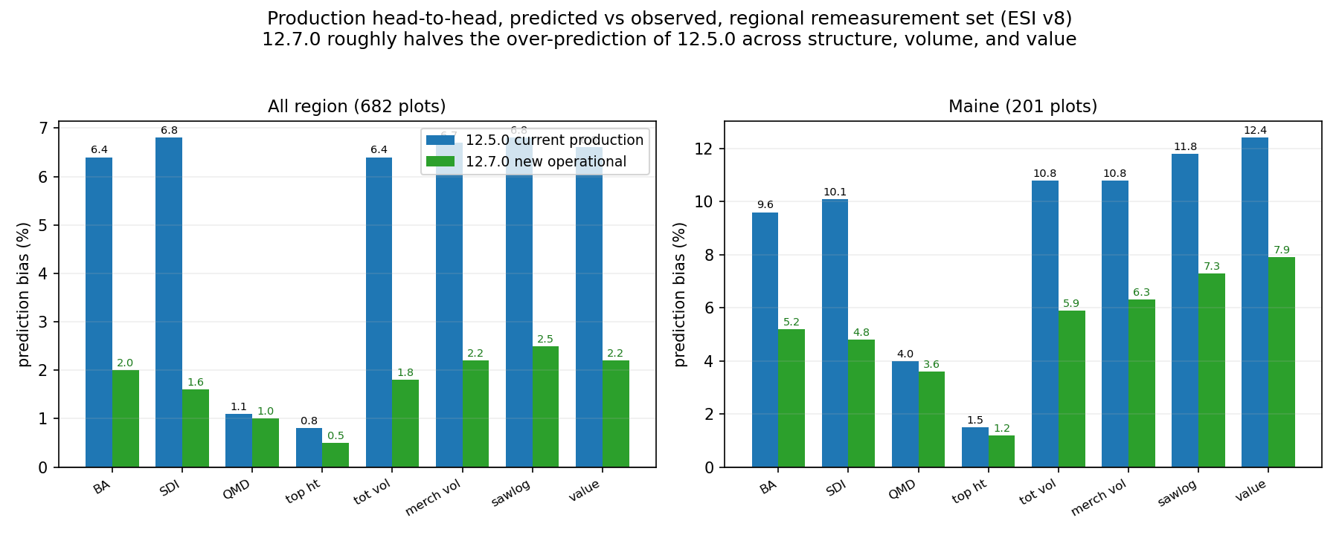
Head-to-head, predicted versus observed bias, regional remeasurement set.

Spatial pattern of bias
The bias is localized, not diffuse. Total-volume over-prediction concentrates in southwestern Maine and the central Penobscot Experimental Forest; New Brunswick and Nova Scotia are near zero. The 12.7.0 surface is markedly less biased than 12.5.0.
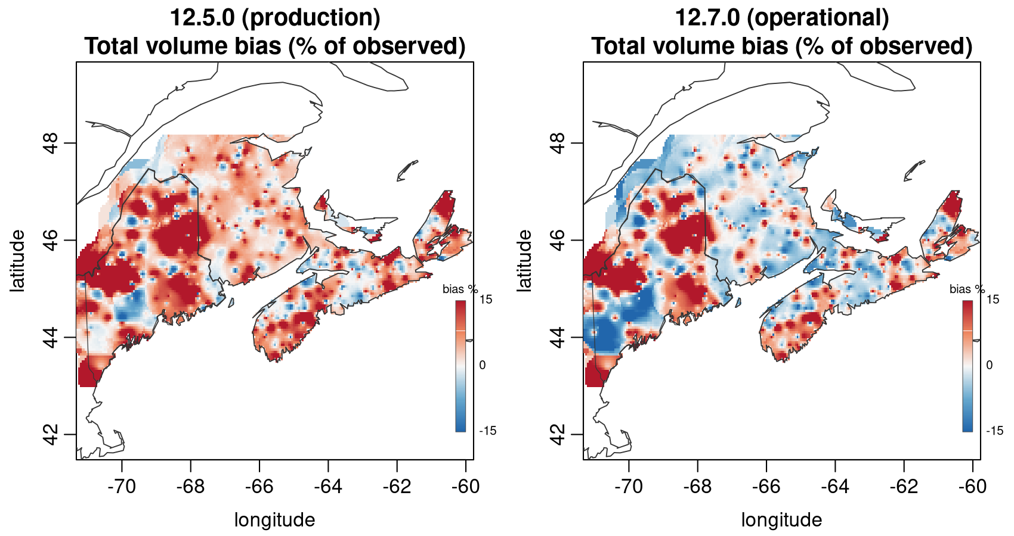
Total-volume bias surface, continuous interpolation, land-masked. 12.5.0 versus 12.7.0.
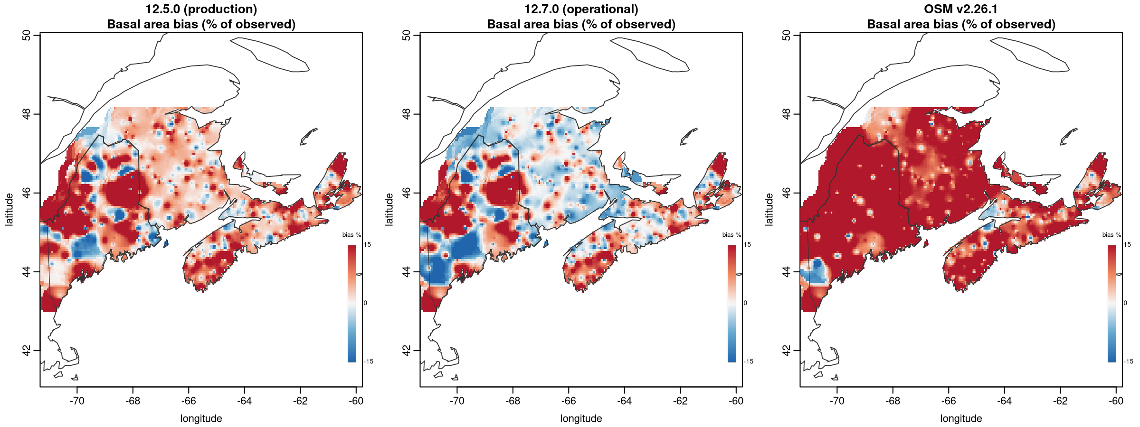
Basal-area bias surface, 12.5.0 versus 12.7.0 versus OSM.

Independent Canadian CFI (MAGPlot New Brunswick, 262 pairs)
On fully independent Canadian data, 12.7.0 is near-unbiased: basal area -2.6 percent, R-squared 0.87, QMD +4.2 percent. With the proper ESI v8 site index (versus a default), basal area improves from -3.5 to -2.6 percent.

Comparison with the Open Stand Model (OSM v2.26.1)
On the MAGPlot New Brunswick stands, FVS-ACD and OSM are both near-unbiased on basal area at the observed intervals (FVS-ACD -2.6, OSM -2.3), and FVS-ACD has the better diameter bias (+4.2 versus -8.9). On the denser, more mature regional remeasurement set, OSM over-predicts basal area by about 20 percent because it under-applies self-thinning (observed basal area moves from 20.1 to 20.5 m2/ha over the interval while OSM grows to 24.4); this was confirmed by re-running OSM with model-consistent heights, so it is a real model-form difference, not an input artifact. FVS-ACD 12.7.0, whose self-thinning tracks the observed plateau, is at +2.0 percent on the same data. On the long-horizon Seven Islands projection the two bracket the trajectory (FVS-ACD self-thins to 27 m2/ha by age 60, OSM accumulates to 42), first-order model-form uncertainty with no observed truth at that horizon.
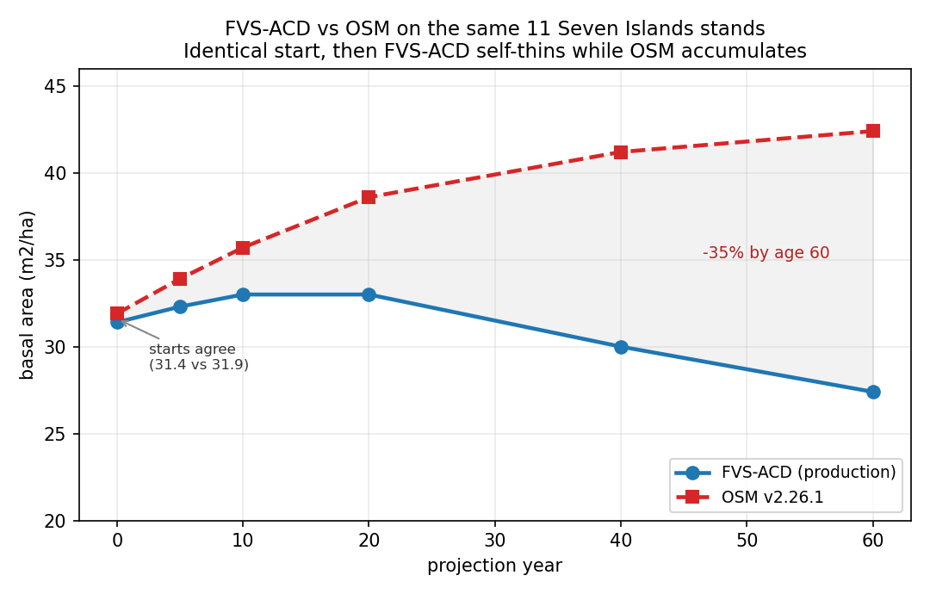
FVS-ACD versus OSM, Seven Islands, identical start then divergent dynamics.

Biological realism (Bakuzis matrix)
The Bakuzis matrix on 12.7.0 projections across the site gradient passes the relations that matter: site ordering is clean (0 of 125 height and volume inversions, the dominant-height anchor fixing the legacy flaw), Reineke self-thinning slopes are -1.28 to -1.35, and the one flag is a moderate Eichhorn volume-height site dependence (CV 22 percent), expected for a mixed-species empirical variant.
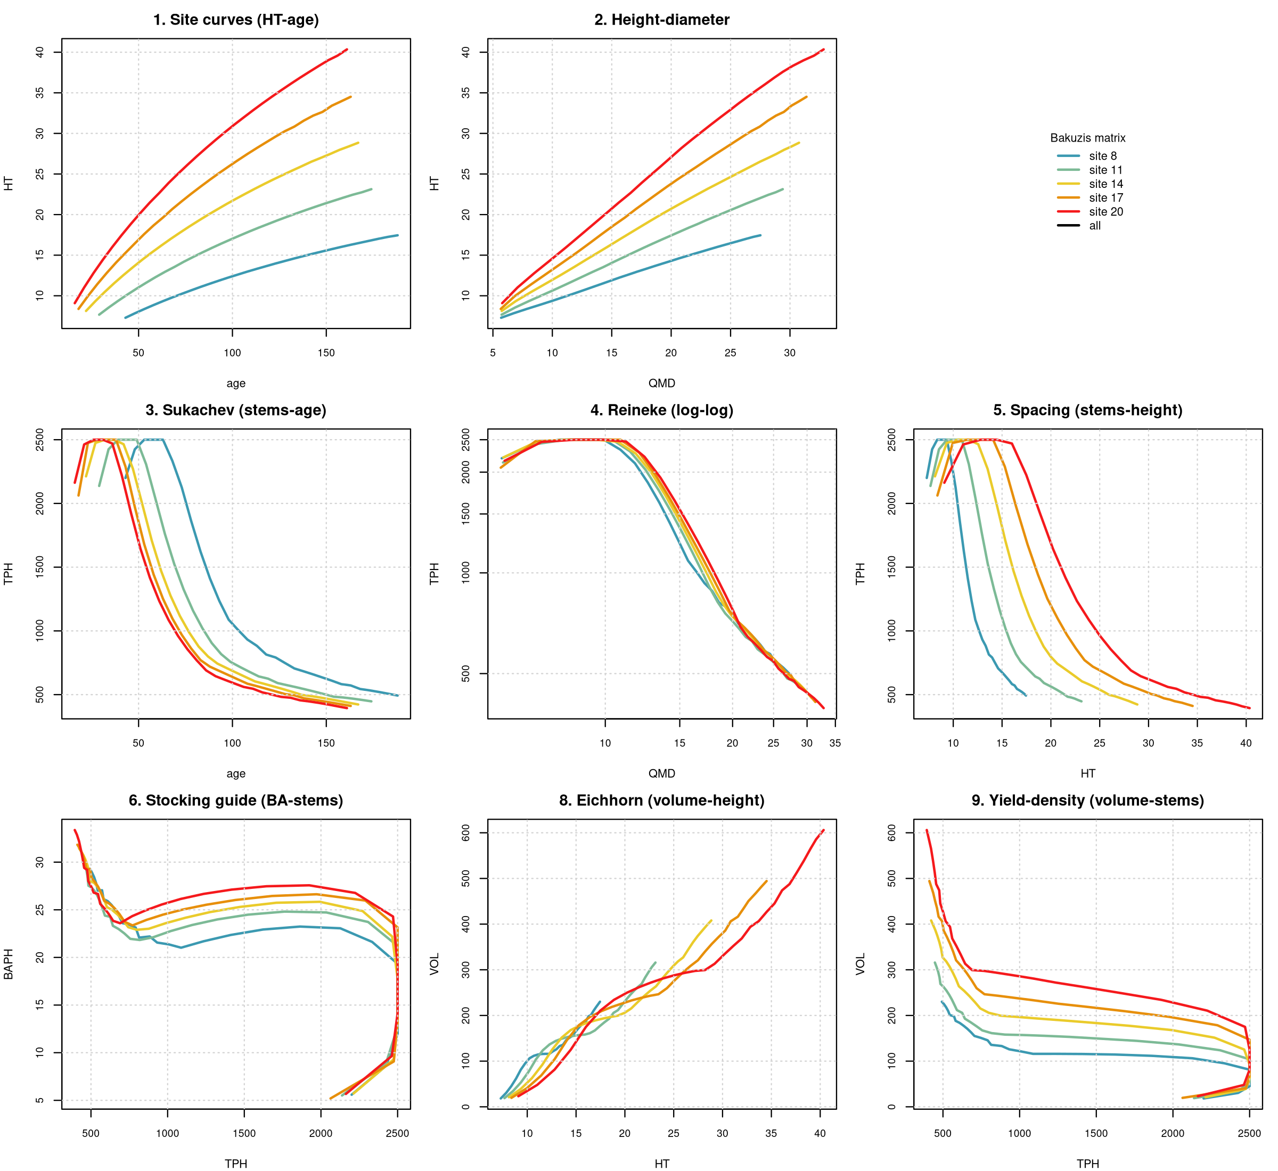
Bakuzis matrix, AcadianGY 12.7.0 site-gradient projections.

Conclusion
12.7.0 is ready for production. It beats current production 12.5.0 on every operationally relevant metric in the calibration region, matches it where 12.5.0 was already good, passes the Bakuzis site-ordering check that 12.5.0 fails, is near-unbiased on independent Canadian data, and substantially outperforms OSM on the regional remeasurement data. The one bounded residual, a Maine basal-area and volume over-prediction localized to specific areas, is smaller than 12.5.0’s and is the documented next-version target (a regional stand-mortality coefficient refit).

