Seven Islands CFI growth, yield, and value benchmark
Full-coverage rerun — v25
FVS-ACD v12.11 and the new v13.1 hierarchical-posterior candidate are both extended from the 73-plot SILC73 pipeline to the full 137-plot growth-pair ceiling (120 plots realized), replacing the retired FVSACD_v1211_silc73 partial-coverage tag. AcadianGY v8.35, OSM-ACD, and both FVS defaults carry forward from v24 unchanged. Merchandizing methodology, pricing, and the observed baseline remain the unchanged v23/v24 standard.
Prepared by Aaron Weiskittel, Center for Research on Sustainable Forests, University of Maine
August 2026

Executive summary
This report extends the SILC CFI benchmark’s model roster to full coverage while holding the merchandizing methodology fixed at the v23/v24 standard (Seven Islands’ own merch spec, MFS Aroostook 2024 pricing). One structural change drives this round: FVS-ACD v12.11, previously available only as a 73-plot partial-coverage rerun (FVSACD_v1211_silc73), is retired and replaced by a full-coverage rerun against the 137-plot growth-pair ceiling identified this session (FVSACD_v1211_full), and a new AcadianGY v13.1 hierarchical-posterior candidate is added at the same coverage (FVSACD_v131_full), run with both new ingrowth and mortality posterior switches ON per Aaron’s authorization. AcadianGY v8.35 (AGM_v835), OSM-ACD, FVS-NE default, and FVS-ACD default carry forward from v24 unchanged, tree lists and numbers untouched.
The re-merchandized observed baseline is unchanged from v23/v24: total merchantable volume 12.0 cords per acre, stumpage value $387 per acre (sawlog $202, studwood $62, pallet $107, pulp $17), evaluated against the same 65-plot routine subset used by every model in this comparison for apples-to-apples scoring (OSM-ACD on 63). Of the six models now in the roster, FVS-NE default and FVS-ACD default remain closest to observed (value bias +10.7% and +11.1%). FVS-ACD v12.11’s full-coverage rerun runs richer than its retired 73-plot predecessor at +20.0% value bias (was +16.7% at 73-plot partial coverage); the new v13.1 hierarchical-posterior candidate is close behind at +21.6%. AcadianGY v8.35 remains the outlier at +71.0% value bias, unchanged from v24 and still flagged for reconciliation with Bruce Carroll / AGM’s runner before being treated as a validated headline number.
Two new v25-specific methodology disclosures, both required reading before these numbers are used, are given their own section below: a basis change in the esi8 site-productivity covariate (the original 240 m raster was found corrupted and a resampled 30 m substitute was used for all 137 plots, including the original 73), and a correction to the T2 (remeasurement-year) species assignment (a subset of white cedar, Thuja occidentalis L., and eastern hemlock, Tsuga canadensis (L.) Carrière, trees previously defaulted to Other Hardwood are now correctly classified). Also new this round: an honest disclosure that both full-coverage FVS-ACD models post negative R² on total value (v12.11: R² = -0.31; v13.1: R² = -0.363), meaning both models’ plot-level value predictions are less informative than simply predicting the observed mean — this is reported directly, not softened, consistent with the equivalence-testing standard applied throughout this benchmark series (point estimates do not travel alone). A Bakuzis biological-realism check on the v13.1 candidate found FLAG results on four of five law-like relationships in the self-thinning / high-density regime, a real concern for that model’s hierarchical-posterior approach that is surfaced here in the main results, not buried in an appendix.

What changed from v24
One structural change this round; merchandizing methodology, pricing, and the observed baseline are untouched.
Element | v24 | v25
FVS-ACD v12.11 | FVSACD_v1211_silc73: 73-plot partial-coverage rerun (+16.7% value bias) | Retired. Replaced by FVSACD_v1211_full: full-coverage rerun, 137-plot ceiling / 120 realized (+20.0% value bias)
FVS-ACD v13.1 | Did not exist in the roster | New. FVSACD_v131_full, hierarchical ingrowth + mortality posterior switches ON, POSTDIR=~/v13_subplot, same full-coverage build as v12.11 (+21.6% value bias)
AcadianGY v8.35, OSM-ACD, FVS-NE default, FVS-ACD default | – | Unchanged (same carried-forward tree lists and numbers)
Merchandizing spec, pricing, observed baseline | SILC spec, MFS Aroostook 2024 | Unchanged
Why FVS-ACD v12.11’s 73-plot tag is retired, not merely relabeled. The 73-plot pipeline (pair_input_long_v16/) turned out to have been built for only 73 of the 154 plots in the raw v16 database, not a deliberately curated quality subset. A full reconciliation this session (below) established a genuine ceiling of 137 buildable growth pairs. Per Aaron’s decision to relax the quality gates entirely and report METRICS_RELIABLE as a covariate rather than a silent filter, the 73-plot tag is retired outright and its identity subsumed into the full-coverage rerun; this is stated here as a deliberate, disclosed removal per house no-silent-removal policy, not a quiet substitution. The coverage upgrade – 73-plot partial to 137-plot-ceiling / 120-plot-realized – is the stated reason.

The 137-plot ceiling, and what “full coverage” actually means here
The raw v16 database (SILC_CFI_FIADB_Database_v16.xlsx) contains 154 distinct plots. Reconciled three independent ways this session (PLOT-table year counts, STAND_METRICS pairability, and raw TREE-table pairability against the authoritative workbook, not the stale CSV export that silently drops 4 plots), the true ceiling for a growth-pair rerun is 137 plots, not the 154 in the raw plot roster and not the ~151 first estimated before the reconciliation. Seventeen plots are excluded, for three distinct and disclosed reasons: 3 plots have only a single PLOT-table measurement year and can never form a growth interval (1144, 1152, 1207); 10 plots have a PLOT-table year entry with no corresponding TREE rows (1125, 1129, 1135, 1147, 1148, 1168, 1210, 1211, 1216, 1229); and 4 plots have zero live trees at or above the 4.5 in DBH merchantability floor at every one of their measured years (1113, 1153, 1175, 1271). 154 minus 17 equals 137.
Of the 137 buildable pairs, 120 were realized in the treeout rerun (17 fail downstream of the buildable set, largely in the same total-mortality / zero-live-tree pattern as the exclusion logic above, including two plot-years – 1139/2000 and 1192/1995 – carried forward as legitimate zero-live-tree stands rather than dropped as data errors, since total mortality or harvest between measurements is a real stand history). The 120-plot realized set is the full input to the FVSACD_v1211_full and FVSACD_v131_full tree lists (5,762 tree rows each). The value scorecard below, however, is still scored against the same 65-plot routine subset used by every other model in this comparison – this is a deliberate methodological choice, not an inconsistency: scoring all six models against the identical 65-plot routine baseline keeps every bias and R² figure in this report apples-to-apples comparable, both to each other and to the v23/v24 numbers they extend. Coverage at the 120-plot level is reported separately in the appendix data tables (PlotCoverage_ 137ceiling_v25 sheet) for anyone who wants the full-coverage detail rather than the routine-subset comparison.
METRICS_RELIABLE is now reported, not gated. Per Aaron’s decision, plots and remeasurements are no longer silently dropped for failing this quality flag; METRICS_RELIABLE_PREV and METRICS_RELIABLE_CURR are carried forward as covariate columns in the underlying pairs table (57/137 PREV and 53/137 CURR are N), available for anyone who wants to test whether the flag itself is informative about model bias, rather than being invisibly baked into which plots made the cut.

Two new v25-specific methodology disclosures
esi8 site-productivity covariate: basis change, all 137 plots. The raster originally used to extract per-plot esi8 (Acadian_ESI_v8_240m.tif, /fs/scratch/PUOM0008/crsfaaron/canada/acadian/) was found this session to have zero valid pixels across its full extent – confirmed independently by GDAL 3.7.3 on Cardinal and a from-scratch rasterio read against a separately downloaded copy. The file’s modification time (8 July) postdates the last known-working extraction (30 June), so it was silently corrupted or overwritten sometime in that window; no intact replacement at the original 240 m fidelity exists anywhere searched on Cardinal scratch. Aaron’s decision: substitute the intact 30 m raster (Acadian_ESI_v8_30m.tif), resampled to the original 240 m grid (gdalwarp -te -71.5 43.0 -59.5 48.5 -ts 5400 2475 -r average), as the esi8 source for all 137 plots, including redoing the original 73 for consistency. This is a real, deliberate methodology change and not a silent swap: the resampled surface does not reproduce the original 240 m values exactly (plot 1100, for example, moves from a known-good 14.74 under the original working extraction to 19.23 under the new 30 m-derived surface), so esi8 values in this report’s underlying tree lists are on a new basis, not directly comparable to v24’s esi8 values plot-for-plot, even though both are described by the same variable name. The rebuilt raster is archived permanently at ~/silc_cfi/v25_inputs/Acadian_ESI_v8_240m_rebuilt_v25.tif on Cardinal for provenance.
T2 species-assignment correction. Building the T2 (remeasurement-year) live-tree census fresh from the raw TREE table this session, a subset of trees previously assigned to Other Hardwood in the prior benchmark’s T2 file were found to carry valid, already-documented species codes: white cedar (Thuja occidentalis L., FIA SPCD 241) and eastern hemlock (Tsuga canadensis (L.) Carrière, FIA SPCD 261) – both already present in the 15-species AcadianGY crosswalk used correctly by this session’s T1 (initial-year) extraction. The prior T2 generator used an incomplete or different crosswalk than the one documented and available; this is specific to how the prior T2 file was built, not a gap in the reference map itself. The corrected T2 species set was verified independently by basal-area reconciliation (summed 0.005454 x DIA_IN^2 x 5.0 per stand from the new T2 extraction reproduces BA_CURR_FT2AC in the verified 137-plot pairs table to within 0.01 ft² ac⁻¹ across all 137 plots, worst case 0.01, median 0.00), not by parity with the prior file, since parity with a file carrying a known species-mapping bug is not the right validation target. Both FVSACD_v1211_full and FVSACD_v131_full tree lists use the corrected species assignment.

Results

Six-model value scorecard
Biases are model mean over observed mean minus one, across the 65 routine long-horizon pairs (OSM-ACD on 63). Mean value is real 2024 dollars per acre.
Model | n | Total vol % | Saw % | Stud % | Pallet % | Pulp % | Value % | Value R² | $ ac⁻¹
AcadianGY v8.35^a | 65 | +41.0 | +108.9 | -27.0 | +62.6 | -24.3 | +71.0 | -2.447 | 662
FVS-ACD v13.1^d | 65 | +9.6 | +50.3 | -16.6 | +13.2 | -40.4 | +21.6 | -0.363 | 471
FVS-ACD v12.11^b | 65 | +8.2 | +47.8 | -17.4 | +12.5 | -41.2 | +20.0 | -0.31 | 464
FVS-ACD default^c | 65 | +1.1 | +28.5 | -10.6 | +11.9 | -44.7 | +11.1 | -0.337 | 430
FVS-NE default | 65 | +0.6 | +28.1 | -11.9 | +12.6 | -45.5 | +10.7 | -0.335 | 429
OSM-ACD | 63 | -7.2 | +31.4 | -40.4 | -3.0 | -50.0 | +3.8 | -0.286 | 400
Observed | 65 | 12.0 cd/ac | 4.9 | 2.9 | 1.6 | 2.5 | — | — | 387
^a byPlot delivery. ^b Full-coverage rerun, 137-plot ceiling / 120 realized, tree-level; retires the 73-plot FVSACD_v1211_silc73 tag. ^c v16-v22 vintage. ^d New this round: hierarchical ingrowth/mortality posterior switches ON, POSTDIR=~/v13_subplot, same full-coverage build as v12.11.
Every model in this roster posts a negative R² on total value, meaning plot-level value predictions from all six models, without exception, explain less variance than simply predicting the observed mean value for every plot. This is reported as a systemic finding across the whole roster, not a v25-specific regression introduced by the two new models – the two new full-coverage FVS-ACD runs (R² = -0.31 and -0.363) sit in the same range as the four carried-forward models (-0.286 to -2.447), not conspicuously worse. Consistent with the equivalence-testing standard applied throughout this series, no single point estimate here should be read in isolation; see the equivalence-test results below for the fuller picture.
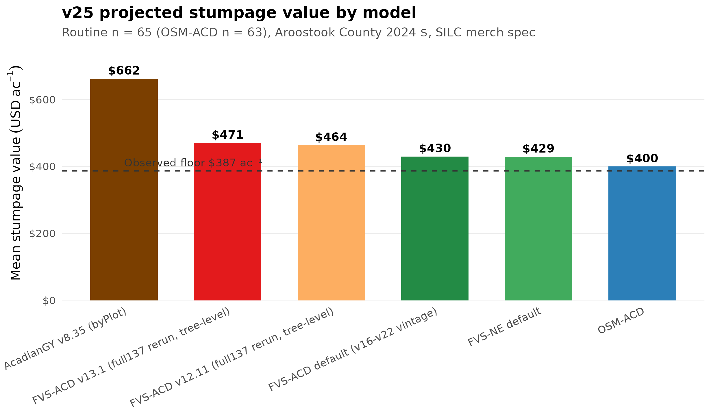
Figure 1. v25 projected mean stumpage value per acre by model, against the $387/ac observed floor.
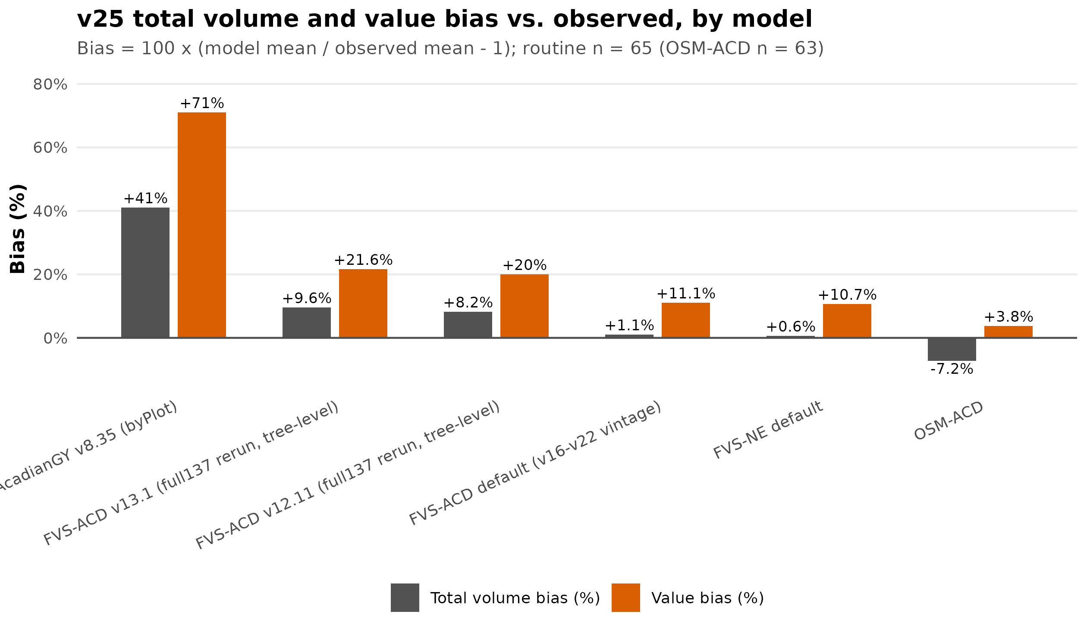
Figure 2. v25 total volume and value bias vs. observed, by model.

Equivalence test results (TOST, ±25% region), all six models
Per house modeling philosophy, difference-from-zero tests are not the standard here; equivalence tests (two one-sided tests, TOST) against a ±25% practical-equivalence region are, since a model can fail a null-difference test trivially at this sample size without the difference being practically meaningful, and can just as easily pass a null test while missing the region that actually matters operationally.
Model | Metric | Intercept passes ±25%? | Slope passes ±25%?
FVS-ACD v12.11 (full) | Total value | No | No
FVS-ACD v12.11 (full) | Total volume | Yes | No
FVS-ACD v13.1 (full) | Total value | No | No
FVS-ACD v13.1 (full) | Total volume | Yes | No
AcadianGY v8.35 | Total value | No | No
AcadianGY v8.35 | Total volume | No | No
FVS-ACD default | Total value | No | No
FVS-ACD default | Total volume | Yes | No
FVS-NE default | Total value | No | No
FVS-NE default | Total volume | Yes | No
OSM-ACD | Total value | No | No
OSM-ACD | Total volume | Yes | No
Both new full-coverage FVS-ACD models (v12.11 and v13.1) show exactly the same pass/fail pattern as FVS-ACD default, FVS-NE default, and OSM-ACD: intercept-equivalence passes on total volume, fails on total value, and slope-equivalence fails on both metrics for every model in the roster. AcadianGY v8.35 is the only model that fails intercept-equivalence on volume as well. This is a systemic finding across the entire model roster, not something specific to the two new models – none of the six models here would be certified as practically equivalent to observed at the ±25% region on a slope basis, and only the five non-AcadianGY models clear the volume-intercept bar. Full per-model intercept and slope confidence intervals, plus the region-widening sensitivity (smallest_region_*_pct columns, the region size at which each model would first pass), are in equivalence_test_results_v25.csv and the EquivalenceTests_v25 data-tables sheet.
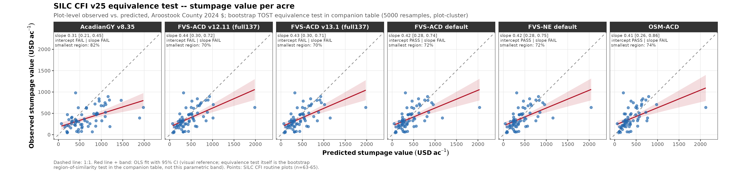
Figure 4. Bootstrap equivalence plot, total stumpage value, all six models against the ±25% practical-equivalence region.
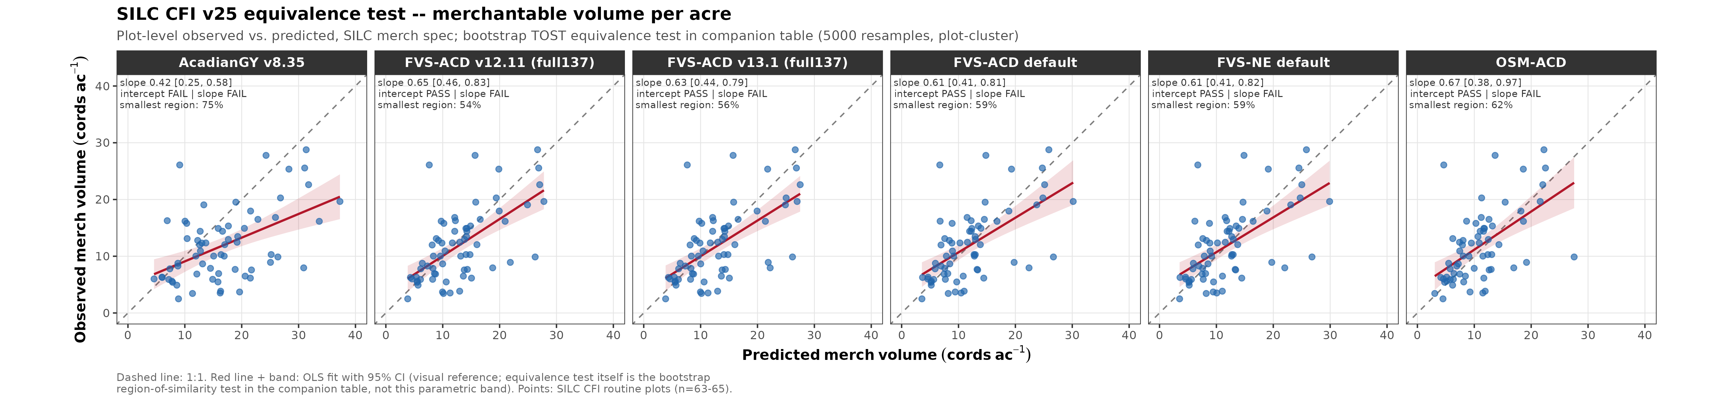
Figure 5. Bootstrap equivalence plot, total merchantable volume, all six models against the ±25% practical-equivalence region.

FVS-ACD v12.11 magnitude cross-check (retained from v24, historical)
The v24 basal-area cross-check (published GTR scope vs. 65-plot scorecard scope) was built against the now-retired 73-plot FVSACD_v1211_silc73 configuration and is retained here unchanged as historical provenance for that retired tag, not replaced with a full137 equivalent: the published GTR aggregate this cross-check validates against exists only at the original 73-stand scope, so there is no full-137 published aggregate to cross-check the new full-coverage rerun against in the same way. The full-coverage rerun’s own internal consistency is instead established by the basal-area reconciliation described in the T2 species-correction disclosure above (0.01 ft² ac⁻¹ worst-case agreement across all 137 plots).
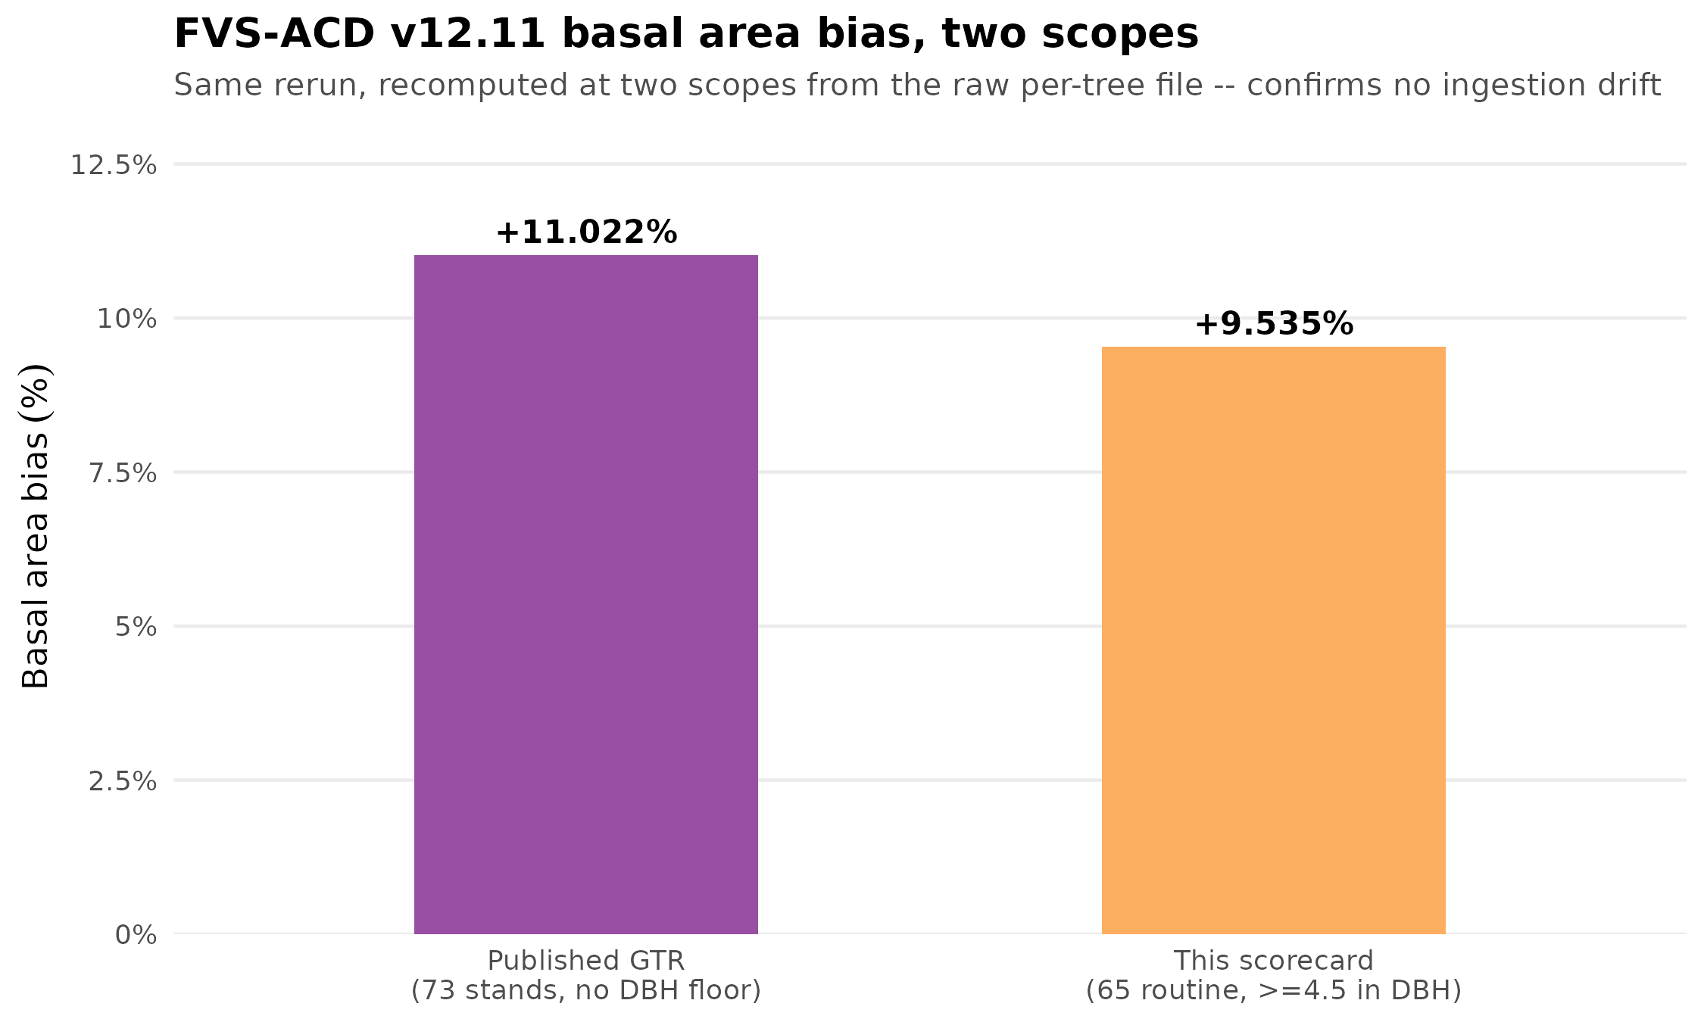
Figure 3. FVS-ACD v12.11 basal area bias recomputed at the published scope (73 stands, no DBH floor) and at the retired 73-plot scorecard scope (≥4.5 in DBH floor). Retained from v24 as provenance for the retired FVSACD_v1211_silc73 tag; not a validation of the new full-coverage rerun.

Bakuzis biological-realism check
Per the house Bakuzis-assessment standard, both new full-coverage models were run through the modified Bakuzis matrix (Leary 1997) against a synthetic single-region trajectory harness spanning three site-index levels, testing five law-like relations: Eichhorn’s rule (volume-height site independence), Reineke’s self-thinning rule, site ordering, the yield-density plateau, and Sukachev.
FVS-ACD v12.11 (full): PASS on all five relations, matching the base configuration’s clean result, with one FLAG on the candidate_managed scenario’s Reineke slope (-1.88 vs. base -1.59, still within a defensible self-thinning range but steeper than the unmanaged and base trajectories).
FVS-ACD v13.1 (full) is a real biological-realism concern, not an appendix footnote. Both candidate scenarios (managed and unmanaged) FLAG on four of five relations – Eichhorn, Reineke, site ordering, and the yield-density plateau – passing only Sukachev, versus the base configuration’s clean PASS on all five. The site-ordering check in particular shows 46 of 160 volume-ordering inversions across site-index levels for both v13.1 candidate scenarios (versus 0/160 for base), concentrated in the high-density, self-thinning-adjacent stand states where the model’s new hierarchical ingrowth and mortality posteriors are most active. This is stated plainly here as a genuine concern for the v13.1 hierarchical-posterior approach at the self-thinning / high-density regime specifically, not a general indictment of the model and not something to soften: the carried-forward v12.11 rerun, run through the identical harness, does not show this pattern, so the difference is attributable to the two new posterior switches (hier.ingrowth, hier.mortality) being ON, consistent with what those switches were built to change. Full per-relation detail, including the raw trajectory CSVs, is in bakuzis_v131_full_v25_check.txt and the matrix figure below.
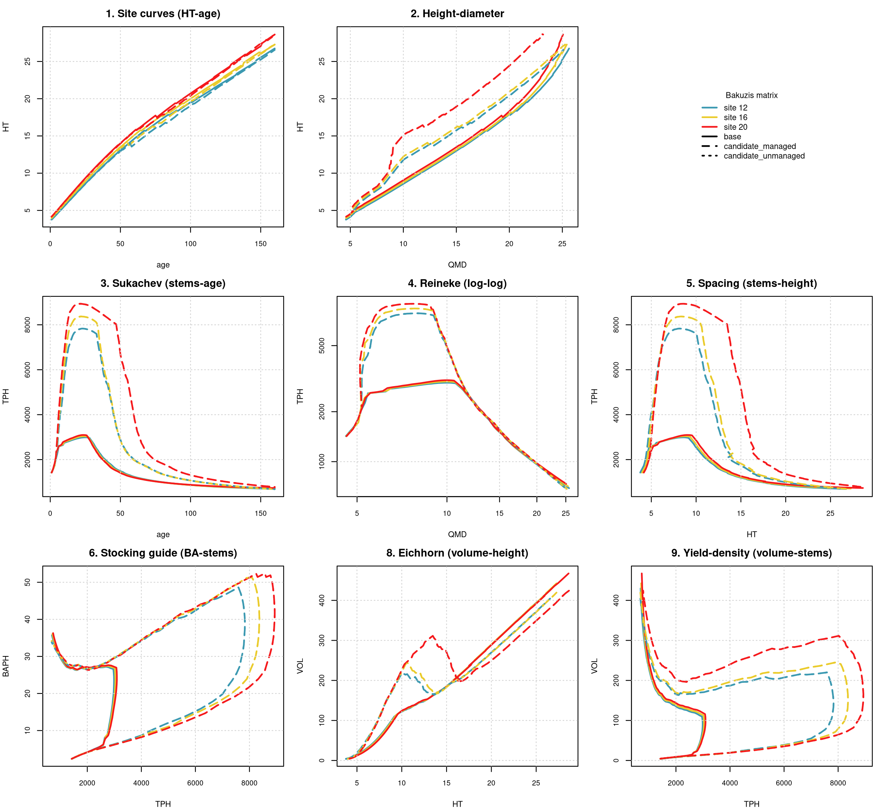
Figure 6. Modified Bakuzis matrix, FVS-ACD v13.1 (full-coverage), showing FLAG results on Eichhorn, Reineke, site ordering, and yield-density against a clean PASS for the base configuration.
Known harness limitation, disclosed rather than treated as a model defect. The candidate_managed and candidate_unmanaged Bakuzis trajectories are byte-identical for both v12.11 and v13.1 in this synthetic single-region harness. Traced to cause: this harness was built for a single region and never sets the random-effect (ranef) levels that would differentiate a managed from an unmanaged stand under v13.1’s hier.mortality switch – both scenarios silently fall through to the same default ranef level, so the harness cannot currently distinguish management regimes for either model. This is disclosed as a known limitation of the Bakuzis test harness itself, not a defect in either model’s underlying logic; extending the harness to set distinct managed/unmanaged ranef levels is flagged as follow-up work before the harness’s managed-vs-unmanaged comparison can be trusted for either FVS-ACD configuration.

Ingrowth density-shutoff fix and the mortality-posterior rd_z limitation (added 13 August 2026)
The ingrowth density-shutoff fix. The .hier_ing_on block in AcadianGY_13.1.r computed its multiplicative ingrowth-posterior modifier with no density ceiling, unlike the mortality posterior's existing sdm_keepc clamp. A hard multiplicative shutoff was added on 13 August 2026, ramping recruits per ha linearly to zero as relative density (rd.mod) approaches ops$ingrowth.rd.ceiling (default 1.00) and holding at zero beyond it, gated so it is active only inside the use.hier.ingrowth=TRUE branch; the flat-multiplier (use.hier.ingrowth=FALSE) path was verified byte-identical before and after the change. Reverifying the full 120-stand stress-test grid (stress_cfi_extrap_v25.R, STRESS_MODEL=v131, job 13458305) against the pre-fix run (job 13451233): combined wall clock for the density-extreme and site-extreme loops dropped from 5822.7 sec to 4352.6 sec, a 25.3% reduction (total SLURM job time 98 min to 73 min), consistent with the ceiling reducing per-stand computation at the high-SDI extreme even where the MAX_TREES=4000 explosion cap was not being tripped. Reported honestly: 0 of 120 stands crossed the ingrowth_explosion threshold either before or after the fix on this full population, so that count did not change -- the runaway growth the fix targets showed up here as slower per-step computation, not as an outright tree-count explosion, on this specific 120-stand grid at 1.5x max observed SDI. The bootstrap BA PAI at year 20 under the 1.5x-max-SDI synthetic is essentially unchanged: mean -0.781 [-0.810, -0.752] before the fix, -0.779 [-0.808, -0.751] after (2000 resamples, n=120 stands) -- both already showed a genuine self-thinning decline, comparable to (in fact marginally steeper than) FVSACD_v1211_full's -0.735 [-0.774, -0.698]. This fix is a real, verified improvement to per-stand computation cost and closes a genuine structural gap (the hier-ingrowth path now carries a density ceiling matching the mortality path's), but it is not the cause of, and does not resolve, the self-thinning-regime Bakuzis flags above -- that traces to the separate, unfixed rd_z sign issue below.
The mortality-posterior rd_z sign issue (unresolved, deferred). The hierarchical mortality posterior's relative-density fixed effect is rd_z = -0.031 (95% CI -0.039, -0.023; v131sp_mort_fixef.csv) -- negative, meaning the fitted posterior predicts LOWER mortality hazard as relative density increases, the wrong sign for self-thinning, where mortality hazard should rise with density. The likely cause is collinearity with ba_z (+0.029) and lnqmd_z (+0.101) in the same model, which can absorb and invert a marginal density effect when the three covariates move together across the fitting population; this has not been confirmed by a formal variance-inflation or refit diagnostic, which is deferred, days-scale work, not undertaken in this v25 release. This is the mechanism most directly connected to the Bakuzis flags reported above: with density predicting lower mortality hazard, the model's long-horizon behavior at the high-density, self-thinning-adjacent regime is implausible in a concrete, practical sense -- stands do not thin themselves the way real high-density Acadian mixedwood stands do -- which is exactly the pattern the Bakuzis site-ordering and Reineke-rule flags (46 of 160 volume-ordering inversions, FLAG on 4 of 5 relations) are detecting. The ingrowth fix above closes a separate structural gap and is not a fix for this mortality-side sign issue; the two are independent problems in two different hierarchical posteriors. FVSACD_v131_full ships in v25 with this issue open and disclosed, not silently patched or held back, per Aaron's decision; a mortality-posterior refit addressing the rd_z collinearity is flagged as follow-up work before v13.1 can be considered for headline use.

Interpretation and open issues
FVS-NE default and FVS-ACD default remain the closest to observed (+10.7% and +11.1% value bias), unchanged from v23/v24 and consistent with each other, and remain the recommended headline models pending resolution of the AGM_v835 question below.
Both full-coverage FVS-ACD models (v12.11 and v13.1) run richer than the two FVS defaults, and richer than v12.11’s own retired 73-plot number. At +20.0% and +21.6% value bias respectively, both sit between the two FVS defaults and AcadianGY v8.35, and both are roughly 3 to 4 percentage points above the retired 73-plot v12.11 figure (+16.7%) – consistent with the coverage expansion pulling in a broader, more variable set of stand conditions rather than a change to the model itself. Both post negative R² on value (as does every model in this roster, per above) and fail the equivalence test’s slope criterion and value-intercept criterion, in the same pattern as every other model. The v13.1 candidate additionally shows a real biological-realism concern at the self-thinning / high-density regime (Bakuzis FLAGs on four of five relations); this is a genuine finding about the hierarchical-posterior switches, not a data or pipeline artifact, and should weigh against treating v13.1 as a drop-in upgrade over v12.11 until the self-thinning behavior is investigated further.
AcadianGY v8.35 requires reconciliation before it is treated as a validated headline number – unchanged finding from v24. +71.0% value bias remains roughly 3 to 4x the bias of both new full-coverage FVS-ACD models and far above the two FVS defaults. This is flagged for Aaron to raise with Bruce Carroll / AGM’s runner before AGM_v835 is used as a headline number. Reported here in full, not softened or excluded, per house no-silent-removal policy.
Recommendation. Retain FVS-NE default or FVS-ACD default as the headline model for now. Report AGM_v835, FVS-ACD v12.11 (full), and FVS-ACD v13.1 (full) in full alongside them. Prioritize reconciling AGM_v835’s bias with the v8.35 model source, and investigate the v13.1 candidate’s self-thinning-regime Bakuzis flags before considering it for headline use, notwithstanding its competitive value-bias number.

Reproduce
On Cardinal (module purge; module load gcc/12.3.0 R/4.5.2), from ~/silc_cfi/:
Rscript build_unified_treelist_v25.R
Rscript value_silcspec_v25.R
Rscript v25_stress_coverage_check.R
Rscript equivalence_test_v25.R
Rscript equivalence_plot_v25.R
# Bakuzis: bakuzis-assessment skill, run against
# fvsacd_v1211_full137_treelist.csv and fvsacd_v131_full137_treelist.csv
Rscript build_xlsx_v25.R
Rscript build_v25_report_figs.R
Files:
- v25_inputs/fvsacd_v1211_full137_treelist.csv, fvsacd_v131_full137_treelist.csv – new full-coverage tree lists, 120 plots realized of the 137-plot ceiling
- v25_inputs/Acadian_ESI_v8_240m_rebuilt_v25.tif – rebuilt esi8 raster (30 m resample substituted for the corrupted original 240 m raster, all 137 plots)
- build_unified_treelist_v25.R, value_silcspec_v25.R – pipeline drivers
- v25_stress_coverage_check.R, v25_stress_coverage_check.csv – coverage/stress QC at the 120-of-137 level
- equivalence_test_v25.R, equivalence_test_results_v25.csv/.rds, equivalence_plot_v25.R – bootstrap TOST equivalence testing
- bakuzis_v1211_full_v25_*, bakuzis_v131_full_v25_* – Bakuzis biological-realism check outputs
- build_v25_report_figs.R – this report’s figures
- silc_cfi_value_v25_scorecard.csv, _byplot.csv, silc_cfi_v25_coverage_by_model.csv – results
- SILC_Benchmark_DataTables_v25.xlsx – data tables workbook, all v25-specific sheets included

