Harmonized Multi-Model CONUS Forest Carbon Assessment
Refreshed synthesis, 11 June 2026 | A. Weiskittel, CRSF | OSC Cardinal (PUOM0008)

1. Design
Five independent forest-carbon models (FVS, LANDIS-II, CBM, yield curves, CEM) are placed on one common pipeline so that model structure is the only thing that differs. Every trajectory is anchored to the same FIA design estimate of 2025 live aboveground carbon by state, and driven by the same HCS common harvest under four scenarios (reserve, conservation, business-as-usual, intensive) with a first-order harvested-wood-products pool. The reserve (no harvest, no disturbance) is the comparison backbone.
Coverage: FVS, yield curves, and CBM run 48 states; CEM 26; LANDIS 9 (WA, MN, OH, IN, WI, MI, ME, plus NH and VT added this cycle). All five models overlap at IN, OH, and NH.

2. Refinements applied this cycle
- CBM eastern under-initialization corrected (entry-point method); spurious 150 to 207% regrowth reduced to a plausible 50 to 87%.
- Data-grounded disturbance and climate overlay; disturbance-aware CONUS 2100 reserve median 24.3 to 23.1 Pg C and inter-model CV 21.5 to 19.3%.
- FVS diameter-growth calibration adopted for all variants (was 7 of 25); validated as carbon-neutral at the reserve level, confirming the western over-projection is intrinsic, not a calibration bug.
- Western common-harvest under-detection documented as a data-product limitation.

3. Cross-model comparison with confidence intervals
2100 reserve carbon (Tg C) with 90% confidence intervals, full-model overlap states. Each interval combines the FIA anchor SE with the model's intra-model band (FVS Bayesian posterior, CBM OAT envelope, yield-curve rcp plus simulation; LANDIS and CEM anchor SE only).
Model | Indiana | Ohio | New Hampshire
LANDIS | 583 [561, 605] | 784 [758, 809] | 271 [264, 279]
FVS default | 359 [346, 373] | 606 [585, 626] | 408 [397, 419]
FVS calibrated | 313 [301, 325] | 511 [494, 528] | 291 [283, 299]
CBM | 307 [291, 322] | 409 [391, 428] | 215 [206, 224]
Yield curves | 231 [222, 239] | 366 [354, 377] | 178 [165, 191]
CEM | 126 [112, 141] | 156 [140, 172] | 78 [74, 82]
Distinguishability: 14 of 15 model pairs separable at IN (only FVS-calibrated and CBM overlap), 15 of 15 at OH and NH. The roughly 4 to 5x cross-model spread is statistically real, not sampling noise.

4. Uncertainty decomposition
Inter-model (structural) uncertainty dominates. On states with a real Bayesian posterior, structural SD is 11x the parameter SD by 2050 and about 40x by 2100. Intra-model bands are uniformly small (FVS ~3%, CBM ~3.2 to 3.5%, yield curves ~8%). Which model you choose dominates parameter and sampling error by more than an order of magnitude.
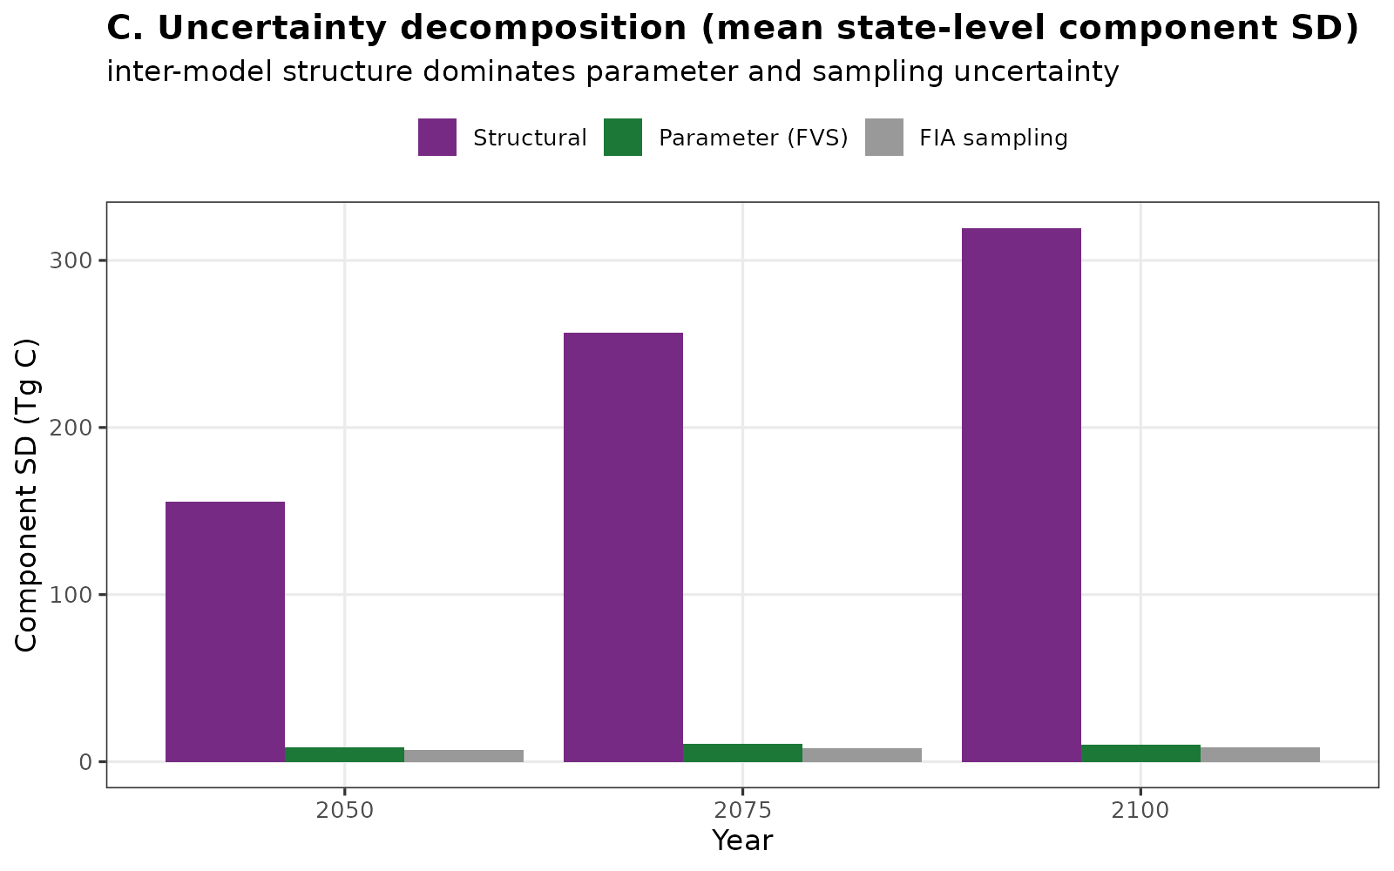

5. Weighted multi-model ensemble best estimate
The disturbance-aware model reserves are combined into a best estimate with a 90% credible interval. Equal weighting (model democracy) is the primary central estimate; a benchmark-informed scheme (down-weighting FVS in the West and CEM, both documented structural outliers) is provided as a transparent sensitivity. The credible interval combines structural, parameter, and sampling uncertainty in quadrature.
Year | Equal weight (Tg C) | Benchmark weight (Tg C)
2025 | 15,279 | 15,279
2050 | 19,939 | 20,004
2075 | 22,601 | 22,643
2100 | 23,517 | 23,549
Per-state 2100 best estimates with 90% intervals are tight where models agree (GA 951 [766, 1137]) and wide where they diverge (CA 1584 [0, 3683], OH 438 [65, 811]), an honest expression of the structural uncertainty.
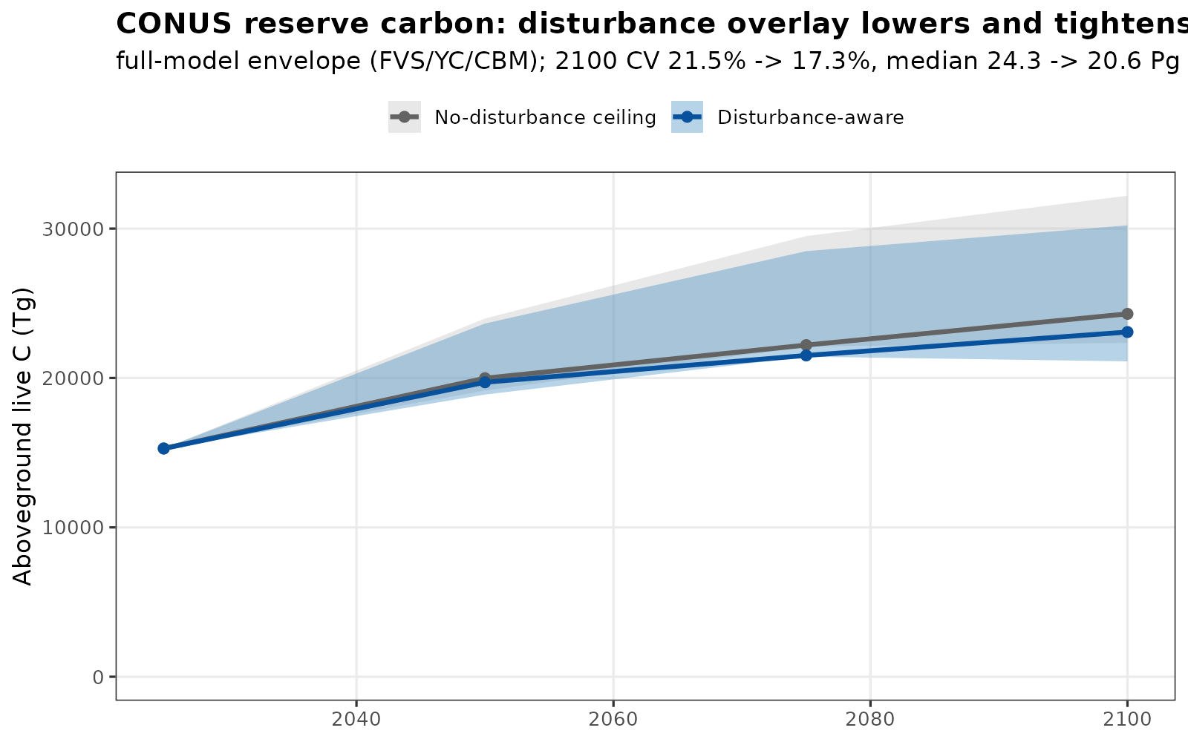

6. Finalized CONUS projection matrix
All five models run all four harvest scenarios across CONUS in both no-disturbance and disturbance-aware modes (master table: model x mode x state x scenario). Ensemble median CONUS 2100 total carbon (standing plus harvested wood products, Tg C):
Scenario | No-disturbance | Disturbance-aware
Reserve | 24,294 | 23,074
Conservation | 22,261 | 21,061
BAU | 20,218 | 19,040
Intensive | 17,860 | 16,714
The harvest gradient is monotonic (more harvest, less total carbon), about a 26% reserve-to-intensive drop, and the disturbance overlay lowers each scenario a further ~5%. Per state the scenario response scales with harvest intensity: strong in heavily harvested states (GA reserve 962 to intensive 163 Tg C) and near-flat in the West, reflecting the documented western harvest under-detection.

7. Key findings
- The cross-model divergence is real structural uncertainty with specific, documented causes, not irreducible noise or pipeline error.
- FVS is the high-biomass-potential end-member: as an individual-tree model it lets western conifers aggrade toward their real 400 to 1000 MgC/ha old-growth potential absent disturbance. Calibration and max-SDI are correct; the divergence is structural.
- Adding realistic disturbance both lowers the central estimate and tightens inter-model disagreement, because the divergence lived in the no-disturbance ceiling.
- Validated against the American Forests state CBM reports (MN, OR, CA, MD, PA); direction and order of magnitude agree where the disturbance overlay applies.

8. Caveats and refinement queue
Western common harvest under-represents real harvest (data product); a better layer would make western management benchmarks testable. The CBM eastern correction is an interim entry-point method pending a true FIA-initialized CBM run. Disturbance rates are LCMS-historical with a literature ramp; MTBS or LANDFIRE calibration would firm them. LANDIS and CEM intra-model bands are not yet measured. A continuous benchmark-skill model averaging would refine the ensemble weights.

