Using LiDAR to quantify, map, and conserve late-successional and old-growth forest in Maine, USA: Comment
Aaron R. Weiskittel
University of Maine, Center for Research on Sustainable Forests, Orono, ME 04469, USA. aaron.weiskittel@maine.edu
Comment on Hagan, J.M., B. Shamgochian, M.M.L. Taylor & J.M. Reed. 2026. Ecosphere 17:e70670.
Positionality: the author conducts forest inventory and biometric modeling in Maine and has a professional interest in how forest-inventory information is used in state policy. The analyses here use the original authors' archived data and public FIA and remote-sensing data, and all code is openly archived.

1. Introduction
All maps and models are wrong; the only useful question is whether they are useful for the decision at hand (Box 1976). This is not a special weakness of forest mapping, and we raise it in that constructive spirit. It is simply more acute for late-successional and old-growth (LSOG) forest, because LSOG is a continuous, multi-dimensional, and partly subjective condition that any classification must force into discrete classes (Gray et al. 2023). The map of Hagan et al. (2026) is a useful and timely product, and the useful question for it is the same as for any map: is it fit for the decision now being made with it, the prioritization of roughly $200-300 million in conservation funding under Maine's LD 1529 (Thompson et al. 2026)? Fitness at those stakes depends on properties the original analysis did not report: the map's agreement with independent maps and with unbiased ground inventory, and a confidence interval on the quantities taken from it. We provide both, using the authors' own archived data and public inventory over the same area, in the hope of strengthening, not diminishing, the use of LiDAR for this purpose.
Hagan et al. (2026) provide a valuable, transparent, and timely contribution: a field-trained, wall-to-wall classification of LSOG forest across approximately 4.2 million hectares of Maine's unorganized townships, derived from publicly available airborne LiDAR. The authors archived their training data and code, the field effort is substantial, and the resulting map has focused overdue attention on older forest in a working landscape. We reproduced their random forest classifier exactly from the archived data, obtaining an out-of-bag accuracy of 94.2% for the Not-LSOG versus LSOG distinction against their reported 94.1%, with the same most-important predictor (canopy cover above 15 m). Nothing in this Comment questions the competence or the openness of the original analysis, both of which we commend. The authors are also candid about the limits of the work: they include a Limitations section, report that the model classifies true old growth correctly only 29.4% of the time, state that they could not estimate ingrowth, emphasize that old-forest definitions vary widely and materially change the result, and recommend ground-truthing before any management or conservation decision. Our aim is not to dispute these caveats but to quantify them, because the map is now being used quantitatively, for parcel-level prioritization and cost estimation, at a scale to which its stated uncertainties were never propagated.
The difficulty of defining and inventorying older forest is long recognized and has been called a wicked problem (Spies 2004; Gray et al. 2023). National FIA-based assessments place old growth at about 6.3% of US forest (Barnett et al. 2023) and quantify it on federal lands (Pelz et al. 2023), and spaceborne GEDI lidar has been used to characterize old-growth structure elsewhere (Spracklen and Spracklen 2021). The original authors engage much of this literature, citing the national FIA assessments, the wicked-problem synthesis, and GEDI-based structural work; what the analysis does not do is use any independent product as a benchmark, place a sampling interval on its quantities, or ground the Maine estimate in the design-based inventory. Against that backdrop, our concern is narrow and methodological: when a single airborne map underwrites parcel-level acquisition and emerging carbon and conservation markets, its fitness depends on its agreement with independent maps and with unbiased ground inventory, on the uncertainty of every quantity derived from it, and on the validity of the trend used to motivate action. We assess each in turn.
Underlying the debate is a question it has largely skipped: what is late-successional and old-growth forest? It is not one attribute but a multidimensional condition, spanning large old live trees and structural complexity, abundant standing and downed dead wood, compositional maturity, and temporal continuity since the last stand-replacing disturbance (Franklin and Van Pelt 2004; Wirth et al. 2009; Gray et al. 2023). These axes develop on different schedules and do not move together. On the authors' own plots a dominant stand-development gradient explains 59% of the variance among the defining attributes, but dead wood is only moderately tied to live structure (Spearman r about 0.5, roughly a quarter of shared variance), so a stand can be tall and big-treed yet deadwood-poor, or old and complex yet recently disturbed (Section 4). Because the axes partly decouple, any single-threshold map reifies a continuous, multidimensional condition into one line, and which hectares fall on either side depends on which axis and threshold an objective privileges, whether biodiversity, carbon, or primary-forest protection. The disagreement we document among credible maps is, in large part, the empirical signature of that multidimensionality rather than a defect of any one product.
We make four points. First, training accuracy is high for every candidate approach and is therefore not the issue (Section 2). Second, independent operationalizations of LSOG, each with high training accuracy, disagree markedly at the landscape scale, which is the scale at which hectares are prioritized (Section 3). Third, the canopy-structure signal the method relies on is sensitive to large trees and tall canopy but largely insensitive to the dead-wood component that distinguishes old growth, so it maps tall, big-tree forest, which is roughly three times more extensive than ground-defined old forest (Section 4). Fourth, ground-based FIA inventory, the unbiased baseline the LiDAR map approximates (unbiased for amount, though imprecise at FIA's plot density), places the amount of older forest with a sampling-error confidence interval the original analysis did not report, and shows the stock to be stable or increasing rather than rapidly declining (Section 5). Sections 6 and 7 then place Maine in a New England context, show how little older forest is already protected, and demonstrate a constructive ensemble-and-uncertainty alternative; Section 8 then distills these into a repeatable multi-axis classification of true LSOG, and Sections 9 and 10 give implications and recommendations.

2. Training accuracy is high for every approach, and is not the issue
The 463 archived training plots carry both the eight LiDAR canopy metrics and a parallel set of ground structural measurements (live and dead basal area, basal area and number of trees >= 40 cm dbh, quadratic mean diameter, coarse woody debris, and diameter variability). Using these, we estimated cross-validated AUC (repeated stratified five-fold cross-validation, 40 repeats; intervals from the repeat distribution) for three predictor sets against three binary targets (Table 1). Hagan's eight LiDAR metrics discriminate the field classes very well in-sample: AUC 0.990 for any-LSOG, 0.988 for LS+OG, and 0.966 for old growth. A canopy-height-only set and a ground-structure set also perform well for the broad classes. The training data are separable and the published classifier is internally sound; we emphasize this because it is the premise that makes the rest of the argument matter. Two features of Table 1 are nonetheless relevant. For old growth specifically, a canopy-height-only model, which approximates the information a spaceborne canopy-height product carries, is the weakest of the three (AUC 0.910), while ground structure is the strongest. And the full LiDAR model's high ranking ability coexists with the operating-point performance the authors report: in their own out-of-bag confusion matrix, only 29.4% of true old-growth plots were classified as old growth. High AUC and low operating accuracy are reconcilable under class imbalance and overlap, but for a map used to select specific hectares, it is operating performance on the rare, high-value class that governs the decision. Discrimination on labelled plots is a necessary property of any usable classifier; because it is achieved here by all three predictor sets, it cannot by itself distinguish among the very different maps those predictors produce when applied across the landscape (Section 3). The pattern is robust to classifier choice: under logistic regression the same ordering holds, with canopy height alone weakest for old growth (AUC 0.91) and ground structure strongest (0.97) (Appendix S1). Because the training plots are spatially dispersed but not independent, these cross-validated intervals are best read as lower bounds on uncertainty.
Table 1. Cross-validated AUC (mean [95% interval]) recovering the field-assigned class from three predictor sets, on the 463 archived training plots.
Target (prevalence) | Hagan 8 LiDAR | Canopy height only | Ground structure
any-LSOG (0.39) | 0.990 [0.988, 0.992] | 0.984 [0.981, 0.987] | 0.966 [0.962, 0.969]
LS + OG (0.21) | 0.988 [0.984, 0.990] | 0.977 [0.973, 0.982] | 0.970 [0.967, 0.973]
old growth (0.04) | 0.966 [0.954, 0.977] | 0.910 [0.868, 0.933] | 0.974 [0.966, 0.981]
Reproducing the published random forest, the out-of-bag confusion matrix makes the same point graphically (Fig. 1): the model recovers Not-LSOG (95%) and the broad classes well, but classifies true old growth correctly only about a quarter of the time (24% in our reproduction, close to the 29.4% the authors report; the small difference is random-forest stochasticity on the 17 old-growth plots), confusing it mostly with late-successional and transitioning forest. Because old growth is the rare, high-value class a prioritization actually targets, this is the operating-point performance that matters. The mapped extent is also sensitive to the probability cutoff used to call a pixel LSOG: across plausible cutoffs the fraction of labelled plots called LSOG, the overall accuracy, and the true-skill statistic all shift substantially (Fig. 2; this is computed on the labelled plots to show the leverage of the cutoff, and reflects training prevalence rather than landscape area). The threshold-independent rank ability is itself high (out-of-bag ROC AUC 0.979 [0.967, 0.989]), so the issue is not that the classifier ranks poorly; it is that the single cutoff baked into a delivered map, and the extent that cutoff produces, are consequential and rarely reported.
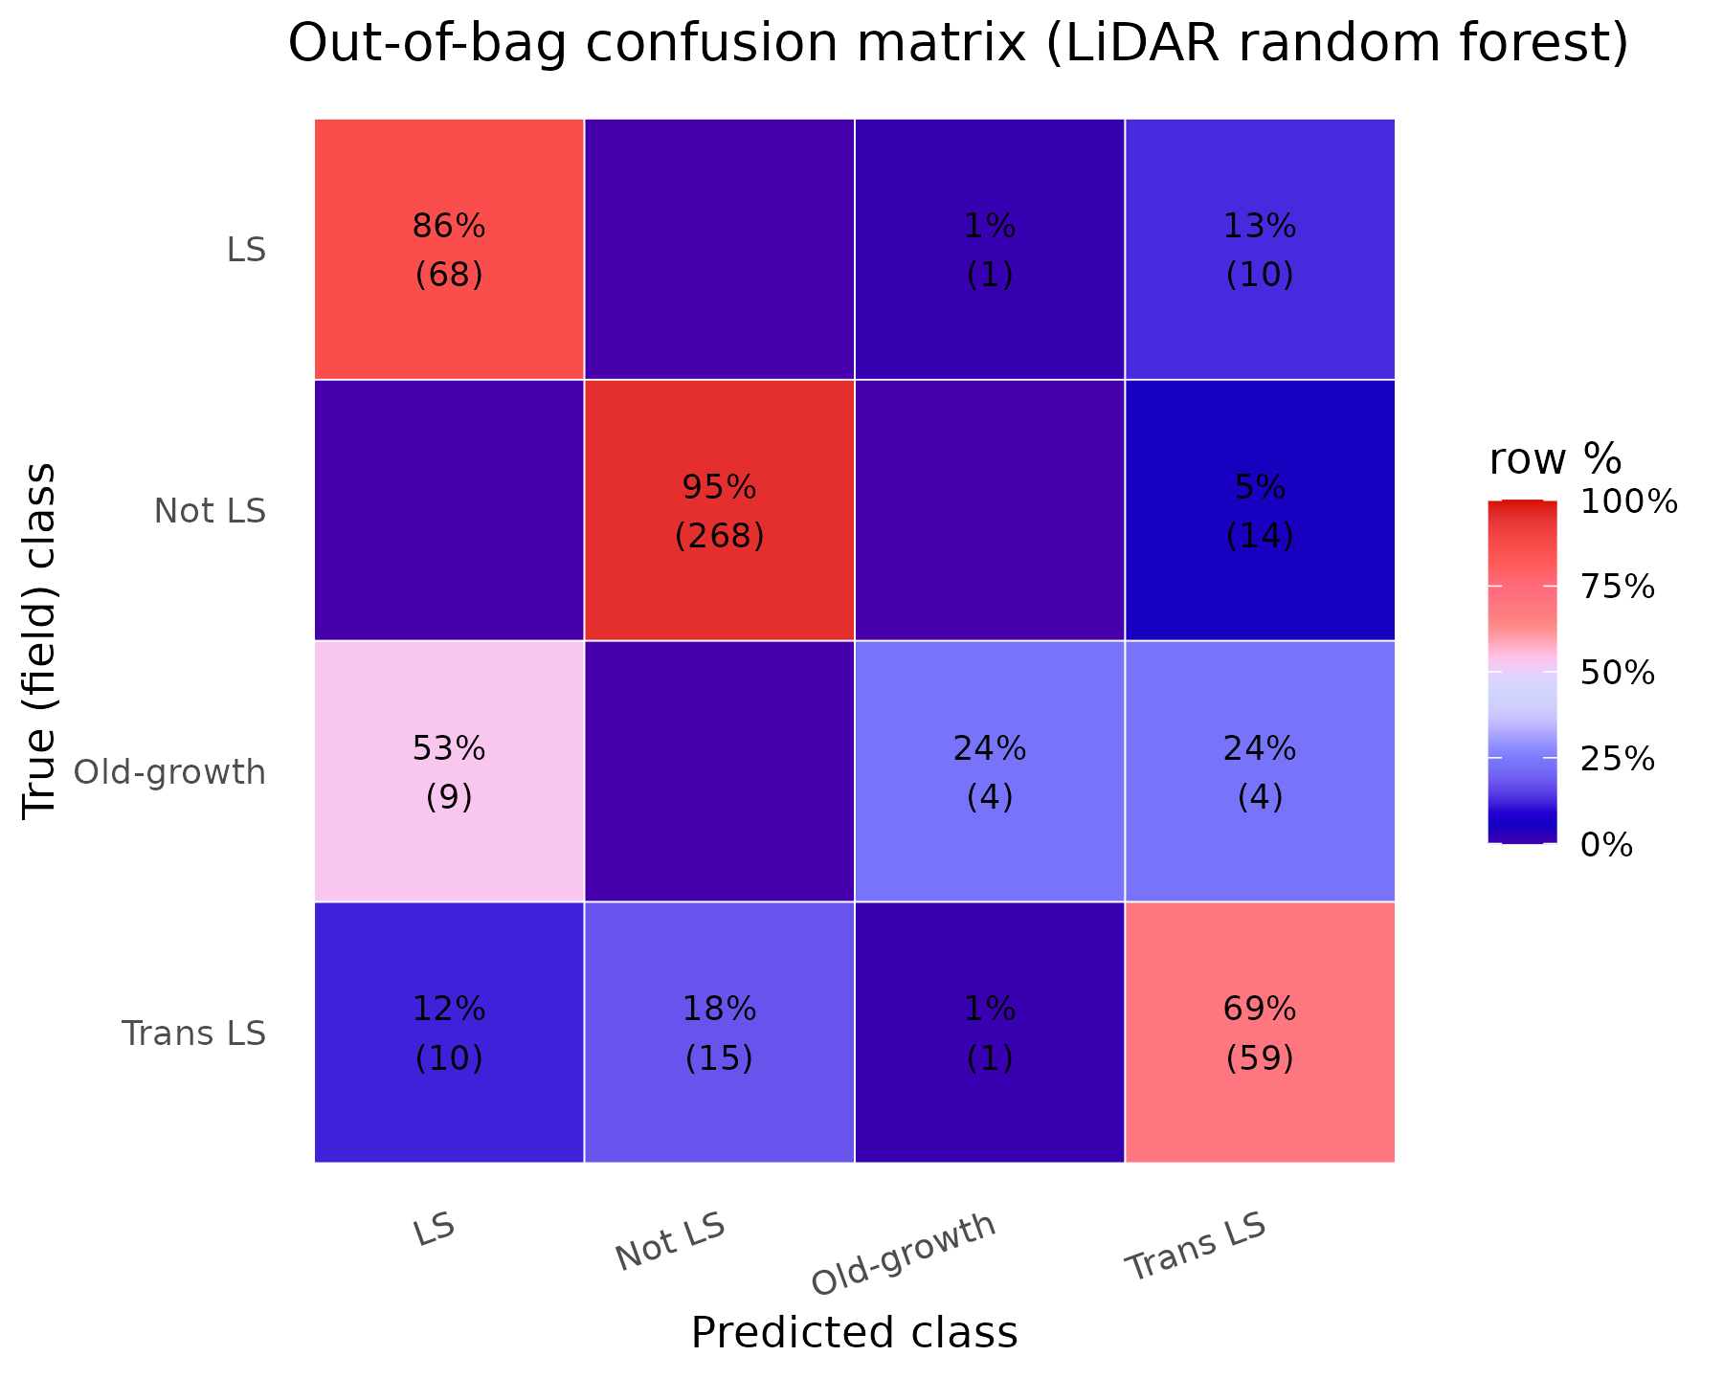
Fig. 1. Out-of-bag confusion matrix for the reproduced airborne-LiDAR random forest, row-normalized (cell counts in parentheses). True old growth is classified correctly only 24% of the time, mostly confused with late-successional and transitioning forest.
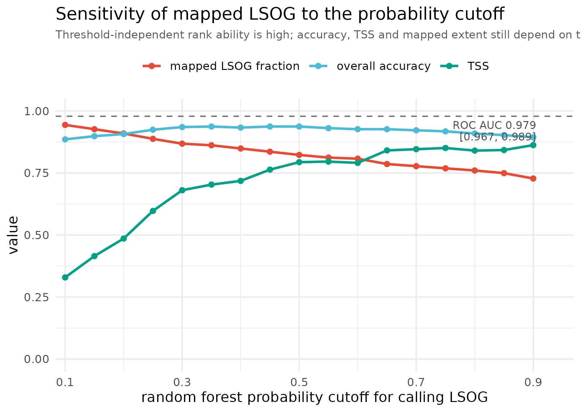
Fig. 2. Sensitivity of the classification to the random forest probability cutoff: the fraction of labelled plots called LSOG, overall accuracy, and the true-skill statistic (TSS), computed on the labelled plots, all change materially across plausible cutoffs. The values reflect training prevalence, not landscape area. The threshold-independent rank ability is high (out-of-bag ROC AUC 0.979 [0.967, 0.989]).

3. High training accuracy does not produce map agreement
The decisive test for policy use is not how well a model separates its own training plots but whether independent, equally defensible operationalizations of LSOG agree on the landscape. We compared three wall-to-wall classifications over the same area on a common 100 m grid: the reproduced Hagan LiDAR classifier; an FIA-field-structure class predicted from Potapov (GEDI-calibrated) canopy height; and the USFS TreeMap imputation of FIA structural class. They disagree substantially. Any-LSOG covers 21.9% of the area under our reproduction of the Hagan classifier, close to the 19.7% the authors report in their Table 7 (the small difference reflects grid resolution and analysis extent), against 14.0% under the canopy-height model and 7.8% under TreeMap, a 2.5- to 2.8-fold range. Spatially, the Hagan and canopy-height maps overlap on only about 21% of the hectares either one flags (Cohen's kappa 0.21); across all three methods, only 21% of the flagged footprint is agreed by all three, and more than half is flagged by a single method (Table 2; Fig. 3). Part of any pixel-level disagreement reflects geolocation and co-registration error among the products rather than true classification difference: spaceborne GEDI footprints alone carry a systematic geolocation error on the order of 10 m (Shannon et al. 2024), and airborne LiDAR and NAIP-derived products are not free of positional error either. This is one reason we emphasize the disagreement in total amount, which is insensitive to position; aggregate the comparison to 8-km hexagons, where such error averages out (Appendix S1); and treat the design-based FIA estimate, which carries no map geolocation error at all, as the reference (Section 5). Because we reproduced the published model exactly and a 20-seed ensemble bounds the reproduced area at 4.23% (SD 0.06), the disagreement among methods is genuine rather than an artifact of our reproduction. We stress that none of these products is ground truth, including the two we constructed; the canopy-height map (built on a noisier, GEDI-calibrated product) and the TreeMap imputation are themselves proxies, and TreeMap imputation smooths rare classes, so its area (computed at native 30 m resolution) is best read as a lower bound and its pixel-level agreement is weak. The point is not that any one map is correct but that credible operationalizations of the same target disagree by this much, which is the property a single-map prioritization must reckon with.
Table 2. Wall-to-wall any-LSOG area and pairwise agreement across three independent maps over the study area. The Hagan any-LSOG area is our reproduction (21.9%); the authors report 19.7% in their Table 7.
Method | any-LSOG (% area) | kappa vs Hagan | Jaccard vs Hagan
Hagan (airborne LiDAR canopy) | 21.9 | n/a | n/a
v5.1-GEDI (FIA class on canopy height) | 14.0 | 0.21 | 0.21
TreeMap (FIA structural imputation) | 7.8 | 0.01 | 0.03
3-way: % of flagged area agreed by all three | 21.0
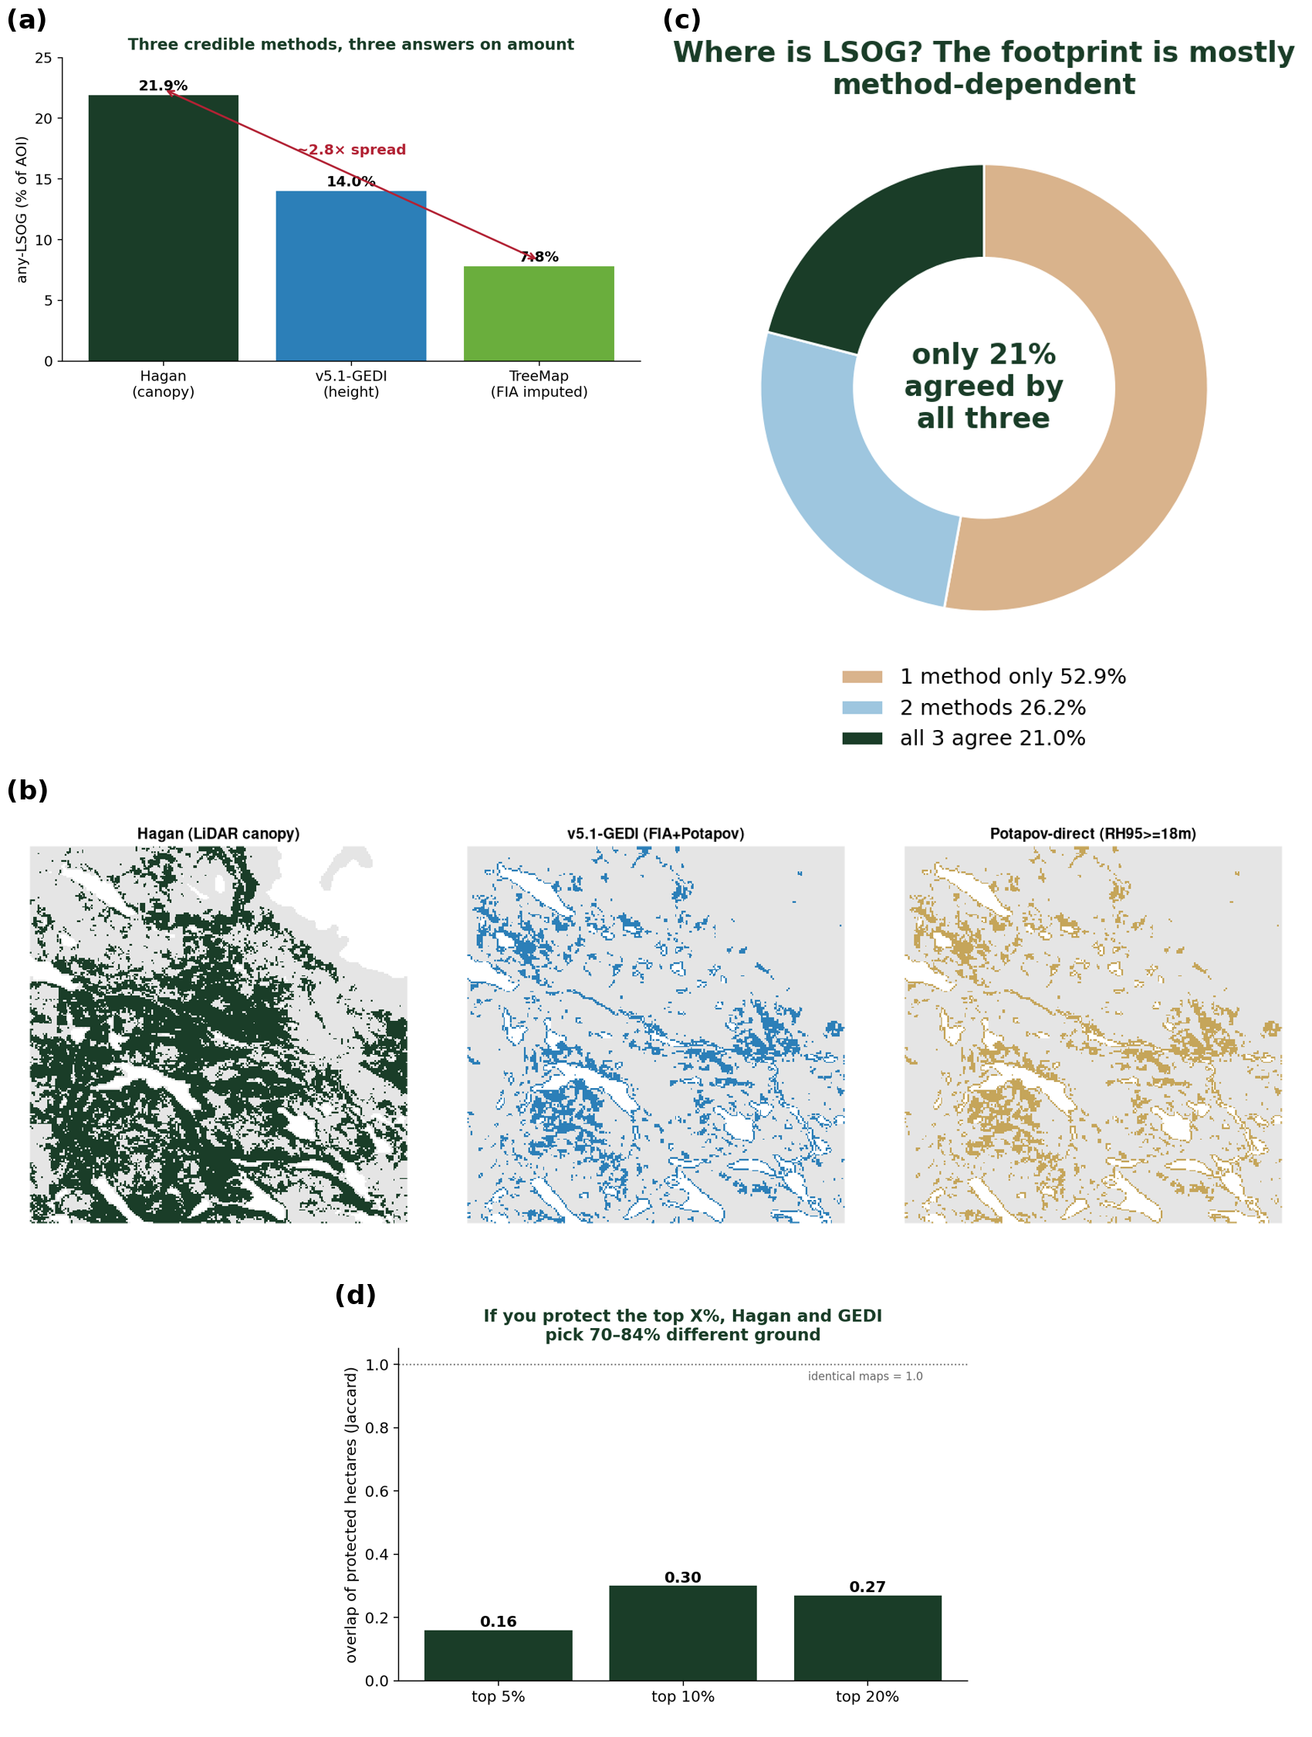
Fig. 3. Cross-map disagreement. (a) any-LSOG area by method (2.8-fold range); (b) the same 24-km window classified by each method; (c) only 21% of the flagged footprint is agreed by all three; (d) overlap of the top-priority protected hectares between maps (Jaccard 0.16-0.30).
The consequence for prioritization is direct. If a program protects the highest-priority hectares, the overlap of the protected sets selected by the Hagan map versus the canopy-height map is only 0.16 to 0.30 (Jaccard) for the top 5% to 20% of hectares; that is, 70% to 84% of the prioritized ground differs depending on which equally defensible map is used (Fig. 3). A US $200-300 million acquisition program steered by one map would purchase substantially different forest than the same program steered by another. Each map can have excellent training accuracy and the maps can still disagree on most of the ground, because the disagreement lives in the definitional and methodological choices rather than in the fit to any one training set.
These figures are for the broad any-LSOG class, which includes the original transitioning category. The picture at the strict old-growth level is different and instructive. The reproduced LS+OGL class covers about 4% of the area, and the unbiased FIA design-based estimate of older forest (Section 5) is 3.9% [3.3, 4.6], so the methods agree closely on the rare, well-defined old-growth core. The disagreement is concentrated in the broad, transitioning envelope, which is also the part that most enlarges the conservation target and its cost. Comparing across these definitions requires care, because the original LSOG class, FIA old forest by stand age, and old growth are related but not identical targets; the design-based FIA estimate is the unbiased anchor for the strict class. The authors themselves emphasize that definitions vary and materially change the result, citing a landscape where relaxing the old-growth definition moved the estimate from 2.7% to 15%; the cross-method spread we document is that same sensitivity expressed spatially.
An independently authored product points the same way. The U.S. Forest Service national old-growth inventory (Pelz et al. 2023), built under region-specific structural definitions, can be compared against the field-structure classification used here on the FIA plots where both apply, the National Forest System plots in the region (n about 925, concentrated in New Hampshire and Vermont because Maine holds little federal forest). The two agree only weakly: Cohen's kappa is 0.25 for the late-successional-plus-old-growth class and 0.12 for any-LSOG (Appendix S1: Table S9). Because Pelz et al. is a third-party operationalization rather than one of our reproductions, this addresses the obvious objection that maps disagree only when compared with their own variants; credible, independently authored definitions of old forest disagree at the plot level too. The sample is small and federal, so we read it as corroboration rather than a primary result.

4. What old growth is, and what a canopy sensor can see
Old growth is defined ecologically by large old trees, structural complexity, and abundant dead wood. Using the archived plots, we asked how well the eight LiDAR canopy metrics predict these defining attributes (cross-validated R-squared). They predict large-tree basal area moderately (R-squared = 0.68) but are largely blind to dead wood: coarse woody debris volume R-squared = 0.20 and standing dead basal area R-squared = 0.24 (Table 3). The original authors are themselves candid that airborne LiDAR cannot reliably separate late-successional from old-growth structure; our result quantifies the reason, namely that the dead-wood component central to that distinction is the attribute least predictable from canopy metrics. The authors anticipate exactly this, proposing that future work add metrics such as canopy-gap density and large downed-log density to better separate late-successional from true old-growth forest; our analysis quantifies why those additions are needed. A classification keyed on canopy height and cover therefore registers tall, continuous canopy whether it is produced by an old, structurally complex stand or by an 80- to 100-year-old fast-growing stand, a failure mode the authors note for Populus. The scale of the resulting ambiguity is illustrated by ground inventory (Section 5): roughly 12.5% of Maine forest carries substantial large-tree basal area, while only about 3.9% meets a stand-age criterion for old forest. These are different criteria and the large-tree threshold is illustrative rather than definitional, but the contrast makes the mechanism concrete: large trees are far more widespread than the full old-growth structural complex, so a canopy- or height-based classifier keys on a signal that need not coincide with a structural or age-based definition. The resulting errors run in both directions rather than as a uniform bias: in aggregate the mapped class is broader than ground-defined old forest, yet independent field truthing now underway indicates local under-classification in parts of western Maine. Either way the mapped class and a structural or age-based definition diverge, consistent with the among-method spread in Section 3, which is the property a single-map prioritization must reckon with.
Table 3. Cross-validated R-squared for predicting ground structural attributes from the eight LiDAR canopy metrics.
Structural attribute | CV R-squared from 8 LiDAR metrics
Live basal area in trees >= 40 cm dbh | 0.68
Number of trees >= 40 cm dbh | 0.59
Diameter variability (CV of dbh) | 0.51
Standing dead basal area (snags) | 0.24
Coarse woody debris volume | 0.20
These mechanics reflect what LSOG fundamentally is. The ground attributes that define it, live basal area, large trees, diameter diversity, snags, and coarse woody debris, share a dominant gradient (the first principal component explains 59% of their variance) but split into partially independent dimensions: the live-structure metrics correlate strongly with one another (r 0.76 to 0.98), whereas dead wood (snags and coarse woody debris) correlates only moderately with them (r about 0.4 to 0.5) and forms a separate axis (Fig. 4). This is decisive for mapping. A canopy sensor resolves the live-structure gradient, and even that imperfectly, but is nearly blind to the dead-wood axis (R-squared 0.20 to 0.24; Table 3), so it cannot by construction recover the full condition; and it cannot see compositional maturity or disturbance history at all. The disturbance-history axis is the sharpest case in Maine's working forest: legacy skid trails and prior partial harvest are pervasive even in stands a canopy classifier labels LSOG, evidence of past entry that is visible on the ground and in fine imagery but invisible to canopy metrics, so a stand can present a late-successional canopy while scoring low on continuity. Continuity is one weighted axis, valued differently by objective, not an absolute disqualifier of ecological maturity, but it is real and a canopy sensor cannot see it. True old growth is the joint position on these structural and dead-wood axes together with a temporal-continuity dimension that no single-date canopy sensor observes, which is why ground plots remain indispensable and why the design-based FIA estimate (Section 5), which measures every axis directly on a probability sample, is the right anchor for how much exists. (These 463 plots are a purposive training sample, so the dimensionality above is conditional on that design; the design-based FIA estimate remains the population anchor.)
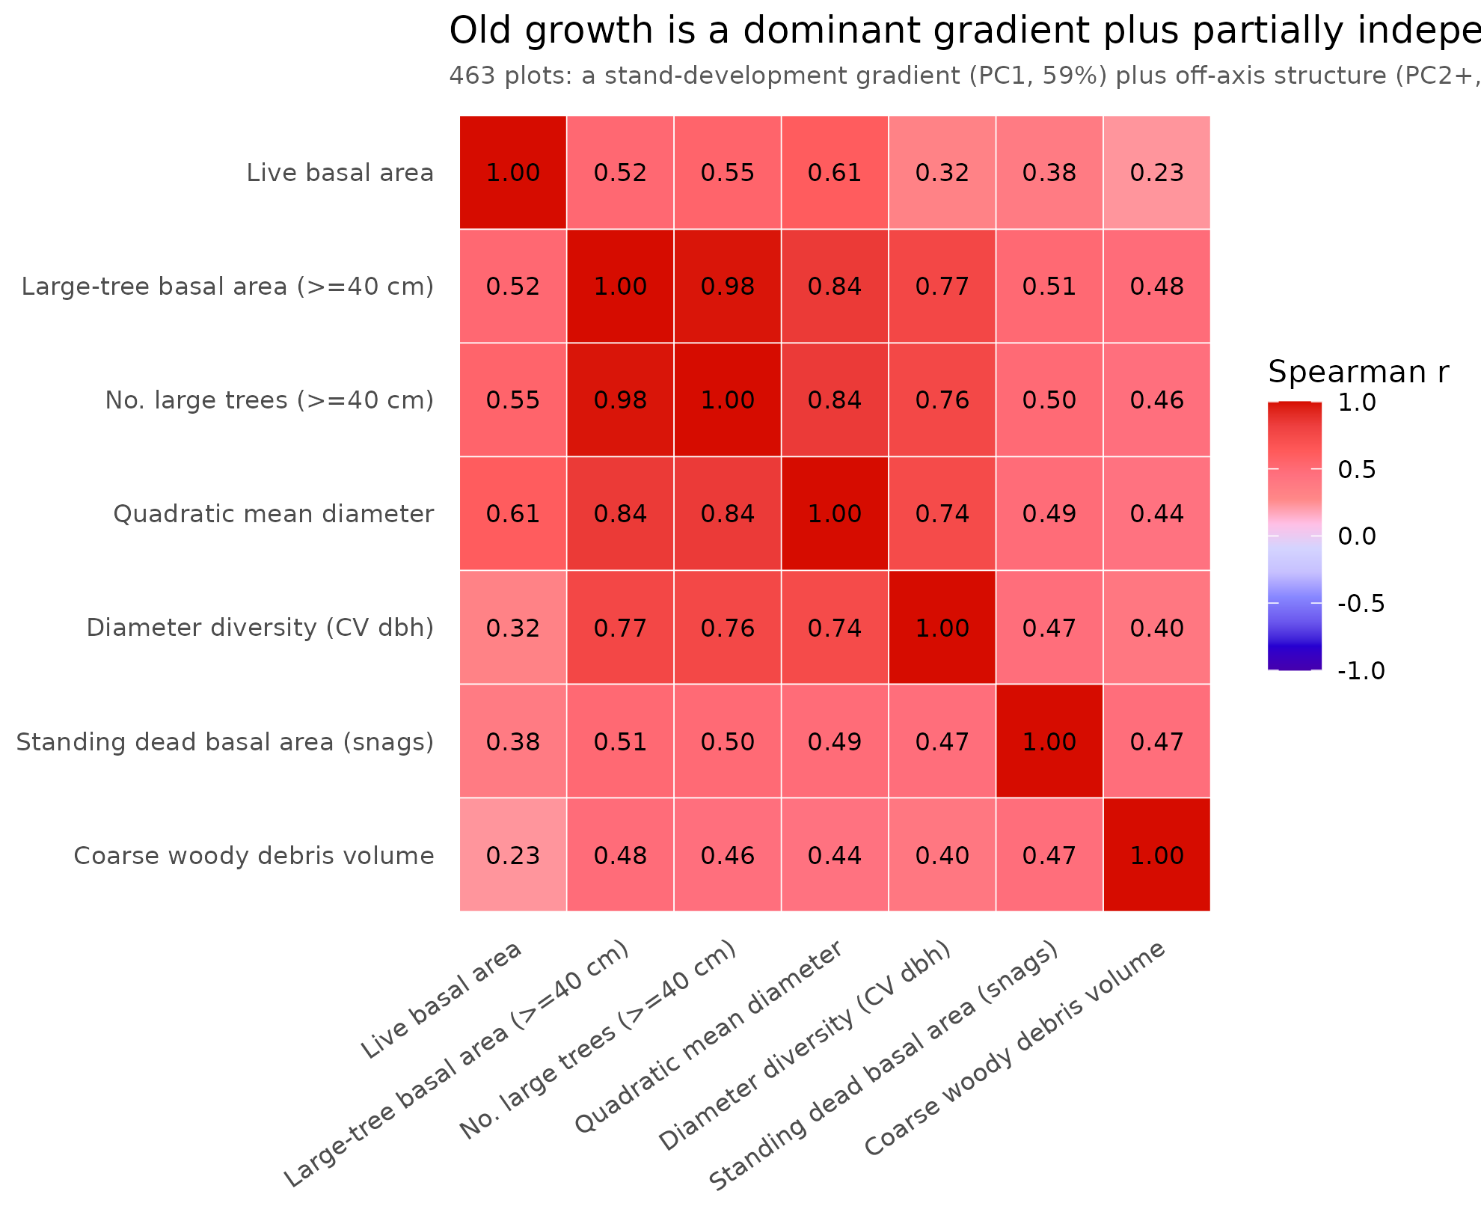
Fig. 4. Correlation structure of the ground attributes that define LSOG on the 463 training plots (Spearman). Live-structure metrics cohere (r 0.76 to 0.98), but standing and downed dead wood form a partially independent axis (r about 0.4 to 0.5). A single stand-development gradient explains 59% of the variance, leaving 41% off-axis; canopy sensors track the live-structure gradient and largely miss the dead-wood axis.

5. Ground-based inventory: the estimate, with the interval the map omits
Airborne LiDAR, TreeMap, and spaceborne canopy height are all proxies for the ground-based structural measurements that define LSOG. The USDA Forest Inventory and Analysis (FIA) program provides those measurements under a probability sample, which permits design-based estimates with sampling-error variance. FIA is unbiased for area but, at its plot density, imprecise; its sparse sample cannot by itself locate or rule out the rare, small LSOG patches a wall-to-wall map can flag. Inventory and map are therefore complementary, not rival: the inventory bounds how much exists, while a verified map locates candidate patches the sparse plots may miss. Using rFIA design-based estimation (post-stratified, with FIA estimation-unit areas; Stanke et al. 2020) over all Maine inventory years, the area of older forest by transparent ground criteria is (2024, 95% CI): stand age >= 100 yr, 12.1% [10.9, 13.2] of forestland; stand age >= 120 yr, 3.9% [3.3, 4.6]; stand age >= 150 yr, 0.7% [0.4, 1.0]; and live basal area in trees >= 40 cm dbh exceeding 30 ft-squared/ac, 12.5% [11.4, 13.7] (Table 4). These statewide figures answer how much older forest Maine holds; because the published map covers only the unorganized townships, we also clipped the same design-based estimate to the map's exact area-of-interest polygon, and within that footprint older forest is increasing rather than declining: stand age >= 120 yr rises from 3.1 to 4.0% and large-tree basal area from 9.1 to 9.7% over 2003-2024, every slope positive with confidence intervals excluding zero (Appendix S1: Table S10). The county-based northern timberland units that approximate the study area give a consistent 4.2% [3.3, 5.1] for stand age >= 120 yr. The trend is therefore not a statewide average masking a loss inside the working-forest townships; the two move the same way. FIA stand age is modeled and is less reliable in the uneven-aged Acadian stands common to the region, which is why we report the large-tree basal-area domain alongside it; the two structural and age-based criteria bracket a consistent range. The increasing trend is robust to the large-tree threshold: at 20, 30, and 40 ft-squared/ac the older-forest share is 19.5%, 12.5%, and 8.2% of forestland, each rising over 2003-2024 with confidence intervals excluding zero (Appendix S1); the same holds across age thresholds (Supporting Information, Fig. S4), where the level depends on the criterion but the increasing direction does not. The point estimate for older forest brackets the published LS+OGL figure of 3.9%, which is reassuring, but the original analysis reported that figure without an interval; the unbiased ground baseline places it in a range of roughly 3.3 to 4.6%, and that uncertainty, partly a matter of FIA's sampling intensity, is exactly what a $200-300 million prioritization should carry.
The design-based series also addresses the loss premise directly. The map is motivated in part by rapid LSOG loss, reported at 1.37% per year overall and 2.19% per year on commercial timberland. That figure is a gross harvest flux: it counts mapped LSOG hectares that subsequently experienced canopy removal in the Global Forest Watch record, and it does not net out ingrowth, the younger stands that mature into older condition each year. The loss criterion is also broad: a mapped hectare is counted as lost when Global Forest Watch records more than 30% canopy removal in a 30 m pixel, which includes the partial and low-grade harvests that, as the authors note for public lands, often retain late-successional structure, so the metric conflates partial harvest with stand conversion. The original authors are explicit about this asymmetry: they state they had no way in this study to estimate the amount and rate of forest growing into an LSOG condition, and they note that on federal Pacific Northwest forests older forest increased over 1993-2017 because ingrowth exceeded harvest (Hagan et al. 2026). Our design-based series supplies the side their data could not, and it moves the other way. Over 2003-2024, older forest increased by every ground measure, with confidence intervals excluding zero: stand age >= 100 yr at +0.19% of forestland per year [0.15, 0.23], stand age >= 120 yr at +0.065% per year [0.054, 0.075], and large-tree basal area at +0.17% per year [0.15, 0.18], while total forestland area was essentially flat (Fig. 5); the robust claim is the direction, not a precise rate. The increase holds where it matters most for certification and policy. On private commercial timberland specifically, older forest (stand age >= 120 yr) is 3.3% [2.7, 4.0] and rising at +0.031% per year (confidence interval excluding zero), and the large-tree basal-area share is 11.5% and rising; public land carries more older forest (10.8%) and is also increasing (Appendix S1). A stock that rises on commercial land while roughly 2% of it is harvested each year implies that ingrowth, the aging of younger stands into older condition, exceeds harvest removals: the reported loss is a gross flux, and the net flow is positive. Where a rate of loss is invoked to convey urgency, the flux and the net stock should be distinguished. A single-date classification is also a snapshot: it cannot credit the LSOG that ongoing conservation and natural ingrowth will produce decades hence. The authors note that the transitioning class, 15.8% of the area (about 1.9 million ha), comprises the best candidates to become late-successional in 25 to 50 years and old growth in roughly a century, and that reserved lands will mature into LSOG; a map that reports current loss without this maturing pipeline understates the trajectory that easements, reserves, and set-asides are deliberately building toward outcomes 30 to 50 years out.
Finally, the original analysis does not benchmark its map against any independent product; although it references GEDI-based structural work (de Conto et al. 2024), the spaceborne canopy-height products covering the area (Potapov et al. 2021; Lang et al. 2023) are neither cited nor used as a cross-check. These are global and free but coarser and noisier than airborne LiDAR, with documented accuracy limits (Moudry et al. 2024); we use the canopy-height product only as one operationalization to demonstrate disagreement (Section 3), never as a reference. The unbiased baseline throughout is the design-based FIA estimate, with the cross-map comparison establishing that credible alternatives disagree.
Table 4. FIA design-based older-forest area (2024) with 95% CI, statewide and in the northern timberland units, with 2003-2024 trend.
Domain (ground criterion) | Statewide % [95% CI] | Northern units % [95% CI] | Trend %/yr [95% CI]
Stand age >= 100 yr | 12.1 [10.9, 13.2] | 12.2 [10.7, 13.7] | +0.19 [0.15, 0.23]
Stand age >= 120 yr | 3.9 [3.3, 4.6] | 4.2 [3.3, 5.1] | +0.065 [0.054, 0.075]
Stand age >= 150 yr | 0.7 [0.4, 1.0] | 0.6 [0.2, 1.0] | +0.000 [-0.005, 0.006]
Large-tree BA >= 30 ft-sq/ac (>=16 in) | 12.5 [11.4, 13.7] | 9.8 [8.4, 11.2] | +0.17 [0.15, 0.18]
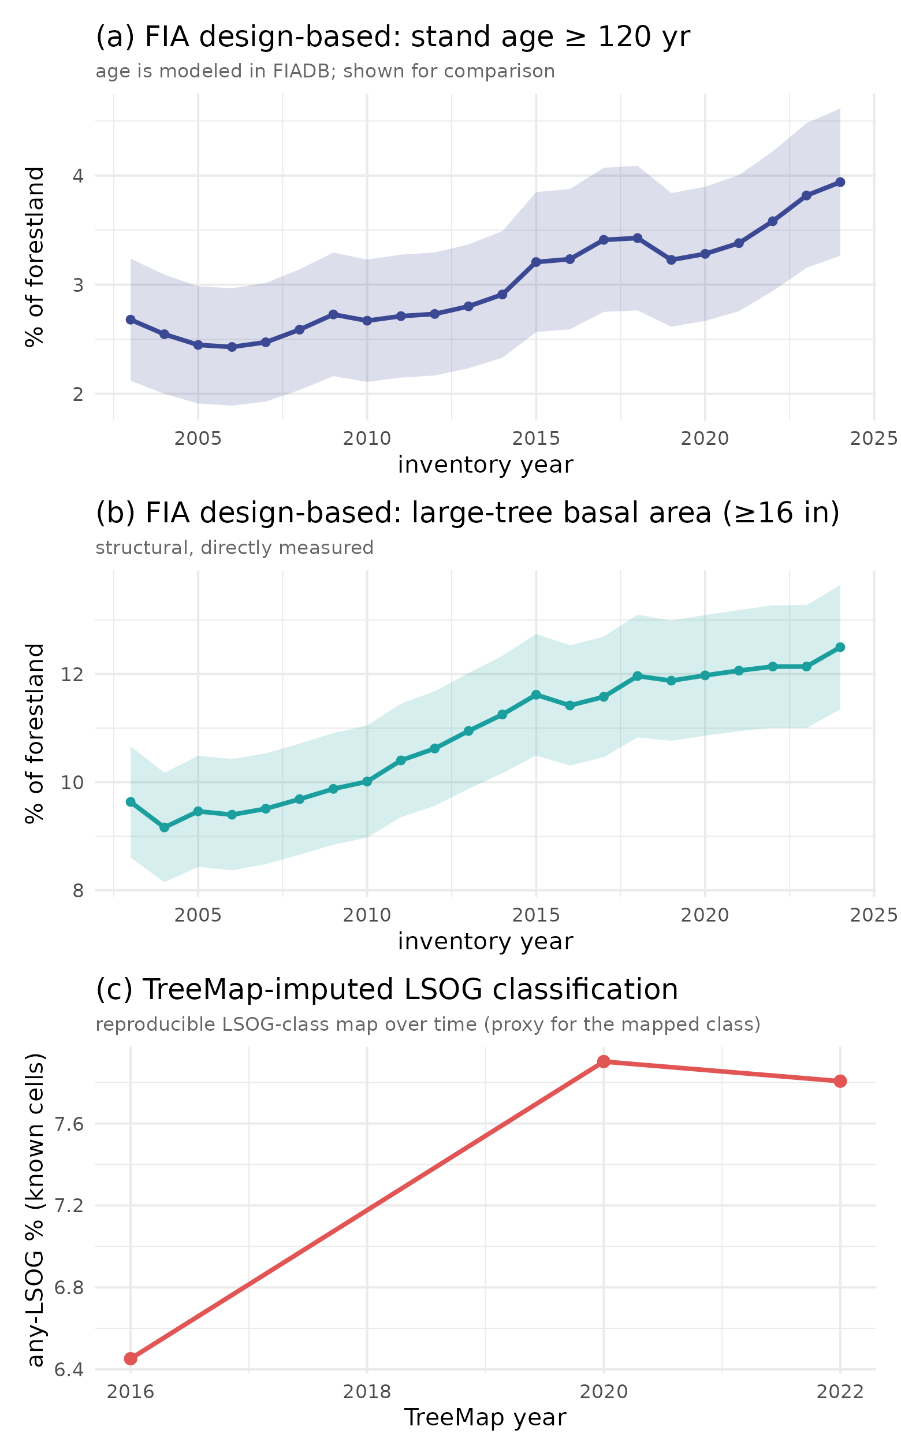
Fig. 5. Older forest over time in Maine by three measures: (a) FIA design-based stand age >= 120 yr (age is modeled in FIADB, shown for comparison); (b) FIA design-based large-tree basal area (directly measured); and (c) the TreeMap-imputed LSOG classification, a reproducible map-based class over time. All three rise; the structural and classification measures, which do not depend on modeled age, agree on the direction.

6. Beyond Maine: increasing older forest and limited existing protection
The Maine result is not an isolate. Applying the same design-based estimator across New England, older forest is stable to increasing in every state over the FIA record, by both stand age and large-tree basal area, with none declining (Fig. 6, Table 5). The two criteria diverge sharply by geography: large-tree basal area runs from 12.5% in Maine, the most intensively managed state, to 38 to 58% in the southern New England states whose forests regrew from near-complete nineteenth-century clearing, while stand age >= 120 yr stays low everywhere (about 1 to 7%). The high southern values are mature second-growth hardwood, structurally large-treed but not old growth, the big-trees-are-not-old-growth point of Section 4 at regional scale. That divergence is the definitional sensitivity of Section 3 expressed geographically: which number one reports depends as much on the criterion chosen as on the forest itself, which is the central reason a single mapped class is a fragile basis for region-wide policy.
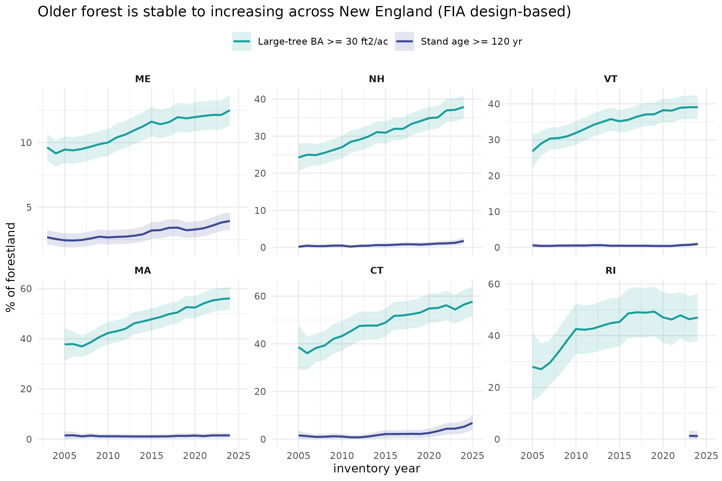
Fig. 6. Design-based older-forest area for the six New England states by stand age >= 120 yr and large-tree basal area, with 95% confidence bands. Both measures are stable to increasing in every state; the gap between them widens from north to south. The Rhode Island age trend is unestimable from its sparse plot panel, so its structural measure is the reliable one there.
Table 5. Design-based older forest in New England (latest inventory year), by state, under two criteria. Both rise in every state.
State | Stand age >= 120 yr % [95% CI] | Large-tree BA % [95% CI] | Trend
Maine | 3.9 [3.3, 4.6] | 12.5 [11.4, 13.7] | both rising
New Hampshire | 1.8 [0.9, 2.6] | 37.9 [34.7, 41.0] | both rising
Vermont | 1.0 [0.4, 1.6] | 39.1 [35.8, 42.4] | both rising
Massachusetts | 1.5 [0.4, 2.5] | 56.1 [51.6, 60.7] | both rising
Connecticut | 6.8 [3.8, 9.8] | 57.7 [51.6, 63.8] | both rising
Rhode Island | 1.2 [0.0, 3.1] | 47.0 [37.9, 56.1] | both rising
A second question bears directly on the policy use of the map: how much older forest is already protected? Using FIA reserved status (RESERVCD, the legal withholding of land from harvest, a conservative lower bound on conserved area because it excludes working easements that permit some cutting), only 11.9% [5.9, 17.9] of Maine older forest (stand age >= 120 yr) is formally reserved, and essentially all of it is on public land; of the broader large-tree structural resource only 5.7% [3.3, 8.1] is reserved (Table 6). Older forest is overwhelmingly private (77% by age, 85% by structure) and almost entirely outside formal protection. The resource a large acquisition program would target is therefore mostly private working forest, the setting in which the map's accuracy, and the owner-by-owner uncertainty documented above, matter most before money moves. A finer split of protection by mechanism (fee versus easement) would draw on the Protected Areas Database; the design-based shares here establish the headline that the great majority of older forest is private and unprotected.
Table 6. Share of Maine older forest formally reserved (FIA RESERVCD, a conservative lower bound on conserved area) and its ownership, design-based with 95% CI. Reserved older forest is almost entirely public; private older forest is essentially unreserved (below the sampling detection limit).
Share of older forest that is ... | Older forest (age >= 120 yr) | Large-tree forest (>=16 in)
reserved (protected) | 11.9% [5.9, 17.9] | 5.7% [3.3, 8.1]
on private land | 77.0% [61.8, 92.3] | 84.6% [76.1, 93.2]
on public land | 23.0% [15.1, 30.8] | 15.4% [11.8, 18.9]
private AND reserved | below detection | below detection

7. A demonstrated prototype: an ensemble agreement score and an uncertainty layer
The recommendation to replace a single map with an ensemble and an explicit uncertainty layer is not hypothetical; we demonstrate it with the products already in hand. Combining the independent operationalizations into an unweighted agreement (membership) surface, with the cross-method standard deviation as a companion uncertainty layer, locates where the methods concur and where they do not. Because two of the inputs are binary class indicators and one is continuous, the surface is an agreement score rather than a calibrated probability, which is sufficient for finding agreement. At the Maine scale (a prototype is in the Supporting Information), cross-method disagreement per 8 km hexagon averages 0.22 (interquartile range 0.19, reaching 0.43 at the 90th percentile) and is highest where the agreement score is intermediate, the transitioning envelope that drives the cost; the defensible acquisition targets are the small high-agreement, low-uncertainty core, while most of the landscape carries high uncertainty where a single map should not by itself move a purchase. The same ensemble extends directly across New England, letting a program prioritize by confidence rather than by one classifier and converting the recommendation of Section 10 into routine practice.
Across the region (Fig. 7), because no trustworthy fine-resolution LSOG map exists region-wide and TreeMap is an imputed product, we summarize the ensemble at the hexagon scale rather than imply pixel-level precision: each 25 km hexagon carries the mean of three transparent ground definitions taken from the FIA condition imputed to each pixel (structural class, stand age >= 120 yr, and large-tree basal area), with their standard deviation as the uncertainty. Across the region the three definitions rarely coincide: only 8.9% of forested area reaches high agreement (two or more definitions), just 0.7% satisfies all three, and 24% of the area carries high uncertainty (cross-definition SD >= 0.4). This is the definitional ambiguity of Section 3 made regional. It is also cross-consistent with the design-based state estimates of Section 6, and it is exactly the layer a prioritization should consult, mapping by confidence and flagging the high-uncertainty majority, before any single classification drives acquisition. We present it hexagonally on purpose: finer resolution would overstate what an imputed product can support.
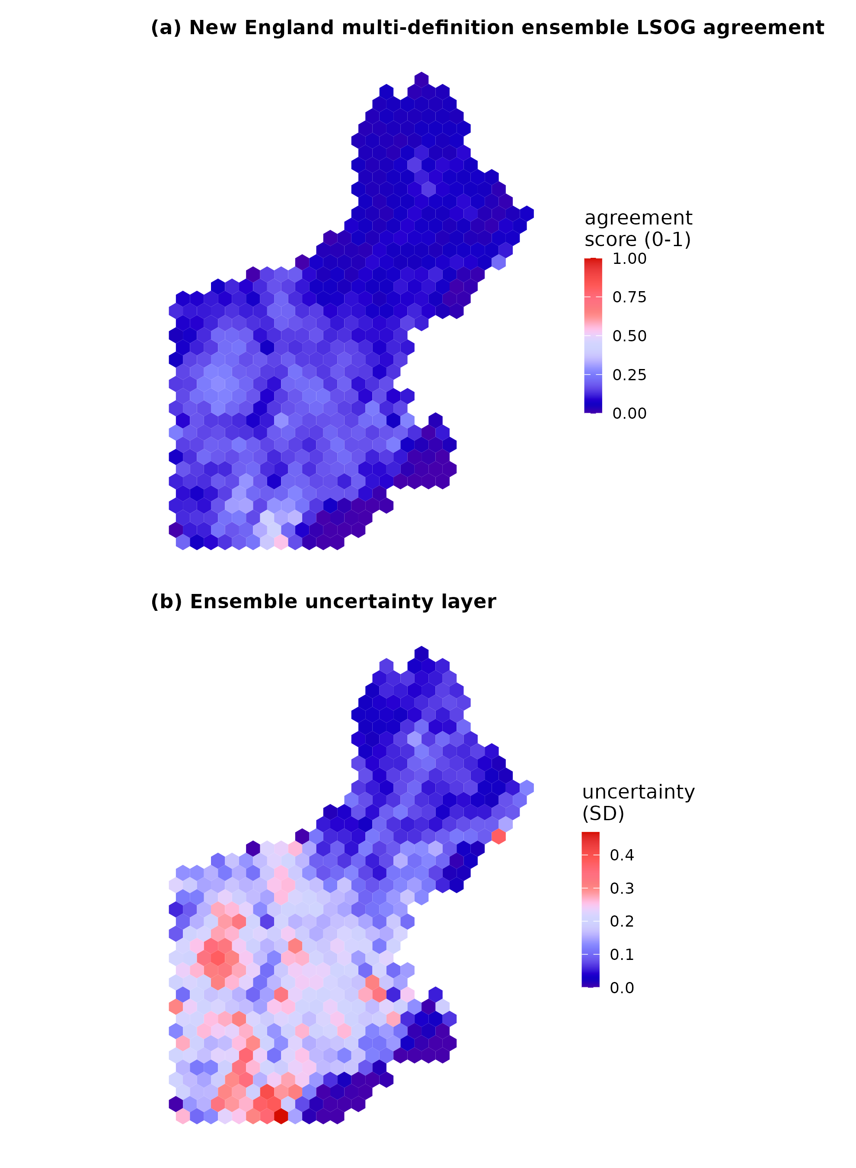
Fig. 7. New England multi-definition ensemble, summarized to 25 km hexagons: (a) agreement score (mean of three FIA-based definitions imputed via TreeMap) and (b) uncertainty (their standard deviation). The ensemble is shown at hex scale because TreeMap is an imputed product; finer resolution would overstate its precision. High agreement is rare and uncertainty is widespread, especially in southern New England where the age and structural criteria diverge most.

8. Toward a repeatable classification of true LSOG
The constructive endpoint of this Comment is a classification that is repeatable and tied to what LSOG actually is. We define true LSOG as forest that satisfies multiple axes, not a single canopy proxy, each from transparent FIA measurements: live structure (large-tree basal area >= 30 ft-sq/ac), dead wood (standing-dead basal area >= 5 ft-sq/ac), compositional maturity (>= 50% of live basal area in shade-tolerant, long-lived species), and temporal continuity (no recent cutting and natural stand origin). Because every criterion is a deterministic function of FIA condition and tree records, the classification is fully reproducible and yields a design-based area with a confidence interval. Requiring more axes narrows the class sharply (Fig. 8): 96% of Maine forestland meets at least one axis, 71% meets two, 30% meets three, and only 6.5% [5.6, 7.4] meets all four, which is the design-based estimate of true LSOG, sensibly between the strict age-based old growth (3.9%) and the broad canopy LSOG (about 20%). Live structure is the scarcest single axis (12.5%) and the most common one missing among near-LSOG stands; temporal continuity, captured here only by FIA treatment codes, is permissive because legacy partial harvest and skid trails are undercounted, so the true continuity-limited figure is plausibly lower. The specific cutoffs are illustrative and a formal threshold-sensitivity analysis is a priority; the dead-wood axis here uses standing snags only, because coarse woody debris was not in the inventory pull and would strengthen it, and continuity from treatment codes is permissive, so 6.5% is best read as an upper bound pending the disturbance-history layer. The requirement that several axes be met simultaneously, however, is what separates true LSOG from tall, big-treed, or merely mature forest, and is robust to the exact thresholds.
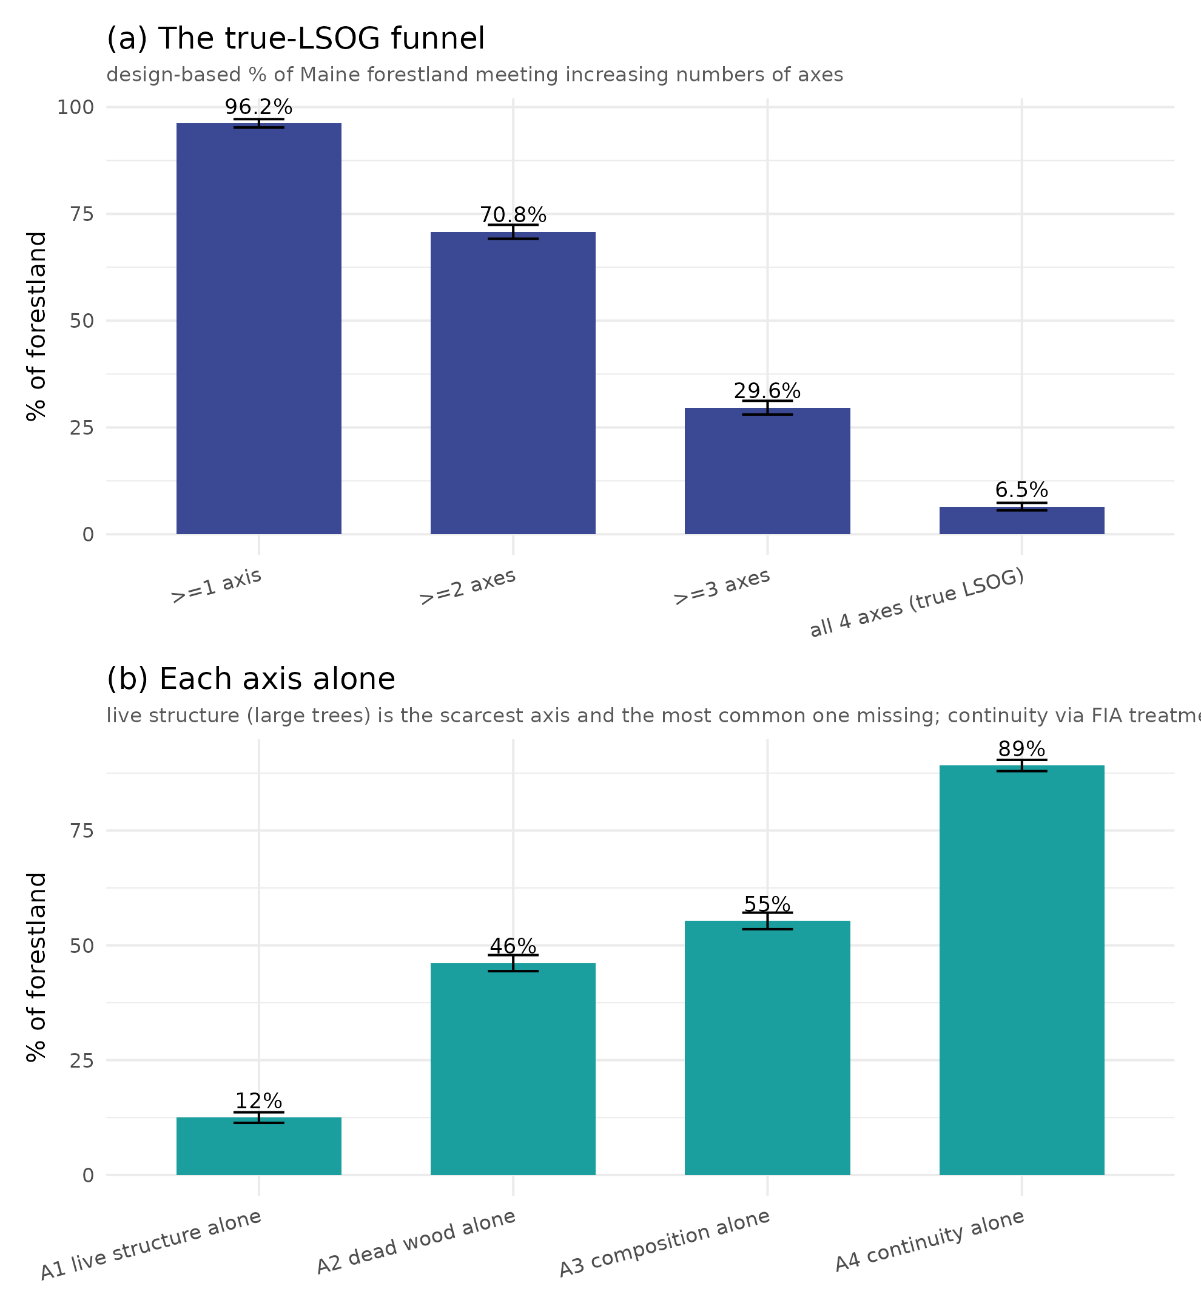
Fig. 8. A repeatable multi-axis classification of true LSOG, FIA design-based for Maine. (a) The class narrows from 96% of forestland meeting one axis to 6.5% meeting all four (true LSOG). (b) Each axis alone; live structure (large trees) is scarcest, while continuity from FIA treatment codes is permissive. Error bars are 95% CIs.
This framework also charts the path from definition to map, by making explicit how observable each axis is. Live structure is the axis canopy LiDAR sees, and even that imperfectly; temporal continuity is observable not from a single date but from the satellite disturbance record, which we demonstrate here: intersecting the mapped LSOG with the Hansen Global Forest Change record (2001-2023), 24% of canopy-mapped LSOG has already experienced Landsat-detected stand-replacing disturbance, failing strict continuity even over this short window, while 76% is intact over the record (Supporting Information, Fig. S6); legacy harvest and skid trails predating 2001 and partial harvests are not captured, so this is a lenient test and the longer LCMS record (1985-) would tighten it. Dead wood and composition are largely invisible to canopy and passive optical sensors and require field plots or structural imputation that carries the full FIA condition. A defensible LSOG map is therefore a multi-layer product, canopy structure from LiDAR, a disturbance-history layer for continuity, and plot-anchored or imputed layers for dead wood and composition, combined into an agreement-and-uncertainty surface (Section 7) and calibrated against the design-based FIA estimate, which remains the unbiased anchor for how much exists. Which axes and thresholds are required should be set by the management objective (Table 7), so that the values choice is explicit rather than hidden inside a single classifier.
Table 7. The same multi-axis framework, tuned to the objective: which axes a given goal should emphasize. Making the choice explicit is what a single LSOG map hides.
Objective | Axes emphasized | Illustrative operational rule
Biodiversity / habitat | dead wood, continuity, composition | snags and downed wood present; no recent cutting; late-successional dominance
Carbon stock | live structure (large trees) | large-tree basal area >= 30 ft-sq/ac; high live basal area
Primary-forest protection | continuity, composition | natural origin, no harvest history; shade-tolerant long-lived dominance
Comprehensive true LSOG | all four axes | meet all four simultaneously (6.5% [5.6, 7.4] of Maine forestland)

9. Implications
None of the above argues against mapping LSOG with LiDAR, nor against conserving older forest in Maine, which we support. Read as what it measures, tall, large-tree forest, the classification is a valuable screening tool; read as a map of strict old-growth-grade forest to be protected at high cost, it counts much transitioning and late-successional forest and so exceeds the strict resource. That breadth is a legitimate, objective-dependent choice rather than an error, the transitioning class captures the small patches and lifeboats that retention ecology values, but it must be read as such, and local errors run in both directions. The risk lies less in the map than in its use: without cross-comparison, field verification, or assessment over time, a screening product carries unintended consequences into acquisition and policy, and the exposure is sharpest for the isolated single-hectare patches it is designed to find, where 1 ha classifications fall on stand boundaries and mixed conditions and the map is least reliable. A single classification, however well trained, is therefore not a sufficient basis for parcel-level expenditures of the magnitude now contemplated; the practices that would make it sufficient, benchmarking against the design-based FIA estimate, cross-comparison against an independent product, parcel-scale field verification (Shamgochian et al. 2025), and reporting uncertainty on every quantity with the harvest flux distinguished from the net stock, are the same ones distilled in Sections 7 and 8. These matter most where a map underwrites cost estimates at the scale of the recent statewide assessment (Thompson et al. 2026), whose $200-300 million estimate is computed parcel by parcel from the mapped patches and inherits the map's accuracy and uncertainty directly.
Where LSOG sits on the landscape is itself informative about risk, and the picture is two-sided. We overlaid the mapped LSOG (the airborne Hagan map, so the comparison is independent of the TreeMap-derived products) with a CONUS harvest-probability model (HCS: modeled annual probability of clearcut plus partial harvest), with slope as a cost-and-logistics constraint on harvesting, and with the satellite disturbance record (Supporting Information, Fig. S5; n = 3.8 million pixels). Mapped LSOG concentrates on high-harvest-probability ground: the LSOG share rises from 13% in the lowest harvest-probability tercile to 34% in the highest, and mapped-LSOG pixels carry a higher mean annual harvest probability than non-LSOG (0.024 versus 0.021). The likely mechanism is that the structure that makes a stand read as LSOG, large trees and high stocking, is also what makes it merchantable, so the harvest model and the LSOG classifier key on overlapping structure, and the mapped resource is not shielded by low harvest demand. Yet it also sits on more difficult terrain: median slope under mapped LSOG is 5.3 versus 3.0 degrees, the LSOG share rises from 12% on the gentlest ground to 37% on the steepest, and similarly from 17% to 35% across the disturbance gradient. These forces pull in opposite directions: the stands are attractive to harvest yet costlier to reach and operate, and steep, disturbance-prone settings raise both operational cost and the chance that a stand does not persist as LSOG regardless of designation. The implication is not reassurance by inaccessibility but nuance, much mapped LSOG is squarely in the merchantable pool while also carrying real terrain and disturbance constraints, so harvest risk is heterogeneous and parcel-specific rather than uniform, and targeting should treat it that way. One further, perverse possibility deserves flagging: an influential but uncertain map can change behavior ahead of policy. There are anecdotal reports of some landowners accelerating harvest in mapped LSOG stands in anticipation of tighter regulation, a pre-emptive response that an unverified, high-profile map can itself trigger and that runs directly against the conservation goal. That risk is its own argument for attaching uncertainty to the map and field-verifying before any stand is designated.
It helps to see the estimates side by side (Table 8). For the same forest, the amount called LSOG ranges from about 4% under a strict old-growth definition to roughly 22% under the broad canopy class, a fivefold span that is the practical face of the multidimensionality argument. The design-based figures carry sampling intervals; the broad canopy figures do not; and the four-axis true-LSOG estimate, 6.5%, falls where the criteria converge. The honest reporting unit is this range with its definitions attached, not a single headline number. The choice is not academic for carbon: in Maine, mean live-tree carbon rises from about 39 Mg per hectare in non-LSOG stands to 72, 91, and 139 across the transitioning, late-successional, and old-growth classes, so where the LSOG line is drawn moves the carbon attributed to it several fold.
Table 8. How much LSOG is in Maine? Estimates for the same forest under different methods and definitions. Design-based (FIA) rows carry 95% confidence intervals; remote-sensing class areas do not. The right number depends on the objective and definition (Table 7).
Method or definition | LSOG (% of forest) | What it captures
Hagan airborne LiDAR, any-LSOG (incl. transitioning) | 19.7 reported; 21.9 reproduced | tall, big-tree canopy; broad screening class
Canopy-height model (v5.1-GEDI) | 14.0 | height and cover proxy
TreeMap structural imputation | 7.8 | imputed FIA structural class (30 m)
FIA large-tree basal area >= 30 ft-sq/ac | 12.5 [11.4, 13.7] | live big-tree structure (design-based)
Reproduced LS + OGL (strict canopy classes) | about 4 | late-successional + old-growth canopy
FIA stand age >= 120 yr (strict old) | 3.9 [3.3, 4.6] | modeled stand age (design-based)
True LSOG, four-axis classification | 6.5 [5.6, 7.4] | structure + dead wood + composition + continuity

10. Recommendations for future research
Several concrete steps would put LSOG mapping in Maine on firmer footing for the decisions now riding on it. First, conduct a formal accuracy assessment of the airborne map against an independent probability sample, reporting a full confusion matrix and class-wise user and producer accuracy by owner group rather than out-of-bag accuracy alone; the FIA plot network is a ready reference. Second, add structural predictors that capture the attributes canopy metrics miss, in particular dead wood and canopy gaps (canopy-gap density, large downed-log density, and multi-return or full-waveform metrics), to separate late-successional from true old-growth forest, as the original authors propose. Third, estimate ingrowth directly, through repeat LiDAR or a NAIP and GEDI time series paired with FIA growth-removal-mortality estimation, so that loss and gain are reported as a net change rather than a one-sided flux. Fourth, propagate geolocation and co-registration error explicitly, for example with the Bayesian correction of Shannon et al. (2024), before any pixel-level overlay or parcel ranking. Fifth, move from a single map to an ensemble of credible operationalizations, reporting per-pixel agreement and an uncertainty layer so that prioritization is driven by confidence rather than by one classifier, the no-regrets logic of systematic conservation planning in which the defensible parcels are those prioritized across all network designs (Schloss et al. 2024); we prototype exactly this in Section 7 and it could be standardized region-wide. Sixth, before acquisition, field-verify a probability sample of the prioritized parcels using the published rapid protocol (Shamgochian et al. 2025) and report the sensitivity of the result to the LSOG definition used. None of these is beyond the reach of the groups already working in this landscape, and several could be done collaboratively. More broadly, LSOG assessment now has several complementary tools, airborne LiDAR, spaceborne GEDI and global canopy-height products, FIA design-based inventory, structural imputation such as TreeMap, and growth-and-yield models that project ingrowth and future condition; no single tool is sufficient, and the constructive path is to combine them, as the ensemble here begins to do, rather than to elevate any one map. Used together they can also represent the forward trajectory that a snapshot cannot, crediting the conservation investments whose LSOG returns arrive decades from now.

Data and code availability
All analyses, code, and derived products supporting this Comment are archived at Zenodo (concept DOI 10.5281/zenodo.20614496). Hagan et al.'s training data and code are at Zenodo 10.5281/zenodo.19696494. FIA data are from the USDA FIA DataMart, accessed June 2026.

References
Barnett, K., G. H. Aplet, and R. T. Belote. 2023. Classifying, inventorying, and mapping mature and old-growth forests in the United States. Frontiers in Forests and Global Change 5:1070372. https://doi.org/10.3389/ffgc.2022.1070372
Box, G. E. P. 1976. Science and statistics. Journal of the American Statistical Association 71:791-799.
de Conto, T., J. Armston, and R. Dubayah. 2024. Characterizing the structural complexity of the Earth's forests with spaceborne lidar. Nature Communications 15:8116. https://doi.org/10.1038/s41467-024-52468-2
Franklin, J. F., and R. Van Pelt. 2004. Spatial aspects of structural complexity in old-growth forests. Journal of Forestry 102(3):22-28.
Gray, A. N., K. Pelz, G. D. Hayward, T. Schuler, W. Salverson, M. Palmer, C. Schumacher, and C. W. Woodall. 2023. Perspectives: the wicked problem of defining and inventorying mature and old-growth forests. Forest Ecology and Management 546:121350. https://doi.org/10.1016/j.foreco.2023.121350
Hagan, J. M., B. Shamgochian, M. M. L. Taylor, and J. M. Reed. 2026. Using LiDAR to quantify, map, and conserve late-successional and old-growth forest in Maine, USA. Ecosphere 17:e70670.
Lang, N., W. Jetz, K. Schindler, and J. D. Wegner. 2023. A high-resolution canopy height model of the Earth. Nature Ecology & Evolution 7:1778-1789. https://doi.org/10.1038/s41559-023-02206-6
Moudry, V., et al. 2024. Comparison of three global canopy height maps and their applicability to biodiversity modeling: accuracy issues revealed. Ecosphere 15:e70026.
Pelz, K., G. Hayward, A. Gray, E. Berryman, C. Woodall, A. Nathanson, and N. Morgan. 2023. Quantifying old-growth forest of United States Forest Service public lands. Forest Ecology and Management 549:121437. https://doi.org/10.1016/j.foreco.2023.121437
Potapov, P., et al. 2021. Mapping global forest canopy height through the fusion of GEDI and Landsat data. Remote Sensing of Environment 253:112165.
Schloss, C. A., D. R. Cameron, B. Franklin, S. A. Morrison, and C. Nolte. 2024. An approach to designing efficient implementation of 30x30 terrestrial conservation commitments. Conservation Science and Practice 6:e13232. https://doi.org/10.1111/csp2.13232
Shamgochian, B., J. Hagan, M. Taylor, and M. Reed. 2025. LSOG Rapid Assessment Protocol (RAP) for Maine (v1.0). Our Climate Common Report, Georgetown, Maine.
Shannon, E. S., A. O. Finley, D. J. Hayes, S. N. Noralez, A. R. Weiskittel, B. D. Cook, and C. Babcock. 2024. Quantifying and correcting geolocation error in spaceborne LiDAR forest canopy observations using high spatial accuracy data: a Bayesian model approach. Environmetrics 35:e2840. https://doi.org/10.1002/env.2840
Spies, T. A. 2004. Ecological concepts and diversity of old-growth forests. Journal of Forestry 102(3):14-20.
Spracklen, B., and D. V. Spracklen. 2021. Determination of structural characteristics of old-growth forest in Ukraine using spaceborne LiDAR. Remote Sensing 13(7):1233. https://doi.org/10.3390/rs13071233
Stanke, H., A. O. Finley, A. S. Weed, B. F. Walters, and G. M. Domke. 2020. rFIA: an R package for estimation of forest attributes with the FIA database. Environmental Modelling & Software 127:104664.
Thompson, J. R., A. Daigneault, J. Plisinski, I. Moon, and J. Norton. 2026. Pathways for protecting Maine's remaining late-successional and old-growth forests. Property and Environment Research Center.
Wirth, C., G. Gleixner, and M. Heimann, editors. 2009. Old-Growth Forests: Function, Fate and Value. Ecological Studies 207. Springer, Berlin.

