Supporting Information
for: Using LiDAR to quantify, map, and conserve late-successional and old-growth forest in Maine, USA: Comment (A. R. Weiskittel).

Appendix S1. Methods
Reproduction. The published random forest was refit from the archived 463-plot training data (8 LiDAR canopy metrics) with mtry=2 and 500 trees, reproducing the binary out-of-bag accuracy (94.2% vs 94.1%) and the top predictor. The model was applied to the archived per-hectare LiDAR metrics for the full area of interest (4,282,675 ha) to reproduce the wall-to-wall classification, and a 20-seed ensemble bounded the area estimate and the cross-validation agreement (Table S3).
Cross-map comparison. Three wall-to-wall classifications were placed on a common 100 m grid: the reproduced Hagan classifier; a logistic model of the FIA field class on Potapov (GEDI-calibrated) canopy height (calibrated to the FIA plot prevalence); and the USFS TreeMap 2022 imputation of FIA structural class. Pairwise Cohen kappa and Jaccard, three-way concordance, and the overlap of top-priority protected sets were computed.
Accuracy on the training plots. Cross-validated AUC (repeated stratified five-fold, 40 repeats) was estimated for three predictor sets (8 LiDAR metrics; canopy height only; ground structure) against three targets, under random forest and logistic regression (Table S1). The capacity of the LiDAR metrics to predict the ground structural attributes that define old growth was assessed by cross-validated R-squared (Table S6).
FIA design-based estimation. Design-based older-forest area and 2003-2024 trend were estimated with rFIA (post-stratified, with FIA estimation-unit areas) over all Maine inventory years, for stand-age and large-tree basal-area domains, statewide and in the northern timberland units. Sensitivity to the large-tree threshold is in Table S2.
Hex-scale summary. Each method's any-LSOG was aggregated to 8 km hexagons (n = 984) over the area of interest; the cross-method disagreement (maximum minus minimum any-LSOG fraction per hexagon) had mean 0.22 and median 0.19 (Fig. S1).
Data and code. All scripts and derived products are archived at Zenodo (concept DOI 10.5281/zenodo.20614496). FIA data are from the USDA FIA DataMart; Hagan training data and code from Zenodo 10.5281/zenodo.19696494.

Table S1. AUC by classifier and predictor set
Table S1. Cross-validated AUC (mean and 95% interval) by classifier (random forest, logistic regression), target, and predictor set. Canopy-height-only is weakest for old growth under both classifiers.
classifier | target | predictors | auc | lo | hi
glm | any-LSOG | LIDAR8 | 0.99 | 0.988 | 0.991
glm | any-LSOG | HEIGHT | 0.989 | 0.989 | 0.99
glm | any-LSOG | STRUCT | 0.968 | 0.964 | 0.971
glm | LS+OG | LIDAR8 | 0.983 | 0.981 | 0.985
glm | LS+OG | HEIGHT | 0.985 | 0.982 | 0.986
glm | LS+OG | STRUCT | 0.977 | 0.972 | 0.98
glm | OG | LIDAR8 | 0.967 | 0.921 | 0.991
glm | OG | HEIGHT | 0.912 | 0.893 | 0.924
glm | OG | STRUCT | 0.973 | 0.966 | 0.978
rf | any-LSOG | LIDAR8 | 0.99 | 0.988 | 0.992
rf | any-LSOG | HEIGHT | 0.984 | 0.982 | 0.987
rf | any-LSOG | STRUCT | 0.965 | 0.961 | 0.968
rf | LS+OG | LIDAR8 | 0.987 | 0.982 | 0.989
rf | LS+OG | HEIGHT | 0.977 | 0.974 | 0.979
rf | LS+OG | STRUCT | 0.969 | 0.966 | 0.972
rf | OG | LIDAR8 | 0.967 | 0.952 | 0.979
rf | OG | HEIGHT | 0.913 | 0.868 | 0.933
rf | OG | STRUCT | 0.975 | 0.97 | 0.98

Table S2. FIA design-based sensitivity to the large-tree threshold
Table S2. Design-based older-forest area (large-tree basal area domain) at three thresholds, with 95% CI and 2003-2024 trend. The increasing trend is robust to the threshold.
domain | yr | 2024 % | lo | hi | trend %/yr | slope lo | slope hi
Large-tree BA >= 20 ft2/ac | 2024 | 19.516 | 18.151 | 20.88 | 0.161 | 0.136 | 0.186
Large-tree BA >= 30 ft2/ac | 2024 | 12.498 | 11.349 | 13.647 | 0.168 | 0.151 | 0.185
Large-tree BA >= 40 ft2/ac | 2024 | 8.179 | 7.217 | 9.14 | 0.114 | 0.096 | 0.133

Table S2b. FIA older forest by ownership (private commercial vs public)
Table S2b. Design-based older-forest area by ownership group with 95% CI and 2003-2024 trend. Older forest is rising on private commercial timberland as well as public land.
domain | owner | 2024 % | lo | hi | trend %/yr | slope lo | slope hi
Stand age >= 120 yr | private | 3.313 | 2.657 | 3.969 | 0.031 | 0.019 | 0.044
Stand age >= 120 yr | public | 10.797 | 7.124 | 14.471 | 0.391 | 0.326 | 0.456
Large-tree BA >= 30 | private | 11.543 | 10.377 | 12.709 | 0.15 | 0.134 | 0.165
Large-tree BA >= 30 | public | 22.943 | 17.633 | 28.253 | 0.21 | 0.111 | 0.309

Table S3. Random forest stochasticity (20-seed ensemble)
Table S3. Mean, SD, and range across 20 random forest seeds for reproduced accuracy, wall-to-wall area, and cross-validation agreement.
metric | mean | sd | min | max
oob_binary_acc | 94.05 | 0.317 | 93.737 | 95.032
ww_any_pct | 21.591 | 0.22 | 21.15 | 22.1
ww_lsogl_pct | 4.235 | 0.063 | 4.115 | 4.339
ww_ogl_pct | 0.945 | 0.032 | 0.88 | 1.007
ww_lsogl_ha | 181,317 | 2,707 | 176,207 | 185,787
kappa_any | 0.128 | 0.004 | 0.122 | 0.139
kappa_lsog | 0.064 | 0.011 | 0.049 | 0.079

Table S4. Cross-method disagreement by owner class
Table S4. Of the LSOG flagged by any method, the share that is contested (flagged by one or two methods, not all) by owner class. Disagreement is pervasive across ownership.
owner code | flagged ha | all-agree ha | contested ha | % contested
3 | 364,952 | 1,624 | 363,328 | 99.6
0 | 344,603 | 1,448 | 343,155 | 99.6
4 | 314,352 | 899 | 313,453 | 99.7
7 | 147,168 | 989 | 146,179 | 99.3
1 | 102,091 | 125 | 101,966 | 99.9
6 | 42,120 | 594 | 41,526 | 98.6
8 | 16,199 | 48 | 16,151 | 99.7
2 | 16,046 | 135 | 15,911 | 99.2
5 | 719 | 0 | 719 | 100
 | 530 | 2 | 528 | 99.6

Table S5. TreeMap LSOG time series
Table S5. TreeMap-imputed LSOG area over 2016-2022 (native 30 m), Maine unorganized townships.
year | any-LSOG % | LS+OG % | known ha
2016 | 6.452 | 0.217 | 3,765,076
2020 | 7.902 | 0.608 | 3,888,375
2022 | 7.806 | 0.594 | 3,876,445

Table S6. LiDAR prediction of structure, and old-growth discriminators
Table S6a. Cross-validated R-squared for predicting ground structural attributes from the eight LiDAR metrics. Dead wood (CWD, snags) is poorly predicted.
structural attribute | CV R-squared from LiDAR | lo | hi
basal_GE_40cmDBH | 0.681 | 0.669 | 0.7
No_treesGE_40cmdbh | 0.586 | 0.578 | 0.597
CWD_vol | 0.201 | 0.175 | 0.23
sum_dead_basalarea | 0.241 | 0.222 | 0.264
CV_livedbh | 0.514 | 0.502 | 0.526
Table S6b. Old-growth discriminators (random forest variable importance) across LiDAR and ground-structure variables.
variable | set | importance (MDA)
sum_live_basalarea | ground structure | undefined
cano_cover_15 | LiDAR canopy | undefined
basal_GE_40cmDBH | ground structure | undefined
percentile_95th | LiDAR canopy | undefined
CV_livedbh | ground structure | undefined
QMD_live | ground structure | undefined
mean_cano_ht | LiDAR canopy | undefined
sum_dead_basalarea | ground structure | undefined
cano_cover_2 | LiDAR canopy | undefined
max_cano_ht | LiDAR canopy | undefined
No_treesGE_40cmdbh | ground structure | undefined
prop_basal_GE_40cmDBH | ground structure | undefined
top_rugosity | LiDAR canopy | undefined
cano_cover_6 | LiDAR canopy | undefined
rumple | LiDAR canopy | undefined
CWD_vol | ground structure | undefined

Table S7. Reproduced random forest out-of-bag confusion matrix
Table S7. Out-of-bag confusion matrix (counts) for the reproduced airborne-LiDAR random forest. Rows are field-assigned classes, columns predicted. True old growth is recovered only about a quarter of the time (Fig. 1 of the Comment).
True | LS | Not LS | Old-growth | Trans LS
LS | 68 | 0 | 1 | 10
Not LS | 0 | 268 | 0 | 14
Old-growth | 9 | 0 | 4 | 4
Trans LS | 10 | 15 | 1 | 59

Table S8. Sensitivity of the classification to the probability cutoff
Table S8. As the random forest probability cutoff for calling LSOG varies, the fraction of labelled plots called LSOG, sensitivity, specificity, overall accuracy, and the true-skill statistic (TSS) all shift (Fig. 2 of the Comment).
cutoff | frac called LSOG | sensitivity | specificity | accuracy | TSS
0.1 | 0.944 | 1 | 0.329 | 0.886 | 0.329
0.15 | 0.927 | 0.997 | 0.418 | 0.898 | 0.415
0.2 | 0.909 | 0.992 | 0.494 | 0.907 | 0.486
0.25 | 0.888 | 0.99 | 0.608 | 0.924 | 0.597
0.3 | 0.868 | 0.984 | 0.696 | 0.935 | 0.681
0.35 | 0.862 | 0.982 | 0.722 | 0.937 | 0.703
0.4 | 0.849 | 0.971 | 0.747 | 0.933 | 0.718
0.45 | 0.836 | 0.966 | 0.797 | 0.937 | 0.764
0.5 | 0.823 | 0.958 | 0.835 | 0.937 | 0.794
0.55 | 0.812 | 0.948 | 0.848 | 0.931 | 0.796
0.6 | 0.808 | 0.943 | 0.848 | 0.927 | 0.791
0.65 | 0.786 | 0.93 | 0.911 | 0.927 | 0.841
0.7 | 0.778 | 0.922 | 0.924 | 0.922 | 0.846
0.75 | 0.769 | 0.914 | 0.937 | 0.918 | 0.851
0.8 | 0.76 | 0.904 | 0.937 | 0.909 | 0.84
0.85 | 0.749 | 0.893 | 0.949 | 0.903 | 0.843
0.9 | 0.728 | 0.875 | 0.987 | 0.894 | 0.862

Table S9. Independent third-party old-growth comparison (Pelz et al. 2023)
Table S9. Plot-level agreement (Cohen's kappa) between the field-structure classification used here and the U.S. Forest Service national old-growth inventory (Pelz et al. 2023), evaluated on the FIA plots where both apply: National Forest System land in Maine, New Hampshire, New York, and Vermont (n about 925, concentrated in NH and VT because Maine holds little federal forest). Agreement is weak even between two independently authored operationalizations of old forest, corroborating the cross-map disagreement documented in the Comment.
Comparison | Cohen's kappa
v5.1 old growth vs Pelz old growth | 0.04
v5.1 late-successional + old growth vs Pelz old growth | 0.25
v5.1 any-LSOG vs Pelz old growth | 0.12

Table S10. FIA older-forest trend clipped to the published map area of interest
Table S10. FIA design-based older-forest area within Hagan et al.'s exact area-of-interest polygon (the unorganized townships, about 4.28 million ha), by rFIA spatial estimation (polys), 2003 to 2024. Within the map's own footprint older forest is increasing on every measure, with all weighted-regression slopes positive and 95% intervals excluding zero. This confirms the statewide trend is not masking a within-UT decline.
Ground criterion | 2003 (%) | 2024 (%) | Trend %/yr [95% CI]
Stand age >= 120 yr | 3.1 | 4.0 | +0.058 [0.043, 0.073]
Stand age >= 100 yr | 9.4 | 13.2 | +0.199 [0.149, 0.249]
Large-tree BA >= 30 ft-sq/ac | 9.1 | 9.7 | +0.052 [0.036, 0.069]

Figure S1. Hex-scale cross-map disagreement
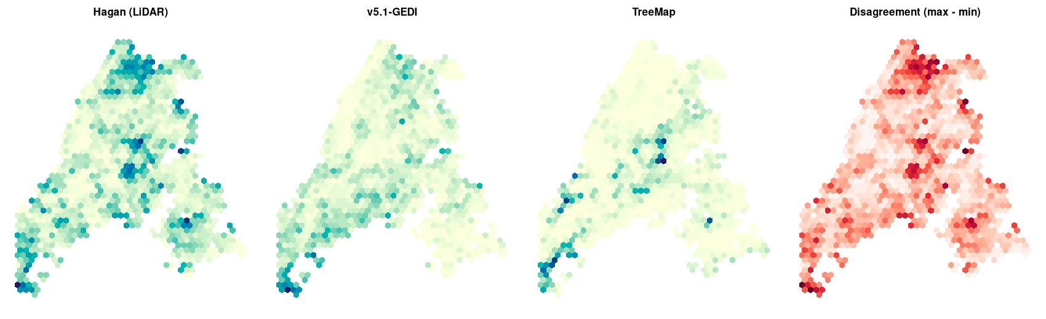
Figure S1. Any-LSOG fraction by method aggregated to 8 km hexagons over the area of interest, and the cross-method disagreement (max minus min). Disagreement concentrates in the northern and central townships.

Figure S2. Maine study-area ensemble (agreement and uncertainty)
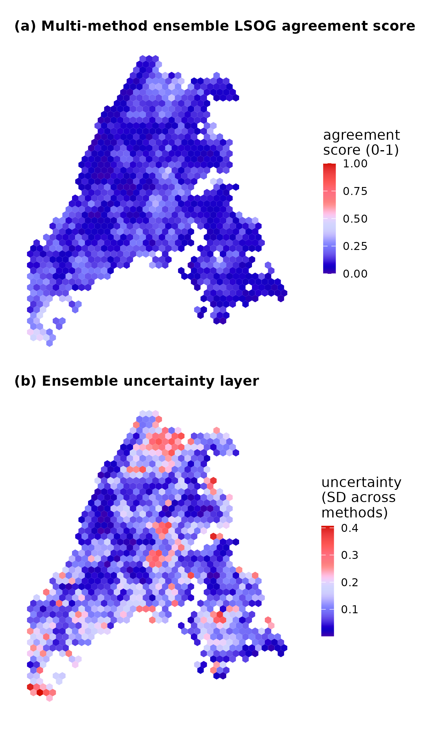
Figure S2. Prototype multi-method ensemble for the Maine study area, aggregated to 8 km hexagons: (a) agreement score (unweighted mean of three method memberships) and (b) uncertainty (standard deviation). The companion New England version is Fig. 7 of the Comment.

Figure S4. Older forest over time under different definitions and thresholds
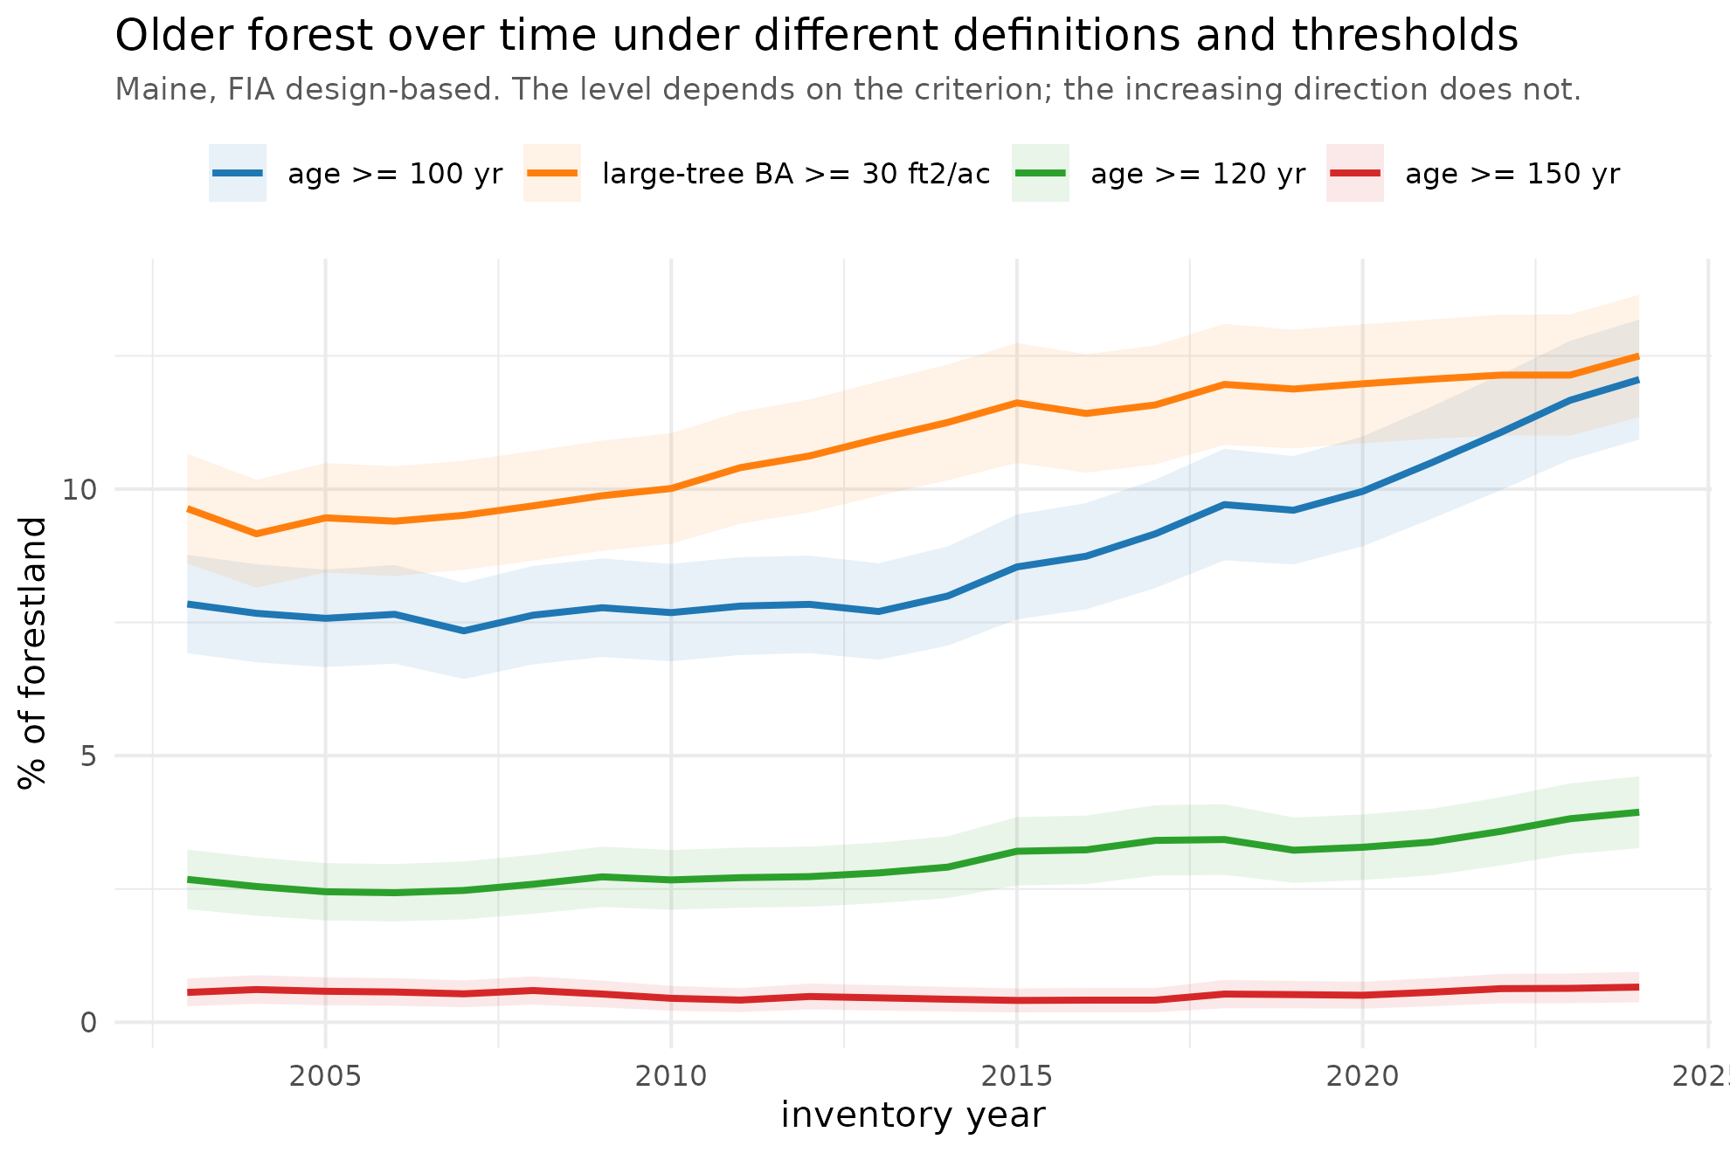
Figure S4. Maine older forest over time (FIA design-based) under four ground definitions: stand age >= 100, >= 120, and >= 150 yr, and large-tree basal area >= 30 ft-sq/ac, each with a 95% band. The level depends on the criterion, but every definition increases over 2003-2024.

Figure S3. Maine ensemble bivariate (agreement by uncertainty)
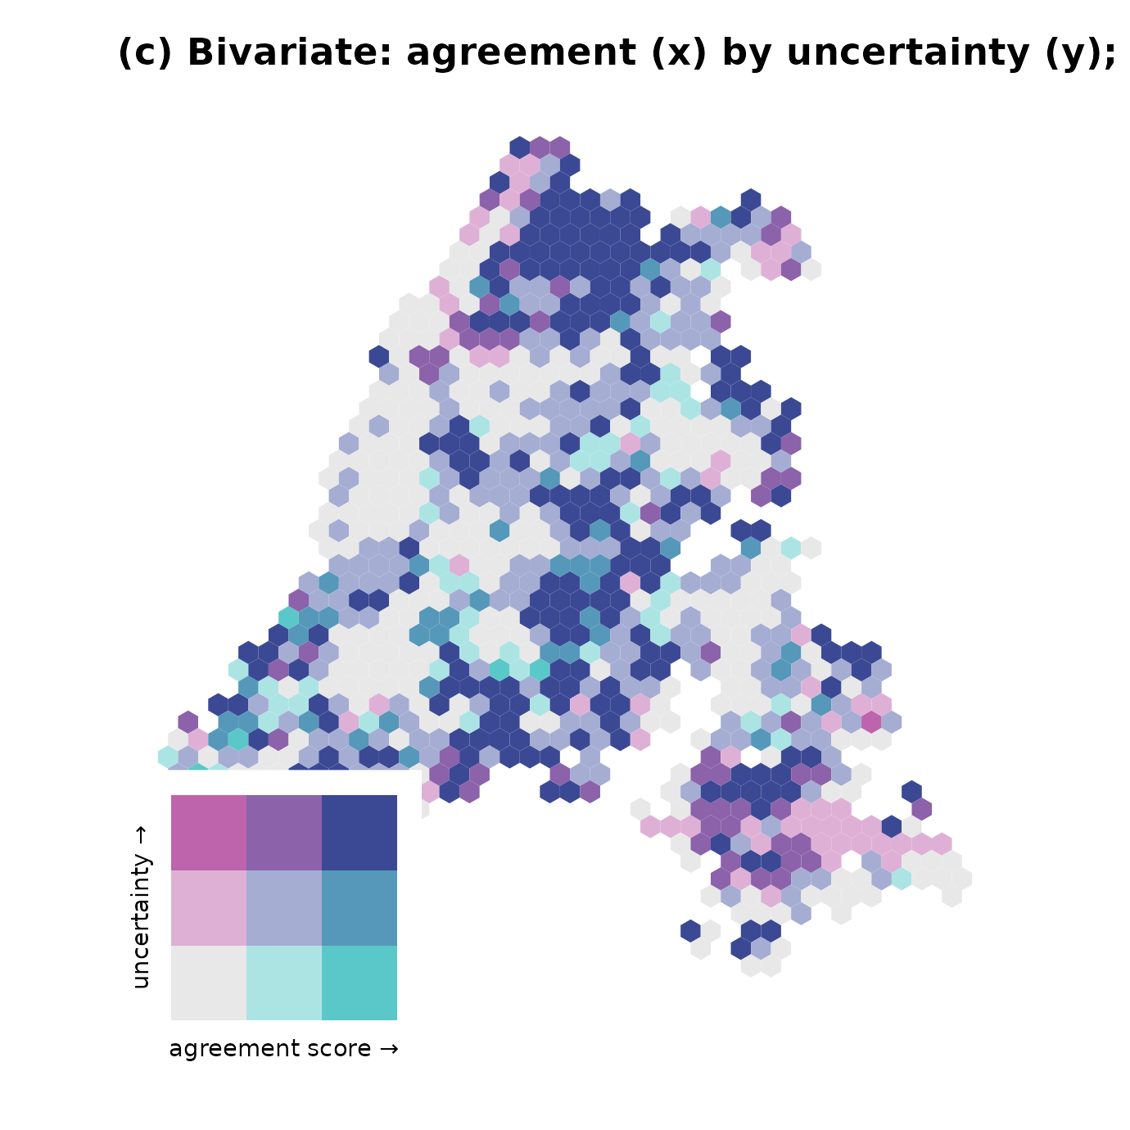
Figure S3. Bivariate map of the prototype ensemble agreement score (horizontal) by uncertainty (vertical) for the Maine study area, tercile breaks. The defensible acquisition targets are the high-agreement, low-uncertainty hexes; most of the landscape carries high uncertainty.

Figure S5. Where LSOG sits: harvest probability, terrain, and disturbance
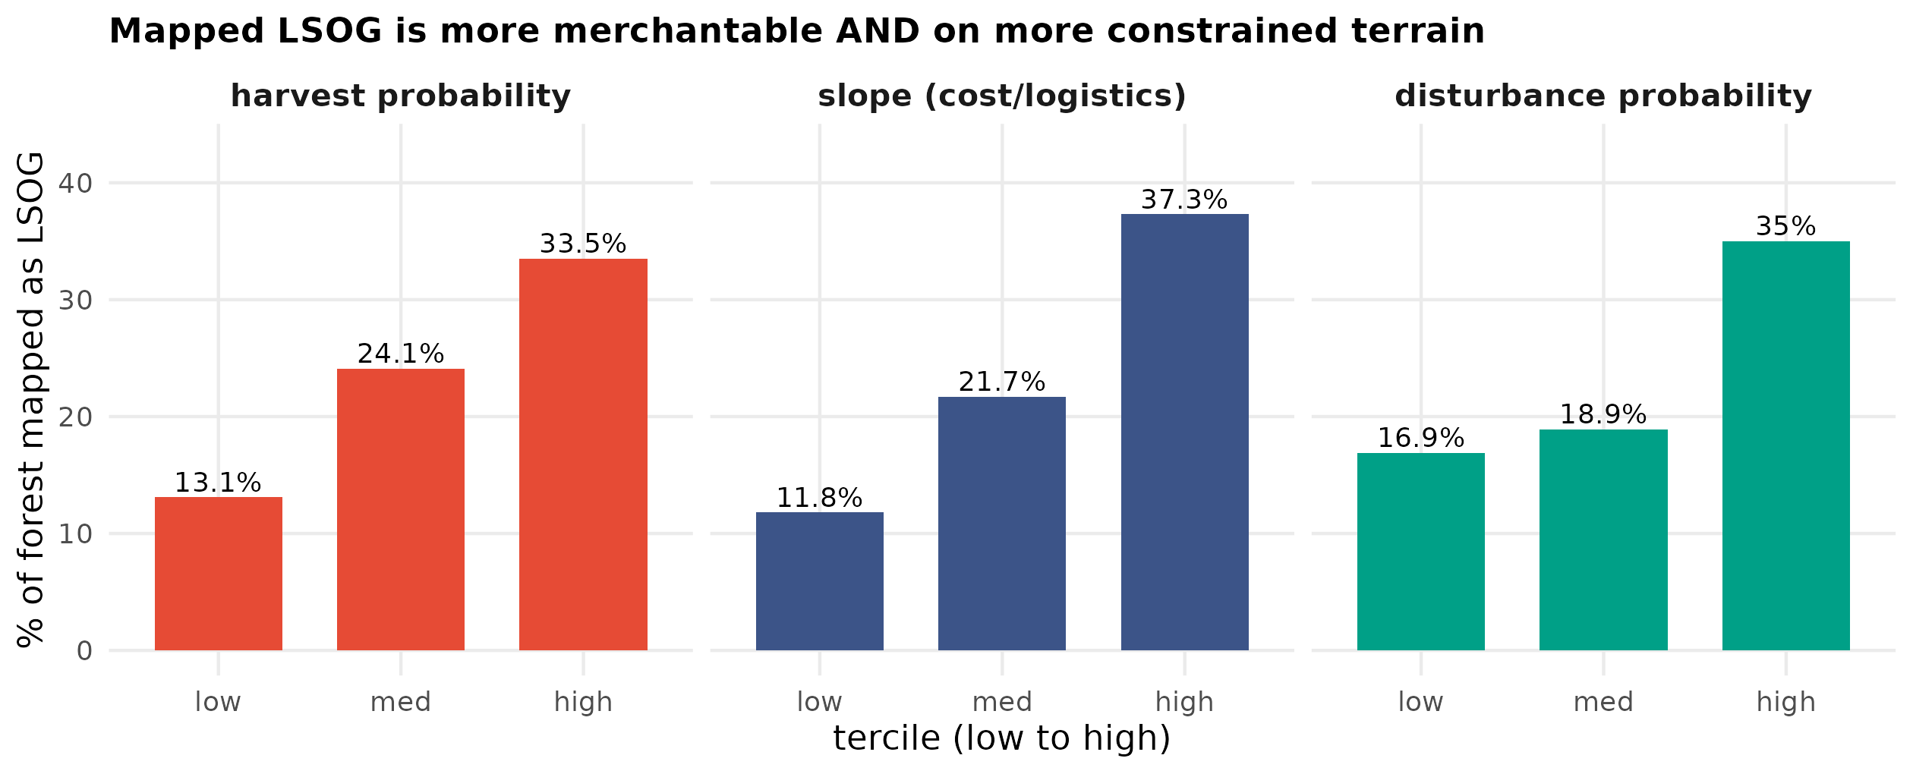
Figure S5. Mapped-LSOG share by tercile of three landscape drivers over the Maine AOI (n = 3.8 million pixels), using the airborne Hagan map as the LSOG layer: (a) modeled annual harvest probability (HCS v5 CONUS, clearcut plus partial), (b) slope (a cost-and-logistics constraint on harvesting), and (c) disturbance probability. Mapped LSOG rises with all three: it is more merchantable (harvest-probability share 13% to 34%) yet on steeper ground (12% to 37%) and in more disturbance-prone settings (17% to 35%). Mean values under LSOG versus non-LSOG: harvest probability 0.024 vs 0.021, slope 5.3 vs 3.0 degrees, disturbance 0.128 vs 0.111. Attractiveness and constraint pull in opposite directions, so harvest risk is heterogeneous rather than uniform.

Figure S6. A Landsat continuity layer for true-LSOG mapping
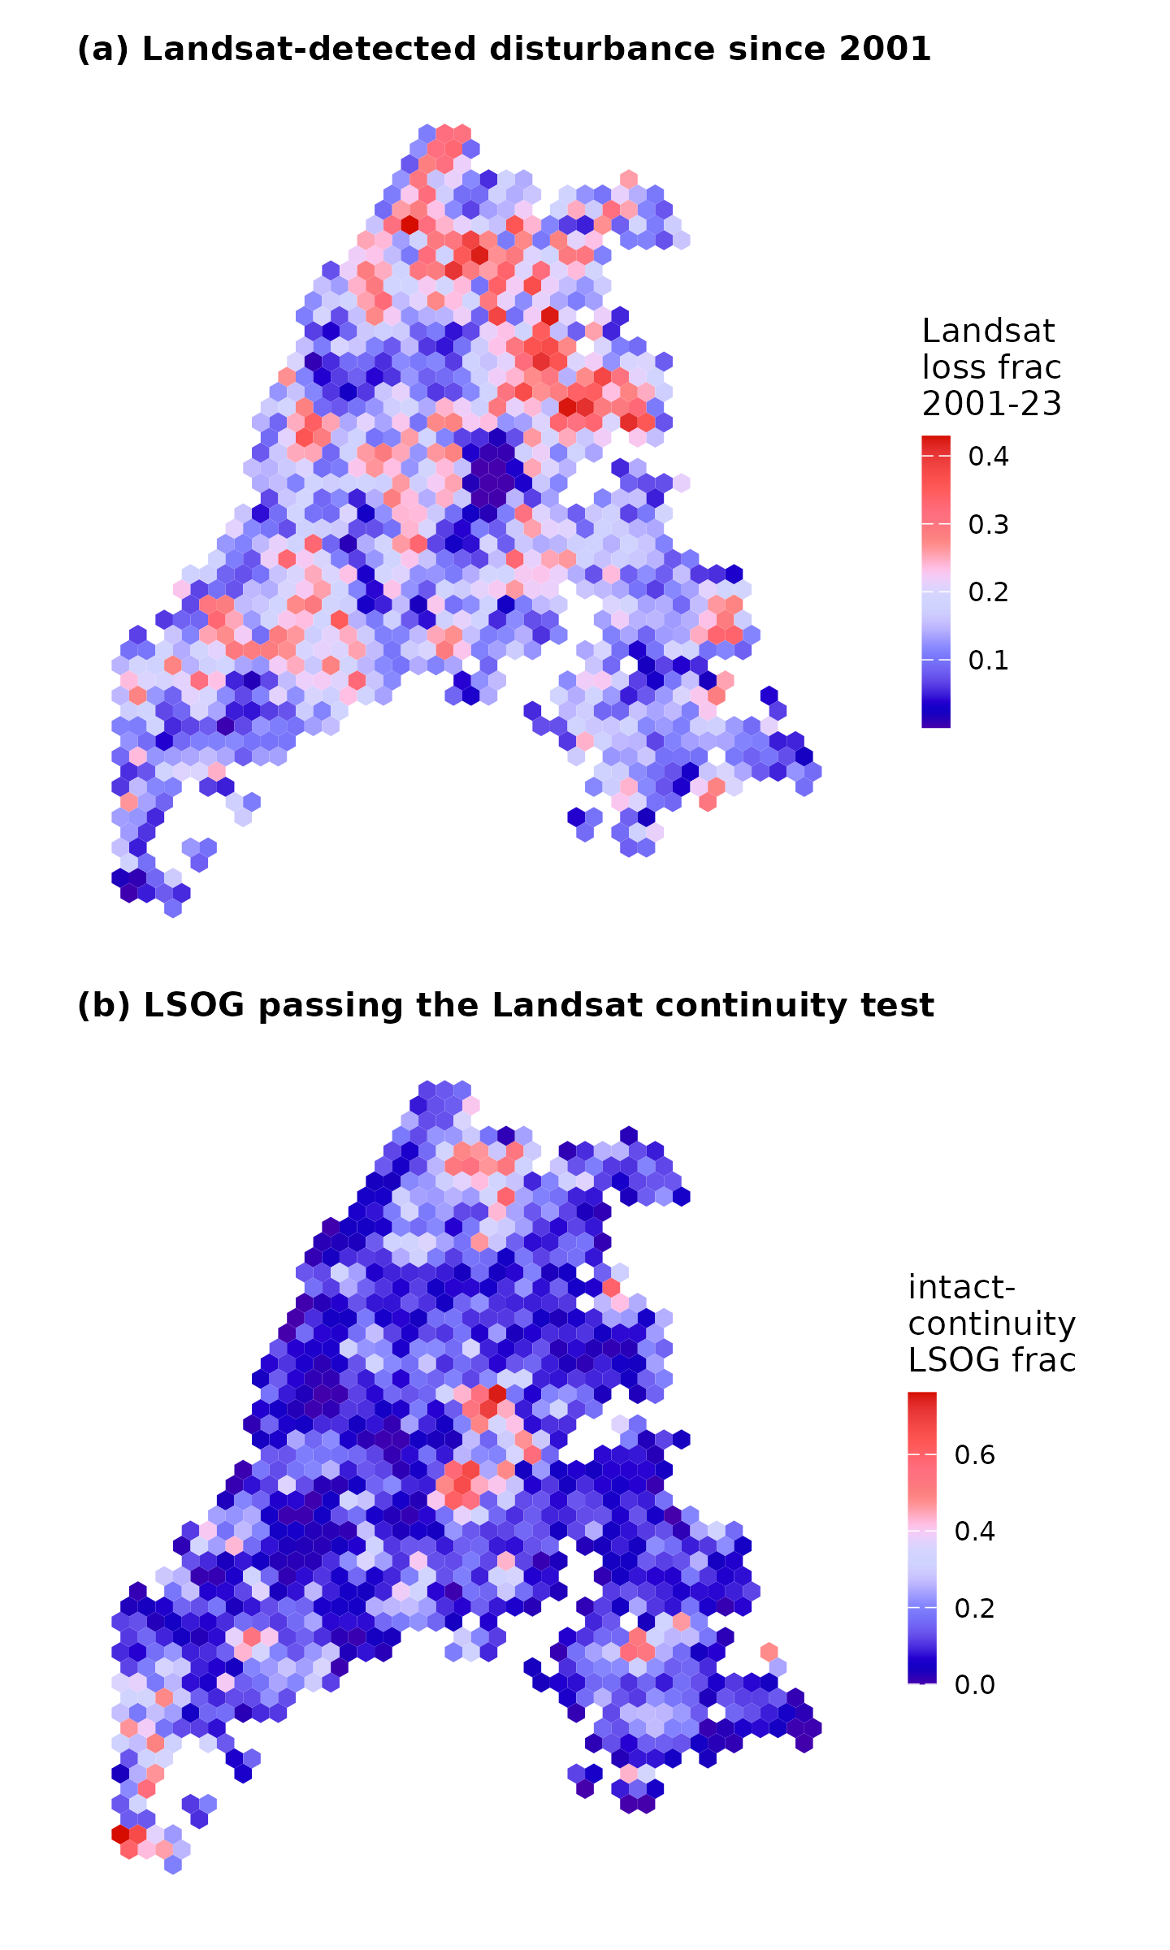
Figure S6. The temporal-continuity axis made mappable from Landsat (Hansen Global Forest Change, 2001-2023), 8 km hexagons: (a) fraction of each hex with stand-replacing canopy loss since 2001; (b) fraction of the canopy-mapped LSOG that is intact over the record. Of canopy-mapped LSOG, 24% shows stand-replacing disturbance since 2001 (failing strict continuity) and 76% is intact; partial harvests and pre-2001 entry (legacy skid trails) are not captured, so this is a lenient test.

